Problem Statement 3: Evaluate the relationship between US equity and bond markets and comment on its evolution over time by substantiating it with statistical analysis and macro-economic reasoning. Further, breakdown the relationship by equity sector.

**Python Code: USmarket.py**

1. Data Collection:

* Equity market data was sourced from Yahoo Finance, for past 10 years including S&P 500 and key sector indices (Technology, Financials, Healthcare).
* Bond market proxy is the 10-Year Treasury Yield (10Y Yield).

1. Statistical Analysis:

* Rolling Correlation: Assessed the time-varying relationship between equity sectors and bond yields.
* Regression Analysis: Quantified the sensitivity of equity return and sector returns to changes in bond yields.

1. Key Findings

* Rolling Correlation:

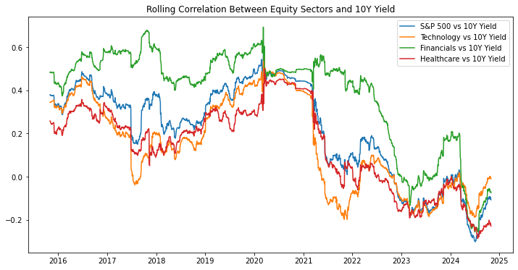

S&P 500: The rolling correlation fluctuates, staying generally positive but dropping below zero at certain periods (late 2020–2021 and 2023). Positive correlation during most of the period suggests that equities and bond yields moving alongside, reflecting economic optimism. Negative correlation in some phases aligns with periods of economic uncertainty, where "flight-to-safety" dynamics dominate.

Technology: Technology shows a weaker correlation compared to other sectors, frequently dropping below zero (late 2018, 2020–2021, and 2023–2024). This reflects the sector's sensitivity to bond yields, as rising yields increase the discount rate for high-growth companies, negatively affecting their valuations.

Financials: Financials display the strongest and most consistent positive correlation with bond yields. This is expected since the sector benefits directly from higher yields through improved interest rate margins and profitability.

Healthcare: Healthcare demonstrates a generally lower and more stable correlation compared to other sectors. It occasionally dips below zero (e.g., early 2021), reflecting its defensive characteristics and lower sensitivity to macroeconomic interest rate changes.

* Regression Analysis:

1. S&P500:

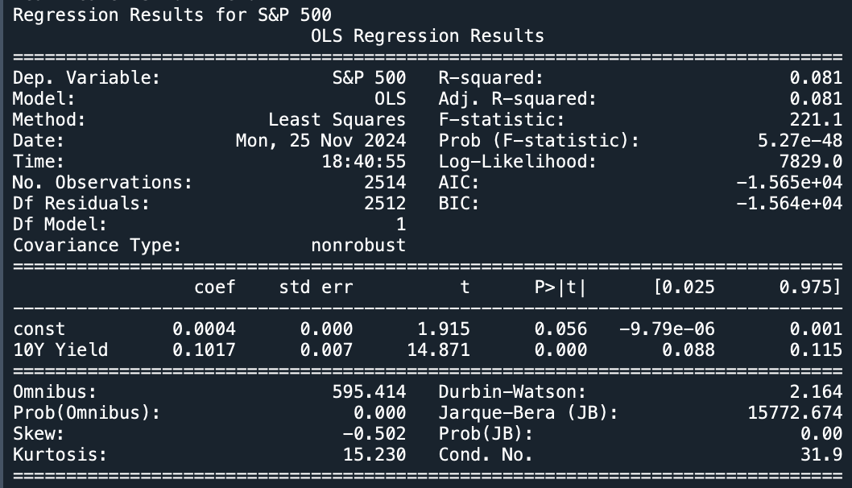

* Regression Coefficients: The coefficient for the 10Y Yield is 0.1017, which is positive and statistically significant (p-value < 0.001). This suggests that a 1% increase in the 10Y Yield is associated with a 10.17 basis points increase in the S&P 500's daily return on average. The constant term is 0.0004 (marginally significant with a p-value of 0.056), implying a small baseline return independent of bond yields.
* Model Fit: R-squared: 0.081, indicating that about 8.1% of the variation in the S&P 500's returns is explained by changes in the 10Y Yield. The implies that the model captures only a small portion of the variability, suggesting other factors also play important roles.

1. Technology:

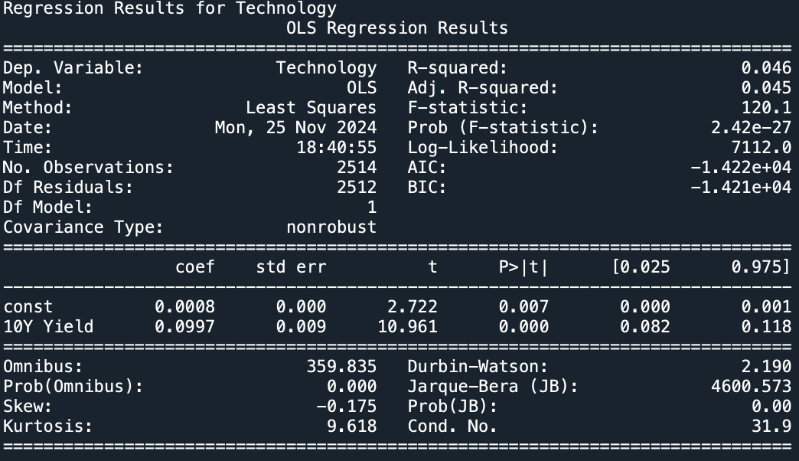

* Regression Coefficients: The coefficient for the 10Y Yield is 0.0997, which is positive and statistically significant (p-value < 0.001). A 1% rise in the 10Y Yield corresponds to an average increase of 9.97 basis points in daily returns for the Technology sector. The constant term is 0.0008, statistically significant (p-value = 0.007), suggesting a small baseline return independent of bond yields.
* Model Fit: R-squared: 0.046, meaning 4.6% of the variability in the Technology sector's returns is explained by bond yield changes. This lower R-squared compared to the S&P 500 highlights weaker predictability for this sector from bond yield movements.

1. Financials:

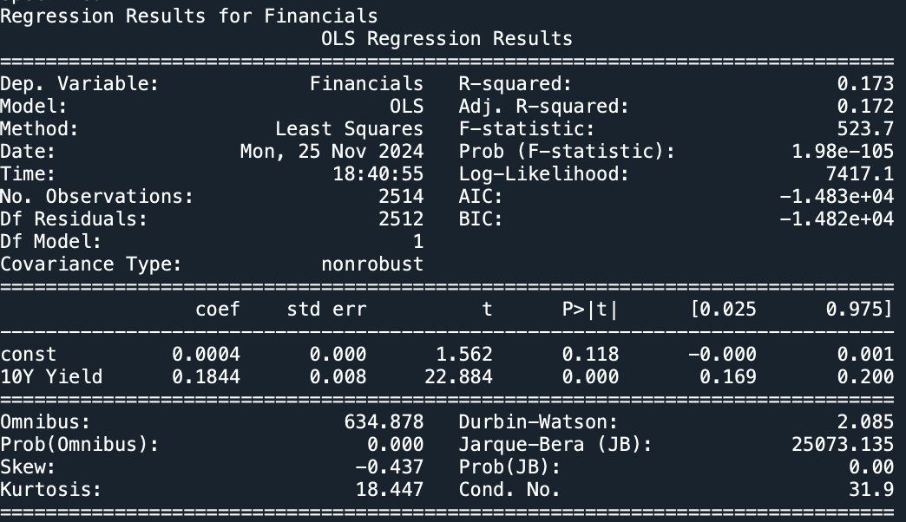

* Regression Coefficients: The coefficient for the 10Y Yield is 0.1814, which is positive and statistically significant (p-value < 0.001). This suggests that a 1% increase in the 10Y Yield is associated with a 18.14 basis points increase in the S&P 500's daily return on average. The constant term is 0.0004 (not much significant with a p-value of 0.118), implying a very small baseline return independent of bond yields.
* Model Fit: R-squared: 0.173, indicating that about 17.3% of the variation in the Financial sector’s return is explained by changes in the 10Y Yield. The implies that the model captures only a small portion of the variability, suggesting other factors also play important roles.

1. Healthcare:

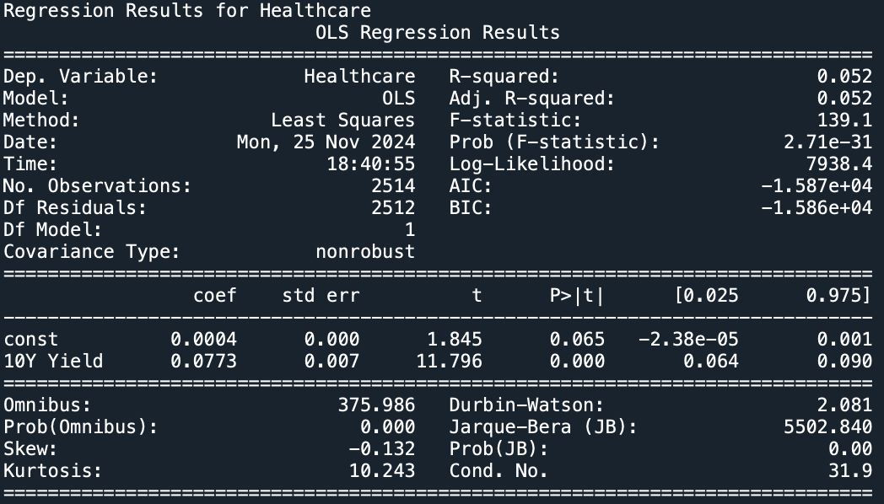

* Regression Coefficients: The coefficient for the 10Y Yield is 0.0773, which is positive and statistically significant (p-value < 0.001). A 1% rise in the 10Y Yield corresponds to an average increase of 7.73 basis points in daily returns for the Technology sector. The constant term is 0.0004, statistically marginally significant (p-value = 0.065), suggesting a small baseline return independent of bond yields.
* Model Fit: R-squared: 0.052, meaning 5.2% of the variability in the Healthcare sector's returns is explained by bond yield changes. This lower R-squared compared to the S&P 500 highlights weaker predictability for this sector from bond yield movements.

5. Macro-Economic Interpretation

* Economic Expansions: Positive correlations emerge during growth periods as bond yields rise alongside equity markets, reflecting optimism about economic prospects. Financials benefit the most, while Technology may underperform due to higher discount rates on future cash flows.
* Economic Downturns or Crises: Negative correlations dominate as investors shift to bonds for safety, causing yields to drop while equities decline. Defensive sectors like Healthcare show resilience during such periods.
* Interest Rate Policies: Tightening monetary policy (rate hikes) often leads to equity sell-offs, particularly in rate-sensitive sectors like Technology. Financials may benefit in the short term but face challenges if higher rates stifle loan demand.

1. Conclusion:

* The relationship between US equity and bond markets is dynamic and evolves based on macroeconomic conditions, monetary policy, and sectoral characteristics. Sectoral breakdown highlights varying sensitivities:
* Technology: Adversely affected by rising bond yields.
* Financials: Positively correlated with higher yields.
* Healthcare: Defensive with minimal sensitivity.
* Rolling correlation trends and regression coefficients align with macroeconomic reasoning, validating the importance of sectoral differentiation in portfolio strategies.
* Investor should combine rate-sensitive sectors (Financials) with defensives (Healthcare) to diversify and mitigate risks during volatile interest rate cycles. And allocate more to defensive sectors during economic slowdowns and to rate-sensitive sectors during periods of economic expansion.