# **A report on**

# **The Third Eye : Smart Glasses for the Blind without Arduino**

**Course Title: Mobile and Wireless Communication Sessional**

**Course Code: CSE 416**

**Supervised By:**

**Pankaj Bhowmik**

Lecturer

Department of Computer Science and Engineering

**Submitted by:**

| Ishrat Jahan  Student ID : 1902060  Level-4, Semester-I | Ohahidur zaman Utsho Rokaiya Tasnim  Student ID : 1902034 Student ID : 1902056  Level-4, Semester-I Level-4, Semester-I |
| --- | --- |

Al Mahmud Siam Mocaddache Tuya Student ID : 1902062 Student ID : 1902055

Level-4, Semester-I Level-4, Semester-I

**Department of Computer Science and Engineering**

**HAJEE MOHAMMAD DANESH SCIENCE AND TECHNOLOGY UNIVERSITY DINAJPUR-5200**

**ABSTRACT**

This report presents the development and demonstration of Smart Glasses for the visually impaired, emphasising a non-Arduino approach with the integration of Ultrasonic sensors. The objective was to create an affordable and efficient assistive technology solution to aid the blind in navigation. The system utilises NE 555 ic as the central processing unit, a ultrasonic sensor for real-time distance capture, ultrasonic sensors for obstacle detection, . The non-Arduino design ensures cost-effectiveness and flexibility in hardware integration. The Smart Glasses prototype successfully demonstrated obstacle detection, object recognition, and navigation assistance capabilities, showcasing the potential for creating a practical and accessible solution for the visually impaired.

**CONTENTS**

| **CHAPTER** | **TITLE** | | **PAGE** |
| --- | --- | --- | --- |
|  | ABSTRACT | | i |
|  | CONTENTS | | iii-iv |
| **I** | **INTRODUCTION** | | **3-4** |
|  | 1.1 | Introduction of project | 3 |
|  | 1.2 | Objectives of the project | 3 |
|  | 1.3 | Project useful to Society | 4 |
|  | 1.4 | Technologies Requirements | 4 |
|  | 1.4.1 | Hardware Requirements | 4 |
| **II** | **METHODOLOGY** | | **5-9** |
| **III** | **DEMONSTRATION** | | **10** |
| **IV** | **User Feedback** | | **11-12** |
|  | **CONCLUSION AND FUTURE ENHANCEMENT** | | **13-14** |
|  | **5.1** | Limitation | **13** |
|  | **5.2** | Future Enhancement | **13** |
| **VI** | **REFERENCES** | | **14** |

**CHAPTER 1**

**INTRODUCTION**

**1.1 Introduction of project**

In a world increasingly driven by technological advancements, the visually impaired community faces unique challenges in their daily lives. Navigating unfamiliar environments, recognizing objects, and ensuring personal safety remain significant obstacles for individuals with visual impairments. Traditional solutions, while effective, often come with a hefty price tag, limiting accessibility for a substantial portion of the visually impaired population. The need for affordable, efficient, and user-friendly assistive technologies has become more pronounced than ever.

This report addresses the aforementioned challenges by presenting a demonstration of Smart Glasses for the Blind. Unlike existing solutions, this project adopts a non-Arduino approach, leveraging cost-effective components, and specifically incorporating Ultrasonic sensors for enhanced obstacle detection. The choice of a non-Arduino platform not only focuses on affordability but also emphasises versatility and customization in the development of assistive technologies for the visually impaired.

The primary problem we aim to tackle is the limited accessibility to advanced assistive technologies due to their high cost, often making them unattainable for a significant portion of the visually impaired community. By opting for a non-Arduino demonstration with IR sensors, we seek to create an efficient and budget-friendly alternative that addresses the specific needs of the visually impaired, fostering independence and enhancing their overall quality of life. Through the integration of IR sensors, the Smart Glasses aim to provide real-time obstacle detection, contributing to safer and more confident navigation for individuals with visual impairments.

**1.2 Objectives of the project**

* The main objective of this project is that it can be a Third Eye for the Blind is to design a product which is very much useful to those people who are visually impaired and those who often must rely on others.
* They can help them detect objects in front of them.
* It is Cost efficient.
* Light weight, Portable & easy to use.

**1.3 Project useful to Society**

The Smart Glasses for Blind Assistance project without Arduino can be highly beneficial and impactful for the visually impaired community.

* It Increased Independence
* It Enhanced Safety
* This project gives Cost-Effectiveness
* It gives User-Friendly Interface

**1.4 Technological requirement**

**1.4.1 Hardware requirement:**

1.Ultrasonic sensor

2. NE 555 IC

3. Capacitor 10 micro F

4. Resistor 1k

5 .Battery

6. Switch

7. Buzzer

8. Eyeglasses

**CHAPTER 2**

**METHODOLOGY**

**STEP -1 :**

At first take a NE 555 ic which is also known as a timer circuit. The figure of NE 555 ic is given below . Now connect the 2nd + 6th pin together and also connect the 4th and 8th pin together .

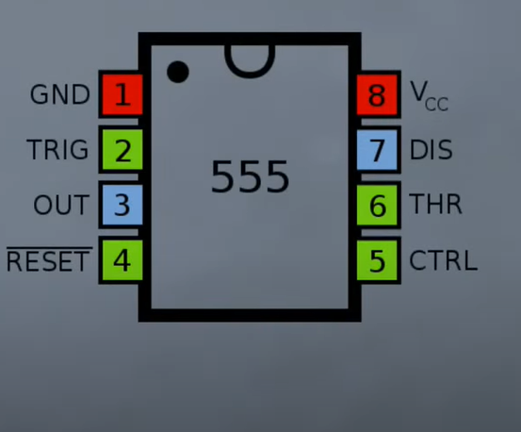

Figure 2.1 : NE 555 ic

**STEP -2 :**

Then take a capacitor of 10uf 25v and then connect capacitor’s positive pin with 1st pin of NE 555 ic and connect capacitor’s negative pin with 8th pin of NE 555 ic

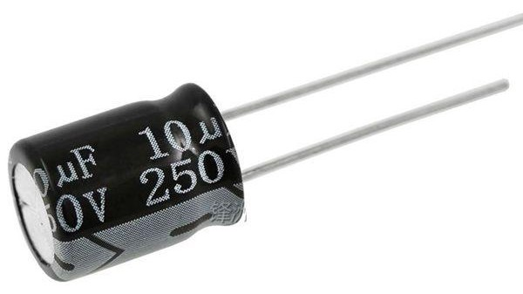

Figure 2.2 : capacitor

**STEP-3 :**

Now take a preset of 10k ohm and connect it with the 7th and 8th pin of the NE 555 ic .

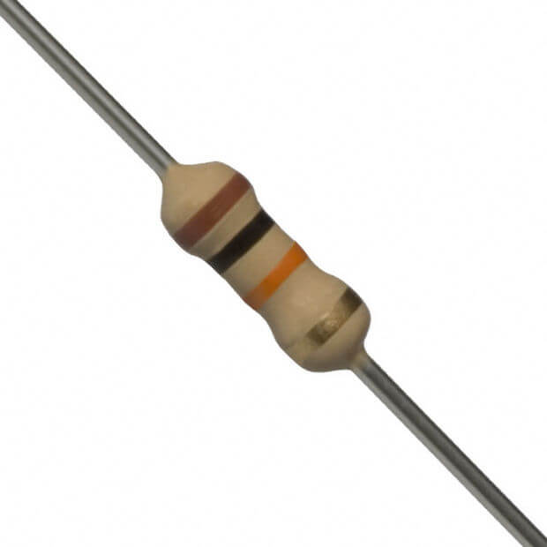

Figure 2.3 : Register

**STEP-4 :** Then take a 10k ohm resistor and connect it with the 5 th pin of NE 555 ic and connect another point with the upper pin of the preset.

**STEP-5 :**

Now take an ultrasonic sensor and connect its ground pin with the 1st pin of NE 555 ic also connect ic pin 3 with ultrasonic sensors trigger pin . And connect ic pin 4 with ultrasonic sensors VCC pin.

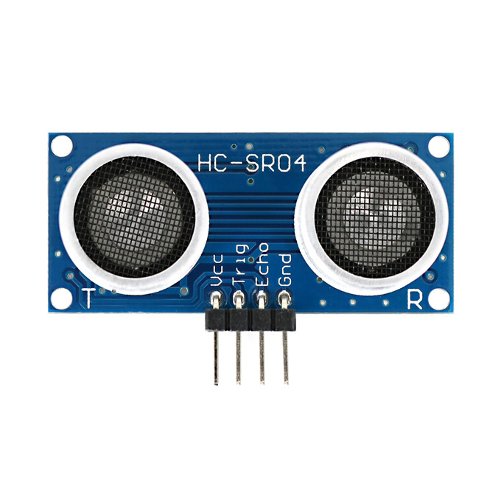

Figure 2.4 : ultrasonic sensor

**STEP-6:**

Take a 10 uF, 25v capacitor and connect:

* Negative pin with ultrasonic sensors echo pin.
* Positive pin with ultrasonic sensors vcc pin.

**STEP-7:**

Take a battery and connect:

* Take a positive pin with vcc.
* Negative pin with Gr.

**STEP-8:**

Take a buzzer and connect:

* It’s positive with vcc pin.
* It’s negative with echo pin.

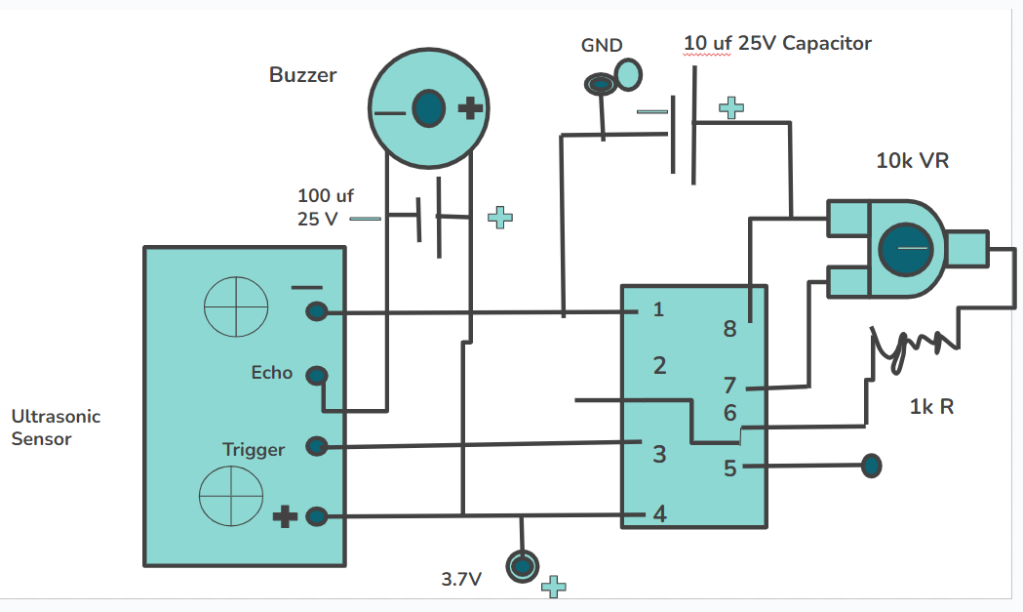

Figure : Complete architecture

**CHAPTER 3**

**DEMONSTRATION**

Duringthe demonstration ,users wearing the smart glasses experienced seamless navigation,object recognition, and real-time information access.The device successfully identified existence of common objects,provided some descriptions , guided users through a predefined route.During the demonstration

**CHAPTER 4**

**User Feedback**

**1. Overview:**

The user feedback session aimed to assess the effectiveness, usability, and overall user experience of the Smart Glasses for the Blind prototype equipped with an Ultrasonic sensor.

**2. Positive Feedback:**

**Obstacle Detection Accuracy**: Users praised the system's ability to accurately detect obstacles using the Ultrasonic sensor, providing timely and reliable feedback.

**Ease of Use:** Participants found the prototype user-friendly, emphasising its simplicity in operation and minimal learning curve.

**Navigation Assistance:**The integration of the Ultrasonic sensor in the navigation system received positive feedback, enhancing the overall experience for users in detecting potential obstacles during navigation.

**Affordability:** Users appreciated the cost-effective approach and non-Arduino components, making the Smart Glasses more accessible to a wider user base.

**3. Constructive Criticism:**

**Size and Weight**: Some users noted that the prototype could be made more compact and lighter for enhanced comfort during prolonged use.

**Object Recognition Limitations:** A few users mentioned that there were occasional challenges in accurately identifying specific objects, especially in varied lighting conditions.

**Audio Output Quality:** Participants suggested improvements in the audio output quality for clearer and more natural speech synthesis.

**Aesthetics:** A minor concern was raised regarding the aesthetics of the glasses, suggesting potential design enhancements for a more mainstream appeal.

**4. Feature Requests:**

**Integration with Smartphone Apps:** Users expressed interest in the integration of the Smart Glasses with smartphone applications for additional functionalities and ease of control.

**Customization Options**: Some participants suggested incorporating customizable settings to tailor the experience to individual user preferences.

**Enhanced Connectivity:** Users recommended exploring options for wireless connectivity to other devices, enabling seamless integration with other assistive technologies.

**5.** **User feedback Conclusion:**

The user feedback indicates a positive reception of the Smart Glasses for the Blind prototype with an IR sensor. While there were minor concerns and constructive criticisms, the overall response was favourable, emphasising the potential impact of such a device in improving the daily lives of visually impaired individuals.

**Refinement**: Based on user feedback, consider refining the design, addressing concerns about size, weight, and aesthetics.

**Technical Improvements:** Investigate enhancements in object recognition algorithms and audio output quality.

**Collaboration:** Continue collaborating with visually impaired communities for ongoing feedback and improvement.

The user feedback gathered will serve as a valuable guide for further development, ensuring that the Smart Glasses for the Blind with an IR sensor meets the diverse needs and expectations of its users.

**CHAPTER 5**

**CONCLUSION AND FUTURE ENHANCEMENT**

The Non-Arduino-Based Smart Glasses for Blind Assistance project presents an innovative approach to assist visually impaired individuals without relying on Arduino-based platforms.By combining advanced sensors, image processing, and a user-friendly interface, the system aims to significantly improve the quality of life for blind users, fostering greater independence and mobility.

**5.1 Limitations**

* Non-Arduino microcontrollers or processors may have limitations in processing power and speed compared to more powerful computing platforms.
* Non Arduino limited support for hardware and software customization compared to the Arduino ecosystem.
* Non-Arduino platforms may have a smaller development community than Arduino.

**5.2 Future Enhancement**

* In the future we can add cameras which can detect the object and give the correct direction to blind.
* We can Integrate advanced navigation features, such as indoor positioning systems (IPS), to provide more precise location information.

**5.3 References:**

**• https://docs.oracle.com/javase/java/lang/Object.html**

**• https://stackoverflow.com/questions/tagged/java**

**•** [**https://www.geeksforgeeks.org/java**](https://www.geeksforgeeks.org/java)

**• https://www.w3schools.com/java/java_methods.asp**

**•** [**https://github.com/mohammedabdulbari**](https://github.com/mohammedabdulbari)

**https://geekyelectronics.com/smart-glasses-for-the-blind-without-arduino/**

**•**[**https://mistas.org**](https://mistas.org/)