Lab Report No: 05
Name of the Lab Report: Connecting database (MySQL) in Linux (Ubuntu) OS.
Name: Ishrath Mostakin
ID: IT-17018
Objective: From this lab i learnt about how to connect MySQL in Linux (Ubuntu) operating system and use the MySQL program as a quick and easy way to access databases directly.

1.Install MySQL on Ubuntu :
Open the terminal and run those commands:

sudo apt-get update
sudo apt-get install mysql-server
mysql_secure_installation

2. Log into MySQL by Ubuntu :
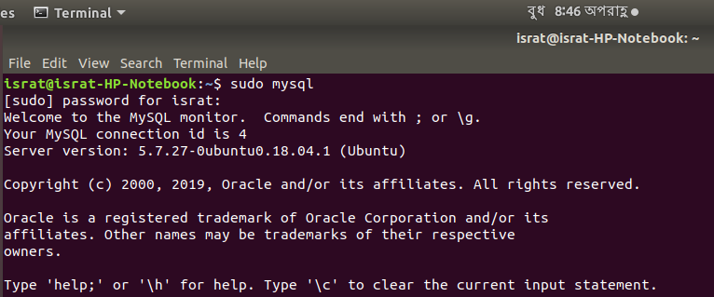
3. Show and Create Database :

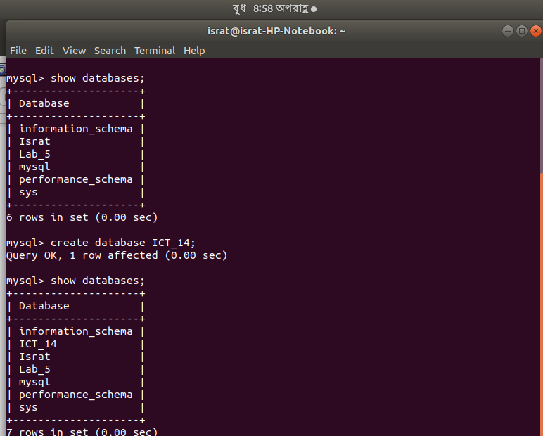

4. Show and Create Table :
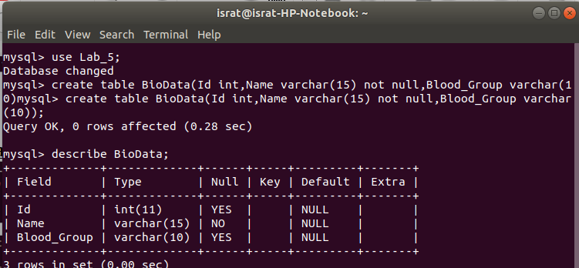
5. Insert Data in Table :
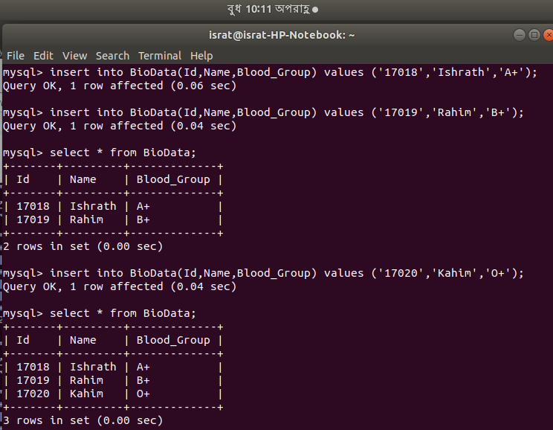

6. Describe Table:
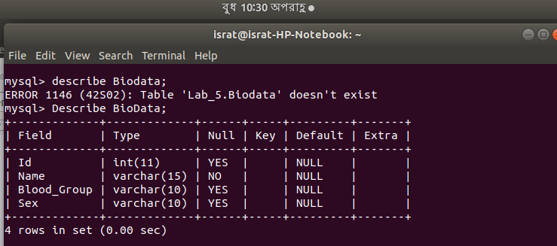
7.Update Table:
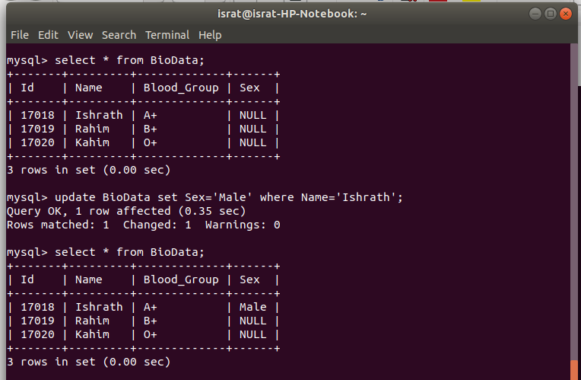

8. Delete From Table:
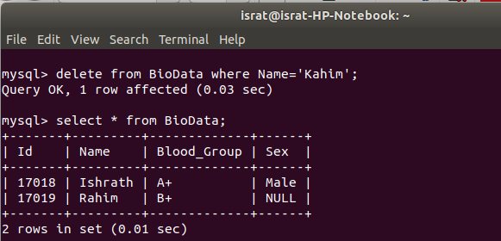

9. Drop Table:
