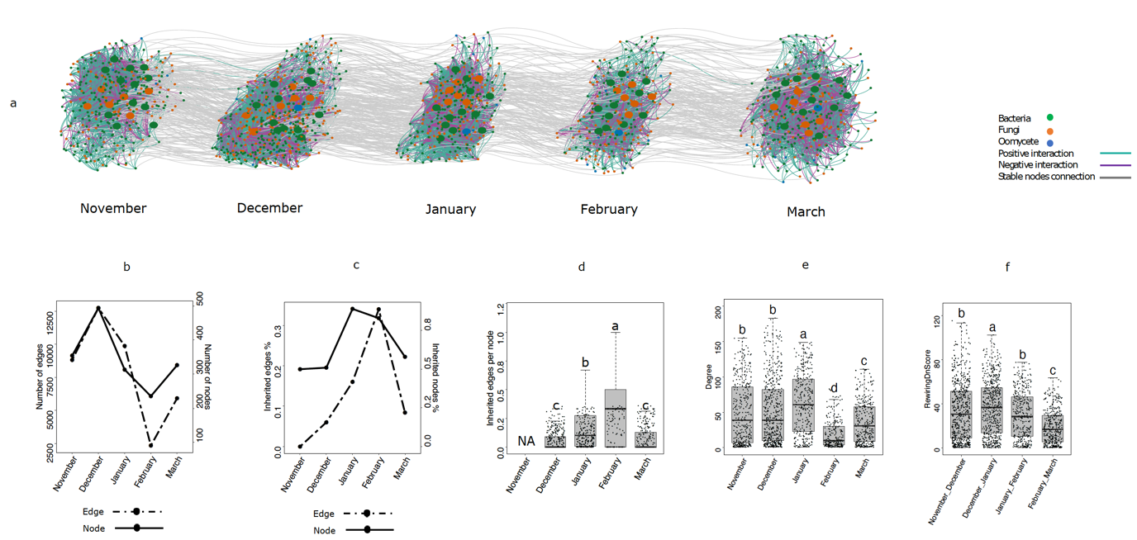

Steps :

Install DyNet in Cytoscape

Calculate Rewaring Dnscore for pairs of months using

(nov-dec , dec-jan, jan-feb,Feb-March)

Example: open 0.001_11_corsparcc.txt and then 0.001_11_corsparcc.txt

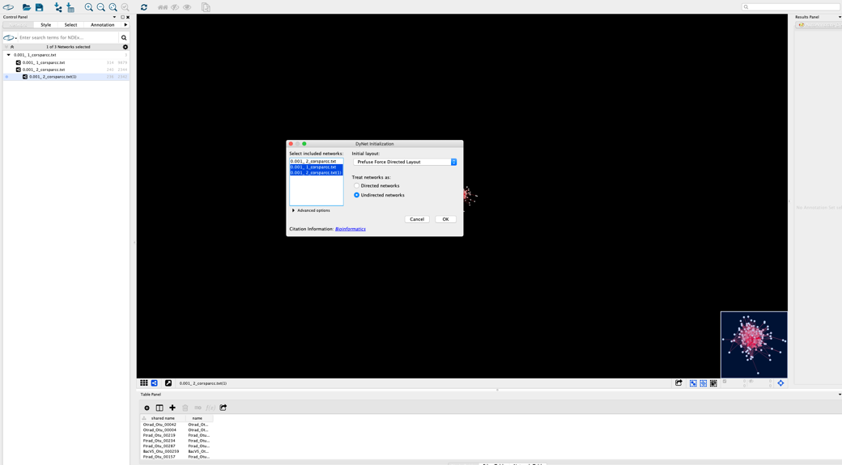

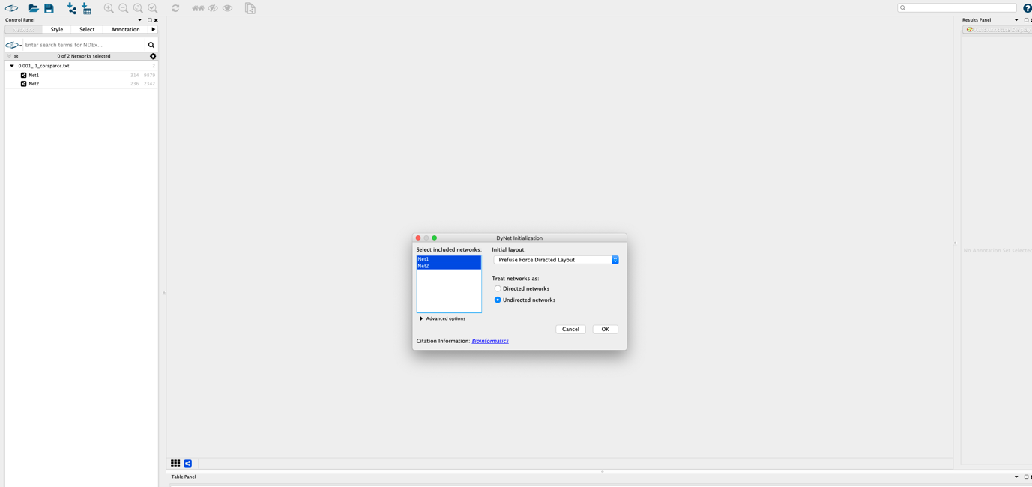

Parameters are default, I did not change/

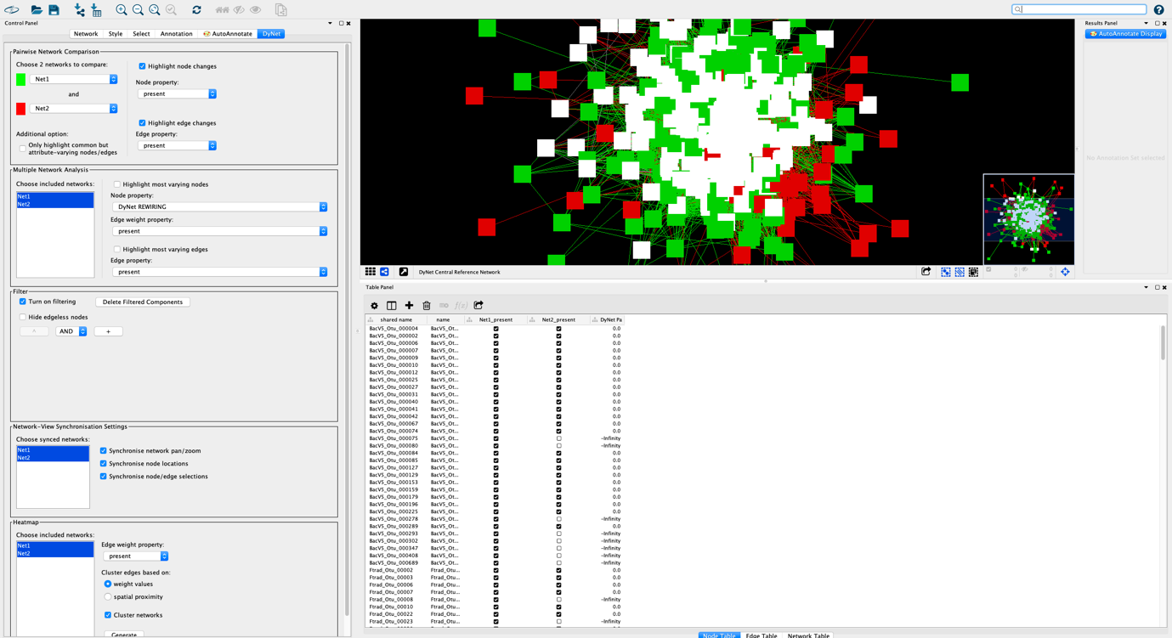

Enable to calculate nodes rewiring score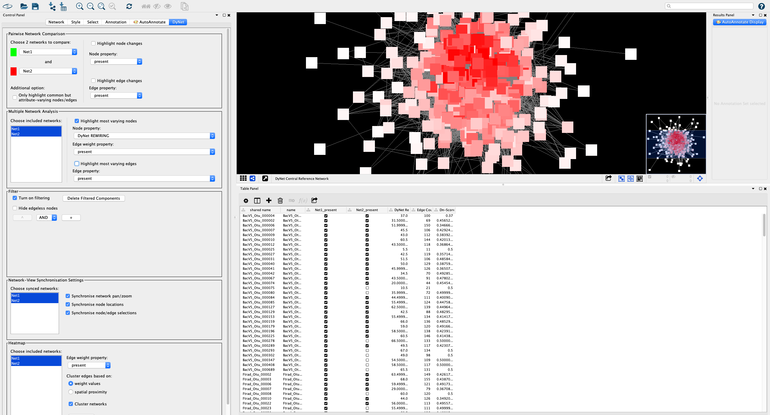

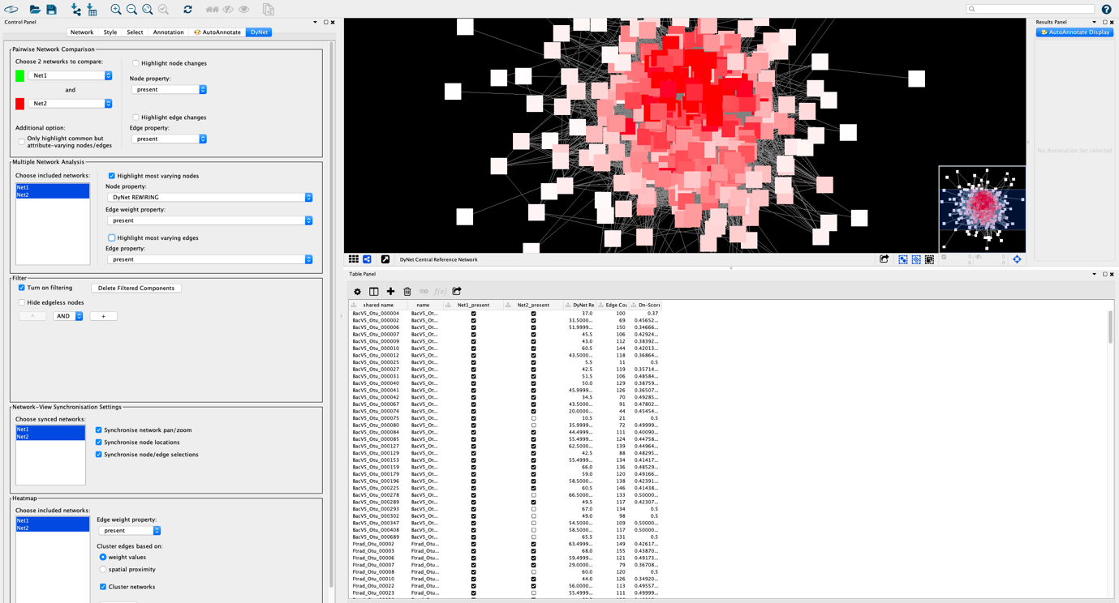

Now export node table and edge table for each pairs and save in :

Step4_DyNetwork/node_edge_tables_FromDyNet/*

Rest are not important will be explain later

This panel(node table) and this column  will be use to calculate figure 4E in R script: (later I will explain )



Look to edge table:

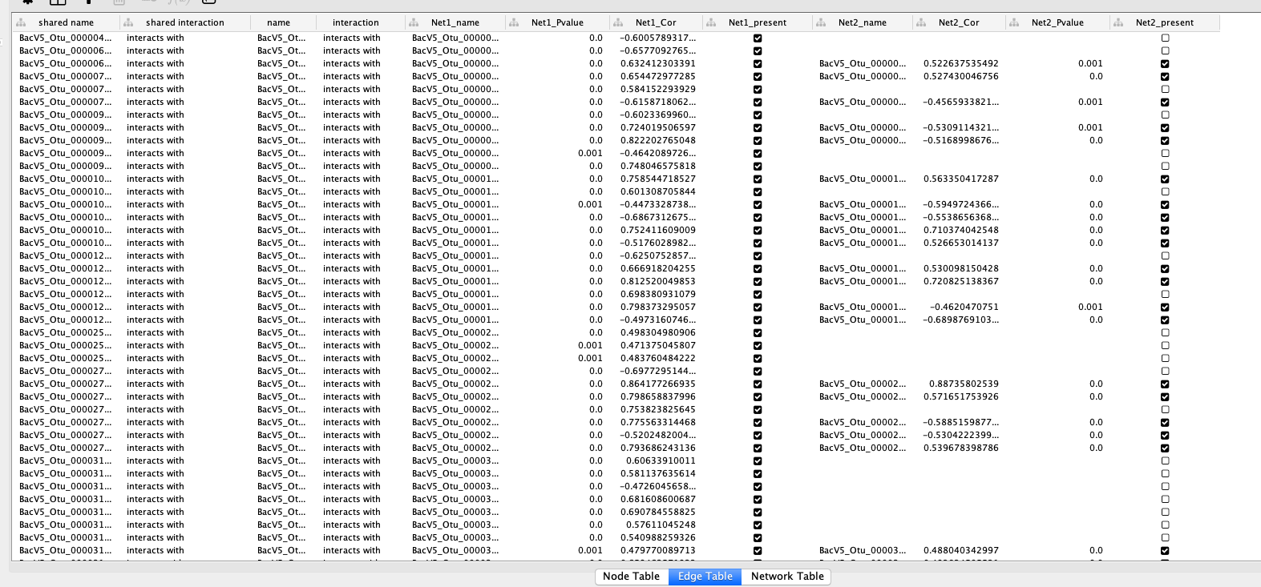

Here are all the interaction(net1) and net2 separately.

If an edge is present in net1 and not Net2 then there is present sympol:

 If an edge is present in net2 and not Net1 then there is present sympol:

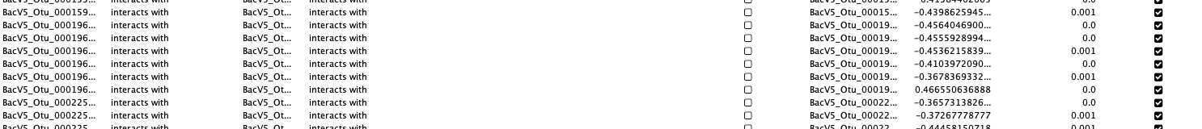

If an edge is present in both network then there is present sympol in both:

