TrueDeed: Algorithmic Land Fraud & Double-Selling Prevention Platform
Official Concept Note & Technical Proposal — DIU LandTech Innovation Hackathon 2026
Team Code: LA-72 (Team TrueDeed) | Track: Digital Land Records, Verification & Digitization | Selected Problem: P3: Catch Fraud & Double-Selling
1. Problem Chosen: P3 — Catch Fraud & Double-Selling
Under Section 5 of the LandTech 2026 Rule Book, Team TrueDeed selects Problem P3: Catch Fraud & Double-Selling. Land disputes are the single largest burden on Bangladesh's judicial and civil administration, and while portals like e-Porcha and e-Namjari digitize historical records, they are passive repositories with no real-time verification gate at the Sub-Registrar desk. Because deed registration (Ministry of Law) and mutation (Ministry of Land) are disconnected, fraudsters exploit the gap to over-sell inherited shares, fabricate intermediate Baya deeds, and double-sell land before records are updated.

2. Why It Matters in Bangladesh (National Urgency & Evidence)
Land disputes drive social friction, generational litigation, and court congestion in Bangladesh. Per Law Commission and Supreme Court data, property and boundary disputes account for roughly 70% of the ~3.5 million pending civil cases, locking up billions of takas in productive wealth.
The Core Institutional Void: Deed registration (Directorate of Registration, Ministry of Law) and Record-of-Rights/Mutation (AC Land offices, Ministry of Land) run separately, with no real-time synchronization at deed execution. Fraud syndicates exploit this in three ways:
- Inheritance Over-Selling: Heirs conceal female siblings or forge heir certificates and sell 30-40 decimals from an estate where their lawful Farayez share is only 15.
- Broken Baya Lineage: Fabricated intermediate deeds with fictitious sub-registry volume numbers break the CS → SA → RS chain of title, and buyers cannot verify them manually.
- 45-Day Double-Selling Window: Mutation takes 30-45 days after registration, during which records still show the original seller, who can sell the same plot to multiple buyers.
The Breadth of Harm:
- Judicial Burden: Land cases congest sub-district and district courts for decades.
- Banking Risk: Banks and NBFIs spend 14-21 days manually vetting titles, yet still suffer NPLs from forged Baya deeds.
- Vulnerable Heirs: Widows, daughters, and minors are deprived when deeds exceed the legal Farayez quota.
- Diaspora Security: Over 10 million Non-Resident Bangladeshis face ancestral land-grabbing risk with no remote, authenticated title-monitoring portal.
3. Proposed Solution: The TrueDeed Infrastructure
TrueDeed is an Algorithmic Decision Support System (ADSS) that bridges the gap between Sub-Registry and AC (Land) offices. Unlike passive portals such as e-Porcha, it acts as an active pre-execution fraud gate, checking title integrity, inheritance quotas, and transaction locks in under 5 seconds, before a deed is executed. It is deployed at Sub-Registry desks, bank credit-vetting portals, and citizen self-service channels, and rests on three pillars:
- Inheritance Math Engine: Calculates each heir's lawful Farayez share and flags any sale that exceeds it (e.g., 30-40 decimals against a lawful 15).
- Baya Lineage Graph Tracer: Uses a Directed Acyclic Graph (DAG) to trace ownership back to CS/SA/RS records, so fabricated intermediate deeds fail verification.
- Plot Concurrency Lock: Places a temporary lock on the plot during registration, blocking duplicate filings across offices until mutation is complete.
4. How It Works: System Architecture & WorkFlow
TrueDeed transforms physical deed scans into mathematical proofs of title authenticity via a modern 5-stage microservice architecture:

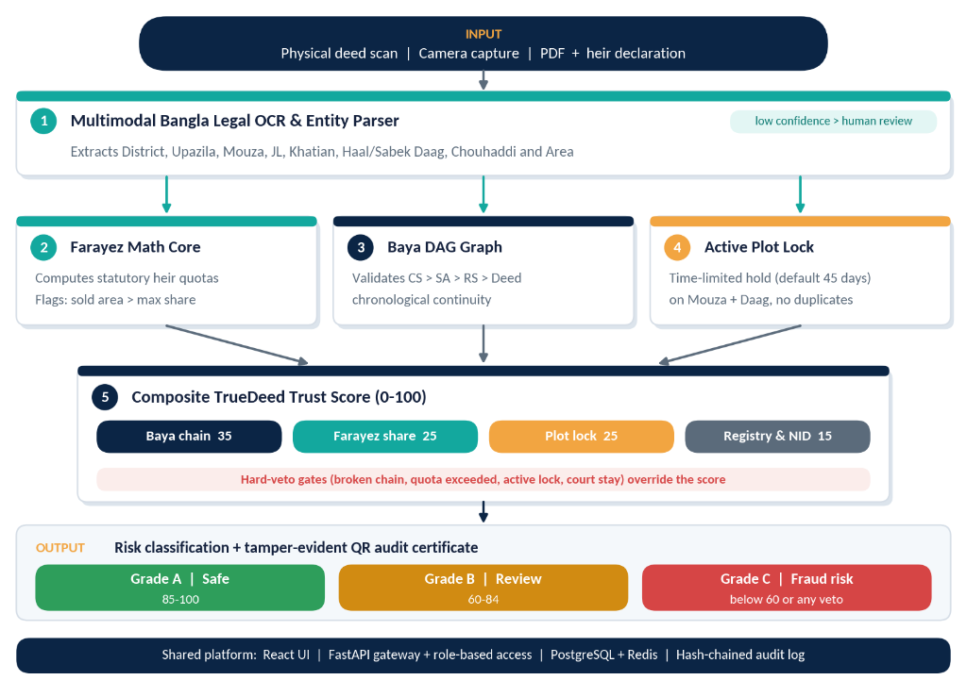

5. Core Technology Stack & Implementation Feasibility
- Frontend Portal (React 19, Tailwind CSS, TypeScript): A fast, responsive web dashboard for Sub-Registrar desks, bank vetting officers, and citizen self-service.
- API Gateway (FastAPI / Python 3.12, Uvicorn, Celery): An asynchronous microservice orchestrator with automated request routing, auth tokens, and audit logging.
- Bangla Legal OCR (Gemini Flash VLM, OpenCV Pipeline): An asynchronous pipeline (3-5s) that extracts District, Mouza, Khatian, Daag, Chouhaddi, and acreage into JSON.
- Farayez & DAG Engine (NetworkX, Custom Math Core): Sub-second (<500ms) graph traversal of historical Baya deeds and mathematical calculation of statutory quotas.
- Database & Ledger (PostgreSQL 16, Redis, SHA-256 Hashes): ACID-compliant storage of Khatians, 45-day active plot locks, and an append-only cryptographic audit trail.
6. Core Functional Modules
TrueDeed delivers five targeted innovations to resolve Problem P3 at the national level:
- Farayez Quota Interceptor: Computes each heir's lawful share (including Aul and Radd) and blocks any sale that exceeds the seller's entitlement.
- DAG Baya Lineage Tracer: Rebuilds the chain of title from CS/SA/RS surveys to the current seller, flagging fake deeds, missing mutations, and broken continuity.
- 45-Day Plot Concurrency Lock: Holds the target Daag record across all registration desks until e-mutation completes, preventing double sales.
- Bangla Legal OCR and Normalizer: Converts handwritten and archaic Bengali deed scans into structured JSON (Mouza, Khatian, Daag, Chouhaddi, acreage), with human-in-the-loop verification.
- Composite Trust Score (0-100%): An explainable, rule-based security score with a tamper-evident, QR-verifiable digital certificate.
7. TrueDeed Composite Trust Score Matrix (0–100%) & Hard Veto Rules
Each transaction is scored out of 100 across four checks:
- Baya Chain Continuity (35): Unbroken DAG lineage from CS/SA/RS to the current seller.
- Farayez Quota Compliance (25): Transferred acreage within the seller's statutory entitlement.
- Active Plot Lock Status (25): No concurrent filings or active locks on the Daag within 45 days.
- NID & Registry Consistency (15): Seller NID, Porcha records, and biometric logs cross-verified.
Hard vetoes: A broken Baya chain drops the score below 30% (fatal block). An active civil court injunction (Order 39, Rules 1-2 CPC) drops it to 0% and locks the transaction.
8. Nationwide Deployment & E-Governance Adoption Strategy
- Sub-Registry Desks (Ministry of Law): Integrated directly into the deed registration software at Sub-Registry desks to verify ownership and statutory heir quotas before printing stamp papers.
- AC Land Offices (Ministry of Land): Automates cross-checking during e-Mutation hearings, instantly detecting forged Baya deed submissions and duplicate applications.
- Commercial Banks & Mortgage Lenders: Integrated via secure B2B REST API into core banking loan origination software, collapsing collateral property title vetting from 21 days down to 5 seconds.
- Citizens & Expatriate Investors: Mobile-responsive citizen portal ('Check Before You Pay') enabling prospective buyers and expatriates to verify title validity before paying token money.
9. Team Composition & Mentors (Rule Book Compliance)
In strict compliance with Section 6 of the LandTech 2026 Rule Book, Team TrueDeed comprises 2 DIU students and 2 specialized mentors:
Role | Name | Affiliation/ID | Contact/Responsibility
Student 1 (Team Leader) | Ishtiak Ahmed | ID: 0242310005101006  Dept. of Computer Science and Engineering, DIU | System Architecture, Full-Stack Engine & Technical Defense
Student 2 (Core Member) | Ashfikur Rahman Mahi | ID: 0242310005101618  Dept. of Computer Science and Engineering, DIU | UI/UX Architecture, Concept Documentation & Quality Assurance
Faculty Mentor | Md. Jubayar Alam Rafi | Lecturer, Department of CSE  Daffodil International University | alamrafi.cse@diu.edu.bd  Phone: 01707587089
Industry Support Mentor | MD Zafor Iqbal | CSE-TECH | xoy4444@gmail.com  GovTech Feasibility & Enterprise Scaling
10. Hackathon Execution Roadmap & Safeguards
- Phase 1 (Current Submission): Concept Note submission, Formal Technical Architecture Blueprints, and Live GitHub Repository showcase.
- Phase 2 (Final On-Site Hackathon): Live interactive prototype demonstration featuring real-time deed upload, asynchronous OCR parsing, Farayez fraud interception, and DAG timeline rendering.
- National Deployment Horizon: Collaborative sandbox pilot with the Ministry of Land and Sub-Registry offices under national e-governance innovation channels.

