Heaven’s Light is our Guide
Rajshahi University of Engineering & Technology
Department of Computer Science & Engineering
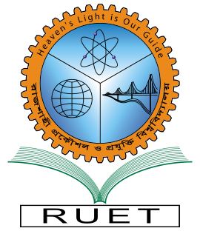
Lab Lecture Documentation

Course Code : CSE 3107
Course Name : Software Engineering Sessional
Assignment Title : Design Pattern Analysis, Implementation and Code Review (Lab 3) Machine Code Translation, and SRAM Subsystem Design

Submitted By:  Name : ISHTIAK AHMAD ANAN  Roll : 2203124  Series : 2022  Section : C | Submitted To:  Course Teacher(s)  Department of Computer Science & Engineering  RUET  RUET

Date of Submission : 28.09.2026

