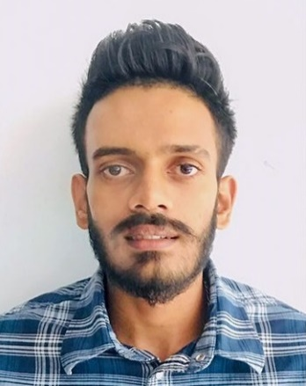

**Personal Details**

Full Name : M.A Hesshan Danushka Mallawarachchi

NIC No : 200007603271

Nationality : Sri Lankan

Age : 22yrs

Gender : Male

Marital Status : Unmarried

Residential Address : 50/2, ‘Laksiri’, Kithulakanda, Radawana, Gampaha (11725)

Email Address : danushkahesha@gmail.com

Contact No : +94764826788 / +94714652276

**Education**

GCE Ordinary Level 2016

*WP/Mahagamasekara Collage*

Sinhala - C English - C

Mathematics - S Science - C

Buddhism - B Health std - B

Citizenship Edu - C Music - C

History - C

**Employment**

Trainee Cook July 2020 – Jan 2021

Wasala Nature Resort(pvt) ltd

Mandawala Rd, Radawana, Gampaha

Commis III Feb 2021 – Jan 2022

Wasala Nature Resort(pvt) ltd

Mandawala Rd, Radawana, Gampaha

**Courses and Certificates**

* National Certificate in Graphic Designing

*Information and communication Technology Education Center-Urapola*

* National Certificate in Computer Hardware

*Information and communication Technology Education Center-Urapola*

**HESHAN DANUSHKA**

I am a punctual and motivated individual who is able to work in a busy environment and produce high standards of work. I am an excellent team worker and can take instructions from all levels and build up good working relationships with all colleagues. I am flexible, reliable and possess excellent time keeping skills.

**Skills**

Strong Communication ●●●●○

Attention to Details ●●●●○

Teamwork and Collaboration ●●●●○

Organizational ●●●●○

**Languages**

Sinhala ●●●●●

English ●●○○○

**Activities**

Repairing Electrical Devices

Graphic Designing

Maintaining & cleaning Swimming Pools