( INTRODUCTION )

- "Panel Data" or "Python Data Analysis"
- Used for analyzing,cleaning,exploring and manipulation of data
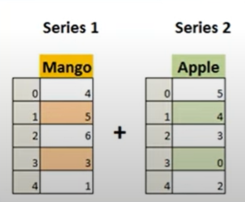
- It can work with - CSV,Text,Json,Zip,etc Files.

Types of Data Structures :-

1. Series : 1D Labeled arrays pd.Series(data).

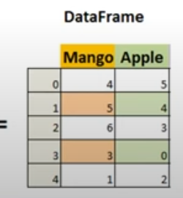
- Dataframes : 2D data structures of colums just like tables.

3. Panel : 3D container of data.

For installation of pandas : -

Write command in cmd : pip install pandas

For importing pandas in python : import pandas as pd

Importance of Pandas :-

1. Pandas allows us to analze big data and make connclusions based on statical theories.
2. Pandas can clean messy data set ,make them reliable and relevant.
3. Eassily handling of missing data (NaN) in floating as well as non-floating.
4. Size Mutability : Can insert and delete data from dataframe and higher dimensional objects.
5. Provide Data set merging and joining.

( DATA STRUCTURES )

Series( ) : It is defined as the 1Darray capable of storing various types of data.

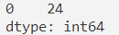
import pandas as pd
A = pd.Series(24)
print(A)
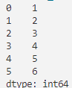
import pandas as pd
X = [1,2,3,4,5,6]
A = pd.Series(X)
print(A)

print(type(A)) # <class 'pandas.core.series.Series'>
print(A[1]) # 2

For Changing the index number
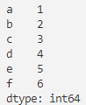
import pandas as pd
X = [1,2,3,4,5,6]
A = pd.Series(X,index=['a','b','c','d','e','f'])
print(A)
print( A['a'])

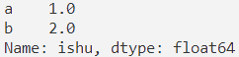
import pandas as pd
X = [1,2]
A = pd.Series(X,index=['a','b'],dtype="float",name="ishu")
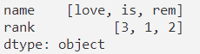
print(A)
import pandas as pd
Dic = {"name":["love","is","rem"],"rank":[3,1,2]}
A = pd.Series(Dic)
print(A)
# name or rank can have more values .Here, the size of the of the list does not matter.

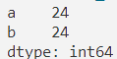
import pandas as pd
A = pd.Series(24,index=['a','b'])
print(A)

# We can use direct operation without the use of broadcasting rule.

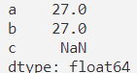
import pandas as pd
A = pd.Series(24,index=['a','b'])
B = pd.Series(3,index=['a','b','c'])
print(A+B)

# NaN : Not a Number
# Here you can see it is working with the missing data.

( DataFrame )

2D Data Structure is the DataFrame. (Eiher List or Dictionary)
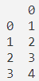
import pandas as pd
A = [1,2,3,4]
Var = pd.DataFrame(A)
print(Var)
print(type(Var)) # <class 'pandas.core.frame.DataFrame'>

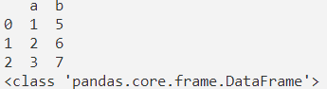
import pandas as pd
D = {"a":[1,2,3],"b":[5,6,7]}
Var = pd.DataFrame(D)
print(Var)
print(type(Var))

# Data must be of same length. In above you cannot put more than 2 element in a list.
# Values passed in a dictionary must be in list or tuple

To get a particular column data . Eg:- We need the column named as “a” .
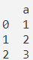
import pandas as pd
D = {"a":[1,2,3],"b":[5,6,7]}
Var = pd.DataFrame(D,columns=["a"])
print(Var)

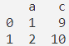
import pandas as pd
D = {"a":[1,2],"b":[5,6],"c":[9,10]}
Var = pd.DataFrame(D,columns=["a","c"])
print(Var)

To get the value from a DataFrame .

import pandas as pd
D = {"a":[1,2],"b":[5,6],"c":[9,10]}
Var = pd.DataFrame(D,columns=["a","c"]) # It will take only “a” and “c” data.
print(Var["a"][0]) # 1

Note: we have to first specify the column then indexing of that data .

Convert a nested list into a DataFrame .

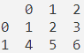
import pandas as pd
Ls = [[1,2,3],[4,5,6]]
Var = pd.DataFrame(Ls)
print(Var)

To convert series of data into DataFrame .
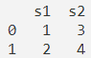
import pandas as pd
Sr = {"s1":pd.Series([1,2]),"s2":pd.Series([3,4])}
Var = pd.DataFrame(Sr)
print(Var)
( ARITHMETIC OPERATIONS )

Operations on columns.
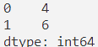
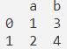
import pandas as pd
Var = pd.DataFrame({"a":[1,2],"b":[3,4]})
print(Var["a"]+Var["b"])

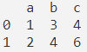
import pandas as pd
Var = pd.DataFrame({"a":[1,2],"b":[3,4]})
Var["c"] = Var["a"]+Var["b"]
print(Var)

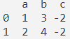
import pandas as pd
Var = pd.DataFrame({"a":[1,2],"b":[3,4]})
Var["c"] = Var["a"]-Var["b"]
print(Var)

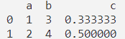
import pandas as pd
Var = pd.DataFrame({"a":[1,2],"b":[3,4]})
Var["c"] = Var["a"]/Var["b"]
print(Var)

import pandas as pd
Var = pd.DataFrame({"a":[1,2],"b":[3,4]})
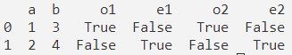
Var["o1"] = Var["a"]%2!=0
Var["e1"] = Var["a"]%2==0
Var["o2"] = Var["b"]%2!=0
Var["e2"] = Var["b"]%2==0
print(Var)

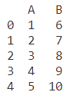
( DELETE / INSERT )

INSERT
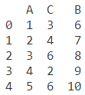
import pandas as pd
Var = pd.DataFrame( { "A" : [1,2,3,4,5], "B" : [6,7,8,9,10] } )
# Object.insert( index_of_place, define_name, data_to_insert )
Var.insert( 1 , "C", [3,4,6,2,6] )
# Remember : Length of data must be equal
print( Var )
For copying the limited amount of data from a column

import pandas as pd
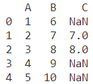
Var = pd.DataFrame({ "A" : [1,2,3,4,5],"B" : [6,7,8,9,10] })
Var["C"] = Var["B"][1:3]
print( Var )

DELETE (pop,del)

import pandas as pd
Var = pd.DataFrame({ "A" : [1,2,3,4,5],"B" : [6,7,8,9,10] })
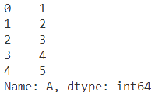
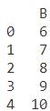
Var1=Var.pop("A")
Var( Before ) Var1 Var ( After )
print(Var1)
print(Var)

Similarly : If you want to use del and want to remove column A . So, Use del Var[“A”]

Excel File : Excel File have Binary Coded data .
CSV File : CSV File have comma separated values as plain text .
( WRITING CSV FILE )

CSV format is a plain text format in which values are separated by commas.

How to write CSV File
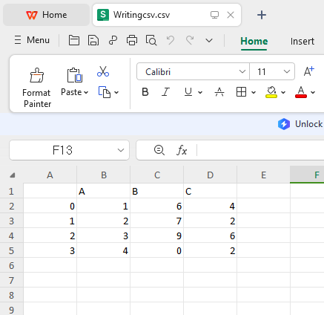

Before writing a CSV file first create dataframe.

import pandas as pd
dic={"A":[1,2,3,4],"B":[6,7,9,0],"C":[4,2,6,2]}
d=pd.DataFrame(dic)
d.to_csv("Writingcsv.csv")

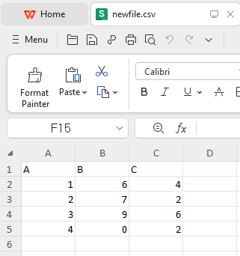
# Here, you can see indexes are also present in the file so to remove this we can set index to False.

import pandas as pd
dic={"A":[1,2,3,4],"B":[6,7,9,0],"C":[4,2,6,2]}
d=pd.DataFrame(dic)
d.to_csv("newfile.csv",index=False)

For changing the header

import pandas as pd
dic={"A":[1,2],"B":[6,7],"C":[4,2],"D":[6,3],"E":[4,6]}
d=pd.DataFrame(dic)
d.to_csv("file.csv",index=False,header=["Aryan","Ishu","Gourav","Adesh","Priyanshu"])
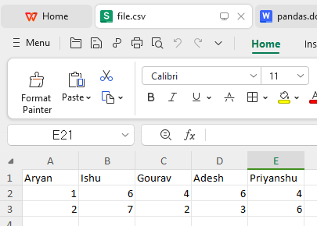

( READING CSV FILE )

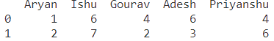
import pandas as pd
csfile=pd.read_csv("file.csv")
print(csfile)

Download link : StudensPerformance.csv file

import pandas as pd
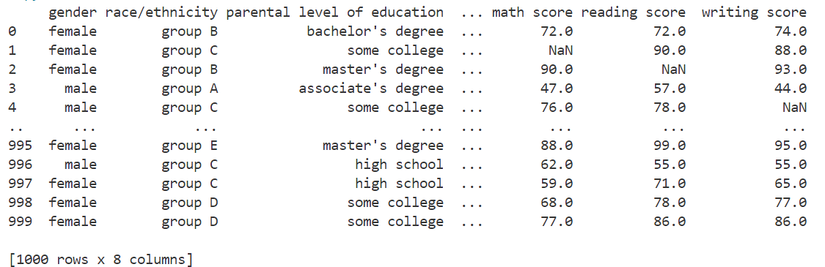
rdcsv=pd.read_csv("StudentsPerformance.csv")
print(rdcsv)
# see here it only give fist and last five record only.

To get the number of rows from starting

import pandas as pd
rdcsv=pd.read_csv("StudentsPerformance.csv",nrows=6)
print(rdcsv)

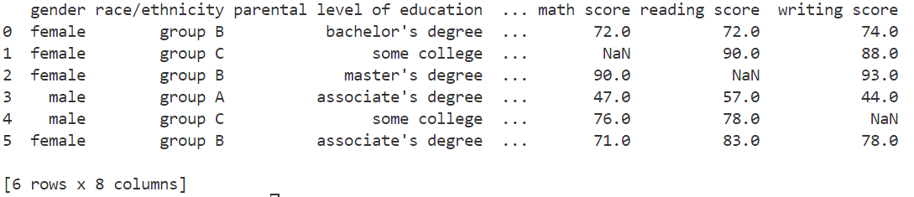

To get columns
import pandas as pd
rdcsv=pd.read_csv("StudentsPerformance.csv",usecols=["math score","reading score"],nrows=3)
print(rdcsv)

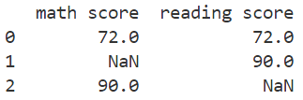
Note : we can also use index instead of writing name of particular column.
Eg: For this we can use usecols = [5,6]

For skipping the Row/Rows
import pandas as pd
rdcsv=pd.read_csv("StudentsPerformance.csv",usecols=[5,6],nrows=3,skiprows=[2])
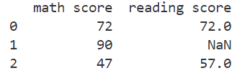
print(rdcsv)

To make a particular column as index
import pandas as pd
rdcsv=pd.read_csv("StudentsPerformance.csv",index_col="gender",nrows=4)
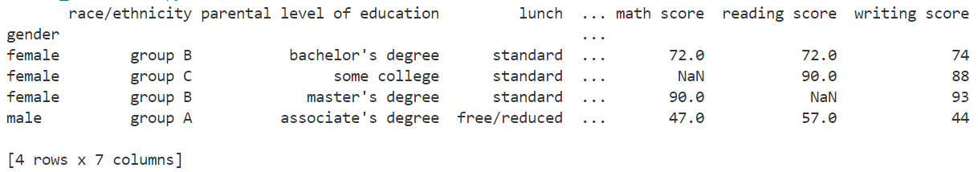
print(rdcsv)

To make row as a Header
import pandas as pd
rdcsv=pd.read_csv("StudentsPerformance.csv",nrows=4,header=2)
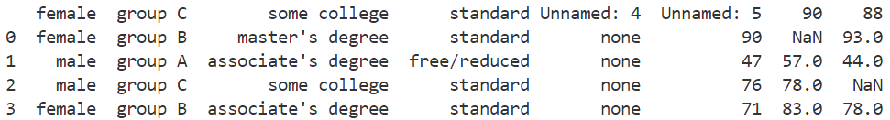
print(rdcsv)

To give name to header
import pandas as pd
rdcsv=pd.read_csv("StudentsPerformance.csv",nrows=4,names=["a","b","c","d","e","f","g"])
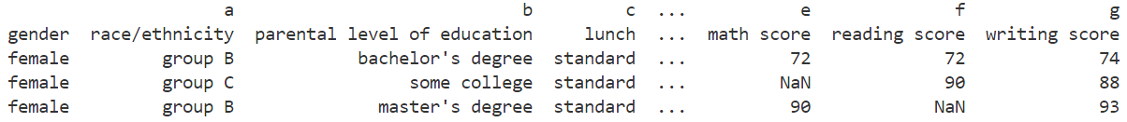
print(rdcsv)

Note: The names of columns must be unique.

To remove header
import pandas as pd
rdcsv=pd.read_csv("StudentsPerformance.csv",nrows=4,header=None)
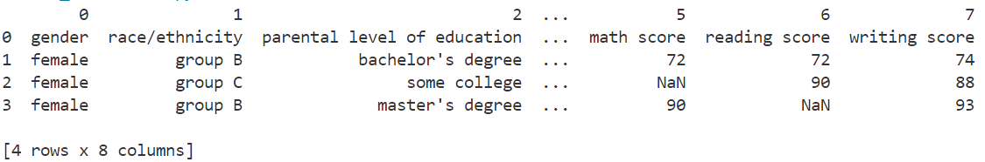
print(rdcsv)
Note : When we remove header it will be replace by indexes of that particular column
You can change the type of a column by using dtype= {“column_name” : “data_type”}
For adding something in adder before use rdcsv.add_prefix(“a”).
For adding something in adder before use rdcsv.add_suffix(“ab”).

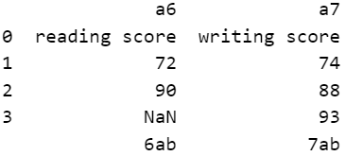
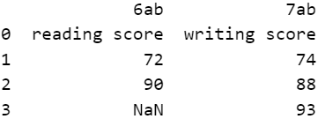

rdcsv.add_prefix(“a”) rdcsv.add_suffix(“ab”)

( PANDAS FUCTION )

For printing index details : index

import pandas as pd
rdcsv = pd.read_csv("StudentsPerformance.csv",nrows=4)
print(rdcsv.index)
For printing columns name : columns

import pandas as pd
rdcsv = pd.read_csv("StudentsPerformance.csv",nrows=4)
print(rdcsv.columns)

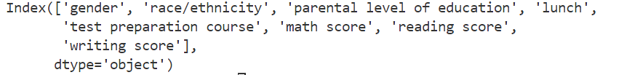
To find all the detail about data : describe()

import pandas as pd
rdcsv=pd.read_csv("StudentsPerformance.csv")
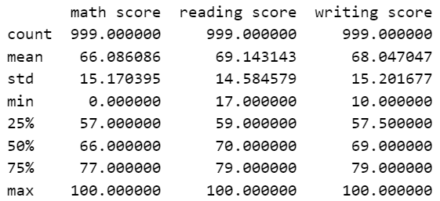
print(rdcsv.describe( ))
# If we use “nrows” then it will data according to those rows.
For getting records from data

print(rdcsv.head( )) # give first 5 rows
print(rdcsv.head(2)) # give first 2 rows
print(rdcsv.tail( )) # give last 5 rows
print(rdcsv.tail(3)) # give last 3 rows
print(rdcsv[2:5]) # give rows from index 2 to 4

To print Indexes as array

import pandas as pd
rdcsv=pd.read_csv("StudentsPerformance.csv")
print(rdcsv.index.array)

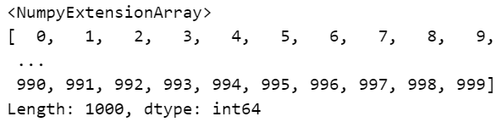

To covert All recors into array

import pandas as pd
rdcsv=pd.read_csv("StudentsPerformance.csv")
print(rdcsv.to_numpy())

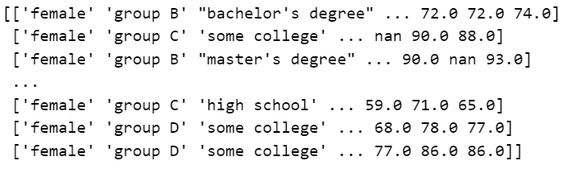

To sort data in ascending order

import pandas as pd
rdcsv=pd.read_csv("StudentsPerformance.csv",nrows=4)
print(rdcsv.sort_index(axis=0,ascending=False))
axis = 0 : according to row.
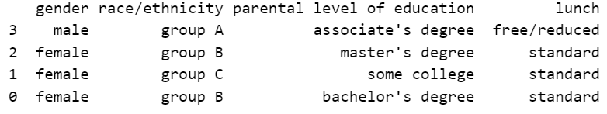
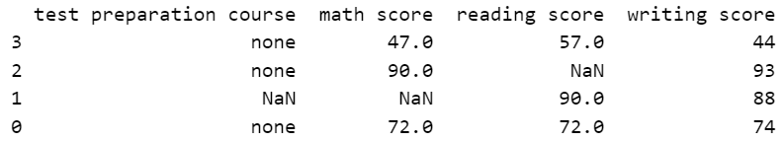
axis = 1 : according to column.
- ) Change the gender from female to make of the first record.
Ans) rdcsv[“gender”][0]=”male”
# This particular statement will work and also though error but this is the wrong way to change the particular thing in in a record.
Correct way : rdcsv.loc[0,"gender"]="male"

- For getting multiple column data using loc .
import pandas as pd
rdcsv=pd.read_csv("StudentsPerformance.csv",nrows=4)
print(rdcsv.loc[[1,2],["gender","parental level of education"]])
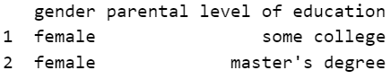

- For getting all the rows :
rdcsv.loc[ : ,["gender","parental level of education"]]

- For getting all the rows and columns :
rdcsv.loc[ : , : ]

Use of iloc : To get a particular data
# in this we pass index number only
import pandas as pd
rdcsv=pd.read_csv("StudentsPerformance.csv",nrows=4)
print(rdcsv.iloc[0,0]) # female
- For multiple rows and columns using iloc
rdcsv.iloc[[0,1],[0,2]])

Use Of drop : For skipping rows and columns
import pandas as pd
rdcsv=pd.read_csv("StudentsPerformance.csv",nrows=4)
print(rdcsv.drop("gender",axis=1))
# if axis is 1 then we can skip columns otherwise rows for 0
- For skipping multiple column
rdcsv.drop(["gender","lunch"],axis=1)

- For skipping a row
rdcsv.drop(1,axis=0)
- For skipping multiple rows
rdcsv.drop([0,2,3],axis=0)
# Last one will give only one row as record because we have select nrows=4 , if you try to drop 4 or greater than 4 index data then it will through error.

( HANDLING MISSING VALUES )

Use of dropna( ) : It will remove the whole record if any NaN value or empty spaces found in that particular record.
import pandas as pd
rdcsv=pd.read_csv("StudentsPerformance.csv",nrows=4)
print(rdcsv.dropna( ))

# In this drop is done along rows .

import pandas as pd
rdcsv=pd.read_csv("StudentsPerformance.csv",nrows=4)
print(rdcsv.dropna(axis=1))
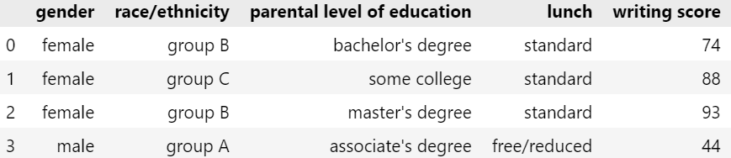
# In this drop is done along columns .
Use of how parameter in drop
- For removing those rows which have any NaN value
rdcsv.dropna(axis=0,how="any")
- For removing those rows which have all NaN value not those which have some record
rdcsv.dropna(axis=0,how="all")

Use of subset parameter in drop :
It will remove the NaN record of a particular columns.
import pandas as pd
rdcsv=pd.read_csv("StudentsPerformance.csv",nrows=4)
print(rdcsv.dropna(axis=0,subset=["math score"]))

rdcsv.dropna(axis=0,subset=["math score","reading score"])

rdcsv.dropna(axis=1,subset=1)
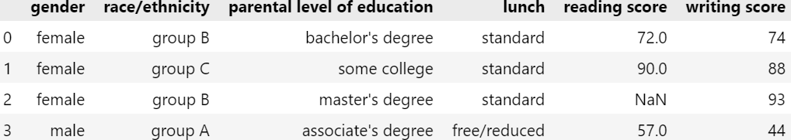

rdcsv.dropna(axis=1,subset=[1,2])
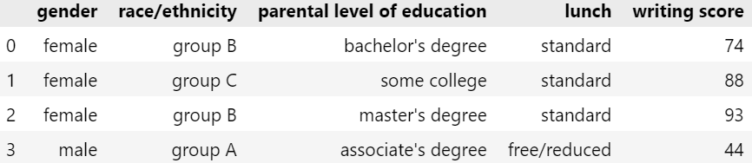

- Use of inplace in dropna: To remove null values and convert into a new database.
Eg: rdscv.dropna(inplace=True)
- Use of thresh in dropna : We can specify no. Of NaN values rows to remove.
Eg: rdscv.dropna(thresh=2)

Use of fillna( )
import pandas as pd
rdcsv=pd.read_csv("StudentsPerformance.csv",nrows=4)
print(rdcsv.fillna("ishu"))
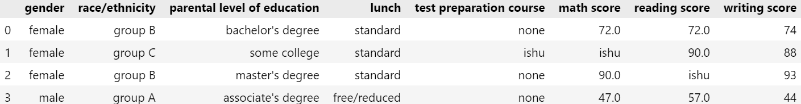
- For filling specific values in columns
import pandas as pd
rdcsv=pd.read_csv("StudentsPerformance.csv",nrows=4)
print(rdcsv.fillna({"math score":45,"reading score":69}))

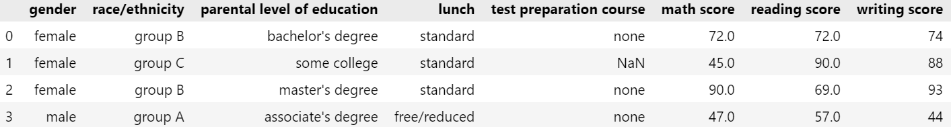
- For filling the data according to forward/backward data
rdcsv.fillna(method="ffill") # for forward filling
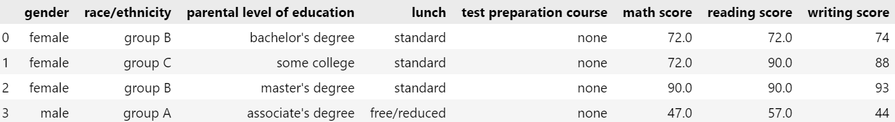

rdcsv.fillna(method="bfill") # for backward filling
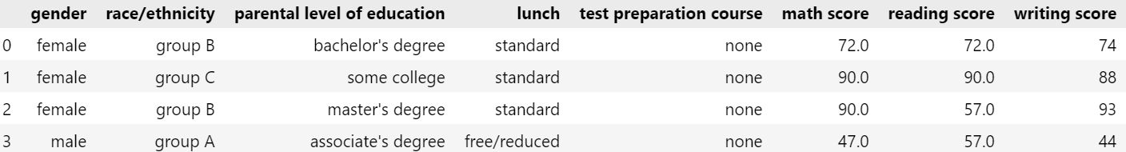

rdcsv.fillna(method="ffill",axis=1)
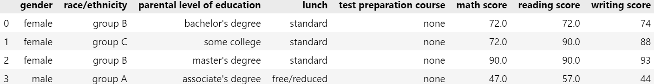

rdcsv.fillna(method="bfill",axis=1)
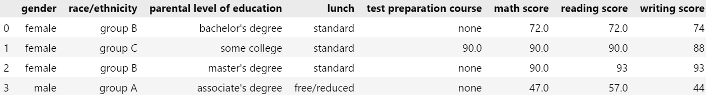

rdcsv.fillna(method="bfill",axis=0)
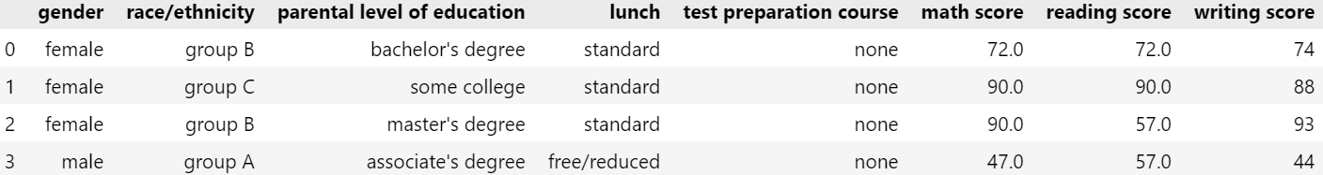

rdcsv.fillna(method="ffill",axis=0)
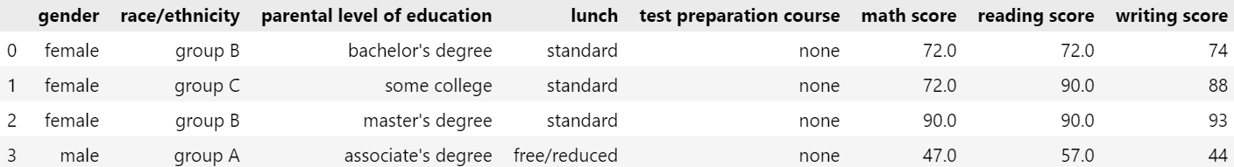

CLASS NOTES

import pandas as pd
a=pd.read_csv("student.csv")
print(a.info()) # gives the information of that data with its column name
print(a.head()) # give first five record by default
print(a.head(7)) # give first seven record
print(a.tail()) # give last 5 records by default
print(a.tail(7)) # give last seven record
print(pd.options.display.max_rows)# give how many records will be visible
pd.options.display.max_rows=13 # defining we can only display 10 records as specified
print(a.head().isnull()) # give the result in which it will replace NaN to True
print(a.loc[0]) # give the zeroth index column data
print(a.loc[[0,2]]) # give the zeroth and second index column data
print(a.loc[1:11]) # give the rows of data from 1 to 11 included
print(a['math score'].loc[[0,1]]) # give only math score on 0 and 1 indexes records
print(a[['gender','math score',]].loc[[0,1]]) # give gender and math score of 0 and 1 indexes records
b=a.fillna(99) # It will fill Nan value to 99 in which variable data is returned
print(b.head()) # Note: it will not affect the original data in a
# a.fillna(99,inplace=True) # It will affect the original data
# print(a.head())
print("msmean",a["math score"].mean(),type(a["math score"].mean())) # gives mean of math score as float
print("msmedian",a["math score"].median(),type(a["math score"].median())) # gives median of math score as float
print("msmode",a["math score"].mode(),type(a["math score"].mode())) # gives mode of math score as series
a["math score"].fillna(a["math score"].mean(),inplace=True) # it will replace Nan value to corresponding statical method
print(a.head())
a["math score"].fillna(a["math score"].mode()[0],inplace=True) # we have to replace zeroth position in order to change mode of the data
print(a.head())
print(a.describe()) # gives all statical record
a.dropna(inplace=True) # drop all Nan valued record
print(a.head())

c=pd.DataFrame([[1,2,3],[4,5,6],[7,8,9]])
print(c)
print(c.agg("cumsum",axis=1)) # give cumsum value row-wise
print(c.agg("cumsum",axis=0)) # give cumsum value column-wise

print(c.agg("sum",axis=1))
print(c.agg("sum",axis=0))

