Assignment- 2Aug

1. SELECT e.emp_no, e.birth_date, e.first_name, e.last_name, e.gender, e.hire_date,d.dept_name, t.title, s.salary

FROM employees e

JOIN dept_emp de ON e.emp_no = de.emp_no

JOIN departments d ON de.dept_no = d.dept_no

JOIN titles t ON e.emp_no = t.emp_no

JOIN (

SELECT emp_no, salary

FROM salaries

WHERE (emp_no, from_date) IN (

SELECT emp_no, MAX(from_date)

FROM salaries

GROUP BY emp_no

)

) s ON e.emp_no = s.emp_no;

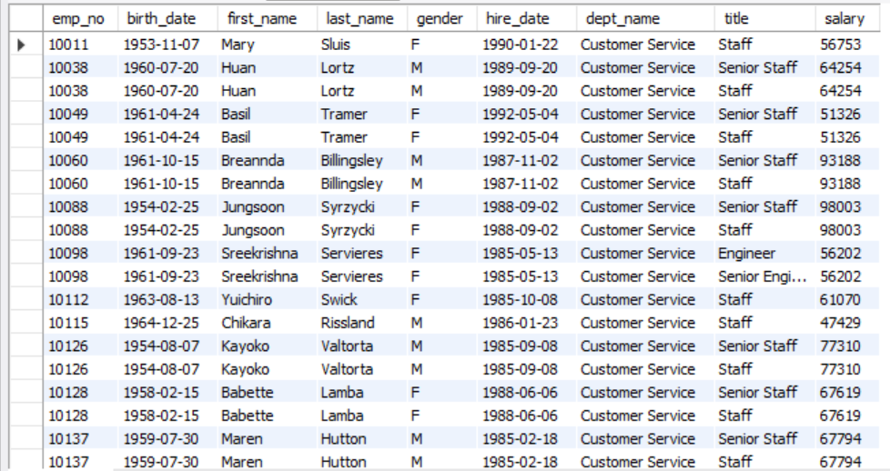

1. DELIMITER $$

CREATE PROCEDURE upsert_employee(IN p_emp_no INT,IN p_birth_date DATE,IN p_first_name VARCHAR(50),IN p_last_name VARCHAR(50),IN p_gender ENUM('M', 'F'),IN p_hire_date DATE)

BEGIN

DECLARE emp_exists INT;

SELECT COUNT(*) INTO emp_exists

FROM employees

WHERE emp_no = p_emp_no;

IF emp_exists > 0 THEN

UPDATE employees

SET birth_date = p_birth_date,

first_name = p_first_name,

last_name = p_last_name,

gender = p_gender,

hire_date = p_hire_date

WHERE emp_no = p_emp_no;

ELSE

INSERT INTO employees (emp_no, birth_date, first_name, last_name, gender, hire_date)

VALUES (p_emp_no, p_birth_date, p_first_name, p_last_name, p_gender, p_hire_date);

END IF;

END $$

DELIMITER ;

CALL upsert_employee(203, '1990-08-20', 'Ishu', 'Jangid', 'M', '9999-01-10');

select * from employees;

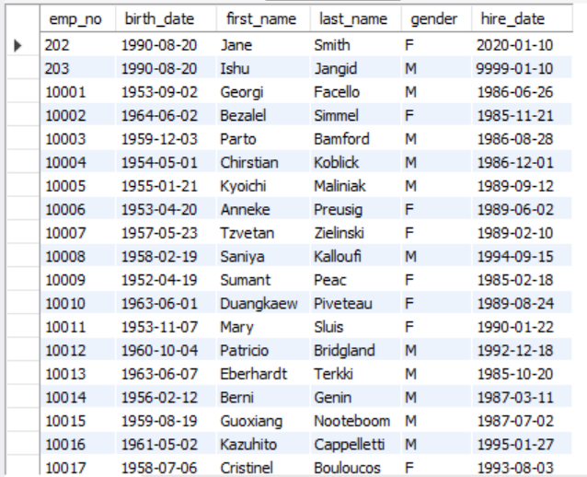

1. DELIMITER $$

CREATE FUNCTION get_experience( p_emp_no INT)

RETURNS INT

deterministic

BEGIN

DECLARE experience INT;

SELECT TIMESTAMPDIFF(YEAR, hire_date, CURDATE()) INTO experience

FROM employees

WHERE emp_no = p_emp_no;

RETURN experience;

END $$

DELIMITER ;

SELECT get_experience(202) AS experience;

