Exercise: Grow your own tech start-up analysis
REPORT

This report looks at the best financing options for a tech start-up using a Python Program that calculates net profit after a given number of years. It will include the revenue and expenses growth that happen over the years.
Current Business Stats:
Monthly Revenue: 5000
Monthly Expenses: 3000
Monthly Profit: 2000
Option 1) Debt:
100000 dollar loan with 5% annual interest over 5 years.
Option 2) Equity:
100000 dollar for 20% of ownership
Option 3) Mix of both:
50000 dollar for 10% ownership and 50000 dollar loan with 5% annual interest over 5 years.
Process of analysis:
Analysis is done by implementing a Python program that will do all the necessary calculations. The Python Program used has been developed under the following assumptions for simplicity.
1) Monthly Revenue and Expense remains constant throughout the year.
2) Revenue and Expense growth happens at the start of the year.
3) Loan expires after 5 years.
4) Investor remains with the company throughout the years.
The process of analysis involves taking multiple scenarios and noting the outcomes. For this report only time periods of 10 and 20 years have been used.
Case 1:
0 Revenue growth, 0 Expense growth, over 10 years

Case 2:
10% Revenue growth and 12% Expense growth every year for 2 years.
7.5% Revenue growth and 6% Expense growth every year for the next 3 years.
5% Revenue growth and 2.5% Expense growth every year for the next 5 years.
Case 3:
12% Revenue growth and 12% Expense growth every year for 2 years.
5% Revenue growth and 8% Expense growth every year for the next 3 years.
0% Revenue growth and 2% Expense growth every year for the next 5 years.
Case 4:
0% Revenue growth and 0% Expense growth every year for 20 years.
Case 5:
10% Revenue growth and 12% Expense growth every year for 2 years.
7.5% Revenue growth and 6% Expense growth every year for the next 3 years.
5% Revenue growth and 2.5% Expense growth every year for the next 5 years.
4% Revenue growth and 1.5% Expense growth every year for the next 10 years.
Case 6:
12% Revenue growth and 12% Expense growth every year for 2 years.
5% Revenue growth and 8% Expense growth every year for the next 3 years.
0% Revenue growth and 2% Expense growth every year for the next 5 years.
-0.25% Revenue growth and 0.5% Expense growth every year for the next 10 years.

The program calculates the monthly revenues, expenses, profits and loans separately. Then equity is taken into consideration at the end. All of it is then summed up and displayed.
The MATPLOTLIB graphs and Excel sheets of 10 year and 20 year studies have been included separately.
The Code of the Program is here:
GitHub: https://github.com/thisisishu264/Comparing_financing_options

Inferences:
10 Years:
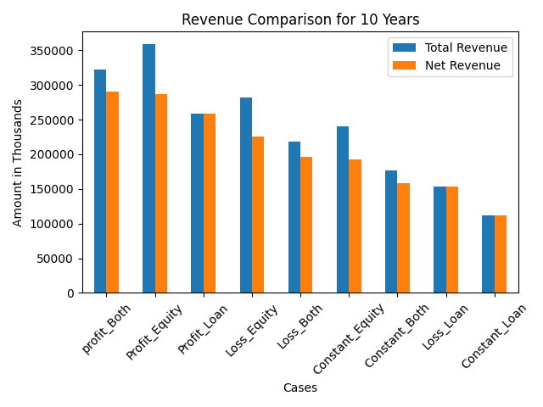

Note: Here “Both” signifies 50k dollar loan and 10% Equity.
For the first 10 Years giving equity is the much better option. However, in the profit case, “Both” exceeds just “Equity” by a little bit. Going in for a standalone “Loan” is not recommended.

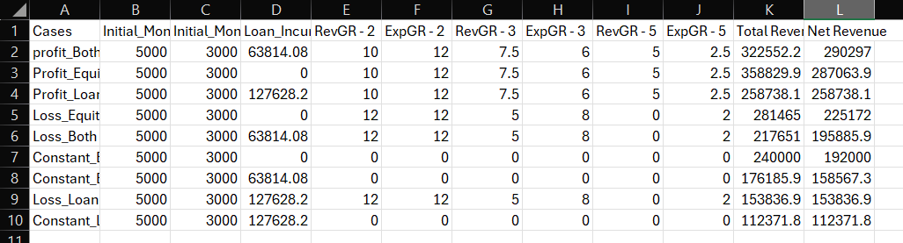

Inferences:
20 Years:
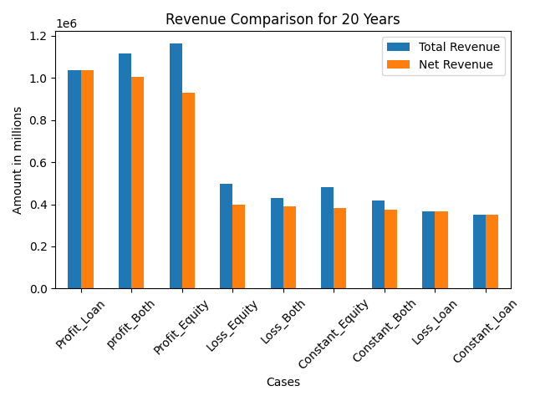
This is where we see the advantages of taking a loan as the revenue at the end of 20 years is significantly higher than the standalone “Equity” case. However, this is only true for a profitable business. In case of loss, the “Loan” case is clearly the worse option.
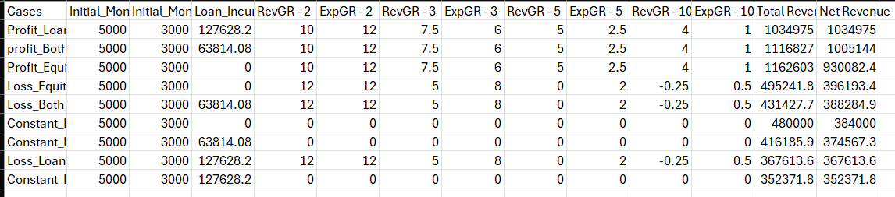

From this we can see that going in for both equity and loan will result in consistent performance regardless of the financing option.
NOTE:
The code allows us to compare other options as well by changing the values of equity%, loans, growth rates, etc. I just took a general case. – Ishan Batra

