PROJECT REPORT
Transaction and Fraud Analysis
An Anti-Money-Laundering Dashboard Built with Microsoft Power BI
Submitted by
P. ISWARYA
Department of FinTech with AI
B.Com (FAI)
October 2026

Table of Contents
No. | Section | Page
1 | Abstract | 2
2 | Introduction and Background | 3
3 | Objectives and Scope | 3
4 | Dataset and Tools Used | 4
5 | Data Model (Figure 1) | 5
6 | Dashboard Design Approach | 6
7 | KPI Dashboard (Figure 2) | 7
8 | Interaction Dashboard (Figure 3) | 8
9 | Tooltip Page (Figure 4) | 9
10 | Key Findings, Recommendations and Conclusion | 10

1. Abstract
Financial institutions process millions of transactions every day, and only a very small fraction of them are fraudulent or linked to money laundering. Finding that fraction quickly is one of the central problems in FinTech. This report presents a Power BI solution that turns a large transaction dataset into an interactive fraud-monitoring dashboard.
The model combines three tables: accounts, alerts and transactions. It covers roughly 1.32 million transactions worth about 153.48 billion in total, across 10,000 accounts. Only 1,719 transactions are flagged as fraudulent, which is about 0.13% of all activity. The dashboard presents these facts through KPI cards, bar charts, a time-series line chart, a donut chart, slicers and a tooltip page, so that an analyst can move from a high-level summary to a specific alert type or fraud status in a few clicks.

2. Introduction and Background
FinTech brings together finance and technology to make payments, lending, investment and risk management faster and more accurate. Artificial intelligence and analytics play a growing part in this field, especially in fraud detection and anti-money-laundering (AML) compliance, where large volumes of data must be monitored continuously.
Money laundering usually involves moving funds through many accounts so that their origin becomes hard to trace. Two common patterns are the cycle pattern, in which money travels through a chain of accounts and returns to its starting point, and the fan-in pattern, in which many accounts send money into a single account. Monitoring systems raise alerts when such patterns appear in the transaction network. Analysts then review these alerts and decide whether they represent genuine suspicious behaviour.
Raw transaction tables are far too large to be read line by line. Business intelligence tools such as Microsoft Power BI help by summarising the data into measures, visuals and filters, allowing compliance teams and managers to understand risk exposure at a glance.

3. Objectives and Scope
The main aim of this project is to design an interactive Power BI report that summarises transaction activity and highlights fraud. The specific objectives are listed below.
- To build a relational data model linking accounts, alerts and transactions.
- To create headline KPIs: total transactions, total transaction amount, average transaction amount, fraudulent transactions, total initial balance and total accounts.
- To compare alert types and measure how fraud compares with genuine activity, both by count and by value.
- To study how transaction volume changes over time.
- To provide slicers for ALERT_TYPE and IS_FRAUD, and a tooltip page that shows key figures on hover.
The scope is limited to descriptive analytics. The report describes what the data shows; it does not train a prediction model, although the findings could feed into one in future work.

4. Dataset and Tools Used

4.1 Tools
The report was built in Microsoft Power BI Desktop. Model view was used to manage tables and relationships, Report view to design the visuals, and DAX (Data Analysis Expressions) to define measures such as totals, averages and counts. A custom purple gradient background gives all pages a consistent look.

4.2 Tables in the model
The data model contains three tables. Their main fields are summarised below.
Table | Purpose | Main fields
accounts | One row per bank account (about 10,000 accounts) | ACCOUNT_ID, ACCOUNT_TYPE, COUNTRY, CUSTOMER_ID, INIT_BALANCE, IS_FRAUD, TX_BEHAVIOR_ID
alerts | Suspicious-pattern alerts raised by the monitoring rules | ALERT_ID, ALERT_TYPE, IS_FRAUD, SENDER_ACCOUNT_ID, RECEIVER_ACCOUNT_ID, TIMESTAMP, TX_AMOUNT, TX_ID, TX_TYPE
transactions | One row per transaction (about 1.32 million rows) | TX_ID, TX_TYPE, TX_AMOUNT, TIMESTAMP, SENDER_ACCOUNT_ID, RECEIVER_ACCOUNT_ID, ALERT_ID, IS_FRAUD

4.3 Measures created
- Total Transactions: count of rows in the transactions table.
- Total Transaction Amount: sum of TX_AMOUNT.
- Average Transaction Amount: total amount divided by the number of transactions.
- Fraudulent Transactions: number of transactions where IS_FRAUD is true.
- Total Initial Balance: sum of INIT_BALANCE from the accounts table.
- Total Accounts: distinct count of ACCOUNT_ID.

5. Data Model (Figure 1)
Figure 1 shows the model view in Power BI. The three tables are connected through one-to-many relationships, which is the standard star-like layout for reporting: each lookup-style table on the "one" side filters the large transactions table on the "many" side.
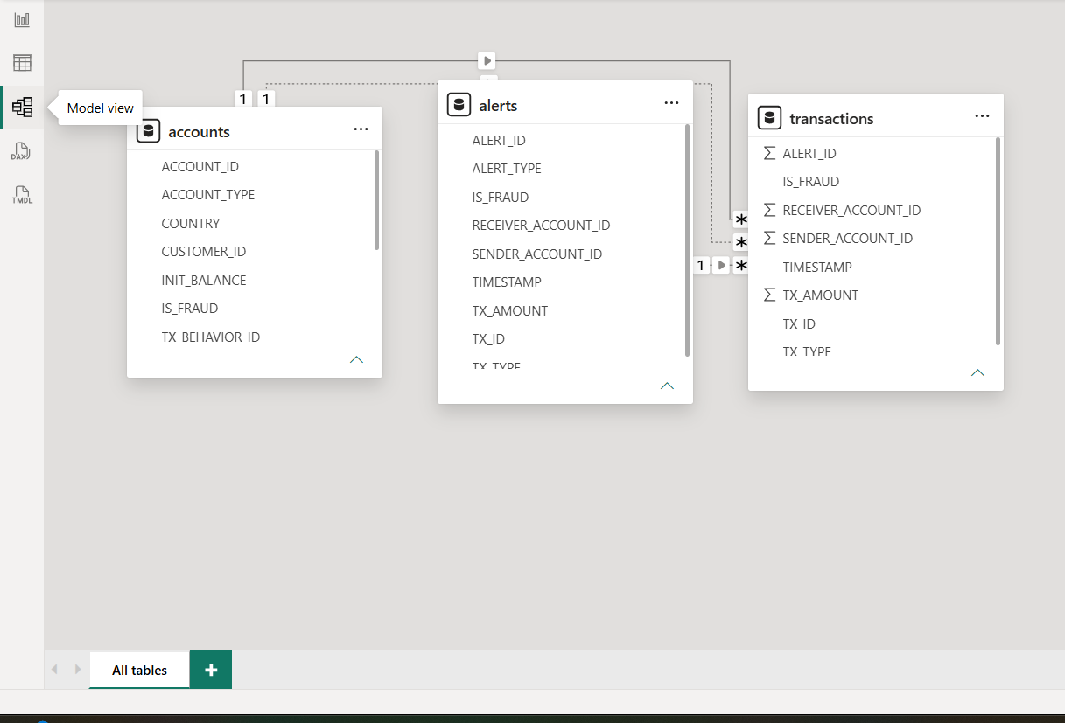
Figure 1: Data model view showing the accounts, alerts and transactions tables
- The accounts table connects to the transactions table through the account identifiers (sender and receiver). Because two relationships cannot both be active between the same pair of tables, one is shown as a solid line (active) and the other as a dotted line (inactive).
- The alerts table connects to the transactions table through ALERT_ID, with one alert related to many transactions.
- The transactions table is the central fact table. Its numeric columns, such as TX_AMOUNT, are aggregated in the visuals.

6. Dashboard Design Approach
The report is organised into three pages, each with a distinct purpose. This separation keeps every page uncluttered and lets different audiences use the report in the way that suits them.
Page | Purpose | Main elements
KPI | Quick summary for managers | Six KPI cards, alert-type bar chart, fraud-versus-genuine amount chart, time-series line chart, donut chart
Interaction Dashboard | Exploration for analysts | Titled page with the same KPIs and charts, plus ALERT_TYPE and IS_FRAUD slicers
Tool Tip | Hover details | Three compact cards: total transactions, total transaction amount and fraudulent transactions

6.1 Design principles followed
- Consistency: one purple colour family and the same gradient background on every page.
- Readability: KPI values are placed in white cards with large numbers, and each chart has a clear title and subtitle that states what is measured and how it is split.
- Progressive detail: the KPI page gives the overview, the interaction page lets the user filter, and the tooltip page gives context on hover.
- Appropriate chart types: bars for category comparison, a line for change over time, and a donut for share of a whole.

6.2 Visuals used
Card visuals display single headline numbers. A horizontal bar chart counts alerts by type. A column chart compares transaction value for fraudulent and non-fraudulent activity. A line chart plots total transactions across time steps, and a donut chart shows the split between fraud and non-fraud transactions. Slicers on the interaction page allow any combination of alert type and fraud status to be selected, and every visual updates accordingly.

7. KPI Dashboard (Figure 2)
The KPI page is the landing page of the report. It answers the first questions a reviewer would ask: how big is the activity, how much money is involved, and how much of it is fraudulent.
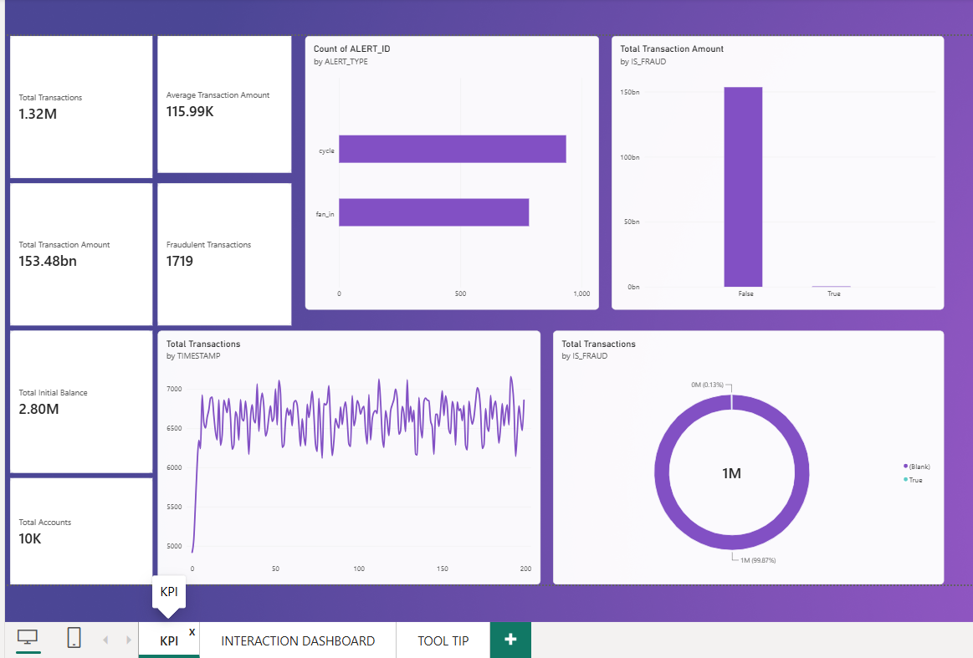
Figure 2: KPI page of the Power BI report
KPI | Value shown
Total Transactions | 1.32 million
Total Transaction Amount | 153.48 billion
Average Transaction Amount | 115.99 thousand
Fraudulent Transactions | 1,719
Total Initial Balance | 2.80 million
Total Accounts | 10 thousand

8. Interaction Dashboard (Figure 3)
The interaction dashboard carries the title "Transaction and Fraud Analysis" and repeats the main KPIs and charts. Its extra feature is the pair of slicers at the bottom left: ALERT_TYPE (with the options cycle and fan_in) and IS_FRAUD. Selecting a value in a slicer cross-filters every other visual on the page.
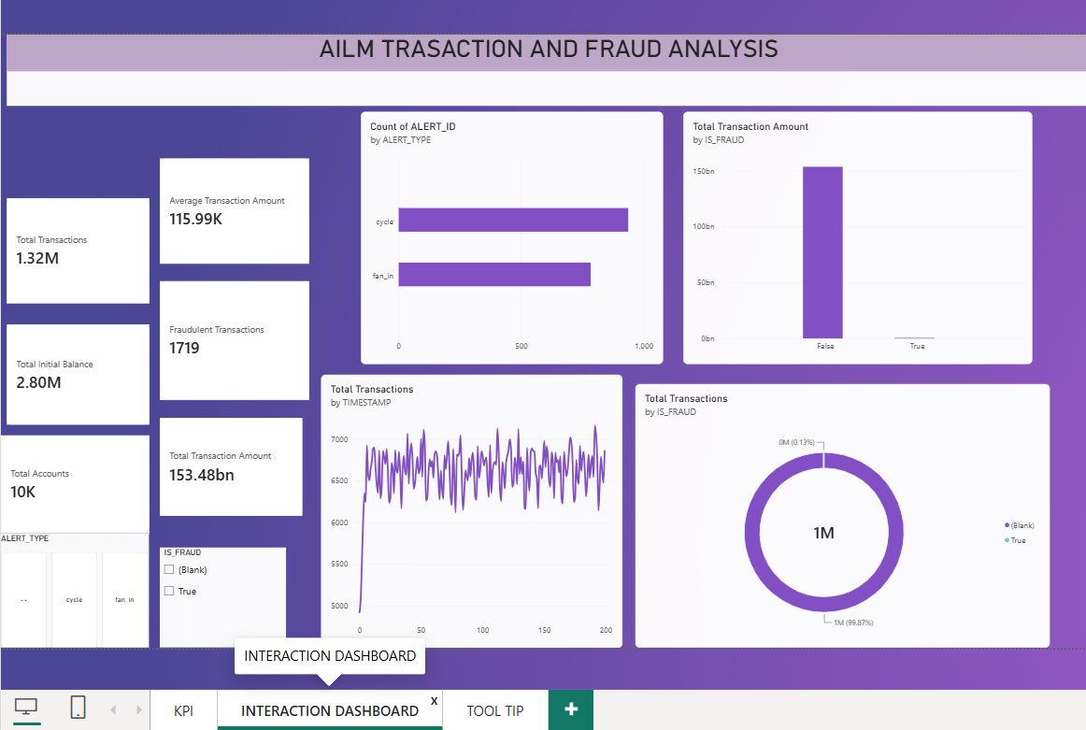
Figure 3: Interaction dashboard with ALERT_TYPE and IS_FRAUD slicers

How an analyst can use this page
- Select "cycle" in the ALERT_TYPE slicer to see how the KPIs, the time series and the fraud split change for cycle alerts only.
- Select the True option under IS_FRAUD to isolate the 1,719 fraudulent transactions and study their value and timing.
- Clear the slicers to return to the full overview.
Note: in the donut chart the non-fraud group appears as "(Blank)" because IS_FRAUD holds a value only for fraudulent transactions in the source data. Treating blank as "not fraud" is the practical reading here.

9. Tooltip Page (Figure 4)
A tooltip page is a small report page that appears when the user hovers over a visual in the main report. In this project the tooltip page shows three cards: Total Transactions (1.32M), Total Transaction Amount (153.48bn) and Fraudulent Transactions (1,719). It gives immediate context without forcing the user to leave the chart they are studying.
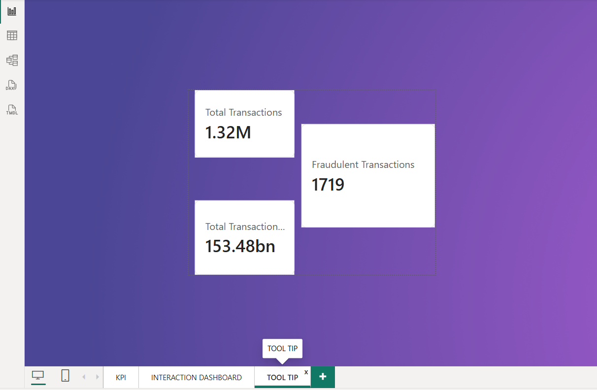
Figure 4: Tooltip page with three summary cards

Benefits of the tooltip page
- It keeps the main pages clean, because supporting numbers appear only when needed.
- It reinforces the scale of the data every time the user explores a chart.
- It uses the same purple background and card style, so the experience feels continuous.

10. Key Findings, Recommendations and Conclusion

10.1 Key findings
- Fraud is extremely rare. Of about 1.32 million transactions, 1,719 are fraudulent (about 0.13%), which is why the donut chart shows an almost unbroken ring for genuine activity.
- By value, fraud is also tiny. The column chart shows total transaction amount of roughly 150 billion for non-fraud, while the fraud column is barely visible.
- Both alert types matter. Cycle alerts number a little under 1,000 and fan_in alerts a little under 800, so neither pattern dominates completely, though cycle is somewhat more frequent.
- Activity rises quickly and then stabilises. The time series starts near 5,000 transactions per step, climbs sharply, and then fluctuates between roughly 6,000 and 7,000 for the remainder of the period.
- The average transaction is about 115.99 thousand, so individual transfers are large relative to the 2.80 million total initial balance. This is a point worth investigating in a real-world setting.

10.2 Recommendations
- Add a fraud-rate measure (fraudulent transactions divided by all transactions) so the percentage is shown directly rather than read from a chart.
- Add account-level views, such as country and account type from the accounts table, to find high-risk segments.
- Use these findings as a base for a machine-learning classifier, taking class imbalance into account.

10.3 Conclusion
The project shows how Power BI can convert a very large transaction dataset into a clear, interactive fraud-monitoring report. The data model links accounts, alerts and transactions; the KPI page summarises scale; the interaction page enables exploration; and the tooltip page adds context. The central insight is that fraud is a rare event hidden in a very large volume of normal activity, which is exactly why well-designed analytics, and later AI models, are essential in modern FinTech.

References
- Microsoft Power BI documentation: learn.microsoft.com/power-bi
- Financial Action Task Force (FATF) guidance on money-laundering typologies.

