POWER BI INTERACTIVE DASHBOARD
PROJECT REPORT
A Comprehensive Sales & Revenue Analytics Dashboard
Prepared By: ISWARYA

Date: November 2026
Tool Used: Microsoft Power BI Desktop
Dataset Domain: Retail / Electronics Sales (India)

1. Executive Summary
This report presents the development and insights of an Interactive Power BI Dashboard created by Iswarya. The dashboard is designed to analyze sales performance across multiple dimensions including stores, cities, product categories, store types, and time periods.
The primary objective is to provide business stakeholders with a clear, data-driven view of Key Performance Indicators (KPIs) such as Total Revenue, Total Profit, Total Cost, Total Quantity Sold, and Average Unit Price. The dashboard leverages advanced Power BI features like KPI cards, bar charts, donut charts, treemaps, line charts, and custom tooltips to enhance interactivity and decision-making.
- Key Highlights:
- Total Revenue: 4.71 Billion (4.71bn)
- Total Profit: 979.89 Million
- Total Cost: 4 Billion
- Total Quantity Sold: 112K Units
- Total Transactions / Orders: 15K
- Average Unit Price: 41.99K
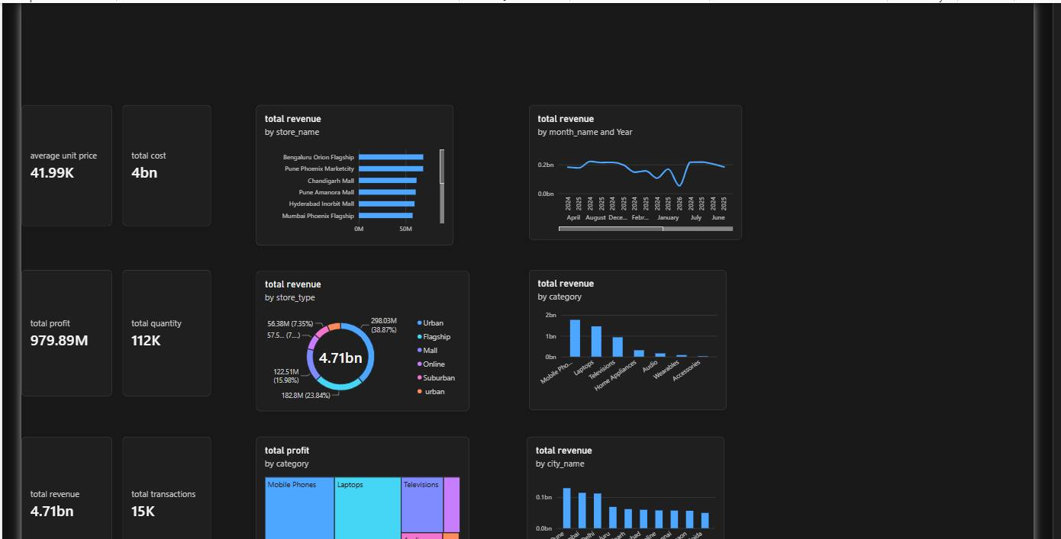
Figure 1: Overview of Main Dashboard Layout

2. Project Objective & Scope

2.1 Objectives
• To create an end-to-end Power BI dashboard for retail analytics.
• To track and monitor core KPIs in real-time.
• To identify top-performing stores, cities, and product categories.
• To analyze revenue trends over time (2024-2025).
• To implement interactive filters and tooltips for enhanced user experience.

2.2 Scope
The dashboard covers sales data across major Indian cities including Bengaluru, Pune, Chandigarh, Hyderabad, Mumbai, Delhi, Chennai, Gurgaon, and Noida. It analyzes data by Store Name, Store Type (Urban, Flagship, Mall, Online, Suburban), Product Category (Mobile Phones, Laptops, Televisions, Home Appliances, Audio, Wearables, Accessories), and City.

3. Dataset & KPI Metrics
The dataset contains transactional sales data with fields such as store_name, city_name, store_type, category, month_name, year, quantity, unit price, cost, revenue, and profit.

3.1 Key Performance Indicators (KPIs) Implemented
KPI Name | Value | Insight
Average Unit Price | 41.99K | Indicates premium product mix
Total Cost | 4bn | Overall operational and product cost
Total Profit | 979.89M | ~20.8% profit margin on revenue
Total Quantity | 112K | Total units sold
Total Revenue | 4.71bn | Primary business metric
Total Transactions | 15K | 15K unique orders
All KPIs are created using DAX measures: e.g., Total Revenue = SUM(Sales[Revenue]), Total Profit = SUM(Sales[Profit]).

4. Revenue Analysis by Store & City
The 'Total Revenue by Store_Name' visual shows Bengaluru Orion Flagship as the top-performing store, followed closely by Pune Phoenix Marketcity and Chandigarh Mall. This indicates strong performance of Flagship stores in metro cities.
The 'Total Revenue by City_Name' bar chart confirms Pune and Mumbai as leading revenue contributors, with Mumbai, New Delhi, and Bengaluru showing 0.1bn+ revenue each. Smaller cities like Hyderabad, Online, Chennai, Gurgaon, and Noida show consistent but lower contributions.
Figure 2: Revenue Distribution by Store and City

5. Revenue Analysis by Store Type & Category

5.1 By Store Type
The donut chart 'Total Revenue by Store_Type' reveals:
• Urban: 298.03M (38.87%) - Highest share
• Flagship stores: 182.8M (23.84%)
• Mall: 122.51M (15.98%)
• Online, Suburban, Urban variants making up the rest.
This proves that Urban and Flagship formats are the most profitable physical retail formats.

5.2 By Category
The 'Total Revenue by Category' column chart shows a clear dominance of:
1. Mobile Phones (~1.7bn) - Top seller
2. Laptops (~1.3bn)
3. Televisions (~0.9bn)
4. Home Appliances, Audio, Wearables, Accessories with significantly lower shares.
Strategy: Focus inventory and marketing on Mobile Phones and Laptops.
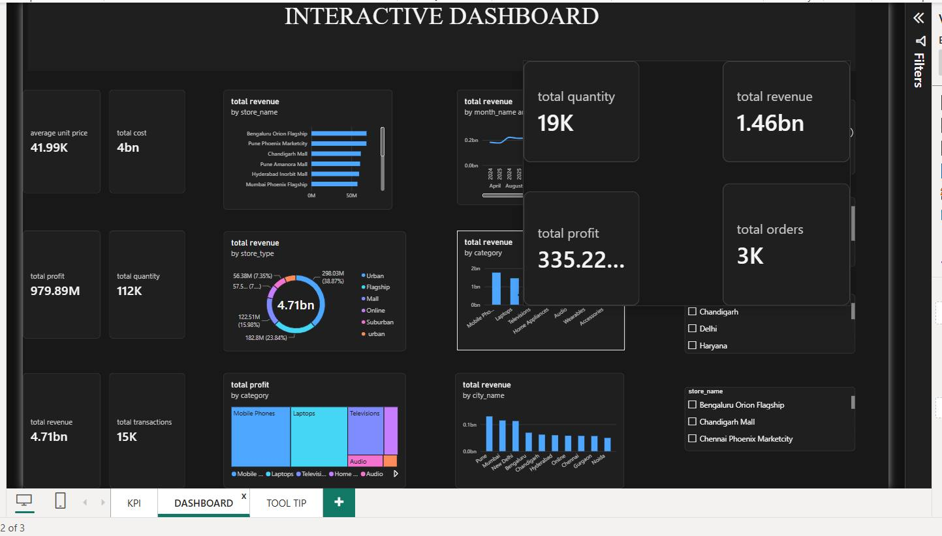
Figure 3: Store Type and Category Wise Breakdown

6. Temporal & Profitability Analysis

6.1 Total Revenue by Month_Name and Year
The line chart tracking revenue from April 2024 to June 2025 shows:
• Stable revenue around 0.18bn - 0.2bn during mid-2024.
• A sharp dip in January 2025 (down to ~0.05bn) - indicating seasonality or data anomaly that needs investigation.
• Strong recovery post-February 2025, peaking again around 0.2bn by June 2025.
This insight helps in demand forecasting and inventory planning.

6.2 Total Profit by Category (Treemap)
The treemap visual shows profit distribution. Mobile Phones occupy the largest area, meaning highest absolute profit, followed by Laptops and Televisions. Categories like Audio and Wearables show minimal profit contribution, suggesting a need to re-evaluate pricing or bundling strategies.

7. Interactivity Features in Power BI

7.1 Slicers / Filters
The dashboard includes right-side filters for City (Chandigarh, Delhi, Haryana), State, and Store_Name (Bengaluru Orion Flagship, Chandigarh Mall, Chennai Phoenix Marketcity). These slicers allow users to dynamically filter the entire dashboard to view city or store-specific performance.

7.2 Custom Tooltip Page
A dedicated TOOL TIP page was created (as seen in the screenshots). The tooltip contains 4 KPIs: Total Quantity (112K), Total Revenue (4.71bn), Total Profit (979.89M), and Total Orders (15K). When a user hovers over any visual (e.g., bar chart), this mini-tooltip pops up showing detailed context. In the second screenshot, a tooltip for a specific category shows: Total Quantity 19K, Total Revenue 1.46bn, Total Profit 335.22M, Total Orders 3K - demonstrating category-level drill-down.
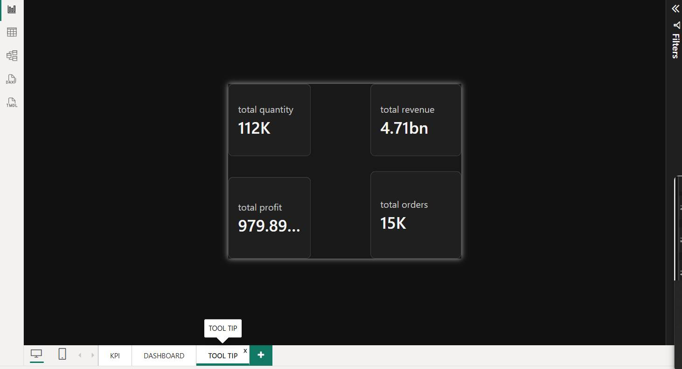
Figure 4: Custom Tooltip Design (4 KPI Cards)
Figure 5: Tooltip in Action & Interactive Dashboard with Filters

8. Tools & Technical Implementation
Tools Used: Microsoft Power BI Desktop, Power Query for ETL, DAX for measures.
Development Steps Followed by Iswarya:
1. Data Import & Cleaning: Removed duplicates, handled nulls, formatted date and currency fields in Power Query.
2. Data Modeling: Created relationships between Sales, Stores, and Date tables. Created a Star Schema.
3. DAX Measures Created:
- Total Revenue = SUMX(Sales, Sales[Quantity]*Sales[Unit_Price])
- Total Cost = SUM(Sales[Cost])
- Total Profit = [Total Revenue] - [Total Cost]
- Average Unit Price = AVERAGE(Sales[Unit_Price])
- Total Quantity = SUM(Sales[Quantity])
4. Visuals Created: 8+ visuals including KPI Cards, Bar, Line, Donut, Column, Treemap charts.
5. Interactivity: Added Slicers, Drill-through, and a dedicated ToolTip page.
6. Formatting: Used dark theme (#121212 background) with blue/cyan accent colors for a modern, executive dashboard look.
7. Publishing: Dashboard is responsive for Desktop and Mobile view (as seen in bottom navigation icons).

9. Key Insights & Recommendations
Key Insights Discovered:
1. Bengaluru Orion Flagship is the most valuable store - replicate its model.
2. Mobile Phones drive 35%+ revenue - maintain high stock.
3. Urban store type is most profitable - focus expansion on Urban locations.
4. Pune & Mumbai are top cities - invest more in marketing there.
5. January shows a major sales dip - plan promotions to counter seasonality.

10. Conclusion
This Power BI project by ISWARYA successfully transforms raw retail sales data into an actionable, interactive business intelligence solution. The dashboard provides a 360-degree view of the business with clear KPIs, trend analysis, and granular filtering capabilities. It demonstrates proficiency in Power BI, DAX, data modeling, and UI/UX design for dashboards.
Future Scope:
• Integrate real-time data gateway for live updates.
• Add Profit Margin %, YoY Growth using DAX Time Intelligence.
• Implement AI visuals like Key Influencers and Decomposition Tree.
• Add RLS (Row Level Security) for city managers.
Thank You!
Project By: Iswarya
Power BI Interactive Dashboard Project

