

**Department Of Information Technology**

**Group Number:**

|  |  |  |
| --- | --- | --- |
| **S. No.** | **Name** | **Roll No.** |
| 1 | **Ishu Kumar Pathak** | **300103320019** |
| 2 | **Jatin Agarwal** | **300103320020** |
| 3 | **Rashi Chauhan** | **300103320037** |
| 4 | **Shivani Singh** | **300103320046** |

**Project Title*:***

A web application to detect multiple diseases using machine learning algorithm .

**Aim Of the Project*:***

To detect multiple diseases using machine learning algorithm .

**Problem Statement:**

Predictive analytics in healthcare is a difficult endeavour, but it can eventually assist practitioners in making timely decisions regarding patients' health and treatment based on massive data. Diseases like Breast cancer, diabetes, and heart related diseases are causing many deaths globally but most of these deaths are due to the lack of timely check-ups of the diseases. The above problem occurs due to a lack of medical infrastructure and a low ratio of doctors to the population. The statistics clearly show the same, WHO recommended, the ratio of doctors to patients is 1:1000 whereas India’s doctor-to population ratio is 1:1456, this indicates the shortage of doctors. The diseases related to heart, cancer, and diabetes can cause a potential threat to mankind, if not found early. Therefore, early recognition and diagnosis of these diseases can save a lot of lives. This work is all about predicting diseases that are harmful using machine learning classification algorithms.

**Solution strategies:**

This work is all about predicting diseases that are harmful using machine learning classification algorithms. In this work, breast cancer, heart, and diabetes are included. To make this work seamless and usable by the mass public, our team made a medical test web application that makes predictions about various diseases using the concept of machine learning. In this work, our aim to develop a disease-predicting web app that uses the concept of machine learning-based predictions about various diseases like Breast cancer, Diabetes, and Heart diseases.

In this section consists of the methodology adopted by our proposed work. As stated earlier our work aims to develop a web application to detect diseases like breast cancer, diabetes, and heart diseases using machine learning models. The machine learning methodologies used in our proposed work are as follows:-

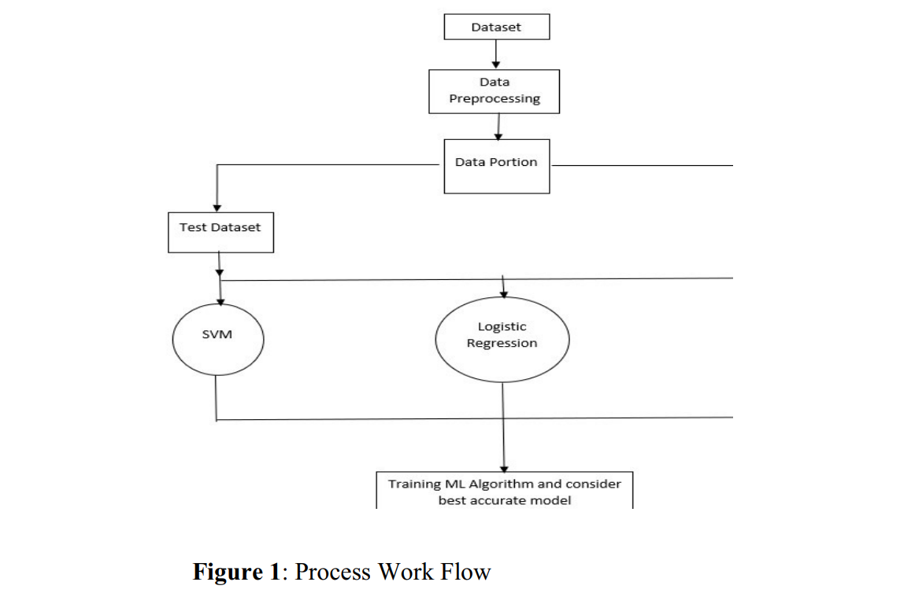

The proposed workwill brings diabetes, heart disease, and breast cancer under a single platform by deploying the trained models using the flask API framework which is a lightweight framework.

Three classification algorithms will be used for training the models, in which the logistic regression gave good accuracy values for the disease prediction of diabetes and breast cancer and KNN for the disease prediction of heart disease. KNN's highest accuracy is calculated by picking the highest value obtained from 1 to 21 neighbors. In the future, we can expand this work by adding more diseases that are trained by machine learning models and also can include

|  |  |  |
| --- | --- | --- |
| **Project Guide** | **Project Incharge** | **Head Of Department** |
|  |  | **Dr. (Mrs.) Ani Thomas** |