



Project on

**NETWORKING**

Submitted

By: To:

Ishu Raj Santu Purkait,

Netcamp ID: 27190171 Director,

Branch: Computer Science and Engineering Netcamp Solutions Pvt. Ltd.

College: MNNIT Allahabad santu@netcamp.in

Reg. No.: 20184074 www.netcamp.in

+91 93310 90003

Acknowledgment

I would like to express my special thanks of gratitude to my mentor **Mr. Santu Purkait** for his able guidance and support in completing my project.

Also, I would like to thank my parents who allowed as well as motivated me for undertaking this course and learning new things through this project.

Also, I would thank my friends who supported me and helped me in this project and made this whole process of learning much easier and more fun.

Last but not the least, I express my thankfulness to the Internet and various useful sites which helped me a lot in understanding the subject and gaining information related to the project.

Certificate

This is to certify that this project on ‘Networking’ has been prepared by ISHU RAJ, Netcamp ID 27190171, pursuing B.Tech. in Computer Science and Engineering at MNNIT Allahabad. This project has been prepared under my guidance and has been completed successfully.

Certified by:

Mr. SANTU PURKAIT,

Director,

Netcamp Solutions Pvt. Ltd.,

[santu@netcamp.in](mailto:santu@netcamp.in)

www.netcamp.in

+91 93310 90003

Date: 24/12/2019

Contents

PROBLEM STATEMENT…………………………………………………………. 5

APPROACH………………………………………………….………………………… 6

DNS SERVER.…….………………………………………………………………….. 7

WEB SERVER…...……………………………………………………………………. 9

MAIL SERVER………………………………………………………………………... 10

DHCP SERVER…………...………………………………………..………………… 15

FILE SERVER………………………………………………………………………..… 17

CHANGING THE MAIL PAGE LOGO……….…………….……………..… 19

Problem Statement

Consider yourself a final year engineering student, who will be passing out in July 2022. You decide that you will start your own company which will provide e-business and e-service solutions to the various small companies across the country. You proposed your idea to some of your friends. You were overwhelmed with the support and their willingness to join your new venture. All wanted to leave their own mark, idea was to be a “JOB Maker – Not a JOB Seeker”.

You all decided to start and decidedthe company name eventually. You decided to start the web services first so that you can display your product lines on the web as well as communicate with your future customers.

You bought the following items to start your company and planned to inaugurate the portal by 9am 1st January 2022:

a)      Rented a space to use it as office and keep your servers

b)      3 Red Hat Linux Enterprise server with plenty of memory and storage space

c)      3 live IP addresses

d)     32Mbps Internet connection

e)      A domain name for your company website

After a group meeting you decided to do the following and get it going:

* Create one web server which will host all the web sites for the company.
* Create one DNS server.
* Create one mail server which will provide the email service for the company (mail.domain – and should be accessed from web). Mail server should have POP3 support so that the users can download email in their own laptop/desktop. (Please customize the mail page with your own company logo and company name).
* The mail server will be the file server which will have file storage space for the user.
* File server will also have a DHCP server (range of IPs =192.168.1.150 to 192.168.1.190 gateway=192.168.1.1 and DNS server = give your DNS server) so that it can give IP addresses to all the client machines.
* You were 6-7 in your group.You decided that you will be the Chairman of the company and will have access to all the files/folders in your company. You created three departments – Sales, Research and Accounts. Please divide the group members in all these groups. For the file management, you decided about the following points.

Email address: username@domain

Domain name: company.com (should also open as www.company_name.com)

Four subdomains: sales.company_name.com

research.company_name.com

accounts.company_name.com

mail.company_name.com

Separate data folder for all the departments(only departmental access – only the department people can read and write on the same)

 /department_name/data

Separate driver folder for all the departments(only departmental access – only the department people can access (r-x)  but can’t write on the same)

/department_name/driver

Please make a note thatthe Chairman will have full access on the data and driver folders.

You should also be able to view other domains and send mail to them.

Please design and implement the same.

Approach

The company name is decided to be ‘Berry Pvt. Ltd.’ and the domain name for the website of the company is ‘berry.com’. We have five subdomains namely, ‘www.berry.com’, ‘sales.berry.com’, ‘accounts.berry.com’, ‘research.berry.com’ and ‘mail.berry.com’. There are total 7 members in the company and are assigned different departments. We create three servers, and use the server with IP 192.168.1.100 as the DNS server, 192.168.1.200 as the web server, and 192.162.1.250 as the mail server, DHCP server, as well as the file server. We create separate user accounts for all the 7 users in the file server, and three secondary groups each concerning a separate department. The users are added in their department-group as per their department allocation. A DHCP server is configured to assign IP addresses to all the client machines. Also, the logo and name of the mail service web-application provided by SquirrelMail is changed and set to the logo of ‘Berry.com’ as per the problem statement.

DNS Server

Domain Name Service(DNS) server is the computer server that contains a database of public IP addresses and their associated hostnames, and in most cases serves to resolve, or translate those names to IP addresses as requested. They communicate with each other using special protocols. It is also known as‘name server’.It works on port number 53.

**Why is DNS important?**

It is easier for people to remember domain names of various websites rather than their IP addresses.

There are two kinds of domain hosting:

**1. Virtual Hosting**(Shared)– It is the method of hosting multiple domain names on a single server(or a pool of servers).

**2. Dedicated Hosting**-It is the method of hosting a single domain name on a single server(or a pool of servers).

**TYPES**

There are two kinds of DNS servers:

**1. Authoritative DNS –** It returns answers only to queries about domain names that have been specifically configured by the domain administrator.

**2. Non-Authoritative DNS-** It does not contain the original source files of domain’s zone. They have cache file for domains that is constructed from all the DNS lookups done previously.

**Root Name Server –** It is a name server for the root zone of the DNS of the Internet. It directly answers requests for records in the root zone and answers other requests by returning a list of authoritative name servers for the appropriate top level domains(TLDs).

**TopLevelDomains (TLDs)** - It is one of the domains at the highest level in the hierarchical name system of the Internet. They are installed in the root zone. For example, .com, .in, .edu , .org, etc.

**Webmin –** It is a web-based system configuration for Unix-like systems. It helps to configure OS internals such as users, services, or configuration files graphically. It works on port number 10000. It can be opened in a browser by typing ‘http://(IP address of the server):10000’.

Here, the IP address of the DNS server is 192.168.1.100.

**Steps for DNS Server Configuration**

* We open the Webmin of the DNS server by typing ‘http://192.168.1.100:10000’ in a browser and login as root.

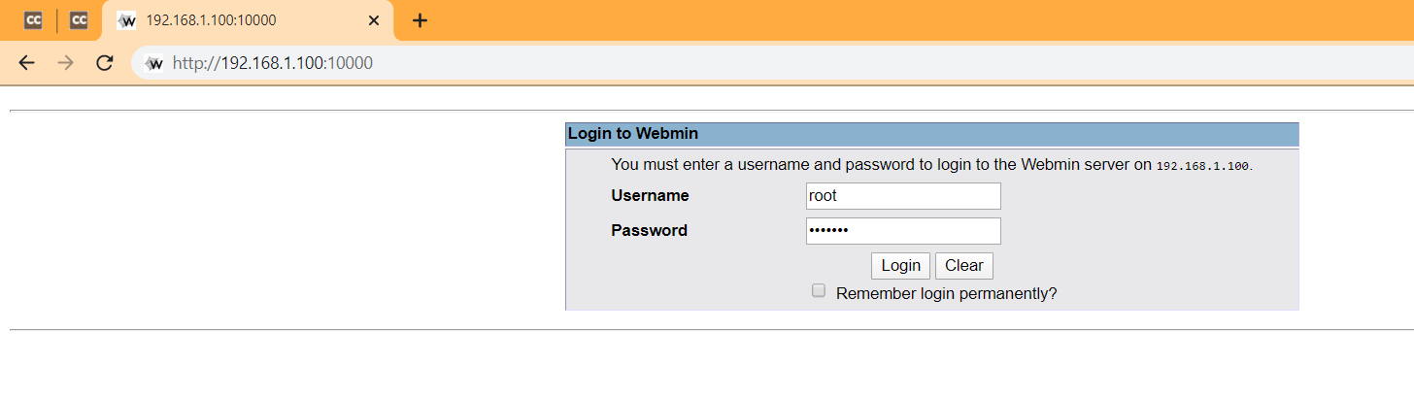

* We click on ‘Bind DNS Server’ link under the ‘Servers’ tab.
* After this, we click on ‘Create master zone’ link on the page that appears and fill the ‘Domain name’ column as below:

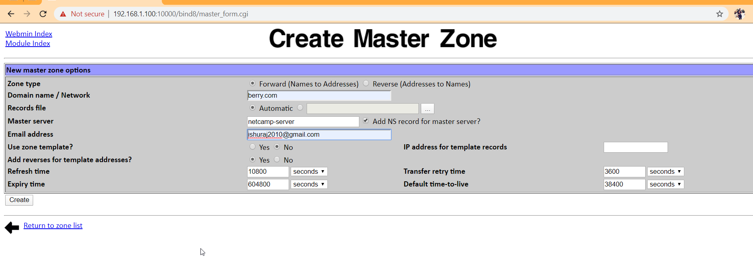

* After this, a link of ‘berry.com’ appears on the ‘Bind DNS Server’ page. Then, we click on the link and open the ‘Address Records’ page that appears after clicking on the ‘Address’ link on the screen that appears. The details for the domain and five subdomains are entered one by one.

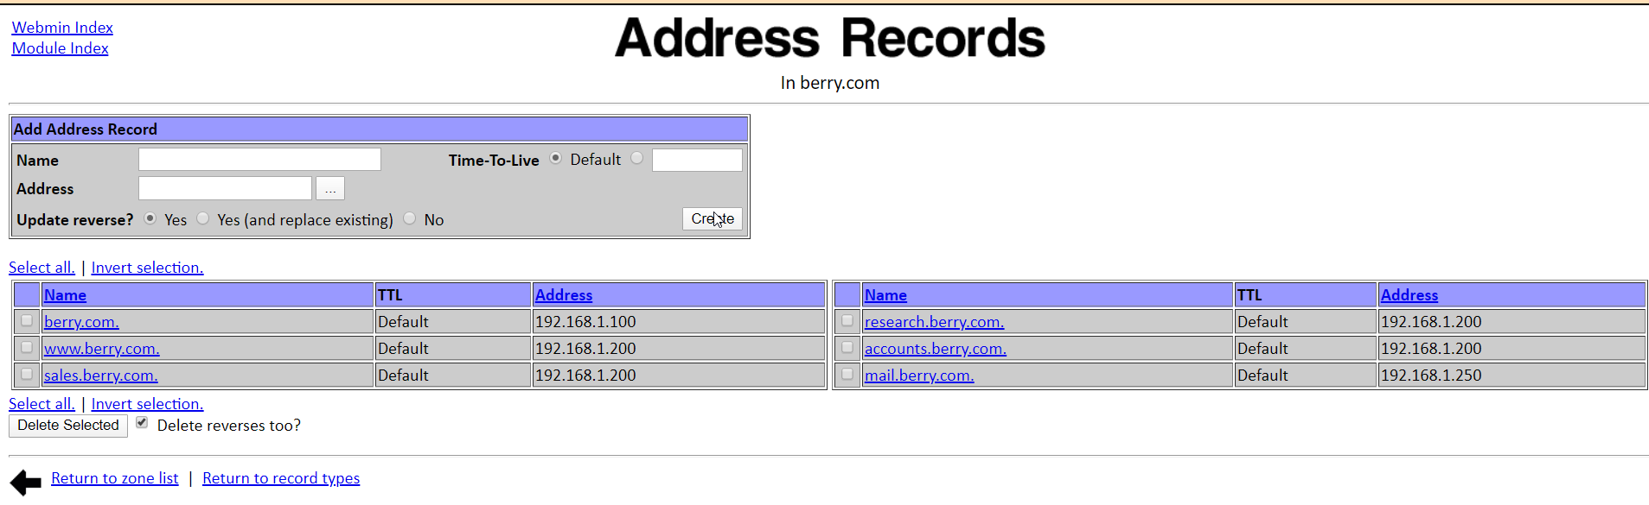

Web Server

Web Server is a computer system that allows us to access files stored on a physical server and use them to serve websites. It processes incoming network requests over HTTP and several other related protocols.

Here, the web server I.P. address is 192.168.1.200.

**Steps for Web Server Configuration**

* We open the Webmin of the web server.
* Then we go to the Apache Webserver under ‘Servers’ tab.
* New virtual servers are created by filling details as per the following screenshot:

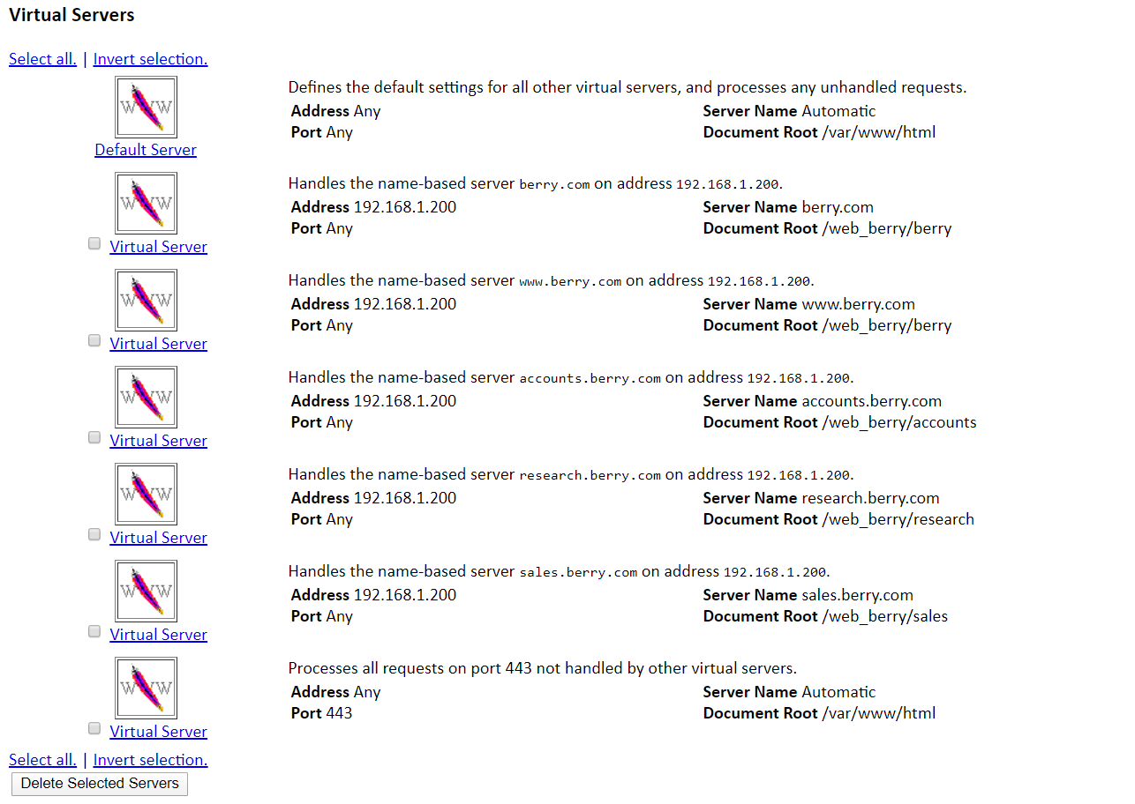

* The root addresses are given accordingly(Refer to the following image..)

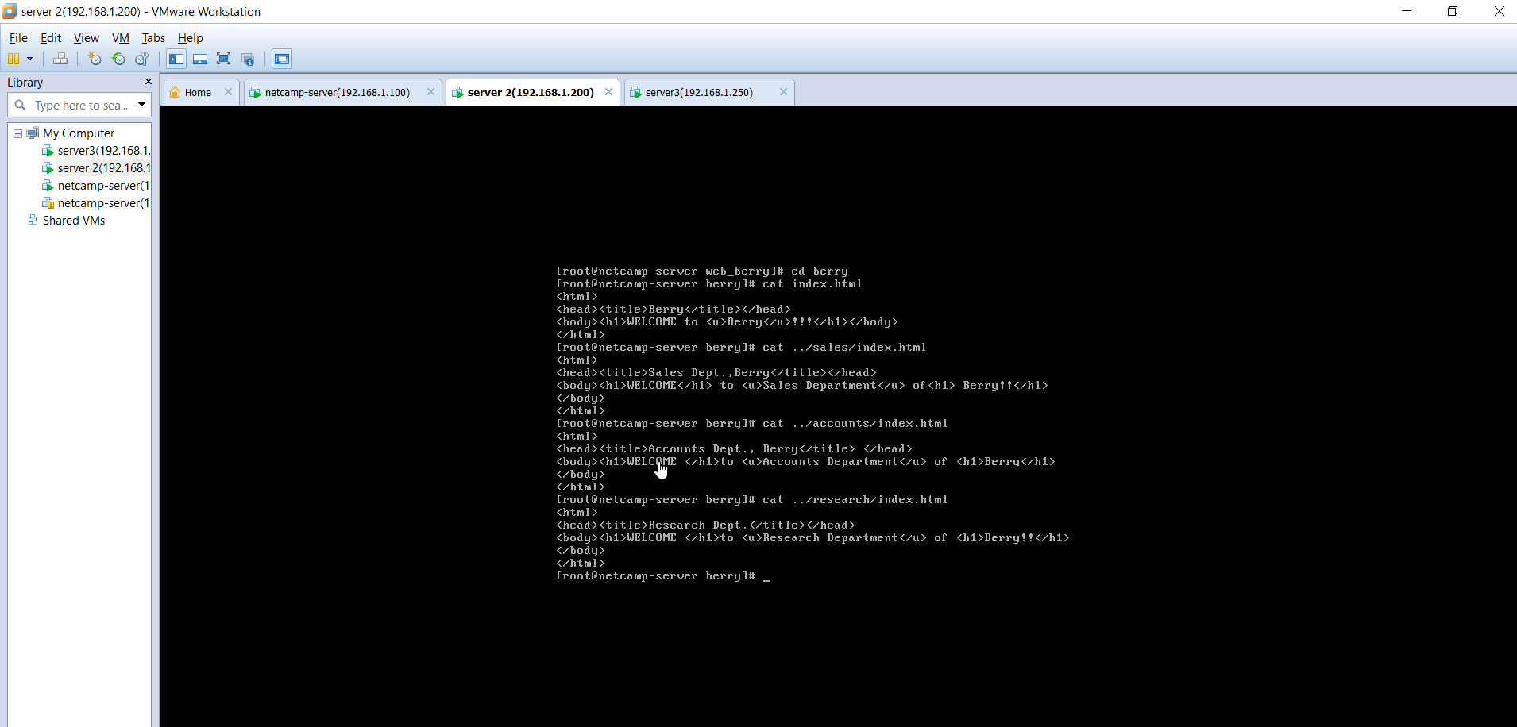

* The web pages of the domain and the three subdomains are given below:

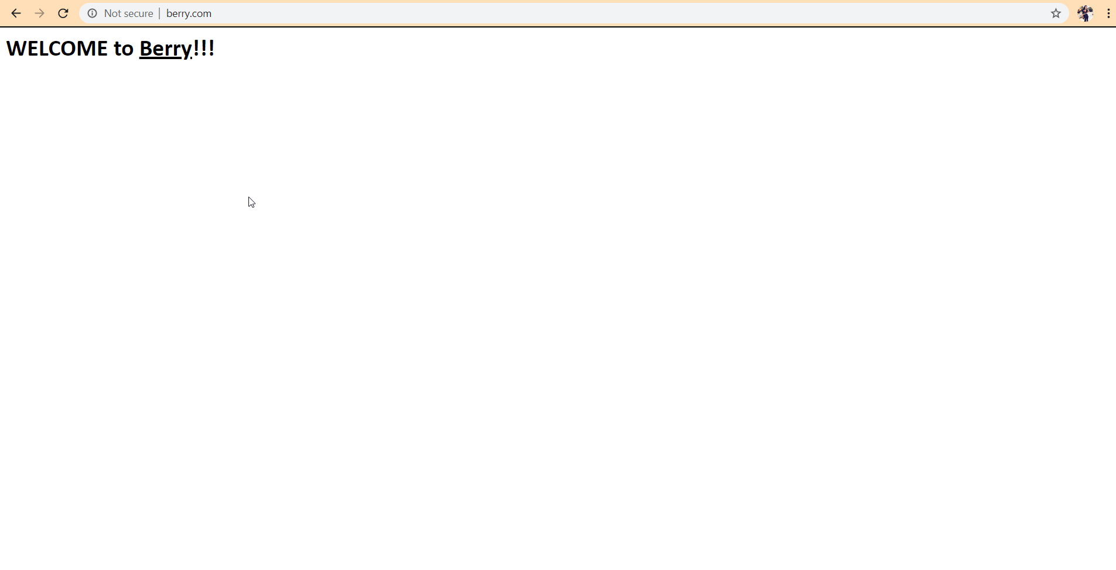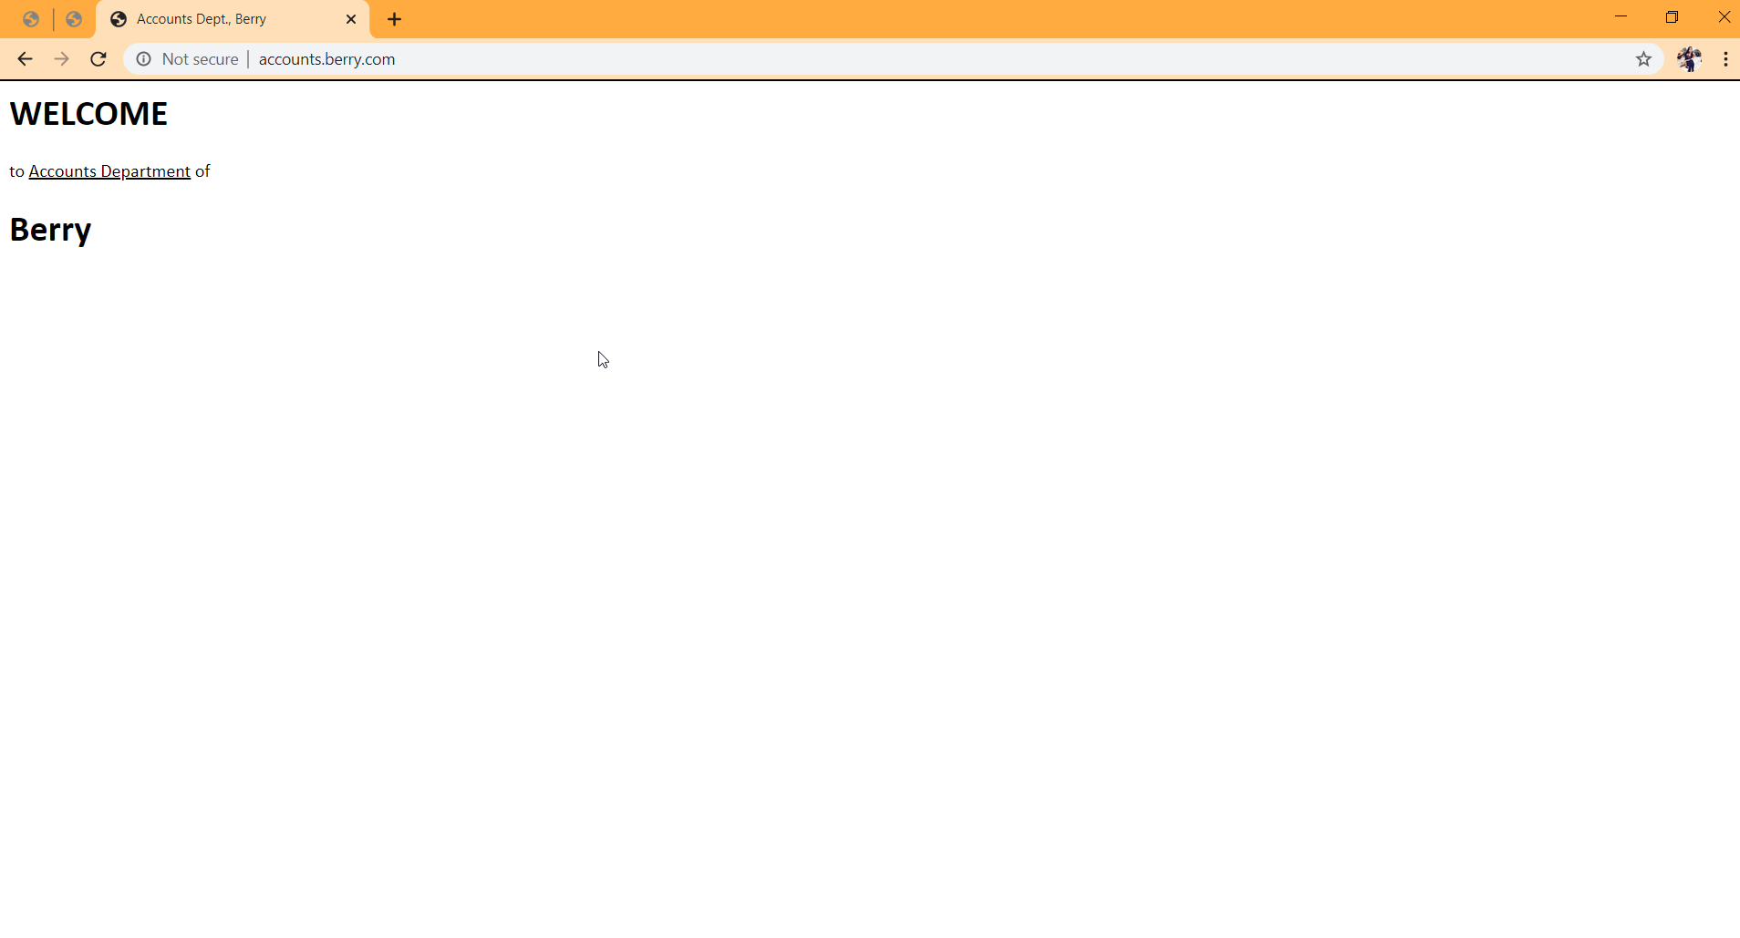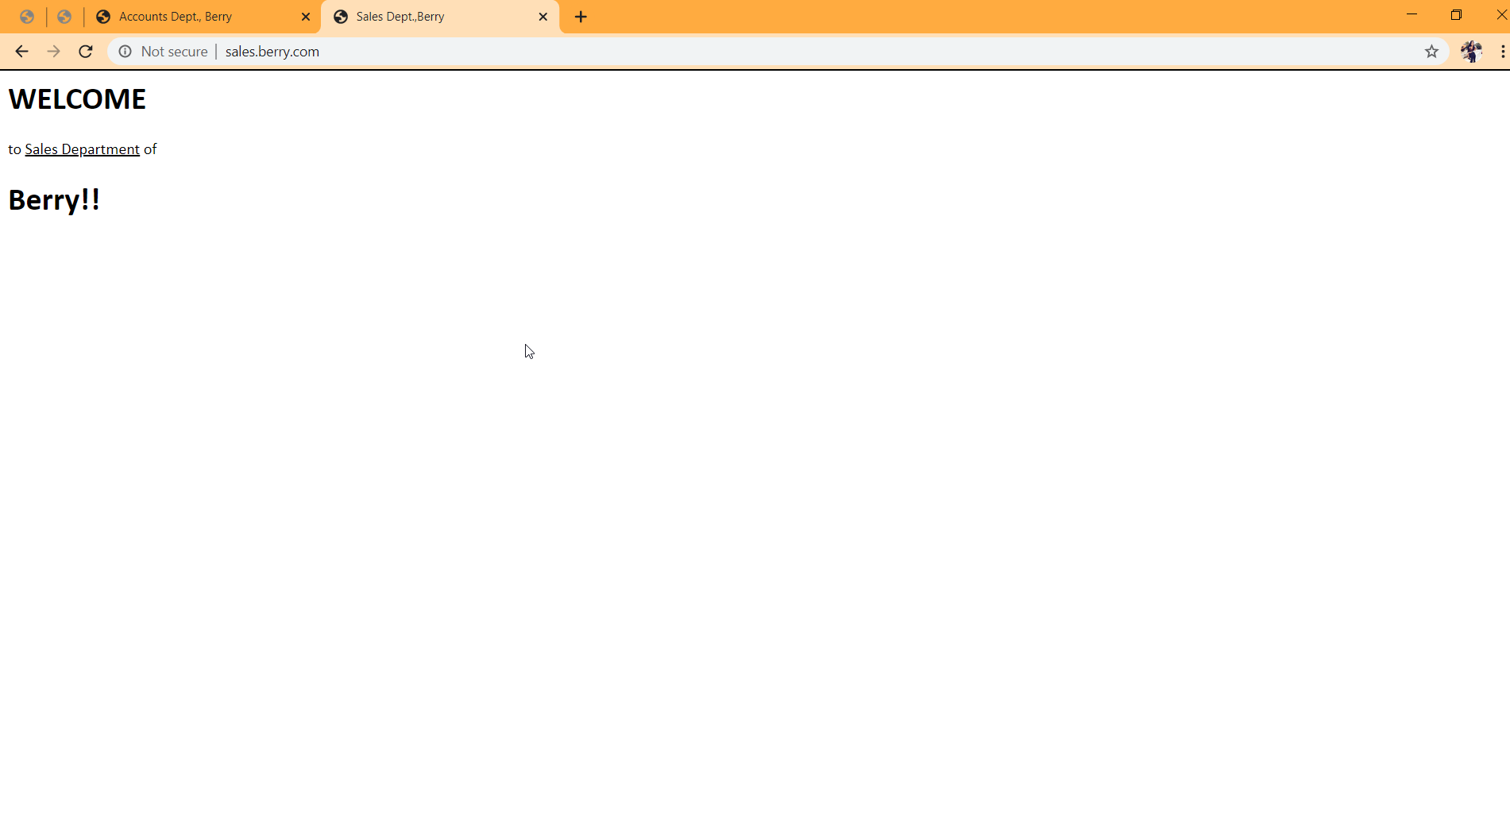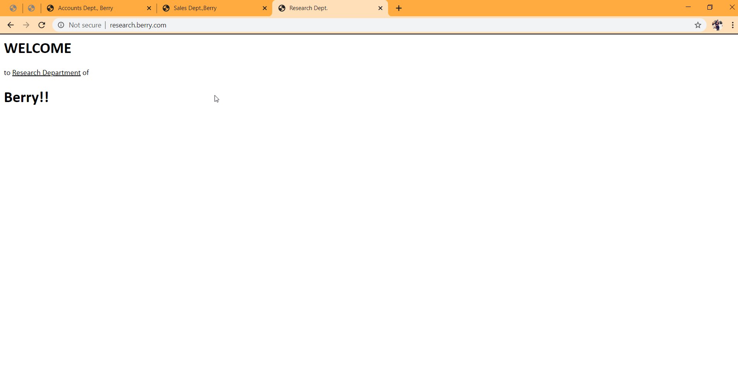

Mail Server

**INTRODUCTION**

Mail server is a computer system that sends and receives email. In order for a computer system to function as a mail server, it is important for it to include mail server software(SquirrelMail here). It sends and receives email using standard email protocols, e.g. SMTP, IMAP, POP3,etc.

There are two divisions of mail-

1. **Intramail** – Transfer of mail between two users of same domain.

e.g. Transfer of mail between [x@gmail.com](mailto:x@gmail.com) to [y@gmail.com](mailto:y@gmail.com) .

2. **Intermail** – Transfer of mail between two users of different domain.

e.g. Transfer of mail between [x@gmail.com](mailto:x@gmail.com) to [y@yaahoo.com](mailto:y@yaahoo.com)

**PORTS**

To facilitate mail transfer, following ports are necessary:

1. Port 53 – for DNS server

2. Port 80/Port 443 – for web server

3. Port 25 – for SMTP (Simple Mail Transfer Protocol)

**STEPS for Mail Server Configuration**

**1. DNS configuration**:

* Webmin of the mail server(192.168.1.250 here) is opened.
* The domain name ‘berry.com’ is clicked under ‘Bind DNS Server’ link under ‘Servers’ tab.
* In ‘Mail Server Records’, we enter ‘mail.berry.com.’(. denotes root) under the ‘Mail Server’ column and any number under the ‘Priority’ column.

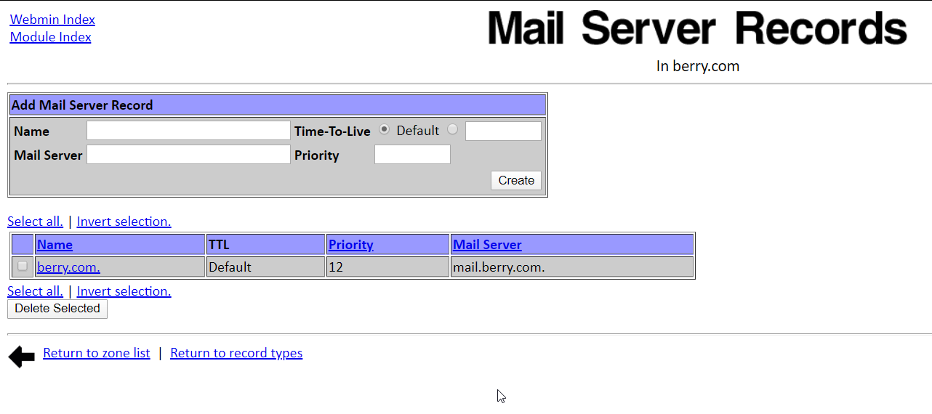

**2.Network configuration**: When the mail server receives a mail request, it checks its localhost file. If the file has the entry ‘mail.berry.com’, it will receive the mail, else will drop it.

* Under the ‘Networking’ tab in the Webmin of the mail server, the link ‘Network Configuration’ is clicked.
* Enter hostnames(here, berry.com and mail.berry.com) in the prescribed column in the ‘Host Address’ page.

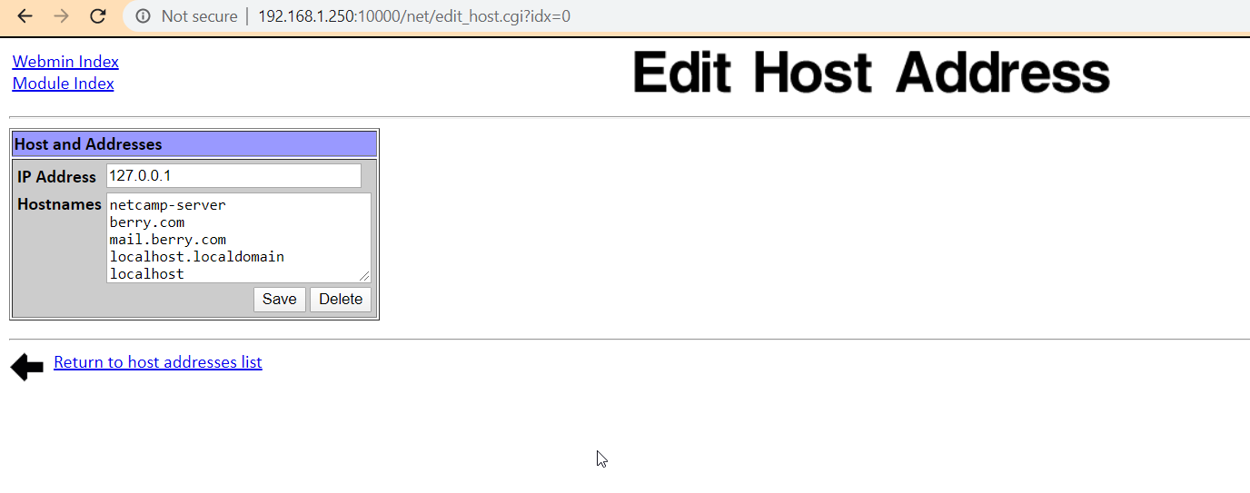

**3. Apache configuration**:

* We click ‘Apache Webserver’ under the ‘Servers’ tab in Webmin of mail server.
* A new virtual server is created by filling details as per the following screenshot:

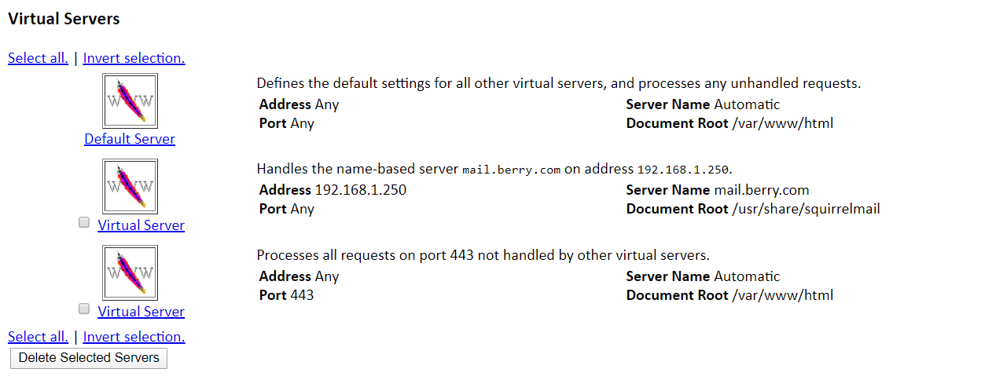

* The root address given is ‘usr/share/squirrelmail’.

**4. Sendmail Configuration:** Simple Mail Transfer Protocol(SMTP) is the protocol for sending e-mail messages between servers. Default port number for SMTP is 25.

* We click on ‘Sendmail Options’ in the page that opens after clicking on ‘Sendmail Configuration’ under ‘Servers’ tab in the Webmin of the mail server.
* In the page that opens, the entry “Addr=127.0.0.1” is deleted from the ‘SMTP port options’ column. This will facilitate faster mail transfer since the server will not check its localhost file every time before sending a mail.

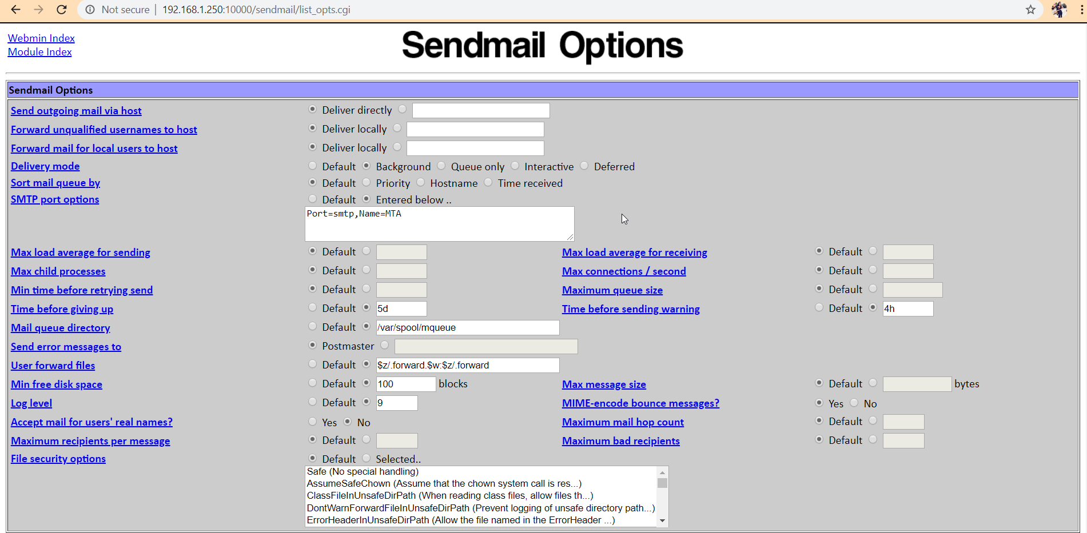

* After this, we click on the link ‘Local Domains’ in the ‘Sendmail Configuration’ page and enter ‘berry.com’ and ‘mail.berry.com’ in the column ‘Domains handled by this server’.

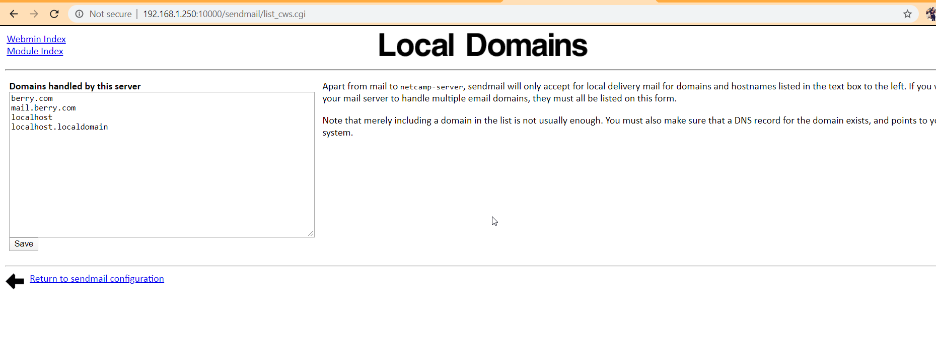

**5. Retrievemail Configuration:**Internet Message Access Protocol(IMAP) stores mails on a mail server and allows the end user to view and manipulate the messages as though they were stored locally. Post Office Protocol v3 (POP3) is another protocol in which email is received and held for the user by her/his server. Default port number for IMAP is 143 and for POP3 is 110.

* We open ‘Dovecot IMAP/POP3 Server’ under the ‘Servers’ tab in the Webmin of the mail server.
* In the ‘Networking and Protocols’ page, all the four options ‘IMAP’, ‘POP3’, ‘IMAP(SSL)’ and ‘POP3(SSL)’ are selected and saved.

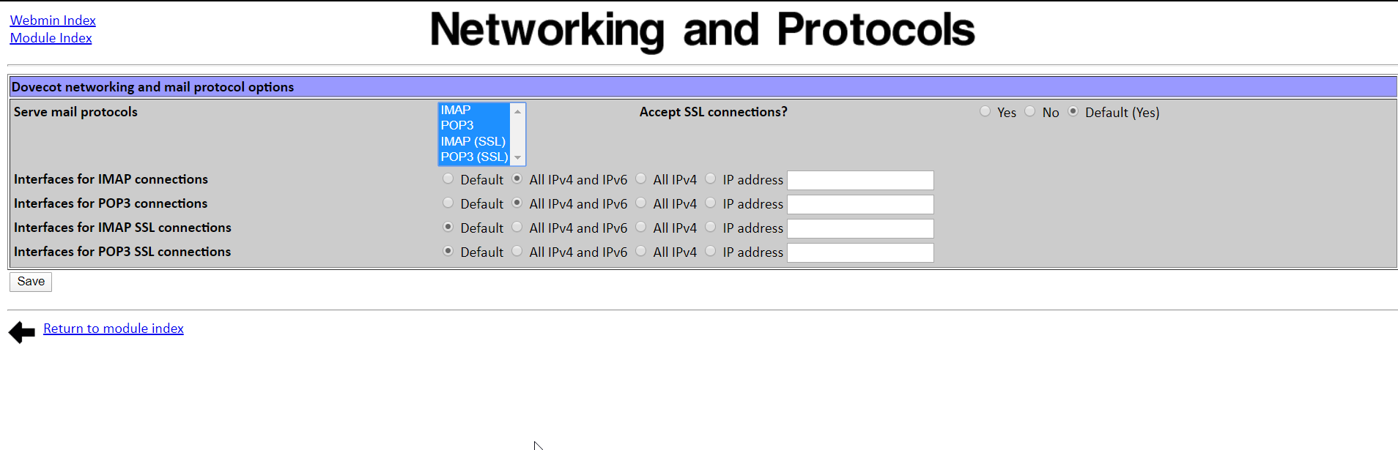

**6. User configuration**: We assign unique email addresses to the users in the mail server.

* ‘mail.berry.com’ is opened in the browser and the user is logged in using his username and password.

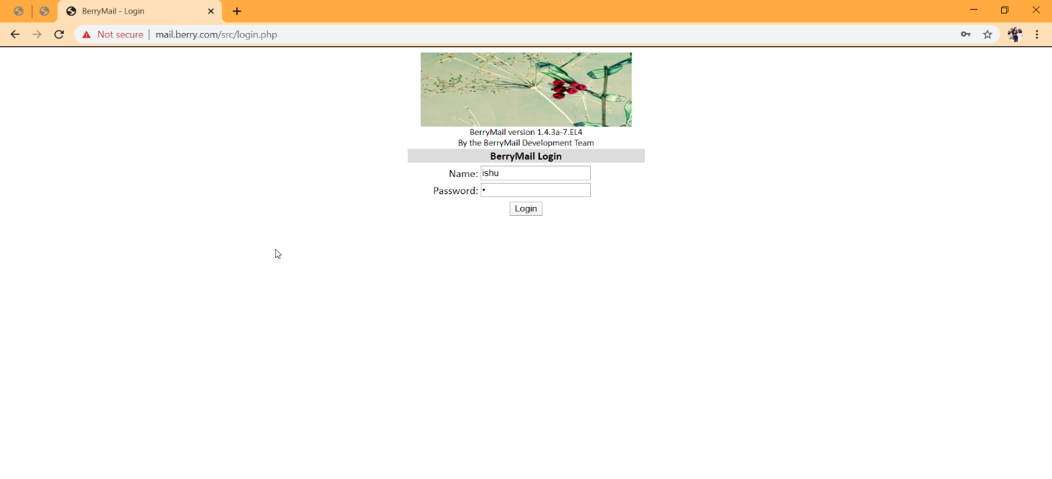

* ‘Options’ link is clicked on, and ‘Username’ and ‘Email Address’ is entered in the provided columns.

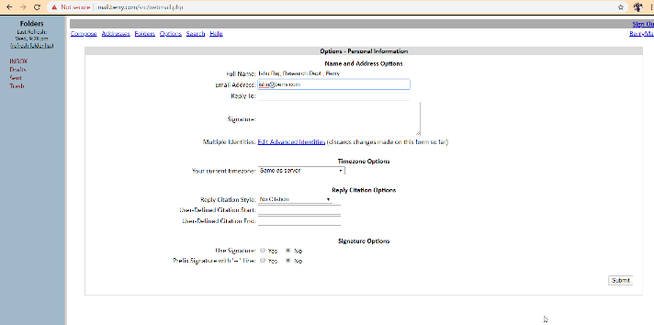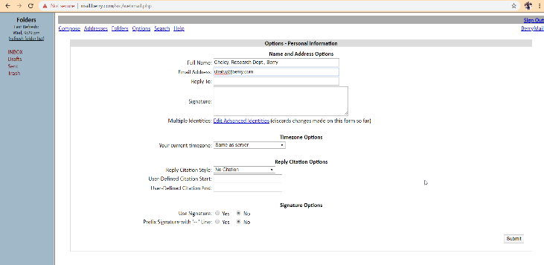

* Now, we can transfer e-mails between users using the assigned e-mail addresses.

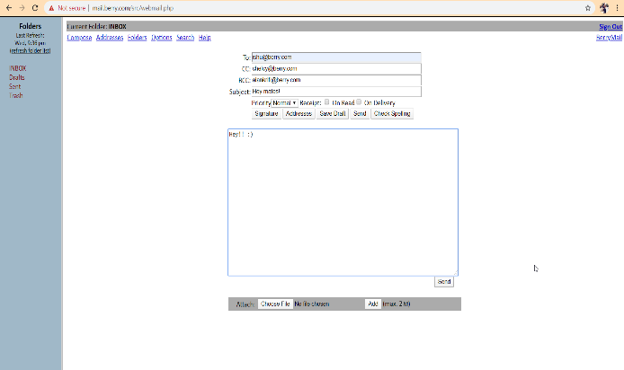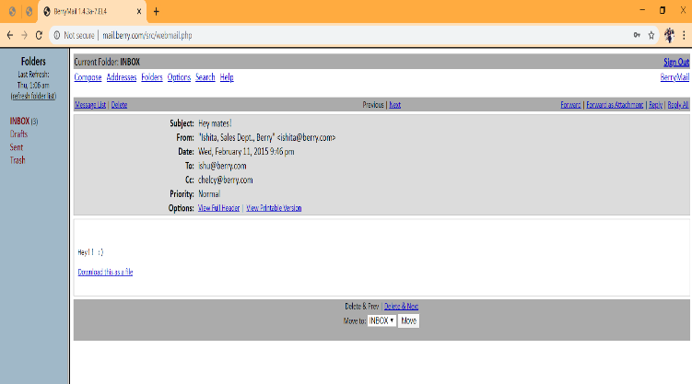

* Mails can be downloaded too.

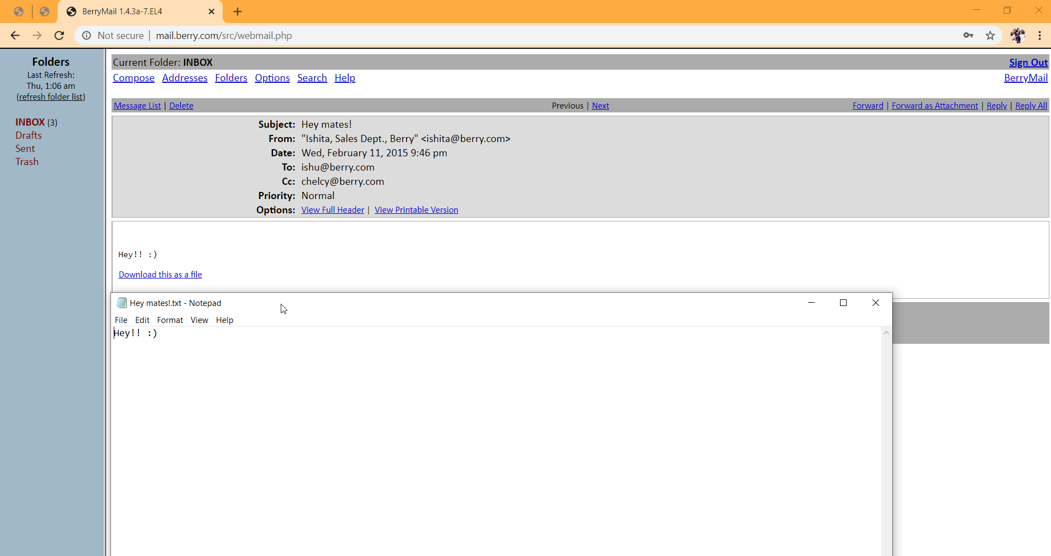

**7. Configuration for Intermail:** These stepsare not required for Intramail.

* In the Webmin of DNS server(I.P. 192.168.1.100 here), we click on ‘Create Forward Zone’ inside the ‘Bind DNS Server’ link.
* Then we enter the domain name(e.g. gmail.com) and its IP Address in the ‘Master servers’ column.
* Now, in the Webmin of mail server, we click on ‘Relay Domains’ in the ‘Sendmail configuration’ page.
* The domains to which intermail is desired(e.g. gmail.com) is entered in the column ‘Domains to which relaying is allowed’.

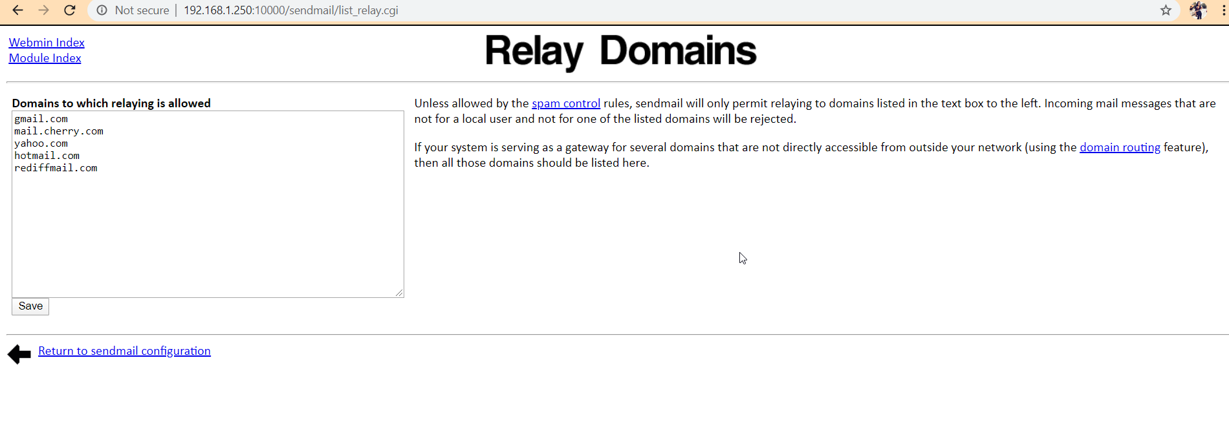

DHCP Server

DHCP stands for Dynamic Host Control Protocol. It is a protocol for assigning dynamic IP addresses to devices on a network. With its help, a device can have different IP address every time it connects to the network. It works on port no. 67/68.

Here, the server with IP address 192.168.1.250 is also the DHCP server.

Steps for DHCP Server Configuration

* In the Webmin of the DHCP server, we open the ‘DHCP Server’ link under the ‘Servers’ tab.
* The following screen appears after clicking on the ‘Create a new subnet’ link, and the details are filled as below:

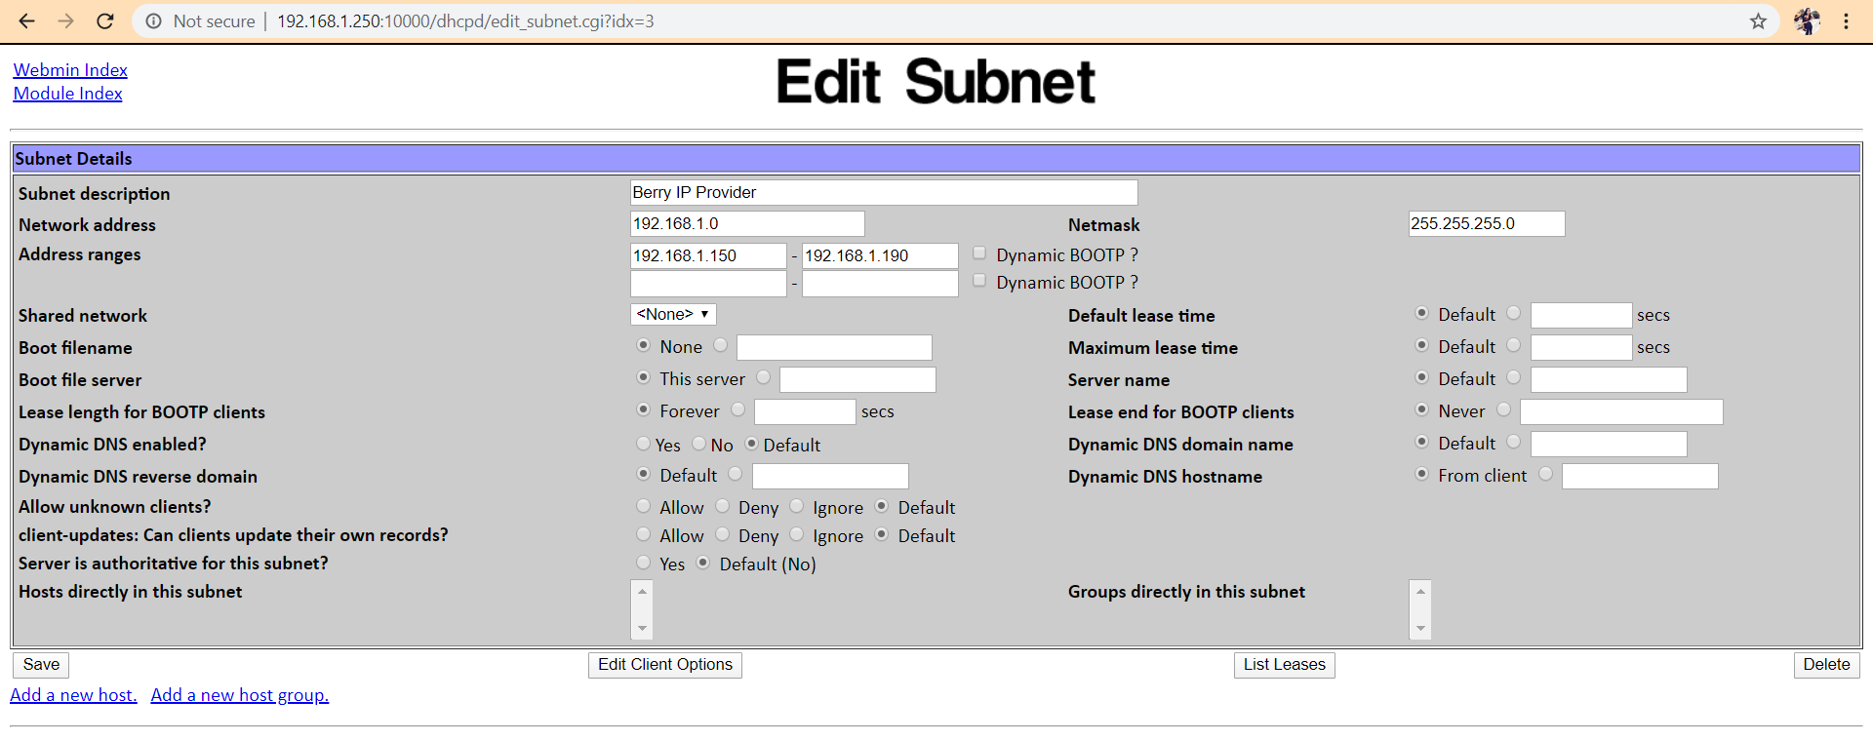

* The following screen appears after clicking on the ‘Edit Client Options’ link, and the details are filled as below:

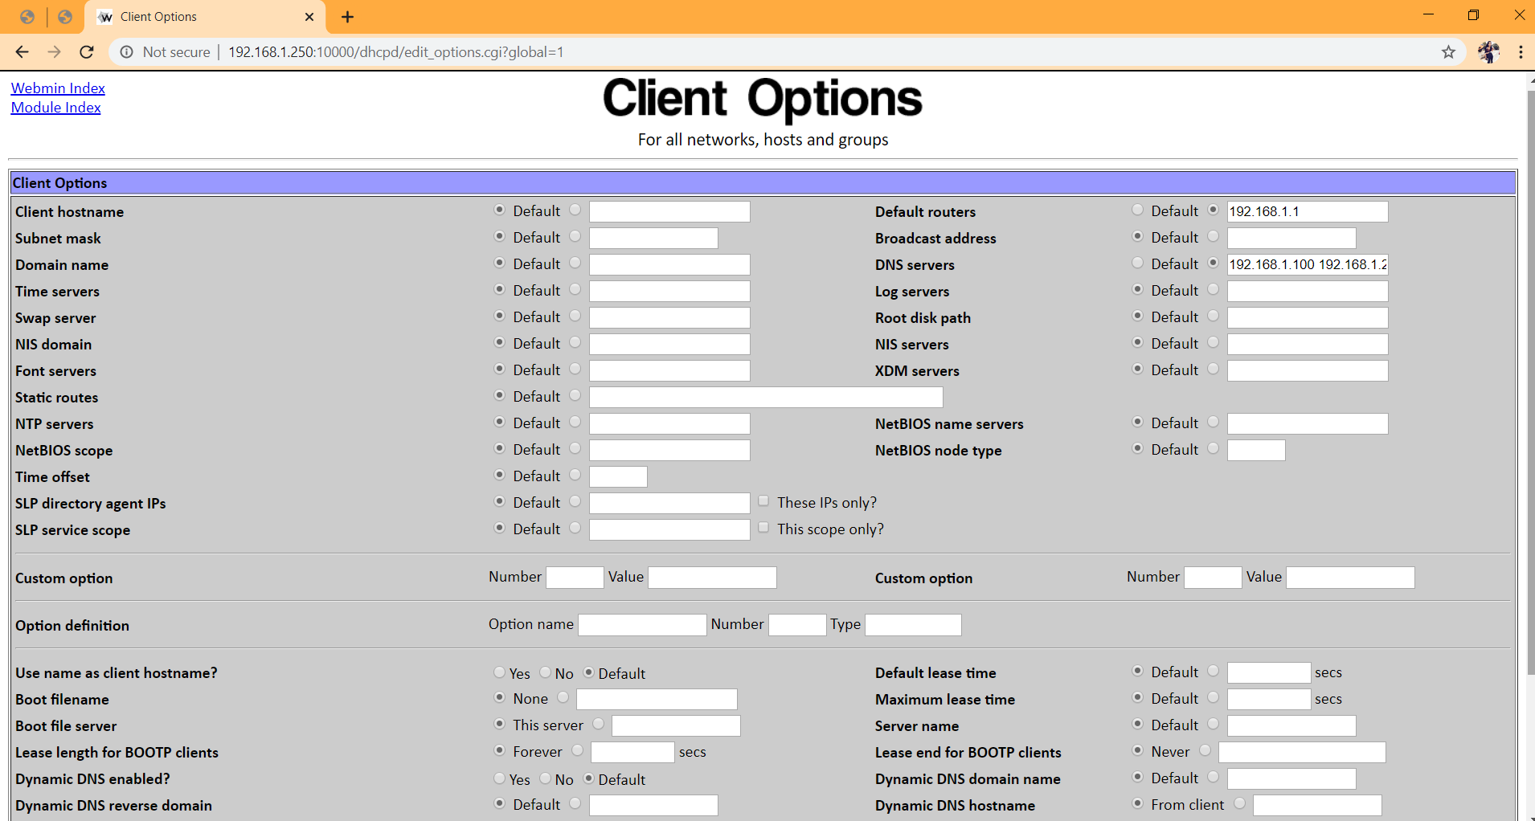

* After this, we open the /etc/dhcpd.conf file in the DHCP server and add the following line in it.

“ddns-update-style ad-hoc;”

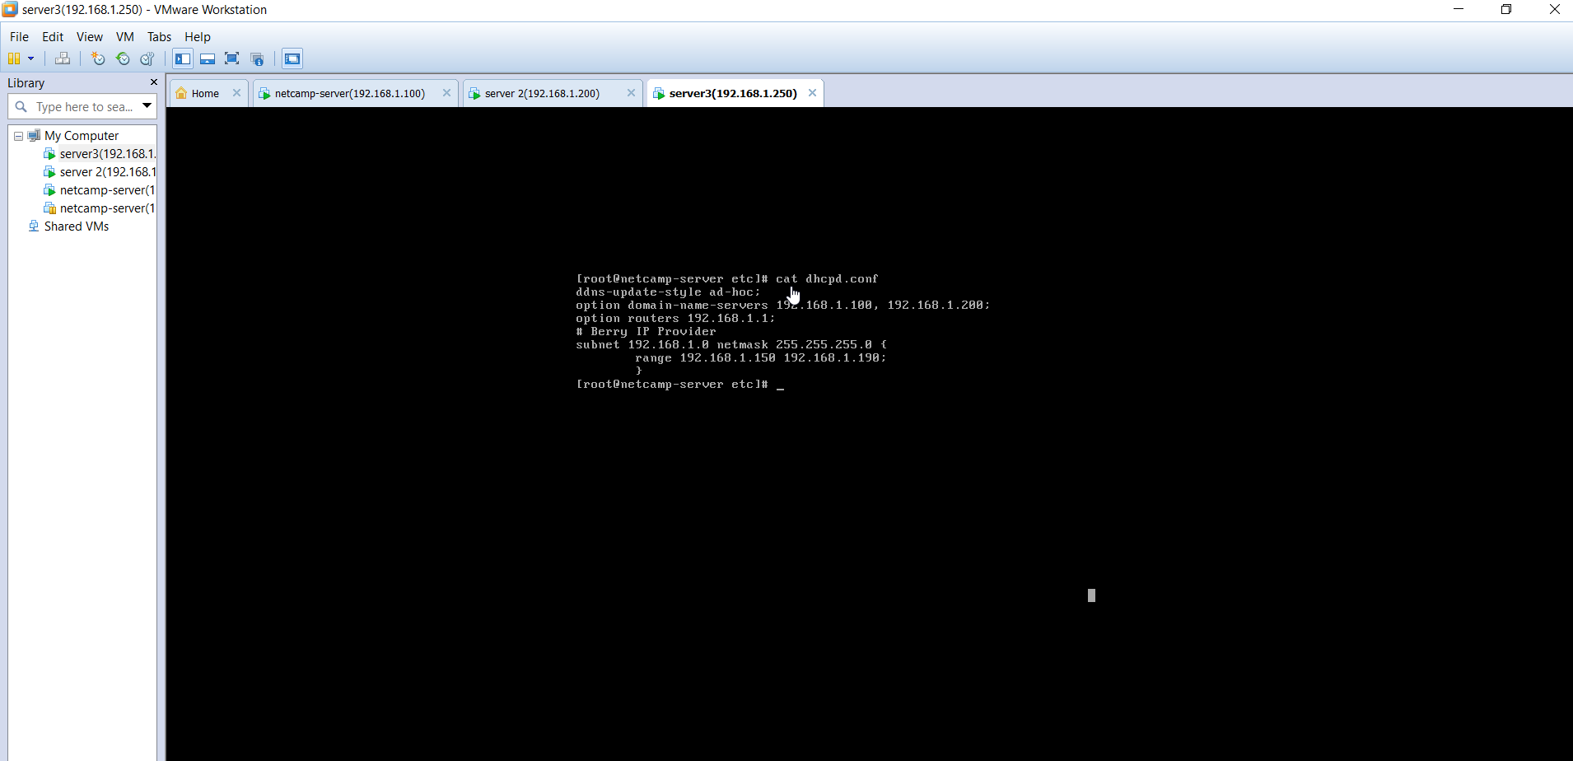

* After this, server is started by clicking on ‘Start Server’.
* After this, we need to stop the virtual machine’s DHCP service. For this, we go to ‘Edit’ -> ‘Virtual Network Editor’. Then, we select VMNet1 and uncheck ‘Use Local DHCP service to distribute IP addresses..’.
* The DHCP server assigns the Windows client a random IP from the pool of IP assigned to the DHCP server.

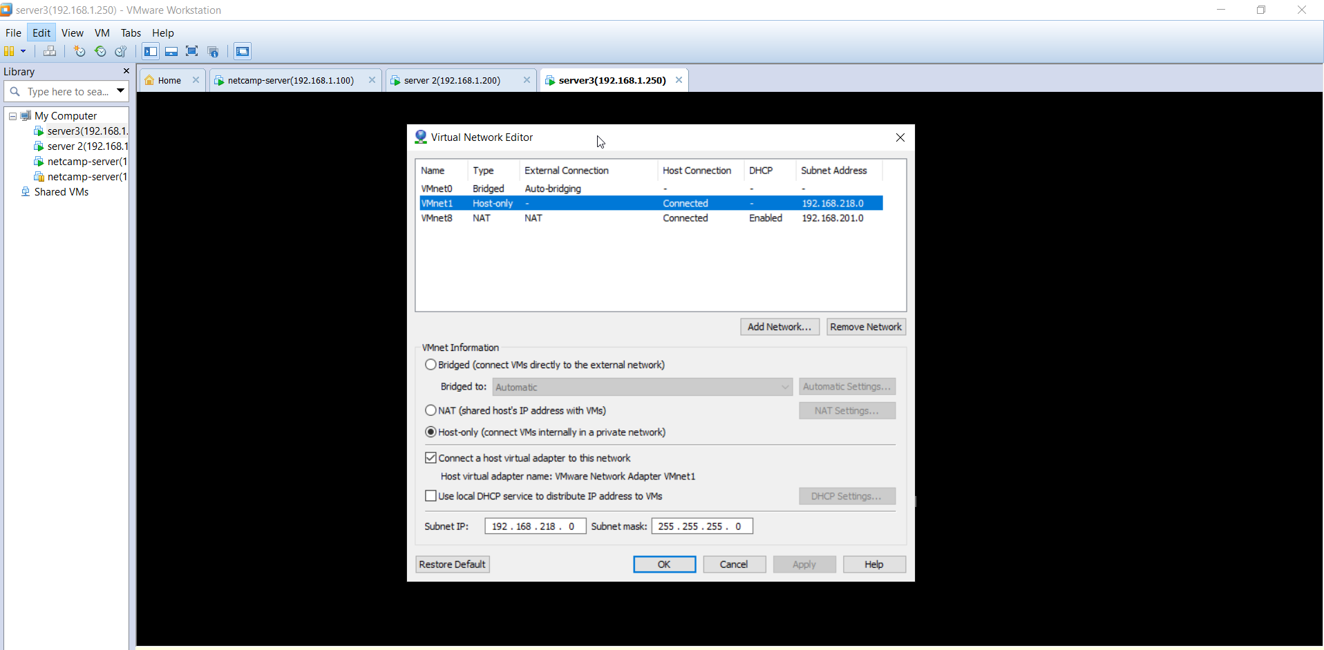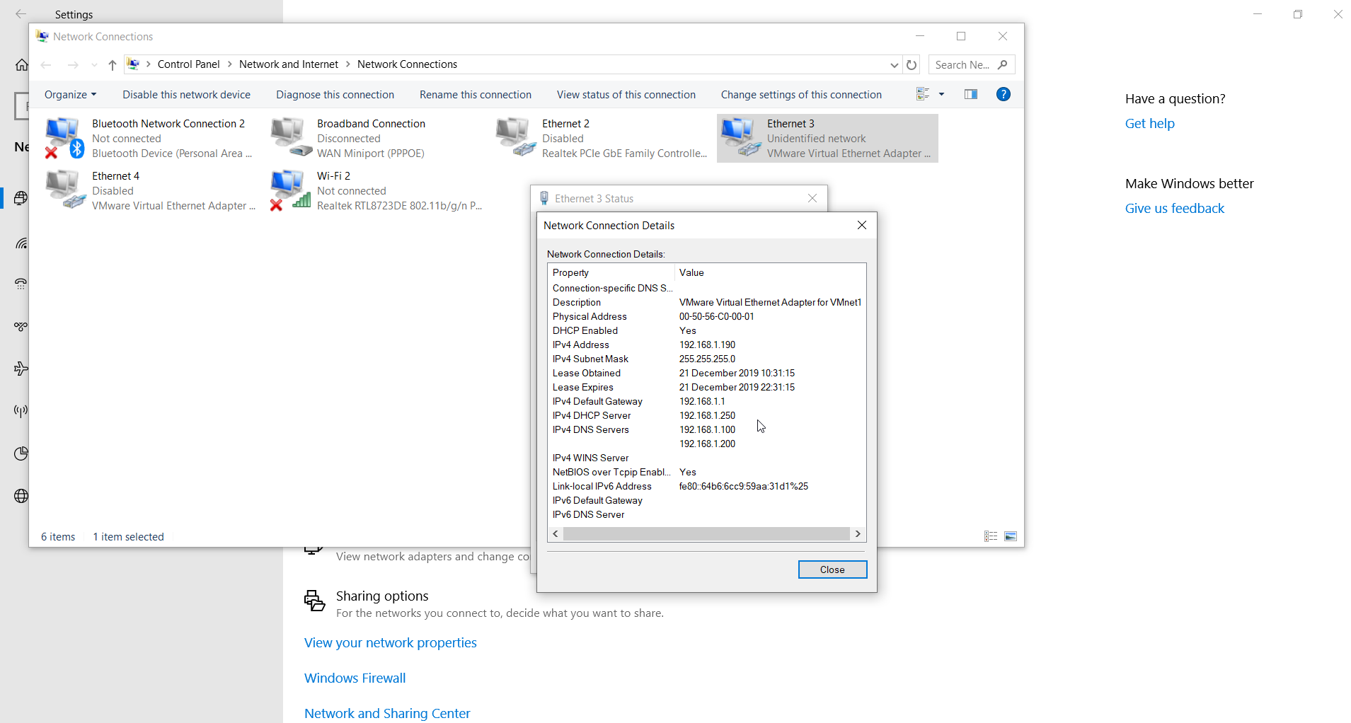

File Server

It is the computer server attached to network that provides a location for shared disk access, i.e. storage of computer files that can be accessed by devices that are able to reach the server.

Here, the server with IP address 192.168.1.250 is also the file server.

Steps for File Server Configuration

* First of all, we create usernames for different users using the ‘useradd’ command in the Linux file server and assign passwords to all of them. Here, 7 users are created. They can be viewed by typing ‘cat passwd’ in /etc directory.

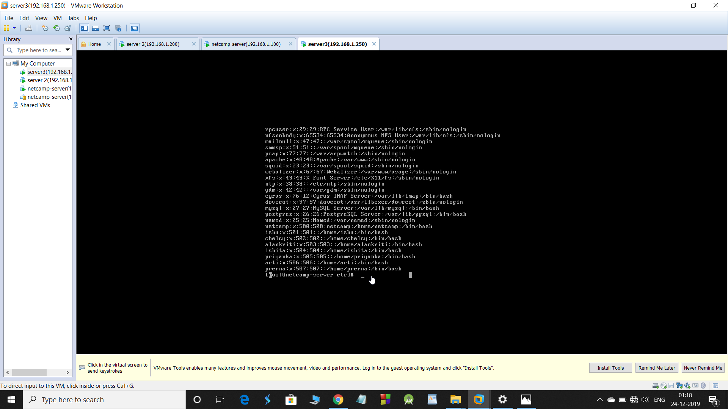

* Then, we create three groups denoting different departments namely ‘sales’, ‘accounts’ and ‘research’ using ‘groupadd’ command as per the problem statement and add users to different departments using ‘usermod’ command. We can check the group details using ‘cat /etc/group’ command.

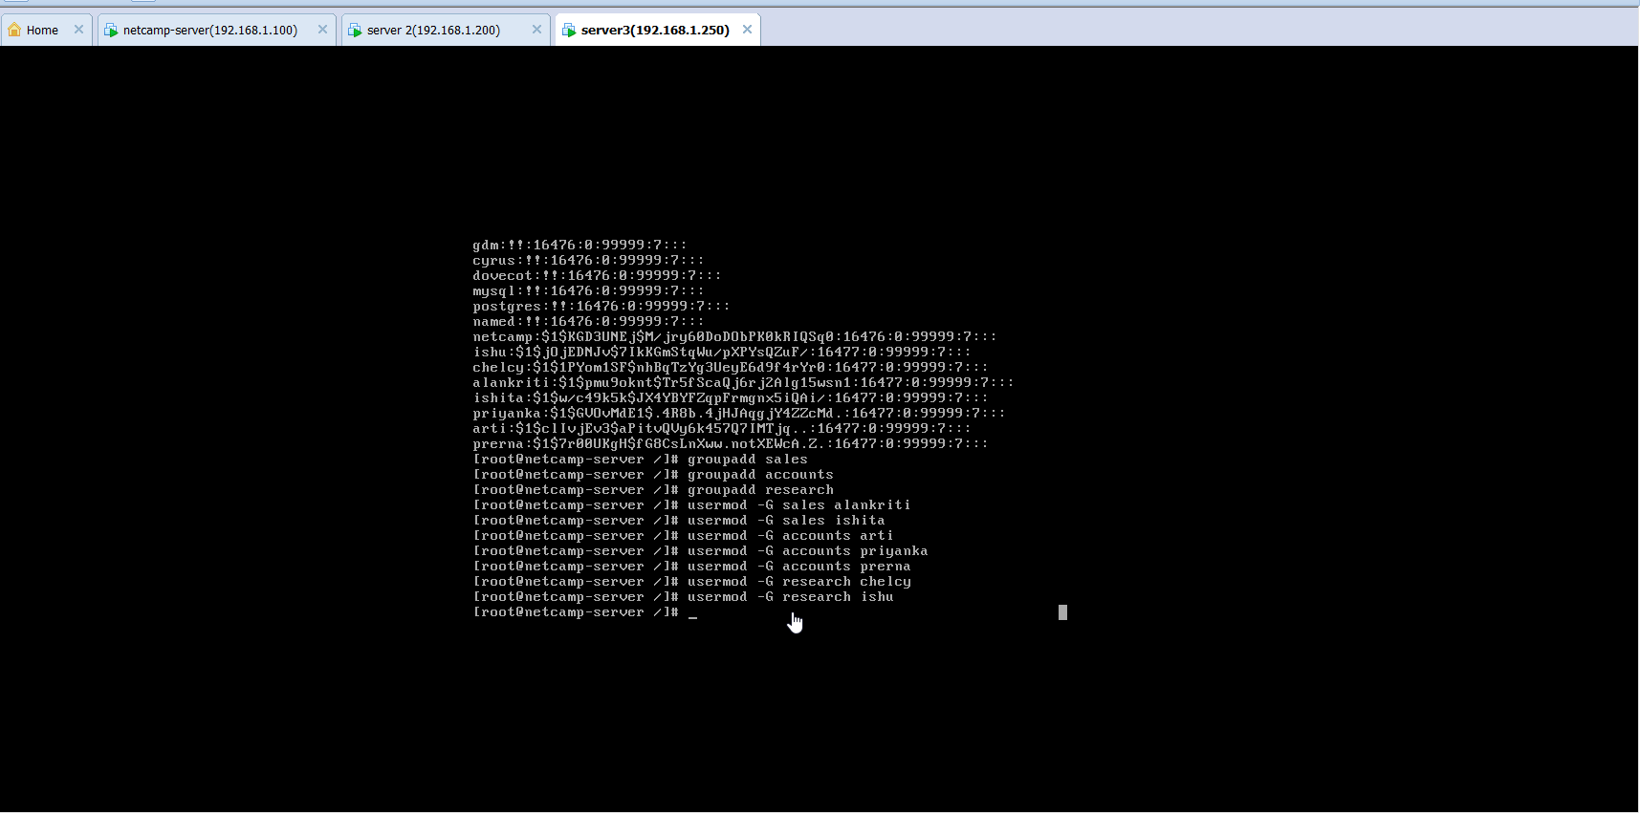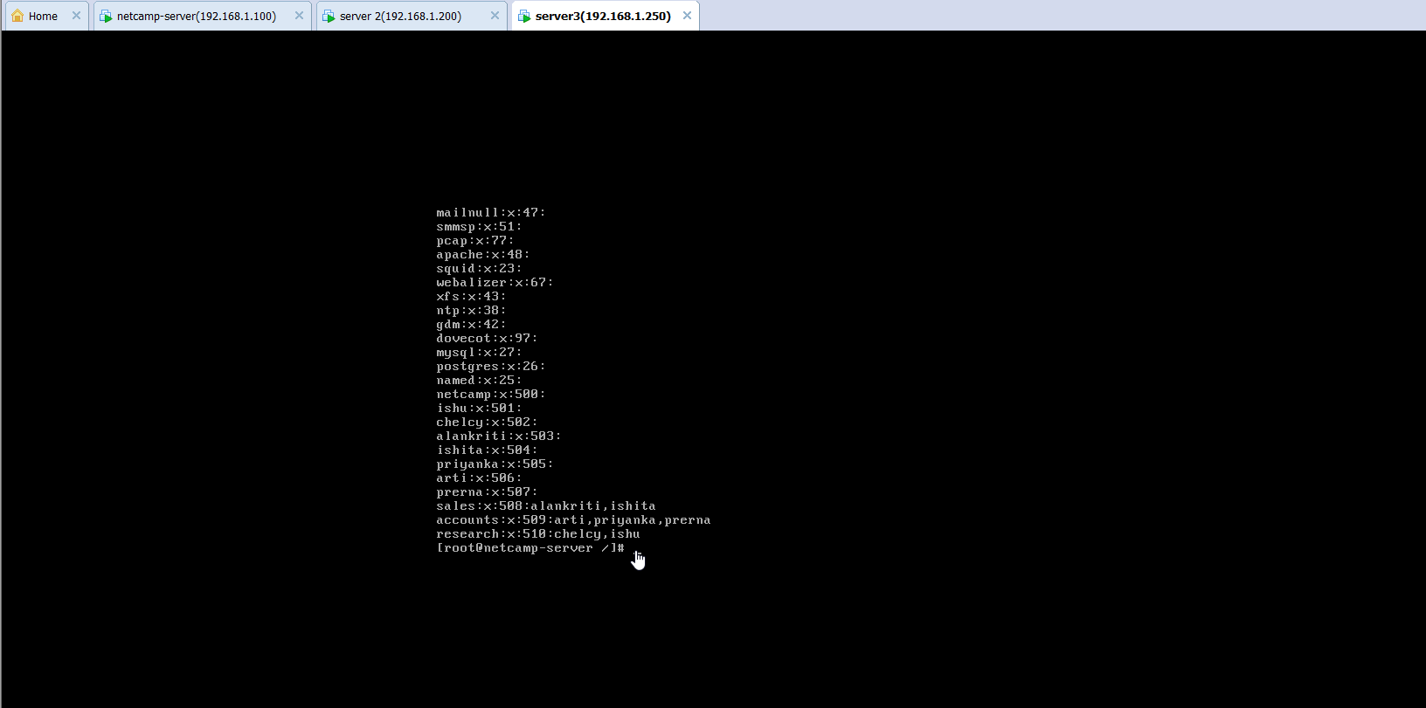

* After this, we create three separate directories for different departments inside /berry directory and two other directories ‘data’ and ‘driver’ inside each department directory using ‘mkdir’ command.

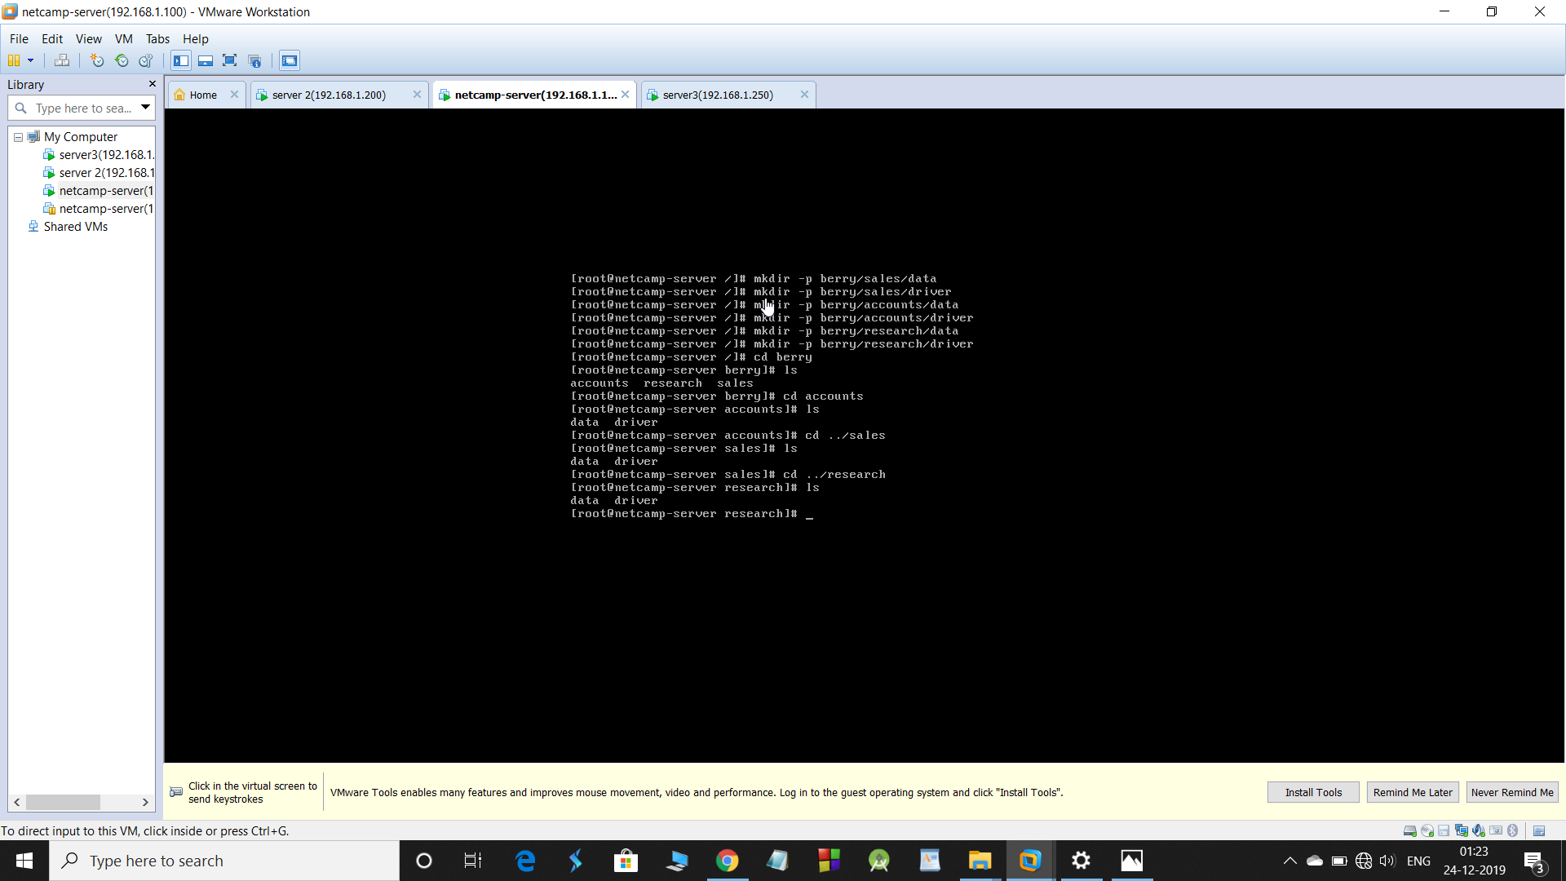

* Then, we change the group owners of the department directories as the primary group of the departments using ‘chgrp’ command and then change the access permission so that only the owner and the concerned department people have access to the directory.

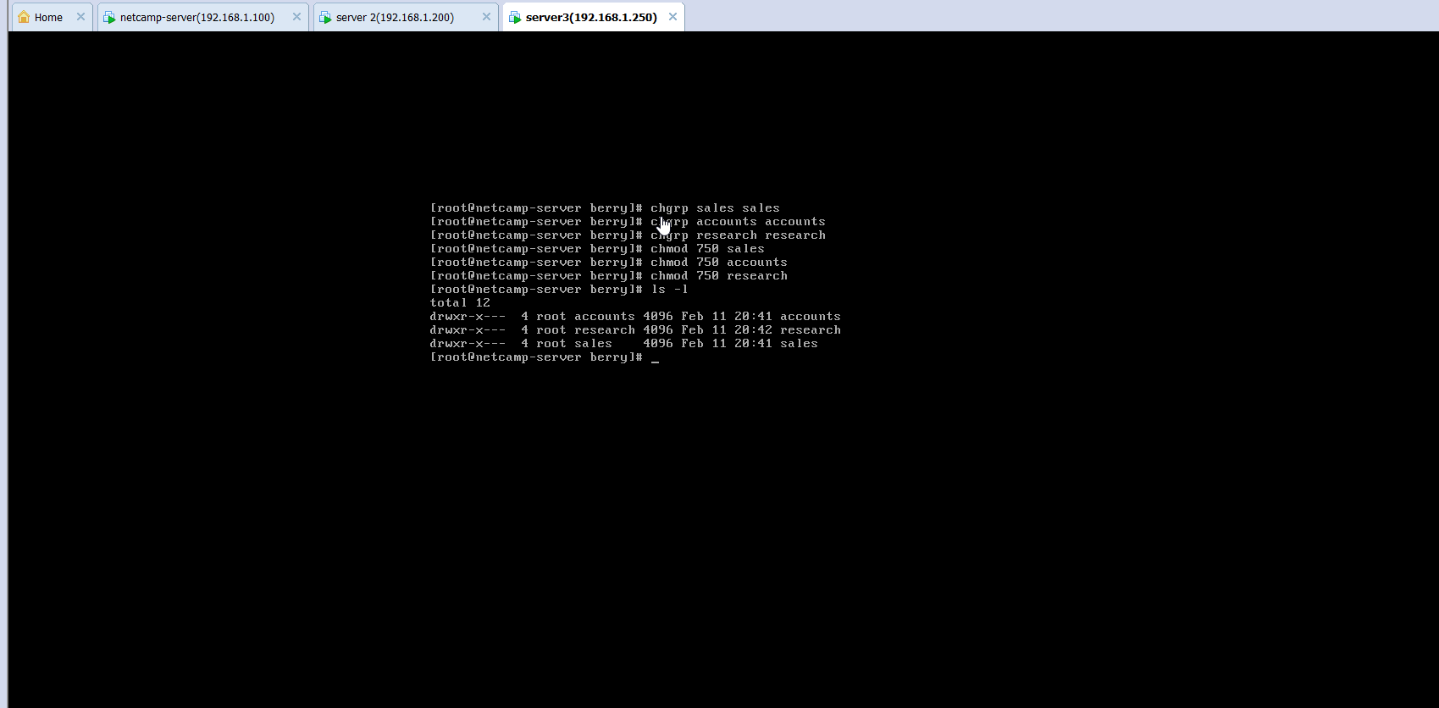

* And finally, we need to change the permission of the the department directories and the ‘data’ and ‘driver’ directories using ‘chmod’ command, so that the concerned department people have full access on the ‘data’ directory and only view access on the ‘driver’ directory.

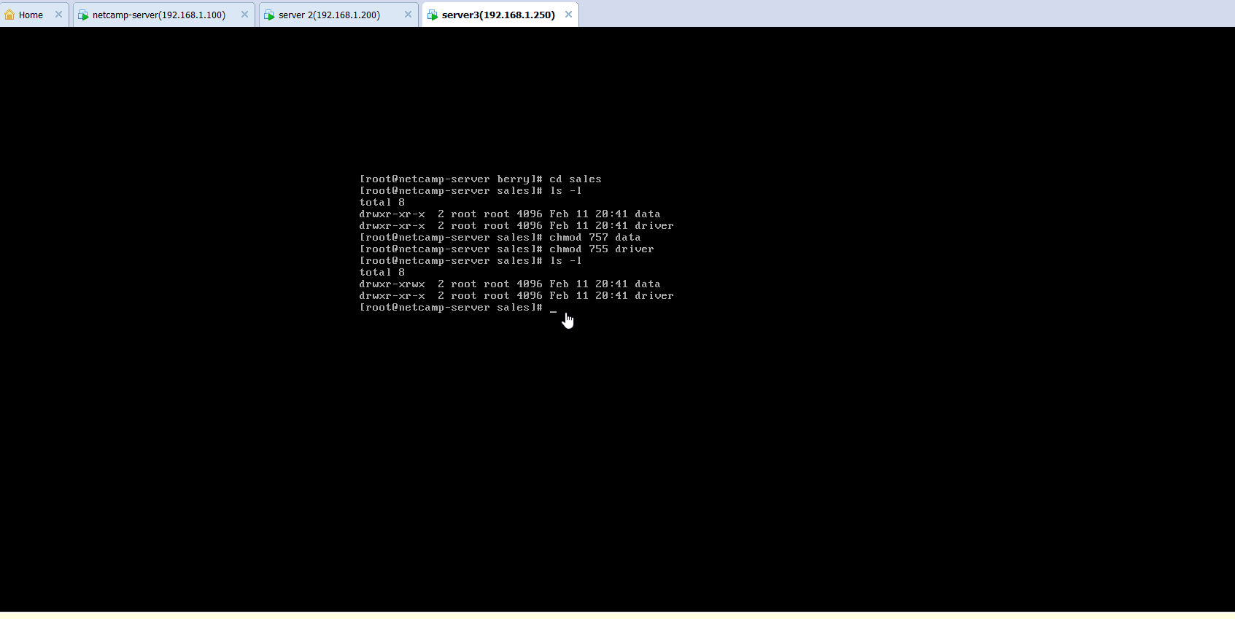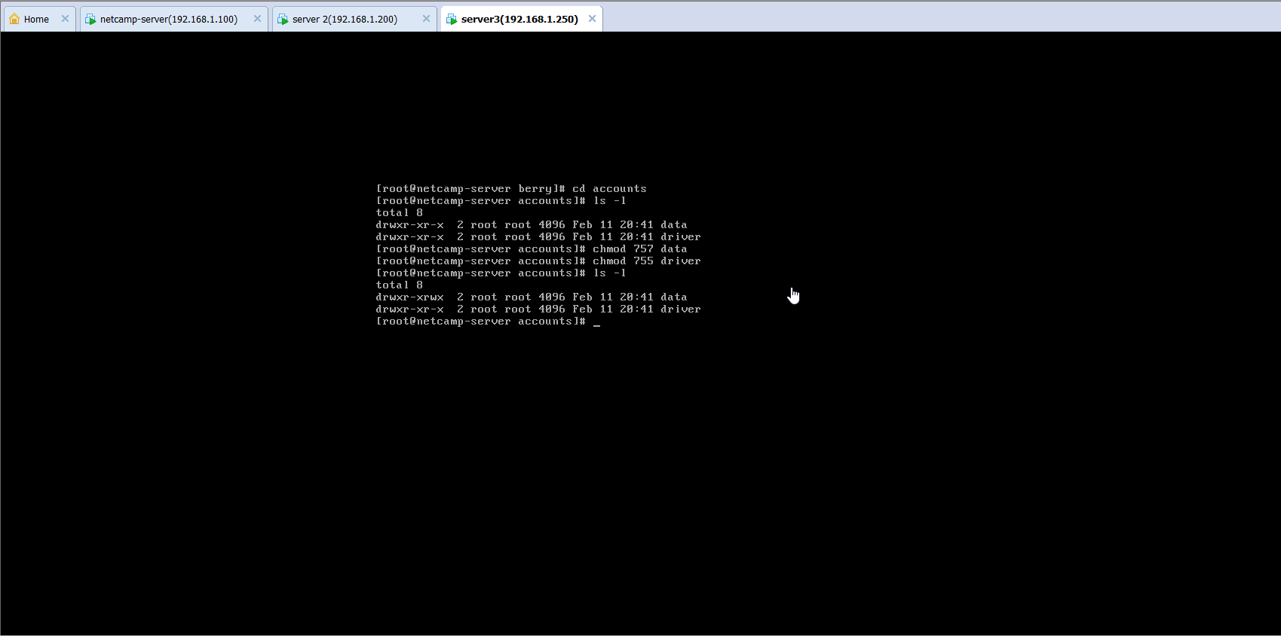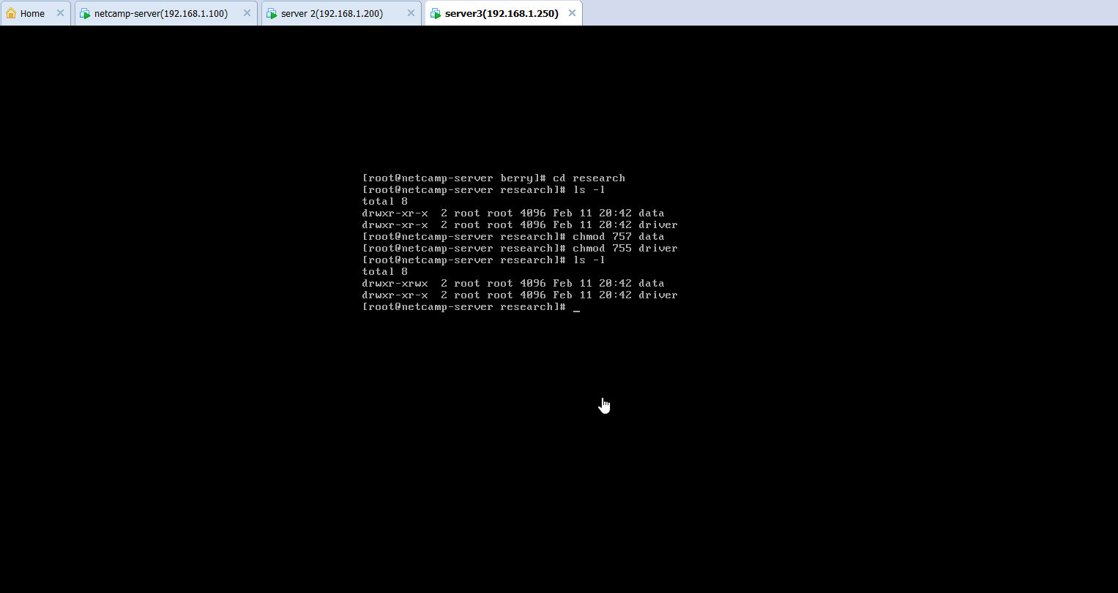

Changing the Logo of the Mail Page

**Aim:** To change the logo of the ‘mail.berry.com’s login page

**Steps:**

* We need to drag and drop the required image file from the device storage to the /usr/share/images directory in the mail server. This is done by FTP using FileZilla.

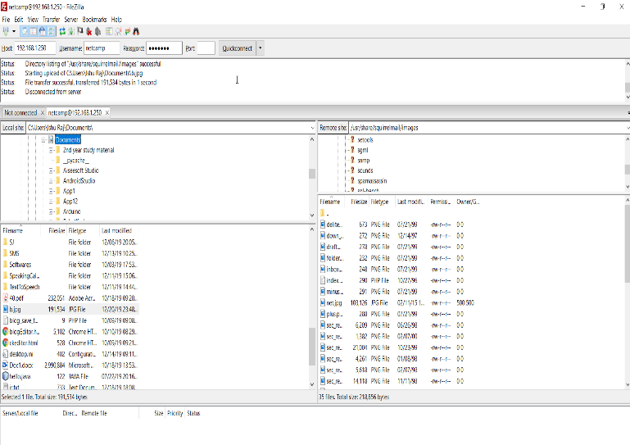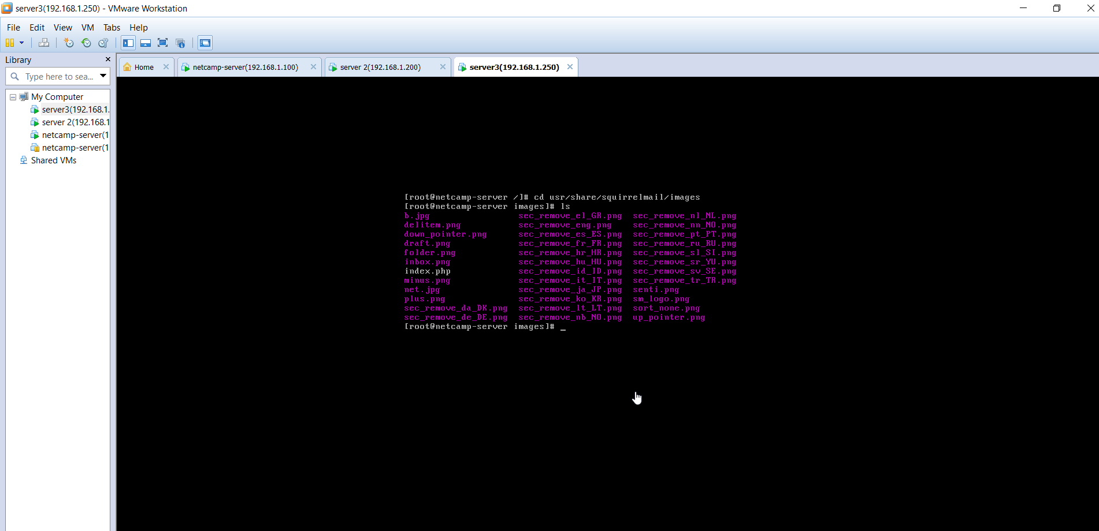

* To be able to edit the ‘/’ directory as a normal user, it’s important to change the permission of the ‘images’ directory for a while. For this we type the command ‘chmod 707 images’ while being in the /usr/share/ directory.

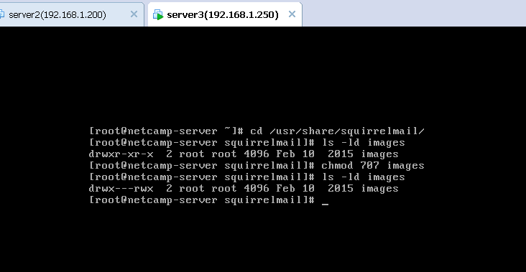

* Then we open the /usr/share/config/config.php file in the editor and change the path of the logo image to “../images/(file_name_with_extension)”.

