To,
The Academic Coordinator
Chandigarh University
Date: 21 March, 2026
Respected Sir/Madam,
I hope this message finds you well. I am writing to formally request duty leave on date 21 March 2026, participated in an online exam. I am very keen to
participate in this event to showcase my creative skills and gain practical
knowledge.
I kindly request your approval for this duty leave and assure you that I will catch
up with any missed coursework promptly.
Thank you very much for considering my request.  Thank you.  Yours sincerely, | 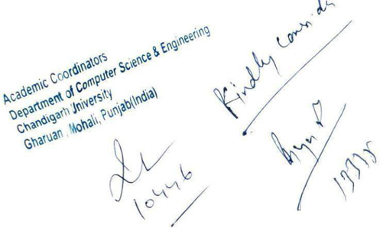
Ishu Raj
UID: 23BCS10079
CSE Department


AmazonCS 21 March, 2026
To:
Dear Ishu,
Amazon Recruiting team is very excited to share with you, that you have been invited to attend an online assessment for the position of Customer Service Associate.
You are highly encouraged to refer the Interview instruction and System Requirements before starting the assessment and ensure that you are completing the entire interview process in one sitting without a break.
Interview Instruction:
Complete the assessment within 48 hours after receiving this email
It is an online proctored test and you will need to provide your answers using your microphone or keyboard
For proctoring purposes, your video, audio & browser session will be recorded and analyzed
Take the test from a quiet environment with low background noise. Avoid taking the test in breakouts, cafeteria or public places
Kindly complete the assessment in one sitting and do not close the assessment window or End the interview
session before completing the assessment
Kindly use laptop or desktop with webcam and microphone to start the assessment and do not attempt this
assessment using mobile phone
Only use Google Chrome browser version 75 & above, with cookies & popups enabled Operating system: Windows 8 or 10, Mac OS X 10.9 Mavericks or Higher
RAM & Processor: 4 GB+ RAM, i3 5th Generation 2.2 Ghz or equivalent/higher Internet Connection: Stable

2 Mbps or more, try using Broadband
Verify your system here: https://ams.hirepro.in/assessment/#/compatibility/amzcsin
20 Question basic English test
10 minutes registration followed by 20 minutes Workstyle Assessment – To understand the cultural
30 minutes Virtual Job Try-out – Simulation round to evaluate your multi-tasking skill fitment25 minutes Versant Test - To evaluate your written & verbal English skill
NOTE- “Post assessment completion request you to please click on End Test & Stop Proctoring. Once you click on this option, scores will be generated and secured in the hiring tool. Unsuccessful completion to this step will lead to delayed candidate application process.”
Technical Help: For technical help or issues, please go to this link: https://amazoncsassessments.hirepro.in | General
Query: https:/
st!
Thank you,
Amazon Recruiting Team
Saurav Kumar | Draft

