**Experiment No 4**

|  |  |
| --- | --- |
| **Student Name: Ishu Rattan** | **UID:** 20BCS7755 |
| **Branch:** CSE **Semester:** 5th | **Section/Group:** 20BCS_MM_806/ B |
|  |  |

**Subject Name:** Machine Learning lab **Subject Code:** 20CSP-317

**1.1 Aim/Overview of the practical:** Implement Support Vector Machine on any data set and analyze the accuracy with Logistic regression.

**1.2. Task to be done:** Perform SVM on given data set.

**1.3 Apparatus/Simulator used:**

* Jupyter Notebook
* Python
* Pandas Library
* Data Set
* Sklearn
* matplotlib

**1.3. Code:**

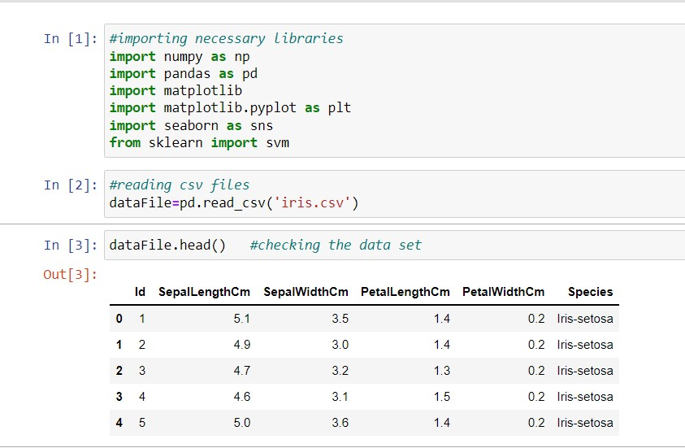

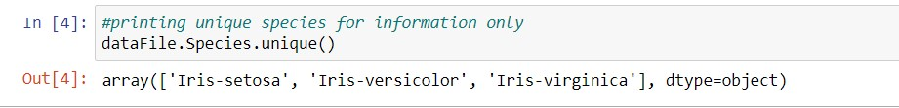

# Creating a pairplot to visualize the similarities and especially difference between the species

sns.pairplot(data=dataFile, hue='Species', palette='Set2')

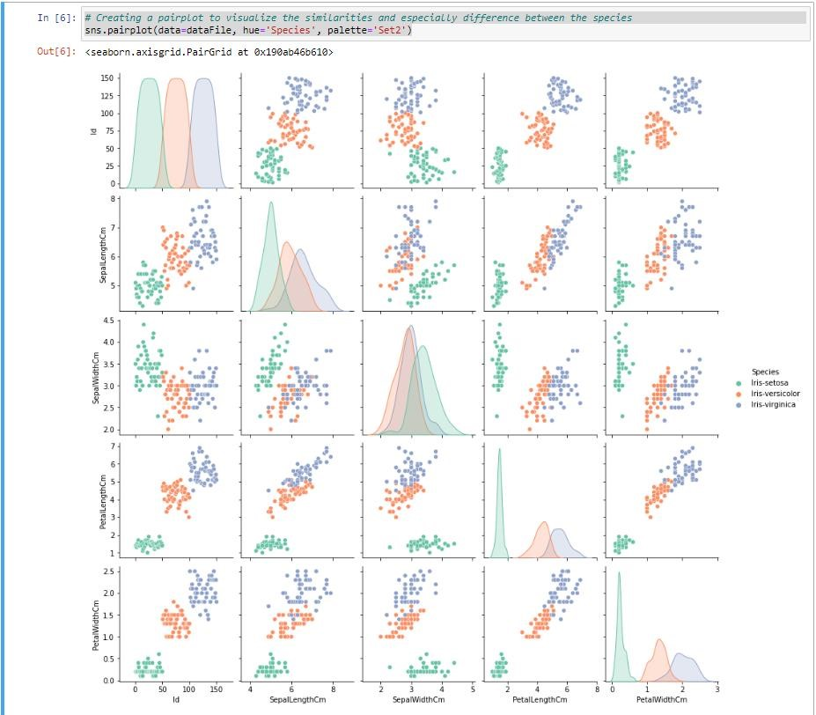

# Train test split

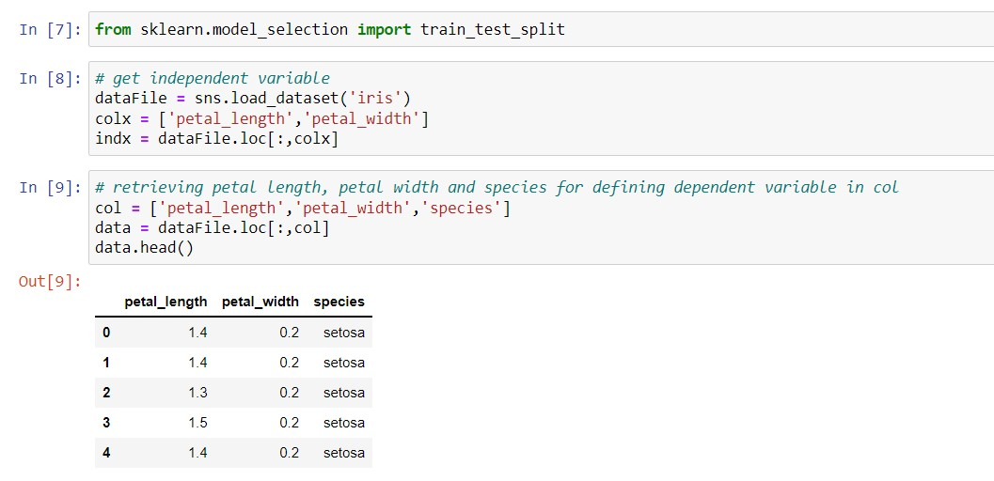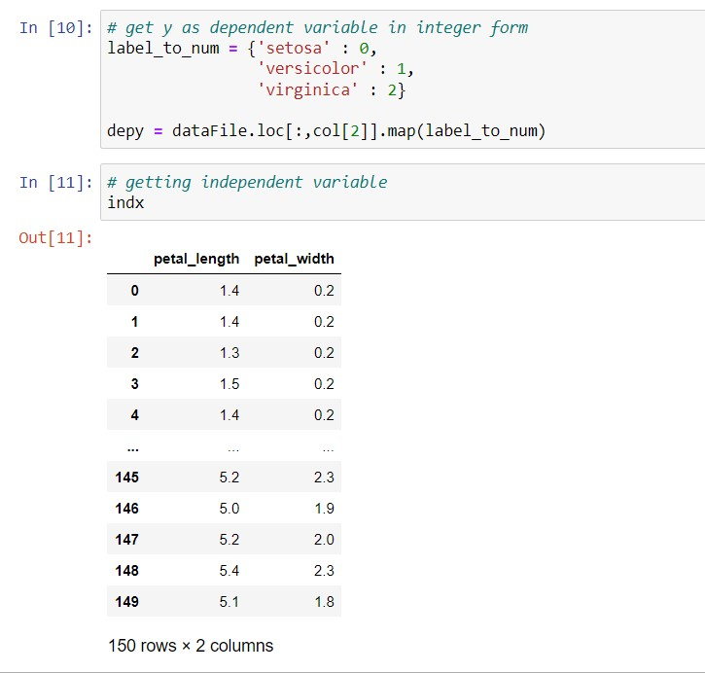

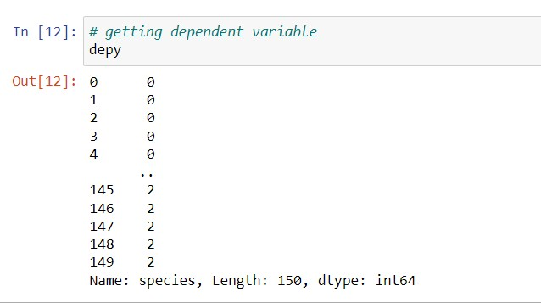

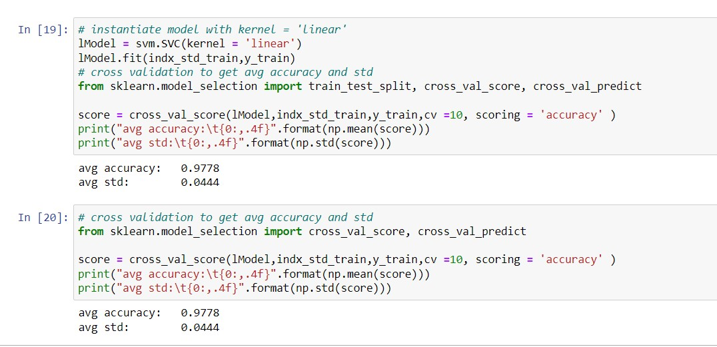

# Predictions from the trained model

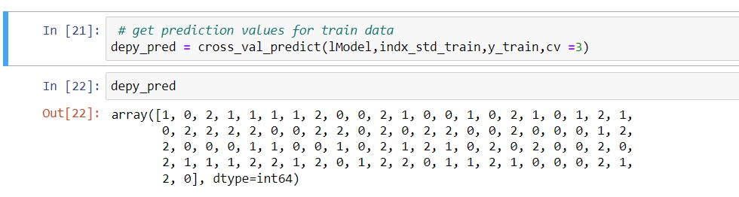

# Model Evaluation

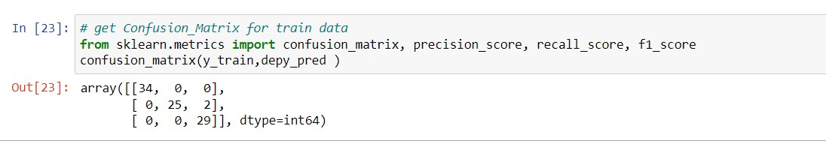

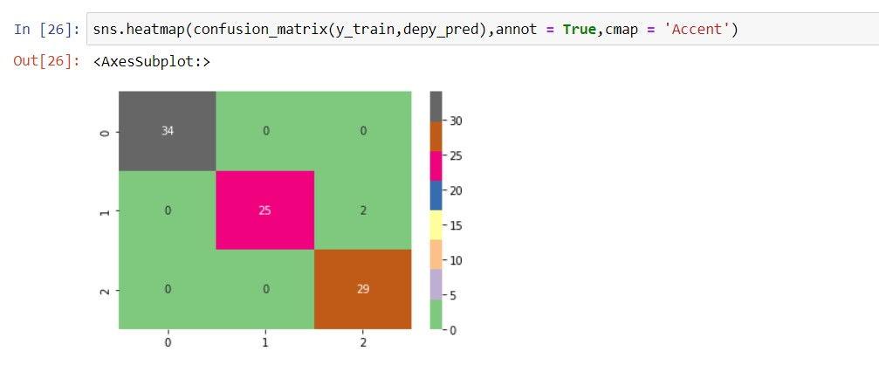

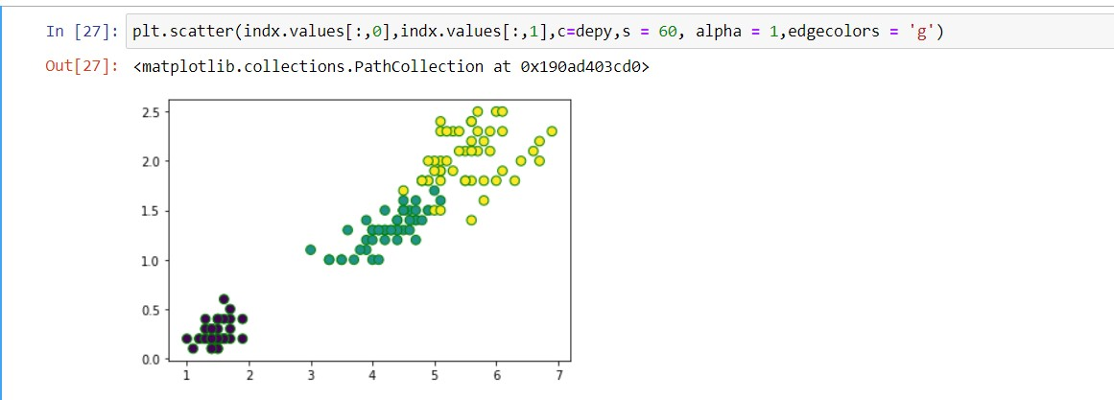

**1.4 Learning Outcomes:**

1. Learned about confusion matrix.
2. Learned about logistic regression.

**Evaluation Grid (To be created as per the SOP and Assessment guidelines by the faculty):**

|  |  |  |  |
| --- | --- | --- | --- |
| Sr. No. | Parameters | Marks Obtained | Maximum Marks |
| 1. |  |  |  |
| 2. |  |  |  |
| 3. |  |  |  |
|  |  |  |  |