**NGF COLLEGE OF ENGINEERING AND TECHNOLOGY, PALWAL (HARYANA)**

**PROJECT SYNOPSIS**

**Submitted To**

**Ms. Bhawna**

**Assistant Professor**

**Submitted By**

**Ishwa**

**B. tech (CSE 4th Year)**

**8th Sem**

**S19CSE022**

INDEX

1. Introduction 3
2. Objective 4
3. Diagram 5
4. Requirements 6
5. Procedure 7
6. Conclusion 8
7. Reference 9

# Introduction

The Online Job Portal project is a web-based application designed to revolutionize the job search process in India. It aims to provide a comprehensive platform for job seekers and employers to connect and facilitate the recruitment process seamlessly. The project leverages technologies such as Servlet, JSP, and MySQL to create an efficient and userfriendly system. The Online Job Portal project offers a wide range of features to cater to the needs of both job seekers and employers. The system consists of two main portals: the Admin Portal and the User Portal. The Admin Portal provides administrators with the necessary tools and functionalities to manage the job portal effectively. It allows administrators to control user registrations, job postings, and perform administrative tasks such as user management, job category management, and report generation. The Admin Portal ensures smooth operation and maintains the integrity of the platform. The User Portal is designed for job seekers and provides a user-friendly interface for them to create an account, search and view job listings, and apply for suitable positions. Users can create a profile, upload resumes, and browse through a wide range of job categories. The system also offers personalized job recommendations based on user preferences and qualifications, enhancing the job search experience. With the User Portal's login functionality, job seekers can securely access their accounts, track the status of their applications, and receive notifications regarding new job opportunities. Additionally, users have the option to update their profiles, making it easier for employers to find suitable candidates. The Online Job Portal project also integrates a robust database system using MySQL, ensuring efficient data storage and retrieval. This allows for seamless connectivity between the web application and the database, enabling real-time updates and accurate information retrieval. Overall, the Online Job Portal project aims to simplify and streamline the job search process by providing an interactive platform for job seekers and employers. By leveraging the power of Servlet, JSP, and MySQL technologies, the project enhances the recruitment experience, facilitating efficient job posting, job searching, and application processes.

# Objective

Time and Money are two crucial aspects of the recruitment process. The main objective of Job Portal s is saving both time and cost by hiring the right candidate at the right time at the right place has been its Success Mantra. They do it by shortening the entire process of selection and on- boarding with its expertise. The team of experienced professionals works closely with clients to assess their requirement and ensure that the best quality resources are provided in the minimum possible time frame. Its recruitment experts enable quickest turnaround by selecting relevant and industry-specific profiles, interfacing with the candidates from start till the end.

# ER-DIAGRAM

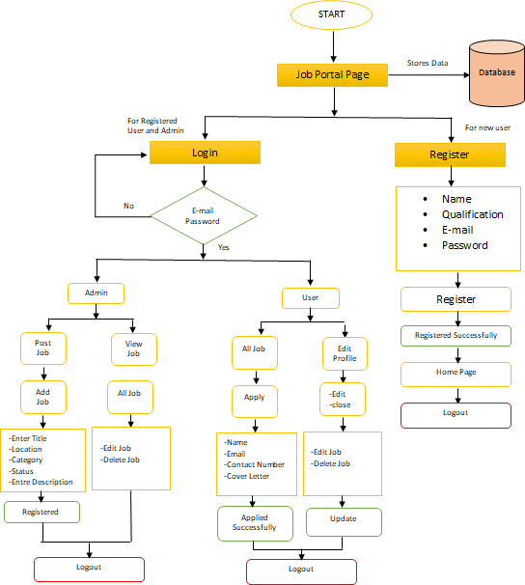

# Requirements

**Hardware Requirement:**

|  |  |
| --- | --- |
| Processor Brand | : Intel |
| Processor Type | : Core i5 |
| Processor Speed | : 2.40 GHz |
| RAM Size | : 8.00 GB |

**Software Specification:**

Operating System : Windows

Technology : Java/j2ee (JDBC, Servlets, JSP)

Web Technologies : Html, JavaScript, CSS

Web Server : Tomcat

Database : MySQL

Software’s : J2SDK15, Tomcat 9, MySQL

# Procedure

* User has to register himself by entering the personal details.
* Enter Academic Details
* Academic Professional Details
* Enter Professional Work Experience
* Declaration
* The information is sent to HR
* Team of experienced professional’s select relevant and industry-specific profiles and ensure that the best quality resource is provided, interfacing with the candidates from start till the end.

# Conclusion

It can be concluded that this project of Online Job Portal was a real learning experience. The principles of software production were well implemented throughout the system. The project has been made as per as the given specifications. A Job Portal provides an efficient search for online information on job vacancies for Job Seekers. The main goal of this portal is to attempt to produce the right graduates based on the industry needs. However, it is important that be aware the Job Portals can never fulfill all the problems of jobless graduates. Its business operations are performed on the key values driven by passion and purpose with an aim to revolutionize the job search process. Through its efficient end-to-end recruitment processes across various industries, it enhances client experience and attains customer satisfaction.

# Reference

* [**Google for problem solving**](https://www.javascripttutorial.net/)
* [**https://www.infoworld.com/category/java/**](https://www.infoworld.com/category/java/)
* **Database programming with JDBC and java by O’Relly**
* **Head First Java 2nd edition**
* [**https://www.jdbc-tutorial.com/**](https://www.jdbc-tutorial.com/)
* [**https://www.javatpoint.com/java-tutorial**](https://www.javatpoint.com/java-tutorial)
* **https://www.tutorialspoint.com/java/index.htm**