**Project Name: Quick Care Service**

**Project Members:**

|  |  |
| --- | --- |
| **PRN No.** | **Name** |
| **220343120044** | **Kapil Thakre** |
| **220343120058** | **Ishwar Mohan** |
| **220343120060** | **Monika Dongale** |
| **220343120087** | **Priyanka Gire** |

**Introduction of Project:**

As technology is ruling the industrial world, manual activities and documentation are digitalizing.

Our application tends to ease the process of finding caretaker in hour of need using technology.

When any elderly or ailing family member is unwell and need help to do their routine work or need exceptional care at that time our application comes as helpful. In that situation we must exhaustively search for skilled people who can help within time constraint. Our application comes as handy here, we provide trained nurses, ward boy to give special attention to them. User does not have to go through the pain of searching Caretaker. We can get skilled help on our fingertips. Our application provides a platform that help to connect skilled nurses, ward boy to needful people for nursing services*.*

Quick care service/taker is a service provider system used for providing service to care receiver(customer) by any type of service provider according to the need of care receiver(customer). This system works on two different users:

1. Care provider (Caretaker) - Care Provider provides the service to the care receiver. Caretaker needs to register into the platform according to their hourly charges and approve the request which is being sent by customer.

2. Care receiver (Customer) - Care Receiver receives the service from care provider. Customer needs to register in platform to enter and book the caretaker according to the location and type of service he wants. Accordingly, customer will end up booking for Caretaker as per their need.

This system helps the service provider to reach to their care receiver(customer) and contact them quickly. Customers must add their details and their need and based on their requirement the nearest caretaker can contact their customer and they can also keep track on their orders. The main objective is to help the customer by providing the service and solve their problem as soon as possible.

**Objective and Scope of Project:**

QCS (Quick Care Service) allows caretaker and customer to register into the platform. Our platform provide service to customer without wasting much time searching for the caretaker. On the other side, caretaker gets a platform for getting a job and providing services. It is easy for customer and caretaker to see details of booking and the records which gets updated every time action is done in the account.

1.Customer (Caretaker/Care Receiver) registration, customer login, customer credential authentication. Customers need to fill required attributes to register.

2. Care Receiver can add patient details and view patient list. Care receiver can choose type of service and service time span. In patient list care receiver can delete and edit details of patient.

3.Care Receiver can book caretaker according to the location and type of care he wants and send request.

4.Care Receiver can view requested caretaker list where he can see status of request and cancel request. Care Receiver can do payment if status is accepted and if rejected can view the reason for it.

5.In payment option he can choose mode of payment and pay the amount displayed on the screen. Care receiver can also give feedback for caretaker and generate report for the service received.

6. Caretaker can view all request and can accept or reject them. If he wants to reject request, he must give reason for rejection.

7.In patient list caretaker can view patient's list, their details and whether request accepted or not. He can also view feedback received from care receiver.

**Modification and improvement over the existing Implementation:**

As of now we have not came across no such existing project in the market. Existing services only have only

**Project Plan:**

No. of User’s and Modules

* **Users-**

1)caretaker

2)customer

* **Modules** –

**SERVICE RECEIVER MODULE (CUSTOMER):**

Customer in this application who is service receiver, who will receive service after their service order being placed. Customers must register themselves if they don’t have their profile, once the registration is done, they can proceed with the login process, if they already have profile, they can directly login into their dashboard. once they reach their dashboard, they can provide placed their service request and can also see their previous records of orders.

* REGISTRATION/LOGIN
* ADDING PERSONAL DETAILS
* ADDING PATIENT DETAILS
* REQUESTED CARETAKER LIST
* BOOKING SERVICE
* PAYMENT

**SERVICE PROVIDER MODULE (CARETAKER):**

Service provider is one of the users who will provide the services according to the customer request. Service provider also must register themselves if they do not have their profile, once the registration is done, they can proceed with the login process, if they already have profile, they can directly login into their dashboard. Once they reach their dashboard, they can see the customer request in the order list and can provide their services accordingly.

* REGISTRATION/LOGIN
* CARETAKER DASHBOARD
* ACCEPT / DECLINE OF SERVICE
* REASON FOR REJECTION
* PATIENT HISTORY

**REGISTRATION MODULE:**

Each user needs to get register before entering platform. The user can check the caregiver details and availability of the caregiver which is nearby them by sorting based on location and type of service. They can also check the booking status on notification section on customer dashboard.

**LOGIN MODULE:**

Users who have completed the registration process once they can access the application anytime in future through just login. After they have verified their username and password, they can directly type the username and password to login.

**Technology:**

Frontend- React

Backend- Java, Spring

Database- MySQL database

Others – Eclips IDE

**Roles and Responsibilities:**

|  |  |  |
| --- | --- | --- |
| **Roles And Responsibilities** | | |
| 1 | Role | Backend, Frontend |
| Member Name | Kapil Thakre |
| PRN No | 220343120044 |
| Description |  |
| 2 | Role | Backend, Frontend |
| Member Name | Ishwar Mohan |
| PRN No | 220343120058 |
| Description |  |
| 3 | Role | Backend, Frontend |
| Member Name | Monika Dongale |
| PRN No | 220343120060 |
| Description |  |
| 4 | Role | Backend, Frontend |
| Member Name | Priyanka Gire |
| PRN No | 220343120087 |
| Description |  |

**Data Flow Diagram (DFD):**

Level 0:

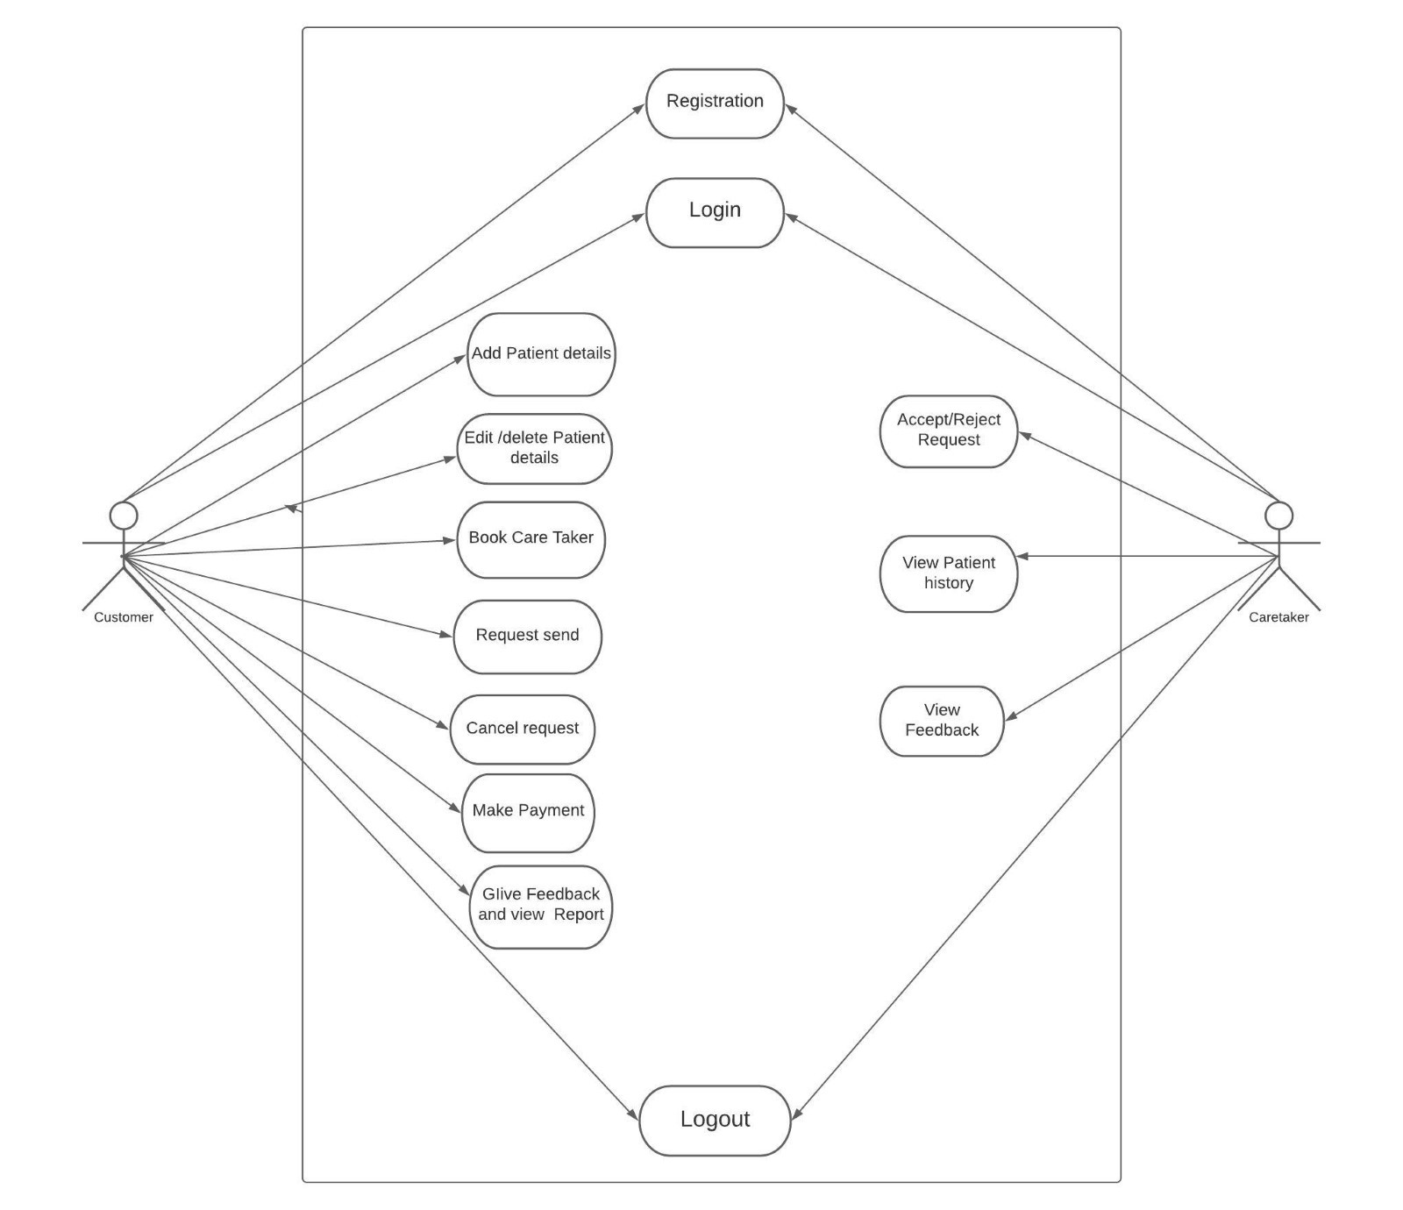

Level1:

**Quick Care Service**

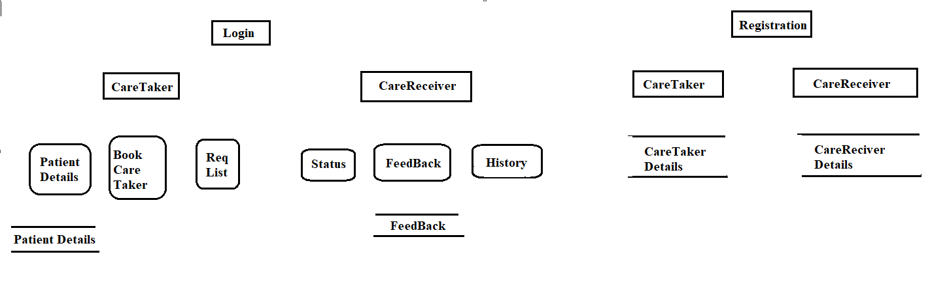

Level2:

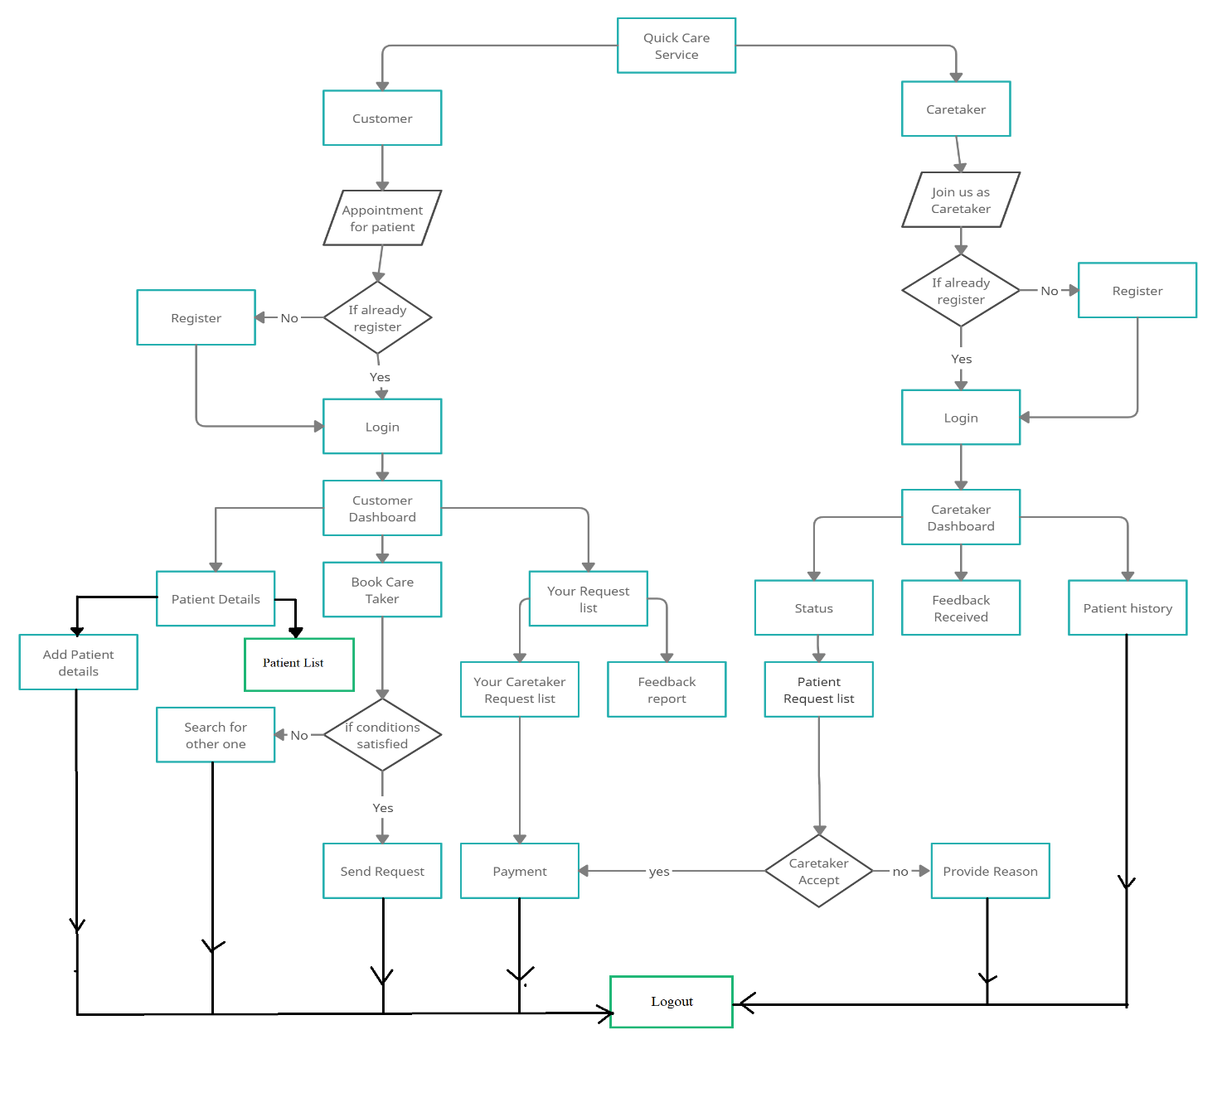

**ERD / Database Tables:**

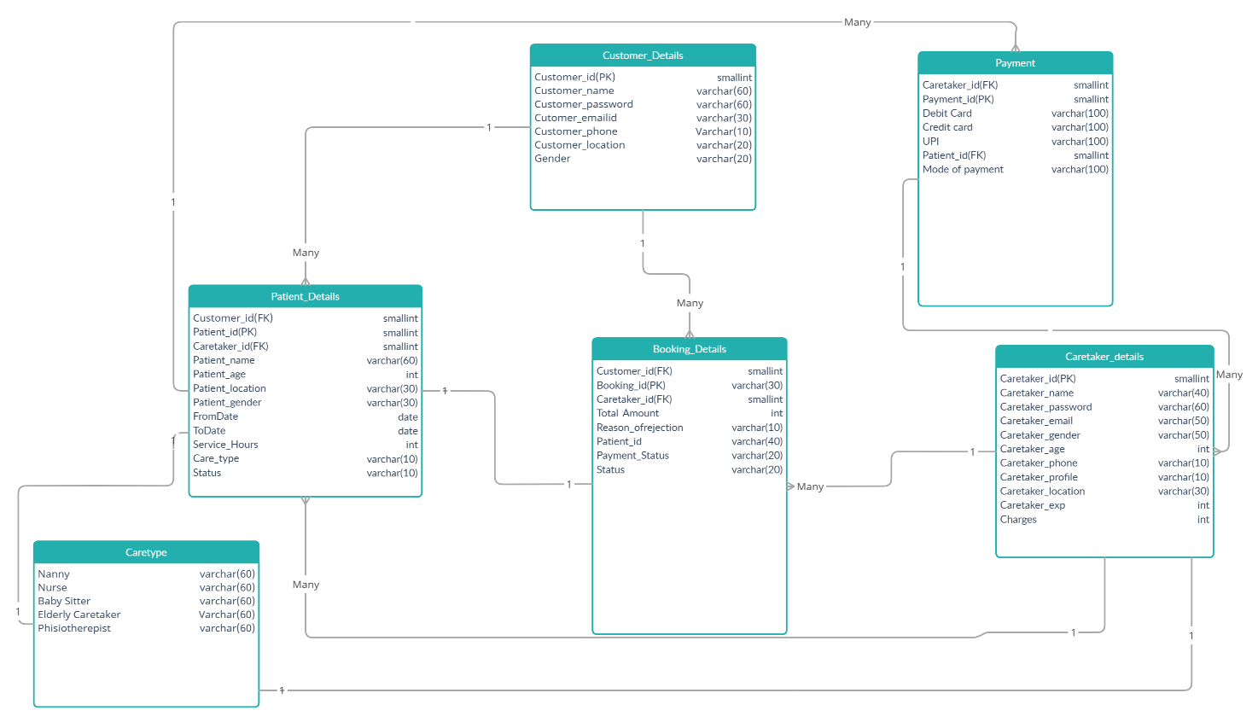

**Future Scope:**

We can latter integrate this project in centralized manner with chain of hospitals, therapy centres and such healthcare service providers etc.