TATA TECHNOLOGIES LTD.
TECH PULSE FY-26 | AI/ML Capstone Project
TECHNICAL REPORT
Field | Details
Institute / University | Pimpri Chinchwad College of Engineering, Pune
Programme / Batch | Computer Engineering (RL) / Batch 2027
Student Name | Ishwar Sudam Sonawane
PRN | 123B1D048
Case Study ID (CS1–CS5) | CS1
Project Title | AutoHLD Insight: AI-Powered AUTOSAR-Inspired High-Level Design Document Analysis Assistant

1. Problem Statement and Intended Users
Automotive High-Level Design documents contain descriptions of software components, interfaces, ports, signals, dependencies, diagnostic events, timing constraints, and functional flows. When these documents are large or distributed across multiple revisions, manual review becomes time-consuming and traceability becomes difficult.
Engineers may need to answer questions such as:
- Which component provides a specific interface?
- Which components consume a particular signal?
- What dependencies are associated with a component?
- Where is an interface defined?
- What changed between two HLD revisions?
- Are referenced interfaces or signals missing definitions?
- Which pages support a particular architecture conclusion?
Traditional keyword search may fail when terminology differs between the question and source document. A general-purpose LLM may also produce unsupported relationships when document evidence is incomplete.
The problem addressed by this project is the development of a traceable AI-assisted HLD analysis system that combines native PDF extraction, OCR for scanned documents, local embeddings, persistent vector retrieval, evidence-grounded LLM generation, page-level citations, architecture entity extraction, candidate relationship extraction, revision comparison, human review, audit history, and structured exports. The system is intended to support engineering review rather than replace engineering judgment.
Intended Users
- Automotive software architects
- Embedded-software engineers
- AUTOSAR engineers
- System-design engineers
- Integration engineers
- Architecture reviewers
- Engineering students and researchers
- Faculty evaluators reviewing the capstone implementation
User Benefits
- Faster retrieval of architecture information
- Source traceability through page-level citations
- Search across native and scanned documents
- Structured architecture inventory
- Candidate dependency discovery
- Revision-comparison support
- Explicit handling of insufficient evidence
- Clear distinction between LLM and deterministic fallback answers
- Human review and auditability

2. Input Data / Knowledge Base
Item | Description
Sources | The project uses a synthetic AUTOSAR-inspired knowledge base created specifically for academic evaluation. The knowledge base includes:  - AUTOSAR_Powertrain_HLD_v1.0.pdf  - AUTOSAR_Powertrain_HLD_v1.1.pdf  - AUTOSAR_BodyControl_HLD_v1.0.pdf  - AUTOSAR_Diagnostics_HLD_v1.0.pdf  - AUTOSAR_Interface_Catalogue_v1.0.pdf  - AUTOSAR_EnergyManagement_Scanned_HLD_v1.0.pdf  No confidential OEM, supplier, customer, vehicle, or organizational HLD data is included. The synthetic documents include components, interfaces, ports, signals, events, relationships, timing requirements, functional-flow descriptions, revision changes, intentional unresolved references, OCR-specific test text, and controlled terminology variations.
Size and format | The tested knowledge base contains:  - Six PDF documents (five native-text PDFs and one image-only scanned PDF)  - Approximately 30 indexed text chunks  - Approximately 146 extracted entity occurrences  - Five automatically extracted candidate relationships  - CSV evaluation questions and CSV measured evaluation results  - JSON ground-truth findings  - PNG evaluation screenshots  - CSV and JSON system exports
Preprocessing / EDA done | The preprocessing pipeline performs: (1) PDF-type validation; (2) secure filename handling; (3) SHA-256 document hashing; (4) page-by-page extraction; (5) native-text character counting; (6) native-text quality inspection; (7) automatic OCR routing; (8) PDF-page rendering; (9) grayscale conversion; (10) adaptive thresholding; (11) Tesseract OCR; (12) OCR confidence calculation; (13) section-heading detection; (14) page metadata preservation; (15) chunk generation; (16) chunk overlap; (17) duplicate chunk detection; (18) local embedding generation; (19) ChromaDB storage; (20) candidate entity extraction; (21) candidate relationship extraction; (22) audit-event creation.  EDA and quality inspection included native versus OCR page count, text-extraction quality, OCR confidence, entity frequencies, relationship review, duplicate entities, OCR spelling variations, document-wise extraction results, retrieval scores, citation availability, evaluation answer correctness, and evaluation latency.
Chunking strategy | The system uses fixed-size overlapping chunks with source metadata.  - Chunk size: 900 characters  - Chunk overlap: 130 characters  - Retrieval top-k: 10  - Final evidence chunks: 5  - Minimum relevance score: 0.20  Each chunk stores the source filename, page number, section, extraction method, and chunk ID. Chunk IDs are checked before insertion, preventing duplicate vector records when a document is re-uploaded.

3. Solution Architecture

Component | Choice (name, version, hosting)
Pre-trained model | - Model: openai/gpt-oss-120b  - Provider / hosting: Groq API (externally hosted by Groq)  Grounded HLD question answering, architecture explanations, revision-change summaries, and evidence-based response generation.  External dependency: internet connection and a valid Groq API key.  Fallback: the system supports deterministic evidence extraction when LLM generation fails. An optional Ollama configuration is included for future local execution.
Embedding model | - Model: BAAI/bge-small-en-v1.5  - Framework: Sentence Transformers  - Hosting: Local  Purpose: document-chunk embeddings, query embeddings, and semantic evidence retrieval.
Vector store (FAISS / ChromaDB) | - Vector store: ChromaDB 1.0.10  - Storage: Persistent local storage  - Collection: autohld_documents  Stored information: embedding vector, chunk text, source document, page, section, extraction method, and chunk ID.
RAG pipeline / AI-agent design | The system implements a custom RAG pipeline: Question → local query embedding → ChromaDB semantic search → top-k retrieved evidence → evidence metadata formatting → grounded prompt → Groq openai/gpt-oss-120b → cited answer.  Response modes: llm_grounded, deterministic_fallback, insufficient_evidence, provider_error.  If the evidence is below the configured relevance threshold, the system returns “Insufficient evidence found in the selected HLD documents.” If Groq generation fails, the system returns a deterministic evidence-based answer and prominently states that the answer was not generated by an LLM.
Service layer and UI | - Backend: FastAPI 0.115.9  - Frontend: Streamlit 1.45.1  - Structured database: SQLite  - Vector storage: ChromaDB  The UI contains Dashboard, Project Workspace, Upload and Ingest, Document Library, Grounded Q&A, Architecture Inventory, Dependency Map, Consistency Checks, Revision Comparison, Engineer Review, Audit History, Export Center, Evaluation, and System Configuration.
Tools / deterministic rules | - PyMuPDF for text extraction and page rendering  - Tesseract OCR and pytesseract for scanned-page recognition  - OpenCV for OCR image preprocessing; Pillow for image handling  - Sentence Transformers for embeddings; ChromaDB for semantic retrieval  - SQLite for structured persistence  - SHA-256 hashing for duplicate-document detection  - Regular expressions for candidate entity extraction  - Heuristic patterns for candidate relationships  - Deterministic sentence extraction for provider failure  - CSV and JSON export utilities; evaluation scripts for answer and citation checks

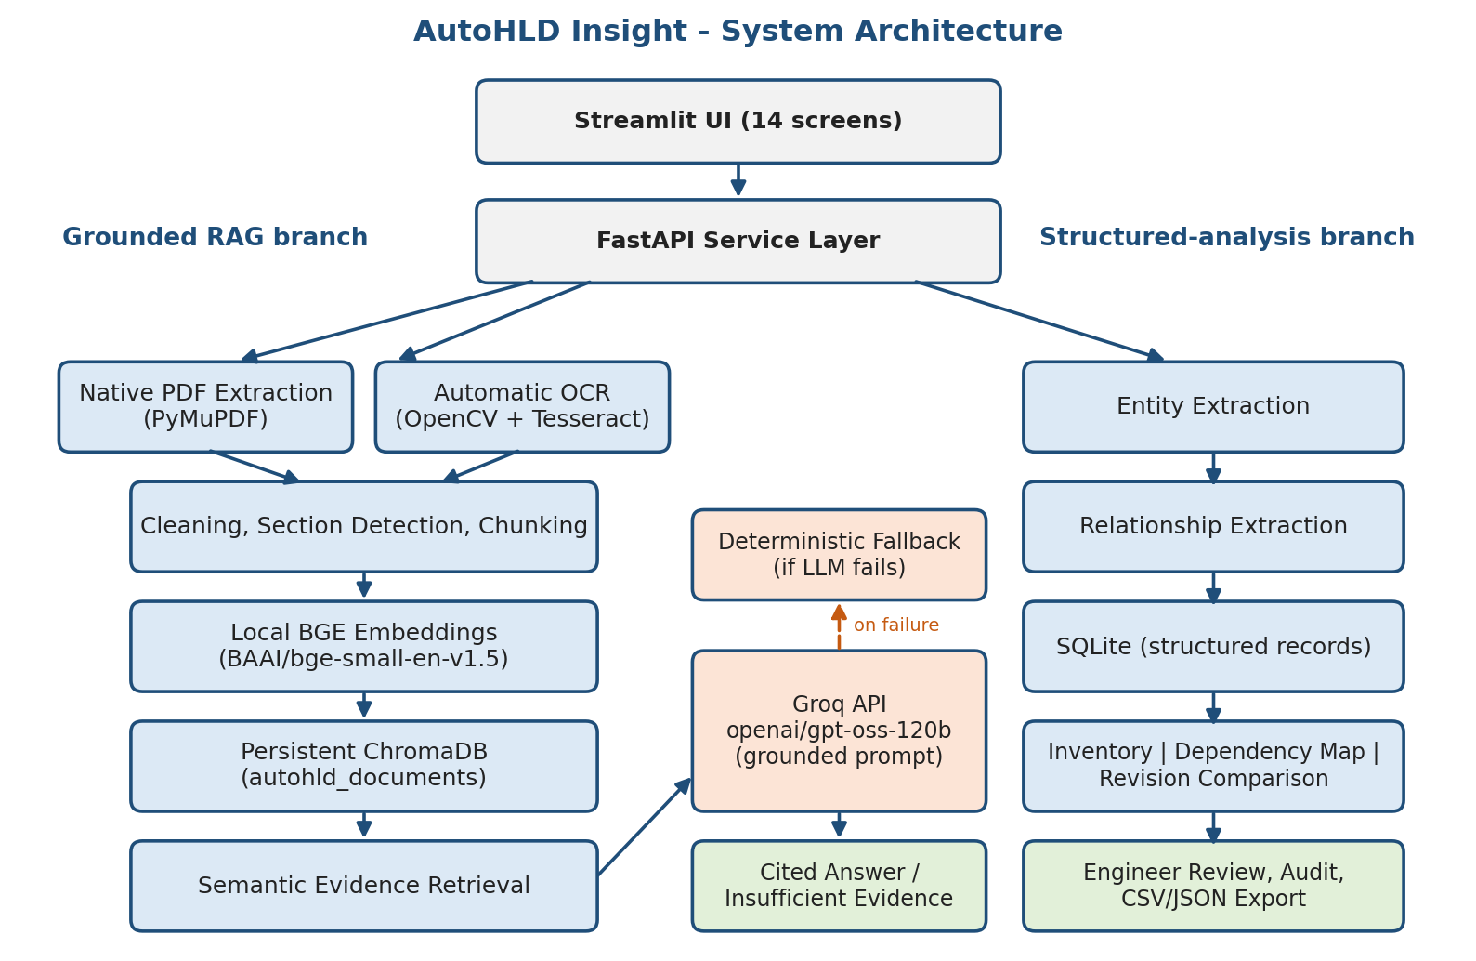
Figure A: System architecture of AutoHLD Insight (RAG branch and structured-analysis branch).

4. Implementation and Configuration
Core Configuration
- Primary LLM provider: Groq
- Primary model: openai/gpt-oss-120b
- Optional provider: Ollama (optional, gpt-oss:20b for future local use)
- Embedding model: BAAI/bge-small-en-v1.5
- Vector store: ChromaDB
- Backend: FastAPI
- Frontend: Streamlit
- Structured database: SQLite
- OCR engine: Tesseract
Generation Configuration
- Temperature: 0.1
- Maximum output tokens: 1400
- LLM timeout: 90 seconds
- Deterministic fallback: Enabled
- Automatic provider fallback: Disabled
OCR Configuration
- OCR enabled: True
- Language: English
- DPI: 300
- Minimum native characters: 80
- Minimum OCR confidence: 45
Retrieval Configuration
- Chunk size: 900 characters
- Chunk overlap: 130 characters
- Vector top-k: 10
- Final top-k: 5
- Minimum relevance score: 0.20
Document-Ingestion Workflow
1. The user uploads one or more PDF documents. 2. The backend validates the filename and extension. 3. A SHA-256 hash is calculated. 4. Each page is checked for native text. 5. Pages containing insufficient native text are routed to OCR. 6. OCR pages are rendered at 300 DPI. 7. OpenCV preprocessing is applied. 8. Tesseract extracts page text. 9. OCR confidence is calculated. 10. Page text and metadata are stored. 11. Text is divided into overlapping chunks. 12. Local embeddings are generated. 13. Chunks are inserted into ChromaDB. 14. Candidate entities and relationships are extracted. 15. Structured records are inserted into SQLite. 16. An audit event is recorded.
Query Workflow
1. The user enters an HLD-related question. 2. The question is embedded locally. 3. ChromaDB retrieves relevant chunks. 4. Sources are ranked by semantic similarity. 5. The top evidence chunks are inserted into a grounded prompt. 6. Groq generates an answer using openai/gpt-oss-120b. 7. The UI displays the answer, response mode, provider, model, citations, pages, evidence, and retrieval scores. 8. If evidence is insufficient, the system abstains. 9. If Groq fails, a deterministic fallback is clearly labeled.
Structured Analysis
Architecture entities are extracted using patterns for components, interfaces, ports, signals, events, and component IDs. Candidate relationships include PROVIDES, REQUIRES, and PUBLISHES. All automatically extracted relationships remain UNREVIEWED until an engineer records a decision.
Revision Comparison
The comparison module compares entity sets between two document IDs and reports added entities, removed entities, and the unchanged-entity count. RAG-based revision analysis complements the entity-level comparison by extracting textual changes such as timing changes and renamed data elements.
Human Review
The reviewer can choose ACCEPTED, REJECTED, CORRECTED, or NEEDS_CLARIFICATION. The review includes item type, item ID, reviewer, comment, decision, and timestamp.
Audit and Export
Audit event types include PROJECT_CREATED, DOCUMENT_INGESTED, and REVIEW_RECORDED. Exportable datasets include documents, entities, relationships, findings, reviews, audit history, and queries, in CSV and JSON formats.
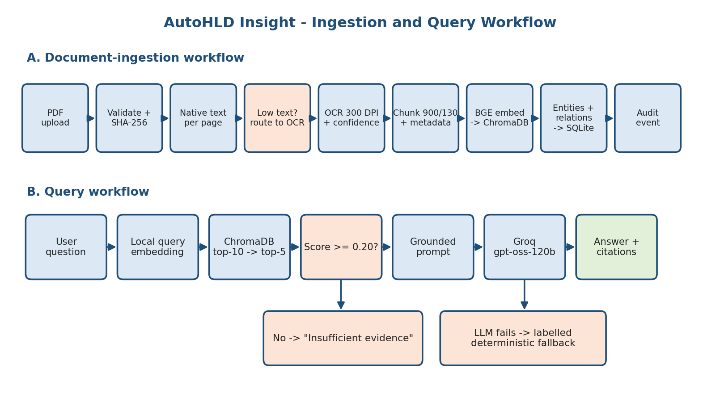
Figure B: Document-ingestion and query workflow of AutoHLD Insight.

5. Evaluation Steps and Results
Describe the test question set, ground truth and metrics. Report actual results, including failures.
# | Test question / scenario | Expected answer / behaviour | Result (Pass/Fail, notes)
1 | Upload AUTOSAR_Powertrain_HLD_v1.0.pdf. | The document is processed using native-text extraction, with zero OCR pages and one or more vector chunks. | Pass. The system detected four pages, used native extraction, generated chunks, and stored the document in the knowledge base.
2 | Upload AUTOSAR_EnergyManagement_Scanned_HLD_v1.0.pdf. | The image-only document is automatically routed to Tesseract OCR, and OCR-derived chunks are indexed. | Pass. The system detected the image-only document (2 pages, 2 OCR pages) and used Tesseract OCR. OCR text from this document was retrievable later (page 2, score 0.7059). The captured re-upload reported 0 new chunks, consistent with duplicate-chunk prevention. Minor OCR spelling variations were observed.
3 | Which component provides If_VehicleSpeed? | VehicleStateManager. The answer should cite the Powertrain HLD. | Pass. Groq produced a grounded answer identifying VehicleStateManager. The response mode was llm_grounded, and the answer included relevant Powertrain citations (Powertrain v1.1 page 2, score 0.8332; v1.0 page 2, score 0.7497).
4 | Which component provides If_EnergyMode? | EnergyManagementCoordinator. The answer should cite the scanned Energy Management HLD. | Fail (safe abstention). The captured run returned “Insufficient evidence” (mode insufficient_evidence). The scanned Energy Management HLD page 2 was retrieved (score 0.7059), but its OCR text contained spelling variations such as EnergyManagementCcoordinator and If_EnergyMade, so the exact interface name If_EnergyMode could not be confirmed. The system did not invent an answer; OCR terminology normalization is needed.
5 | What changed between the Powertrain HLD version 1.0 and version 1.1? | The response should identify the added cruise-control component and interface, renamed thermal-limit field, timing change, consumer removal, and TorqueArbitrator dependency. | Pass. The grounded answer identified: added CruiseControlManager; added If_CruiseTorqueDemand; renamed DeratingReason to ThermalLimitReason; changed vehicle-speed timing from 20 ms to 10 ms; removed DiagnosticEventManager from If_EngineState consumers; updated TorqueArbitrator to require If_CruiseTorqueDemand. The strongest citation was the Powertrain v1.1 change-record page.
6 | Architecture Inventory (additional scenario) | Components, interfaces, ports, signals, events, and component identifiers are extracted with source page and review status. | Pass with limitations. Approximately 146 entity occurrences were extracted (all UNREVIEWED). Repeated occurrences and imperfect section classifications were observed.
7 | Candidate Relationship Extraction (additional scenario) | PROVIDES, REQUIRES, and PUBLISHES candidates are extracted and exported with UNREVIEWED status. | Pass with limitations. Five candidate relationships were extracted and exported. Some false positives and OCR spelling errors were observed. All relationships remained UNREVIEWED.
8 | Revision Comparison (additional scenario) | Entity-level comparison of Powertrain v1.0 and v1.1 reports added, removed, and unchanged entities. | Pass with limitations. Detected SWC-PT-006, If_CruiseTorqueDemand, If_DriverOverride, CruiseTorque_Nm and 24 unchanged entity names. Candidate removals were also reported that may represent missing mentions rather than confirmed deletion.
9 | Engineer Review (additional scenario) | A review decision is saved with reviewer and comment and appears in the audit history. | Pass. The system saved a NEEDS_CLARIFICATION decision with reviewer and comment, and recorded REVIEW_RECORDED in Audit History.
10 | Audit History (additional scenario) | Project creation, document ingestion, and review actions are logged. | Pass. The system recorded project creation, six document-ingestion events, and the review event.
11 | Export Center (additional scenario) | CSV exports are generated for the stored datasets. | Pass. The system generated CSV exports for documents, entities, relationships, reviews, audit history, and queries.

Metric | Score / observation
Answer relevance / expected-keyword correctness | Initial baseline: 33.33% across three automated evaluation questions. This indicates that the first evaluation set requires further alignment between exact expected keywords, OCR-normalized terminology, and generated answer wording. In the five manually tested scenarios, four passed and one (If_EnergyMode on the OCR document) ended in a safe insufficient-evidence abstention.
Retrieval hit rate / citation accuracy | Expected-document citation accuracy: 100% across the initial three-question evaluation set.
Latency | Per-question latency is recorded in measured_results.csv. Latency depends on network speed, Groq availability, document volume, local embedding initialization, and system hardware.
OCR routing | The image-only Energy Management PDF was correctly routed to OCR (2 of 2 pages processed by OCR).
Revision analysis | The manually tested RAG revision question identified all intended change-record items (CHG-101 to CHG-105).
Candidate relationship quality | The relationship extractor produced five candidates. Manual inspection found valid relationships, OCR spelling variations, and false positives. The output must be treated as candidate evidence requiring review.

6. Responsible AI Measures
Area | Measure adopted in this project
Grounding and citations | - The LLM receives retrieved HLD evidence in the prompt.  - The model is instructed not to use outside knowledge.  - Answers display document filename, page, section, evidence excerpt, and retrieval score.  - Unsupported questions return insufficient evidence.  - Citation correctness is included in the evaluation.  - Deterministic fallback is clearly distinguished from LLM generation.
Privacy | - Only synthetic documents are used.  - No confidential OEM or organizational documents are included.  - No personal or production vehicle data is processed.  - The synthetic-data declaration is included in the submission.
Security | - The Groq API key is stored in .env, which is excluded from the final submission; .env.example contains placeholder values only.  - Uploaded filenames are sanitized and document hashes are calculated.  - External API dependency is formally declared.  - API keys are not displayed in the UI, screenshots, report, or video.
Human oversight / review | - Entities and relationships default to UNREVIEWED.  - The UI supports acceptance, rejection, correction, and clarification.  - Automatically detected relationships are treated as candidate relationships.  - AI-assisted outputs are not treated as certified engineering decisions.  - Audit history records reviewer actions.  - The system states that it does not replace qualified automotive engineers.

7. Innovation Highlights
What did you add beyond the baseline? Custom tools, agent behaviours, prompt design, guardrails, UI features.
- Hybrid native-text and OCR ingestion: The system automatically selects native extraction or Tesseract OCR at page level, enabling analysis of both digital and scanned HLD documents.
- Evidence-aware response modes: The UI differentiates llm_grounded, deterministic_fallback, and insufficient_evidence, preventing deterministic outputs from being presented as LLM-generated answers.
- Integrated architecture intelligence: The prototype combines RAG-based question answering with architecture entity extraction, candidate relationship extraction, dependency visualization, and revision comparison.
- Human-in-the-loop engineering workflow: Extracted results remain unreviewed until an engineer records a decision and comment.
- Dual revision-analysis approach: Entity-level comparison identifies candidate additions and removals, while grounded RAG identifies textual and behavioral changes such as timing updates and renamed data elements.
- Traceability and auditability: Document hashes, evidence pages, retrieval scores, audit events, reviewer decisions, and structured exports improve transparency.
- Offline-capable core processing: PDF extraction, OCR, embeddings, ChromaDB retrieval, deterministic fallback, and structured analysis run locally. Only new LLM generation depends on Groq.
- Controlled synthetic evaluation design: The knowledge base includes a scanned document, revision pair, terminology inconsistency, undefined interfaces, orphan signal references, and unanswerable questions.

8. Screenshots, Logs and Evidence
Add labelled screenshots: UI with a cited answer, retrieval logs, evaluation run, Docker/MLOps evidence. Add a one-line caption to each.
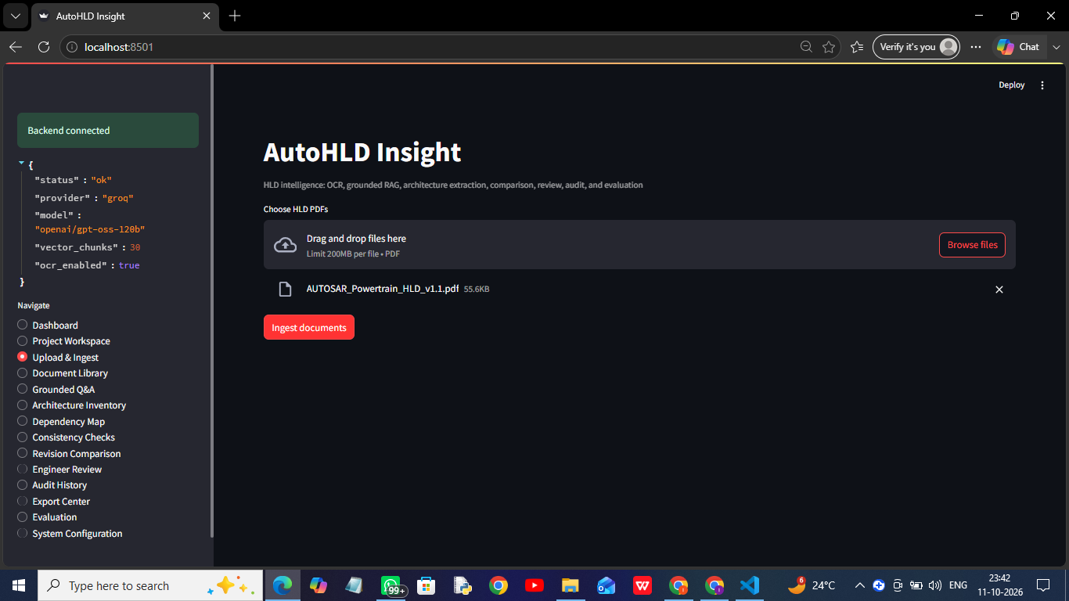
Figure 1: Upload and Ingest screen with AUTOSAR_Powertrain_HLD_v1.1.pdf (55.6 KB) selected for ingestion; the sidebar shows the backend connected with Groq, openai/gpt-oss-120b, 30 vector chunks, and OCR enabled.

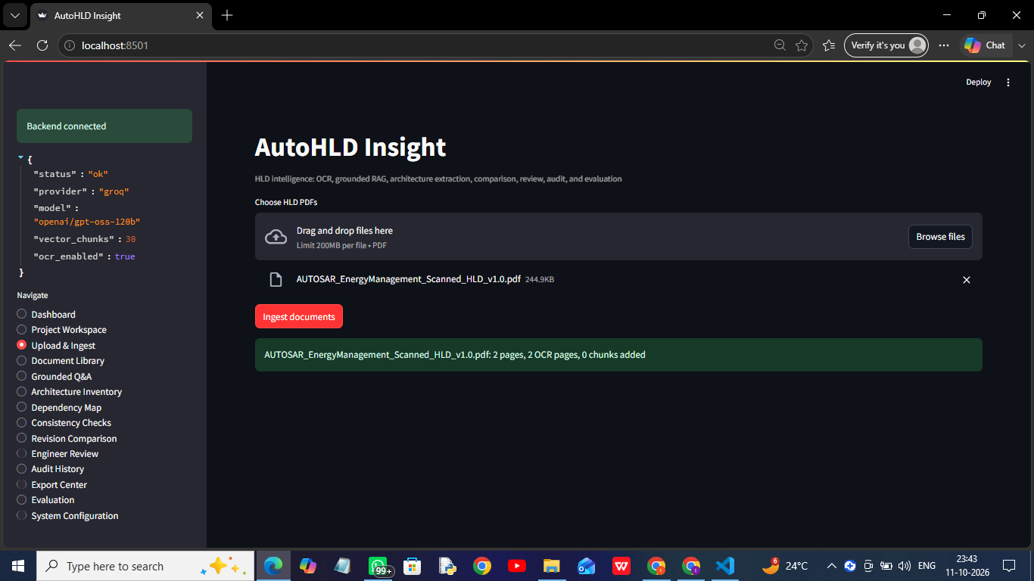
Figure 2: Scanned Energy Management HLD ingestion showing automatic OCR routing: 2 pages, 2 OCR pages (Tesseract).

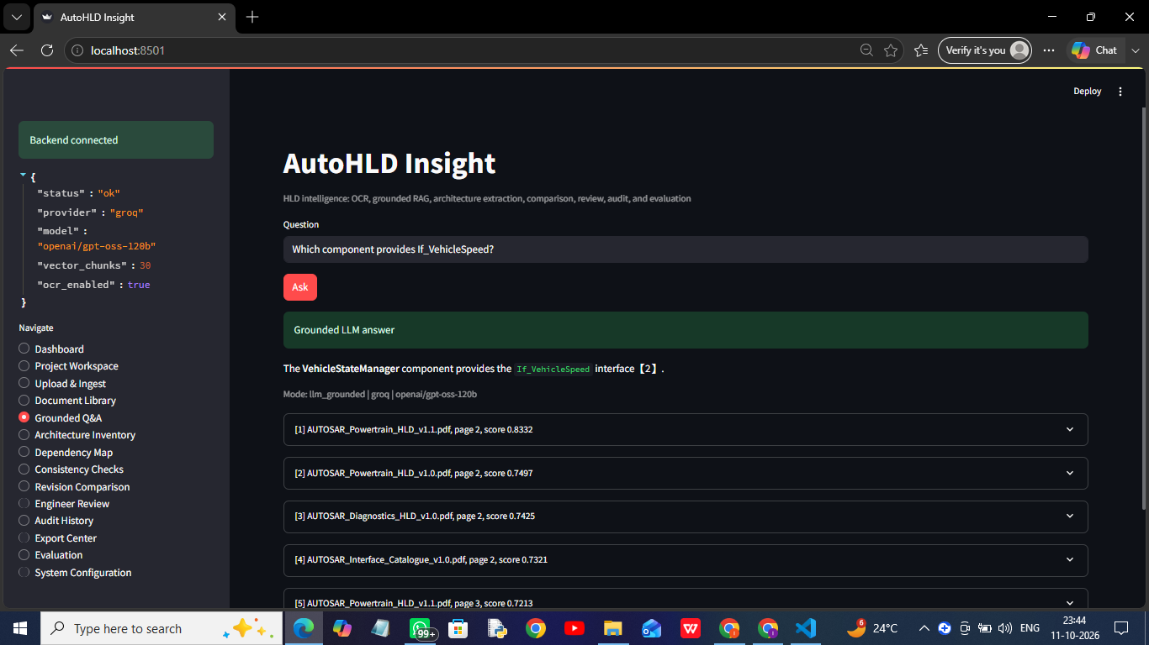
Figure 3: Grounded answer identifying VehicleStateManager as the provider of If_VehicleSpeed, with Groq model details, response mode llm_grounded, and ranked page citations.

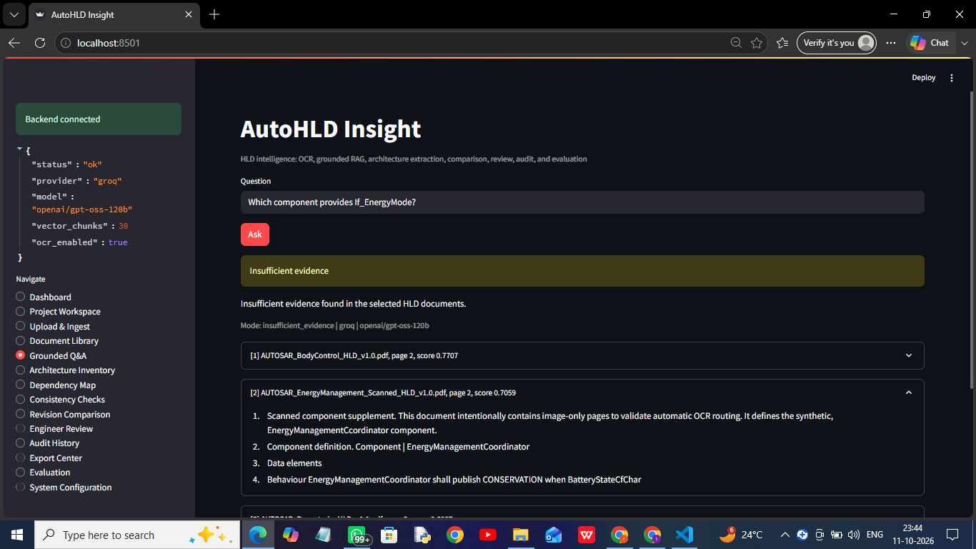
Figure 4: Insufficient-evidence response for If_EnergyMode: the retrieved OCR evidence from the scanned Energy Management HLD contains spelling variations, so the system abstained instead of guessing.

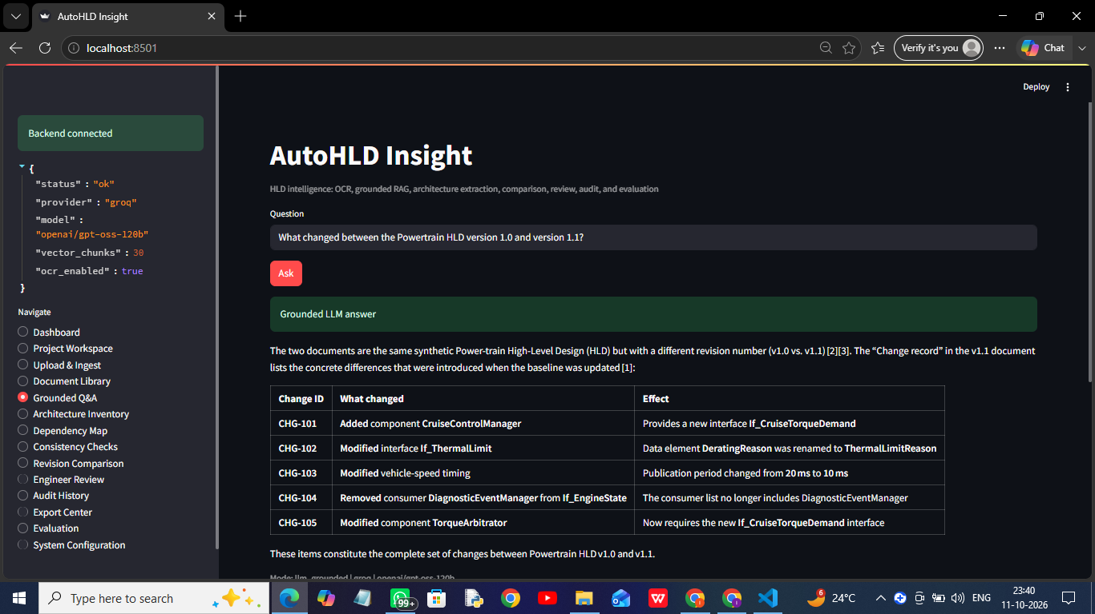
Figure 5: Grounded Powertrain v1.0 vs v1.1 revision explanation showing component, interface, timing, data-element, and consumer changes (CHG-101 to CHG-105) with citations.

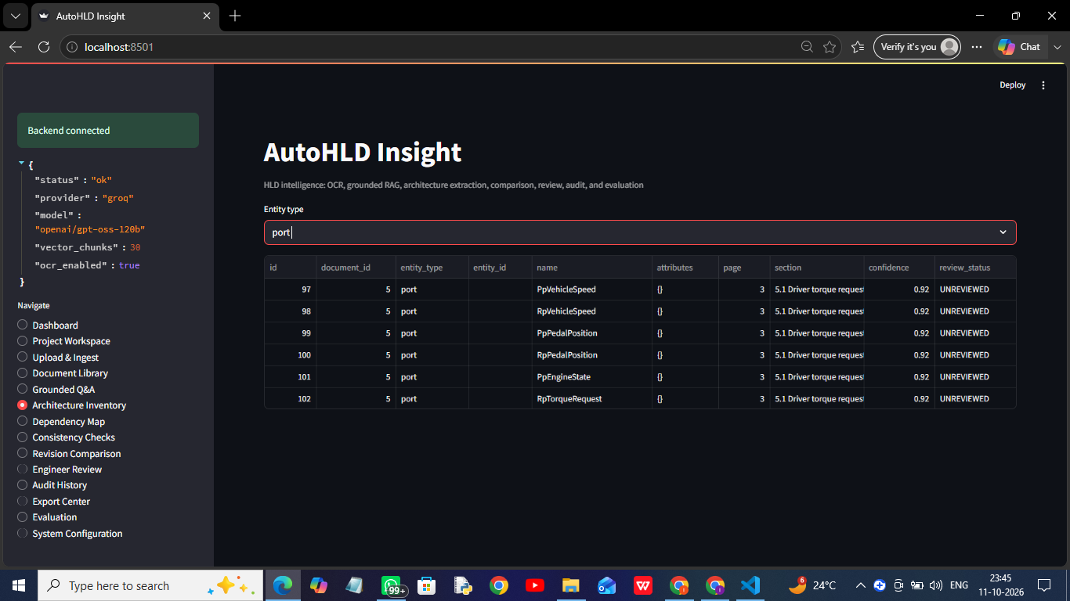
Figure 6: Architecture Inventory (entity type: port) showing extracted port names, source page, section, confidence values, and UNREVIEWED status.

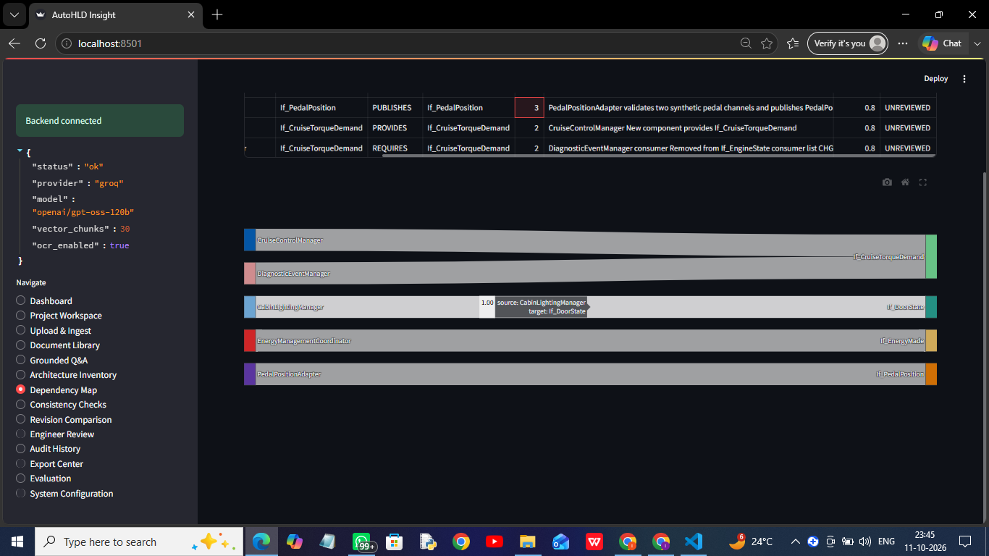
Figure 7: Candidate dependency map showing automatically extracted component-interface relationships (provides / requires / publishes) and review status.

Supporting Logs and Files
- Evaluation_Results/measured_results.csv
- Evaluation_Results/evaluation_questions.csv
- Code/storage/exports/documents.csv
- Code/storage/exports/entities.csv
- Code/storage/exports/relationships.csv
- Code/storage/exports/reviews.csv
- Code/storage/exports/audit.csv
- Code/storage/exports/queries.csv

9. Reflection and Conclusions
Key learnings, challenges faced, limitations, and future improvements.
The project demonstrated that a practical HLD analysis assistant can combine native PDF extraction, OCR, semantic retrieval, grounded LLM generation, architecture extraction, revision comparison, and human review in one integrated workflow.
A major learning was that document understanding requires more than a chatbot. Reliable HLD analysis also requires source metadata, OCR routing, structured architecture entities, revision awareness, explicit abstention, auditability, and human oversight.
The native PDF pipeline produced high-quality text from the supplied synthetic documents. The OCR pipeline correctly detected and processed the image-only Energy Management PDF, and its text was retrievable. However, OCR spelling errors such as If_EnergyMade and EnergyManagementCcoordinator prevented the exact OCR-based question about If_EnergyMode from being answered in the captured run; the system correctly abstained rather than inventing an answer, which shows the value of the insufficient-evidence guardrail and the need for OCR terminology normalization.
Grounded Q&A successfully answered the manually tested questions about the If_VehicleSpeed provider and the Powertrain revision changes. The revision-analysis response identified all intended change-record items and cited the correct Powertrain documents.
The architecture inventory extracted approximately 146 entity occurrences. However, repeated entity occurrences were stored when the same component appeared on multiple pages. Section detection also assigned some imperfect headings. Future work should consolidate entities per document and version and attach richer structured attributes.
Five candidate relationships were extracted. Manual inspection showed that the relationship extractor produced both valid relationships and false positives when multiple architecture terms appeared near each other. Therefore, extracted relationships must remain candidate relationships until reviewed.
The entity-level revision comparison successfully detected important v1.1 additions, including SWC-PT-006, If_CruiseTorqueDemand, If_DriverOverride, and CruiseTorque_Nm. It also reported candidate removals that may indicate missing mentions rather than explicit deletion. Combining entity-level comparison with RAG-based semantic comparison produced a more complete revision analysis.
The initial automated evaluation produced 33.33% expected-keyword answer accuracy and 100% expected-document citation accuracy across three questions. The citation result shows that retrieval selected the expected documents, but exact-answer evaluation requires a larger question set, better answer normalization, OCR terminology correction, and more robust ground truth.
Key Challenges
- Windows path-length limitations during PyTorch installation
- Python-version compatibility
- Tesseract PATH configuration
- OCR spelling variation
- Repeated entity occurrences
- Candidate relationship false positives
- Exact-keyword evaluation sensitivity
- Separating confirmed facts from automatically extracted candidates
- Maintaining clear separation between LLM and deterministic fallback results
Limitations
- Synthetic data only
- Small evaluation set
- Heuristic entity extraction
- Heuristic relationship extraction
- Repeated entities across pages
- Imperfect section classification
- OCR errors
- Empty structured findings table in the tested run
- Heuristic confidence values
- No enterprise authentication
- External-network dependency for Groq generation
- No formal automotive architecture certification
Future Improvements
- Consolidate repeated entities by document and version
- Add richer component and interface attributes
- Improve table extraction
- Add OCR terminology normalization
- Calibrate confidence scores
- Add hybrid vector and keyword retrieval
- Add reranking
- Expand the ground-truth question set
- Add entity and relationship precision, recall, and F1 evaluation
- Improve structured consistency detection
- Validate reviewer item IDs
- Add document approval and version filters
- Add project-specific vector collections
- Add Docker packaging
- Add enterprise access control
- Support ARXML ingestion
- Add graphical source highlighting
- Add report generation in PDF format
Conclusion
AutoHLD Insight provides a working academic prototype for traceable analysis of synthetic AUTOSAR-inspired HLD documents. It demonstrates native and OCR ingestion, grounded RAG, citations, architecture extraction, revision analysis, human review, audit history, and structured exports.
The system is designed as an engineering-assistance tool. It does not certify architecture, and all automatically extracted entities, relationships, findings, and revision impacts require qualified human review.

10. AI-Tool Usage Declaration
AI tool / model | Purpose | Artifact affected | Verified by Student (Y/N)
Groq API - openai/gpt-oss-120b | Grounded HLD question answering and revision explanations based on retrieved evidence. | Generated answers, revision-analysis outputs, and evaluation samples. | Y
BAAI/bge-small-en-v1.5 | Local embedding generation for document chunks and user questions. | ChromaDB vector index, semantic retrieval, and citation selection. | Y
Microsoft Copilot | Assistance with architecture planning, coding guidance, debugging, test preparation, documentation drafting, and report structuring. | Source-code development support, run guide, synopsis draft, technical-report draft, and evaluation planning. | Y
Tesseract OCR | Optical character recognition for image-only scanned HLD documents. | Extracted OCR text, scanned-document chunks, OCR-based answers, and OCR evaluation evidence. | Y

11. Student Declaration
I confirm that this report represents my own understanding and contribution, that the work follows the approved case-study scope, and that I can explain every significant part of the implementation.

Signature: | 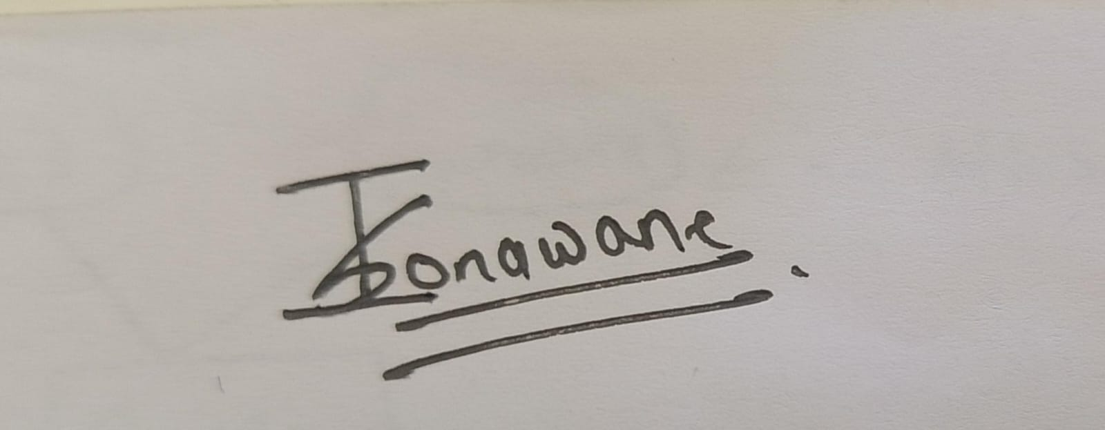 | Date: | 12/10/2026
Name: | Ishwar Sudam Sonawane | PRN: | 123B1D048

