TATA TECHNOLOGIES LTD.
TECH PULSE FY-26 | AI/ML Capstone Project
PROJECT SYNOPSIS

Student Details
Institute/University: Pimpri Chinchwad College of Engineering, Pune
Programme / Batch: Computer Engineering (RL) / Batch 2027
Student Name: Ishwar Sudam Sonawane
PRN: 123B1D048
1. Case Study ID and Project Title / Topic
Case Study ID (CS1 to CS5): CS1
Project Title / Topic: AutoHLD Insight: AI-Powered AUTOSAR-Inspired High-Level Design Document Analysis Assistant
2. Objectives
Define the specific objectives and focus areas of the allocated AIML case study.
Objectives
- To develop a document-ingestion pipeline that supports native-text PDFs and scanned image-based PDFs using automatic OCR.
- To build a Retrieval-Augmented Generation pipeline for answering HLD-related engineering questions using retrieved document evidence.
- To provide grounded answers with source filename, page number, section, evidence excerpt, and retrieval score.
- To extract architecture entities such as software components, interfaces, ports, signals, events, and component identifiers.
- To identify candidate relationships between components and interfaces for dependency analysis.
- To support entity-level and RAG-based comparison of two HLD document revisions.
- To implement explicit insufficient-evidence behavior so that the system does not invent unsupported architectural relationships.
- To implement a clearly labeled deterministic fallback when Groq LLM generation is unavailable.
- To support a human-in-the-loop review workflow for accepting, rejecting, correcting, or requesting clarification on extracted results.
- To maintain audit history for project creation, document ingestion, and reviewer decisions.
- To provide structured CSV and JSON exports for documents, entities, relationships, reviews, audit events, and query results.
- To evaluate the system using a controlled synthetic knowledge base, ground-truth questions, expected answers, citations, latency, and documented failure cases.
3. Scope
Clearly state what will be implemented in the project and what will not be covered. Respect mandatory controls such as citations, human review, and approved or synthetic data.
In Scope – To Be Implemented
- Creation of a synthetic AUTOSAR-inspired HLD knowledge base containing components, interfaces, ports, signals, events, dependencies, timing requirements, and controlled inconsistencies.
- Upload and ingestion of multiple PDF documents.
- Native PDF text extraction using PyMuPDF.
- Automatic detection of image-only or low-text pages.
- Tesseract OCR for scanned HLD pages.
- OCR confidence recording and low-confidence warnings.
- Text cleaning, page-level metadata preservation, section detection, chunking, and duplicate chunk prevention.
- Local embedding generation using BAAI/bge-small-en-v1.5.
- Persistent vector storage using ChromaDB.
- Evidence retrieval using semantic similarity.
- Grounded question answering using Groq API and openai/gpt-oss-120b.
- Page-level source citations and retrieved evidence display.
- Insufficient-evidence handling for unsupported questions.
- Explicit deterministic fallback when the LLM provider fails.
- Architecture entity extraction for components, interfaces, ports, signals, events, and component IDs.
- Candidate component-interface relationship extraction.
- Architecture Inventory and Dependency Map screens.
- Entity-level comparison of HLD revisions.
- RAG-based semantic comparison of HLD revisions.
- Engineer review decisions and reviewer comments.
- Audit-history recording.
- CSV and JSON export generation.
- Automated evaluation script and screenshot evidence.
- Documentation of limitations and responsible AI controls.
Out of Scope – Will Not Be Implemented
- Automatic approval or certification of automotive software architecture.
- Replacement of qualified AUTOSAR architects or engineering reviewers.
- Use of confidential OEM, supplier, customer, or production HLD documents.
- Automatic modification of authoritative HLD documents.
- Vehicle control, ECU flashing, calibration, or interaction with production vehicle systems.
- Formal functional-safety certification under ISO 26262.
- Cybersecurity certification or production deployment.
- Guaranteed detection of every architecture defect or inconsistency.
- Guaranteed OCR correctness for low-quality, handwritten, or severely damaged documents.
- Full semantic parsing of official AUTOSAR XML or ARXML specifications.
- Enterprise-grade role-based access control and organizational identity integration.
- Claiming automatically extracted relationships as confirmed facts without human review.
4. Proposed Approach
Pre-trained model (name, version, local/private hosting)
The primary generation model will be openai/gpt-oss-120b, accessed through the external Groq API. The model will generate answers, summaries, and revision explanations only from retrieved HLD evidence. An active internet connection and valid Groq API key will be required for new LLM-generated answers.
The project will retain an optional Ollama configuration in .env.example for future local-model use. Ollama will not be the primary provider in the submitted configuration. If Groq generation fails, the system will produce a clearly labeled deterministic evidence-based fallback instead of presenting the fallback as an LLM answer.
Embedding model
BAAI/bge-small-en-v1.5
The embedding model will run locally through Sentence Transformers. It will convert document chunks and user questions into vector representations for semantic retrieval.
Vector store (FAISS / ChromaDB)
The project will use ChromaDB with persistent local storage.
ChromaDB will store chunk text, document filename, page number, section, extraction method, vector embeddings, and source metadata. Duplicate chunk IDs will be checked before insertion to avoid repeated indexing.
RAG pipeline and/or AI-agent design – brief description
The proposed pipeline will follow these stages: PDF upload → file validation and hashing → native-text extraction → automatic OCR routing → page-level metadata preservation → text cleaning and section detection → architecture-aware chunking → local embedding generation → ChromaDB indexing → user question → semantic evidence retrieval → grounded prompt construction → Groq LLM generation → answer with citations → insufficient-evidence or deterministic fallback → audit and export.
The model will be instructed to answer only from retrieved evidence and to return insufficient evidence when the knowledge base does not support an answer.
Service layer and UI (e.g., FastAPI / Flask / Streamlit)
The service layer will use FastAPI. FastAPI will provide endpoints for health monitoring, document upload, document inventory, question answering, architecture entities, architecture relationships, project workspaces, revision comparison, reviews, audit history, and exports.
The user interface will use Streamlit. The UI will provide: Dashboard, Project Workspace, Upload and Ingest, Document Library, Grounded Q&A, Architecture Inventory, Dependency Map, Consistency Checks, Revision Comparison, Engineer Review, Audit History, Export Center, Evaluation, and System Configuration.
Tools / deterministic rules, if applicable
- PyMuPDF for native PDF extraction and page rendering
- Tesseract OCR and pytesseract for scanned pages
- OpenCV for OCR image preprocessing
- Sentence Transformers for local embeddings
- ChromaDB for persistent vector search
- SQLite for structured records, reviews, and audit history
- Regular-expression and heuristic rules for candidate entity extraction
- Heuristic relationship extraction for provider, publisher, and required-interface relationships
- SHA-256 hashing for duplicate-document identification
- Deterministic evidence-sentence extraction when the LLM is unavailable
- Explicit response-mode labels for LLM, fallback, and insufficient-evidence outputs
- CSV and JSON export utilities
- Automated evaluation scripts
Proposed System / Architecture
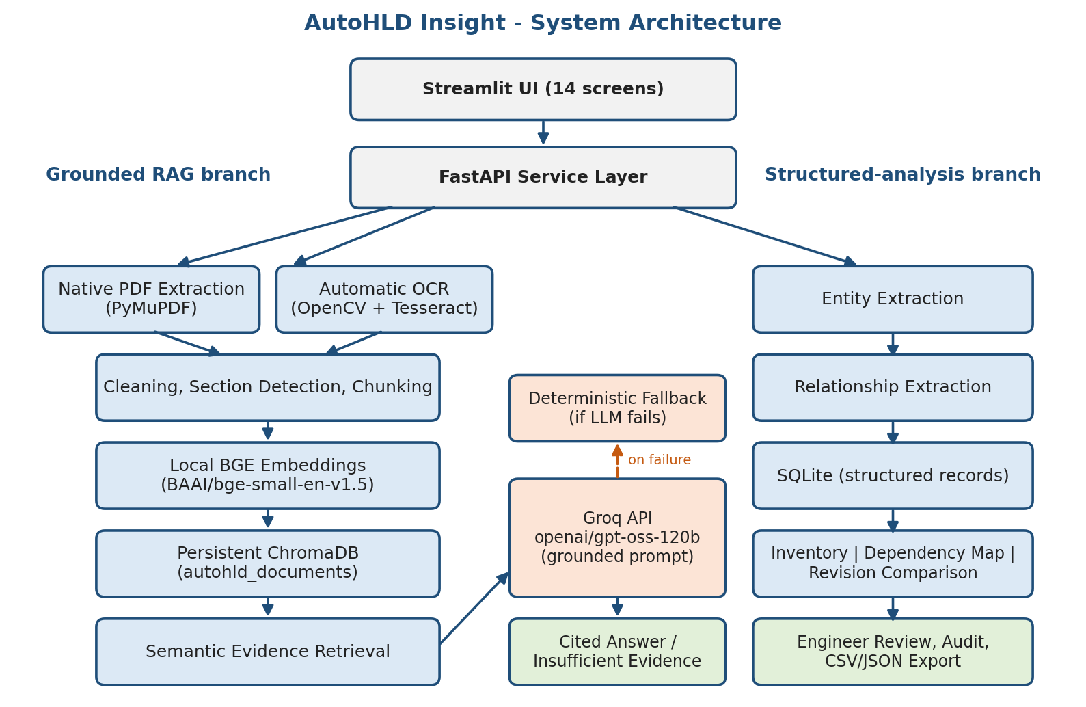
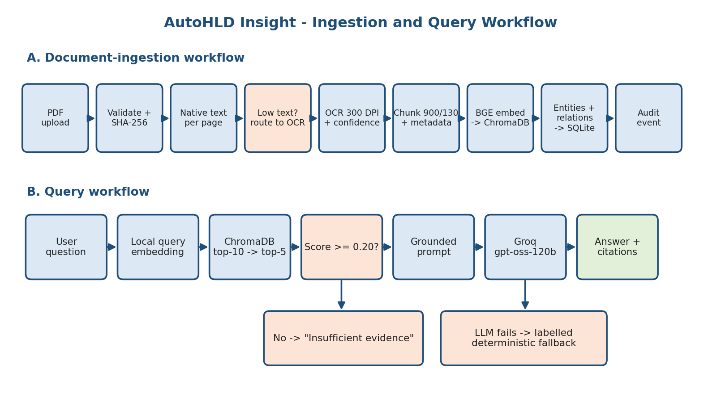
5. Input Data / Knowledge Base
Use approved or synthetic data only.
Data / Knowledge Sources
The project will use an independently created synthetic AUTOSAR-inspired HLD knowledge base. No confidential company, OEM, supplier, customer, or production data will be included. The knowledge base will include:
- AUTOSAR_Powertrain_HLD_v1.0.pdf
- AUTOSAR_Powertrain_HLD_v1.1.pdf
- AUTOSAR_BodyControl_HLD_v1.0.pdf
- AUTOSAR_Diagnostics_HLD_v1.0.pdf
- AUTOSAR_Interface_Catalogue_v1.0.pdf
- AUTOSAR_EnergyManagement_Scanned_HLD_v1.0.pdf
The documents contain synthetic software components, component identifiers, interfaces, ports, signals and data elements, diagnostic events, provider-consumer relationships, timing requirements, functional flows, revision changes, intentional unresolved references, terminology variations, and OCR test content.
Approximate Size and Format
The initial knowledge base contains six PDF documents:
- Five native-text PDFs
- One image-only scanned PDF for OCR validation
- Approximately 30 indexed chunks in the tested build
- Approximately 146 extracted entity occurrences
- Five automatically extracted candidate relationships
Additional supporting files include evaluation questions in CSV format, measured evaluation results in CSV format, ground-truth findings in JSON format, exported entities, documents, relationships, reviews, and audit history in CSV or JSON format, and evaluation screenshots in PNG format.
Preprocessing and EDA Planned
- PDF file-type validation
- SHA-256 document hashing
- Duplicate-document and duplicate-chunk checks
- Page-by-page native-text extraction
- Native-text quality and character-count checks
- Automatic routing of low-text pages to OCR
- Grayscale conversion, noise reduction, and adaptive thresholding
- OCR text extraction and confidence recording
- Repeated-header and footer handling
- Section-heading detection
- Page and source metadata insertion
- Text chunking with overlap
- Chunk-quality inspection
- Entity-frequency inspection and document-wise entity distribution
- Relationship extraction review
- OCR error identification
- Evaluation-question validation
- Revision-pair validation
6. Expected Outcomes and Evaluation Plan
Expected Outputs – aligned to the case study
- A working FastAPI backend and Streamlit frontend
- Native and scanned PDF ingestion
- OCR extraction evidence
- Persistent HLD knowledge-base indexing
- Grounded HLD question answering
- Page-level citations
- Explicit insufficient-evidence responses
- Clearly labeled deterministic fallback answers
- Component, interface, port, signal, event, and component-ID inventory
- Candidate architecture relationships
- Dependency visualization
- Entity-level revision comparison
- RAG-based revision explanation
- Engineer review records
- Audit history
- CSV and JSON exports
- Automated evaluation results
- Screenshots and sample outputs
- External API declaration
- Model, embedding, vector-store, prompt, and OCR configurations
- Technical report, synopsis, run guide, and demonstration script
Evaluation Method – test question set / ground truth / metrics / validation approach
The evaluation will use a controlled question set containing direct factual questions, interface-provider questions, OCR-based questions, revision-comparison questions, relationship questions, unsupported or unanswerable questions, and provider-failure tests.
Ground truth will include expected answer keywords, expected source documents, expected evidence pages, known revision changes, expected OCR text, controlled unresolved references, and known candidate inconsistencies.
The evaluation metrics will include:
- Expected-keyword answer correctness
- Expected-document citation correctness
- Retrieval relevance score
- Citation availability
- Response mode correctness
- Insufficient-evidence accuracy
- OCR routing success and OCR entity recognition
- Response latency
- Entity extraction precision, recall, and F1 when sufficient annotations are available
- Candidate relationship precision and false-positive analysis
During the initial tested run, the number of evaluation questions was 3, the expected-keyword answer accuracy was 33.33%, and the expected-document citation accuracy was 100%. These values will be treated as an initial baseline rather than final optimized performance.
Responsible AI Measures – grounding and citations / privacy / security / human oversight
- Answers will be restricted to retrieved document evidence.
- Every normal LLM answer will display citations and retrieved evidence.
- Unsupported questions will return insufficient evidence.
- Deterministic answers will be clearly labeled as non-LLM answers.
- Synthetic data will be used instead of confidential engineering data.
- The Groq API key will be stored only in .env.
- .env will be excluded from source control and final submission.
- Candidate entities and relationships will remain UNREVIEWED until reviewed.
- Engineer review decisions will include acceptance, rejection, correction, and clarification.
- Audit logs will preserve significant system actions.
- The system will explicitly state that it does not certify automotive architecture.
- OCR confidence and OCR limitations will be disclosed.
- False positives and failed evaluation cases will be reported rather than hidden.
MLOps / Deployment Elements Planned – versioning / Docker / tracking
- Dependency pinning through requirements.txt
- Environment-variable configuration through .env.example
- Separate primary and optional LLM-provider settings
- Local persistent ChromaDB storage
- SQLite audit and review storage
- Document hashing
- Model and provider configuration recording
- Versioned synthetic documents
- Revision-pair testing
- Automated evaluation script
- Structured CSV and JSON exports
- Clean-environment execution guide
- Git-based source-code versioning
- Future Docker packaging for reproducible deployment
- Submission checklist and project manifest
7. Planned AI-Tool Usage
Mention the AI tools / models used for coding assistance and specify the purpose and project artifact affected. This information will be carried into the final AI-tool usage declaration.
AI Tool / Model 1
Groq API, openai/gpt-oss-120b
Purpose
Evidence-grounded question answering, document explanations, and semantic revision summaries.
Artifact Affected
Generated answers, cited revision analysis, and sample outputs.
AI Tool / Model 2
BAAI/bge-small-en-v1.5
Purpose
Local text and query embedding generation for semantic retrieval.
Artifact Affected
Vector index, retrieval results, and source selection.
AI Tool / Model 3
Microsoft Copilot
Purpose
Assistance with planning, code structuring, debugging, documentation drafting, test-case preparation, and review of implementation steps.
Artifact Affected
Source-code development support, documentation drafts, run guide, evaluation planning, and report structure.
Verification Statement
All AI-generated suggestions, code, documentation, answers, and evaluation observations will be reviewed by the student. The student will remain responsible for understanding and explaining every significant project component.
Student Declaration
☑ I will not change the approved case-study scope, major methodology, or implementation approach without prior faculty approval.
☑ I confirm that the work submitted under this synopsis represents my own understanding and contribution, and I will be responsible for explaining every significant part of the selected case study and its implementation.

Name and Signature: Ishwar Sudam Sonawane  Date: 12/10/2026

