1. Emp id:8077994
2. Name of Participant: Mr.Ishwarappa Kalbandi
3. Email ID: ishwar.kalbandi@gmail.com
4. Mobile Number: 7767987465

********************************************

**Day1 Date 06 May 2020**

**<Assignment Number 1 > <Maven >**

Assignment-1

1. Create a Maven archetype project from command line providing groupId and artifactId as input parameters.

mvn archetype:generate -DgroupId=org.dypiemr -DartifactId=org.dypiemr.java -DarchetypeArtifactId=maven-archetype-quickstart -DinteractiveMode=false

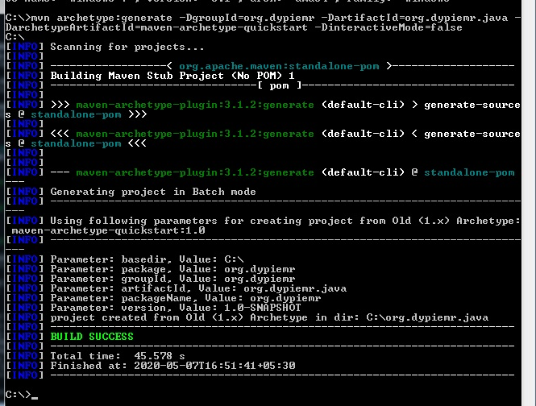

1. Create a project (for e.g. Calculator) where the packaging type is "jar" file, and install that into local repository.

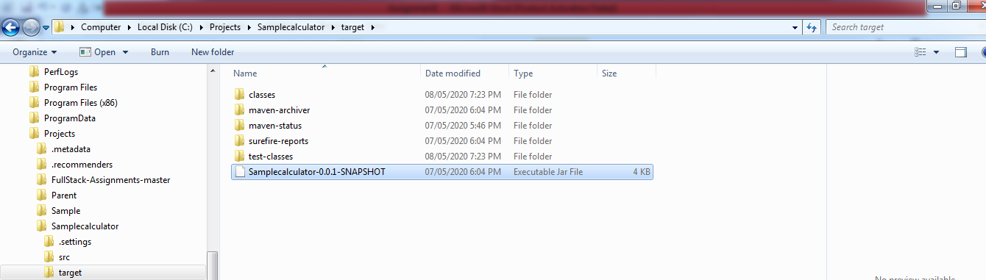

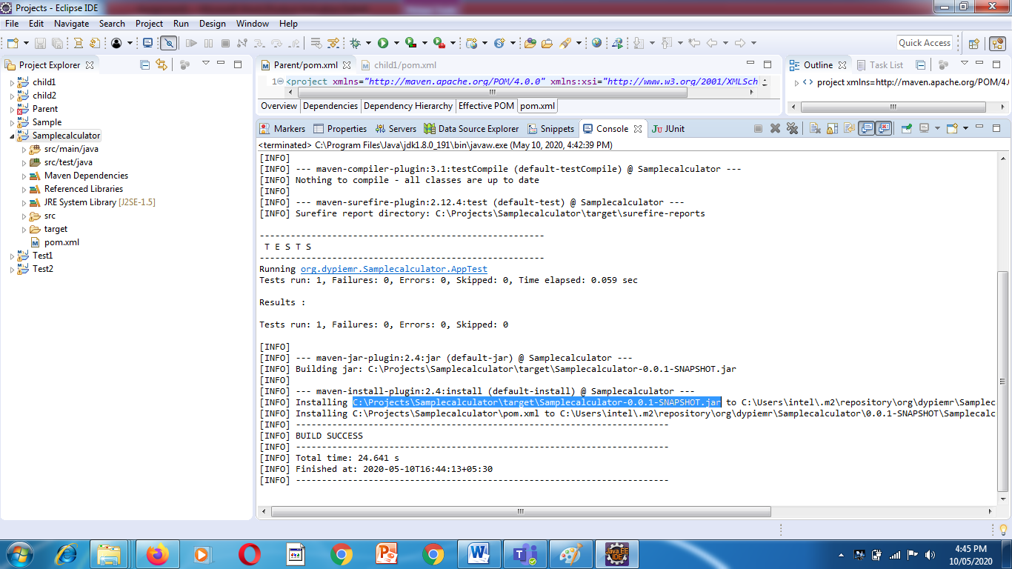

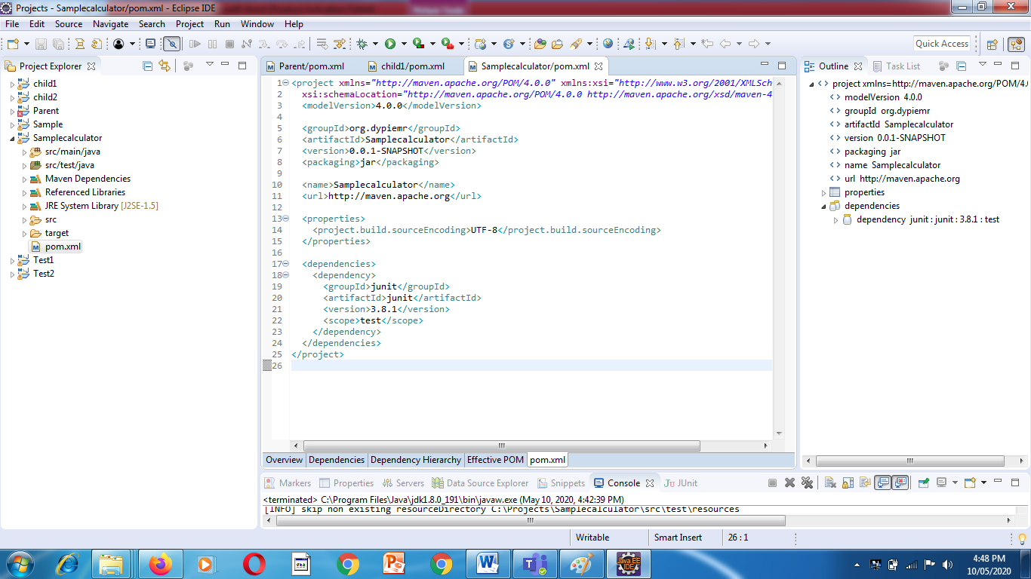

1. Create a different project, add above project as dependency. Develop an application using above APIs from the above jar, and check if it's working fine at compile time and run time.

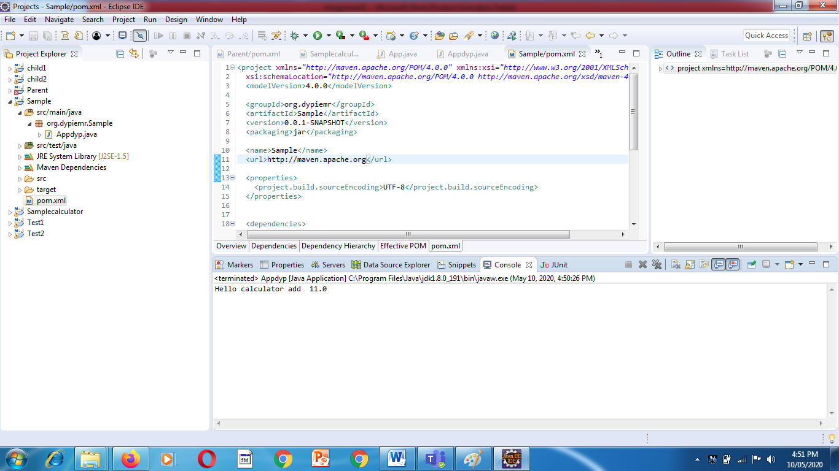

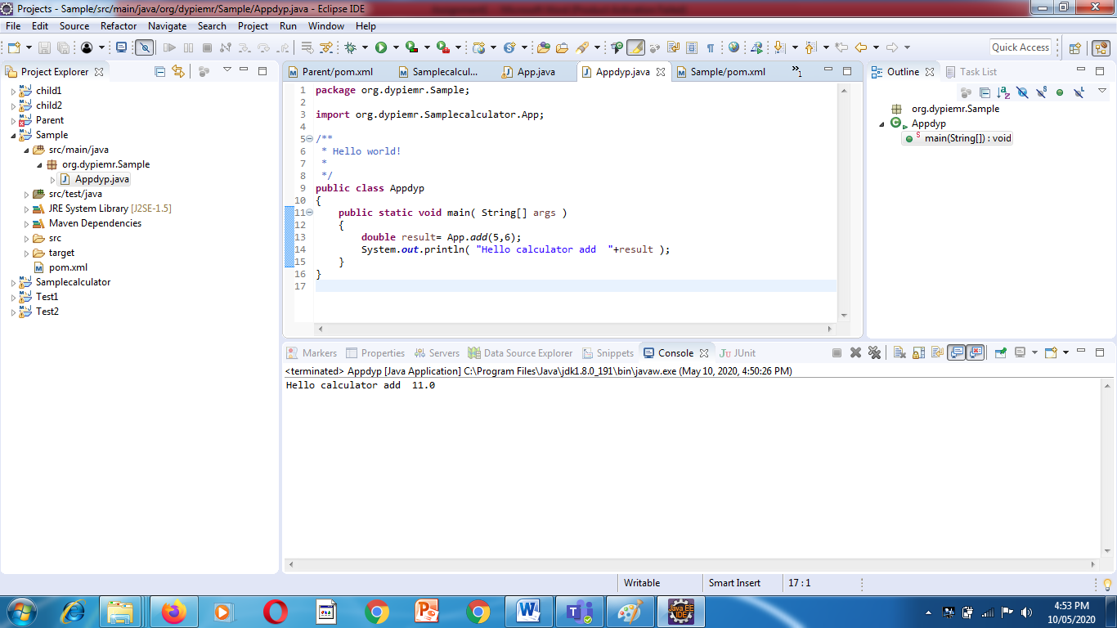

1. Create a project with 2 independent modules where each module will have its own pom.xml and main project pom.xml is configured as parent.

