**Ansible**

**Ansible**

**Installation and configuration**

**Communication framework**

**Password less Authentication**

**Ansible command line**

**Ansible playbooks**

**Ansible roles**

**Ansible tags**

**Ansible Vault**

**Ansible variables- precedence**

**Ansible jinja2 templates**

**Ansible galaxy**

Chef,Puppet,Ansible, Saltstack these tools are for the same purpose – configuration management.

**System admin/Operational tasks**

provision server

deploy

configure

Monitor

Scale

Secure

Application reliability and scalability directly affect the business profits

Difficult to manage thousands of servers.

As the application grows in functionality the day to day activities takes more time

We need to control and flexibility, as well as ease of use.

**Automation:**

Automation of these tasks is becoming extremely important, hence DevOps

Smart Automation is the key

Recognize the most common tasks and automate

-Defined way of doing things is Recipes

In today’s world everything is code

kernel

OS

shell

Application

Configuration management tools

Provisioning resources

**Ansible**

**Ansible in short is an IT Automation, configuration management and provisioning tool.**

Simple to start

Scales up on demand

No agents are needed

sshd on remote machine can be used

Parallel by default

Automaton language is like English

212 core modules

Ansible is a tool to manage systems and their configuration. Without the need for a client installed agent and with the ability to launch programs with command line, it seems to fit between classic configuration management like Puppet on one hand and ssh/dsh on the other.

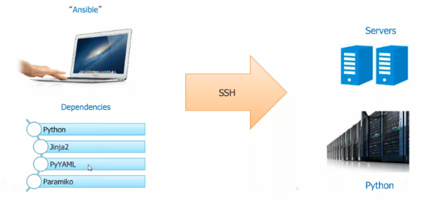

Ansible based on python

Jinja2 supports templates for Ansible – templating engine

PyYAML – yet another markup language – playbooks are written in this language

Paramiko – kind of ssh implementation.

**Ansible Architecture**

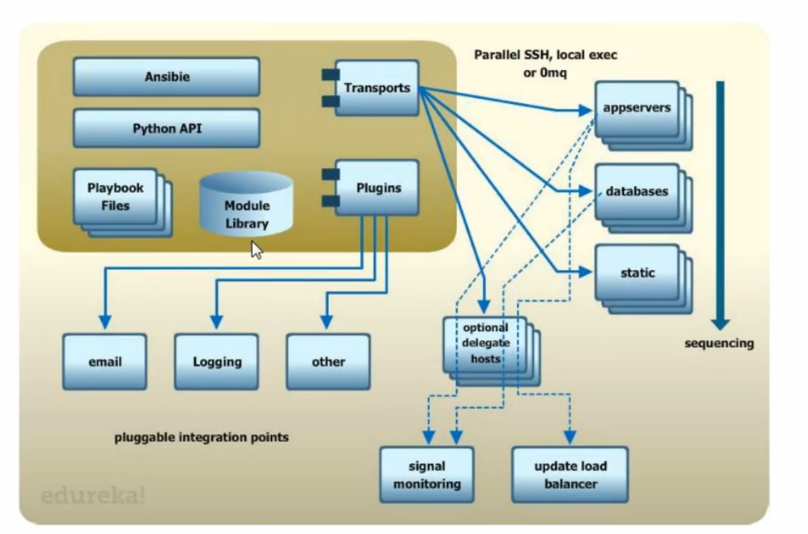

Playbook files – infrastructure as code is maintained in this files

Python API – execute commands using API

Module – is a resource – file/package/command/item trying to configure

transports – by default ssh – to talk to servers

plugins – email logging other

playbooks are executed on parallel fashion

**Ansible terminology**

Inventory: file contains list of hosts, groups or variables.

Modules: Actually do the work

Plugins: call back actions, and other hooks

Facts: Data gathered from target hosts

Playbooks: Collection of plays

Plays: Loops over a list of takes mapped to list of hosts

Tasks: Invokes a module to do the work

**Ansible Install:**

ssh-key has to setup on both the nodes

Ansible server talks to managed nodes using ssh

Default location of inventory: /etc/ansible/hosts

Its in INI format

Ansible repository Ansible Galaxy

How to use Ansible

ansbile inventory –m modulename

ansible-playbook

Ansible-playbook playbook.yml

Ansible command mode:

add hosts to /etc/ansible/hosts

and configure password less authentication

Ansible needs to know the hosts its going to serve. They can be managed on the central server in /etc/ansible/hosts or in a file configured in the shell variable ANSIBLE_HOSTS. The hosts can be listed as IP addresses or host names, and can contain additional information like user names, ssh port and so on:

**Installation and configuration:**

1. Install ansible on the node using

yum install ansible

1. Add nodes to ansible server using inventory file

/etc/ansible/hosts

1. Generate ssh keys and setup password less authentication between server and clients
2. Perform jobs either using ansible command line or playbooks.

**Ansible command line:**

**[root@ctx1p05 RHEL5]# ansible all -m ping**

ctx1p10.in.vp.com | SUCCESS => {

"changed": false,

"ping": "pong"

}

ctx1p11.in.vp.com | SUCCESS => {

"changed": false,

"ping": "pong"

**[root@ctx1p05 RHEL5]# ansible all -a "touch /tmp/hello "**

ctx1p10.in.vp.com | SUCCESS | rc=0 >>

ctx1p11.in.vp.com | SUCCESS | rc=0 >>

to execute command on local machine (ansible server)

ansible all -i "localhost," -c local -m shell -a 'echo hello world'

to execute command on remote single machine (ansible client)

ansible all -i "ctx1p10" -m shell -a 'echo hello world'

**Grouping the nodes:**

Nodes can be grouped into groups like webserver dbserver application server etc in hosts file

[root@ctx1p05 RHEL5]# ansible webservers -m ping

ctx1p10.in.vp.com | SUCCESS => {

"changed": false,

"ping": "pong"

}

[root@ctx1p05 RHEL5]#

[webservers]

ctx1p10.in.vp.com

[dbservers]

ctx1p11.in.vp.com

to execute a command on local/ansible server

ansible all -i "localhost," -c local -m shell -a 'hostname'

root@ctx1p05 ~]# ansible all -i "localhost," -c local -a 'hostname'

localhost | SUCCESS | rc=0 >>

ctx1p05.in.vpath.com

to execute command on single host

[root@ctx1p05 ~]# ansible all -i "reviewb.in.vpath.com," -a 'hostname'

reviewb.in.vpath.com | SUCCESS | rc=0 >>

reviewb.in.vpath.com

**Ansible Playbooks:**

**A sample playbook:**

[root@ctx1p05 playbooks]# cat httpd.yaml

---

- hosts: webservers

tasks:

- name: install httpd

yum: pkg=httpd state=installed

[root@ctx1p05 playbooks]#

[root@ctx1p05 playbooks]# ansible-playbook httpd.yaml

PLAY [webservers] **************************************************************

TASK [setup] *******************************************************************

ok: [ctx1p10.in.vp.com]

TASK [install httpd] ***********************************************************

changed: [ctx1p10.in.vp.com]

PLAY RECAP *********************************************************************

ctx1p10.in.vp.com : ok=2 changed=1 unreachable=0 failed=0

[root@ctx1p05 playbooks]#

Playbooks:

hosts defined on which target this configuration is pushed

user: to login to remote server

vars:

http_port:80

max_client: 200

Variables are declared and can be passed , wherever http_port is used, 80 will be replaced

Tasks: collection of actions we need to perform

each action will have a name

action will call the module

name: ensure apache is at the latest version

action: yum pkg=httpd state=latest

here yum is the module for rhel

we are passing some variables to yum

1st one is package name, 2nd one is action to install/remove/latest

for specific version we need to replace state with version

action: template src=httpd.j2 dest=/etc/httpd.conf

we want to create a file /etc/httpd.conf with template file httpd.j2

here we are using template

notify:

* restart apache

Whenever you perform this action (when template is notified), this action has to be performed

-name ensure httpd is running

action=service name =httpd state=started

handlers:

-name: restart apache

action: service name=httpd state=restarted

to understand handles, execute below playbook 2 times

[root@ctx1p05 playbooks]# cat template.yaml

---

- hosts: webservers

tasks:

- name: copy application code to destination on clients

template: src=index.html.j2 dest=/var/www/html/index.htm

notify: restart apache

handlers:

- name: restart apache

service: name=httpd state=restarted

**1st run**

[root@ctx1p05 playbooks]# ansible-playbook template.yaml

PLAY [webservers] **************************************************************

TASK [setup] *******************************************************************

ok: [ctx1p11.in.ibm.com]

TASK [copy application code to destnation on clients] **************************

ok: [ctx1p11.in.ibm.com]

PLAY RECAP *********************************************************************

ctx1p11.in.ibm.com : **ok=2 changed=0** unreachable=0 failed=0

**2nd run:**

**Modify something in index.html on ansible master and deploy**

[root@ctx1p05 playbooks]# ansible-playbook template.yaml

PLAY [webservers] **************************************************************

TASK [setup] *******************************************************************

ok: [ctx1p11.in.ibm.com]

TASK [copy application code to destnation on clients] **************************

changed: [ctx1p11.in.ibm.com]

RUNNING HANDLER [restart apache] ***********************************************

changed: [ctx1p11.in.ibm.com]

PLAY RECAP *********************************************************************

ctx1p11.in.ibm.com **: ok=3 changed=2** unreachable=0 failed=0

Note: if there is any change only handles will be used to restart service

To list all tasks in a module

[root@ctx1p05 playbooks]# ansible-playbook apache.yaml --list-tasks

playbook: apache.yaml

play #1 (webservers): webservers TAGS: []

tasks:

ensure apache is installed TAGS: []

ensure apache is running TAGS: []

copy files to document root TAGS: []

copy application code to document root TAGS: []

[root@ctx1p05 playbooks]#

[root@ctx1p05 playbooks]# ansible-playbook apache.yaml --list-tasks

playbook: apache.yaml

play #1 (webservers): webservers TAGS: []

tasks:

ensure apache is installed TAGS: []

ensure apache is running TAGS: []

copy files to document root TAGS: []

copy application code to document root TAGS: []

[root@ctx1p05 playbooks]# ansible-playbook --check apache.yaml

PLAY [webservers] **************************************************************

TASK [setup] *******************************************************************

ok: [ctx1p10.in.ibm.com]

TASK [ensure apache is installed] **********************************************

ok: [ctx1p10.in.ibm.com]

TASK [ensure apache is running] ************************************************

ok: [ctx1p10.in.ibm.com]

TASK [copy files to document root] *********************************************

ok: [ctx1p10.in.ibm.com]

TASK [copy application code to document root] **********************************

ok: [ctx1p10.in.ibm.com]

PLAY RECAP *********************************************************************

ctx1p10.in.ibm.com : ok=5 changed=0 unreachable=0 failed=0

ansible-playbook php.yaml --^Cmit @/etc/ansible/playbooks/php.retry

to retry a failed playbook execution

[root@ctx1p05 playbooks]# ansible-playbook php.yaml --limit @/etc/ansible/playbooks/intaractive.retry

PLAY [webservers] **************************************************************

TASK [setup] *******************************************************************

ok: [ctx1p10.in.ibm.com]

TASK [xyz] *********************************************************************

changed: [ctx1p10.in.ibm.com]

PLAY RECAP *********************************************************************

ctx1p10.in.ibm.com : ok=2 changed=1 unreachable=0 failed=0

Online Ansbile Playbook repository : Ansible – galaxy

Ansible tower – licensed version of Ansible

Ansible is not supported on Windows, its supported only on Linux

in Ansbile modules are tools

playbooks are instruction manuals

5 basic components in Ansible

1)Inventory:

A text file that contains information of servers and systems in the infrastructure

Group hosts into categories

Define any variables required by specific hosts (ex: ssh username and password)

2)Ansible configuration:

custom configuration can be defined here

3)Modules

It is the command center of the system

2 types

core modules – developed by Ansible

other modules – developed by community

4)Playbooks

Play: It is a single task or set of tasks which can be executed on hosts with the help of modules

it Is set of plays built in specific order sequence to produce an expected outcome

5) Ansible global configuration

It is a file that contains global variables

execution types:

remote

local : when python is not installed on the agent

ex: router

Handles: wait for event to occur

once event occurs with notify action, handler which is mapped that event will gets executed

--

hosts: webservers

user: root

example playbooks

[root@ctx1p05 playbooks]# cat apache.yaml

---

- hosts: webservers

tasks:

- name: ensure apache is installed

yum: pkg=httpd state=latest

- name: ensure apache is running

service: name=httpd state=running enabled=yes

- name: copy files to document root

copy: src=cloud.png dest=/var/www/html/cloud.png

- name: copy application code to document root

template: src=index.html.j2 dest=/var/www/html/index.html

notify: restart apache

handlers:

- name: restart apache

service: name=httpd state=restarted

[root@ctx1p05 playbooks]#

[root@ctx1p05 playbooks]# cat index.html.j2

<head>

<title>Vp Ansible Demo</title>

</head>

<body>

<h1>

Welcome to Visual path Ansible demo.

</h1>

<br/><br/><br/>

<p>

<img src="cloud.png" alt="Logo"/>

</p>

</body>

</html>

[root@ctx1p05 playbooks]#

roles:

[root@ctx1p05 playbooks]# cat myrole.yaml

---

- hosts: webservers

roles:

- webservers

[root@ctx1p05 playbooks]#

include:

[root@ctx1p05 playbooks]# cat myrole.yaml

---

- hosts: webservers

roles:

- webservers

[root@ctx1p05 playbooks]# cat sample.yaml

---

- hosts: webservers

tasks:

- include: /etc/ansible/tasks/file.yaml

- hosts: dbservers

tasks:

- include: /etc/ansible/tasks/file.yaml

[root@ctx1p05 playbooks]#

include is for making the code look simpler, manageable

small playbooks can be created and can be included

To see what hosts would be affected by a playbook before running it, try

root@ctx1p05 playbooks]# ansible-playbook apache.yaml --list-hosts

playbook: apache.yaml

play #1 (webservers): webservers TAGS: []

pattern: [u'webservers']

hosts (1):

ctx1p10.in.vp.com

Ansible all –list-hosts

shows the nodes

Ansible all –s –m shell –a “mount –a”

installed – will install

latest - will upgrade if available

absent – will remove

with –check option – dry run method, will not do changes to machine

deprication_warnings = make it to no in cfg

-v is for verbose

--vv explain completely

--vvv full versbose

**tags**

to execute based on the task

with_loop

to execute in a loop

Interactive play book

include:

[root@ctx1p05 playbooks]# cat sample.yaml

---

- hosts: webservers

tasks:

- include: /etc/ansible/tasks/file.yaml

- hosts: dbservers

tasks:

- include: /etc/ansible/tasks/file.yaml

**Roles:**

Yaml file will grow with time as and when the tasks are increased

Directory structures and templates

[root@ctx1p05 playbooks]# cat myrole.yaml

---

- hosts: webservers

roles:

- webservers

[root@ctx1p05 playbooks]#

Using ansible facts to get os family

---

- hosts: ext1

tasks:

- name: install httpd

yum: name=httpd state=present

when: ansible_os_family == "RedHat"

- name: install httpd

apt: name=httpd state=present

when: ansible_os_family == "Debian"

[root@ctx1p05 playbooks]#

Getting info about the facts

ansible ext1 -m setup --tree /tmp/facts

using user module to add user

ansible webservers –s –m user –a “name=user1 uid=20000 shell=/bin/bash”

**including multiple roles in playbook:**

[root@reviewb playbooks]# cat role.yaml

---

- hosts: webservers

roles:

- common

- webservers

[root@reviewb playbooks]#

[root@reviewb playbooks]# cat /etc/ansible/roles/common/tasks/main.yaml

- name: create a dummy file for common role

command: touch /tmp/dummy2role

[root@reviewb playbooks]# cat /etc/ansible/roles/webservers/tasks/main.yaml

- name: ensure apache is installed

yum: pkg=httpd state=latest

- name: ensure apache is running

service: name=httpd state=running enabled=yes

- name: copy files to document root

copy: src=cloud.png dest=/var/www/html/cloud.png

- name: copy application code to document root

template: src=index.html.j2 dest=/var/www/html/index.html

[root@reviewb playbooks]# cat /etc/ansible/roles/webservers/templates/index.html.j2

<head>

<title> Ansible </title>

</head>

<body>

<h1>

Welcome to Ansible Roles </h1>

<br/><br/><br/>

<p>

<img src="cloud.png" alt="Logo"/>

</p>

</body>

</html>

**parallel vs serial execution:**

change forks=15 in cfg file

[root@ctx1p05 playbooks]# cat parallel.yaml

**Parallel execution:**

---

- hosts: all

tasks:

- name: sleep for 5 seconds

shell: /bin/sleep 5

**Serial execution:**

[root@ctx1p05 playbooks]# cat serial.yaml

---

- hosts: all

**serial: 1**

tasks:

- name: sleep for 5 seconds

shell: /bin/sleep 5

[root@ctx1p05 playbooks]#

Serial:1 is for executing the playbook on single machine (one by one)

Serial:2 will execute on each of 2 machines (first 2 machines parallelly, then goes to third,forth)

pre and post tasks execution

[root@ctx1p05 playbooks]# cat preposttask.yaml

---

- hosts: webservers

serial: 1

pre_tasks:

- name: install package

yum: name=httpd state=installed

- name: copy new template

copy: src=/index1.html dest=/var/www/html/index.html

- name: restart http

service: name=httpd state=restarted

- name: sleep for 5 sec

shell: /bin/sleep 5

tasks:

- name: deploy website content

copy: src=/index2.html dest=/var/www/html/index.html

- name: restart http

service: name=httpd state=restarted

post_tasks:

- name:

service: name=httpd state=restarted

[root@ctx1p05 playbooks]#

**Roles:**

Roles define what each type of server has to perform

Sample:

- name: install and configure webservers

hosts: webservers

remote_user: ec2-user

sudo: yes

roles:

- webservers

- common

Here common and webservers role is associated with hosts webservers

[root@ctx1p05 playbooks]# cat myrole.yaml

---

- hosts: webservers

roles:

- webservers

[root@ctx1p05 playbooks]# cat /etc/ansible/roles/webservers/tasks/main.yaml

- name: ensure apache is installed

yum: pkg=httpd state=latest

- name: ensure apache is running

service: name=httpd state=running enabled=yes

- name: copy files to document root

copy: src=cloud.png dest=/var/www/html/cloud.png

- name: copy application code to document root

template: src=index.html.j2 dest=/var/www/html/index.html

notify: restart apache

Playbook to create users

[root@ctx1p05 playbooks]# cat create.yaml

---

- hosts: webservers

tasks:

- name: add several users

user: name={{ item.name }} state=present groups={{ item.groups }}

with_items:

- { name: 'testuser1', groups: 'root' }

- { name: 'testuser2', groups: 'root' }

[root@ctx1p05 playbooks]#

Playbook to explain notify:

imagine a setup where you copy a file, and if that file was copied (so not there before or changed in the meantime) , we need to restart sshd:

---

- hosts: webservers

remote_user: liquidat

tasks:

- name: copy file

copy: src=~/tmp/test.txt dest=~/test.txt

notify:

- restart sshd

handlers:

- name: restart sshd

service: name=sshd state=restarted

sudo: yes

**Using Inventory file to provide the variables/values:**

[root@ctx1p05 playbooks]# ***cat inventory***

web1 ansible_ssh_host=9.184.184.145 ansible_ssh_user=john ansible_ssh_pass=root123

*[root@ctx1p05 playbooks]#* ***ansible web1 -i inventory -a "touch /tmp/hello15thfeb2017 "***

web1 | SUCCESS | rc=0 >>

Executing a playbook/command line ansible using non-root user

Create the user called user1 on Ansible server, assign the password and generate the keys

Create another user called user1 on Ansible agent, assign the password.

Copy keys from server to agent using ssh-copy-id for user1

Then execute:

[user1@reviewb ~]$ **ansible webservers1 -i inventory -a "touch /tmp/hello15thfeb2017 "**

webservers1 | SUCCESS | rc=0 >>

[root@ctx1p05 playbooks]# ***cat echo2.yaml***

---

- hosts: all

tasks:

- name: run echo command

command: /usr//bin/touch /tmp/hellofeb

***ansible-playbook -i inventory echo2.yaml***

Ansible Vault

Installing Ansible vault:

Comes by default with ansible

From Ansible 1.5, “Vault” is a feature that allows keeping sensitive data such as passwords or keys in encrypted files, rather than as plaintext in playbooks or roles. These vault files can then be distributed or placed in source control.

How to encrypt data

Encrypt files with ansible vault

* AES 256 encryption

Ansible will decrypt at the runtime

To encrypt the passwords for privacy ansible vault can be used

***ansible-vault encrypt intaractive.yaml***

***ansible-playbook intaractive.yaml --ask-vault-pass***

*[root@ctx1p05 playbooks]# ansible-playbook intaractive.yaml --ask-vault-pass*

*Vault password:*

*Install which package? [telnet]:*

*PLAY [webservers] \*\*\*\*\*\*\*\*\*\*\*\*\*\*\*\*\*\*\*\*\*\*\*\*\*\*\*\*\*\*\*\*\*\*\*\*\*\*\*\*\*\*\*\*\*\*\*\*\*\*\*\*\*\*\*\*\*\*\*\*\*\**

*TASK [setup] \*\*\*\*\*\*\*\*\*\*\*\*\*\*\*\*\*\*\*\*\*\*\*\*\*\*\*\*\*\*\*\*\*\*\*\*\*\*\*\*\*\*\*\*\*\*\*\*\*\*\*\*\*\*\*\*\*\*\*\*\*\*\*\*\*\*\**

*ok: [ctx1p11.in.ibm.com]*

*TASK [ensure apache is installed] \*\*\*\*\*\*\*\*\*\*\*\*\*\*\*\*\*\*\*\*\*\*\*\*\*\*\*\*\*\*\*\*\*\*\*\*\*\*\*\*\*\*\*\*\*\**

*ok: [ctx1p11.in.ibm.com]*

*PLAY RECAP \*\*\*\*\*\*\*\*\*\*\*\*\*\*\*\*\*\*\*\*\*\*\*\*\*\*\*\*\*\*\*\*\*\*\*\*\*\*\*\*\*\*\*\*\*\*\*\*\*\*\*\*\*\*\*\*\*\*\*\*\*\*\*\*\*\*\*\*\**

*ctx1p11.in.ibm.com : ok=2 changed=0 unreachable=0 failed=0*

ansible-vault encrypt <> - to encrypt the file

ansible-valut edit <> - to edit the file

ansible-vault rekey – to change password

**Ansible until loop:**

Sometimes we may want to retry a task until a certain condition is met. Here’s an example:

[root@ctx1p05 playbooks]# cat until.yaml

- hosts: webservers

tasks:

- action: shell ifconfig

register: result

until: result.stdout.find("ens192") != -1

retries: 5

delay: 10

[root@ctx1p05 playbooks]# ansible-playbook until.yaml

PLAY [webservers] **************************************************************

TASK [setup] *******************************************************************

ok: [ctx1p11.in.ibm.com]

TASK [command] *****************************************************************

changed: [ctx1p11.in.ibm.com]

PLAY RECAP *********************************************************************

ctx1p11.in.ibm.com : ok=2 changed=1 unreachable=0 failed=0

[root@ctx1p05 playbooks]#

The above example run the shell module recursively till the module’s result has “all systems go” in its stdout or the task has been retried for 5 times with a delay of 10 seconds. The default value for “retries” is 3 and “delay” is 5.

The task returns the results returned by the last task run. The results of individual retries can be viewed by -vv option. The registered variable will also have a new key “attempts” which will have the number of the retries for the task.

**Ansible if loop:**

**Jinja2 template language can be used to populate the template files on the destination with loops as below:**

**If loop**

**For loop**

If loop can be used to populate the destination template file using input variables we specify during playbook execution.

[root@ctx1p05 role1]# pwd

/etc/ansible/roles/role1

[root@ctx1p05 role1]# ls -lrt

total 0

drwxr-xr-x. 2 root root 21 Feb 17 02:37 templates

drwxr-xr-x. 2 root root 21 Feb 17 02:42 vars

[root@ctx1p05 role1]#

[root@ctx1p05 role1]# cd templates/

[root@ctx1p05 templates]# ls -lrt

total 4

-rw-r--r--. 1 root root 295 Feb 17 02:37 myvar.j2

[root@ctx1p05 templates]# cat myvar.j2

{% if param1 is defined and param2 is defined and param3 is defined %}

myvariable: 'param1,param2,param3'

{% elif param1 is defined and param2 is defined %}

myvariable: 'param1,param2'

{% elif param1 is defined %}

myvariable: 'param1'

{% else %}

myvariable: 'default-param'

{% endif %}

[root@ctx1p05 templates]#

[root@ctx1p05 role1]# cd vars/

[root@ctx1p05 vars]# ls

main.yml

[root@ctx1p05 vars]# cat main.yml

myvariable: 'param1,param2'

[root@ctx1p05 vars]#

[root@ctx1p05 playbooks]# cat role1.yml

- hosts: xyz

gather_facts: yes

# connection: local

become: yes

tasks:

- template: src=/etc/ansible/roles/role1/templates/myvar.j2 dest=/etc/ansible/roles/role1/vars/main.yml

- debug: var=myvariable

roles:

- { role: role1 }

[root@ctx1p05 playbooks]#

[root@ctx1p05 playbooks]# ansible-playbook role1.yml -e "param1=value1 param2=value2 param3=value3"

PLAY [xyz] *********************************************************************

TASK [setup] *******************************************************************

ok: [ctx1p18.in.ibm.com]

TASK [template] ****************************************************************

changed: [ctx1p18.in.ibm.com]

TASK [debug] *******************************************************************

ok: [ctx1p18.in.ibm.com] => {

"myvariable": "param1,param2"

}

PLAY RECAP *********************************************************************

ctx1p18.in.ibm.com : ok=3 changed=1 unreachable=0 failed=0

On the destination machine:

root@ctx1p18:/etc/ansible/roles/role1/vars# cat main.yml

myvariable: 'param1,param2,param3'

**example 2:**

[root@ctx1p05 playbooks]# ansible-playbook role1.yml

PLAY [xyz] *********************************************************************

TASK [setup] *******************************************************************

ok: [ctx1p18.in.ibm.com]

TASK [template] ****************************************************************

changed: [ctx1p18.in.ibm.com]

TASK [debug] *******************************************************************

ok: [ctx1p18.in.ibm.com] => {

"myvariable": "param1,param2"

}

PLAY RECAP *********************************************************************

ctx1p18.in.ibm.com : ok=3 changed=1 unreachable=0 failed=0

[root@ctx1p05 playbooks]#

**On destination machine:**

root@ctx1p18:/etc/ansible/roles/role1/vars# cat main.yml

myvariable: 'default-param'

**Template if loop:**

[root@ctx1p05 playbooks]# pwd

/etc/ansible/playbooks

[root@ctx1p05 playbooks]# cat role2.yml

- hosts: xyz

gather_facts: yes

become: yes

tasks:

- template: src=/etc/ansible/roles/role2/templates/myvar.j2 dest=/etc/ansible/roles/role2/vars/main.yml

- debug: var=myvariable

roles:

- { role: role2 }

[root@ctx1p05 playbooks]#

[root@ctx1p05 role2]# pwd

/etc/ansible/roles/role2

[root@ctx1p05 role2]# ls -rlt

total 0

drwxr-xr-x. 2 root root 21 Feb 17 05:47 vars

drwxr-xr-x. 2 root root 21 Feb 17 06:00 templates

[root@ctx1p05 role2]# cat templates/myvar.j2

Tower name is: {{ hostvars['ctx1p18.in.ibm.com']['ansible_hostname'] }}

The epochs of the clients are:

{% for host in groups['xyz'] %}

- {{ hostvars[host]['ansible_date_time']['epoch'] }}

{% endfor %}

[root@ctx1p05 role2]#

[root@ctx1p05 playbooks]# ansible-playbook role2.yml

PLAY [xyz] *********************************************************************

TASK [setup] *******************************************************************

ok: [ctx1p18.in.ibm.com]

TASK [template] ****************************************************************

changed: [ctx1p18.in.ibm.com]

TASK [debug] *******************************************************************

ok: [ctx1p18.in.ibm.com] => {

"myvariable": "param1,param2"

}

PLAY RECAP *********************************************************************

ctx1p18.in.ibm.com : ok=3 changed=1 unreachable=0 failed=0

[root@ctx1p05 playbooks]#

root@ctx1p18:/etc/ansible/roles/role1/vars# cat /etc/ansible/roles/role2/vars/main.yml

Tower name is: ctx1p18

The epochs of the clients are:

- 1487329302

**Writing variables to index.html using roles:**

[root@ctx1p05 playbooks]# cat /etc/ansible/playbooks/role3.yml

- hosts: webservers

vars:

http_port: 80

company: example.com

roles:

- { role: role3 }

[root@ctx1p05 playbooks]# cat /etc/ansible/roles/role3/tasks/main.yml

---

- name: Copy index file.

template:

src: /etc/ansible/roles/role3/templates/myvar.j2

dest: /var/www/html/index.html

[root@ctx1p05 playbooks]# cat /etc/ansible/roles/role3/templates/myvar.j2

<head>

<title> Ansible </title>

</head>

<body>

<h1>

Welcome to Ansible {{ http_port }} {{ company }}

</h1>

<br/><br/><br/>

<p>

<img src="cloud.png" alt="Logo"/>

</p>

</body>

</html>

**How to use facts variables inside template:**

Get the facts from the below command:

ansible -m setup ctx1p11.in.ibm.com

example:

ctx1p11.in.ibm.com | SUCCESS => {

"ansible_facts": {

"ansible_all_ipv4_addresses": [

"9.182.76.101"

],

"ansible_all_ipv6_addresses": [

"fe80::d039:46f6:236:45f4"

],

"ansible_architecture": "x86_64",

"ansible_bios_date": "10/13/2009",

"ansible_bios_version": "6.00",

"ansible_cmdline": {

"BOOT_IMAGE": "/vmlinuz-3.10.0-514.el7.x86_64",

"LANG": "en_US.UTF-8",

"crashkernel": "auto",

"quiet": true,

"rd.lvm.lv": "rhel/swap",

"rhgb": true,

"ro": true,

"root": "/dev/mapper/rhel-root"

These variables can be directly used in tempaltes

Example: To display on site using index.html

**Galaxy:**

Download a role nfs server setup and use it to export a file system

Download the role and copy , extract it to roles

Create a playbook

[root@ctx1p05 playbooks]# cat nfs.yaml

---

- hosts: webservers

roles:

- ansible-role-nfs-master

Go thr readme

Provide directory name in defaults/main.yml

[root@ctx1p05 ansible-role-nfs-master]# cat defaults/main.yml

---

nfs_exports: [/abc]

nfs_exports: { "/home/public *(rw,sync,no_root_squash)" }

Ansible galaxy role mysql

Download the cookbook

Check the compatible versions/OS matrix

Download and create a playbook and use it to install mysql

geerlingguy.mysql

***ansible-galaxy install geerlingguy.mysql***

**Ansible variable precedence:**

**Variables precedence or priority is in this order:**

Variables declared in playbooks along with role

Variables declared in vars directory in the role

Variables defined in defaults

How to declare variables in playbook

**Example 1:**

[root@ctx1p05 playbooks]# cat role3.yml-bk

- hosts: webservers

vars:

http_port: 80

company: example.com

roles:

- { role: role3 }

[root@ctx1p05 role3]# cat templates/myvar.j2

<head>

<title> Ansible </title>

</head>

<body>

<h1>

Welcome to Ansible ROLES

</h1>

<h1>

Welcome to {{ company }}

</h1>

<h1>

Port is {{ port_num }}

</h1>

<br/><br/><br/>

<p>

<img src="cloud.png" alt="Logo"/>

</p>

</body>

[root@ctx1p05 role3]# cat tasks/main.yml

---

- name: Copy index file.

template:

src: /etc/ansible/roles/role3/templates/myvar.j2

dest: /var/www/html/index.html

**Example2:**

[root@ctx1p05 playbooks]# cat role3.yml

- hosts: webservers

roles:

- role3

[root@ctx1p05 playbooks]# cd /etc/ansible/roles/role3/

[root@ctx1p05 role3]# ls

tasks templates vars

[root@ctx1p05 role3]# cat vars/main.yml

port_num: 8081

company: XYZ123

[root@ctx1p05 role3]# cat /etc/ansible/playbooks/role3.yml

- hosts: webservers

roles:

- { role: role3, port_num: 9090 } 🡺 this has the highest precedence

[root@ctx1p05 role3]# cat vars/main.yml

port_num: 8081

company: XYZ123

[root@ctx1p05 role3]# cat templates/myvar.j2

<head>

<title> Ansible </title>

</head>

<body>

<h1>

Welcome to Ansible ROLES

</h1>

<h1>

Welcome to {{ company }}

</h1>

<h1>

Port is {{ port_num }}

</h1>

<h1>

My host name is {{ hostvars[groups['webservers'][0]].ansible_default_ipv4 }}

</h1>

<br/><br/><br/>

<p>

<img src="cloud.png" alt="Logo"/>

</p>

</body>

**File module to create a file/directory**

[root@ctx1p05 playbooks]# cat file.yml

---

- hosts: webservers

tasks:

- name: create a directory

file:

path: /etc/xyz

state: directory

mode: 755

if state=directory 🡪 creates directory

if nothing is given -> creates file

**Register module to store value from command line:**

[root@ctx1p05 playbooks]# cat register.yml

---

- hosts: webservers

tasks:

- shell: cat /etc/motd

register: motd_contents

- name: motd contains the word hi

shell: echo "motd contains the word hi"

when: motd_contents.stdout.find('hi') != -1

[root@ctx1p05 playbooks]# ansible-playbook register.yml

PLAY [webservers] **************************************************************

TASK [setup] *******************************************************************

ok: [ctx1p11.in.ibm.com]

TASK [command] *****************************************************************

changed: [ctx1p11.in.ibm.com]

TASK [motd contains the word hi] ***********************************************

changed: [ctx1p11.in.ibm.com]

PLAY RECAP *********************************************************************

ctx1p11.in.ibm.com : ok=3 changed=2 unreachable=0 failed=0

**Ansible cheatsheat**

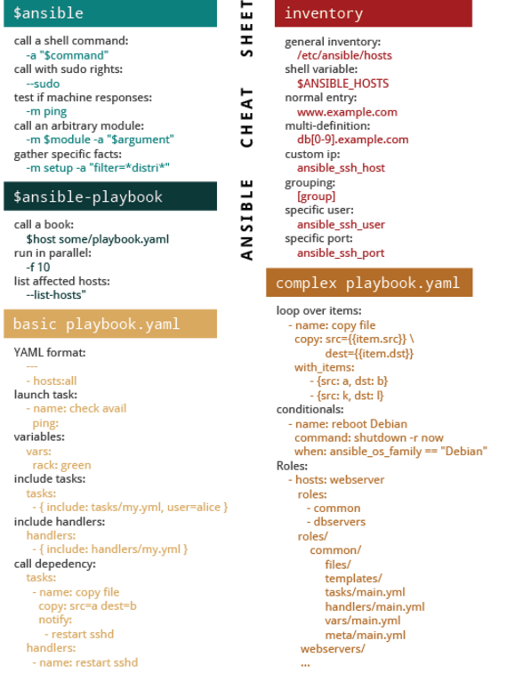

Create user yaml:

---

- hosts: webservers

tasks:

- name: create user

user:

name: user12345

comment: "user12345 "

uid: 1090

shell: "/bin/bash"

createhome: yes

home: "/home/user12345"

password: kieVINJhMcitY

to generate password in encrypted format:

openssl passwd

run_once keyword:

run_once: true to run task only once per playbook run.

Example:

[root@reviewb playbooks]# cat run_once.yaml

---

- hosts: webservers

tasks:

- name: create a dummy file

command: touch /tmp/dummymay30

run_once: true

even though there are 2 hosts in webservers, it will be executed only on 1 host.