EXPERIMENT – 10

Perform Wireless Audit on Routers and Decrypt WPA Keys Using Aircrack-ng in Kali Linux

Aim
To perform a wireless security audit on Wi-Fi routers and demonstrate WPA/WPA2 key cracking using the Aircrack-ng suite in Kali Linux with an external USB Wi-Fi adapter.

Software Requirements
- Host Operating System: Windows / Linux / macOS
- Virtualization Software: Oracle VirtualBox
- Guest Operating System: Kali Linux
- Wireless Audit Tool: Aircrack-ng
- Hardware Requirement: External USB Wi-Fi Adapter (Monitor Mode supported)
- System Requirements:
  - RAM: Minimum 4 GB (8 GB recommended)
  - Disk Space: Minimum 30 GB
  - Processor: Intel/AMD with Virtualization support

Introduction
Wireless networks are widely used but are vulnerable to attacks if weak encryption or passwords are used.
Aircrack-ng is a suite of tools used for monitoring, attacking, testing, and cracking Wi-Fi networks.
This experiment demonstrates how WPA/WPA2 handshakes can be captured and cracked to analyze the strength of wireless security.
Kali Linux with an external Wi-Fi adapter provides a controlled environment for ethical wireless security testing.

Procedure

Step 1: Start Kali Linux Virtual Machine
- Open Oracle VirtualBox.
- Start Kali Linux.
- Connect the external USB Wi-Fi adapter and attach it to the VM.

Step 2: Verify Wireless Adapter
- Open Terminal.
- Check wireless interfaces:
- iwconfig
- Identify the wireless interface (e.g., wlan0).

Step 3: Enable Monitor Mode
- Enable monitor mode:
- sudo airmon-ng start wlan0
- Monitor interface (e.g., wlan0mon) is created.

Step 4: Scan Nearby Wireless Networks
- Scan for Wi-Fi networks:
- sudo airodump-ng wlan0mon
- Note the BSSID, Channel, and Encryption type of the target network.

Step 5: Capture WPA Handshake
- Lock onto the target network:
- sudo airodump-ng -c <channel> --bssid <BSSID> -w capture wlan0mon
- Wait for a client to connect, or deauthenticate a client.

Step 6: Deauthenticate Client (Optional)
- Force client reconnection:
- sudo aireplay-ng --deauth 5 -a <BSSID> wlan0mon
- WPA handshake is captured.

Step 7: Crack WPA Key
- Use Aircrack-ng with a wordlist:
- sudo aircrack-ng capture-01.cap -w /usr/share/wordlists/rockyou.txt
- Observe password cracking process.

Step 8: Stop Monitor Mode
- Stop monitor mode:
- sudo airmon-ng stop wlan0mon

Output
- WPA/WPA2 handshake successfully captured.
- Password cracking attempt performed.
- Weak passwords are recovered successfully.
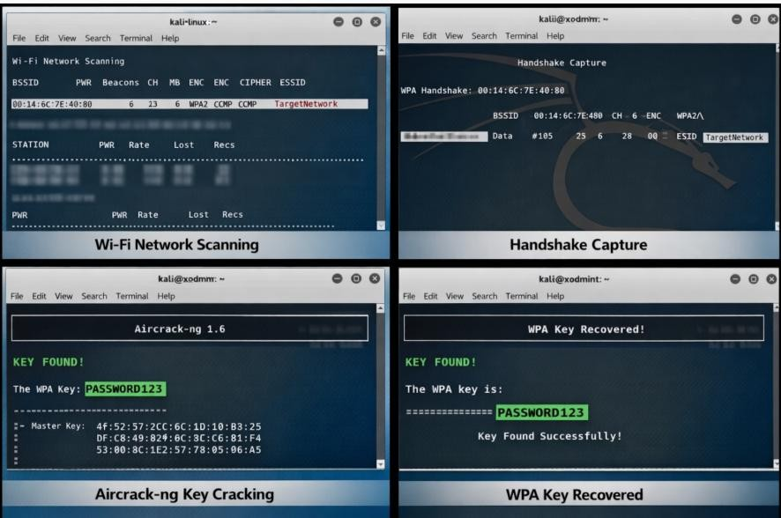

Result
Wireless auditing and WPA key decryption were successfully demonstrated using the Aircrack-ng tool in Kali Linux.
The experiment highlights the importance of strong passwords and secure wireless encryption methods.

