Experiment 2
Encryption – Crypto 101 using TryHackMe Platform

Aim:
To understand the fundamentals of cryptography by performing hands-on exercises in the Crypto 101 room on the TryHackMe platform, including basic encryption, encoding, hashing, and cryptographic concepts.
Tools / Platform Required
Web browser (Chrome / Firefox)
Internet connection
TryHackMe account (free)
Built-in TryHackMe terminal (AttackBox) or local Linux machine
Theory (Brief)
Cryptography is the practice of securing information by converting plain text into unreadable format (cipher text) using encryption techniques.
Crypto 101 introduces basic concepts such as:
Encoding vs Encryption
Symmetric and Asymmetric encryption
Hashing
Common ciphers (Caesar, Base64, etc.)
Steps to Perform the Experiment
Step 1: Login toTryHackMe
- Open browser and go to: https://tryhackme.com
- Login using your registered credentials.
Step 2: Open Crypto 101 Room
- In the search bar, type Crypto 101
- Click on the room named Crypto 101
- Click Join Room
Step 3: Start the Machine (if required)
- Click Start Machine / Start AttackBox
- Wait for the virtual environment to load.
Step 4: Perform Cryptography Tasks
Complete the tasks provided in the room, such as:
4.1 Encoding & Decoding
(a) Base64 Encoding / Decoding
Purpose:
Base64 is an encoding technique used to represent binary data in readable ASCII format.
How to Solve
To Decode Base64
- Copy the given Base64 string from the question.
- Open the TryHackMe terminal.
- Use the command:
echo "Q3J5cHRvZ3JhcGh5" | base64 -d
- The output will be the decoded plain text.
- Enter the decoded text into the answer box.
To Encode Base64
echo "cryptography" | base64
Expected Output Example: Cryptography
(b) Hexadecimal Conversion
Purpose:
Hexadecimal is a base-16 encoding system commonly used in computing.
How to Solve
Hex to Text
echo 48656c6c6f | xxd -r -p
Text to Hex
echo "Hello" | xxd -p
Expected Output: Hello
4.2 Classical Ciphers
(a) Caesar Cipher
Purpose:
Caesar cipher shifts letters by a fixed number.
How to Solve
- Identify the shift value (given or by trial).
- Use online Caesar decoder or terminal tool.
Using terminal
echo "KHOOR" | tr 'A-Z' 'X-ZA-W'
(Shift = 3)
Expected Output: HELLO
(b) Shift-Based Encryption
Purpose:
Similar to Caesar cipher but may use different shift values.
How to Solve
- Try different shift values until meaningful text appears.
- Online tools can be used if allowed.
Example:
Shift 1 incorrect
Shift 3 readable text correct answer
4.3 Hashing
(a) Understanding Hash Algorithms
Hash Type Length
MD5 32 characters
SHA-1 40 characters
SHA-256 64 characters
(b) Identifying Hashes
How to Solve
- Count the number of characters in the given hash.
- Match it with the table above.
Example:
5d41402abc4b2a76b9719d911017c592
32 characters MD5
Generating Hashes
echo -n "hello" | md5sum
echo -n "hello" | sha1sum
echo -n "hello" | sha256sum
4.4 Encryption Concepts
(a) Encryption vs Hashing
Encryption Hashing
Reversible Irreversible
Uses keys No keys
Used for secure communication Used for password storage
(b) Symmetric vs Asymmetric Encryption
Symmetric Asymmetric
One key Two keys
Fast Slower
Example: AES Example: RSA
Step 5: Verify Completion
- Ensure all tasks are marked Completed
- Observe the success message at the end of the room
Output
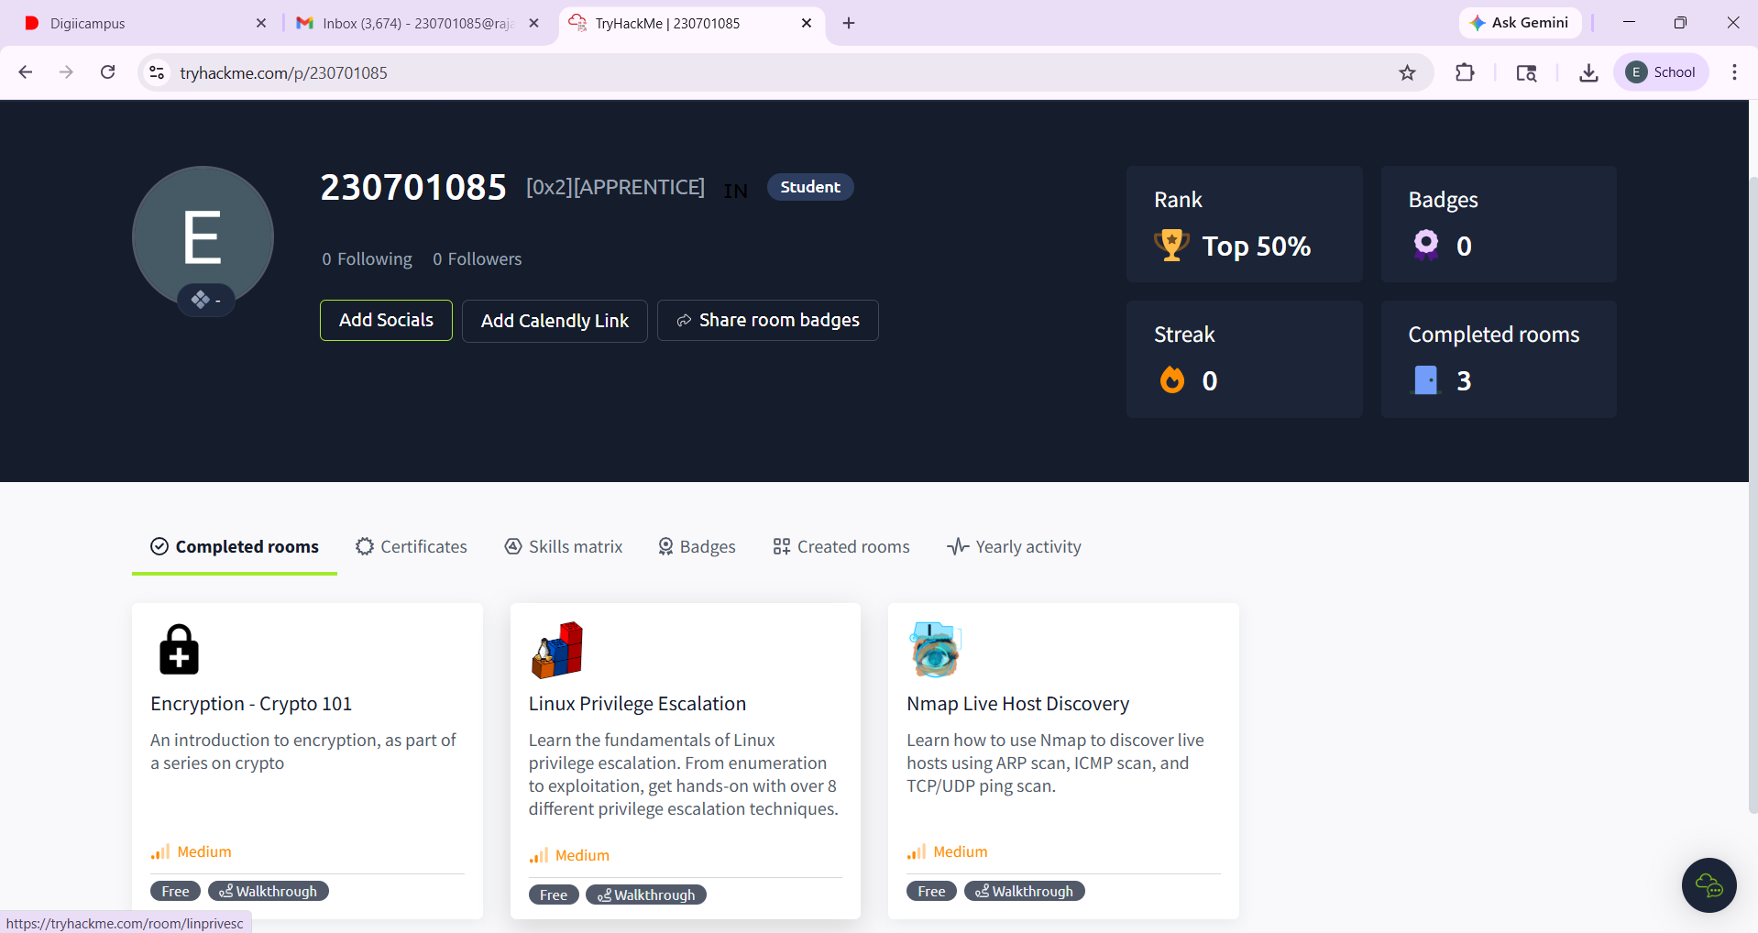
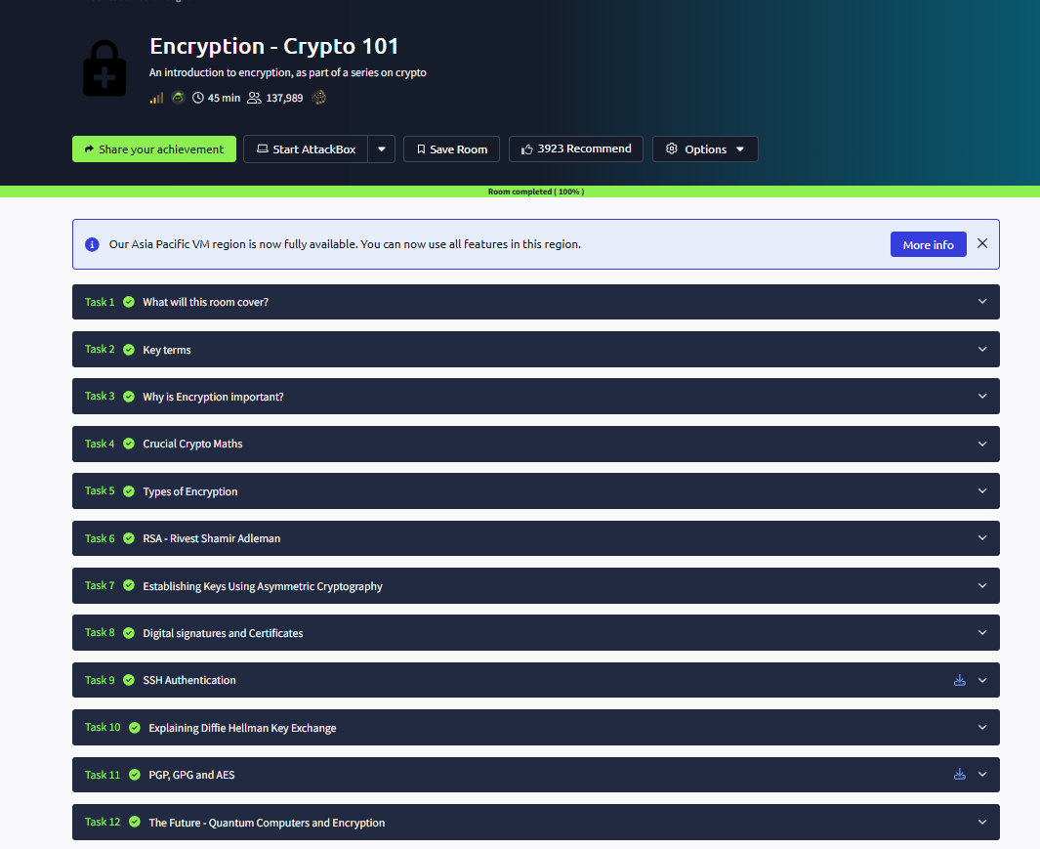

Result
Thus, the Crypto 101 experiment was successfully completed on the TryHackMe platform.
The experiment helped in understanding basic cryptographic concepts, encryption techniques, encoding methods, and hashing algorithms through hands-on practice.

