EXPERIMENT – 6

Snort IDS/IPS to Detect and Prevent Real-Time Threats Using TryHackMe Platform

Aim
To understand and demonstrate the working of Snort as an Intrusion Detection System (IDS) and Intrusion Prevention System (IPS) by detecting real-time network threats using the TryHackMe platform.

Tools / Platform Required
- Web Browser (Chrome / Firefox)
- Internet Connection
- TryHackMe Account (Already Created)
- TryHackMe AttackBox (Built-in Linux Environment)
- Snort IDS/IPS Tool (Pre-installed in AttackBox)

Theory (Brief)
Intrusion Detection Systems (IDS) and Intrusion Prevention Systems (IPS) are essential components of network security used to monitor, detect, and prevent malicious activities.
Snort is an open-source, signature-based IDS/IPS capable of real-time traffic analysis and packet inspection.
TryHackMe provides a safe and legal environment to practice IDS/IPS concepts by simulating real-world attacks and defenses without impacting live systems.

Steps to Perform the Experiment

Step 1: Login to TryHackMe
- Open browser and go to: https://tryhackme.com
- Login using registered credentials.

Step 2: Open Snort Room
- In the search bar, type Snort.
- Select a room related to Snort IDS/IPS.
- Click Join Room.

Step 3: Start the AttackBox
- Click Start AttackBox.
- Wait for the Linux environment to load.
- Open the terminal inside AttackBox.

Step 4: Verify Snort Installation
- In the terminal, check Snort version:
- snort --version
- Ensure Snort is successfully installed.

Step 5: Run Snort in IDS Mode
- Start Snort in console mode:
- sudo snort -A console -q -c /etc/snort/snort.conf -i eth0
- Snort begins monitoring network traffic in real time.

Step 6: Detect Network Threats
- Perform network scanning or simulated attacks as instructed in the TryHackMe room.
- Observe alerts generated by Snort.
- Analyze alerts indicating suspicious or malicious activity.

Step 7: Configure Snort as IPS (Optional)
- Run Snort in inline (IPS) mode:
- sudo snort -Q --daq afpacket -c /etc/snort/snort.conf -i eth0
- Configure rules to drop malicious packets.
- Observe blocked traffic in real time.

Step 8: Analyze Alerts
- Review generated alerts on the terminal.
- Identify attack types such as port scanning, brute force, or suspicious packets.

Output

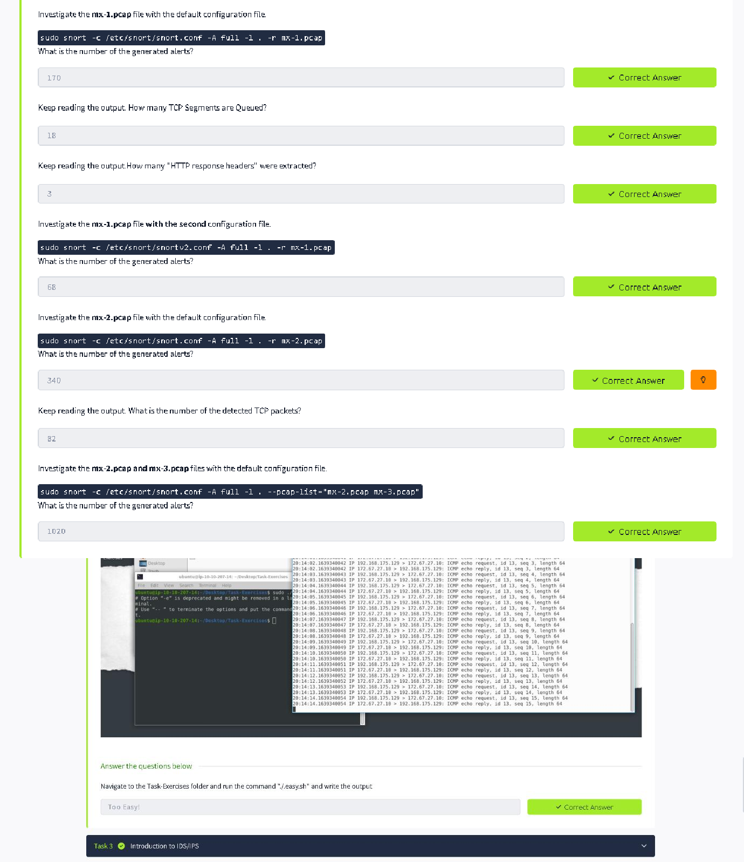

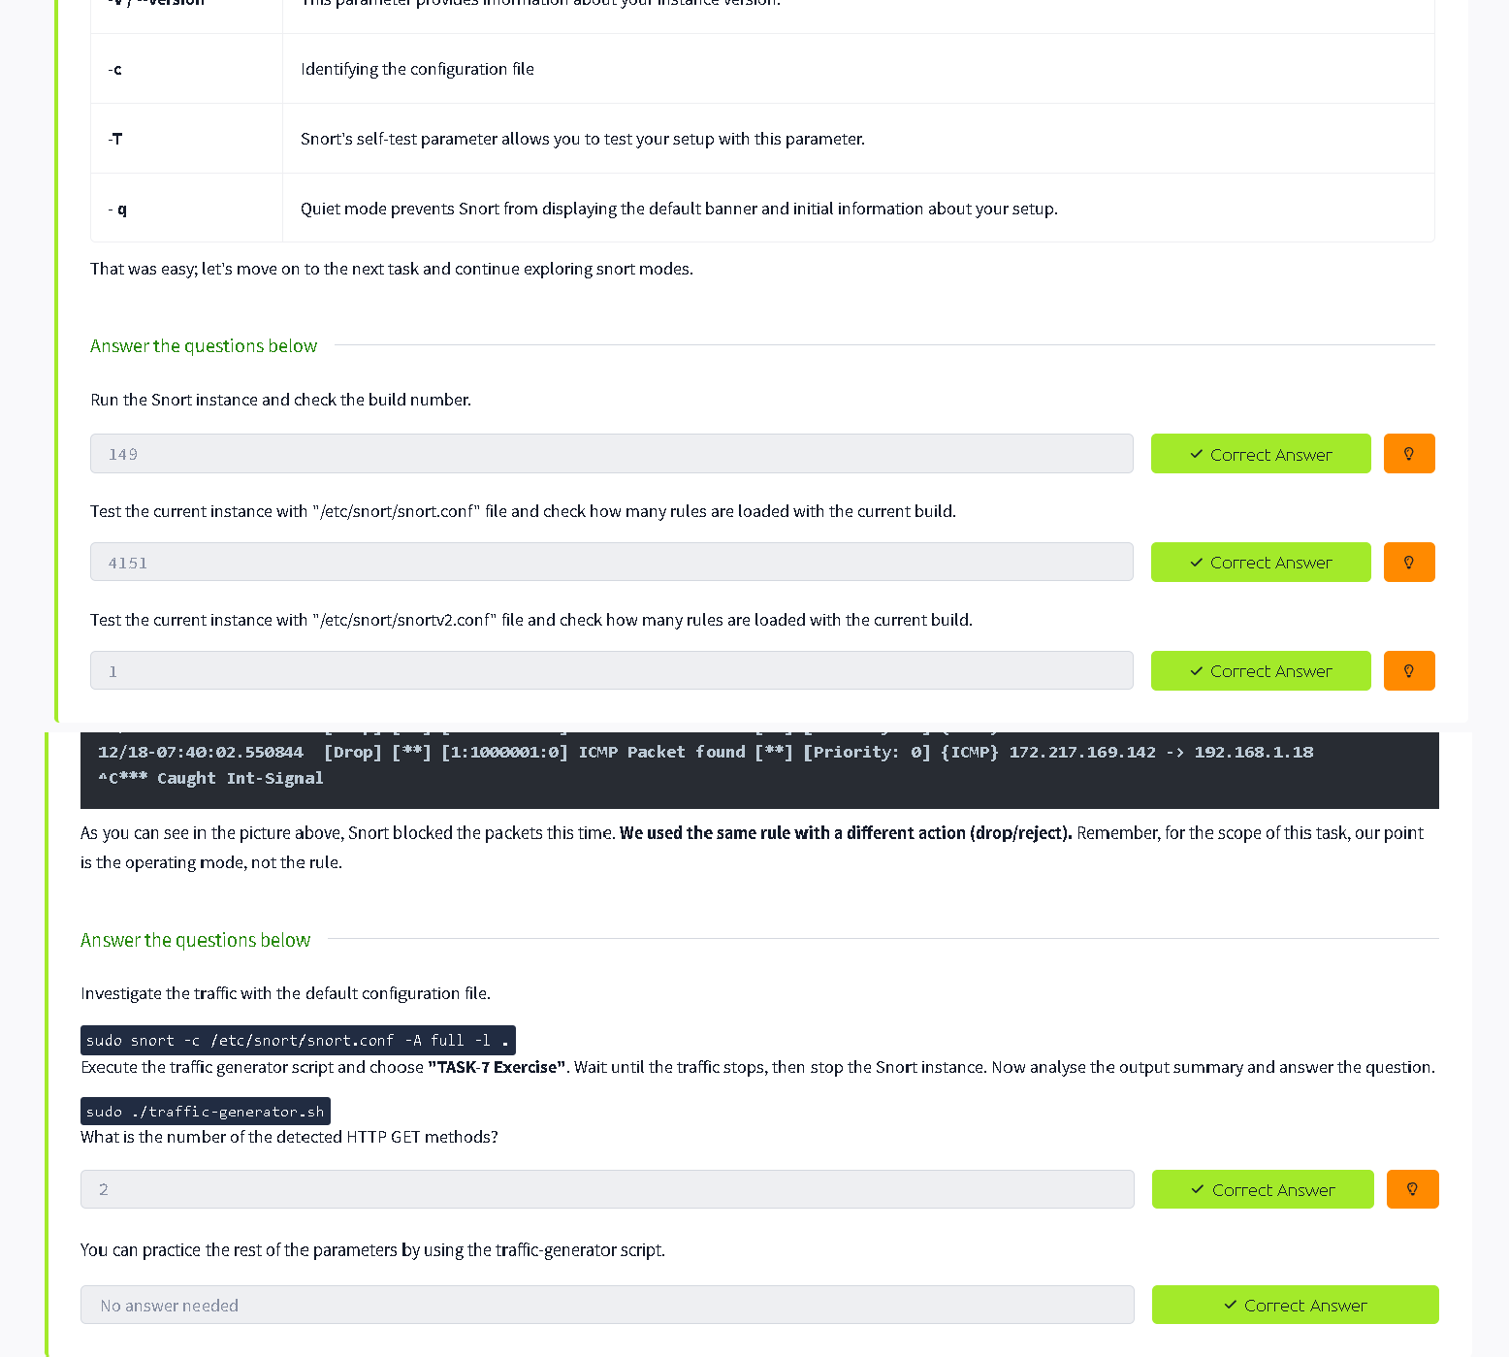

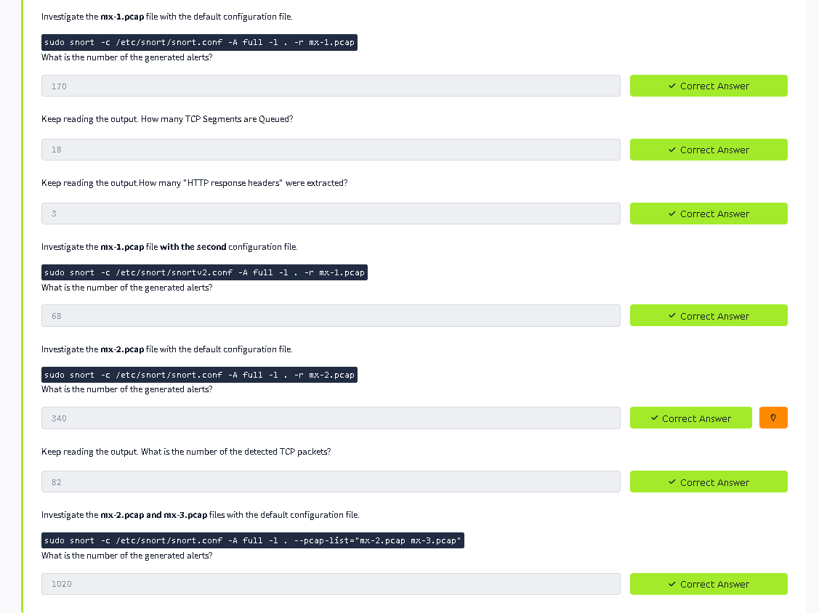

Result
Thus, Snort IDS/IPS was successfully used to detect and prevent real-time network threats using the TryHackMe platform. The experiment enhanced understanding of intrusion detection, prevention mechanisms, and real-time network security monitorin

