EXPERIMENT – 8
Privilege Escalation Using TryHackMe Platform
Aim
To understand and demonstrate Linux privilege escalation techniques by exploiting system misconfigurations and vulnerabilities using the TryHackMe platform.
Tools / Platform Required
Web Browser (Chrome / Firefox)
Internet Connection
TryHackMe Account (Already Created)
TryHackMe AttackBox (Built-in Linux Environment)
Linux Privilege Escalation Tools (LinPEAS, sudo, find, etc.)
Theory (Brief)
Privilege Escalation is a technique used to gain higher-level permissions than originally assigned.
In Linux systems, attackers often exploit misconfigured permissions, vulnerable binaries, or weak sudo rules to escalate from a normal user to root.
TryHackMe provides a legal and controlled environment to practice privilege escalation techniques and understand real-world attack scenarios.
Steps to Perform the Experiment
Step 1: Login to TryHackMe
- Open browser and go to: https://tryhackme.com
- Login using your registered credentials.
Step 2: Open Privilege Escalation Room
- In the search bar, type Linux Privilege Escalation.
- Click on the appropriate room.
- Click Join Room.
Step 3: Start the AttackBox
- Click Start AttackBox.
- Wait for the Linux environment to load.
- Open the terminal inside AttackBox.
Step 4: Initial Enumeration
- Check current user:
- whoami
- Check system information:
- uname -a
- Check sudo permissions:
- sudo -l
Step 5: Identify Privilege Escalation Vectors
Common techniques explored:
Sudo misconfigurations
SUID binaries
Weak file permissions
Environment variable abuse
Cron job misconfigurations
Example command:
find / -perm -4000 2>/dev/null
Step 6: Exploit Vulnerability
- Execute the vulnerable binary or misconfigured command.
- Escalate privileges to root user.
- Verify escalation:
- whoami
Step 7: Capture Flags / Complete Tasks
- Obtain root-level access.
- Capture the required flags.
- Mark all tasks as completed.
Output
Successful privilege escalation from normal user to root.

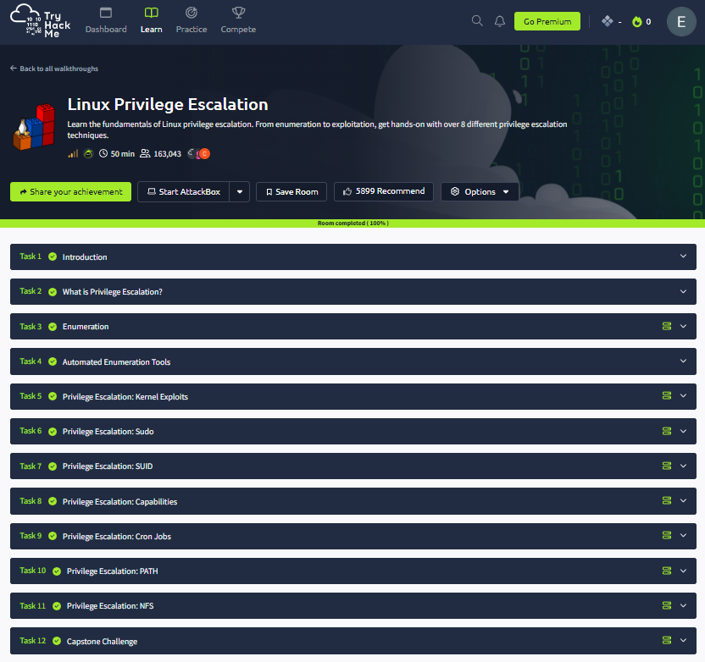
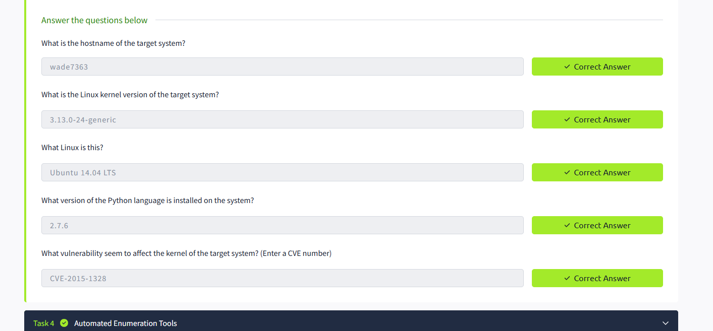
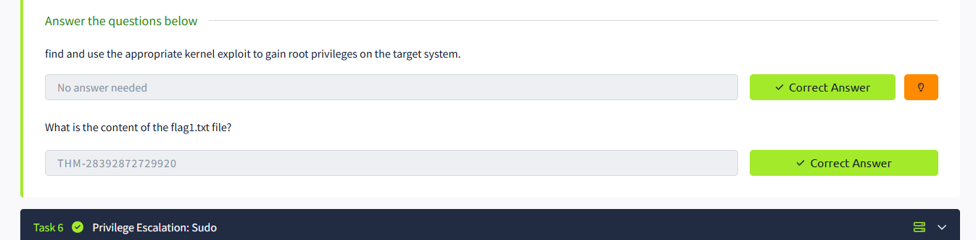
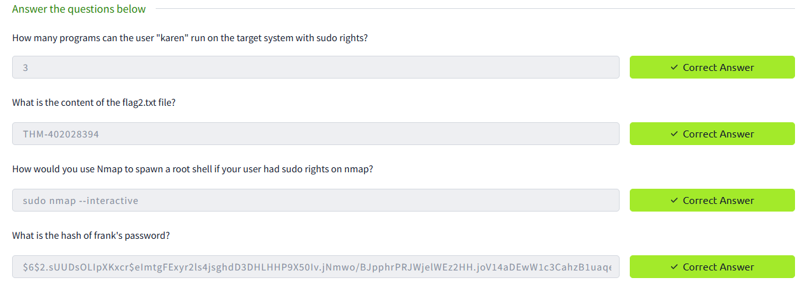
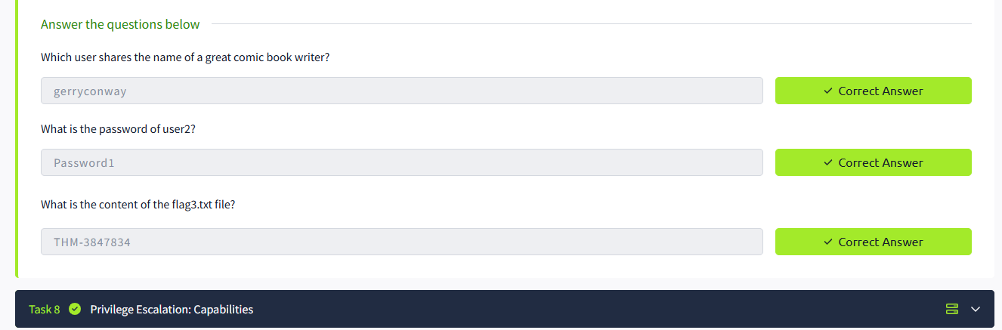
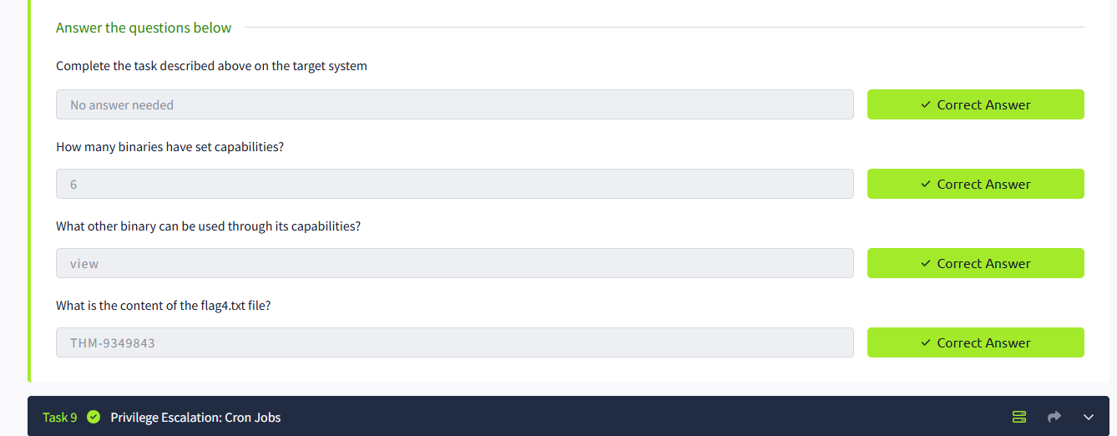
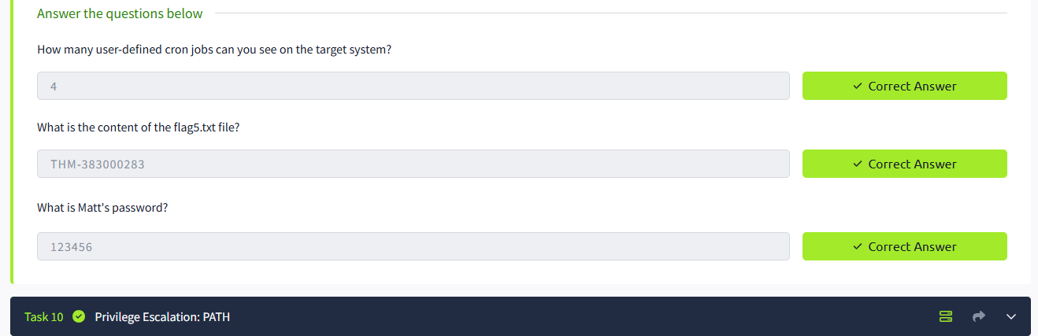
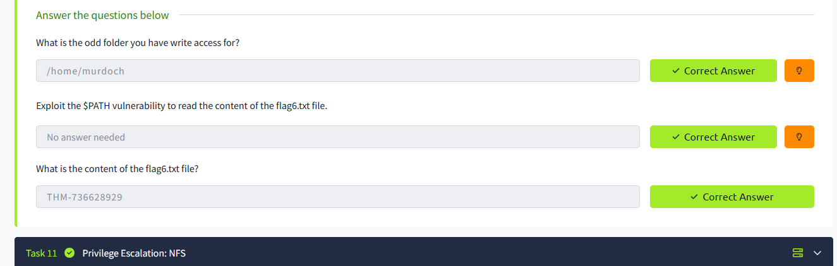
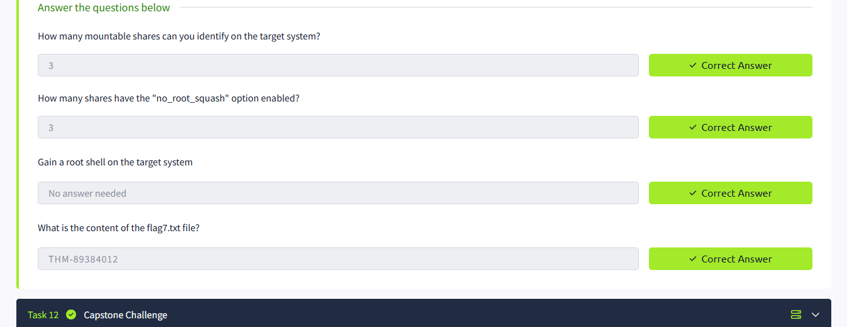
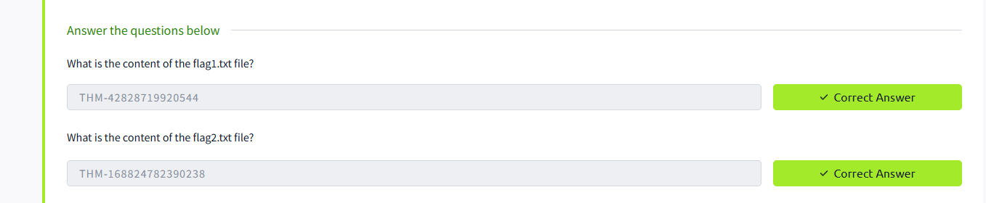

Result
Thus, privilege escalation was successfully performed using the TryHackMe platform.
The experiment provided hands-on understanding of Linux privilege escalation techniques and system security weaknesses.

