**ONLINE QUIZ**

**BACHELOR OF TECHNOLOGY**

**IN**

**COMPUTER SCIENCE AND ENGINEERING**

**BY**

**NALLA NAGA SAI NANDITHA (21501A05C3)**

**MADUPU ISHWARYA (22505A0508)**

**Under the Guidance of**

**Mrs. D. SREE LAKSHMI (Ph.D.)**

**Assistant Professor**

**&**

**Ms. KILARI JYOTHSNA DEVI (M.Tech., Ph.D)**

**Assistant Professor**



**PRASAD V POTLURI SIDDHARTHA INSTITUTE OF TECHNOLOGY**

(Permanently affiliated to JNTU :: Kakinada, Approved by AICTE)

(An NBA & NAAC accredited and ISO 9001:2008 certified institution)

**Kanuru, Vijayawada - 520007**

**(2023-2024)**

**PRASAD V POTLURI**

SIDDHARTHA INSTITUTE OF TECHNOLOGY

(Permanently affiliated to JNTU :: Kakinada, Approved by AICTE)

(An NBA & NAAC accredited and ISO 9001:2008 certified institution)

**Kanuru, Vijayawada – 520007**



**CERTIFICATE**

This is to certify that the project report title**“ONLINE QUIZ “**is the bonafied work of **NALLA NAGA SAI NANDITHA[21501A05C3]** and **MADUPU ISHWARYA[22505A0508]** in partial fulfilment of completing the Academic project in Web Application Development during the academic year 2023-2024.

**Signature of the In-charge Signature of the HOD**

**Mrs. D. SREE LAKSHMI Dr. A. Jayalakshmi**

Asst. Professor, CSE Dept. Head, Department of CSE

**INDEX**

|  |  |  |
| --- | --- | --- |
| **S. No.** | **Content** | **Page No. (s)** |
| 1 | Abstract | 4-5 |
| 2 | Introduction | 6-7 |
| 3 | Objectives and Scope of the Project | 8-9 |
| 4 | Software used – Explanation | 10-11 |
| 5 | Web Pages (with explanation) | 12-15 |
| 6 | Sample Code | 16-30 |
| 7 | Result/Output Screen shots | 31-33 |
| 8 | Conclusion | 34-35 |

**ABSTRACT**

This report outlines the development of an open-access online quiz portal designed for school students, leveraging modern web technologies. In an educational landscape increasingly reliant on digital resources, the creation of an interactive web-based platform for quizzes becomes a pivotal endeavor. This project utilizes HTML, CSS, JavaScript, and database integration to provide an engaging and educational experience for students.

The primary objectives of this project include:

**User-Centric Interface:** The web application offers an intuitive and engaging interface, allowing students to easily access, attempt, and review quizzes.

**Educational Content:** The portal includes a diverse range of subject-specific quizzes, enhancing students' learning experiences and reinforcing classroom knowledge.

**Progress Tracking**: Students can monitor their quiz performance, review their answers, and receive immediate feedback to facilitate self-assessment.

**User Authentication Not Required:** The system is intentionally designed without user authentication, allowing access to anyone, whether they have an email or not.

**Teacher/Admin Tools:** Educators have the ability to create, manage, and monitor quizzes, making this platform an effective tool for both students and teachers.

**Accessibility:** Efforts are made to ensure the portal complies with web accessibility standards, allowing all students, including those with disabilities, to benefit from the platform.

**Mobile Responsiveness:** The web application is designed to be responsive, ensuring a seamless user experience across various devices, including smartphones and tablets.

**Error Handling:** The system is equipped with robust error handling to address any technical issues or user-related errors.

The development process involves creating HTML templates for the user interface, utilizing CSS for attractive design, and implementing JavaScript for dynamic interactions and we have used dictionary to store quiz data and response of the particular attempt made.

Our website randomly chooses the questions from given set of questions and every time all the options provided are jumbled randomly. This helps the user to learn the topic rather than remembering the answers.

The online quiz portal for school students exemplifies the fusion of technology and education, offering a modern, engaging, and accessible platform for students to enhance their learning experience without the need for user authentication. This project addresses the evolving educational landscape and demonstrates the potential of web technologies to facilitate effective and interactive learning.

The successful development of this online quiz portal underscores the power of HTML and web technologies in the realm of education, contributing to improved learning experiences and catering to the needs of tech-savvy students in a digital era, all while allowing access to anyone, regardless of email presence.

**INTRODUCTION**

**Unlock the World of Knowledge Through Quizzes**: In the age of digital education and interactive learning, our online quiz portal opens the door to a world of knowledge and fun. Designed with students in mind, this platform provides a unique opportunity to test, reinforce, and expand your understanding of various subjects and topics.

**Learning Made Engaging**: Education doesn't have to be dull or one-sided. Our online quiz portal adds an element of excitement to the learning process. Through a wide range of quizzes spanning different subjects, students can engage with educational content in a dynamic and interactive manner.

**No Boundaries, No Logins Required**: What sets our portal apart is its accessibility. There are no boundaries to access; no need for complicated logins or personal information. It's a hassle-free experience, designed for anyone with a thirst for knowledge, whether you're a student with an email or without one.

**Teachers and Students - Partners in Learning**: Teachers play a pivotal role in this ecosystem. They can create quizzes, manage content, and track student progress, making it a collaborative tool for both educators and students. It's a platform for teachers to empower their students and students to enhance their understanding.

**Challenge Yourself, Track Progress**: Beyond just answering questions, our portal encourages students to challenge themselves, track their progress, and strive for improvement. Each quiz is an opportunity to learn, self-assess, and ultimately excel in their studies.

**Empowerment Through Gamification**: Gamification elements, such as timed quizzes, leaderboards, and achievements, add an extra layer of motivation. Learning becomes a game, and success is rewarded. It's a journey of exploration and self-discovery.

**For the Tech-Savvy Generation**: In a world where technology shapes the way we learn, our online quiz portal aligns perfectly with the preferences of the tech-savvy generation. It's a modern educational tool that adapts to the digital age.

**Open Education for All**: We believe that knowledge should be open and accessible to all. Our platform embodies the spirit of open education, offering a wealth of resources to those eager to learn.

In summary, our online quiz portal is a gateway to interactive and engaging learning, a place where students can challenge themselves, track their progress, and explore a world of knowledge, all without the constraints of complex logins. It's the future of education, where learning is fun, accessible, and empowering.

**OBJECTIVES FOR THE ONLINE QUIZ**

**Facilitate Learning:** The primary objective of the project is to provide a platform where students can enhance their learning experience through interactive quizzes covering a wide range of subjects.

**Accessible Education:** Create a space where education is accessible to all, without the need for user authentication, allowing students with or without email addresses to participate.

**Engagement and Motivation:** Foster student engagement by incorporating gamification elements like timers, leader-boards, and achievements to make learning more exciting and motivating.

**Teacher Empowerment**: Provide educators with tools to create, manage, and monitor quizzes, enabling them to actively participate in their students' learning journeys.

**Progress Tracking:** Enable students to track their quiz performance, review their answers, and receive immediate feedback for self-assessment and improvement.

**Open Educational Resource:** Establish the portal as an open educational resource that serves as a valuable complement to classroom learning and traditional study materials.

**Modern Learning**: Cater to the preferences of the tech-savvy generation by offering a modern, web-based learning environment.

**No Boundaries To Learning**: Ensure that there are no boundaries to learning by allowing access for anyone interested in acquiring knowledge, regardless of their email status.

**SCOPE OF THE ONLINE QUIZ**

**Quiz Content:** The portal will offer a wide range of quiz content, covering various subjects and topics, catering to students from diverse educational backgrounds.

**User Accessibility:** The platform will not require users to create accounts or provide personal information, making it accessible to a broad user base.

**Gamification:** Gamification features will be integrated to enhance user engagement, including timed quizzes, leaderboards, and achievement badges.

**Teachers and Admin Features:** Teachers and administrators will have access to create, manage, and monitor quizzes, ensuring the quality and relevance of the content.

**Progress Tracking:** The system will enable students to track their quiz performance, view correct answers, and receive immediate feedback for each question.

**Modern Web Technologies:** The portal will leverage modern web technologies for a responsive and user-friendly experience across various devices and screen sizes.

**Content Curation:** The project will involve the curation of educational content to ensure its accuracy and relevance to the intended audience.

**Privacy and Security:** While user authentication is not required, the portal will maintain appropriate privacy and security measures to protect user data and ensure a safe online environment.

**Scalability:** The project will be designed with scalability in mind, allowing for the addition of more quizzes and features as the platform grows.

**Open Education Initiative:** The portal aligns with the principles of open education, offering knowledge and resources to all who seek to learn, fostering a culture of shared learning and self-improvement.

By defining these objectives and the scope of the project, the online quiz portal aims to provide an inclusive, engaging, and modern educational platform for students, teachers, and lifelong learners.

**SOFTWARE USED**

**HTML (Hypertext Markup Language):**

HTML is the fundamental building block of web pages. In the "ONLINE QUIZ" project, HTML is used for creating the structure and content of web pages. As an average student, you may know that HTML uses tags to define elements like headings, paragraphs, forms, and links. For example, HTML is used to create web pages in our project.

**CSS (Cascading Style Sheets):**

CSS is used to make web pages visually appealing. It controls the layout, design, and styling of the web pages created with HTML. As a student with basic knowledge, you may be aware that CSS allows you to change the color, size, and position of elements on a web page. In the project, CSS is used to style the pages and make them user-friendly. For instance, CSS styles are applied to index page, sign in page, and the overall layout of the "ONLINE QUIZ " platform, making it visually attractive and easy to navigate.

**JAVA SCRIPT:**

JavaScript is a programming language used to add interactivity and dynamic features to web pages. As a student, you might know that JavaScript can be used to store data and can be manipulated. In our project, we used JavaScript for validating the answers provided, generate random order of question and answers and also to display the result of the attempt made.

**TEXT EDITORS:**

Text editors are software tools used to write and edit code. As a student, you may use a simple text editor like Visual Studio Code. These text editors are where

HTML, CSS, and JavaScript code for the "ONLINE QUIZ" project is written and edited. Code is saved in files with specific extensions like **.html, .css, and .js**. Not only they are saved with extensions sometimes based on the requirement we have scripted and styled the js and css code in the html code itself.

**WEB BROWSERS:**

Web browsers like Google Chrome are used to view and interact with web pages. As an average student, you would open your web browser to access the "ONLINE QUIZ" platform. Web browsers interpret and display the HTML, CSS, and JavaScript code to present the web pages in a user-friendly format.

**WEB PAGES**

**HTML Structure:** The code starts with the HTML5 document structure. It includes the essential tags, such as<html>,<head> and <body> to define the structure of the webpage.

**Meta Tags:** Meta tags in the <head> section provide important information about the document, including character encoding and viewport settings for responsive design.

**Title:** The <title> tag sets the title of the webpage that is displayed in the browser's title bar or tab. In this case, it's "Quiz Portal."

**External Resources:** The code links external resources, such as a CSS stylesheet ("frontpage.css") and a JavaScript file ("frontpage.js") to enhance the presentation and interactivity of the webpage.

**Navagation (nav):** The <nav> section contains navigation links for "Login/Signup," "Home," and links to classes 6 through 10. It allows users to navigate between different sections of the website.

**Header:** The <header> section includes a large heading ("Welcome to the Quiz Portal") that serves as the main title or banner of the webpage.

**Main Content:** The main content is wrapped in a **<center>** tag. It provides a brief introduction to the quiz portal and its mission. It mentions the types of quizzes available and their educational purpose.

**Class Links:** There are images and text links for classes 6 through 10. Each class link is associated with an image and a description to guide users to the respective quiz sections.

**Footer:** The <div> with class "footer" contains copyright information ("© 2023 Question Hub. All rights reserved.") for the website, typically found at the bottom of the webpage.

**Image Links:** Images are used to represent each class, making the content visually appealing and engaging. Each class image is hyperlinked to the corresponding quiz section.

**Lists:** Unordered lists (<ul>) are used to organize and group class links, images, and descriptions for each class.

**JAVA SCRIPT USED:**

**Quiz Data:** An array named quizData is defined. This array contains objects, each representing a quiz question. Each question object has the following properties:

**question**: The actual question text.

**options:** An array of answer options.

**answer:** The correct answer to the question.

Several HTML elements are referenced and stored in variables. These elements are used to dynamically update the content on the webpage. These variables include:

**quizContainer:** References the <div> element with the id "quiz" where questions are displayed.

**resultContainer:** References the <div> element with the id "result" where the quiz results are displayed.

**submitButton:** References the "Submit" button.

**retryButton:** References the "Retry" button.

**showAnswerButton:** References the "Show Answer" button.

**Functions:**

**shuffleArray(array):** This function shuffles the order of elements in an array. It's used to randomize the order of answer options for each question.

**displayQuestion():** This function displays the current question and its answer choices on the webpage. It creates HTML elements to show the question and its answer options, which are then appended to the quizContainer.

**checkAnswer():** This function checks if the user's selected answer is correct. It retrieves the selected option, compares it to the correct answer for the current question, updates the score, and moves to the next question.

**displayResult():** This function displays the user's score and hides the quiz questions. It's called when the user has answered all the questions.

**retryQuiz():** This function resets the quiz, allowing the user to retry it. It sets the currentQuestion back to 0, resets the score, and clears the incorrect answers. It then displays the first question.

**showAnswer():** This function displays both the user's score and a list of incorrect answers, along with the correct answers for those questions. This is used when the user requests to see the correct answers.

**Event Listeners:**

submitButton, retryButton, and showAnswerButton have event listeners attached to them. When clicked, these buttons trigger the respective functions (checkAnswer, retryQuiz, and showAnswer).

**CSS USED:**

**.main:**

Applied to a <div> element in the HTML with the class attribute set to "main."

Defines styling for the main content area of your web page.

Sets a fixed width, padding, margin, background color, box shadow, and border radius.

It positions the content in the center of the page.

**.header:**

Applied to a <div> element in the HTML with the class attribute set to "header."

Defines styling for the header section of your web page.

Sets a background color, padding, and text alignment.

**.content:**

Applied to elements within your web page's content area.

Defines padding, which creates space around the content.

**.cover-image:**

Applied to an <img> element, presumably for images.

Sets the width and height to 50% (making the image responsive).

Uses the object-fit property to control how the image fits within its container.

Defines background positioning and repeat properties, which may affect how the image is displayed.

**#popup-container:**

Applied to a <div> element with the id "popup-container."

Sets the background color and arranges the child elements within the container.

The child elements are expected to be clickable elements (divs) within the popup container.

**#popup-container div:**

Applied to div elements within the popup container.

Sets background color, text color, padding, and cursor type for these elements.

They are presumably used for displaying popup content.

**SAMPLE CODES**

1. **frontpage.html:**

<!DOCTYPE html>

<html lang="en">

<head>

<meta charset="UTF-8">

<meta name="viewport" content="width=device-width, initial-scale=1.0">

<title>Quiz Portal</title>

<link rel="stylesheet" href="frontpage.css">

<script src="frontpage.js" defer></script>

</head>

<body>

<nav>

<a href="login.html" id="login">Login/Signup</a>

<a href="frontpage.html" id="home">Home</a>

<a href="class6.html" id="about">CLASS 6</a>

<a href="class7.html" id="about">CLASS 7</a>

<a href="class8.html" id="about">CLASS 8</a>

<a href="class9.html" id="about">CLASS 9</a>

<a href="class10.html" id="about">CLASS 10</a>

</nav>

<header>

<h1>Welcome to the Quiz Portal</h1>

</header>

<center>

<div class="main">

<h1>Get Ready for Exams!</h1>

<h2>

The Quiz Portal is a unique and interactive educational platform designed specifically for children aged 6 to 10 . Our mission is to create an engaging and entertaining learning experience that combines traditional academic concepts with interactive and imaginative elements.

Our platform features a wide array of age-appropriate quizzes, puzzles, and games that cover a variety of topics, including math, science, history, geography, and literature. These interactive activities not only challenge students' cognitive skills but also foster a love for learning and an appreciation for diverse cultural backgrounds.

</h2>

<ul>

<li> <a href="class6.html"> <img src="https://1.bp.blogspot.com/-jExNrUjlZ-k/YULyyuHO19I/AAAAAAAAEP8/O6tuow2Eae8Yu8NuTHH3bRGiMFjjlXktgCLcBGAsYHQ/s320/Class%2B6%2B%2528onlinestudywith.us%2529.JPG" alt="Class 6" style="width: 250px; height: 250px;"> </a> </li>

<h1><br><br> Here comes your class 6 quiz!! </h1>

<li> <a href="class7.html"> <img src="https://1.bp.blogspot.com/-XirOS2_xP_I/YULyWOpFvcI/AAAAAAAAEP0/AFiPa_1i3MQPcMXbXk0Csqj7vbIUP6P9wCLcBGAsYHQ/w1200-h630-p-k-no-nu/Class%2B7%2B%2528onlinestudywith.us%2529.JPG" alt="Class 7" style="width: 250px; height: 250px;"> </a> </li>

<h1><br><br><br><br> Here comes your class 7 quiz!! </h1>

<li> <a href="class8.html"> <img src="https://1.bp.blogspot.com/-t55erV5kgQ0/YULx9Al9X3I/AAAAAAAAEPs/BoK1Pkel9NM9qLZjqk2OYVTMMGcZjoBEwCLcBGAsYHQ/w1200-h630-p-k-no-nu/Class%2B8%2B%2528onlinestudywith.us%2529.JPG" alt="Class 8" style="width: 250px; height: 250px;"> </a> </li>

<h1><br><br><br><br><br><br> Here comes your class 8 quiz!! </h1>

</ul>

<center>

<ul>

<li> <a href="class9.html"> <img src="https://1.bp.blogspot.com/-wETBHs8cjWE/YULxTAMCHwI/AAAAAAAAEPk/WTOONy4lmHEgvVpMK1vcnVPsB-rs2466gCLcBGAsYHQ/s320/Class%2B9%2B%2528onlinestudywith.us%2529.JPG" alt="Class 9" style="width: 250px; height: 250px;"> </a> </li>

<h1><br><br><br> Here comes your class 9 quiz!! </h1>

<li> <a href="class10.html"> <img src="https://encrypted-tbn0.gstatic.com/images?q=tbn:ANd9GcTrQmiea9OJ-Ueh88OkHmKztOgtym0IJygQmQ&usqp=CAU" alt="Class 10" style="width: 250px; height: 250px;"> </a> </li>

<h1><br><br><br><br> Here comes your class 10 quiz!! </h1>

</ul>

</center>

</div>

</center>

<div class="footer">

<p>&copy; 2023 Question Hub. All rights reserved.</p>

</div>

</body>

</html>

1. **frontpage.css:**

body {

background-image: url('https://media.istockphoto.com/id/1464722744/photo/yellow-question-mark-surrounded-by-colorful-question-marks-on-blue-background.webp?b=1&s=170667a&w=0&k=20&c=xbjop9H6o0Wh1PREqZfFUwmwIrrZ0nt5ESGGZvTMvMM=');

background-repeat: no-repeat;

background-attachment: fixed;

background-size: cover;

font-family: Arial, sans-serif;

}

nav {

background-color: black;

display: flex;

justify-content: space-around;

padding: 10px 0;

}

nav a {

color: white;

text-decoration: none;

}

header {

background-color: rgba(0, 0, 0, 0.5);

color: white;

padding: 20px;

text-align: center;

}

.main {

width: 500px;

padding: 200px;

margin-top: 200px;

background-color: #fff;

box-shadow: 0 20px 40px rgba(0, 0, 0, 0.1);

border-radius: 200px;

justify-content: center;

}

.footer {

background-color: #f1f1f1;

padding: 20px;

text-align: center;

}

.header{

background-color: #f1f1f1;

padding: 30px;

text-align: center;

}

#navbar {

overflow: hidden;

background-color: #333;

}

#navbar a {

float: left;

display: block;

color: #f2f2f2;

text-align: center;

padding: 14px 16px;

text-decoration: none;

font-size: 17px;

}

#navbar a:hover {

background-color: #ddd;

color: black;

}

#navbar a.active {

background-color: #04AA6D;

color: white;

}

.content {

padding: 16px;

}

.sticky {

position: fixed;

top: 0;

width: 100%;

}

.sticky + .content {

padding-top: 60px;

}

#popup-container {

background-color:transparent;

display: flex;

justify-content: space-around;

margin-top: 50px;

}

#popup-container div {

background-color: rgba(0, 0, 0, 0.5);

color: transparent;

padding: 20px;

text-align: center;

cursor: pointer;

}

.cover-image {

width: 50%;

height: 50%;

object-fit: cover;

background-position: center;

background-repeat: no-repeat;

}

ul {

list-style-type: none;

margin: 0;

padding: 0;

overflow: hidden;

background-color: transparent;

}

li {

float: left;

}

li a {

display: block;

color: black;

text-align: center;

padding: 14px 16px;

text-decoration: none;

}

li a:hover {

background-color: lightblue;

}

1. **class6.html:**

<!DOCTYPE html>

<html lang="en" xmlns="http://www.w3.org/1999/xhtml">

<head>

<meta charset="utf-8" />

<title>CLASS 6</title>

<link rel="stylesheet" href="classes.css">

<script>

function redirectToArticle(url) {

window.open(url, '_self');

}

</script>

</head>

<body>

<center><h1>WELOCME TO CLASS 6 QUIZ PORTAL<br> CHOOSE A SUBJECT </h1><br><br></center>

<section class="container" onclick="redirectToArticle('class6_telugu.html')">

<h2>TELUGU</h2>

<img src="https://cdn.telanganatoday.com/wp-content/uploads/2021/06/Telugu.jpg" alt="TELUGU" style="width: 250px; height: 250px;">

</section>

<section class="container" onclick="redirectToArticle('class6_hindi.html')">

<h2>HINDI</h2>

<img src="https://i.pinimg.com/736x/c6/53/11/c65311387fae67c918fa2c750a90116d.jpg" alt="HINDI" style="width: 250px; height: 250px;">

</section>

<section class="container" onclick="redirectToArticle('class6_english.html')">

<h2>ENGLISH</h2>

<img src="https://encrypted-tbn0.gstatic.com/images?q=tbn:ANd9GcQkvcZ1bW9HG0k040hBRHtmuJM_Si6QTgZ-xg&usqp=CAU" alt="ENGLISH" style="width: 250px; height: 250px;">

</section>

<section class="container" onclick="redirectToArticle('class6_maths.html')">

<h2>MATHS</h2>

<img src="https://encrypted-tbn0.gstatic.com/images?q=tbn:ANd9GcRcV0L4cAMlyNdWSR_0lgKUhJBOaMZN7JLkug&usqp=CAU" alt="MATHS" style="width: 250px; height: 250px;">

</section>

<section class="container" onclick="redirectToArticle('class6_science.html')">

<h2>SCIENCE</h2>

<img src="https://encrypted-tbn0.gstatic.com/images?q=tbn:ANd9GcT4Rei912vUQnLuy6eaVxX9_YhIh1vyUddF_A&usqp=CAU" alt="SCIENCE" style="width: 250px; height: 250px;">

</section>

<section class="container" onclick="redirectToArticle('class6_social.html')">

<h2>SOCIAL</h2>

<img src="https://encrypted-tbn0.gstatic.com/images?q=tbn:ANd9GcR0n4-pEivtg5rPjCnOoIgNOQPWoNzU4y7X3g&usqp=CAU" alt="SOCIAL" style="width: 250px; height: 250px;">

</section>

</body>

</html>

**4. class6_telugu.html:**

<!DOCTYPE html>

<html lang="en" xmlns="http://www.w3.org/1999/xhtml">

<head>

<meta charset="utf-8" />

<link rel="stylesheet" href="quiz1.css">

<title>CLASS 6 TELUGU</title>

</head>

<body>

<center>

<div class="container">

<h1>CLASS 6 TELUGU QUIZ</h1>

<div id="quiz"></div>

<div id="result" class="result"></div>

<button id="submit" class="button">Submit</button>

<button id="retry" class="button hide">Retry</button>

<button id="showAnswer" class="button hide">Show Answer</button>

</div>

</center>

<script>

const quizData = [

{

question: 'గోనబుద్ధారెడ్డి ఏ శతాబ్దం వాడు?',

options: ['13', '14', '15', '16'],

answer: '13',

},

{

question: 'వార్ధి-అనగ?',

options: ['నీరు', 'నిప్పు', 'సముద్రం', 'చెరువు'],

answer: 'సముద్రం',

},

{

question: 'సూర్యవంశ రాజు ఎవరూ?',

options: ['వాలి', 'సుగ్రీవుడు', 'రాముడు', 'రావణడు'],

answer: 'రాముడు',

},

{

question: 'వడి-అనగ',

options: ['వేగం', 'రాగం', 'ఆగం', 'పాణం'],

answer: 'వేగం',

},

{

question: 'సేతువు-అనగ',

options: [

'వంతెన',

'మంథెన',

'నిచ్చన',

'సాగరం',

],

answer: 'వంతెన',

},

{

question: 'భక్తి-వికృతి',

options: ['బత్తి', 'నత్తి', 'పత్తి', 'సత్తి'],

answer: 'బత్తి',

},

{

question: 'మూషికం- అనగ',

options: ['ఎలుక', 'ఉడుత', 'ఉడుము', 'నడుము'],

answer: 'ఎలుక',

},

];

const quizContainer = document.getElementById('quiz');

const resultContainer = document.getElementById('result');

const submitButton = document.getElementById('submit');

const retryButton = document.getElementById('retry');

const showAnswerButton = document.getElementById('showAnswer');

let currentQuestion = 0;

let score = 0;

let incorrectAnswers = [];

function shuffleArray(array) {

for (let i = array.length - 1; i > 0; i--) {

const j = Math.floor(Math.random() * (i + 1));

[array[i], array[j]] = [array[j], array[i]];

}

}

function displayQuestion() {

const questionData = quizData[currentQuestion];

const questionElement = document.createElement('div');

questionElement.className = 'question';

questionElement.innerHTML = questionData.question;

const optionsElement = document.createElement('div');

optionsElement.className = 'options';

const shuffledOptions = [...questionData.options];

shuffleArray(shuffledOptions);

for (let i = 0; i < shuffledOptions.length; i++) {

const option = document.createElement('label');

option.className = 'option';

const radio = document.createElement('input');

radio.type = 'radio';

radio.name = 'quiz';

radio.value = shuffledOptions[i];

const optionText = document.createTextNode(shuffledOptions[i]);

option.appendChild(radio);

option.appendChild(optionText);

optionsElement.appendChild(option);

}

quizContainer.innerHTML = '';

quizContainer.appendChild(questionElement);

quizContainer.appendChild(optionsElement);

}

function checkAnswer() {

const selectedOption = document.querySelector('input[name="quiz"]:checked');

if (selectedOption) {

const answer = selectedOption.value;

if (answer === quizData[currentQuestion].answer) {

score++;

} else {

incorrectAnswers.push({

question: quizData[currentQuestion].question,

incorrectAnswer: answer,

correctAnswer: quizData[currentQuestion].answer,

});

}

currentQuestion++;

selectedOption.checked = false;

if (currentQuestion < quizData.length) {

displayQuestion();

} else {

displayResult();

}

}

}

function displayResult() {

quizContainer.style.display = 'none';

submitButton.style.display = 'none';

retryButton.style.display = 'inline-block';

showAnswerButton.style.display = 'inline-block';

resultContainer.innerHTML = `You scored ${score} out of ${quizData.length}!`;

}

function retryQuiz() {

currentQuestion = 0;

score = 0;

incorrectAnswers = [];

quizContainer.style.display = 'block';

submitButton.style.display = 'inline-block';

retryButton.style.display = 'none';

showAnswerButton.style.display = 'none';

resultContainer.innerHTML = '';

displayQuestion();

}

function showAnswer() {

quizContainer.style.display = 'none';

submitButton.style.display = 'none';

retryButton.style.display = 'inline-block';

showAnswerButton.style.display = 'none';

let incorrectAnswersHtml = '';

for (let i = 0; i < incorrectAnswers.length; i++) {

incorrectAnswersHtml += `

<p>

<strong>Question:</strong> ${incorrectAnswers[i].question}<br>

<strong>Your Answer:</strong> ${incorrectAnswers[i].incorrectAnswer}<br>

<strong>Correct Answer:</strong> ${incorrectAnswers[i].correctAnswer}

</p>

`;

}

resultContainer.innerHTML = `

<p>You scored ${score} out of ${quizData.length}!</p>

<p>Incorrect Answers:</p>

${incorrectAnswersHtml}

`;

}

submitButton.addEventListener('click', checkAnswer);

retryButton.addEventListener('click', retryQuiz);

showAnswerButton.addEventListener('click', showAnswer);

displayQuestion();

</script>

</body>

</html>

**RESULTS/OUTPUTS SCREEN SHOTS**

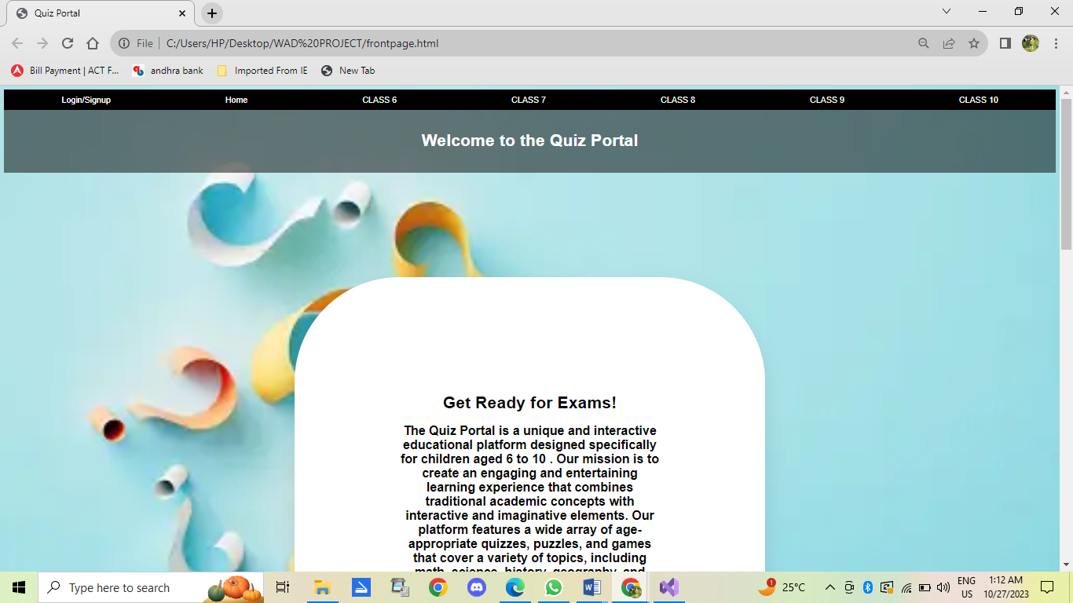

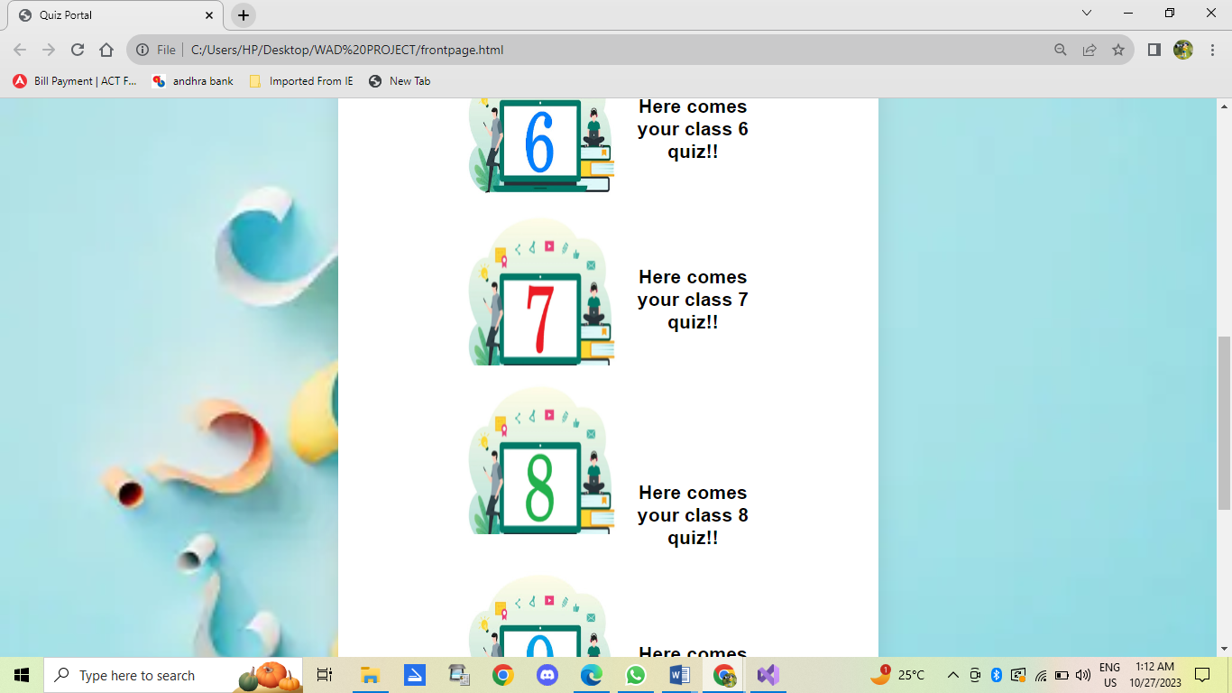

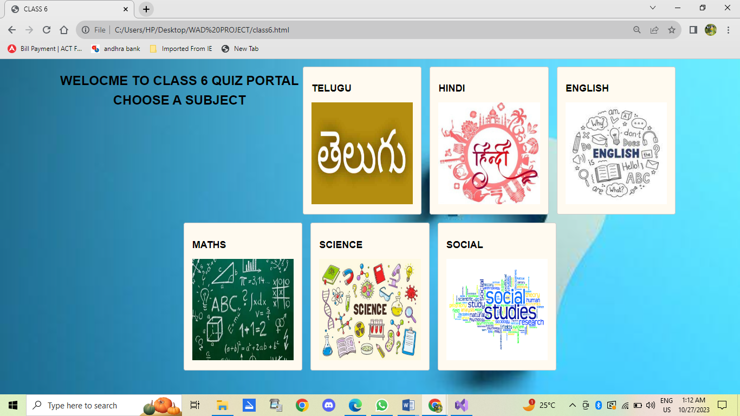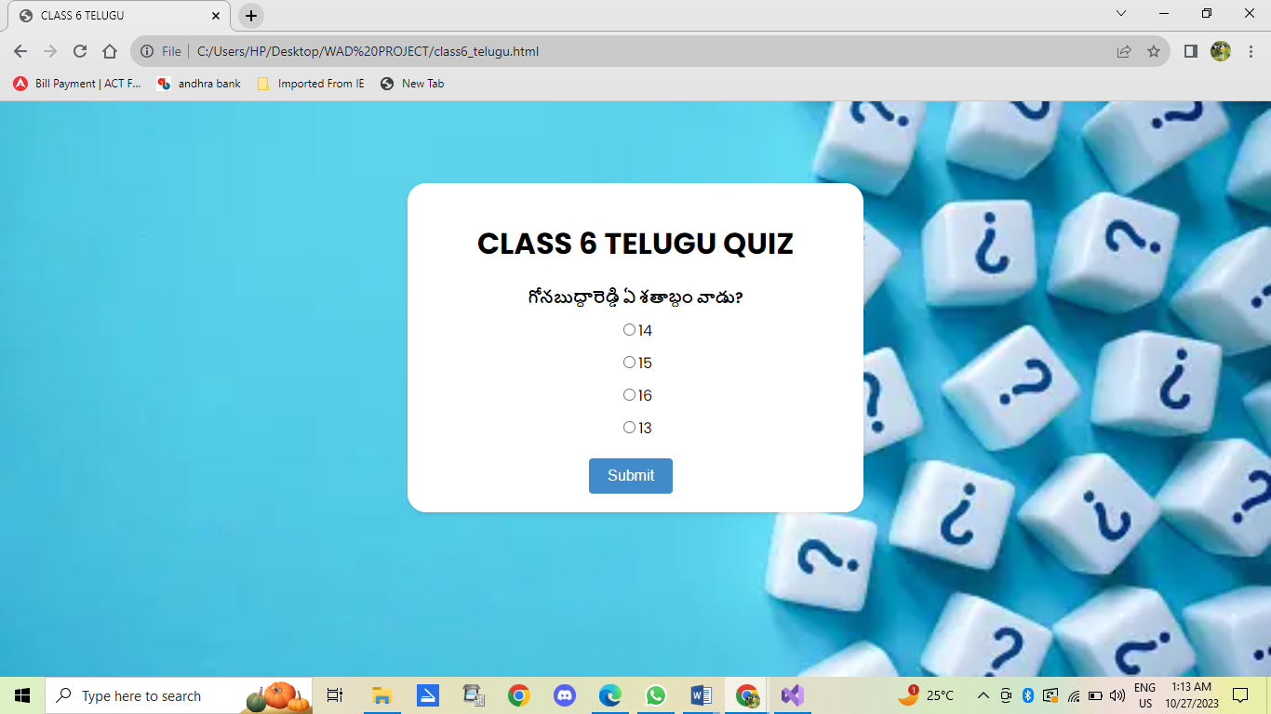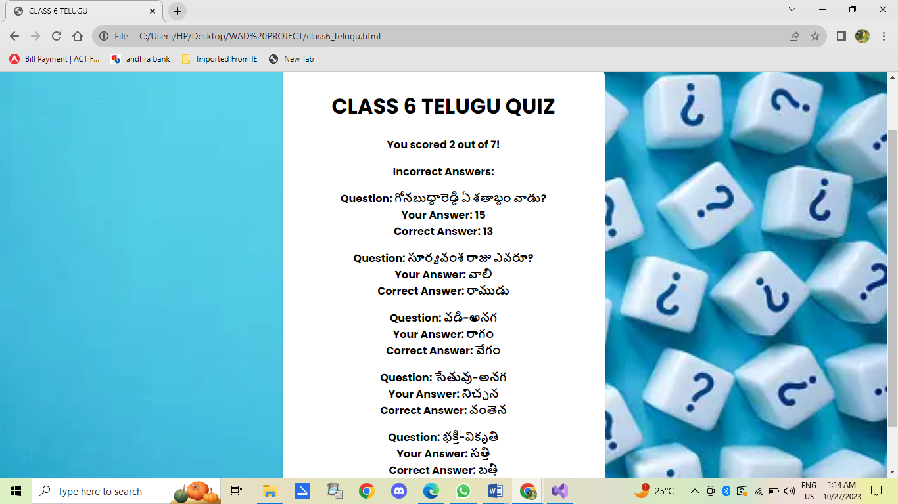

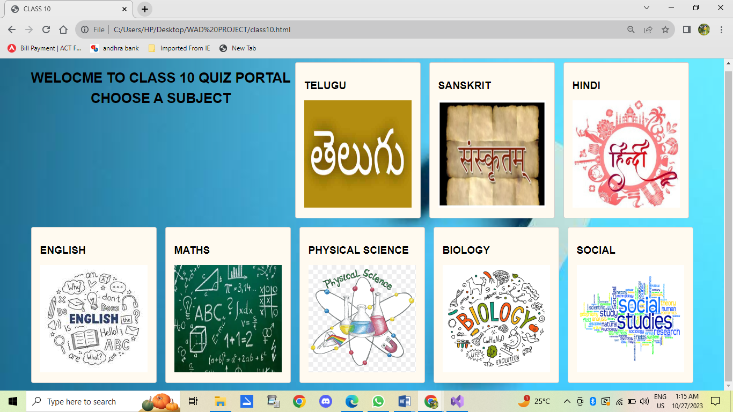

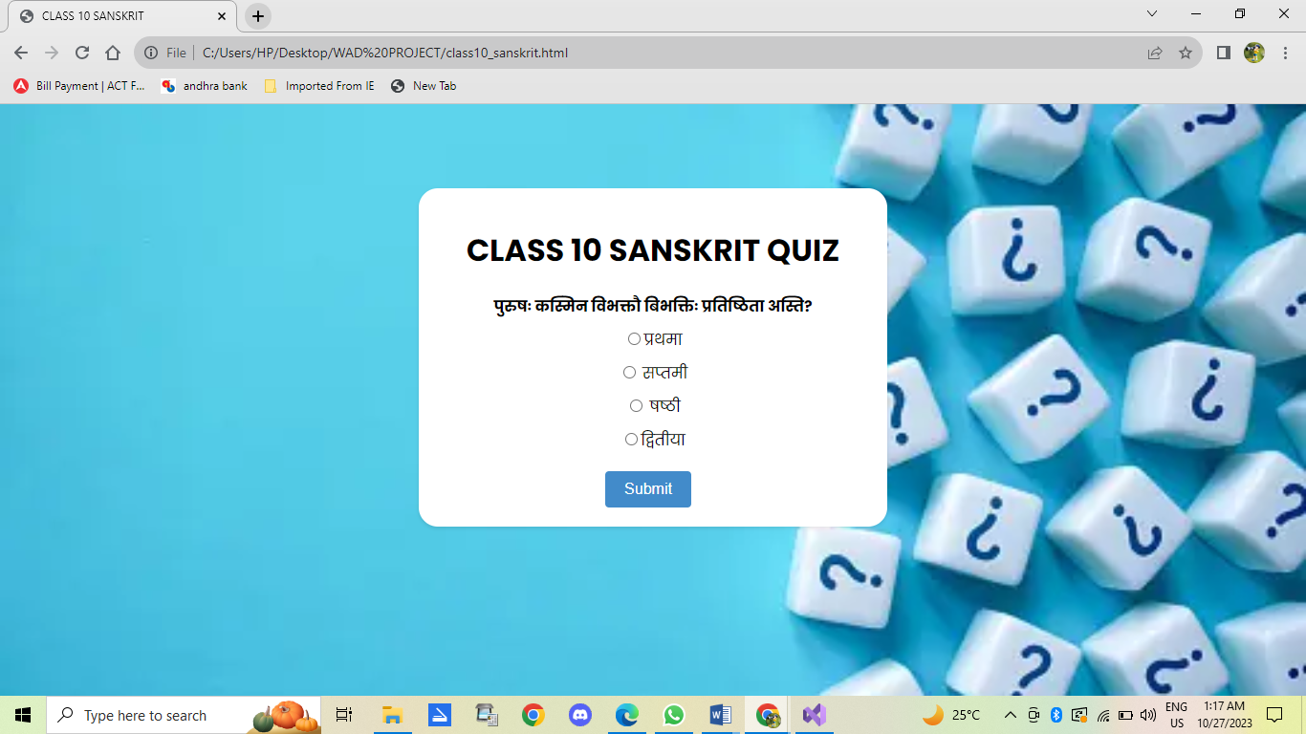

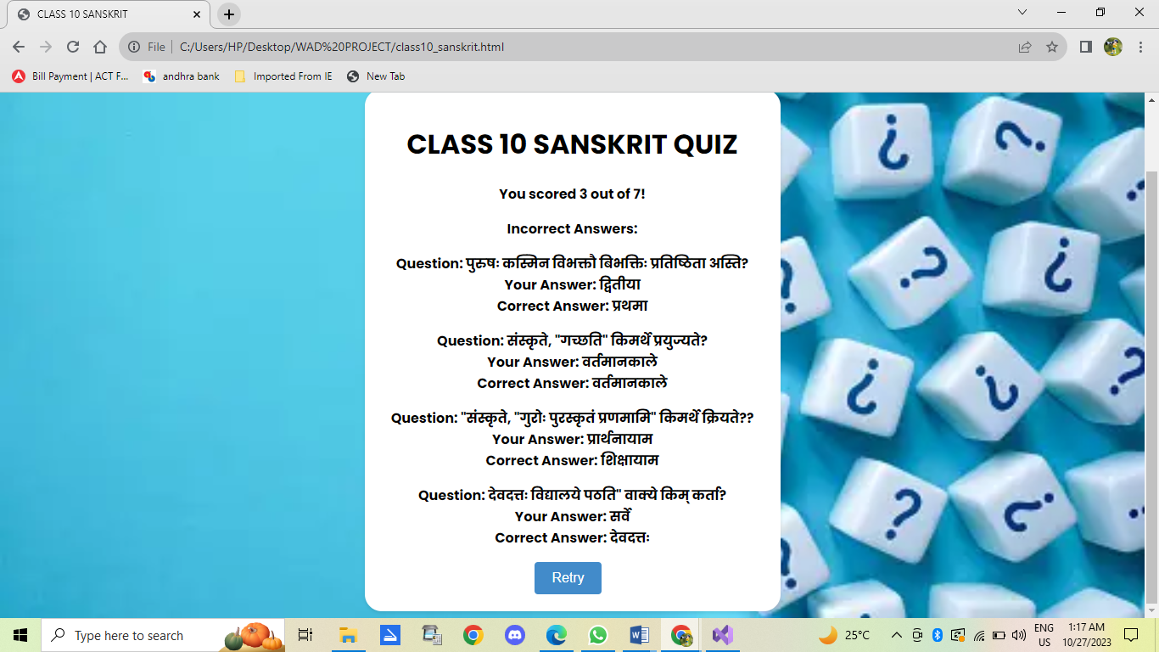

**CONCLUSION**

The development of the Online Quiz Web Application with the fusion of technology and education at its core. In conclusion, the following are the key takeaways from this project:

**1. Modern Learning Paradigm:** The project has effectively harnessed the power of modern technology to reshape the way we learn. It goes beyond traditional classroom teaching and offers a dynamic, interactive, and engaging learning experience.

**2. Universal Access:** The decision to remove barriers to entry by not requiring user authentication demonstrates the commitment to universal education. By allowing access without the need for email addresses, the project is inclusive, ensuring that knowledge is accessible to all.

**3. Technological Versatility:** The utilization of JavaScript as a full-stack language showcases its versatility. From front-end interactivity to back-end data handling, JavaScript played a central role in creating and handling questions and results of the quiz.

**4. Educational Empowerment:** The project empowers both students and educators. Students benefit from the gamified and interactive quizzes, enabling them to assess and deepen their knowledge. Educators gain a platform to create and disseminate content, extending the classroom beyond physical boundaries.

**5. Instant Feedback:** The real-time feedback mechanism provides an invaluable learning tool. Users receive immediate insights into their performance, helping them identify areas for improvement and enhancing their understanding of the subject matter.

**6. Potential for Growth:** The project's scalability ensures it can adapt to future needs and expanding user bases. It serves as a foundation for further developments, accommodating new features and content to cater to evolving educational requirements.

**7. Educational Evolution:** The Online Quiz Web Application represents a step in the ongoing evolution of education. It embraces technology and gamification to make learning not only informative but also enjoyable. It aligns with the evolving needs of learners in a digital age.

**8. A Bright Future:** The project's success points to a promising future in the realm of online education. It has the potential to become a significant player in the education technology landscape, offering innovative and accessible learning experiences to a wide range of users.

In conclusion, the Online Quiz Web Application Development Project has successfully transformed the way we approach education. By harnessing the potential of technology, it has created a platform that is not only accessible but also enjoyable, motivating, and empowering for students and educators alike. The project's positive impact on learning and its potential for growth in the ever-evolving field of education bodes well for the future.