**Machine Learning (Assignment # 1)**

**CS-5710**

**Name: Satya Ishyanth Kadali**

**Id: 700735513**

**CRN: 11813**

**Video link:** [**https://drive.google.com/drive/folders/1RLHZ5lY0HByWKbaFn29dUVo3ajMKOHIO?usp=sharing**](https://drive.google.com/drive/folders/1RLHZ5lY0HByWKbaFn29dUVo3ajMKOHIO?usp=sharing)

**Modifying Lists, Sets, Tuples, Dictionaries**

**Question 1**

Created a list of 10 students ages.

• Sorting the list by using sort() method .

and finding the min and max age by using min() and max() methods.

• By using append() the min age and the max age are added to the list. Basically append() adds values to the list at last

• Finding the median age by using floor division // operator we can find index of the list to calculate median.

• Average is sum of all the values of the list using sum() method divided by length of the list by using len() method.

• Already we have max and min values, so max- min gives range of the ages.

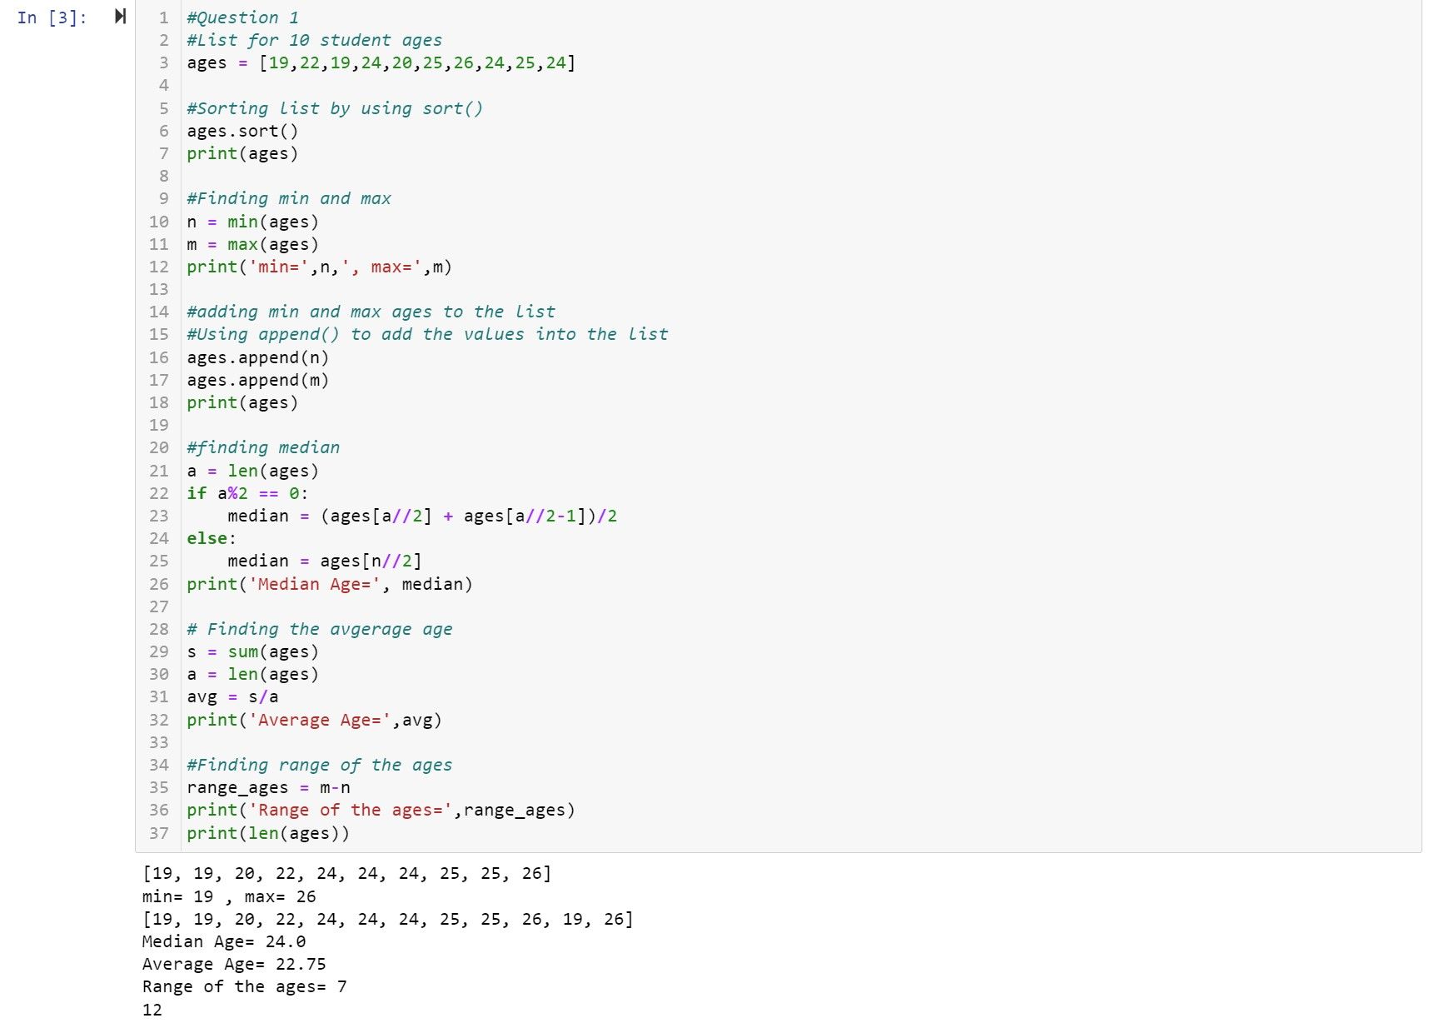

**Question 2**

• Created an empty dictionary called dog and added name, color, breed, legs, age to the dog dictionary

• Created a student dictionary and add first_name, last_name, gender, age, marital status, skills, country, city and address as keys for the dictionary.

• By using len() method to find length of the student dictionary.

• By using get(), printing the value of skills and checking the data type with type() method.

• Modify the skills values by appending to the skills key .

• Using keys() we can print all the keys in the dictionary.

• Using values() we can print all the values in the dictionary.

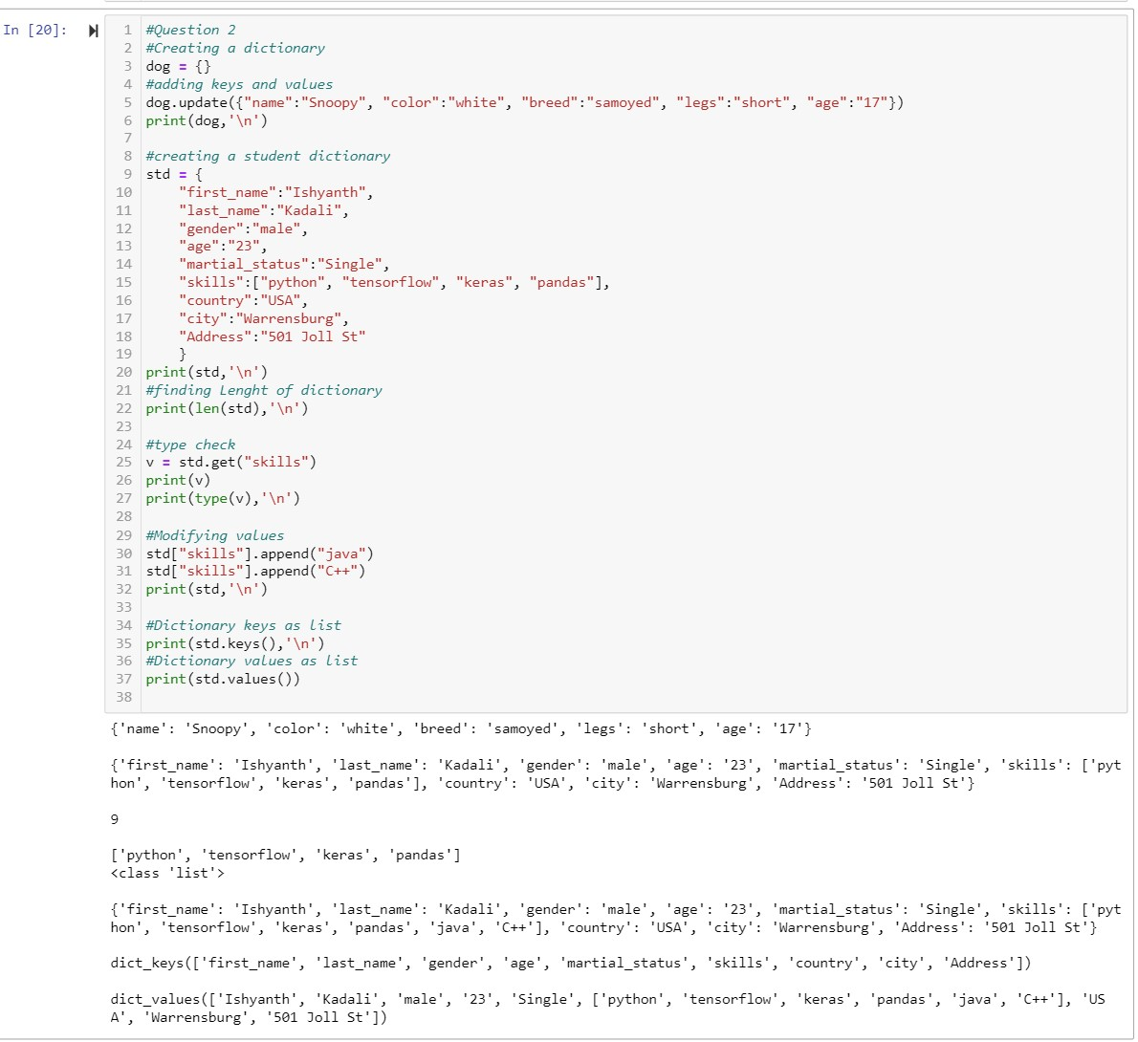

**Question 3**

• Created 2 tuples containing names of sisters and brothers.

• Joined brothers and sisters tuples by using + operator and assigned it to siblings.

• Used len() method to find out the length of the tuple.

• We can’t modify the siblings tuple. So I created a parents tuple with name of father and mother and assign it to family_members by joining siblings and parents tuples.

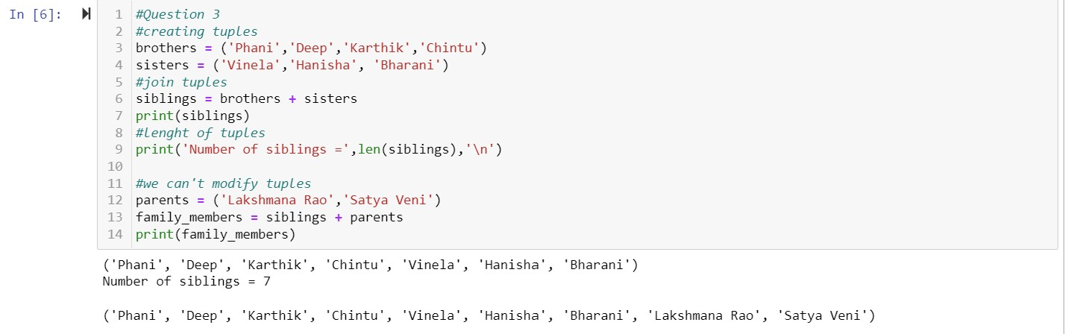

**Question 4**

• len() to find the length of the set it_companies

• Added 'Twitter' to it_companies by append() method.

• Inserted multiple IT companies at once to the set it_companies by appending values in list format.

• Removed one of the companies from the set it_companies using remove() function.

• Difference between remove and discard is if the item doesn't exist, the remove() function will raise an error, but the discard() method won't.

• Joining A and B using union()

• By using intersection() we can find A intersection B

• We can know A subset of B or not by issubset().

• We can know A and B disjoint sets or not by using isdisjoint().

• Using update() method joined A with B and B with A.

• Common values by using symmetric difference between A and B

• Clear() deletes the sets completely.

• By converting the ages to a set, it removes the duplicated and comparing the length of the list and the set will results list is greater than set as there are no duplicates in set.

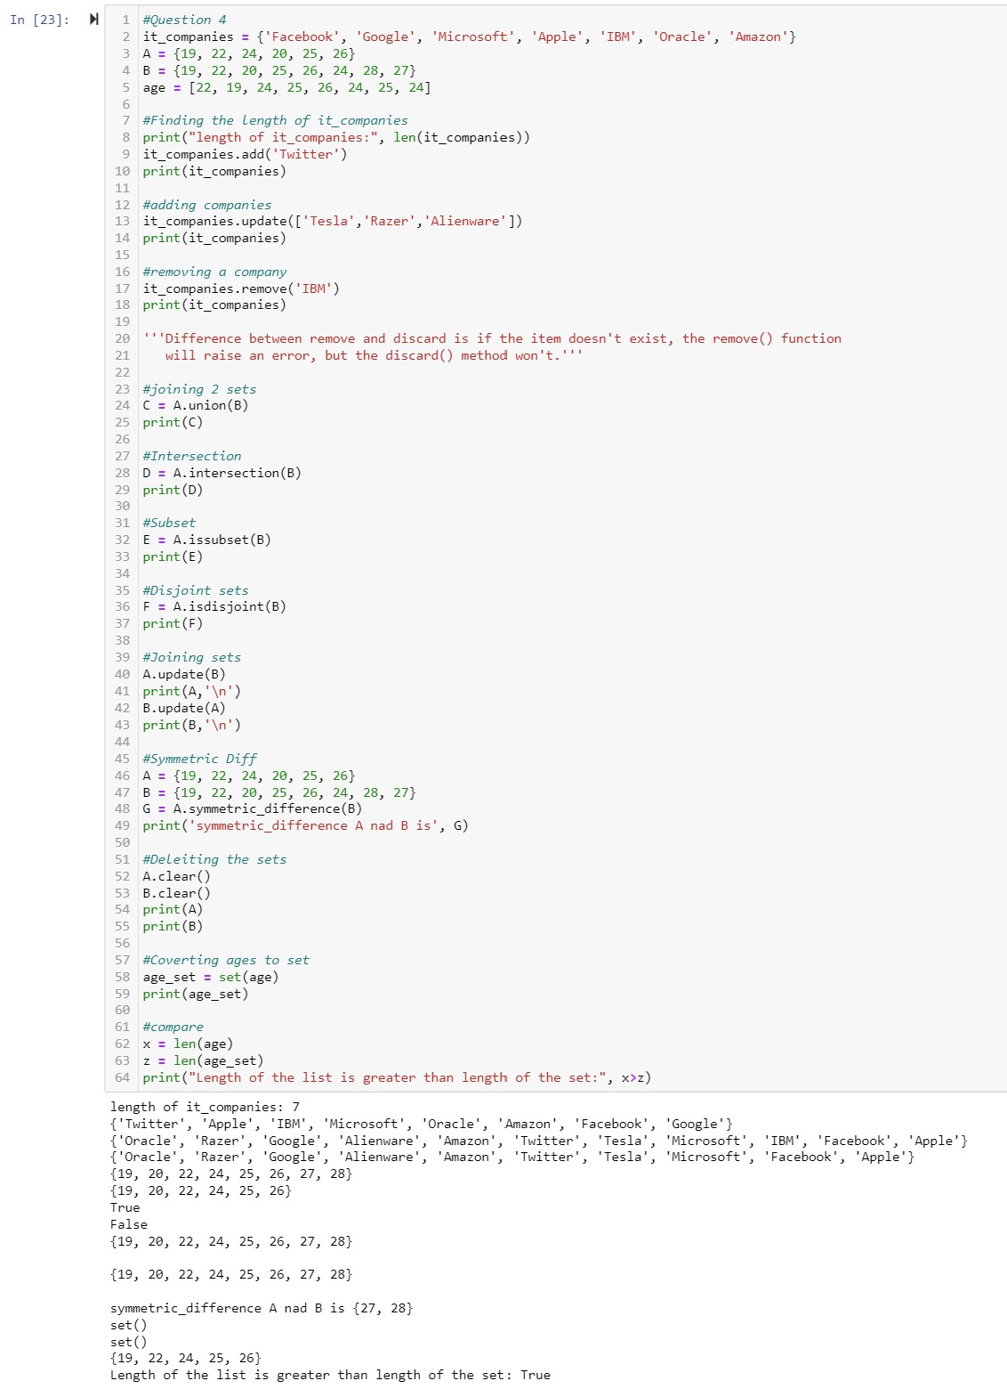

**Question 5**

Radius = 30 meters.

* 1. Using ** operator for calculating exponential values

• Took the input radius from user and calculated the area.

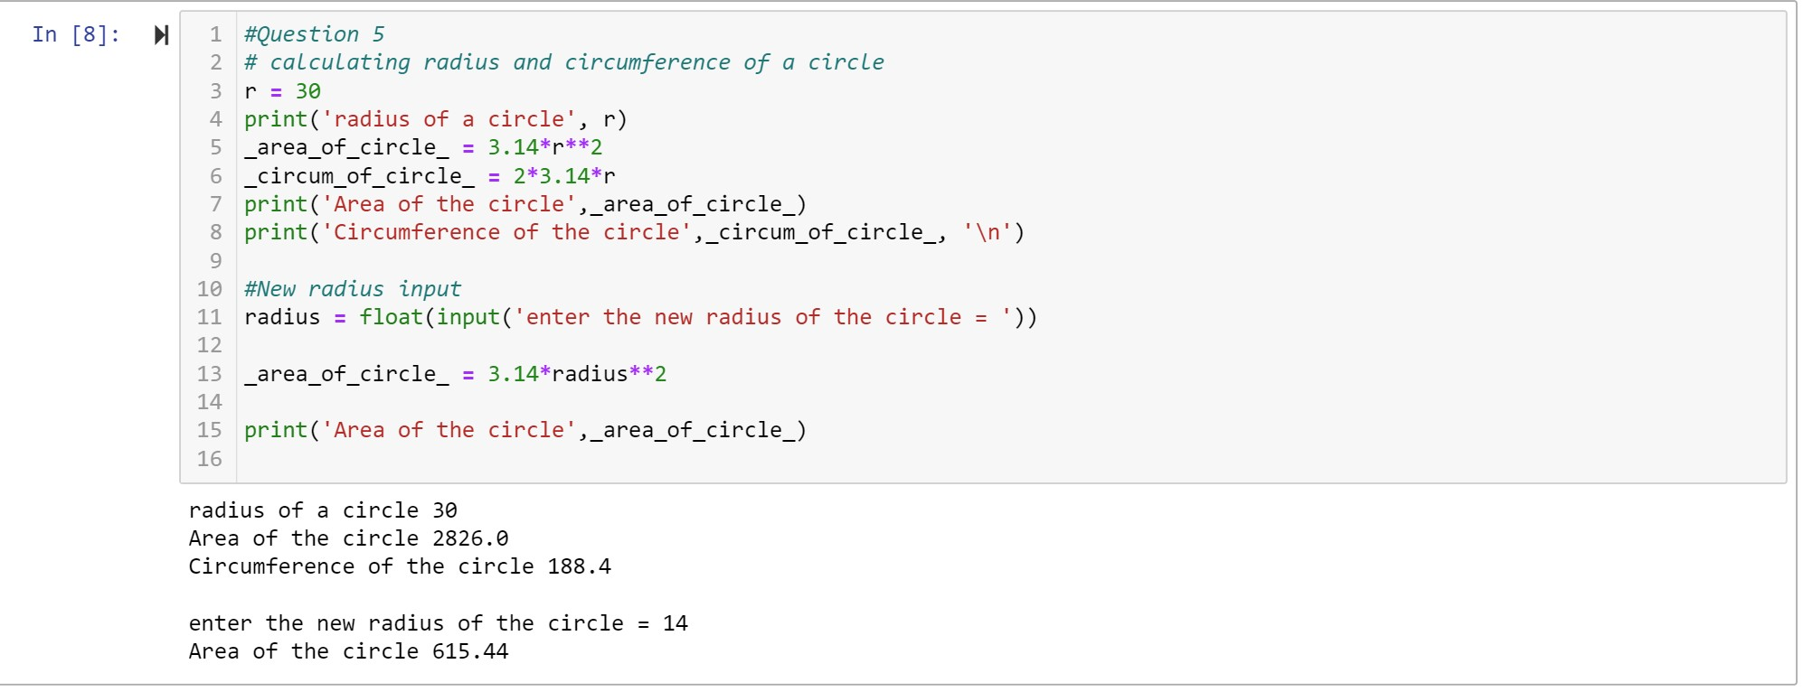

**Question 6**

“I am a teacher and I love to inspire and teach people”

There are 10 unique words in the sentence.

By split methods and set we can produce unique words.

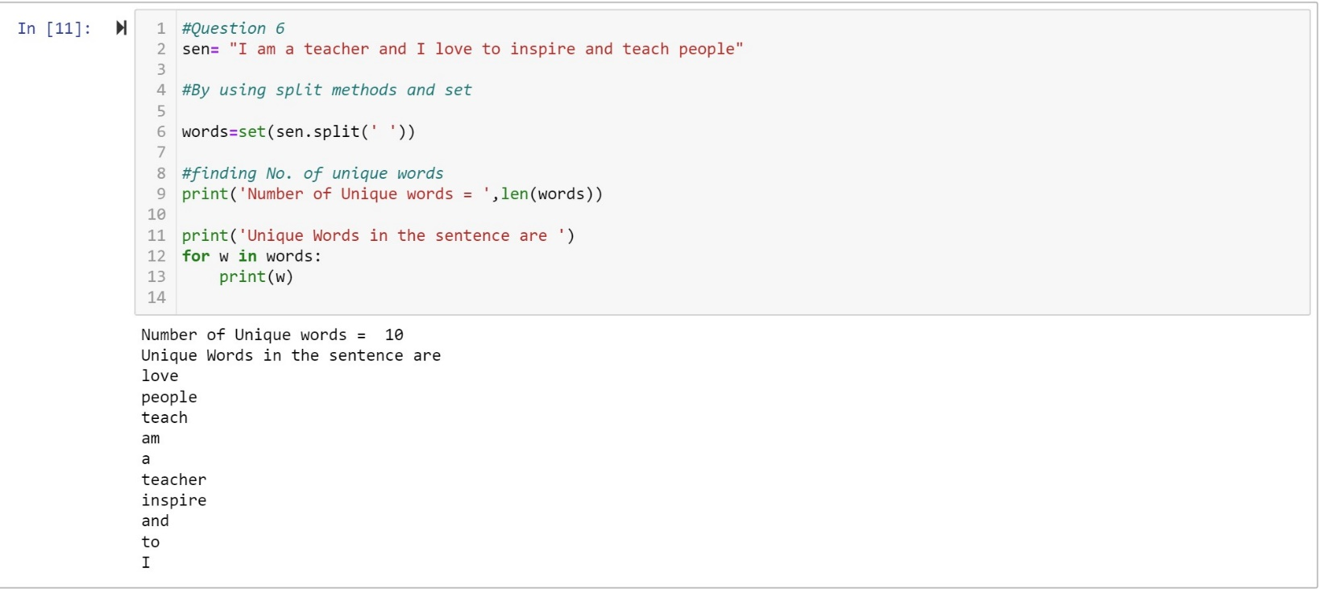

**Question 7**

By using tab escape sequence

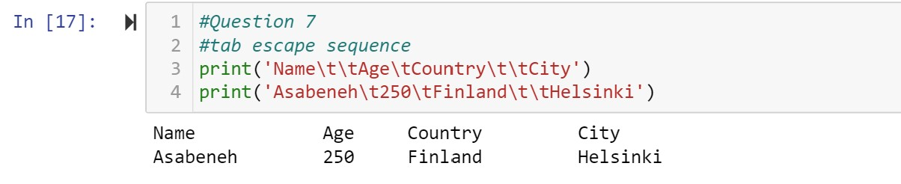

**Question 8**

By using string formatting method

Variables and sentences can be displayed in one print statement.

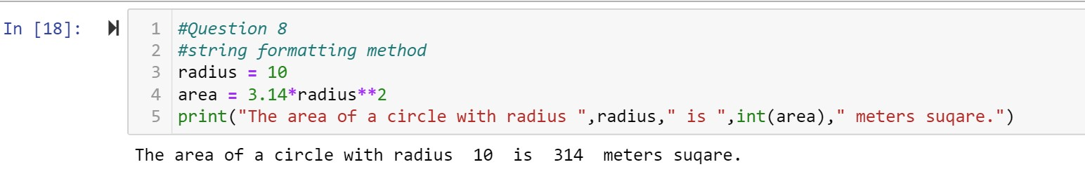

**Question 9**

Python program, which reads weights (lbs.) of N students into a list and convert the weights to kilograms in a separate list using for Loop.

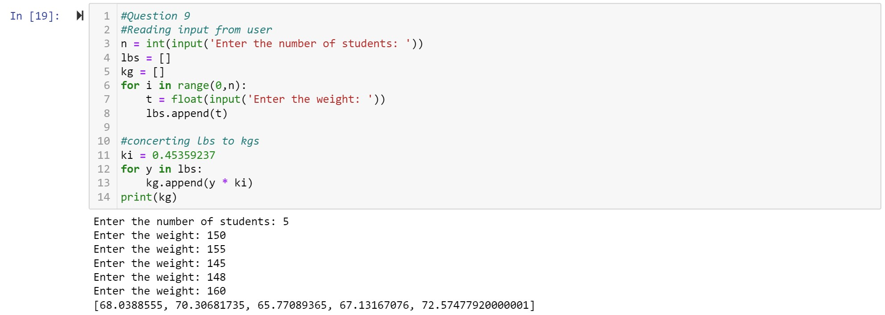

**Question 10**

* Importing libraries which are numpy to work with arrays, pandas to import and feed the dataset to the model.
* Importing scikit learn to work with KNN classifier and confusion matrix and to split the data into test data and training data.

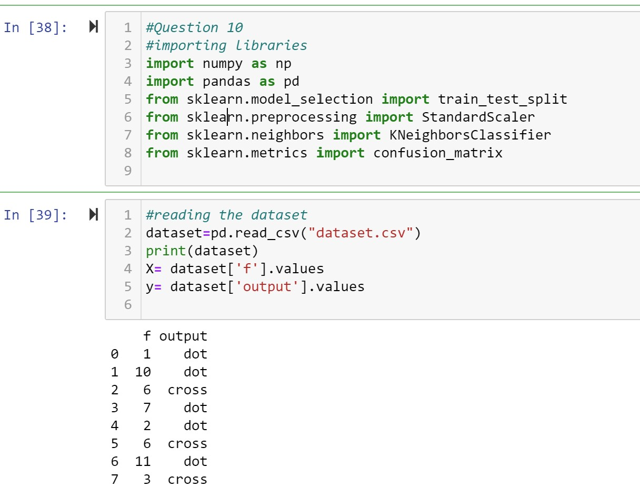

* Using reshape() method to convert data into 2 dimensional array.
* Split the data into 50:50 ratio.
* Using StandardScaler()to normalize the data.
* Creating a K Nearest Neighbor classifier to predict the output.
* Giving the k=3 to KNN model.
* Fitting the data into the model to train.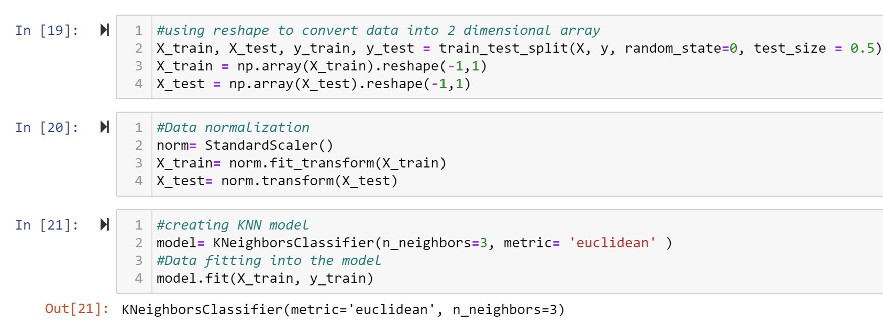
* Predicting the test set result by giving test data.
* Put a threshold if the values in X_test less than 1.5 then it will be classified as **cross** or else **dot.**
* Checking the predicted results by using confusion matrix.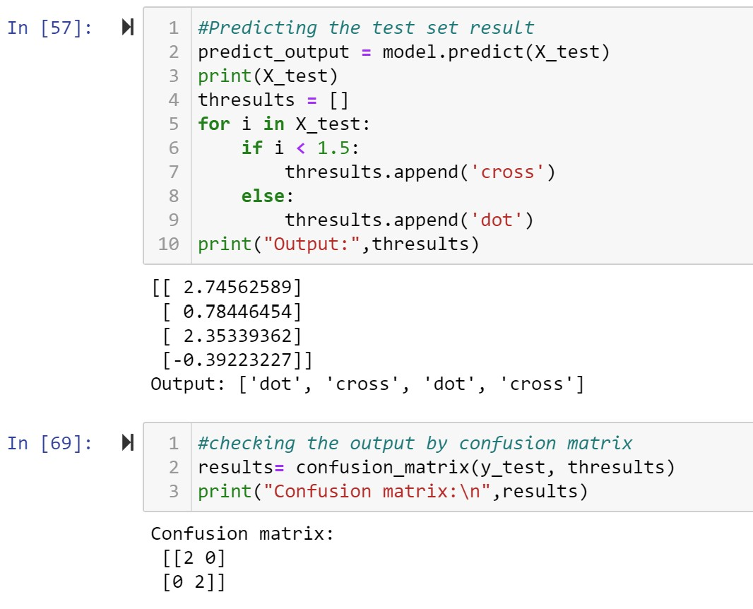
* Here, we got 2 true positives and 2 true negatives.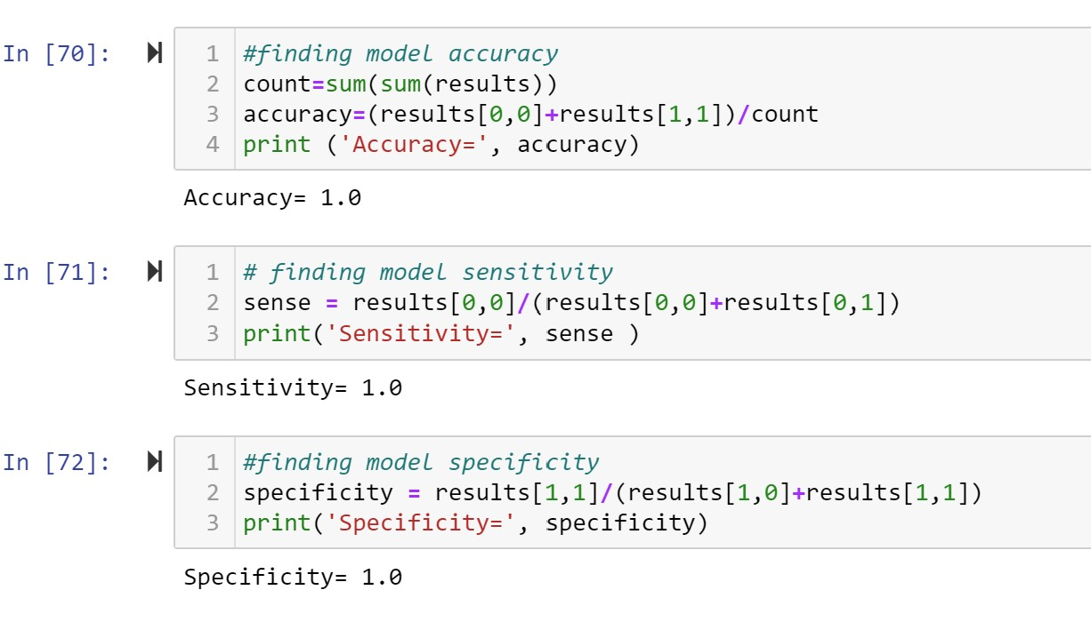
* The model got 100% accuracy.
* The model got 100% sensitivity as it is correctly predicting positives instances.
* The model got 100% specificity as it is correctly predicting negative instances.

Video link: <https://drive.google.com/drive/folders/1RLHZ5lY0HByWKbaFn29dUVo3ajMKOHIO?usp=sharing>