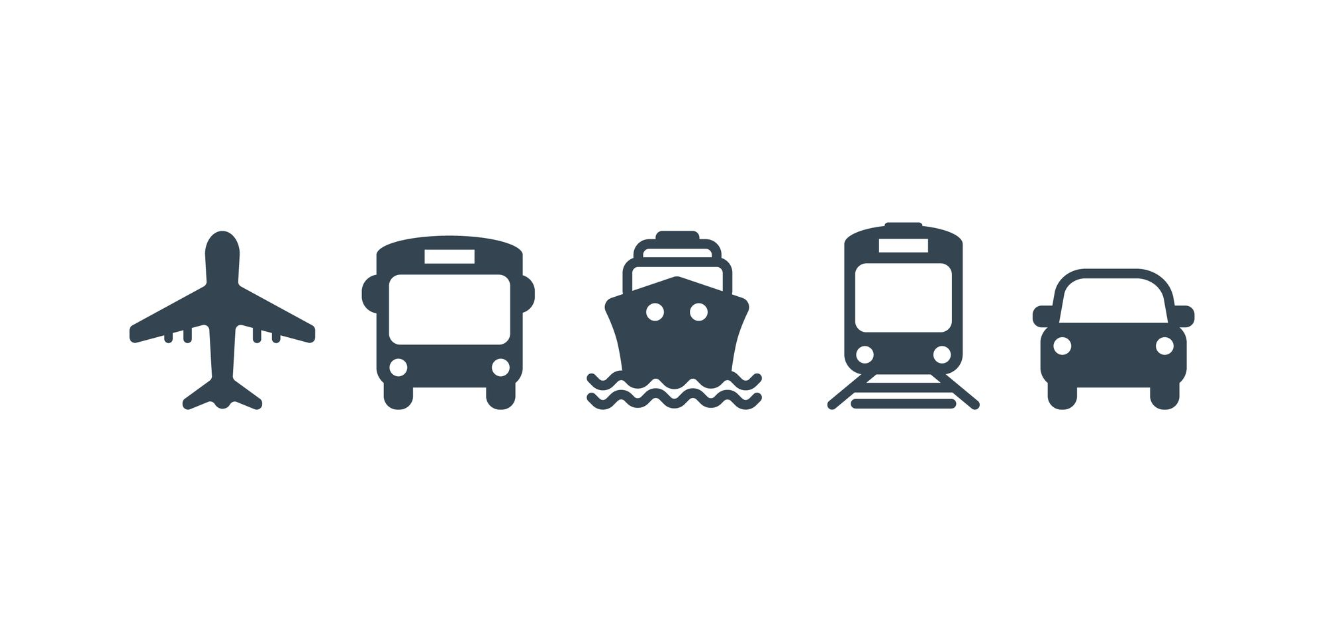**APPENDIX**

Figure 1.1.1

Table 1.2.1 List of emerging technologies in Transport

|  |  |  |  |
| --- | --- | --- | --- |
| **Emerging technology** | **Status** | **Potential applications** | **Related articles** |
| Airless tire | Research, development, early prototypes | Safer tires | Tweel |
| Autonomous Rail Rapid Transit | Commercialization, diffusion | Reducing air pollution, decreasing oil consumption | Electric vehicle |
| Electro hydrodynamic propulsion | Research, development, prototypes | Better flying transportation, efficient propulsion in air | Electrohydrodynamics |
| Flexible wings (X-53 Active Aeroelastic Wing, Adaptive Compliant Wing), fluidic flight controls | Experiments, prototypes | Controlling aircraft, ships | Aircraft flight control system, BAE Systems Demon, fluidics |
| Flying car | Early commercialization, prototypes | More effective transportation | Terrafugia Transition, Moller M400 Skycar, Urban Aeronautics X-Hawk, AeroMobil |
| Fusion rocket | Research, development | Fast interplanetary travel, with limited Interstellar applications |  |
| Ground-level power supply | Standardisation, commercialisation | Reduction of required battery size and weight for battery electric vehicles | Trafikverkets Program för Elvägar |
| Hoverbike | Working prototypes, early commercialisation | Package delivery, search and rescue |  |
| Hovertrain, Ground effect train | Research, development | Trains with higher speed | Aérotrain, Duke Hospital PRT, Hovercraft |
| High Altitude Platforms | Experimentation | Communications |  |
| Jet pack or backpack helicopter | Early commercialisation, prototypes | More effective transportation |  |
| Maglev train, Vactrain | Research, early commercialisation | Trains with higher speed | Transrapid, Shanghai Maglev Train, Linimo |
| Magnetic levitation | Research, development, Commercialisation (Maglev Train) | High-temperature superconductivity, cryogenics, low-temperature refrigerators, superconducting magnet design and construction, fibre-reinforced plastics for vehicles and structural concretes, communication and high power solid-state controls, vehicle design (aerodynamics and noise mitigation), precision manufacturing, construction and fabrication of concrete structures, maglev car, maglev based spacecraft launch. | Vactrain, Levitra |
| Mass driver | Prototypes |  |  |
| Personal rapid transit | Early commercialization, diffusion | More effective transportation | Morgantown PRT, ULTra |
| Photonic laser thruster | Prototypes |  |  |
| Physical Internet | Research |  |  |
| Scooter-sharing system | Commercialization | Increased density | Bird (company) |
| Vactrain | Research, development | A faster way to get somewhere | ET3 Global Alliance, Hyperloop |
| Propellant depot | Research, development | enabling deep-space missions with more massive payloads and satellite life extension, ultimately lowering the cost per kg launched to space |  |
| Pulse detonation engine | Testbed demos | Fast interplanetary travel, with some possible interstellar travel applications |  |
| Self-driving car | Research, development, early commercialisation | Reducing concerns of tiredness while driving and also looking outside in the car. Helpful in countries where the employment of personal drivers is expensive. | Waymo, Tesla FSD |
| Space elevator | Research, development |  | Non-rocket space launch, Orbital ring, Skyhook, Space fountain |
| Spaceplane | Research, development | Hypersonic transport | A2, Skylon |
| Vehicular communication systems | Research and development, some diffusion | Vehicle safety obstacles inform others of warnings on entering intersections, traffic management, accommodating ambulances, fire trucks, and police cars to specific situations such as hot pursuits and lousy weather, driver assistance systems, and automated highways. | Artificial Passenger, Dedicated short-range communications, Intelligent transportation system |

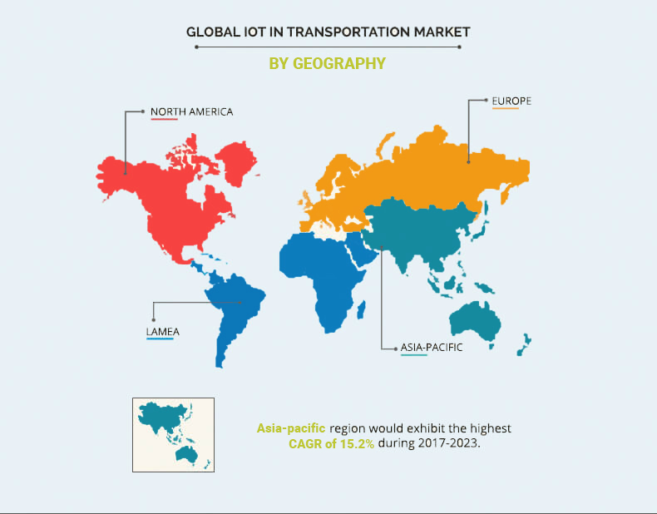

Figure 1.3.1

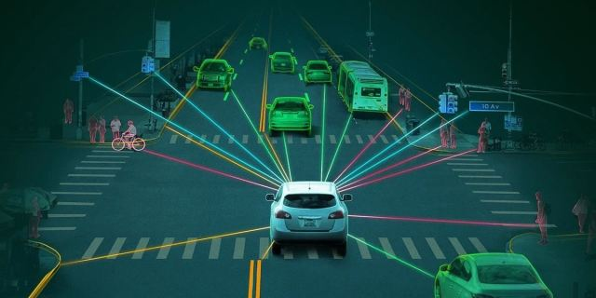

Figure 1.3.2

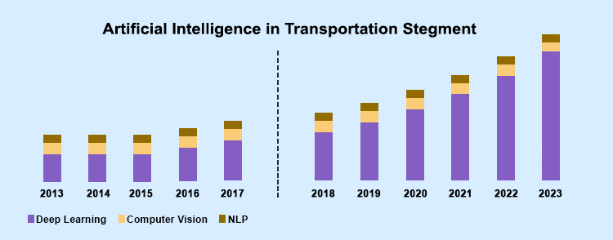

Figure 1.3.3

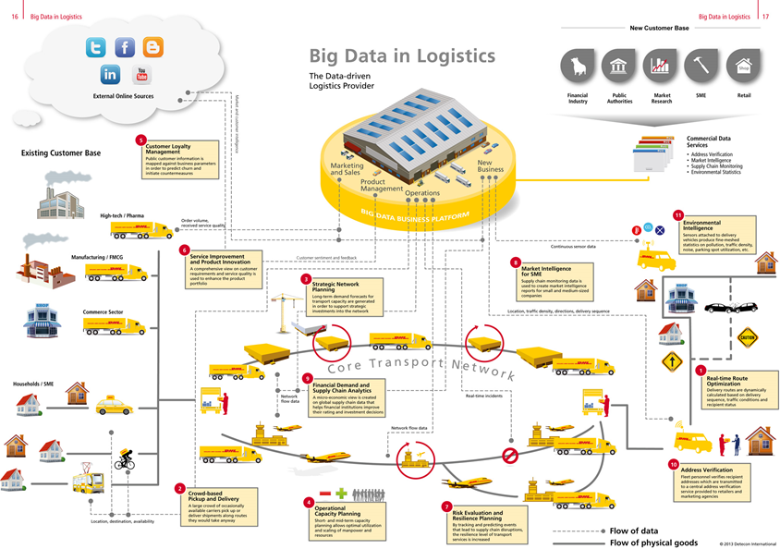

Figure 1.4.1

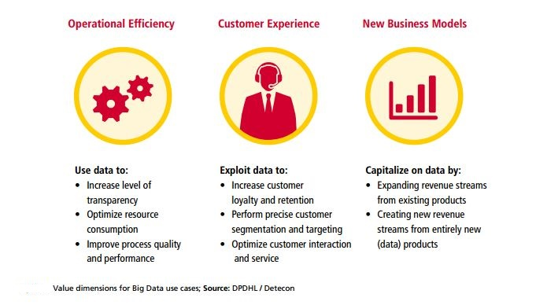

Figure 1.4.2

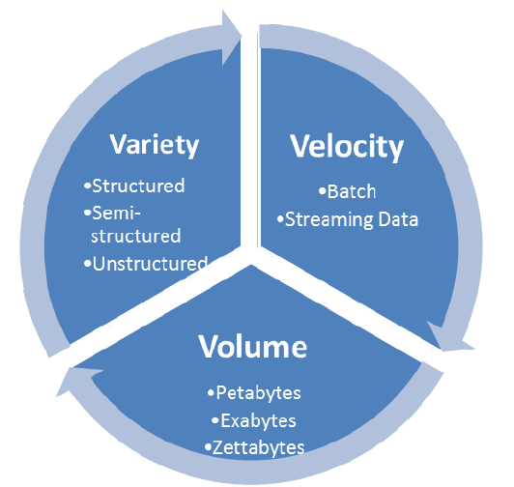Figure 2.1.1

**Table 3.2.1**Big Data approaches used in ITS application areas

|  |  |  |
| --- | --- | --- |
| **Big Data approach** | **Problem/application (year)** | **Ref.** |
| *Driver assistance and instrumented vehicles* | | |
| multi-sensor data fusion for instrumented vehicles (2012) | Big Data fusion | [[127](https://ietresearch.onlinelibrary.wiley.com/doi/10.1049/iet-its.2018.5188#itr2bf00496-bib-0127)] |
| efficient vehicle design (2015) | Big Data Analytics | [[128](https://ietresearch.onlinelibrary.wiley.com/doi/10.1049/iet-its.2018.5188#itr2bf00496-bib-0128)] |
| driving data fusion techniques (2016) | Big Data fusion | [[129](https://ietresearch.onlinelibrary.wiley.com/doi/10.1049/iet-its.2018.5188#itr2bf00496-bib-0129)] |
| RDMP framework for ADAS (2016) | Big Data platform | [[130](https://ietresearch.onlinelibrary.wiley.com/doi/10.1049/iet-its.2018.5188#itr2bf00496-bib-0130)] |
| driving tendency recognition method (2016) | Big Data Analytics | [[131](https://ietresearch.onlinelibrary.wiley.com/doi/10.1049/iet-its.2018.5188#itr2bf00496-bib-0131)] |
| behaviour and vehicle dynamics risk analysis (2016) | Big Data framework and policies | [[132](https://ietresearch.onlinelibrary.wiley.com/doi/10.1049/iet-its.2018.5188#itr2bf00496-bib-0132)] |
| mobile agents for data management in vehicular networks (2017) | vehicular networks | [[133](https://ietresearch.onlinelibrary.wiley.com/doi/10.1049/iet-its.2018.5188#itr2bf00496-bib-0133)] |
| *Traveller information* | | |
| Big Data schemes in social transportation systems (2016) | Big Data social transportation | [[125](https://ietresearch.onlinelibrary.wiley.com/doi/10.1049/iet-its.2018.5188#itr2bf00496-bib-0125)] |
| guidelines to pioneer public transport (2016) | Big Data services | [[11](https://ietresearch.onlinelibrary.wiley.com/doi/10.1049/iet-its.2018.5188#itr2bf00496-bib-0011)] |
| *Roadway operation and management* | | |
| roadway control environmental footprint (2016) | Big Data Analytics | [[134](https://ietresearch.onlinelibrary.wiley.com/doi/10.1049/iet-its.2018.5188#itr2bf00496-bib-0134)] |
| traffic congestion on limited access roadways (2016) | Big Data Analytics | [[135](https://ietresearch.onlinelibrary.wiley.com/doi/10.1049/iet-its.2018.5188#itr2bf00496-bib-0135)] |
| road traffic operation (2016) | Big Data | [[136](https://ietresearch.onlinelibrary.wiley.com/doi/10.1049/iet-its.2018.5188#itr2bf00496-bib-0136)] |
| *Traffic management* | | |
| traffic flow prediction based on deep learning (2015) | Big Data predictive analysis | [[137](https://ietresearch.onlinelibrary.wiley.com/doi/10.1049/iet-its.2018.5188#itr2bf00496-bib-0137)] |
| R.C. evolution patterns (2015) | Big Data real-time analysis | [[138](https://ietresearch.onlinelibrary.wiley.com/doi/10.1049/iet-its.2018.5188#itr2bf00496-bib-0138)] |
| O.D. matrix generation (2017) | Big Data Analytics | [[139](https://ietresearch.onlinelibrary.wiley.com/doi/10.1049/iet-its.2018.5188#itr2bf00496-bib-0139)] |
| *Transit management* | | |
| route planning services optimization (2016) | Big Data Analytics | [[140](https://ietresearch.onlinelibrary.wiley.com/doi/10.1049/iet-its.2018.5188#itr2bf00496-bib-0140)] |
| bus planning (2016) | Big Data Analytics | [[141](https://ietresearch.onlinelibrary.wiley.com/doi/10.1049/iet-its.2018.5188#itr2bf00496-bib-0141)] |
| general traffic planning using IoT (2016) | Big Data Analytics | [[142](https://ietresearch.onlinelibrary.wiley.com/doi/10.1049/iet-its.2018.5188#itr2bf00496-bib-0142)] |