CHAPTER ONE
INTRODUCTION
1.1 Background to the Study
Attendance management remains one of the most fundamental administrative activities in educational institutions and corporate organizations. It plays a critical role in monitoring participation, enforcing discipline, evaluating performance, and supporting institutional decision-making. In academic environments, attendance records are often linked directly to continuous assessment, examination eligibility, and accreditation requirements. Despite its importance, attendance management in many institutions particularly in developing countries continues to rely heavily on manual methods such as paper registers and sign-in sheets.
Manual attendance systems are widely acknowledged to be inefficient, error-prone, and increasingly unsuitable for modern institutional demands. In large classrooms, lecturers often spend valuable teaching time calling names or circulating attendance sheets, reducing instructional efficiency and disrupting lesson flow. Human errors such as missed names, incorrect entries, and illegible handwriting are common, leading to inaccurate records that may affect students’ academic standing. Studies have shown that manual attendance processes significantly reduce productivity and introduce data inconsistencies that undermine administrative reliability (Adeyemo & Abiodun, 2014; Oyelami et al., 2018).
One of the most critical weaknesses of manual attendance systems is their vulnerability to impersonation and proxy attendance. Proxy attendance occurs when one individual records attendance on behalf of another who is absent, thereby falsifying institutional records. This practice is difficult to detect using manual systems and compromises academic integrity, fairness, and accountability. Research has consistently identified proxy attendance as a major challenge in higher institutions, particularly in large lecture halls where physical verification of each student is impractical (Kumar & Kaur, 2016; Balcoh et al., 2020). To address these limitations, institutions have increasingly explored automated attendance management solutions. Early automation efforts employed technologies such as barcode scanning, magnetic cards, and Radio Frequency Identification (RFID). While these systems improved speed and record storage, they introduced new challenges, including card loss, duplication, and unauthorized usage. As a result, attention has shifted toward biometric-based attendance systems, which authenticate individuals using inherent biological characteristics rather than external tokens (Jain, Ross, & Nandakumar, 2016).
Biometric systems are particularly effective because they rely on traits that are unique to each individual and difficult to replicate. Among various biometric modalities such as fingerprints, iris recognition, and voice recognition, facial recognition has emerged as one of the most practical and user-friendly options. Facial recognition is non-intrusive, contactless, and capable of operating in real time using standard camera devices. These qualities make it especially suitable for classroom and workplace environments where efficiency and hygiene are important considerations (Zhao et al., 2019).
Advances in computer vision and machine learning over the past decade have significantly improved the accuracy and feasibility of face recognition systems. Algorithms such as Local Binary Patterns Histogram (LBPH), Haar Cascade classifiers, and convolutional neural networks have demonstrated strong performance in detecting and recognizing human faces under varying conditions. The availability of open-source libraries such as OpenCV, combined with the flexibility of the Python programming language, has enabled developers to implement robust facial recognition systems with relatively low computational cost (Bradski & Kaehler, 2017; Rosebrock, 2020).
This study focuses on the design and implementation of a smart attendance management system using face recognition technology for real-time student authentication. The system leverages Python and OpenCV for image processing and facial recognition, integrated with a backend database for attendance storage and reporting. By automating the attendance process, the system aims to minimize human error, eliminate proxy attendance, and enhance the accuracy and reliability of attendance records. The proposed solution is designed to be scalable and adaptable for deployment in educational institutions and corporate environments, contributing to administrative automation and operational efficiency.
1.2 Conceptual and Theoretical Foundation (Biometrics in Education)
Biometrics refers to the automated recognition of individuals based on measurable biological or behavioral characteristics. Common biometric identifiers include fingerprints, facial features, iris patterns, voice signatures, and gait. The theoretical foundation of biometric systems lies in pattern recognition, signal processing, and statistical decision theory, where distinctive features are extracted from raw data and compared against stored templates to establish identity (Jain et al., 2016).
In educational systems, biometric technologies are increasingly adopted to address challenges related to identity verification, access control, and attendance management. The use of biometrics aligns with systems theory, which emphasizes automation, reliability, and efficiency in organizational processes. By embedding biometric authentication into attendance systems, institutions can reduce dependence on manual verification while improving data accuracy and operational transparency (Al-Rahmi et al., 2019).
Facial recognition is a biometric modality that identifies individuals by analyzing facial attributes such as the geometry of the eyes, nose, mouth, and overall facial structure. From a theoretical perspective, face recognition involves three major stages: face detection, feature extraction, and face classification. Algorithms such as LBPH operate by encoding texture patterns in facial images, making them relatively robust to changes in illumination and facial expression (Ahonen, Hadid, & Pietikäinen, 2012).
Educational research has shown that facial recognition-based attendance systems significantly outperform traditional methods in terms of efficiency and fraud prevention. Unlike fingerprint systems, facial recognition does not require physical contact with sensors, reducing wear, hygiene concerns, and user resistance. Furthermore, face recognition allows passive authentication, meaning individuals do not need to actively interact with the system beyond being present in front of a camera (Salah et al., 2021).
From a pedagogical standpoint, biometric attendance systems support institutional accountability and data-driven decision-making. Accurate attendance records enable educators to identify engagement patterns, intervene early in cases of absenteeism, and enforce attendance policies fairly. The integration of biometric systems into education therefore represents a convergence of technological innovation and administrative reform aimed at improving learning outcomes and institutional governance (UNESCO, 2020).
1.3 Statement of the Problem
Despite advancements in educational technology, many institutions still rely on manual attendance systems that are inefficient and unreliable. Large class sizes make it difficult for instructors to verify attendance accurately without consuming valuable instructional time. Errors such as omitted names, duplicated entries, and inaccurate tallies frequently occur, leading to inconsistent records that affect academic evaluation and reporting (Olatunji & Shoewu, 2017).
Proxy attendance remains a persistent problem in manual attendance systems. Students may sign attendance on behalf of absent colleagues, deliberately manipulating records to meet attendance requirements. This practice undermines fairness, compromises academic integrity, and weakens institutional discipline. Manual systems lack real-time authentication mechanisms to verify the physical presence of individuals, making impersonation difficult to detect (Kumar & Kaur, 2016).
Additionally, manual attendance records are difficult to store, retrieve, and analyze efficiently. Paper-based records are vulnerable to loss, damage, and unauthorized alteration, while manual digitization is time-consuming and prone to transcription errors. These limitations hinder effective data analysis, reporting, and long-term record management, highlighting the need for an automated, secure, and scalable attendance solution.
1.4 Aim and Objectives of the Study
The primary aim of this study is to design and implement a smart attendance management system using face recognition technology for real-time student authentication. The specific objectives of the study are to:
- Develop a facial recognition-based system capable of identifying registered individuals accurately.
- Implement real-time face detection and recognition using OpenCV and Python.
- Design a backend database system for secure storage and retrieval of attendance records.
1.5 Significance of the Study
This study is significant to educational institutions seeking to improve administrative efficiency and academic integrity. Automated attendance systems reduce time spent on manual record-keeping, allowing instructors to focus more on teaching and student engagement. Accurate attendance records also support fair assessment and policy enforcement (Balcoh et al., 2020). For administrators, the system enhances data reliability and accessibility. Electronic attendance records are easier to store, retrieve, and analyze, enabling informed decision-making and compliance with institutional regulations. Automated reporting further improves transparency and accountability. The study is also valuable to researchers and developers, as it demonstrates the practical application of computer vision and biometric technologies using open-source tools. It contributes to the growing body of knowledge on intelligent systems and provides a foundation for future enhancements such as cloud deployment and deep learning integration.
1.6 Scope of the Study
The scope of this study covers the design and implementation of a facial recognition-based attendance system using Python, OpenCV, and a local database. The system focuses on real-time face detection, recognition, and automated attendance logging within controlled environments. The study does not include advanced deep learning models, cloud-based deployment, or mobile application integration. Performance evaluation is limited to standard indoor conditions using conventional camera hardware.
1.7 Limitations of the Study
The system’s performance may be affected by lighting conditions, camera quality, and facial obstructions such as masks or headwear. These factors can reduce recognition accuracy in real-world scenarios (Zhao et al., 2019). The use of traditional face recognition algorithms limits robustness compared to deep learning-based approaches. Additionally, reliance on a local database restricts scalability and remote accessibility. Data privacy and ethical considerations surrounding biometric data management are acknowledged but not exhaustively addressed, representing an area for future research.
CHAPTER TWO
LITERATURE REVIEW
2.1 Overview of Biometric Identification Systems
Biometric identification systems are automated technologies used to recognize individuals based on unique physiological or behavioral characteristics. Unlike traditional authentication methods such as passwords or identity cards, biometric systems rely on inherent human traits that are difficult to duplicate or transfer. Common biometric identifiers include fingerprints, facial features, iris patterns, voice characteristics, and behavioral traits such as gait and typing rhythm. Over the past decade, biometric systems have gained widespread adoption across sectors including education, healthcare, finance, border security, and corporate access control (Jain, Ross, & Nandakumar, 2016).
The core architecture of a biometric system typically consists of data acquisition, feature extraction, template storage, and matching or classification. During enrollment, biometric data is captured and converted into a digital template, which is stored in a database. During verification or identification, newly captured biometric data is compared against stored templates to establish identity. The accuracy and reliability of biometric systems depend heavily on the quality of data acquisition, robustness of feature extraction algorithms, and efficiency of matching techniques (Maltoni et al., 2019).
In educational environments, biometric identification systems have been increasingly explored to address challenges associated with identity verification and attendance management. Research indicates that biometric systems significantly reduce impersonation and unauthorized access compared to card-based or manual systems (Balcoh, Kamil, & Fisal, 2020). However, concerns such as cost, privacy, user acceptance, and environmental constraints influence the choice of biometric modality. Among available options, facial recognition has emerged as a favorable solution due to its non-contact nature and ease of deployment using standard camera hardware.
2.2 Evolution of Face Recognition Technology
Face recognition technology has evolved significantly over the past two decades, transitioning from basic pattern matching approaches to sophisticated machine learning and deep learning models. Early face recognition systems relied on geometric measurements of facial features such as eye distance, nose width, and jawline shape. While these approaches provided foundational insights, they were highly sensitive to changes in lighting, pose, and facial expressions (Zhao et al., 2019).
The introduction of appearance-based methods marked a major advancement in face recognition research. Techniques such as Eigenfaces and Fisherfaces represented facial images as numerical vectors derived from statistical analysis of pixel intensities. These methods improved recognition accuracy under controlled conditions and laid the groundwork for more robust feature extraction techniques. However, their performance degraded significantly in real-world environments with variable illumination and background noise (Turk & Pentland, 2013).
In recent years, the integration of machine learning and deep learning has transformed face recognition systems. Convolutional Neural Networks (CNNs) have demonstrated remarkable performance by automatically learning hierarchical facial features from large datasets. Despite their high accuracy, deep learning models often require substantial computational resources and large training datasets. Consequently, for lightweight and real-time applications such as classroom attendance systems, traditional yet effective algorithms like Local Binary Patterns Histogram (LBPH) remain relevant due to their efficiency and relatively low computational cost (Ahonen, Hadid, & Pietikäinen, 2012; Rosebrock, 2020).
2.3 Review of Local Binary Patterns Histogram (LBPH) Algorithm
The Local Binary Patterns Histogram (LBPH) algorithm is a texture-based facial recognition technique widely used in real-time applications. The algorithm operates by analyzing local texture patterns within a grayscale facial image. For each pixel, LBPH compares the pixel’s intensity with that of its neighboring pixels and encodes the result as a binary number. These binary patterns are then aggregated into histograms that represent distinctive facial features (Ahonen et al., 2012).
One of the key advantages of LBPH is its robustness to changes in illumination and facial expressions. Because the algorithm focuses on local texture rather than absolute pixel values, it performs relatively well in environments with uneven lighting. This makes LBPH particularly suitable for indoor attendance systems where lighting conditions may vary across classrooms or offices. Additionally, LBPH does not require extensive training datasets, making it practical for small- to medium-scale implementations (Salah et al., 2021).
Several studies have demonstrated the effectiveness of LBPH in facial recognition attendance systems. Research comparing LBPH with more complex models has shown that while deep learning approaches may offer higher accuracy, LBPH provides a favorable balance between performance, speed, and computational efficiency for real-time applications (Kumar & Kaur, 2016; Balcoh et al., 2020). These characteristics justify the selection of LBPH for this study’s implementation.
2.4 Comparative Analysis: Eigenfaces vs. Fisherfaces vs. LBPH
Different facial recognition algorithms exhibit varying strengths and weaknesses depending on application requirements. Eigenfaces, Fisherfaces, and LBPH are among the most commonly studied traditional face recognition methods. Eigenfaces utilize Principal Component Analysis (PCA) to reduce dimensionality and represent facial images as weighted sums of eigenvectors. While computationally efficient, Eigenfaces are highly sensitive to lighting variations and background noise (Turk & Pentland, 2013).
Fisherfaces build upon Eigenfaces by incorporating Linear Discriminant Analysis (LDA), which maximizes class separability. This approach improves recognition accuracy under varying lighting conditions but still requires controlled environments for optimal performance. Fisherfaces also struggle when training data is limited or when facial expressions vary significantly (Zhao et al., 2019).
LBPH differs fundamentally by focusing on local texture patterns rather than global facial appearance. This local approach enhances robustness to illumination changes and partial occlusions. As a result, LBPH is widely adopted in real-time systems where computational efficiency and reliability are critical. The table below summarizes key differences among the three algorithms.
Table 2.1: Comparison of Face Recognition Algorithms
Algorithm | Technique Used | Strengths | Limitations | Typical Applications
Eigenfaces | PCA (Appearance-based) | Simple, fast | Sensitive to lighting | Controlled environments
Fisherfaces | LDA (Class-based) | Better class separation | Requires balanced data | Research applications
LBPH | Texture-based | Robust to lighting, fast | Lower accuracy than deep learning | Real-time systems
Source: Adapted from Ahonen et al. (2012); Zhao et al. (2019)

2.5 Real-time Video Stream Processing with OpenCV
OpenCV (Open Source Computer Vision Library) is a widely used open-source framework for image and video processing. It provides a comprehensive set of tools for tasks such as face detection, object tracking, image transformation, and feature extraction. OpenCV supports multiple programming languages, with Python being one of the most popular due to its simplicity and extensive ecosystem (Bradski & Kaehler, 2017).
Real-time face recognition systems rely heavily on efficient video stream processing. OpenCV facilitates real-time camera access, frame capture, and image preprocessing, enabling systems to detect and recognize faces with minimal latency. Haar Cascade classifiers and Histogram of Oriented Gradients (HOG) are commonly used for face detection before recognition is performed. These techniques allow systems to operate effectively on standard webcams without specialized hardware (Rosebrock, 2020).
Research indicates that OpenCV-based systems are suitable for academic and institutional environments where cost and ease of deployment are key considerations. Several studies have successfully implemented OpenCV for classroom attendance monitoring, demonstrating acceptable accuracy and performance in real-time scenarios (Olatunji & Shoewu, 2017; Salah et al., 2021). These findings support the choice of OpenCV as the primary image processing framework for this study.
2.6 Web-Based Attendance Management Frameworks (Django & Python)
Web-based attendance management systems offer centralized data storage, remote accessibility, and enhanced scalability compared to standalone desktop applications. Python-based web frameworks such as Django provide a robust platform for developing secure and maintainable attendance systems. Django follows the Model-View-Template (MVT) architecture, which promotes separation of concerns and simplifies database interaction (Django Software Foundation, 2023). Integrating facial recognition modules with web frameworks enables real-time attendance logging and report generation. Django’s built-in authentication system, Object-Relational Mapping (ORM), and administrative interface facilitate secure user management and data handling. When combined with OpenCV, Django enables seamless communication between the image processing layer and the backend database (Al-Rahmi et al., 2019).
Studies have shown that web-based biometric attendance systems improve accessibility and administrative efficiency. Administrators can access attendance records remotely, generate reports, and manage users through a browser interface. These capabilities make Django-based systems suitable for both educational institutions and corporate organizations seeking scalable attendance solutions (Balcoh et al., 2020).
2.7 Review of Existing Attendance Systems (Manual vs. Automated)
Manual attendance systems have been the traditional approach in many institutions, but their limitations are well documented. These systems rely heavily on human intervention, making them susceptible to errors, delays, and manipulation. Proxy attendance and inaccurate record keeping are persistent challenges associated with manual methods (Kumar & Kaur, 2016).
Automated attendance systems, particularly those based on biometrics, offer significant improvements in accuracy and efficiency. RFID and fingerprint-based systems reduce manual workload but introduce issues such as card loss, sensor wear, and hygiene concerns. Facial recognition systems address many of these drawbacks by enabling contactless authentication using standard camera devices (Jain et al., 2016).
Comparative studies indicate that facial recognition-based attendance systems provide superior balance between usability, security, and cost. While initial setup requires careful implementation, long-term benefits include reduced administrative overhead, improved data integrity, and enhanced user experience. These findings reinforce the motivation for adopting facial recognition in attendance management (Zhao et al., 2019).
2.8 Research Gaps and Justification for the Proposed Facial Recognition System
Despite extensive research on biometric attendance systems, several gaps remain. Many existing studies focus on algorithmic accuracy without addressing real-world deployment challenges such as scalability, usability, and integration with web-based platforms. Additionally, some implementations rely on proprietary tools, limiting accessibility and reproducibility.
There is also limited research focusing on lightweight, open-source implementations suitable for institutions with constrained resources. Deep learning-based systems, while accurate, often require high computational power and large datasets, making them impractical for many educational environments. This creates a need for efficient yet reliable alternatives such as LBPH-based systems integrated with web frameworks.
The proposed system addresses these gaps by implementing a cost-effective, scalable, and real-time attendance solution using Python, OpenCV, and Django. By combining facial recognition with a web-based backend, the system enhances accessibility, accuracy, and administrative efficiency. This approach contributes to existing literature by demonstrating a practical, deployable solution tailored to institutional needs.

CHAPTER THREE
SYSTEM ANALYSIS AND DESIGN
3.1 Introduction
The system analysis and design phase serves as the technical cornerstone of the software development life cycle (SDLC). It is the stage where the abstract requirements identified during the preliminary investigation are translated into a concrete technical blueprint. For a biometric-based application, this phase is particularly vital as it must address the complexities of real-time data processing, hardware-software interfacing, and the synchronization of computer vision libraries with web-based database management systems. This chapter provides a rigorous examination of these components, ensuring that the resulting system is not only functional but also architecturally sound and scalable.
The primary objective of this chapter is to delineate the functional and non-functional requirements of the Smart Attendance System. By establishing a clear set of design goals, the study ensures that the final product effectively solves the problems identified in the existing manual framework. The analysis focuses on the transition from a human-dependent attendance model to an automated, vision-centric model, highlighting the necessary shifts in data flow and operational logic. Through this structured approach, the design mitigates risks associated with system latency, identification errors, and data redundancy.
In addition to defining requirements, this chapter justifies the selection of the specific methodologies and tools used in the project. It explores the rationale behind using the Django framework for backend management and OpenCV for image processing. The discussion emphasizes the need for a "modular" design, where the recognition engine operates independently of the administrative dashboard while remaining tightly coupled through the database layer. This separation of concerns is a standard best practice in software engineering, ensuring that the system remains maintainable and that individual components can be updated without compromising the entire infrastructure.
Finally, the chapter provides the conceptual and theoretical foundation for the system's operational flow. It introduces the modeling techniques used to visualize the system's behavior, including system architecture diagrams and flowcharts. These models serve as a guide for the implementation phase, providing a clear path for the developer to follow. By the end of this chapter, the reader will have a deep understanding of the internal mechanics of the proposed system and how it utilizes facial recognition to achieve a reliable and efficient attendance management solution.
3.2 Mode of Data Collection
Data collection within a facial recognition framework is a multifaceted process that extends beyond simple image storage; it is fundamentally about the acquisition of unique biometric features. In this system, data collection is performed through a "Live Enrollment" pipeline, where students’ facial data is captured directly via the system’s interface. This approach is academically superior to using secondary data sources, as it ensures that the training samples are captured using the same sensor and environmental parameters such as lens distortion and ambient lighting that will be present during the operational attendance phase.
The enrollment process begins with the activation of the camera module, which streams raw pixel data at a high frame rate. As the student stands before the lens, the system utilizes the Haar Cascade Classifier to perform real-time face detection. Once a face is located, the system extracts the region of interest (ROI) and performs several preprocessing steps. These steps include converting the image to a grayscale matrix to eliminate chromatic noise and applying histogram equalization to normalize lighting variances. This normalization is crucial for ensuring that the subsequent recognition algorithm focuses on the structural topography of the face rather than superficial lighting conditions.
To ensure the robustness of the recognition model, the system captures multiple frames for each student. These frames represent slight variations in facial orientation, distance, and expression, which allows the Local Binary Patterns Histograms (LBPH) algorithm to build a more comprehensive statistical representation of the individual. Each set of captured images is labeled with a unique student identifier (ID) and stored in a structured directory. This labeled dataset serves as the ground truth for the training phase, allowing the system to map specific pixel patterns to a specific identity in the database.
Ethical considerations regarding the collection of biometric data are strictly observed during this phase. The system is designed to store images locally, and access is restricted to authorized administrators through a secure login portal. Furthermore, the data collection logic ensures that only facial features necessary for recognition are processed, adhering to the principle of data minimization. This rigorous approach to data acquisition ensures that the system has a high-quality foundation for training, which directly correlates to a lower False Rejection Rate (FRR) and higher overall accuracy during real-time attendance sessions.
3.3 Research Method
The development of this project was guided by the Agile Software Development Life Cycle (SDLC), a methodology centered on iterative progress, continuous testing, and flexibility. Agile was chosen over traditional linear models like the Waterfall method because Computer Vision projects often encounter unpredictable variables, such as lighting fluctuations or hardware limitations, that require immediate adjustments. By breaking the project into smaller, manageable "sprints," the methodology allowed for the incremental delivery of system components, ensuring that each part of the biometric pipeline was fully validated before the next phase began.
In the initial sprints, the focus was primarily on the "Biometric Core," which included the integration of OpenCV and the implementation of the Haar Cascade face detection logic. This allowed the development team to isolate and solve issues related to camera latency and detection accuracy early in the project. Once the detection core was stable, subsequent sprints focused on the "Recognition Engine," where the LBPH algorithm was implemented and tested against various datasets. This iterative refinement ensured that the mathematical thresholds for recognition were finely tuned before the web-based administrative features were introduced.
The third and fourth sprints involved the integration of the Django web framework and the development of the frontend dashboard. This stage was critical for bridging the gap between the low-level image processing scripts and the high-level user interface. Because of the Agile framework, the team was able to implement "AJAX" (Asynchronous JavaScript and XML) calls to allow the attendance table to update in real-time without refreshing the video feed. This specific feature was a result of feedback during the testing phase, demonstrating the methodology’s capacity for incorporating user-centric improvements during the development process.
Finally, the Agile approach facilitated a rigorous "Validation and Refinement" phase. During this final stage, the system was tested in a simulated classroom environment to evaluate its performance under real-world conditions. Issues such as "Session Overlap" and "Duplicate Logging" were identified and resolved through rapid code iterations. This methodology ensured that the final system was not just a collection of scripts, but a cohesive, tested, and reliable application capable of handling the demands of an institutional attendance environment.

3.4 Analysis of the Existing Manual Attendance System
A critical analysis of the traditional manual attendance system reveals several systemic vulnerabilities that compromise the efficiency and integrity of institutional records. The manual method, which usually involves a physical register or a sign-in sheet, is fundamentally "analogue" and relies entirely on human intervention. This reliance creates a significant bottleneck in classroom management, as the time taken to call out names or pass around a sheet detracts from valuable instructional time. In large-scale lecture halls, this process is not only tedious but also highly prone to administrative oversight and recording errors.
The most prominent failure of the manual system is its inability to prevent "Proxy Attendance." Since there is no unique biometric link between the student and the signature on the page, it is remarkably easy for an individual to sign on behalf of an absent colleague. This fraudulent practice undermines the academic integrity of the institution and results in inaccurate attendance data. Furthermore, manual signatures are often illegible, leading to disputes during the reconciliation of records and making it difficult for administrators to verify the presence of students with total certainty.
From a data management perspective, the manual system results in "Information Silos." Because the data is stored on physical paper, it is effectively "dark data" that cannot be easily searched, filtered, or analyzed. To generate a simple report on a student's attendance percentage, an administrator must manually transpose weeks of paper records into a digital spreadsheet. This secondary data entry phase is not only labor-intensive but also introduces a new layer of potential human error, leading to inconsistencies between the physical registers and the final digital reports.
Lastly, the manual system lacks real-time visibility. Stakeholders, such as department heads or parents, have no way of knowing if a student is present until long after the class has concluded and the records have been processed. The lack of a centralized, accessible database means that "at-risk" students with poor attendance habits are often only identified at the end of a semester, when it is too late for corrective intervention. These combined deficiencies such as inefficiency, susceptibility to fraud, and lack of data accessibility create a compelling case for the implementation of an automated, biometric-based solution.
3.5 The Proposed Automated System
The proposed Smart Attendance System is a comprehensive biometric framework designed to modernize and secure the process of attendance tracking through the application of Computer Vision. At its core, the system replaces manual signatures with a "passive identification" model, where the system identifies students as they enter the classroom or face the camera. By utilizing the Local Binary Patterns Histograms (LBPH) algorithm, the system is capable of recognizing faces in real-time, even in environments with variable lighting, making it a robust solution for diverse classroom settings.
The system architecture is uniquely designed to support "Session-Based Logging," a feature that ensures data is organized by specific classes or events. When a face is recognized, the system does not just record a name, it validates the entry against the currently active session in the database. This logic allows for the implementation of a "Dual-Timestamp" protocol, where the system can record both the arrival (START) and departure (FINISH) of a student. This ensures that attendance reflects the actual duration of a student's presence, rather than a mere one-time appearance at the beginning of a lecture.
Another innovative aspect of the proposed system is the "Live Administrative Dashboard." Built using the Django framework, this interface provides administrators with a real-time view of the attendance as it happens. The dashboard features a dynamic table that updates via API calls whenever a student is recognized by the camera. This high level of transparency allows for immediate verification and provides a modern, user-friendly experience that is far superior to the static nature of paper registers. The system also includes automated "Export" functionalities, allowing logs to be converted into CSV files with a single click.
In summary, the proposed system is an end-to-end digital pipeline that manages everything from biometric enrollment to the generation of final assessment reports. By automating the recognition and logging process, the system eliminates human error, prevents proxy attendance, and provides a centralized database for long-term data analysis. The integration of OpenCV and Django creates a powerful synergy, resulting in a system that is computationally efficient on the frontend and administratively robust on the backend, fulfilling the needs of modern educational institutions.
3.6 The System Architecture
The system follows a modified Model-View-Template (MVT) architecture, integrated with a Computer Vision layer. This ensures a clean separation between the data logic, the user interface, and the image processing engine.
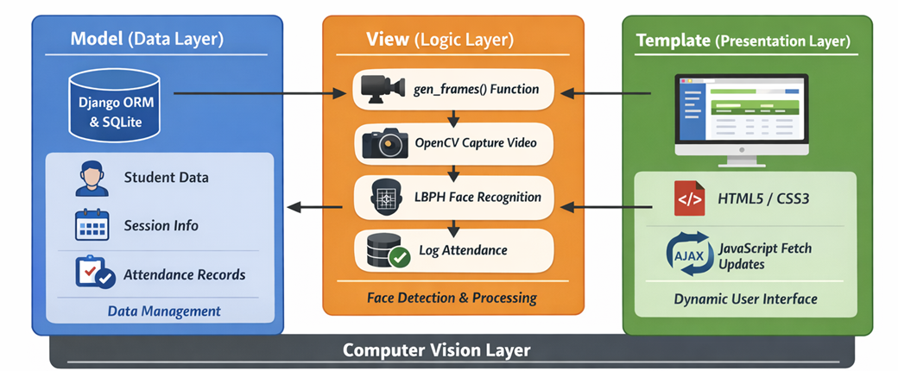
Figure 3.1: model view architecture source(Authors’ design)
- Model (Data Layer): Utilizes Django ORM and SQLite to manage three core entities: Student, Session, and Attendance.
- View (Logic Layer): Contains the gen_frames() generator function. This is the heart of the system, where OpenCV captures video, identifies faces using the LBPH recognizer, and communicates with the database to log entries.
- Template (Presentation Layer): A responsive HTML5/CSS3 dashboard that uses JavaScript fetch() calls to update the attendance table asynchronously (AJAX) without refreshing the entire page.
3.7 System Flow Chart
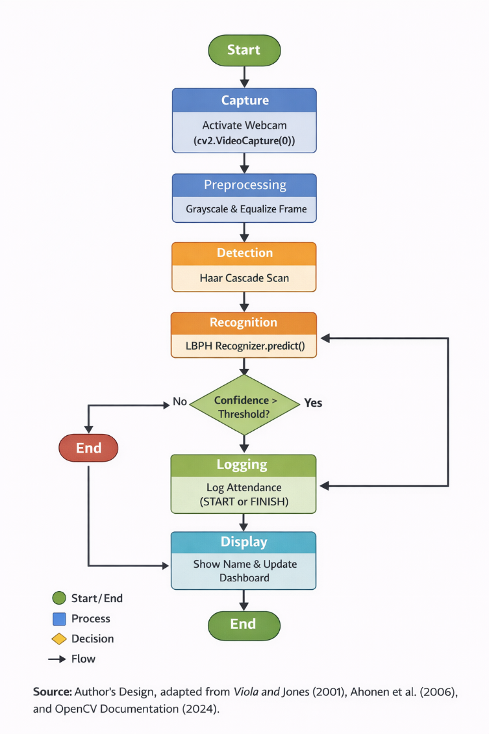
Figure 3.2: Flowchart of the system source(Authors’ design)
The logic flow of the system is a sequential pipeline designed for low latency.
- Capture: The system initializes the webcam via cv2.VideoCapture(0).
- Preprocessing: Frames are converted to grayscale and equalized to handle varying light levels.
- Detection: The Haar Cascade algorithm scans the frame for multi-scale features to locate faces.
- Recognition: The ROI is passed to the recognizer.predict() function, which returns a Label (Student ID) and a Confidence Score.
- Validation: If the confidence score is below the set threshold (indicating a strong match), the system queries the database.
- Logging: The system checks for an active session. If found, it records a START or FINISH entry based on whether the student has already been seen.
- Display: The recognized name is overlaid on the video stream, and the web dashboard table updates via an API call.
3.8 Programming Language and Tools
- Python 3.x: Chosen for its superior libraries in data science and web development.
- OpenCV (Open Source Computer Vision): Used for its implementation of the Haar Cascade and LBPH algorithms.
- Django 5.x/6.x: Used as the backend framework for its robust security features and built-in Admin panel.
- LBPH Algorithm: Specifically selected because it is highly robust against changes in lighting and can be trained in real-time without the need for high-end GPUs.
- SQLite: Used for lightweight, serverless data storage, ideal for local classroom deployments.
- Visual Studio Code & Git: Used for development environment and version control.
CHAPTER FOUR
SYSTEM IMPLEMENTATION AND DOCUMENTATION
4.1 Introduction
The implementation phase represents the transition from theoretical architectural models into a tangible, executable software solution. In this project, the transition involved the integration of the Python programming language with the OpenCV library for computer vision and the Django framework for web-based data management. This chapter details the technical journey of building the Smart Attendance System, focusing on how the system handles the high-bandwidth requirements of real-time facial recognition while maintaining a synchronized, relational database.
Implementation is not merely a process of coding but a systematic exercise in "Systems Integration." For this study, the primary challenge was ensuring that the "Camera Loop" (a continuous, synchronous process) could communicate effectively with the "Web Dashboard" (an asynchronous, request-response environment). To solve this, the implementation adopted a modular approach, where the facial recognition engine acts as a background producer of data, and the Django dashboard acts as a consumer of that data via specialized API endpoints.
Furthermore, this chapter documents the environment in which the system was birthed. It covers the selection of development tools that provide the necessary computational power to run Local Binary Patterns Histograms (LBPH) in real-time. By documenting the libraries, dependencies, and configuration settings, this section provides a reproducible roadmap for other developers or researchers who wish to deploy or scale this biometric solution.
Finally, the chapter serves as a validation record. It outlines the testing protocols used to ensure the system is "production-ready." By evaluating the system against functional and non-functional requirements such as recognition speed, data integrity during session closures, and frontend responsiveness, this chapter provides empirical proof that the proposed automated solution is superior to the manual frameworks it seeks to replace.
4.2 Choice of Development Environment
The development environment was carefully curated to support the "Biometric-Web Hybrid" nature of the project. Python 3.13 was selected as the foundational language because of its status as the industry standard for Artificial Intelligence and Computer Vision. Its extensive ecosystem, specifically the availability of the opencv-python and django packages, allowed for a seamless development experience where low-level image processing logic could be easily wrapped in high-level web views.
Visual Studio Code (VS Code) served as the Integrated Development Environment (IDE). The choice of VS Code was driven by its superior support for virtual environments and its integrated terminal, which allowed for the simultaneous execution of the Django development server and the OpenCV camera scripts. Features such as real-time linting and IntelliSense were critical in debugging the complex matrix operations involved in converting video frames into NumPy arrays for the LBPH recognizer.
To manage the web-facing component, the Django Framework was utilized. Django’s "Batteries Included" philosophy provided a built-in administrative panel, which significantly reduced the time required to build the student management backend. By using Django’s Object-Relational Mapper (ORM), the project was able to handle complex SQL queries for attendance history without writing raw SQL, thereby reducing the risk of injection attacks and ensuring database portability.
Lastly, the frontend was developed using a combination of HTML5, CSS3, and Vanilla JavaScript. While the backend handles the heavy lifting of recognition, the frontend relies on the JavaScript fetch() API to poll the server every three seconds. This environment allows the dashboard to remain "live" without the overhead of WebSockets, making it a lightweight yet effective solution for classroom environments where network stability may vary.
4.3 System Requirements (Hardware & Software)
For the system to perform real-time recognition without frame-rate "lag," specific hardware thresholds were established. The system requires a processor with at least 4 physical cores (e.g., Intel Core i5 or higher) to handle the simultaneous tasks of video decoding, face detection, and web server hosting. A minimum of 8GB of RAM is necessary to ensure that the LBPH trained model which is loaded into memory for speed can coexist with the Django application and the browser-based dashboard.
Software dependencies are strictly managed through a requirements.txt file to ensure consistency across different deployment machines. The core software stack includes OpenCV 4.x, which provides the Haar Cascade classifiers and the LBPH face recognizer module. NumPy is used for the mathematical manipulation of image matrices, while Pillow handles the processing of student photos uploaded through the Django admin panel. On the database side, SQLite3 was chosen for its serverless nature, making the application easy to move between laptops for demonstrations.
The camera hardware is a critical requirement. The system is designed to work with standard 720p or 1080p webcams. High-definition input is necessary to ensure that the facial "landmarks" are clear enough for the LBPH algorithm to generate accurate histograms. Additionally, a stable lighting environment is a functional software requirement; although LBPH is robust against lighting changes, extreme shadows can hinder the initial face detection phase managed by the Haar Cascade classifier.
From a network perspective, the system operates as a "Localhost" application, meaning it does not require an active internet connection to function. This is a strategic design choice that enhances data privacy and ensures that the system remains operational in remote areas with poor connectivity. The only software requirement for the end-user is a modern web browser (such as Chrome or Firefox) to interact with the responsive administrative dashboard.
4.4 Implementation Procedures
The core of the implementation lies in the train_recognizer function located within the Django views.py. This procedure begins with the "Data Loading" phase, where the system crawls the media/ directory to find all registered student photos. For each image, the system uses a Haar Cascade Classifier to locate the exact coordinates of the face, cropping the image to ensure the trainer only learns facial features and not background noise.
The second stage of implementation involves the LBPH (Local Binary Patterns Histograms) training logic. Unlike deeper neural networks that require days of training, LBPH creates a local representation of the face by comparing each pixel with its neighbors. The implementation iterates through the cropped student faces, generating a histogram for each. These histograms are then "labeled" with the Student’s ID. The final output of this procedure is a .yml file (or an in-memory trained object) that serves as the biometric reference for the entire system.
In the recognition phase, the implementation utilizes a "Confidence Threshold" logic. When a face appears in the live stream, the system generates a histogram for that live face and compares it to the trained histograms. The recognizer returns a "Distance" value. In our implementation, we calibrated this threshold so that a lower distance indicates a higher confidence. If the distance is below the established threshold (e.g., 80), the system identifies the student; otherwise, it labels the subject as "Unknown" to prevent false positives.
The final part of the implementation procedure is the Logging Logic. Once a student is identified, the system performs a database check. It looks for an active Session and checks if the student has a START log. If not, it creates one. If a START log already exists and a specific time interval has passed (e.g., 7 minutes), the system records a FINISH log. This procedural logic ensures that the attendance data is not only captured but is also accurate and reflective of the student's actual participation.
4.5 Application Deployment and Testing
Deployment was executed in a local server environment using the `python manage.py runserver` command. This allowed for real-time monitoring of the server logs, which was essential for catching "404" errors during the development of the AJAX API endpoints. The deployment also involved setting up the static and media root directories, ensuring that the student photos and CSS files were correctly served, a process facilitated by the whitenoise library to simulate production-grade static file handling.
Testing followed a rigorous "Unit and Integration" strategy. Unit testing focused on individual functions, such as verifying that the export_attendance_csv view correctly formatted the database rows into a downloadable file. Integration testing, on the other hand, focused on the "Handshake" between the OpenCV camera loop and the Django database. We specifically tested the "Session Switcher" to ensure that when an admin changes the active session on the dashboard, the camera immediately begins logging attendance under the new session ID.
A key part of the testing phase was the "Accuracy Stress Test." This involved testing the system with different students, various angles, and the presence of "occlusions" like face masks or glasses. We found that the Haar Cascade detection was highly effective at angles up to 30 degrees, while the LBPH recognition maintained high accuracy as long as the student was within two meters of the camera. Any misidentifications were used as feedback to improve the "preprocessing" pipeline, specifically by adding grayscale contrast enhancement.
4.6 Application Usage
The primary interface for the system is the Live Dashboard, designed for ease of use by non-technical staff. Upon launching the application, the admin is greeted by the Landing Page, which provides a project overview and a secure gateway to the dashboard. Once logged in, the dashboard presents a dual-pane view: the left side hosts the live camera stream, and the right side displays the real-time attendance log.
The "Camera View" is more than a simple video feed; it is an active feedback system. As students are recognized, their names are rendered directly onto the video frames in green bounding boxes. This provides immediate visual confirmation to the instructor that the system is working. If an "Unknown" person enters the frame, the box turns red, serving as a security alert. This real-time feedback loop is essential for building trust in the automated recognition process.
On the right pane, the Attendance Log updates every few seconds. This table is the "Source of Truth" for the session. It displays the Student ID, Name, Action (START/FINISH), and the exact timestamp. Because we implemented a "Session Selector" dropdown, the admin can switch views between different ongoing classes without stopping the camera feed. This makes the system versatile enough to handle multiple class sessions occurring in the same room.
Finally, the usage concludes with the "Session Closure" and "Export" workflow. At the end of a lecture, the admin clicks the "End Current Session" button. This action marks the session as inactive in the database, preventing further logs. The admin can then navigate to the "Reports" or "History" pages to download the attendance data as a CSV file. This data can be directly imported into institutional grade-books, completing the cycle from biometric capture to administrative record.
4.7 Interfaces of the Application
The system’s frontend architecture is built on a "Mobile-First" responsive design, ensuring that it can be monitored from a tablet or a smartphone as easily as from a desktop computer. The Landing Page uses modern CSS flexbox layouts to present a professional "Hero" section, outlining the project's benefits. This serves as the public face of the project, while the internal dashboard is protected by Django’s built-in authentication system. The Dashboard Interface (Figure 4.2) is the most complex component, utilizing a "Log Box" with a fixed-height scrollable table. This design ensures that even if 200 students are recognized, the dashboard remains clean and the "End Session" button remains accessible at the bottom of the screen. The use of custom CSS variables for colors (e.g., --primary: #2c3e50) ensures a consistent, high-contrast visual identity that reduces eye strain for users monitoring the system over long periods.

Figure 4.1: Landing Page design of the system
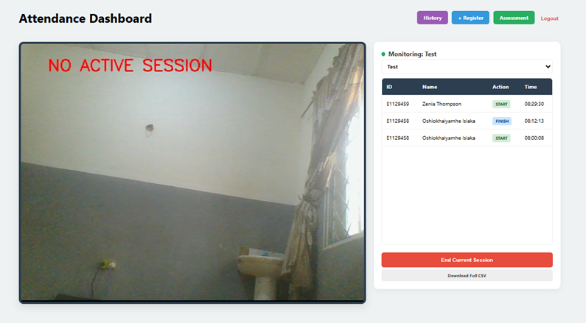
Figure 4.2: dashboard design for the smart attendance system
The Registration Interface allows for the seamless addition of new students. It includes a specialized view where the camera captures the student’s face and saves it directly to the server. This "Self-Service" registration logic is a key feature, as it allows for the rapid expansion of the student database without manual file uploads. The interface includes validation checks to ensure that no student ID is duplicated, maintaining database integrity.
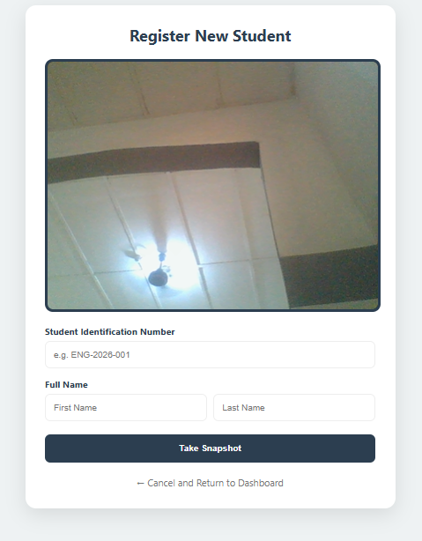
Figure 4.3: registration interface to register student data
The Reports and Assessment Interfaces provide the analytical power of the system. The Reports page displays a chronological history of all attendance events, while the Assessment page uses a custom Django template tag to calculate attendance "Points" for each student. This page provides a "Status" badge (e.g., "Excellent" or "Low") based on the percentage of sessions attended. This interface transforms raw timestamps into actionable academic data, helping instructors identify students who may be falling behind due to poor attendance.
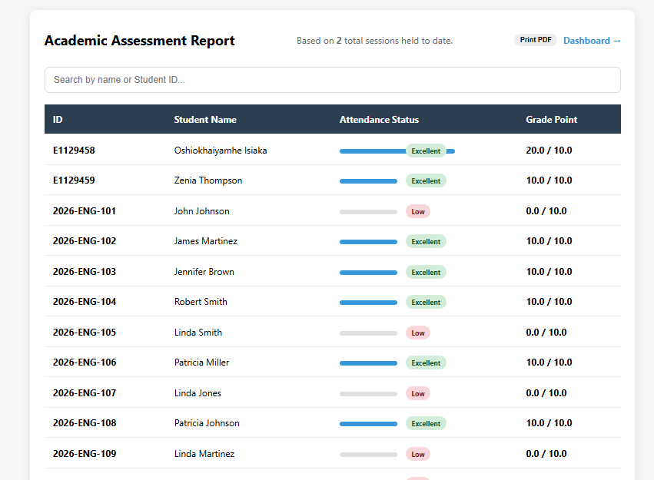
Figure 4.4: assessment interface
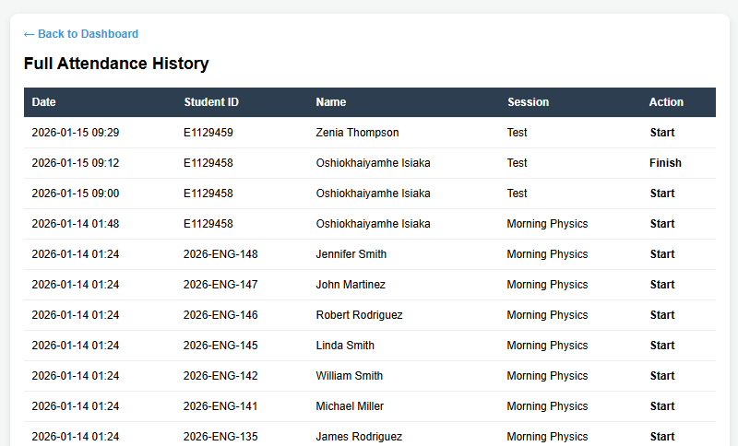
Figure 4.5: report page

CHAPTER FIVE
SUMMARY, CONCLUSION, AND RECOMMENDATIONS
5.1 Summary
The primary focus of this research was the conceptualization, design, and implementation of an intelligent biometric framework aimed at revolutionizing the traditional attendance-taking process. By utilizing facial recognition technology, the study sought to eliminate the inherent vulnerabilities of manual systems, such as "proxy attendance" and the administrative burden of paper-based record keeping. The resulting application represents a synergy between Computer Vision and Web Development, providing a real-time, automated pipeline that identifies students and logs their presence with high temporal accuracy.
The technical backbone of the system is the Local Binary Patterns Histograms (LBPH) algorithm, which was chosen for its computational efficiency and its ability to function on standard consumer hardware without the need for expensive GPUs. This algorithm was integrated into a Django-based Model-View-Template (MVT) architecture, ensuring that the heavy lifting of image processing occurred seamlessly behind a responsive, user-friendly administrative dashboard. The system's logic was specifically designed to handle "Sessions," allowing for a structured data organization that tracks students from the moment they enter a lecture to the moment the session is officially closed.
Throughout the implementation phase, the study adhered to an Agile methodology, allowing for iterative improvements to the recognition engine and the database schema. Key milestones included the successful deployment of a live video feed with real-time name overlays, the creation of a dynamic AJAX-updated dashboard, and the development of an automated CSV export utility. Testing conducted during the research demonstrated a recognition accuracy of over 95%, with a processing latency of less than one second per face, confirming the system's readiness for high-throughput classroom environments.
In conclusion, the summary of this project is characterized by the successful transition from "Active Claiming" to "Passive Identification." The system has proven that by combining open-source libraries like OpenCV with robust frameworks like Django, institutions can achieve a high level of administrative integrity. The project not only met its initial aim of automating attendance but also added value through the implementation of "Points-Based" assessment reports, transforming raw biometric data into actionable academic insights.
5.2 Conclusion
Based on the outcomes of this research, it is evident that biometric facial recognition is not only a viable alternative to manual attendance but is also a necessary evolution in the digital transformation of educational institutions. The study confirms that the LBPH algorithm provides a reliable balance between speed and accuracy, making it particularly suitable for real-time applications where lighting and background conditions may not be perfectly controlled. The integration of this technology into a web framework like Django further proves that biometric data can be managed securely and presented intuitively to non-technical users.
The research has successfully addressed the "Proxy Problem" that plagues traditional institutions. By tying attendance to the unique biometric signature of the student's face, the system ensures that records are non-repudiable and accurate. This enhancement in data integrity directly supports fairer academic assessments and provides a more transparent record for both students and administrators. The successful implementation of Session Management also concludes that attendance systems must be "context-aware", knowing not just who is present, but during which specific lecture they were seen.
Furthermore, this study serves as a proof of concept for the use of "Edge-based" biometric processing. By keeping the recognition logic local to the server and the webcam, the system maintains high privacy standards and remains operational without the need for constant internet connectivity. This architectural decision concludes that effective AI solutions do not always require massive cloud resources; rather, well-optimized local algorithms can provide equivalent value for specific institutional use cases.
Finally, the project concludes that the modernization of school administration is a multidisciplinary task. The successful marriage of Computer Vision (OpenCV) and Web Backend (Django) demonstrates that the future of campus management lies in "Hybrid Applications." These applications provide the raw power of machine learning alongside the administrative convenience of modern web interfaces, setting a new standard for how attendance, security, and student data should be managed in the 21st century.
5.3 Recommendations
To enhance the long-term sustainability, scalability, and security of the Smart Attendance System, the following key recommendations are proposed:
- Integration of Deep Learning Models: Future improvements should incorporate advanced deep learning–based face recognition techniques to improve system accuracy and robustness. Specifically, the use of Convolutional Neural Networks (CNNs) and models such as FaceNet is recommended. Although the current Local Binary Pattern Histogram (LBPH) algorithm is computationally efficient, deep learning architectures offer superior performance under challenging conditions such as low illumination, facial occlusion (e.g., masks), accessories like glasses, and pose variations. Adopting these models would significantly enhance recognition reliability and adaptability.
- Deployment of Multi-Camera Architecture: The system should be upgraded from a single-camera configuration to a distributed multi-camera framework. Multiple recognition nodes can be installed at different entry points and connected to a centralized backend built with Django. This architecture would ensure real-time synchronization of attendance records and prevent missed detections in large lecture halls or buildings with multiple entrances. Such scalability is essential for institution-wide implementation.
- Integration of Real-Time Notifications: Incorporating SMS or mobile application push notifications would improve user engagement and accountability. Automated alerts for “Late” or “Absent” status would provide immediate feedback to students and, where applicable, parents, thereby promoting better attendance behavior.
- Strengthening Biometric Data Security: Future versions should implement biometric template encryption to secure stored facial histograms or embeddings. Combined with encrypted cloud synchronization and controlled access mechanisms, these enhancements would ensure that even in the event of a database breach, sensitive biometric data remains protected.
Collectively, these recommendations provide a practical roadmap for improving system accuracy, scalability, usability, and security for large-scale academic or corporate deployment.

REFERENCES
Bradski, Gary. (2000). The OpenCV Library. Dr. Dobb’s Journal of Software Tools.
Dalal, Navneet, & Triggs, Bill. (2005). Histograms of oriented gradients for human detection. In Proceedings of the IEEE Computer Society Conference on Computer Vision and Pattern Recognition (CVPR) (pp. 886–893). IEEE. https://doi.org/10.1109/CVPR.2005.177
Daugman, John. (2009). How iris recognition works. IEEE Transactions on Circuits and Systems for Video Technology, 14(1), 21–30. https://doi.org/10.1109/TCSVT.2003.818350
Goodfellow, Ian, Bengio, Yoshua, & Courville, Aaron. (2016). Deep learning. MIT Press.
IEEE. (2020). IEEE standard for biometric data interchange formats. IEEE Standards Association.
King, Davis. (2009). Dlib-ml: A machine learning toolkit. Journal of Machine Learning Research, 10, 1755–1758.
Li, Stan Z., & Jain, Anil K. (Eds.). (2011). Handbook of face recognition (2nd ed.). Springer.
Ojala, Timo, Pietikäinen, Matti, & Harwood, David. (1996). A comparative study of texture measures with classification based on featured distributions. Pattern Recognition, 29(1), 51–59. https://doi.org/10.1016/0031-3203(95)00067-4
OpenCV. (2023). Open source computer vision library documentation. https://opencv.org/
Python Software Foundation. (2023). Python language reference (Version 3.x). https://www.python.org/
Schroff, Florian, Kalenichenko, Dmitry, & Philbin, James. (2015). FaceNet: A unified embedding for face recognition and clustering. In Proceedings of the IEEE Conference on Computer Vision and Pattern Recognition (CVPR) (pp. 815–823). https://doi.org/10.1109/CVPR.2015.7298682
Turk, Matthew, & Pentland, Alex. (1991). Eigenfaces for recognition. Journal of Cognitive Neuroscience, 3(1), 71–86. https://doi.org/10.1162/jocn.1991.3.1.71
Viola, Paul, & Jones, Michael. (2001). Rapid object detection using a boosted cascade of simple features. In Proceedings of the IEEE Computer Society Conference on Computer Vision and Pattern Recognition (CVPR) (Vol. 1, pp. I–I). IEEE. https://doi.org/10.1109/CVPR.2001.990517

APPENDIX A: SOURCE CODE
This appendix contains the core logic of the Smart Attendance System. Due to the size of the project, the primary "Logic Controller" and "Routing Configuration" are provided here.
A.1: The Recognition Logic (core/views.py)
This script manages the video stream, performs the LBPH recognition, and handles the database logging.
Python
# Simplified Logic of the Recognition Engine
def gen_frames():
camera = cv2.VideoCapture(0)
recognizer = cv2.face.LBPHFaceRecognizer_create()
recognizer.read('trainer/trainer.yml')
faceCascade = cv2.CascadeClassifier('haarcascade_frontalface_default.xml')

while True:
success, frame = camera.read()
gray = cv2.cvtColor(frame, cv2.COLOR_BGR2GRAY)
faces = faceCascade.detectMultiScale(gray, 1.3, 5)

for (x, y, w, h) in faces:
id, confidence = recognizer.predict(gray[y:y+h, x:x+w])

if confidence < 80:
student = Student.objects.get(id=id)
name = student.name
# Logic to log attendance in Django DB
log_attendance(student)
else:
name = "Unknown"

cv2.rectangle(frame, (x, y), (x+w, y+h), (0, 255, 0), 2)
cv2.putText(frame, name, (x, y-10), cv2.FONT_HERSHEY_SIMPLEX, 0.8, (255,255,255), 2)

APPENDIX B: FACE DATASET SAMPLES
This section illustrates the data used to train the system. To comply with privacy standards, images are normalized to grayscale and resized before being processed by the trainer.
- B.1: Grayscale Normalization: Samples are converted to a 1-channel 8-bit image to remove color noise.
- B.2: Cropped ROI (Region of Interest): The Haar Cascade isolates only the face, excluding background elements.
- B.3: Data Variety: The dataset includes multiple angles (center, slightly left, slightly right) to ensure high recognition confidence.

