**INFOSTUD DATA IN THE SERVICE OF DETECTING THE PROCESS OF DEPOPULATION IN SERBIA**

*InfostudData team*

**INTRODUCTION**

Generally known definition of depopulation is that this is substantial reduction in the population of an area. This pehnomenon is very frequent in poor country, like Serbia. Following this, UNDP published article about depopulation in Serbia (Cerović, 2019). According to this study, Serbia is among the world’s fastest shrinking populations, and some of reasons are low fertility rates, and high out-migration and low immigration.

Previous scientific and professional research dealing with the topic of depopulation of the population of the Republic of Serbia has mostly focused on socio-economic and demographic factors that affect migration from smaller to larger areas (Babović et al., 2016; Nikitović, 2013; Rašević, 2016). Furthermore, some of the mentioned studies dealt with the emergence of a large percentage of mortality in the Republic of Serbia as one of the most important factors influencing the general process of depopulation (Marinković & Radivojević, 2016), as well as depopulation of the Balkan population (with a focus on Serbia), because of the events in this area over the past few decades (Lukić et al., 2012). The results of all the above-mentioned research have suggested the existence of a drastic increase in the depopulation of the Serbian population in the last few decades, primarily for the above-mentioned reasons (e.g. poverty, wars etc.). All those findings are in general contexts, but there is a study interested in specific case – Serbs who migrate to Italy (Reynaud, Nikitović & Tucci, 2017). According to the results of this study, Italy is one of the most popular destination among Serbs, in XXI centry. Some of the reasons are: education, traditioanlity which is similar to our etc. However, a very interesting case is an increasing percentage of female immigrants from Serbia to Italy (Reynaud, Nikitović & Tucci, 2017), because of the increasing need for nurses who do not demand large salaries, as a native population.

However, previous scientific and professional research dealing with this topic has not focused on the depopulation of the working age population and students, as well as on the quantitative analysis of where they go (countries), to which work positions (or studies) abroad, as well as which trend (decrease or increase of depopulation) are current in the last few years in this group of the population, etc. abroad in the past few years. This is exactly the data that Infostud has at its disposal. Furthermore, none of the previously presented studies used advanced tools in the field of artificial intelligence (e.g. machine learning algorithms (ML), text analysis (NLP) etc.). In accordance with all the above, a draft was created for conducting DS-based research on the depopulation of the Serbian population. The research will be based on knowledge and algorithms in the field of artificial intelligence, and it will analyze large amounts of data that Infostud has had for years.

The data that would be used on this project are unique and have not been published publicly so far. Consequently, the insight into the data on the real demand for jobs/studies abroad (compared to those in the country) by the able-bodied population and students could be a very important quantitative indicator of the migration of the Serbian population. The final results and findings from this research would benefit both legal entities of the Republic of Serbia (which want to provide better working conditions in the country and thus reduce depopulation), and individuals, i.e. academics who are interested in this topic. In addition, data on which area of ​​job advertisements abroad most often belong to (low class workers, medicine, IT etc.) could give a specific direction towards a potential solution to the problem of depopulation, i.e. deciding how to keep the working age population in the country. Furthermore, data on how many students from our country are interested in studies and internships abroad are of great importance for gaining insight into what depopulation looks like in the case of a talented young population, which is increasingly leaving the country early (in studies) and they continue their life abroad. Overall, the final results of this research would offer a realistic, detailed and timely picture (from 2013 until 2020) of the depopulation of the Serbian population to the foreign labor market, ie the migration of Serbian students to the foreign educational market. All this in order to understand in detail the process of depopulation of the population of the Republic of Serbia, ie to take further measures by the responsible persons in order to reduce the depopulation of the population in the future.

**METHODOLOGY**

For this study, we used two data sets – one from *Poslovi.infostud.com* site, and the other one from *NajStudent.com*. The first one obtained 6139 cases, and the second one in general have had 1656 cases. All those cases range from 2013. to 2020. The raw text data selected from the ads from *Poslovi.infostud.com* site has 1650 ads, in general (all work areas), also from 2013 to 2020.

**RESULTS**

For the purpose of data analysis, three data analytics perspectives were use: *Exploratory data analysis* (EDA), *Linear regression* (as Machine Learning technique), and *Text mining*. Each of this analysis will be interpreted in the text below.

Exploratory Data Analysis (EDA) - *Poslovi.infostud.com*

Exploratory Data Analysis involves the analysis of data sets in order to gain insight into the main characteristics of these sets (i.e. distribution of numerical variables, detection of extreme values, etc.). Also, it is important to mention, that the data data for 2020 refer only to the first half of the year. Below, you can see exploratory analyses of variables we analyzed, one by one.

**Ads for jobs abroad throughout the years**

Over the years, there has been a continuous increase in ads published for jobs abroad, and the largest number of them were published in 2018 and 2019 (Graph 1). During 2020, there is a noticeable decline, probably as a consequence of the world facing a global economic slowdown due to the COVID-19 pandemic.

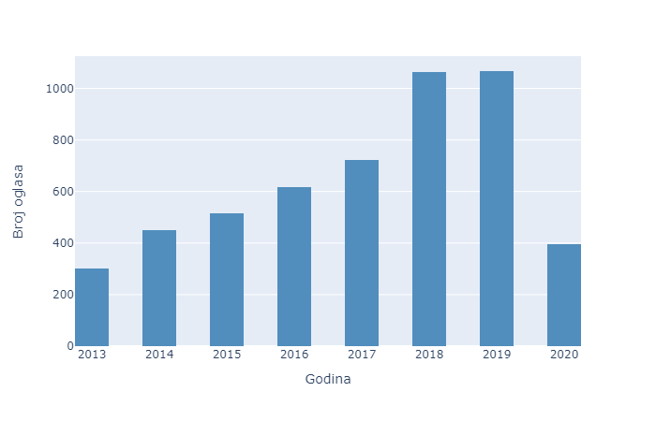

*Graph 1*. The number of ads (sum) (y axis), by years (x axis)

**Which categories are ads for jobs abroad from**

The job category implies the field of work which includes several related job positions. For the purposes of this research, we have selected 10 areas of work that are most frequently advertised on our portal. We are noticing that the largest number of ads was in the field of mechanical engineering, construction and IT. Electrical engineering, catering, food preparation, healthcare, and transport also stand out (Graph 2).

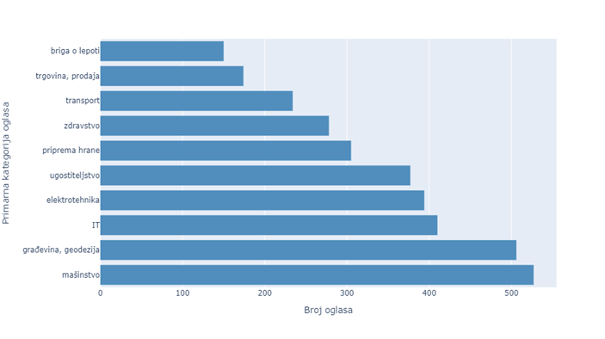*Graph 2.* The number of ads (sum; x axis) by job categories (y axis), from 2013 to 2020

**Which job positions are most often found in job ads abroad**

When we look at individual work positions, the greatest demand was for drivers and cooks. This is followed by civil engineers, waiters, mechanical engineers, electricians, doctors, and nurses (Graph 3).

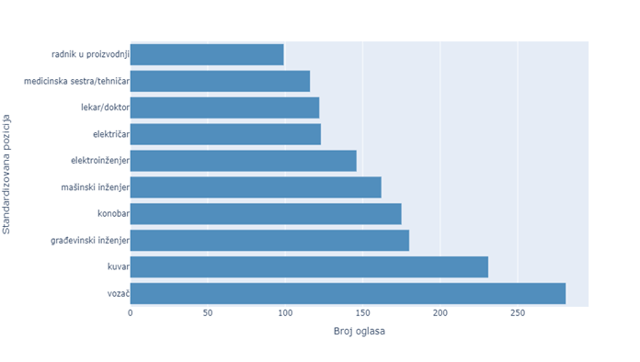

*Graph 3.* The number of ads (sum; x axis) by job positions abroad (y axis), from 2013 to 2020

**Candidates' interest in jobs abroad**

In the context of applying for job opportunities abroad, we see an increase in the number of applications from 2013 to 2019, with slight declines in 2017 and 2019 compared to the years preceding them (Graph 4). This behavior of users is in line with the trend of abroad job offers on our website - in both cases there was an increase from 2013 to 2019. It is also important to note that the noticeable decline in the number of applications, which we are seeing for 2020, is probably a consequence of the current pandemic.

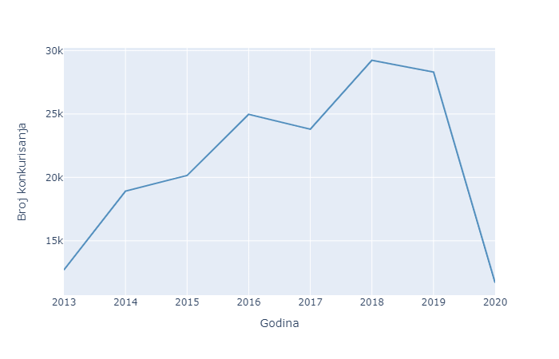

*Graph 4.* The number of applications (sum) (y axis), by years (x axis)

**Areas of work for which the candidates applied**

Most of the applications for abroad job ads were in the field of technical sciences, trade and services, as well as tourism, catering, and economy (Graph 5).

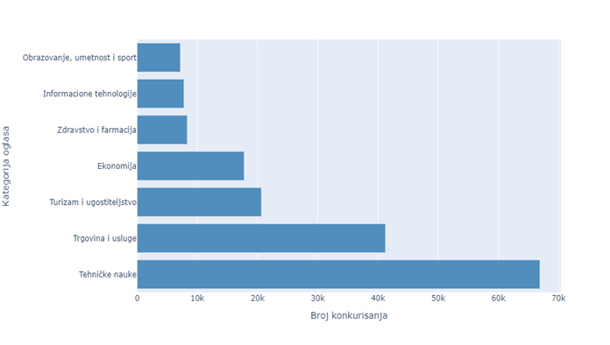

*Graph 5.* The number of applications (sum) (from 2013 to 2020; x axis), by categories (y axis)

**Countries from which most of the abroad job ads come from**

Based on the graph below, we can conclude which are the foreign countries with the majority of job offers (Gprah 6).

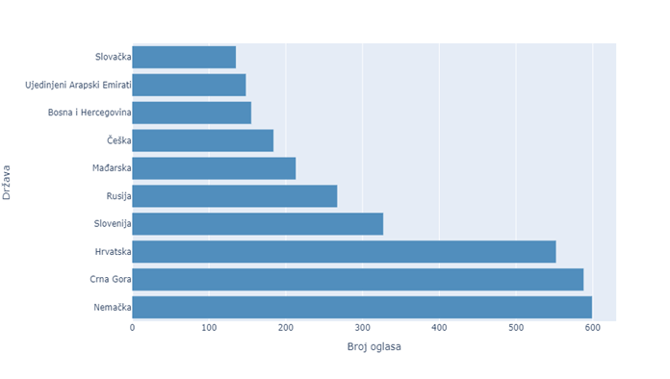

*Graph 6*. The number of ads (sum) (from 2013 to 2020) (x axis), by country (y axis)

**For which foreign countries do candidates apply the most**

Based on the graph below, we can conclude that the largest number of candidates apply for positions in Germany, followed by the countries in our region, as in the case of graphs illustrating the offer (Graph 7).

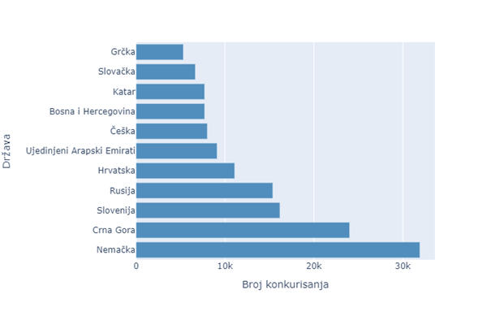

*Graph 7.* The number of applications (sum) (from 2013 to 2020) (x axis), by country (y axis)

Exploratory Data Analysis (EDA) – *NajStudent.com*

This report presents an analysis of data from the *NajStudent.com* database, which for the purposes of the research are linked to certain data collected within the same site through *Google Analytics*. The data on which the exploration data analysis (EDA) was performed is data on scholarships advertised on our portal from the beginning of 2013 to the middle of 2020.

**Ads for scholarships abroad by year**

The largest number of scholarships on the site was announced in 2013 and 2014, as well as in 2019. During 2020, there was a decline in available scholarships abroad (2 and a half times less than in 2019), which is expected given the situation related to COVID-19 and all the restrictions that exist on the issue of staying abroad (Graph 8). Most countries "closed" borders, making it very difficult to obtain student visas. Furthermore, one of the potential explanations for the decline in the number of ads for foreign scholarships in the period from 2015 to 2018 is the change of the business plan of the *NajStudenta.com*, which in that period shifted the focus to the domestic market (namely scholarships and internships within the Republic Serbia).

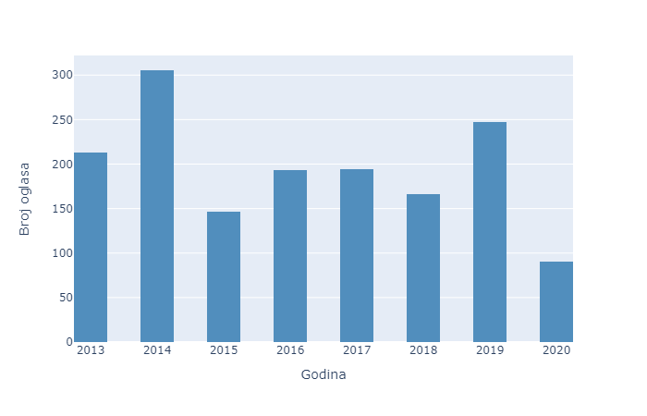

*Graph 8*. The number of ads (sum) for scholarships (y axis), by years (x axis)

**Students' interest in scholarships abroad**

The trend in the graph below suggests that most of the time spent on the pages of ads for foreign scholarships was during 2014 and 2019, and the least time spent was during 2015 and 2018. This result is relatively in line with the offer of ads in those years (Graph 9).

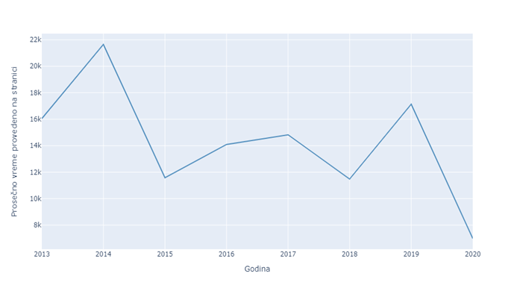

*Graph 9*. Average time (sum) that users spend on a page (in seconds) (y axis), by years (x axis)

Over the years, there has been a decline in unique views of pages of advertised scholarships for studying abroad (Graph 10). One of the assumptions explaining such behavior might be that students are often turning to official websites of foreign Universities in search of further information about scholarships. Throughout the years, students were more often directed to external pages of original ads and application forms, outside the *NajStudent.com* website, to finish the application process and find out more detailed information. Accordingly, the user does not need to stay on the site more than once.

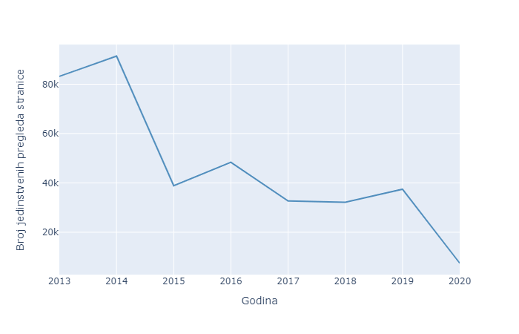

*Graph 10.* Yearly (x axis) total unique pageviews (sum) (y axis)

**Top countries offering scholarships for Serbian students**

The graph below shows which countries offer scholarships to Serbian students, most often (Graph 11). The United Kingdom is in the first place. This is not a surprise, considering the UK has a lot of funds offering scholarships for non-EU citizens (e.g. The British Scholarship Trust, Chevening Scholarship, Ivan D Jankovic Studentship etc.). A similar interpretation of the results is in the case of the second-ranked country - Germany, from which come very well-known funds with scholarships for all levels of study (e.g. DAAD Scholarship, BAYHOST Scholarship, etc.). Italy ranks third, as one of the countries that provide a lot of scholarships for certain faculties, which have been very popular among students from Serbia for years (e.g. Bocconi University, Polytechnic University, etc.).

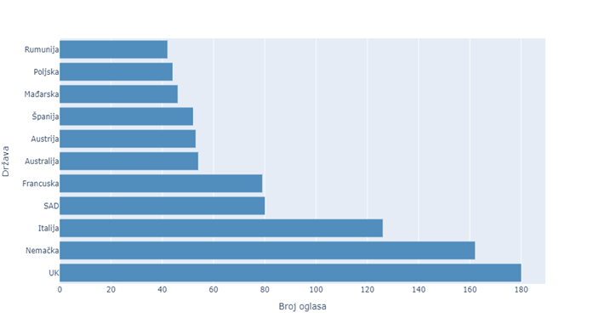

*Graph 11.* Total scholarship ads (x axis) per admission country (y axis), from 2013 to 2020

**From which areas of study are scholarships for studying abroad the most common?**

The largest number of scholarships was offered in the field of social sciences (N = 564). This is followed by natural sciences (N = 345), technical sciences (N = 206), humanities (N = 111), art (N = 84), medical sciences (N = 40), biotechnical sciences (N = 25) and finally sport and physical culture (N = 7). The result, which suggests that the greatest demand for the social sciences may be since economics, law, and similar fields of social sciences are some of the most sought after among students in Serbia (Graph 12). Accordingly, students from these areas go on to further education and specialization abroad. In the case of second-ranked natural sciences, for years a large number of students in the field of mathematics have been leaving Serbia and going to United Kingdom for further education with the help of prestigious scholarships. Furthermore, the global demand for IT candidates, and thus schools in these fields, has brought technical sciences to third place among the most sought-after fields for study abroad. However, why didn't such a popular discipline end up in the first place? It is assumed that the reason is that in Serbia there are many quality faculties, which educate experts in this field, at all three levels of study (BSc, MSc, Ph.D.).

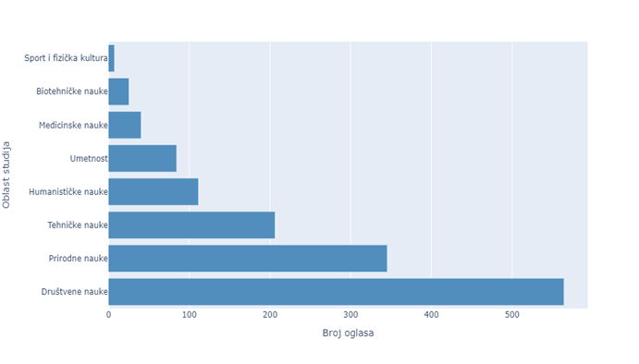

*Graph 12.* Total scholarship ads per field of study (y axis), from 2013 to 2020

**Disciplines for studies abroad**

The highest-ranked discipline is economics, and it is assumed that this is due to MBA programs, which do not exist in our country in the format in which they exist abroad, and these studies are very popular among our students. MBA programs are most commonly attended in the UK and USA, which further suggests that this is one of the reasons why the UK is also the most popular among the countries that give scholarships to our students (Graph 13). Furthermore, ERASMUS+ and similar exchange programs collaborate with UCL and other prestigious UK colleges, which further facilitates obtaining scholarships for this country. In second place are the biological sciences, which as a study program are not popular in our country, but that is why they are in Germany and the UK. It is assumed that this is the reason why Serbian students want to study in the field of biology in those countries. As expected, IT stood out in the high third place as an academic discipline, which is not surprising considering that specific IT areas, such as AI, are quite developed abroad, especially in UK, Germany, Italy, and the USA (Graph 13).

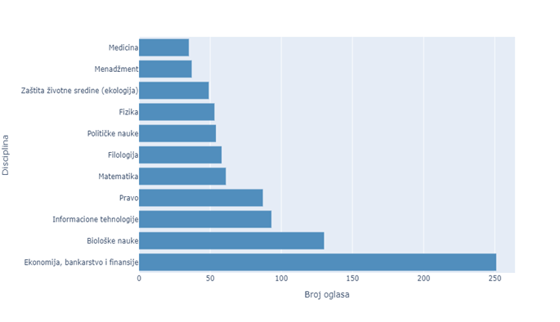

*Graph 13.* Total scholarship ads (x axis) per field of study (y axis) (2013. - 2020.)

Linear regression (Machine Learning) – *Poslovi.infostud.com*

Linear regression was used in this research to gain insight into the existence of a certain pattern of behavior among users - does a larger number of pageviews of job postings for working abroad necessarily bring a larger number of candidates applying for them? Based on the results of linear regression (height of the coefficient of determination), it can be concluded that this is the case in almost all areas of work and for all years. The exeption is IT.

Because of the limited amount of data in some subsets (fields of work), the modified version of linear regression was conducted too, for each field. In this, modified linear regression, the values are grouped around the Median, due to the pronounced scatter (a lot of nonrelated data) we had in the case of some categories in standard linear regression. On the graphs below, you can se the results of the linear regression for each field of work. Left scatter diagram is related with standard linear regression, and right scatter diagram is related with modified linear regression.

*Graph 14*. The regression graphs for Economy

*Graph 15*. The regression graphs for IT

*Graph 16*. The regression graphs for Education, Art and Sport

*Graph 17*. The regression graphs for Technical fields

*Graph 18*. The regression graphs for Commerce

*Graph 18*. The regression graphs for Commerce

*Graph 19*. The regression graphs for Tourism and Hospitality

*Graph 20*. The regression graphs for Medicine and Pharmacy

For the final information about regression effects look the table below. The higher the Linear coefficients are, the closer relationship between variable is.

Table 1

*Coefficients of the linear regression (both, standard-updated)*

Text mining – *Poslovi.infostud.com*

Within this section, we have dealt in more detail with the content of job postings within different categories (areas of work). In the graph 21, you can see what the frequency graph of the words most often mentioned in IT job postings for positions abroad looks like. Furthermore, the same representations for all other area of work you can find in other graphs below.

*Graph 21*. The text mining results for the IT field of work

*Graph 22*. The text mining results for the Economy

*Graph 23*. The text mining results for the Education, Art and Sport

*Graph 24*. The text mining results for the Technical field

*Graph 25*. The text mining results for the Commercial

*Graph 26*. The text mining results for the Tourism and Hospitality

*Graph 27*. The text mining results for the Medicine and Pharmacy

**CONCLUSIONS**

Over the years, there has been a continuous growth of published ads for jobs abroad, and the largest number of them were published in 2018 and 2019, respectively. During 2020 there is a slowdown, probably as the consequence of the world facing a global economic slowdown due to the COVID-19 pandemic. The largest number of the analyzed job ads were in the field of mechanical engineering, construction and IT. Electrical engineering, catering, healthcare and transport also stand out. Furthermore, most of the competitions for advertisements for jobs abroad were in the field of technical sciences, trade and services, as well as tourism and catering, economy. When we look at individual work positions, the greatest demand was for drivers and cooks. This is followed by civil engineers, waiters, mechanical engineers, electricians, doctors, and nurses. The results of the text mining from the IT ads suggest that the following technologies are most often mentioned, listed in order by number of mentions: C, SAP, JAVA, PHP, CSS and JavaScript. In the field of economics, it is obvious that there are mostly terms related with the managerial positions. The following terms were most often mentioned in advertisements for this branch: Project, MS, Management, Business, Communication and Manager. In the category of technical positions, the advertisements mostly mention words related to construction (i.e. installation, construction, electronics) or transport. In the field of services and production -- operators, hairdressers and drivers are most often sought, and in tourism -- waiters and cooks. Candidates' interest in jobs abroad, as measured by the number of applications for advertisements published in foreign countries, grew in parallel with the growth in the number of published advertisements for jobs published. This growth has been constant since the beginning of the measurement covered by this research – i.e. since 2013, with slight slowdowns during 2017 and 2019. We record a drastic slowdown in 2020, as the consequence of the world facing a global economic slowdown due to the COVID-19 pandemic. Offers for jobs abroad since 2013 most often came from Germany, followed by countries from the region – Montenegro, Croatia, and Slovenia (mostly seasonal jobs). If we take into consideration the number of candidate applications, the order is similar, with a slightly lower interest in relation to the job offers in Croatia (5th place) and slightly higher for work in Russia (4th place).

With the reference to the offers of scholarships, the United Kingdom is in the lead country, followed by Germany and Italy. This result is not unexpected when we take into account the fact that the first two countries have several funds and scholarships that allow our students to continue their studies abroad. Also, there is a fact that certain faculties in Italy have become well-known places for students from Serbia. The largest number of scholarships was offered in the field of social sciences (564). This is followed by natural sciences (345), technical sciences (206), humanities (111) and art (84). The result that suggests that the social sciences is the most popular field may be due to the fact that economics, law, and similar fields of social sciences, are some of the most popular among students in Serbia. The highest ranked discipline is economics, and it is assumed that this is due to MBA programs, which do not exist in our country in the format in which they exist abroad. MBA programs are most commonly attended in the UK and USA, which further suggests that this is one of the reasons why the UK is also the most popular among the countries that give scholarships to our students.

**LITERATURE**

Babović, S., Lović-Obradović, S., & Prigunova, I. (2016). Depopulation of villages in southeastern Serbia аs hindrance to economic development. *Journal of Geographical Institute of "Jovan Cvijić", 66*(1), 61-74.

Cerović, I. (2019). *Depopulation: what’s it all about?* Blog posted at UNDP RS site:<https://www.rs.undp.org/content/serbia/en/home/blog/2019/depopulation--whats-it-all-about--.html>

Lukić, T., Stojsavljević, R., Đurđev, B., Nađ, I., & Dercan, B. (2012). Depopulation in the western Balkan countries. *European Journal of Geography, 3*(2), 6-23.

Marinković, I., & Radivojević, B. (2016). Mortality trends and depopulation in Serbia. *Geographica Pannonica, 20*(4), 220-226.

Nikitović, V. (2013). Migraciona tranzicija u Srbiji: demografska perspektiva. *Sociologija, 2,* 187-208.

Rašević, M. (2016). *Migracije i razvoj u Srbiji*. Beograd: Međunarodna organizacija za migracije (IOM).

Reynaud, C., Nikitović, V., & Tucci, T. (2017). Recent immigration from Serbia to Italy: the beginning of a new tradition? In L.A. Janeska V. (a cura di), *The population of the balkans at the dawn of the 21st century* (pp. 205-220). Skopje: Institut économique - Skopje, Université Saints-Cyrille-et-Méthode de Skopjet.