DECT NR+ V2 DLC/MAC Explained

Purpose
This demo application implements DECT NR+ communication between two nRF9151 DK boards using the NR+ firmware release 2.0.0. Focus is on the API usage and showing the power saving options that are available.
Nordic Connect SDK contains a very nice sample of IPv6 over NR+. However, the Network control and IP-stack adaptation hides how the DECT API (nrf_modem_dect.h) actually operates underneath. This document explains the main operation flow of the DECT API for plain data, without IPv6.
At the end are some personal thoughts on AI Agent based development that I used for the first time in this project.

Needed Devices and SW
If you want to duplicate this, or play with the code, you need:
- two nRF9151 DevKits
- the NR+ modem firmware (delivered free of charge, ask you closest friendly Nordic representative)
- the application SW for demo, that can be found at the end of this blog in a zip.
- Nordic Power Profiler Kit II for measurements
How to program the devkits, take a look at our earlier blog on the PHY API.

NR+ Basics
NR+ is an ETSI radio standard for IoT, both for massive mesh networks and low latency communications. It is already seeing growing adaptation in audio use cases ßand in factory and process automation use cases all of which demand predictable latency and interference free radio channel. Massive networks can be implemented with mesh networking support. For more information on the technology please visit Dect Forum or a recent deep dive video by Psychogenic Technologies. The architecture standard is a good source too.

Nordic NR+ firmware
Nordic NR+ firmware v2.0.0 comes in two flavors, PHY and DLC/MAC access. They are separate firmware files and have different APIs. The earlier blog on the PHY API explains the low level PHY access. The DLC/MAC API is altogether different, much higher level API introduced in release 2.0.0.
Nordic NR+ firmware v2.0.0 supports star network currently. The central device, FT in NR+ parlance, advertises the network availability with beacons. Child devices, PT devices in NR+, find the FT beacons, associate to it and then receive information in those beacons when the FT device is listening for the child’s transmission uplink. In Nordic implementation the PT devices are not listening all the time for downlink messages from the FT but instead receive notification in beacons if a message is buffered for the PT device at the FT. The PT will then poll for the message. Uplink transmissions can be fast, if the FT is listening all the time, but downlink is slower, dependent on the beacon advertisement period. This is shown in the sequence graph in Figure 1.
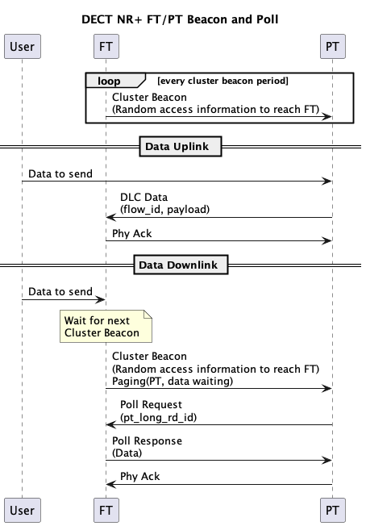
Figure 1 Sequence graph for uplink and downlink send

Architecture of the Demo SW
It started small and simple to show the beacon period impact and power save operation. But there is a surprising amount of parameters and commands needed. It is a shell-controlled application that provides textual feedback on the shell terminal.
The main point for SW development is that the DECT API callbacks are in Interrupt service context (ISR) , requiring them to be fast non-blocking operations. To facilitate this the SW architecture has a DECT Adapter that maps those callbacks to message queue for application event handlers to process. Adapter also hides the DECT specific enumerations from application. SW Architecture of this demo SW is shown in Figure 2.
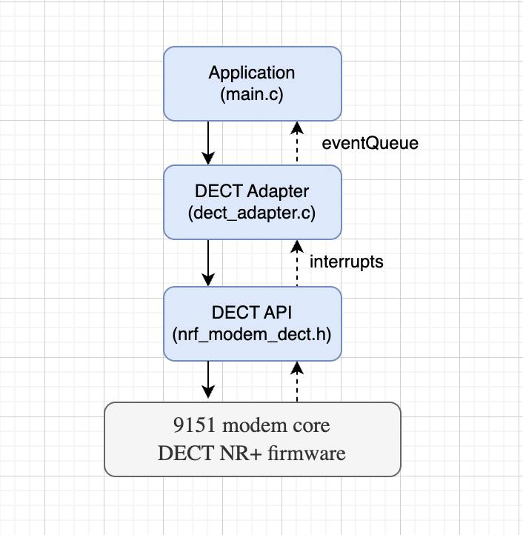
Figure 2 SW architecture
The application handles shell commands, controls the operation and processes the resulting events. There are callbacks on operation completion and application events for data processing notifications from the adapter. The asynchronous operation completion is handled in the prepare_wait, wait_for_prepared_operation and complete_wait functions and semaphores.
The DECT adapter’s main function is to map the DECT API callbacks into message queue events. This separation prevents dependency leakage and (hopefully) simplifies maintenance.

Device Roles and Operation
The FT device scans channels (SCAN command) and on user command starts FT beaconing and waiting for associations on a free channel (FT <channel> command). The other device is started in PT mode on the channel (PT <channel>). Currently only 1 FT and 1 PT is supported, although it should be simple to add support for more PT devices (association list, show list to direct send to individual device). User can also scan if there are multiple FT devices and select the wanted FT device then (first PT_SCAN, then PT <channel>). FT and PT commands can be given with the channel number (carrier number in NR+ standards) for faster network start and finding and association. With very long beacon periods the advertisement and PT listening on different channels can take considerable time.
In the connected mode the devices can send messages (SEND <ASCII>) to the other device. There is an additional command STOP to return to initial state and some advanced commands to highlight the operation parameters: PERIOD,POWERSAVE and ACTIVETIME. Period controls the beacon period of the FT device (stop, adjust period and restart, also on PT to adjust the listening period per channel if scanning more channels). POWERSAVE is demonstrated how it impacts the power consumption as measured with the Power Profiler Kit. LIMIT command can be used to try different values when a channel is deemed free or busy.

Main functions
Majority of the functionality is the radio link setup, as shown in Table 1 (PT is Portable Terminal, child device, and FT is Fixed Terminal the parent).
Function | Description
nrf_modem_dect_mac_callback_set | Init. Register op and ntf callback structs
nrf_modem_dect_control_systemmode_set | Init. Set DECT system mode (MAC / PHY / none)
nrf_modem_dect_control_functional_mode_set | Init. Activate or deactivate the modem
nrf_modem_dect_control_configure | Init. Set TX power, MCS, RSSI target, long RD ID, power save
nrf_modem_dect_mac_association | PT Send association request to FT
nrf_modem_dect_mac_association_release | Release an existing association
nrf_modem_dect_mac_cluster_beacon_receive | PT Subscribe to FT cluster beacon  (learns random access schedule)
nrf_modem_dect_mac_cluster_beacon_receive_stop | PT Stop cluster beacon subscription
nrf_modem_dect_mac_cluster_configure | FT Configure cluster (channel, beacon period, RACH, association limits)
nrf_modem_dect_mac_network_beacon_configure | FT Configure and start optional network beacon
nrf_modem_dect_mac_network_scan | PT Scan for FT network and cluster beacons
nrf_modem_dect_mac_network_scan_stop | PT Stop ongoing network scan
nrf_modem_dect_mac_rssi_scan | FT Scan RSSI across channels (free channel selection)
nrf_modem_dect_mac_rssi_scan_stop | FT Stop ongoing RSSI scan
nrf_modem_dect_mac_cluster_info | Request current cluster info (channel load etc.)
nrf_modem_dect_mac_neighbor_info | Request info about a specific neighbor by long RD ID
nrf_modem_dect_mac_neighbor_list | Request list of all known neighbors
nrf_modem_dect_dlc_data_tx | Transmit DLC data to a neighbor
nrf_modem_dect_dlc_data_discard | Discard a pending DLC transmission by transaction ID
Table 1. Functions in DECT API (nrf_modem_dect.h)
As can be seen, only two functions are for the data transmission, nrf_modem_dect_dlc_data_tx and a discard function to cancel a transmission. The DLC implementation supports acknowledgements with segmentation and reassembly of messages over the radio link. The rest of the functions establish the radio link. They do initializations, scans and association control. There are operation callbacks and notifications. Notifications are asynchronous modem-initiated callbacks passing data from different events to the higher controlling layer. These are shown in Table 2.
control_functional_mode | Functional mode set operation callback
control_configure | Configuration operation callback
control_systemmode | Systemmode set operation callback
association | Association request callback
association_release | Association release request callback
cluster_beacon_receive | Cluster beacon reception request callback
cluster_beacon_receive_stop | Cluster beacon reception stop request callback
cluster_configure | Cluster configuration request callback
cluster_info | Cluster info request callback
neighbor_info | Neighbor info request callback
neighbor_list | Neighbor list request callback
dlc_data_tx | DLC data transmission send callback
dlc_data_discard | DLC data discard request callback
network_beacon_configure | Network beacon configuration request callback
network_scan | Network scan request callback
network_scan_stop | Network scan stop request callback
rssi_scan | RSSI scan request callback
rssi_scan_stop | RSSI scan stop request callback
association_ntf | FT receives an association request from a PT
association_release_ntf | Association released by peer or modem
cluster_ch_load_change_ntf | Cluster channel busy% crosses the configured threshold
neighbor_inactivity_ntf | A neighbor has been inactive longer than the configured timer
neighbor_paging_failure_ntf | Paging a neighbor failed
rssi_scan_ntf | Per-channel RSSI result during an RSSI scan (one per channel)
cluster_beacon_ntf | A cluster beacon is received over the air
cluster_beacon_rx_failure_ntf | Consecutive cluster beacon misses exceed configured threshold
ipv6_config_update_ntf | IPv6 address configuration updated
network_beacon_ntf | A network beacon is received over the air
capability_ntf | Modem reports its PHY capabilities (bands, max MCS)
dlc_data_rx_ntf | DLC data received from a neighbor
dlc_flow_control_ntf | DLC flow control status change
Table 2. Callbacks and notification
It is a bit scary looking (hence my approach with AI Agents) but really the minimal flow can be defined.
The control flow in this demo for FT device is shown in Figure 3, showing the functions called and the state transition events. Association acceptance is automatic if there is memory left in the modem.
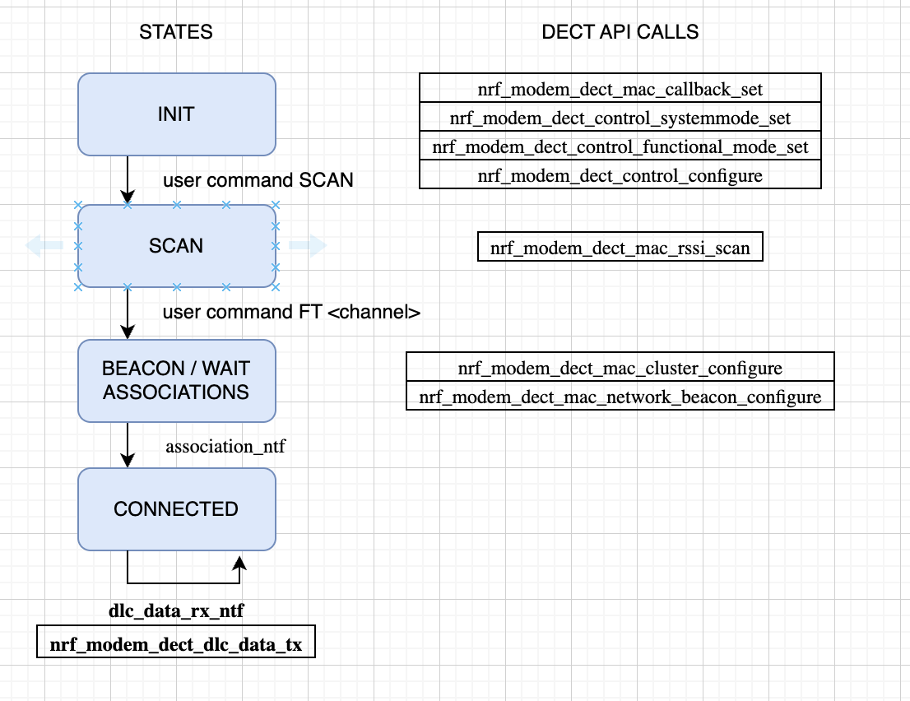
Figure 3 FT Flow

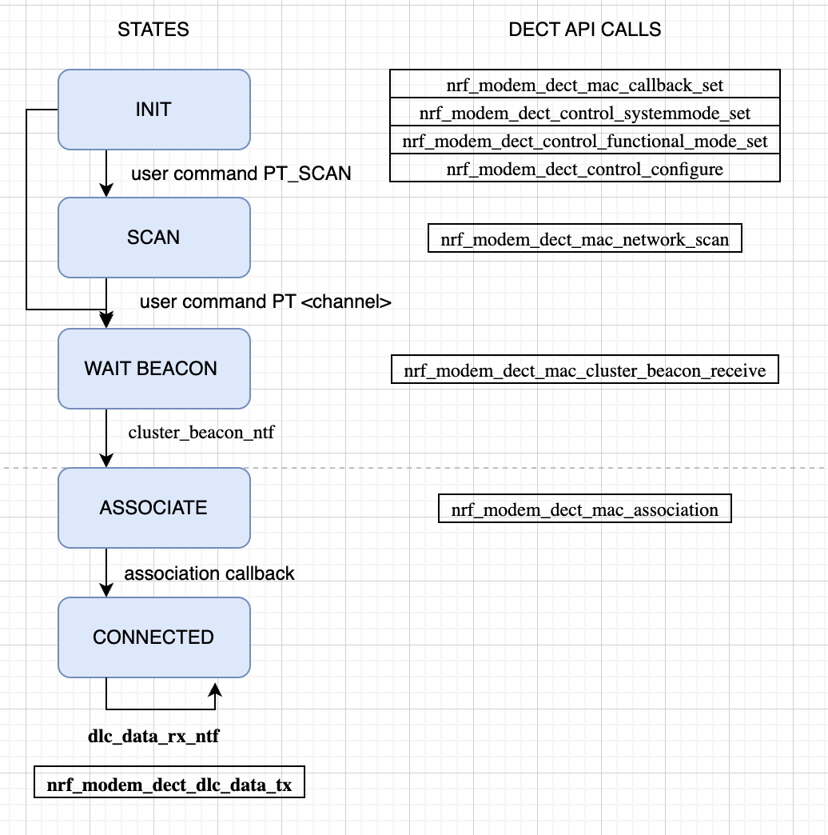
Figure 4 PT flow
The PT flow is shown in Figure 4. There is an optional network scan state, listing found networks (and cluster beacons) on all channels. This was kept for later use of the code. The key thing is to start the beacon receive from the FT and then associate to the FT device. A beacon must be received for modem to have the radio parameters how to contact the FT device.
Figures 5 shows a common failure mode. FT tried to send data to the PT, but the PT has dropped out of radio network and sending fails. Note that the timeouts are long, NRF_MODEM_DECT_DLC_SDU_LIFETIME_60_S, those can be controlled in the DECT adapter’s custer_configure_ft and association_request functions with parameter dlc_sdu_lifetime .
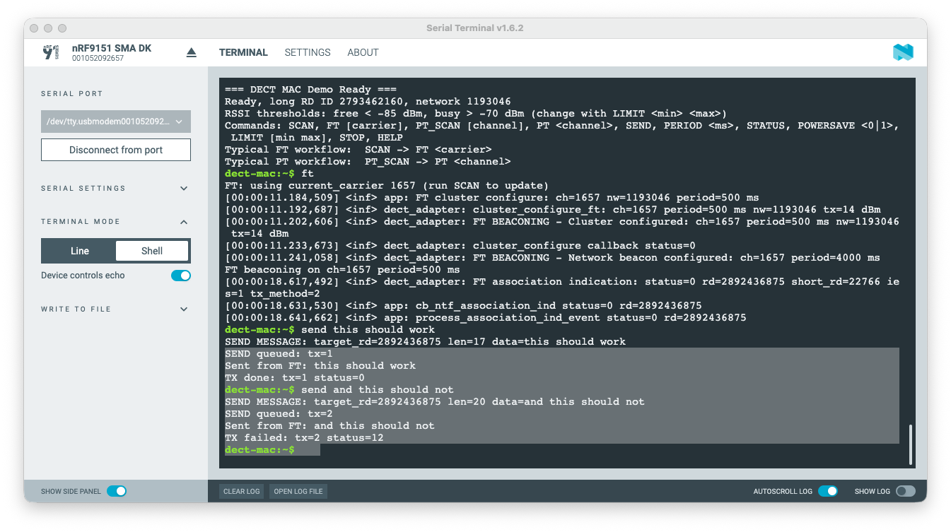
Figure 5 FT showing failed transmission
The FT device is sticky to stay in the beaconing state and accept associations. On the PT side there is fallback (a worker) that is kicked off if there are multiple DLC TX errors, association release or loss of beacon reception. It stops possible ongoing work, re-initializes and associates on the same channel – assumption is that the FT stays there. This is rudimentary and very poorly tested too! This re-subscribe is shown in Figure 6. The key is to check the callbacks status values, and for example the notification cluster_beacon_rx_failure_ntf which signals that the FT signal has not been seen. How soon the notification is fired can be configured in nrf_modem_dect_mac_association_params.
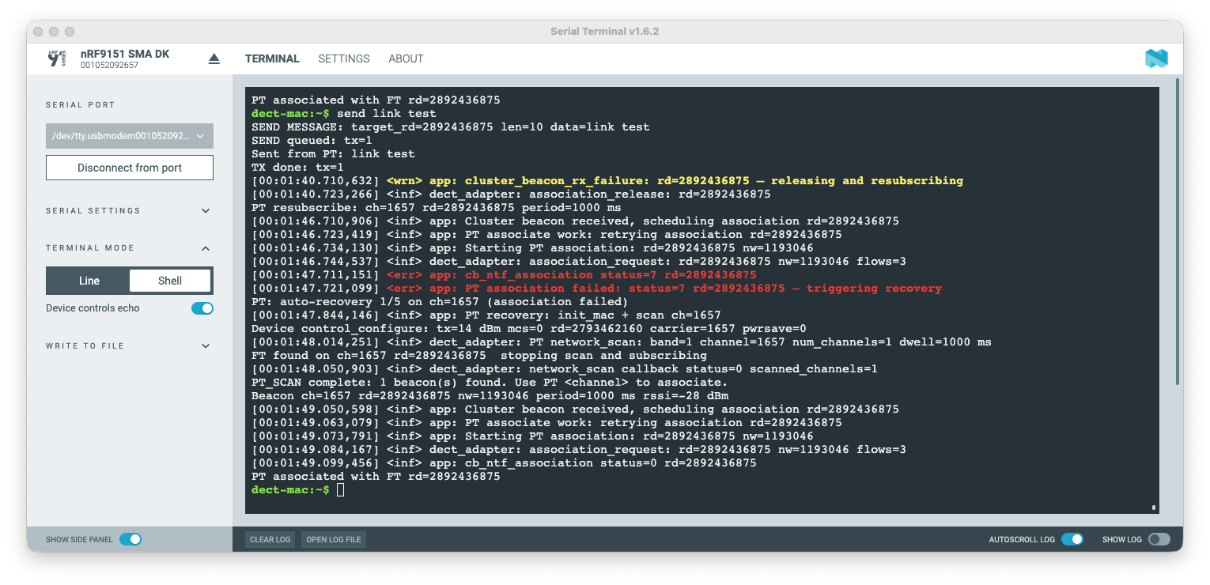
Figure 6. PT recovery from lost beacons
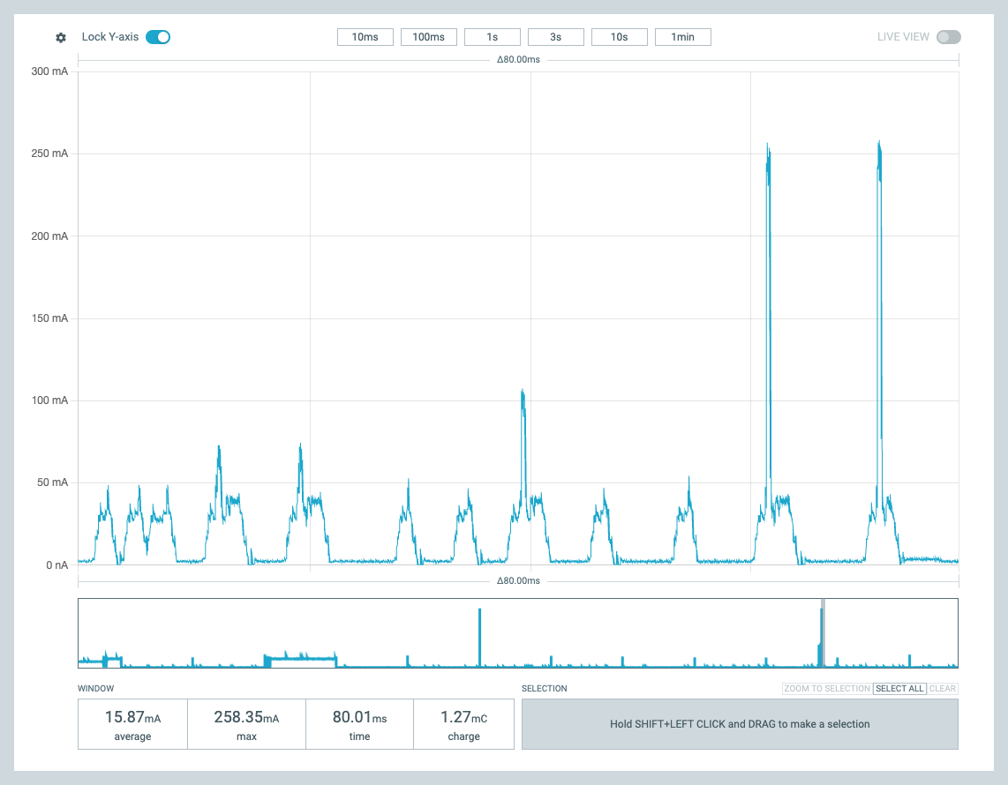
Figure 7. Retries
Figure 7 shows retries as done by the modem implementation. Sorry for the messiness, it was a bit hard to produce manually and mostly a lucky chance. There are short Listen-Before-Talk reception peaks, where the channel is measured if it is free for transmission to start. The higher peaks are the transmission attempts, with increasing power as no response is received. Each TX peak is followed by the ACK listening window. In the end it did succeed.

Power Behavior
This exercise started with aim of showing the power consumption impact of beacon period control and the powersave parameters. Powersave command controls the DECT API nrf_modem_dect_control_configure_params.power_save directly. The results are shown below.

Basic Operation, no powersave
Figure 8 shows the PT power profile without powersave for network scan and association – the high peak. Scan is active listening, at around 50mA power consumption level. Then association is done, TX peak at 260mA followed by a short response reception window at 50mA. Since this is the first communication, the TX power is not adjusted. After association period reception peaks are seen, these are the beacon receptions from the FT.

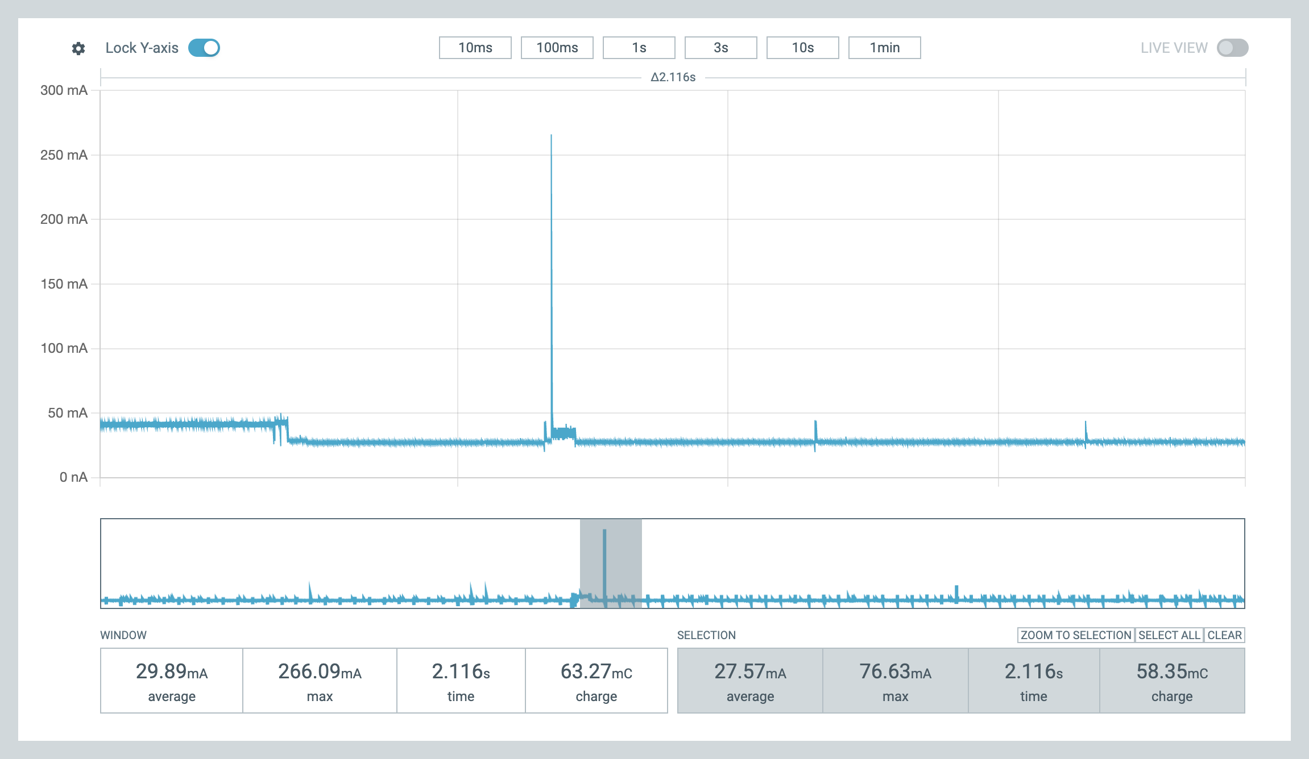
Figure 8. Scan and association, no powersave

Powersave features in practice
Figure 9 shows similar association with powersave enabled. There is the scan window at around 50mA (and before that the processing of the user command). Association TX peak is once again around 260 mA. But after this, the power usage drops significantly, the radio is shut down and power consumption is around 2.2mA as shown in Figure 10. The application does not implement any powersave optimizations and so the application core is running, further power savings are possible. The periodic spikes are once again the beacon reception windows when the radio is powered back on for reception.
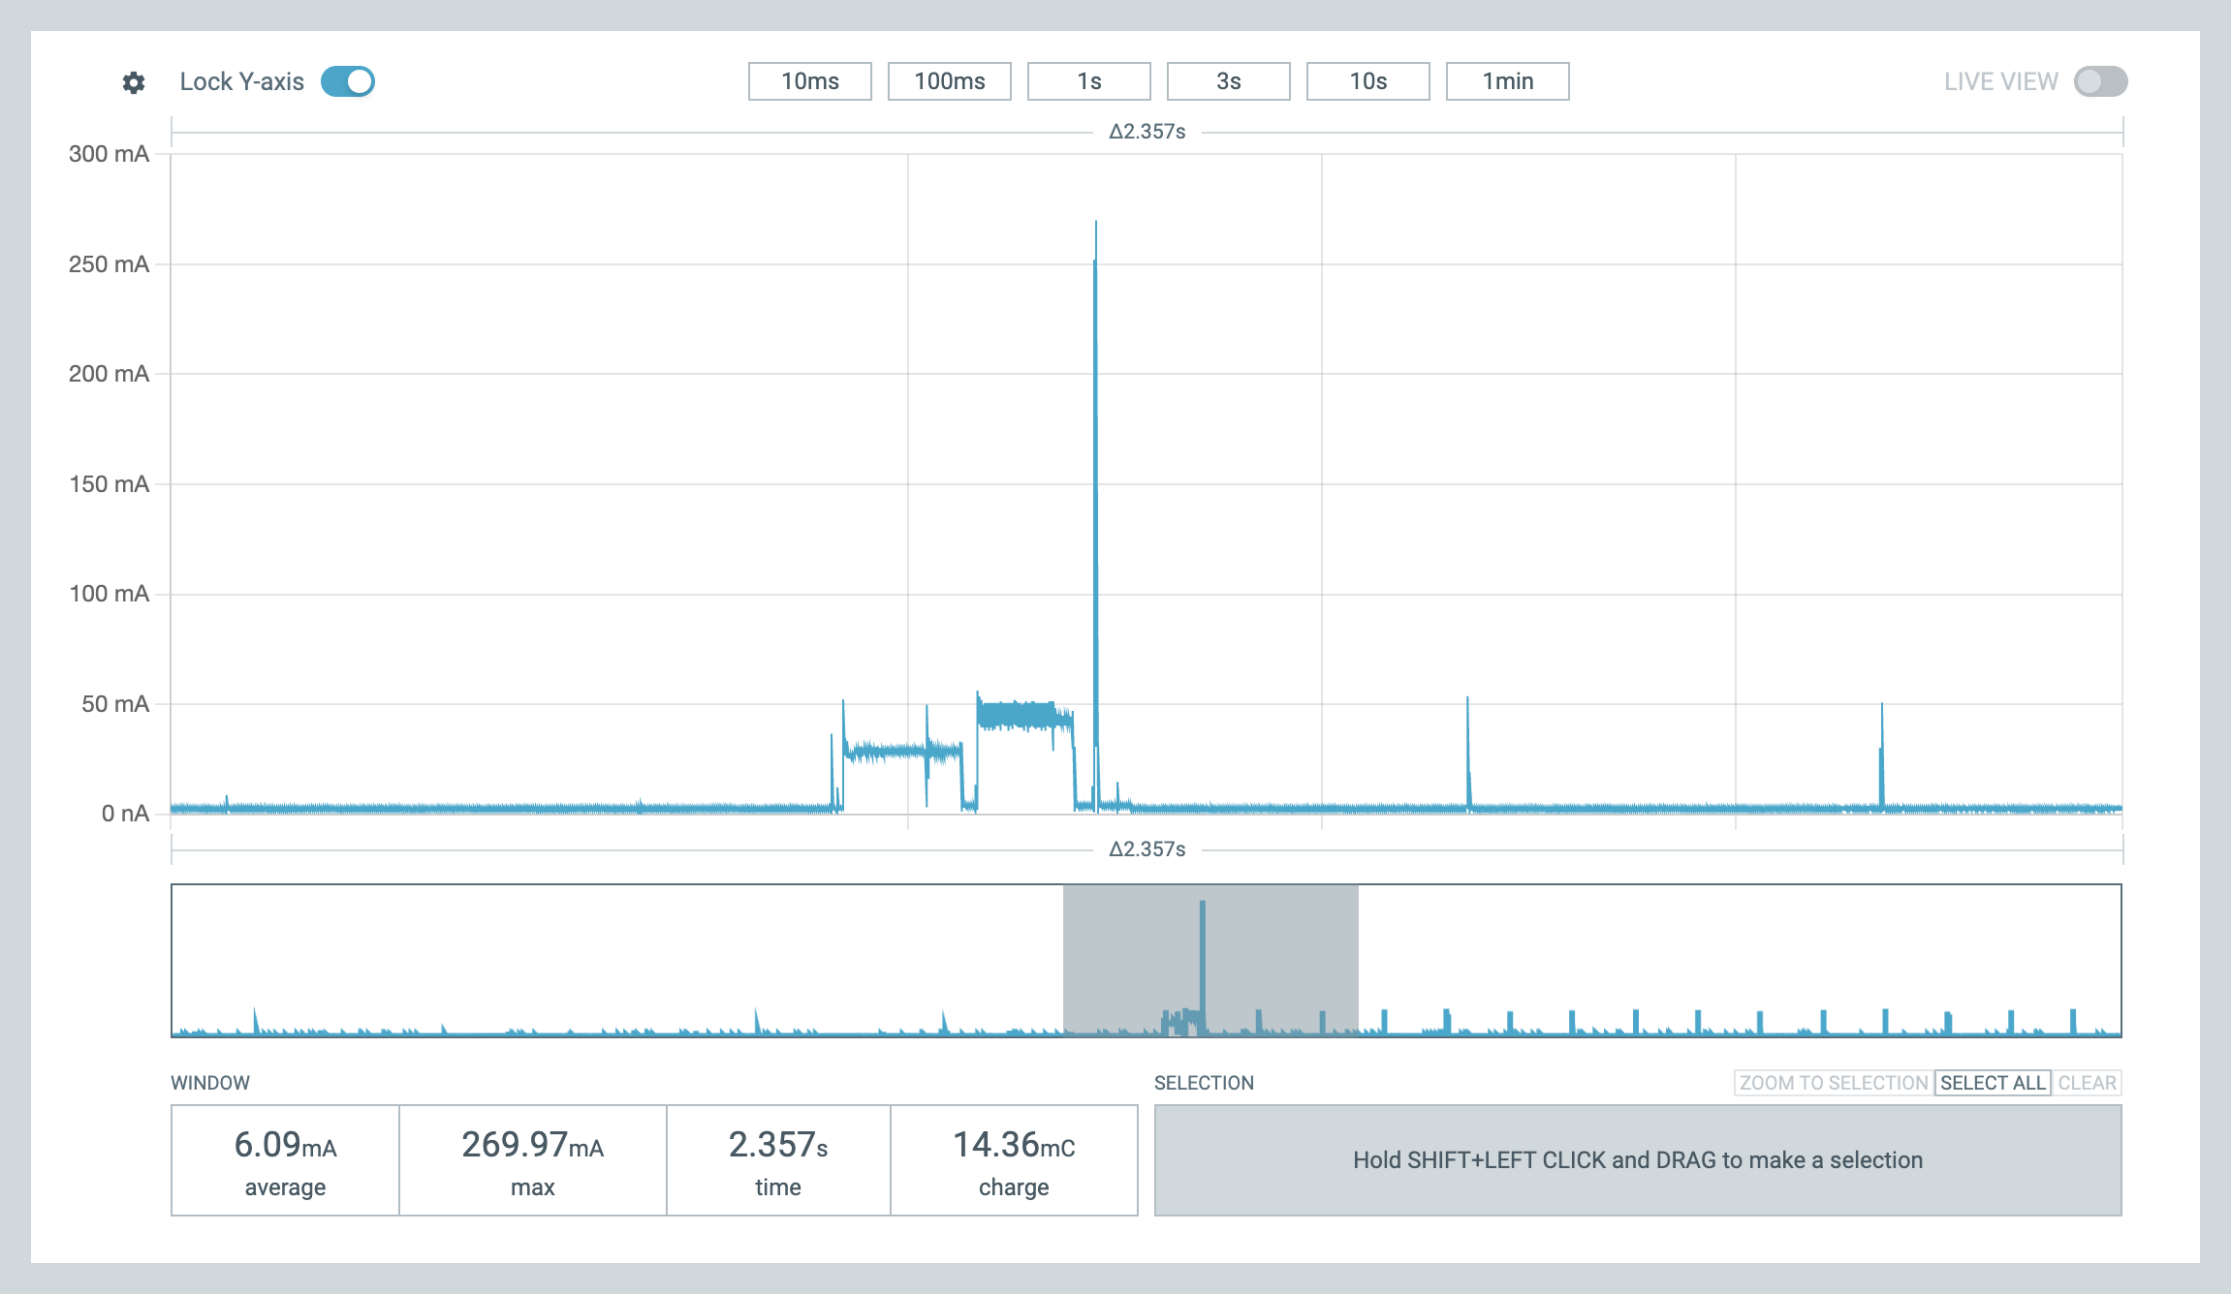
Figure 9. PT Association with powersave

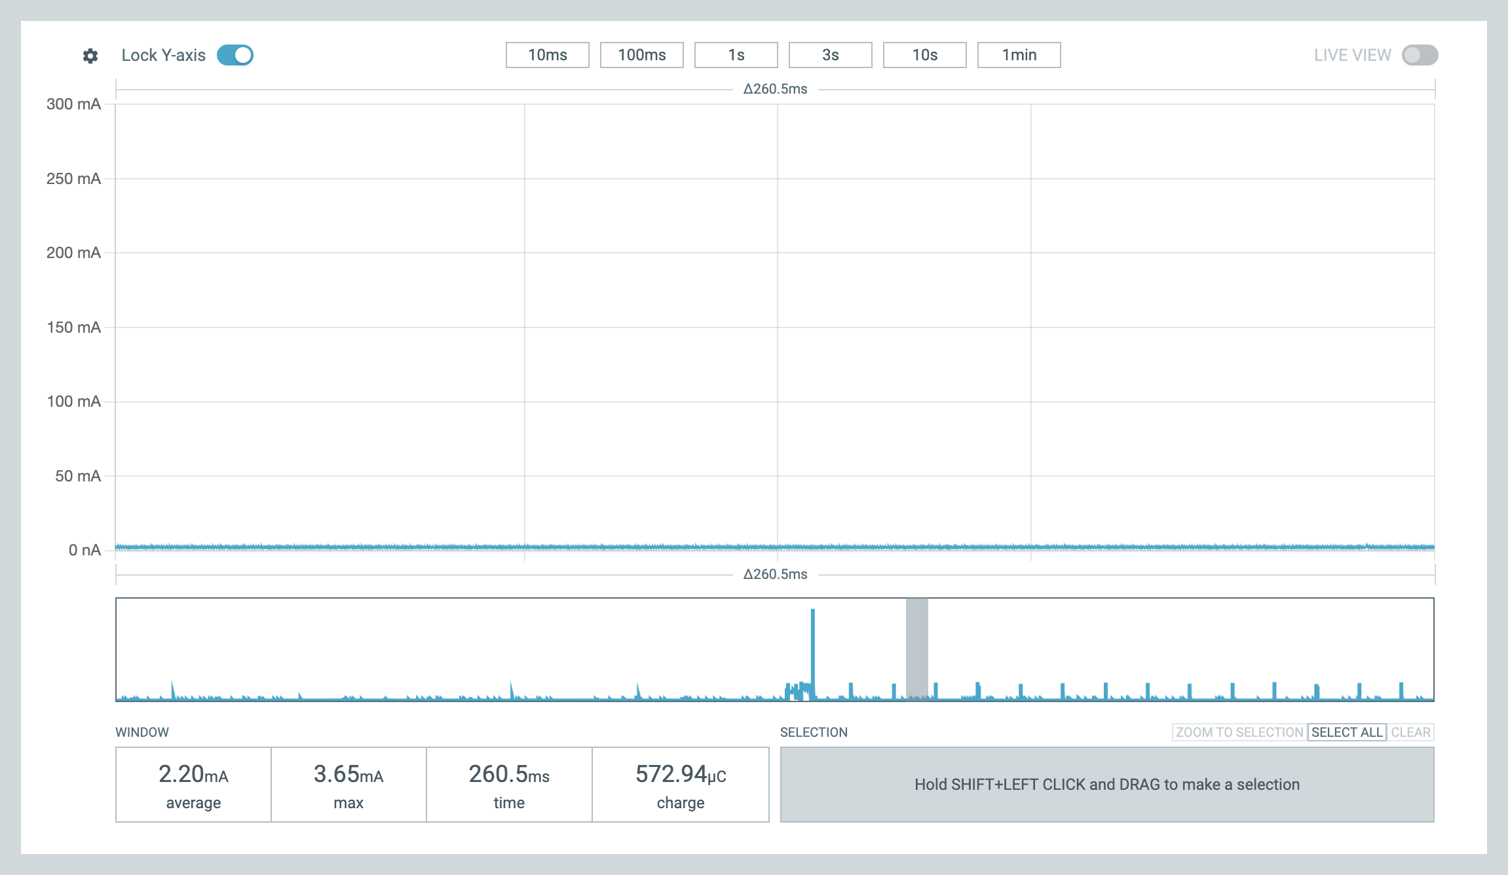
Figure 10. Idle in power save mode
Once in association state the TX power can be adjusted. As shown in Figure 11 the TX peak power usage is controlled, and in this instance is around 70mA. The 50mA peak earlier is the beacon reception window. This TX power adjustment is done based on the nrf_modem_dect_control_configure_params params.expected_mcs1_rx_rssi_level. The power levels are tracked in association based on reported transmission power in NR+ PHY header and on the measured reception power. This is then used to calculate TX power needed to meet this communicated expected level for reception.
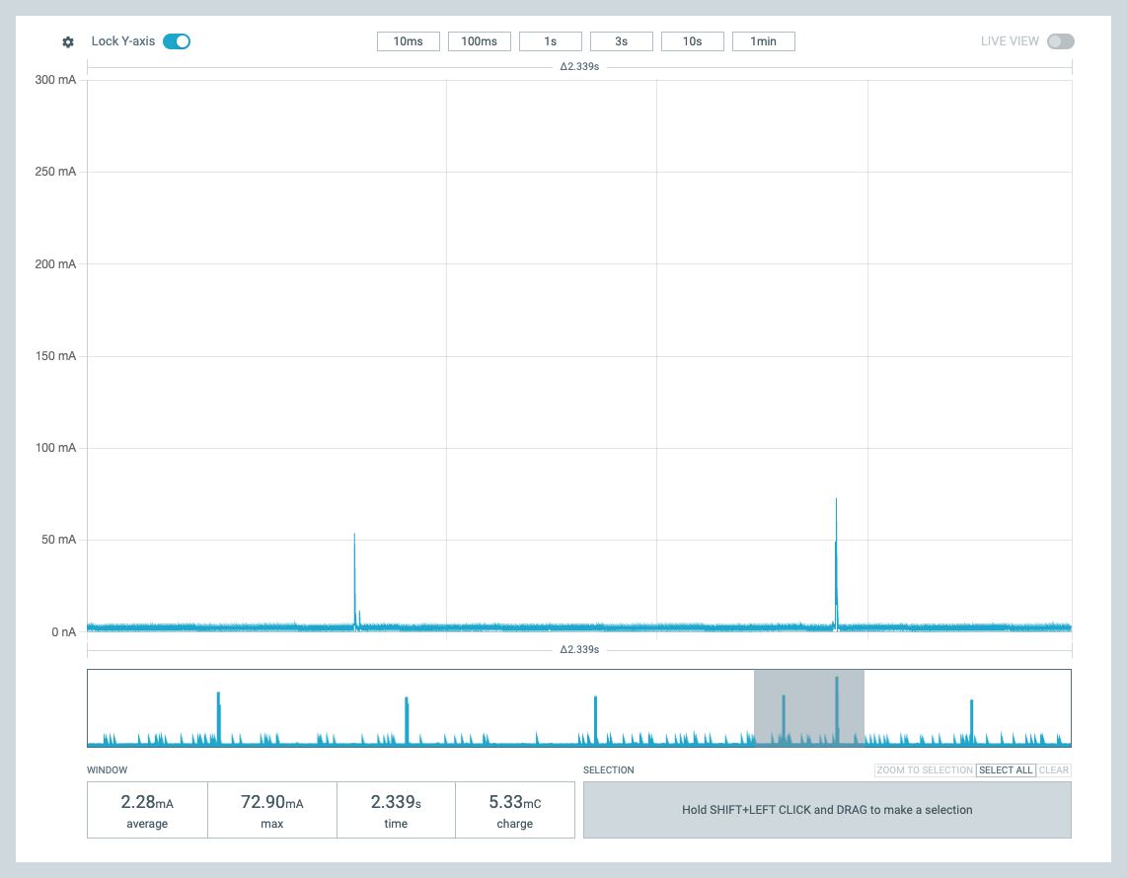
Figure 11. Adjusted send TX power in association
FT side powersave mode is also possible. This is shown in Figure 12. The FT beacons but as can be seen the reception window is only part of the beacon period, rest of the period the radio can be powered down. This is controlled with the command ACTIVETIME and is placed in the cluster_config.rach_configuration.config.fill.percentage in DECT API. The modem implementation then adjusts the advertised random access window that is sent in cluster beacons and PT devices wait for next window if sending uplink. This of course impacts the latency for communications. Note that FT implementation can not power down the radio as deep as a PT device can; the idle power consumption is not as low as for PT devices.
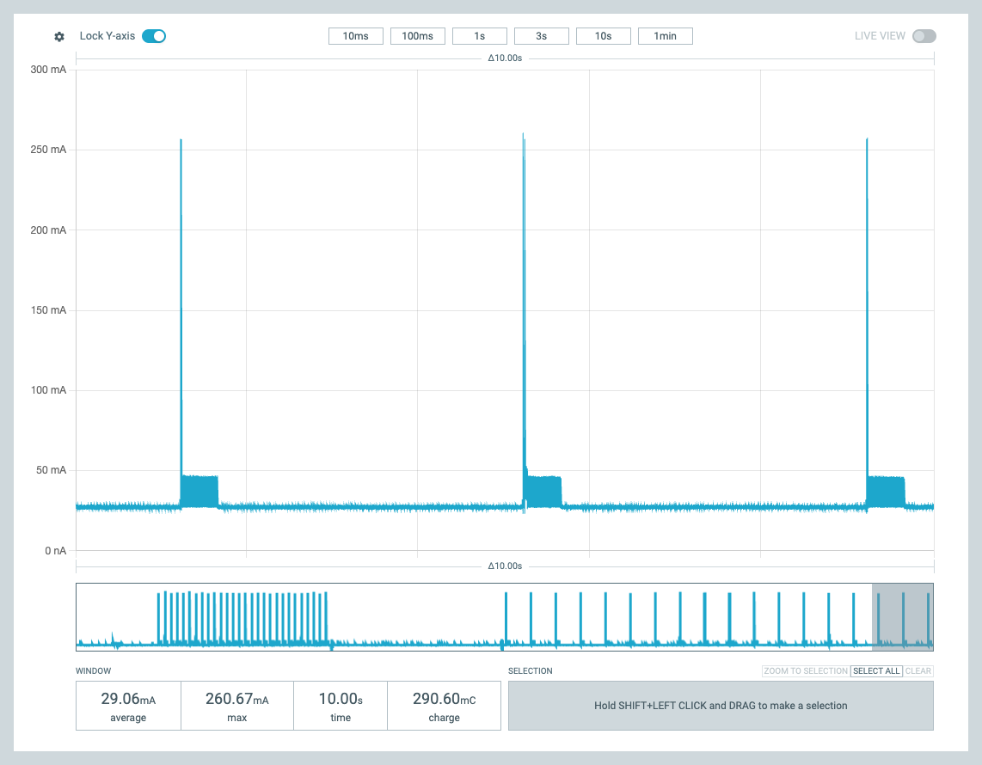
Figure 12. FT powersave

Learnings

AI Learnings
Like said, to me this was a personal introduction to AI Agent programming. As I understand, AI is a chat sandbox, and an AI Agent can be given permissions to access folders and run commands on the user’s machine. I used Claude, but other AI Agents should work very similarly. Based on some guidance from friends and Internet, I started with this kind of approach:
- Agent to make itself some new skills
- Agent to make a Plan (iterate)
- Agent to generate code from the plan
- Agent to add feature and test (iterate, update plan, update skills)
It was simple to instruct the AI Agent to create itself some re-usable skills. For example, a build skill using the right west environment and commands – and to flash the merged.hex after some confusion. Also a really usable skill is flashing devices, reset and verifying there is a terminal response. I used nrfutil for that. If there was no response, run nrfutil recover and reflash. “Make a flashing skill, there are 2 devices in USB port that can be programmed with nrfutil command”.
The AI also could run a test script, to give the command and look for correct response from the devices. I believe these skills are largely AI Agent independent, seemed to be markdown documentation and bash and python scripts, but of course heavily dependent on the host computer and environment.
Planning phase seems essential. The plan is a markdown document, edited by me and the Agent. What commands to do, what HW is used, what NCS version and so on. Architecturally significant requirement is the ISR-context protection with the event queue. In planning the AI also asks clarifications and builds better context for the task. The code generation is done in a second, but still the developer needs time to understand it. I fear to think what would have been the output without planning, and how many iterations and code reviews it would have taken. Asking about an issue can automatically generate fix change in code, and not always in the right place. Learned to ask for “analysis no fix”. Maybe it was test driven design I ended up using, adding operations and commands one at a time and checking the outcome after the initial plan implementation.
At times the Agent felt so human, noticing missing error code handling or dead code from earlier change. To me it was surprising that the Agent might fix an issue but sometimes leave dead code and parameters into the source files. So human! It is good to ask the Agent to analyze the code for weaknesses and dead code every now and then.
I was surprised how easy it was to hit the usage limits. And the Agent can stop in the middle of a change being done -- this is not nice for a developer. I strongly recommend paid subscription, even then there are limits that are all too easy to hit as I learned. This was worsened by the skills usage, that makes the Agent process more messages and data than strictly needed as it also parsed the outputs. Of course, skills are bash scripts so running them by hand is an option, but it is so much easier to command “build, flash and test”.
The real learning for me was to improve the header documentation in future. For example, if the function is for specific role, or if the function starts generating notifications or events and what is the actual flow of separate function calls. When we work with the technology we easily assume everybody to know this, but an AI Agent for sure does not know. But got surprisingly good result after I made it analyze the sample application and libraries in the SDK.

Other Learnings
A mysterious USB dependency had me puzzled for a long time. Seems that a display that acts as a USB hub impacts the USB speed also of more directly connected devices. I was stuck that the SW worked at home, but not at work. Then removing the external display at work, that acts as a USB hub too, brought the operation back to what I was seeing at home. The devices are in both cases connected with an external USB adapter. Speed configuration changes on the PC USB controller when the display is added? Of course this also strongly hints at the weakness of my code.

Conclusion
It was fun to code in a long while. With AI Agent helping it is more fun as ideas can form in seconds, instead of long and mistakes full manual coding. And in the end did manage to get some nice figures of the power behavior. I hope it also explains and clarifies the DECT API and implementation behavior.

Appendix A – Raw Material

SOURCE and CONFIGS
Link to zip
AGENT.MD
initial, not updated, can be named anything for the Agent to read and understand. I wonder if starting from this again produces anything like the sources above…
Goal:
Create a Zephyr shell application for nRF9151 DK that demonstrates DECT NR+ communication between two boards.

Architecture:
- main.c handles shell commands and mode orchestration --no direct nrf_modem_dect.h dependency
- dect_adapter.h / dect_adapter.c encapsulate ALL nrf_modem_dect_* and nrf_modem_lib API calls
- main.c only includes dect_adapter.h; uses primitive types (uint8/16/32_t, bool, int, size_t) throughout
- Callbacks are defined in dect_adapter.h using plain types only (no nrf_modem enums or structs in the public API)

Important API note:
- The intended API level is the higher-level DECT MAC API:
https://docs.nordicsemi.com/bundle/nrfxlib-apis-latest/page/group_nrf_modem_dect.html
- nrf_modem_dect.h is only included in dect_adapter.c

Callback context ‚ CRITICAL:
- All nrf_modem_dect op and ntf callbacks run in a restricted modem library context
(treat as ISR: no blocking, no re-entrant modem API calls).
- Permitted in callbacks: k_sem_give, k_msgq_put(K_NO_WAIT), k_work_submit/reschedule, LOG_DBG.
- Forbidden in callbacks: k_mutex_lock(K_FOREVER), any nrf_modem_dect_* API call, printk, LOG_INF/ERR.
- Pattern used in main.c: callbacks are minimal --they put a typed app_event onto app_evt_msgq
(K_NO_WAIT) and return immediately. All logic runs in the main event loop (thread context)
via process_*_event() handlers. complete_wait() (k_sem_give) may also be called in callbacks
where the main thread is blocking on op_sem.
- dect_adapter.c internal callbacks: LOG_DBG only + dispatch to app callback. No LOG_INF.

Environment:
- Primary NCS version: 3.3.0
- A preview NCS tree is available at `/opt/nordic/ncs/main`
- Build output directory: '~/code/mac_demo/build'
- nrfutil location: `/opt/nordic/ncs/toolchains/561dce9adf/nrfutil/bin/nrfutil`
(must be in PATH or called with full path --not in system PATH by default)

Target hardware:
- Board: nRF9151 DK (target: nrf9151dk/nrf9151/ns)
- Two boards connected for build/flash/test validation
- Serial numbers: 1052092657 and 1052013419
- UART ports (vcom0, 115200 baud):
- 1052092657: /dev/tty.usbmodem0010520926571
- 1052013419: /dev/tty.usbmodem0010520134191

Transport and payload rules:
- Payloads are ASCII text
- UART shell is the control interface (vcom0 on each board, 115200 baud)

Shell commands:
- `SEND <ascii text>`
- `FT` -- RSSI scan, select least busy channel, start beaconing
- `PERIOD <ms>` -- beacon period for FT device
- `PT` -- scan all channels in band, find FT beacon, associate
- `CHANNEL <uint16>` --when given while in FT mode, skips RSSI scan and beacons directly on that channel
- `POWERSAVE 1|0` -- toggles power saving and re-initializes radio
- `STATUS` --reports mode, channel, FT period, PT scan time, power save state

Current runtime defaults:
- FT period: 1000 ms
- PT scan time: 2000 ms

Mode behavior:
- FT: performs RSSI scan across all channels in the band, selects least busy channel,
configures cluster beacon + network beacon, waits for PT association.
Once PT is associated, FT can send/receive DLC messages.
CHANNEL <N> while in FT skips RSSI scan and beacons on channel N directly.

- PT: scans ALL channels in the band (num_channels=0 in network scan params) to find an
FT beacon. Once a network/cluster beacon is received, PT subscribes to cluster beacons
and initiates association. Then PT can send/receive DLC messages.
Note: FT must be beaconing before PT can associate. Send from either side only works
after association is established.

Flashing --CRITICAL:
- Must flash merged.hex (TF-M + application), NOT zephyr.hex (app only):
/opt/nordic/ncs/main/build/merged.hex ‚Üê CORRECT
/opt/nordic/ncs/main/build/mac_demo/zephyr/zephyr.hex ‚Üê WRONG (no TF-M, board won't boot)
- Must reset after programming, device does NOT boot automatically:
nrfutil device program --serial-number <SN> --firmware merged.hex --traits jlink
nrfutil device reset --serial-number <SN>
- Without --traits jlink the command exits silently with 0 but may not program anything

Recovery (unresponsive board):
- If a board does not respond or is in a bad state, use recover before reflashing:
nrfutil device recover --serial-number <SN>
nrfutil device program --serial-number <SN> --firmware merged.hex --traits jlink
nrfutil device reset --serial-number <SN>
- recover performs ERASEALL via CTRL-AP, disables AP-Protect, and clears all flash
- recover exit 0 = success; board is then blank and ready to program
- Verified working on nRF9151 DK (PCA10201)

Console / logging:
- CONFIG_UART_CONSOLE=y --logs go to UART (vcom0)
- CONFIG_RTT_CONSOLE=n --do NOT use RTT; RTT sends logs to J-Link only, nothing on UART
- Shell prompt: `dect-mac:~$ `

Test sequence:
1. Flash merged.hex to both boards (with reset after each)
2. FT board: send `FT` --wait ~10-15s for RSSI scan to complete and beaconing to start
3. PT board: send `PT` --PT will scan all channels, find FT, subscribe to cluster beacons, associate
4. Wait for PT association (check `STATUS` on FT shows associated, or watch for association_ind log)
5. FT sends first: `SEND <text>` (FT must have an associated PT to send)
6. PT sends: `SEND <text>` (PT must be associated to send)
- Do NOT send before association is confirmed; SEND returns -ENOTCONN (-128) if not associated

Validation requirements:
- Build for `nrf9151dk/nrf9151/ns`
- Flash both attached boards using merged.hex with explicit reset
- Serial monitor on /dev/cu.usbmodem* at 115200 baud

Implementation status:
- Adapter layer: complete --dect_adapter.h has no nrf_modem types; all API isolated in dect_adapter.c
- Shell commands: all 8 implemented (SEND, FT, PT, STATUS, CHANNEL, PERIOD, WINDOW, POWERSAVE)
- RSSI scan + channel selection: implemented in FT mode startup
- CHANNEL override: implemented --skips RSSI scan when user sets channel explicitly
- PT broadband scan: implemented --scans all channels in band (num_channels=0)
- LED indicators: simplified (FT=all on, PT=blinking)

Execution guidance:
- Keep build, flash, and serial test commands documented locally
- Record any DECT MAC vs DECT PHY assumptions explicitly
- If a behavior works only with raw PHY workarounds, call that out as provisional

