STEAM RUNNER

by Damien Claras
& Pierre Casati

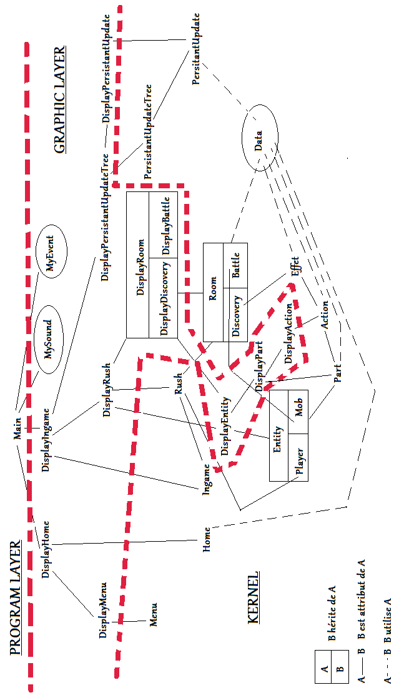
Kernel

Module Menu ….......................................................................................... Page 4
Module Home …......................................................................................... Page 4
Module Ingame …....................................................................................... Page 4

Module Rush …........................................................................................... Page 5
Module Entity …......................................................................................... Page 6
|__________Module Player ….............................................................. Page 7
|__________Module Mob …................................................................. Page 7
Module Part …............................................................................................. Page 7
Module Action …........................................................................................ Page 8
Module Effect …......................................................................................... Page 8
Module Room …......................................................................................... Page 9
|__________Module Discovery …........................................................ Page 9
|__________Module Battle …............................................................... Page 9

Module PersistantUpgradeTree ….............................................................. Page 9
Module PersistantUpgrade ….................................................................... Page 10

Module Data …......................................................................................... Page 10

Module Menu
Class Menu
- vector<void*> _fonctions

+ Menu()
+ ~Menu()
+ void* GetFonction(unsigned short int i) const
+ void SetFonction(const void* value, unsigned short int i)

Module Home
Class Home
- Menu* _menu
- string _pathBackground

+ Home()
+ ~Home()
+ Menu* GetMenu() const
+ string GetPathBackground() const
+ void SetMenu(const Menu* value)
+ void SetPathBackground(const string value)

Module Ingame
Class Ingame
- Rush* _rush
- listLocalisation _localisation

+ Ingame()
+ ~Ingame()
+ Rush* GetRush() const
+ listLocalisation GetLocalisation() const
+ void SetRush(const Rush* value)
+ void SetLocalisation(const listLocalisation value)

Enumération
enum{PERSISTANTUpgradeTREE=0, RUSH=1}

Module Rush
Class Rush
- unsigned short int _difficulty
- Player* _player
- vector<Room*> _rooms
- int _stockOre
- short int _stockVestige
- unsigned short int _maxDifficulty
- string _pathBackground

+ Rush()
+ ~Rush()
+ unsigned short int GetDifficulty() const
+ Player* GetPlayer() const
+ Room* GetRomm(const unsigned short int i) const
+ int GetStockOre() const
+ short int GetStockVestige() const
+ unsigned short int GetMaxDifficulty() const
+ string GetPathBackground() const
+ void SetDifficulty(const unsigned short int value)
+ void SetPlayer(const Player* value)
+ void SetRoom(const unsigned short int i, const Room* value)
+ void SetStockOre(const int value)
+ void SetStockVestige(const short int value)
+ void SetMaxdifficulty(const unsigned short int value)
+ void SetPathBackground(const string value)

Module Entity
Abstract Class Entity
± int _integrity
± short int _armor
± short int _valueTmpDebuffArmor
± vector<Part*> _parts
± listTypeEntity _typeEntity
± bool _tmpDebuffArmor
± bool _startDelayedAttack
± bool _endDelayedAttack

+ Entity()
+ ~Entity()
+ int GetIntegrity() const
+ short int GetArmor() const
+ short int GetValueTmpDebuffArmor() const
+ Part* GetPart(const unsigned short int i) const
+ listTypeEntity GetTypeEntity() const
+ bool GetTmpDebuffArmor() const
+ bool GetStartDelayedAttack() const
+ bool GetEndDelayedAttack() const
+ void SetIntegrity(const int value)
+ void SetArmor(const short int value)
+ void SetValueTmpDebuffArmor(const short int value)
+ void SetPart(const unsigned short int i, const Part* value)
+ void SetTypeEntity(const listTypeEntity value)
+ void SetTmpDebuffArmor(const bool value)
+ void SetStartDelayedAttack(const bool value)
+ void SetEndDelayedAttack(const bool value)
+ void TakeDamage(const unsigned int damage, const bool armorIgnored)
+ void TakeHeal(const unsigned int heal)
+ void DoAction(const string part, const string direction, Entity* enemy)
+ void DoEndTurnAction(Entity* enemy)

Enumération
enum listTypeEntity{PLAYER=0, MOB=1}

Module Player
Class Player : Entity
- short int _pressurePerTurn
- int _steam
- int _maxPressure

+ Player(const int integrity, const short int armor, vector<Part*> parts, const short int pressurePerTurn, const int steam, const int maxPressure)
+ ~Player()
+ short int GetPressurePerTurn() const
+ int GetSteam() const
+ int GetMaxPressure() const
+ void SetPressurePerTurn(const short int value)
+ void SetSteam(const int value)
+ void SetMaxPressure(const int value)

Module Mob
Class Mob : Entity
+ Mob(const int integrity, const short int armor, const vector<Part*> parts)
+ ~Mob()
+ void DoTurn(Entity* enemy)

Module Part
Class Part
- string _type
- string _pathSprite
- vector<Action*> _actions
- string _name

+ Part()
+ ~Part()
+ string GetType() const
+ string GetPathSprite() const
+ Action* GetAction(const unsigned short int i) const
+ string GetName() const
+ void SetType(const string value)
+ void SetPathSprite(const string value)
+ void SetAction(const unsigned short int i, const Action* value)
+ void SetName(const string value)
+ void LoadPart()

Module Action
Class Action
- unsigned short int _pressureCost
- unsigned short int _lineSprite
- vector<Effect*> _effects
- string _flag
- listDirection direction

+ Action()
+ ~Action()
+ unsigned short int GetPressureCost() const
+ unsigned short int GetLineSprite() const
+ Effect* GetEffect(const unsigned short int i)
+ string GetFlag() const
+ listDirection GetDirection() const
+ void SetPressureCost(const unsigned short int value)
+ void SetLineSprite(const unsigned short int value)
+ void SetEffect(const unsigned short int i, const Effect* value)
+ void SetFlag(const string value)
+ void SetDirection(const listDirection value)
+ void DoAction()
+ void LoadAction()

Enumération
enum listDirection{UP=0, DOWN=1, LEFT=2, RIGHT=3}

Module Effect
Class Effect
- int _value
- string _typeEffect

+ Effect()
+ ~Effect()
+ int GetValue() const
+ string GetTypeEffect() const
+ void SetValue(const int value)
+ void SetTypeEffect(const string value)
+ void LoadEffect()

Module Room
Abstract Class Room
± string _background
± string _type

+ Room()
+ ~Room()
+ string GetBackground() const
+ string GetType() const
+ void SetBackground(const string value)
+ void SetType(const string value)

Module Discovery
Class Discovery : Room
- Effect* _effect
- string _pathSprite

+ Discovery()
+ ~Discovery()
+ Effect* GetEffect() const
+ string GetPathSprite() const
+ void SetEffect(const Effect* value)
+ void SetPathSprite(const string value)

Module Battle
Class Battle : Room
- Entity* _enemy

+ Battle()
+ ~Battle()
+ Entity* GetEnemy() const
+ void SetEnemy(const Entity* value)

Module PersistantUpgradeTree
Class PersistantUpgradeTree
- vector<PersistantUpgrade*> _persistantUpgrades
- int _stockOre
- unsigned int _countNewUpgrade

+ PersistantUpgradeTree()
+ ~PersistantUpgradeTree
+ PersistantUpgrade* GetPersistantUpgrade(const unsigned short int i) const
+ int GetStockOre() const
+ unsigned int GetCountNewUpgrade() const
+ void SetPersistantUpgrade(const PersistantUpgrade* value, const unsigned short int i)
+ void SetStockOre(const int value)
+ void SetCountNewUpgrade(const unsigned int value)
+ void SavePersitantUpgradeTree() const

Module PersistantUpgrade
Class PersistantUpgrade
- unsigned short int _id
- unsigned short int _level
- unsigned short int _maxLevel
- Statistic* _cost
- vector<Part*> _parts
- string _type
- string _name
- string _description

+ PersistantUpgrade(const unsigned short int i)
+ ~PersistantUpgrade()
+ unsigned short int GetId() const
+ unsigned short int GetLevel() const
+ unsigned short int GetMaxLevel() const
+ Statistic* GetCost() const
+ Part* GetPart(const unsigned short int i) const
+ string GetType() const
+ string GetName() const
+ string GetDescription() const
+ void SetId(const unsigned short int value)
+ void SetLevel(const unsigned short int value)
+ void SetMaxLevel(const unsigned short int value)
+ void SetCost(Statistic* value)
+ void SetPart(const Part* value, const unsigned short int i)
+ void SetType(const string value)
+ void SetName(const string value)
+ void SetDescription(const string value)
+ void SavePersistantUpgrade() const
+ void UpgradePersistantUpgrade()

Module Data
Class Data
+ Data()
+ ~Data()
+ string Read(const string type, string keys)
+ void Write(const string type, string keys, const string value)

Graphic Layer

Module MySound …............................................................................... Page XX
Module MyEvent …................................................................................ Page XX

Module DisplayMenu …......................................................................... Page XX
Module DisplayHome …......................................................................... Page XX
Module DisplayIngame …....................................................................... Page XX

Module DisplayRush …........................................................................... Page XX
Module DisplayEntity …......................................................................... Page XX
Module DisplayPart …............................................................................ Page XX
Module DisplayAction …........................................................................ Page XX
Module DisplayRoom …......................................................................... Page XX
|__________Module DisplayDiscovery …........................................ Page XX
|__________Module DisplayBattle ….............................................. Page XX

Module DisplayPersistantUpgradeTree ….............................................. Page XX
Module DisplayPersistantUpgrade …..................................................... Page XX

Module MySound
Class MySound

Module MyEvent
Class MyEvent

Module DisplayMenu
Class DisplayMenu
- Menu* _menu
- sf::Image* _image
- int _x
- int _y

+ DisplayMenu()
+ ~DisplayMenu()
+ Menu* GetMenu() const
+ sf::Image GetSprite() const
+ int GetX() const
+ int GetY() const
+ void SetMenu(const Menu* value)
+ void SetSprite(const sf::Image* value, const int x, const int y)
+ void SetX(const int value)
+ void SetY(const int value)
+ void DisplayMenuOn(sf::Window* window) const

Module DisplayHome
Class DisplayHome
- Home* _home
- DisplayMenu* _displayMenu
- sf::Image* _background

+ DisplayHome()
+ ~DisplayHome()
+ Home* GetHome() const
+ DisplayMenu* GetDisplayMenu() const
+ sf::Image* GetBackground() const
+ void SetHome(const Home* value)
+ void SetDisplayMenu(const DisplayMenu* value)
+ void SetBackground(const sf::Image* value)
+ void DisplayHomeOn(sf::Window* window) const

Module DisplayIngame
Class DisplayIngame
- Ingame* _ingame
- DisplayRush* _displayRush
- DisplayPersistantUpgradeTree* _displayPersistantUpgradeTree

+ DisplayIngame()
+ ~DisplayIngame()
+ Ingame* GetIngame() const
+ DisplayRush* GetDisplayRush() const
+ DisplayPersistantUpgradeTree* GetDisplayPersistantUpgradeTree() const
+ void SetIngame(const Ingame* value)
+ void SetDisplayRush(const DisplayRush* value)
+ void SetDisplayPersistantUpgradeTree(const DisplayPersistantUpgradeTree* value)
+ void DisplayIngameOn(sf::Window* window) const

Module DisplayRush
Class DisplayRush
- Rush* _rush
- sf::Image* _background
- vector<DisplayRoom*> _displayRooms
- DisplayPlayer* _ displayPlayer
- short int _current room

+ DisplayRush()
+ ~DisplayRush()
+ Rush* GetRush() const
+ sf::Image* GetBackground() const
+ DisplayRoom* GetDisplayRoom(const unsigned short int i) const
+ DisplayPlayer* GetDisplayPlayer() const
+ short int GetCurrentRoom() const
+ void SetRush(const Rush* value)
+ void SetBackground(const sf::Image* value)
+ void SetDisplayRoom(const unsigned short int i, const DisplayRoom* value)
+ void SetDisplayPlayer(const DisplayPlayer* value)
+ void SetCurrentRoom(const short int value)
+ void DisplayRushOn(sf::Window* window)

Module DisplayEntity
Class DisplayEntity
- Entity* _entity
- sf::Image _image
- int _x
- int _y
- vector<DisplayPart*> _displayParts

+ DisplayEntity()
+ ~DisplayEntity()
+ Entity* GetEntity() const
+ sf::Image* GetImage() const
+ int GetX() const
+ int GetY() const
+ DisplayPart* GetDisplayPart(const unsigned short int i) const
+ void SetEntity(const Entity* Entity)
+ void SetImage(const Image* image)
+ void SetX(const int x)
+ void SetY(const int y)
+ void SetDisplayPart(const unsigned short int i, const DisplayPart* displayPart)
+ void CreateImage()
+ void DisplayImageOn(sf::Window* window) const

Module DisplayPart
Class DisplayPart
- Part* _part
- sf::Image* _image
- vector<DisplayAction*> _displayActions

+ DisplayPart(const string path, const Part* part)
+ ~DisplayPart()
+ Part* GetPart() const
+ sf::Image* GetImage() const
+ DisplayAction* GetDisplayAction(const unsigned short int i) const
+ void SetPart(const Part* part)
+ void SetImage(const sf::Image* image)
+ void SetDisplayAction(const DisplayAction* displayAction)
+ void DisplayPartOn(sf::Window* window) const

Module DisplayAction
Class DisplayAction
- Action* _action
- sf::Image* _image

+ DisplayAction(const string path, const Action* action)
+ ~DisplayAction()
+ Action* GetAction() const
+ sf::Image* GetImage() const
+ void SetAction(const Action* action)
+ void SetImage(const sf::Image* image)
+ void DisplayActionOn(sf::Window* window) const

Module DisplayRoom
Class DisplayRoom
± Room* _room
± sf::Image* _background

+ DisplayRoom()
+ ~DisplayRoom()
+ Room* GetRoom() const
+ sf::Image* GetBackground() const
+ void SetRoom(const Room* value)
+ void SetBackground(const sf::Image* value)
+ void DisplayRoomOn(sf::Window* window)

Module DisplayDiscovery
Class DisplayDiscovery : DisplayRoom
- Discovery* _discovery
- sf::Image* _sprite

+ DisplayDiscovery()
+ ~DisplayDiscovery()
+ Discovery* GetDiscovery() const
+ sf::Image* GetSprite() const
+ void SetDiscovery(const Discovery* value)
+ void SetSprite(const sf::Image* value)
+ void DisplayDiscoveryOn(sf::Window* window) const

Module DisplayBattle
Class DisplayBattle : DisplayRoom
- Battle* _battle
- DisplayEntity* _displayEntity

+ DisplayBattle()
+ ~DisplayBattle()
+ Battle* GetBattle() const
+ DisplayEntity* GetDisplayEntity() const
+ void SetBattle(const Battle* value)
+ void SetDisplayEntity(const DisplayEntity* value)
+ void DisplayBattleOn(sf::Window* window) const

Module DisplayPersistantUpgradeTree
Class DisplayPersistantUpgradeTree
- vector<DisplayPersistantUpgrade*> _displayPersistantUpgrades
- PersistantUpgradeTree* _persistantUpgradeTree
- sf::Image* _image

+ DisplayPersistantUpgradeTree(const string path)
+ ~DisplayPersistantUpgradeTree()
+ DisplayPersistantUpgrade* GetDisplayPersistantUpgrade(const unsigned short int i) const
+ PersistantUpgradeTree* GetPersistantUpgradeTree() const
+ sf::Image* GetImage() const
+ void SetDisplayPersistantUpgrade(const DisplayPersistantUpgrade* displayPersistantUpgrade, const unsigned short int i)
+ void SetPersistantUpgradeTree(const PersistantUpgradeTree* persistantUpgradeTree)
+ void SetImage(const sf::Image* image)
+ void DisplayPersistantUpgradeTreeOn(sf::Window* window) const

Module DisplayPersistantUpgrade
Class DisplayPersistantUpgrade
- PersistantUpgrade* _persistantUpgrade
- sf::Text* _text
- sf::Image* _image
- int _x
- int _y

+ DisplayPersistantUpgrade(const string path, PersistantUpgrade* persitantUpgrade, const int x, const int y)
+ ~DisplayPersistantUpgrade()
+ PersistantUpgrade* GetPersistantUpgrade() const
+ sf::Text* GetText() const
+ sf::Image* GetImage() const
+ int GetX() const
+ int GetY() const
+ void SetPersistantUpgrade(const PersistantUpgrade* persistantUpgrade)
+ void SetText(const sf::Text* text)
+ void SetImage(const sf::Image* image)
+ void SetX(const int x)
+ void SetY(const int y)
+ void DisplayPersistantUpgrade(sf::Window* window) const

