Mini Project

DMX4411

Signal Processing

W.M.I.U. Rathnayake [s92083119@ousl.ac.lk](mailto:s92083119@ousl.ac.lk) Reg No: 421653119

Submitted To:

Department of Mechanical Engineering, Faculty of Engineering Technology Date of Submission: November 30, 2023

Due Date: November 30, 2022

Table of Contents

Abstract 1

Question 01 2

1.1 Signal Noise Definition 2

1.2 Causes of Signal Noise 2

1.3 Problems Due to Signal Noise 3

Question 02 4

2.1 Time Domain Graph 4

2.2 Frequency Spectrum. 5

2.3 Fundamental Frequency 5

2.4. Denoising Techniques. 6

2.5. Output Signal. 6

Discussion 7

Additional Work 8

## Abstract

This project delves into signal processing, emphasizing noise reduction and signal enhancement. Utilizing FFT and IFFT transforms, the study dissects signals and explores their characteristics. Additionally, it employs MATLAB to experiment with filters and denoising methods, providing insights into practical applications and efficacy.

## Question 01

### Signal Noise Definition

Signal noise refers to unwanted or random electrical disturbances that interfere with the accuracy and reliability of signals in a communication system. It manifests as additional electrical fluctuations or variations superimposed on the intended signal, making it challenging to accurately interpret the original information.

**Example**: Imagine listening to a faint radio station in your car, but static or interference from other electronic devices makes it difficult to hear the music clearly. The interference represents signal noise in this scenario.

### Causes of Signal Noise

Electromagnetic Interference (EMI): EMI occurs when electrical signals from one device interfere with the signals of another device, leading to disruptions. For example, electronic devices such as smartphones or fluorescent lights emitting electromagnetic waves can interfere with audio signals in a recording.

Radio Frequency Interference (RFI): RFI involves unwanted signals from radiofrequency sources affecting communication signals. A classic example is a radio station's signal bleeding into audio equipment, causing distortion in nearby electronic devices.

Thermal Noise: Also known as Johnson-Nyquist noise, thermal noise arises due to the random motion of electrons in conductors at finite temperatures. It's present in all electronic circuits and can degrade signal quality. In a communication system, thermal noise can introduce a hissing sound in audio signals or degrade the quality of transmitted data.

Crosstalk: Crosstalk happens when signals from one conductor unintentionally couple into adjacent conductors. This phenomenon is common in systems with multiple signal lines running close to each other, leading to signal interference.

### Problems Due to Signal Noise

Noise can obscure the intended information in a signal, making it challenging to interpret or analyze accurately. In digital communication, noise can corrupt transmitted data, leading to errors in the received information. Signal noise can cause misinterpretation of data, leading to incorrect readings or commands. For example, in industrial control systems, misinterpreted signals might result in machinery operating at incorrect parameters. In audio and video signals, noise can manifest as unwanted sounds or visual artifacts, diminishing the overall quality of the content. Noise can disrupt communication channels, causing dropouts or interruptions in the transmission of signals.

## Question 02

### 2.1 Time Domain Graph

In the initial phase of our analysis, the time domain graph of the signal reveals key characteristics. The signal is sampled at a rate of 44,100 Hz and possesses a duration of 2 seconds. A discernible click sound manifests in the middle of the signal. Additionally, visual inspection reveals instances of signal clipping, indicative of sound intensity surpassing the dynamic range of the recording medium.

### 2.2 Frequency Spectrum.

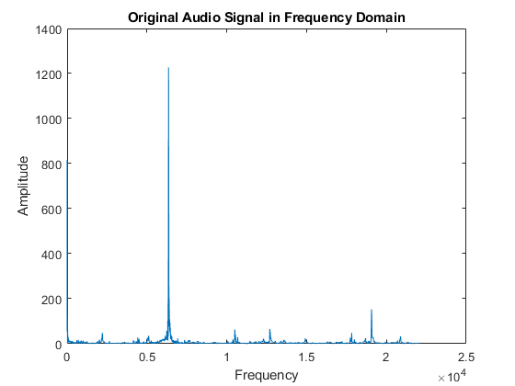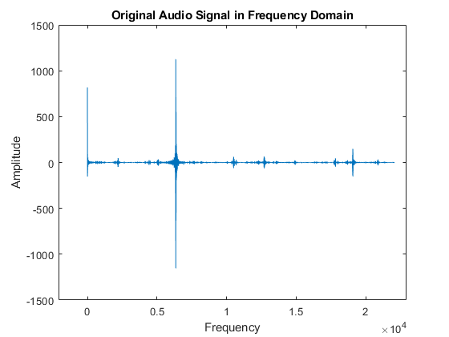

By employing the Fast Fourier Transformation (FFT), the frequency spectrum of the signal was unveiled. Noteworthy features include several prominent spikes within the frequency domain graph. Analysis of the spectrum enables the identification of the fundamental frequency, denoted by the peak amplitude. In this instance, the highest amplitude is localized at approximately 6353 Hz, indicating the dominant frequency component. Additionally, a consistent amplitude at 0 Hz signifies a constant signal, reflecting a lack of variation and, consequently, no discernible sound. A third peak is discernible at 19060 Hz, a frequency likely beyond the audible range for humans, suggesting potential high-frequency components or harmonics.

### 2.3 Fundamental Frequency

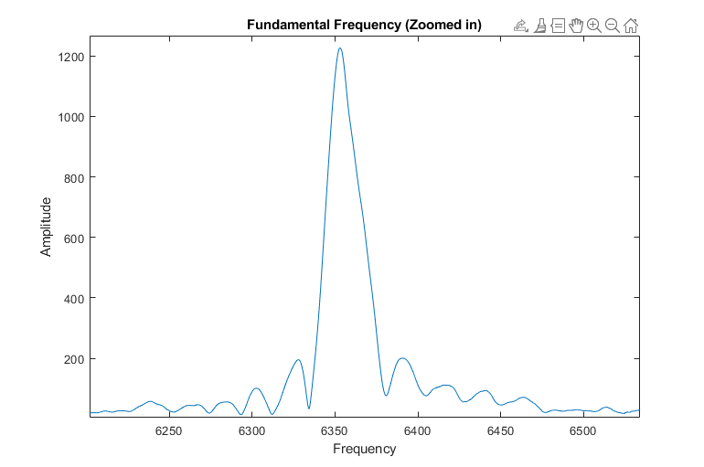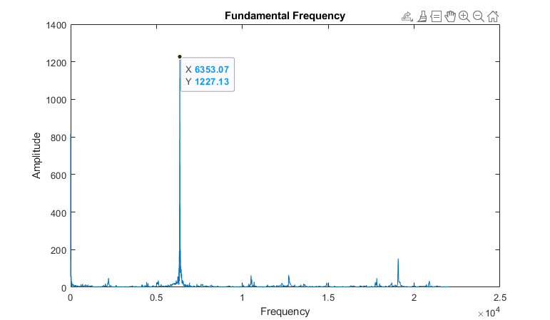This peak amplitude at around 6353 Hz signifies the fundamental frequency, representing the primary and most pronounced frequency component within the signal.

### 2.4. Denoising Techniques.

To remove noise an ideal bandpass filter was implemented to isolate the fundamental frequency from the input signal.

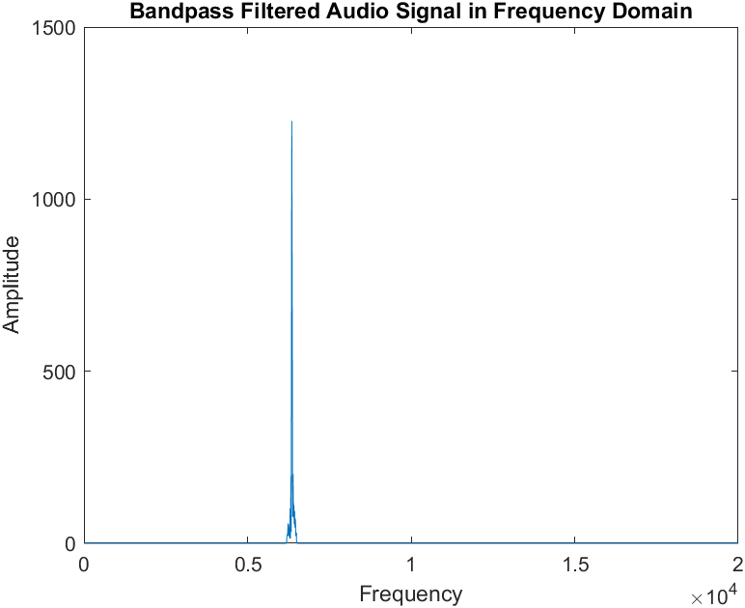

### 2.5. Output Signal.

Implementing Inverse Fast Fourier Transformation (IFFT) to reconstruct the signal, resulting in the generation of a refined output signal.

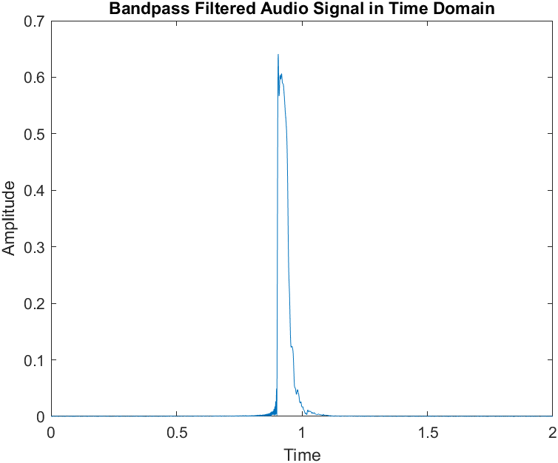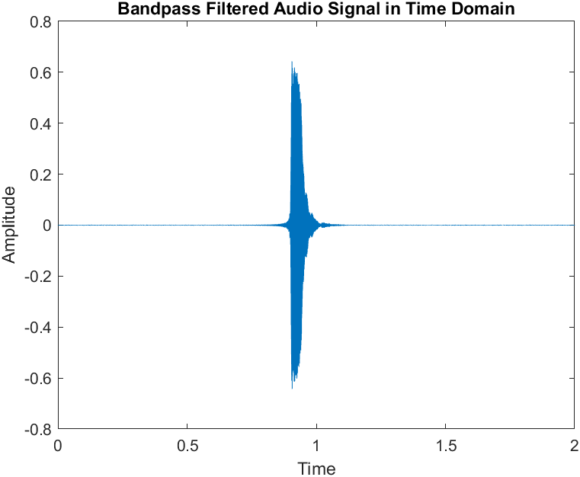

## Discussion

In addressing the challenge of signal noise, a simple bandpass filter was employed as a mitigation strategy. The bandpass filter, is designed to isolate specific frequencies while suppressing others. However, it's crucial to acknowledge the limitations, such as the predefined frequency range for suppression.

While the bandpass filter effectively isolates the identified frequencies, future work could explore the optimization of filter parameters for enhanced adaptability to varying noise characteristics. Additionally, a comparative analysis with other noise reduction techniques could provide insights into the strengths and weaknesses of different approaches.

## Additional Work

As an addition, Various smoothing techniques, including moving mean, moving median, Gaussian, linear regression, quadratic regression, robust linear regression, robust quadratic regression, and Savitzky-Golay, were applied to mitigate noise. Additionally, a range of filters, such as lowpass, highpass, bandpass, bandstop (Butterworth), and ideal brick wall filters, were employed to selectively eliminate unwanted frequencies. Spectral subtraction techniques, including custom high and low amplitude frequency filters, were implemented to further refine the denoising process. Adaptive thresholding based on local mean was utilized for noise reduction in non-stationary segments of the signal. All MATLAB code, graphs depicting denoising results, and exported WAV files can be accessed on my GitHub repository [[Github link](https://github.com/IsiraUdaththa/signal_matlab_ousl)]A few sample graphs are provided below to illustrate these denoising techniques in enhancing the audio signal quality.

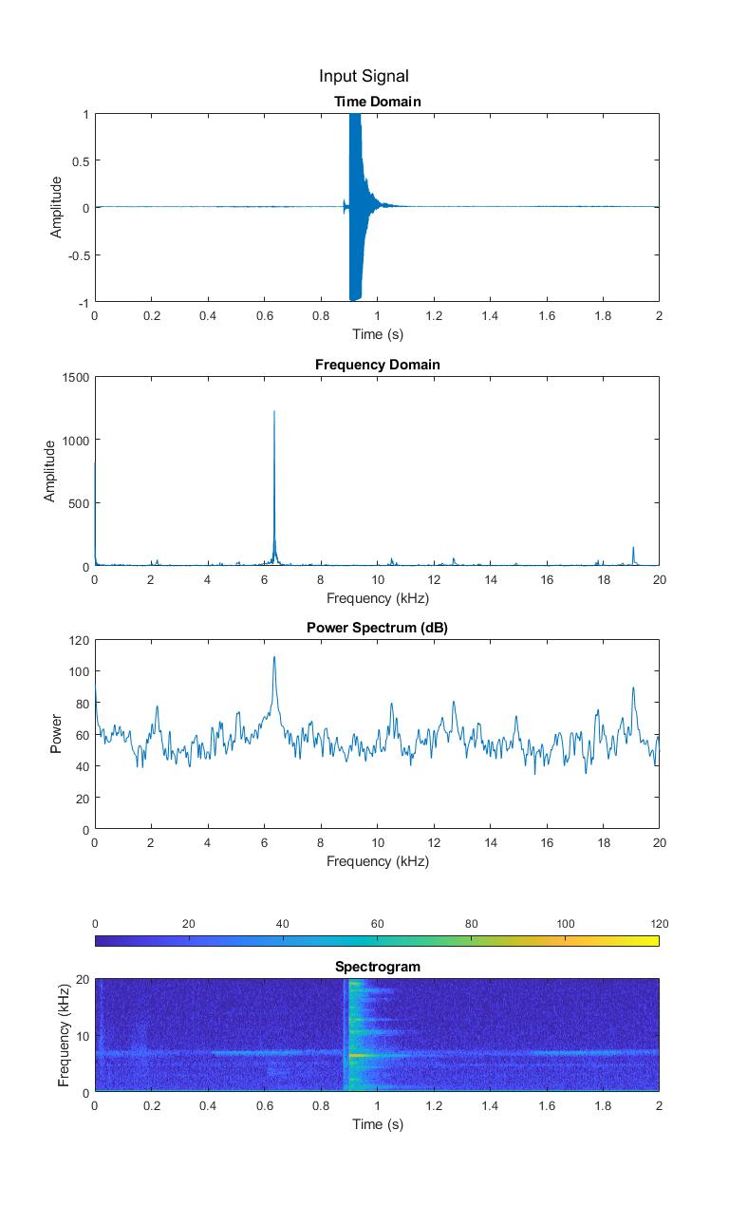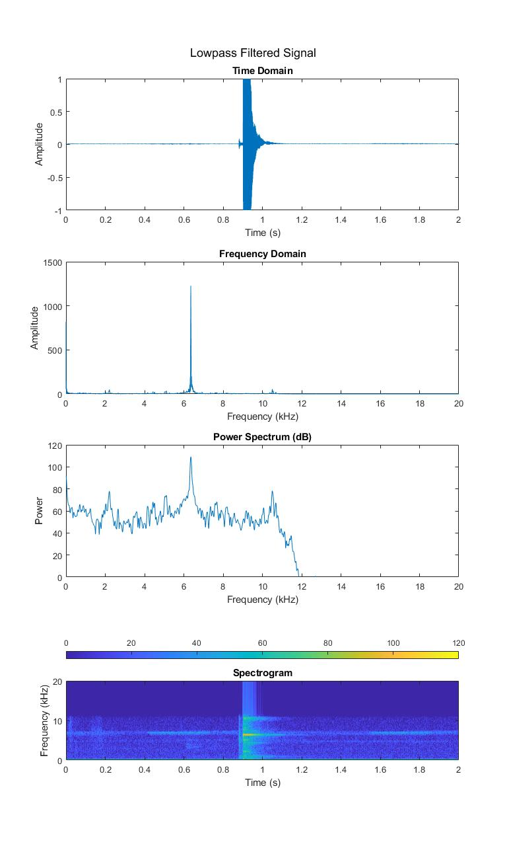

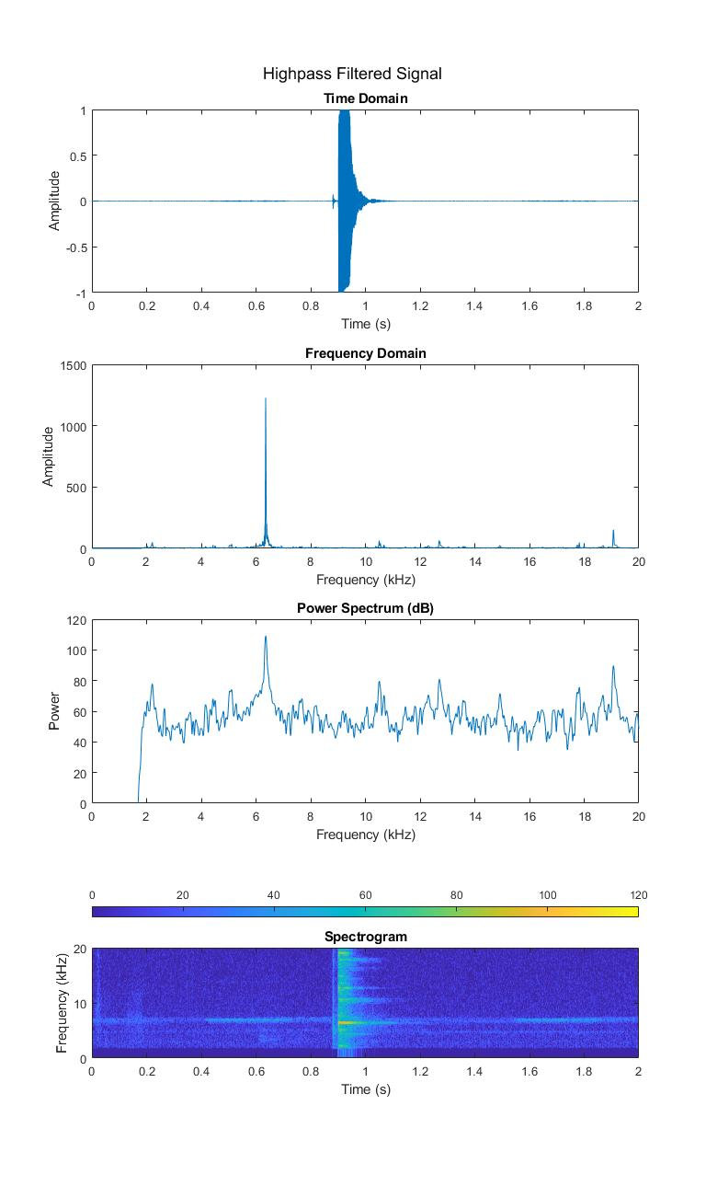

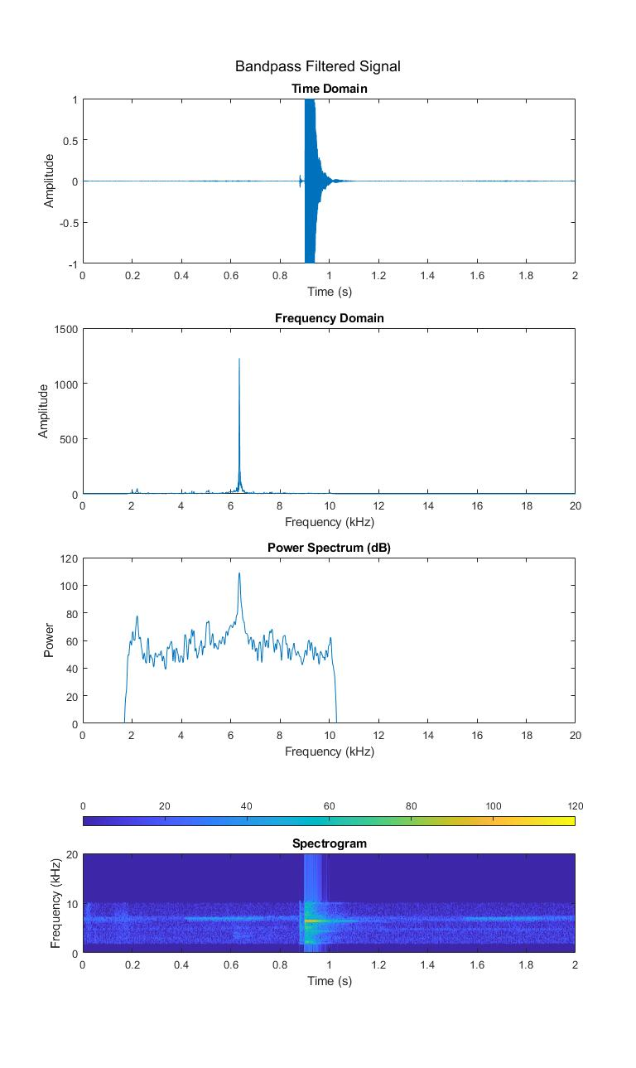

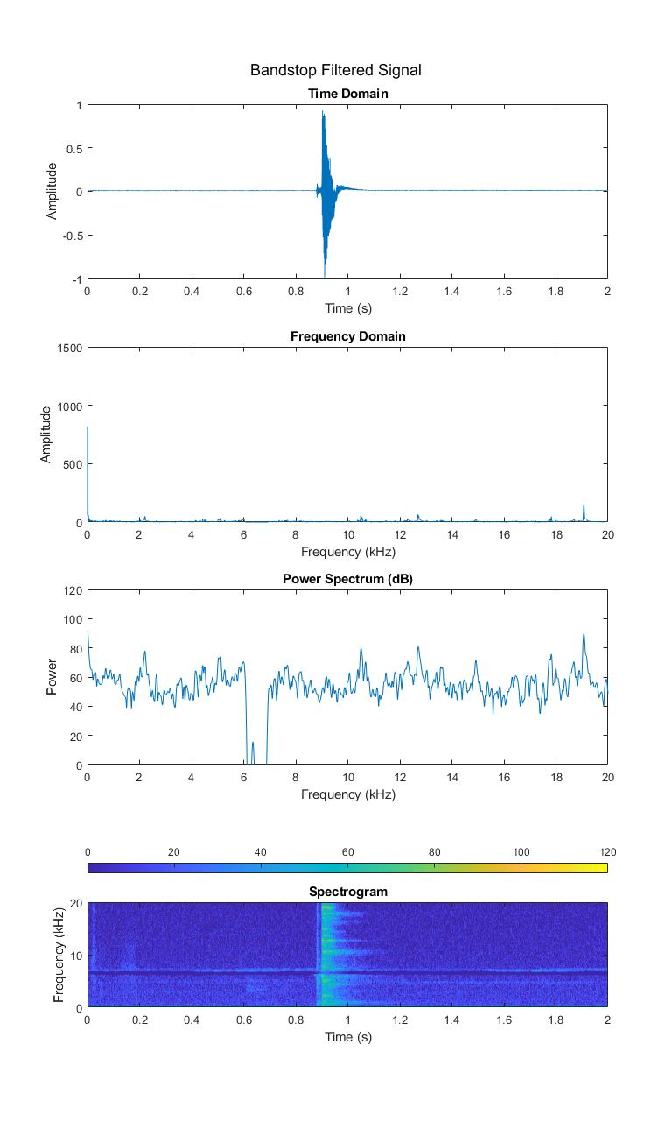

## Appendix

[1]. MATLAB Programs and Signal Reports

In this appendix, you'll find a collection of MATLAB programs, report, and exported signals related to the project. All the files and documentation can be accessed on my GitHub repository: [IsiraUdaththa/signal_matlab_ousl.](https://github.com/IsiraUdaththa/signal_matlab_ousl)