Computers in Human Behavior 59 (2016) 9e17

Contents lists available at ScienceDirect

Computers in Human Behavior

j o u r n a l h o m e p a g e : w w w . e l s e v i e r . c o m / l o c a t e / c o m p h u m b e h

Full length article

Leveraging adjusted user behavior in the detection and prevention of outgoing malicious SMSs in Android devices

Abdelouahid Derhab ^{a,} *, Kashif Saleem ª, Jalal Al-Muhtadi ^{a,} ^{b}, Mehmet A. Orgun ^{c}

- Center of Excellence in Information Assurance (COEIA), King Saud University (KSU), Riyadh, Saudi Arabia

- College of Computer and Information Sciences (CCIS), King Saud University (KSU), Saudi Arabia

- Intelligent Systems Group (ISG), Department of Computing, Macquarie University, NSW 2109, Australia

a r t i c l e i n f o

Article history:

Received 22 October 2015 Received in revised form 13 January 2016 Accepted 18 January 2016 Available online xxx

Keywords:

Android

SMS malware

Detection

Prevention

User behavior

Usability

a b s t r a c t

In this paper, we propose OnDroid, a prevention system to defend against outgoing malicious SMSs in Android devices. OnDroid is user-friendly as it considers the user's little understanding of the Android system. It also considers multiple threat scenarios and requires less interaction with the user. For each SMS-sending operation, OnDroid first checks if the mobile device state mismatches the user's behavior. If so, the operation is blocked. Otherwise, it is delayed for a while and the user is notified to confirm or reject the operation. If the SMS is considered normal, the user does not need to take any action and the SMS is sent when the delay expires. Efficiency analysis shows that malicious SMS operations might be missed when the user is unavailable. To deal with this issue, we propose a method by which the user behavior can be adjusted to achieve 100% of malicious SMS prevention. Formal analysis as well as comparative study show that OnDroid offers a good tradeoff between security efficiency and usability.

© 2016 Elsevier Ltd. All rights reserved.

1. Introduction

The Android operating system is largely popular among mobile device users. According to some several reports (Mawston, July 2014; http://www.idc.com/prodse), Android dominated the Smartphone market with a share of 85% and 82:8% in the second quarter of 2014 and 2015 respectively. Due to this popularity, it has been highly targeted by malware developers, which aim at profit-ing financially by infecting a large number of mobile devices. A study (Maslennikov, February 2014) has shown that Android ac-counts for 98:05% of mobile threats. According to F-secure report (Labs, April 2014), 99% of the emerged threats, which were discovered in the first quarter of 2014, were designed to run on the Android operating system. F-secure also reported in 2013 that 81:1% of the mobile malware were financially-motivated and 97:14% of the latter targeted Android OS (Labs, November 2013). Most of the financially-motivated malware perform SMS-sending

* Corresponding author.
E-mail addresses: abderhab@ksu.edu.sa (A. | Derhab), kashif@ksu.edu.sa
(K. Saleem), jalal@ccis.edu.sa (J. Al-Muhtadi), | mehmet.orgun@mq.edu.au
(M.A. Orgun).
http://dx.doi.org/10.1016/j.chb.2016.01.023
0747-5632/© 2016 Elsevier Ltd. All rights reserved.

activities during their attacks. This fact was supported by a report published in 2014 (Labs, April 2014). The report showed that 83% of the Android malwares analyzed by F-secure were performing SMS-sending activities, also called SMS-based attacks. These attacks are charged to the victim's account without his/her consent or knowledge, and can take the following forms:

SMS Spam: It is an unsolicited message sent from the compro-mised mobile device to advertise goods and products. The spammers send instructions to the compromised devices to launch SMS spam campaigns (Cloudmark, March 2014).

SMS Premium rate fraud: The malware sends an SMS to a pre-mium rate number, which results in transferring costly sums from the user's account to that of the cybercriminal (Labs, April 2014).

SMS malware propagation: The malware sends an SMS con-taining links to malicious applications in order to infect the recipient devices.

SMS privacy attack: Some malware secretly send through SMS sensitive information stored at the device to the attacker such as: bank account, phone identifiers (IMES, IMSI), and GPS location.

10 A. Derhab et al. / Computers in Human Behavior 59 (2016) 9e17

SMS flooding attack: Many unauthorized SMSs are generated to attack a target, which might lead to a Denial-of-Service (DoS) (Traynor et al., 2009).

The applications in Android use APIs to access resources such as: telephony, SMS and other network functions. These APIs are pro-tected through a security mechanism called permissions. The application developer must define the list of requested permissions in the AndroidManifest.xml file. To complete the installation pro-cess of the application, the user must grant all the requested per-missions. Otherwise, the installation fails. In Android 4.2 (Jelly Bean), when an application tries to send an SMS to a premium-rate number, the user is notified. However, a malware can hide the notification from the user. Starting from Android 4.4 (KitKat), the user has to select only one default SMS application, which is allowed to write to the SMS provider and receive SMSs. The other SMS applications can only read the SMS provider and are notified when an SMS is received. However, this configuration cannot completely prevent the SMS attacks. It has been reported in (Labs, April 2014) that 0:1% of the applications, which are received from Google's Play Store, were found malicious. Therefore, a user might download a compromised SMS application that sends both legiti-mate and malicious SMSs. If the user selects it as default, the ma-licious SMSs cannot be detected as they cannot be distinguished from the legitimate ones.

Most of the users have little understanding and knowledge of the Android permission policy. This was confirmed in a survey (Felt et al., 2012), which showed that only 17% of the users look at the requested permissions when installing applications. It has also been observed that developers request more permissions than they actually require (Felt, Chin, Hanna, Song, & Wagner, 2011). As legitimate and malicious applications can request the same types of permissions, it is often difficult for the users to determine during the installation process if the requested permissions are harmful or not. To deal with this issue, many complementary se-curity mechanisms have been proposed to detect or prevent ma-licious activities. These mechanisms offer different levels of security efficiency and different user interaction durations, and sometimes require users to have some knowledge of Android security.

In order to help the user to accurately distinguish between legitimate and malicious SMS applications, we propose OnDroid, a prevention system against outgoing malicious SMSs in Android devices. In this paper, we consider two types of SMS threats: (a) SMSs generated by a malicious application without the users knowledge, and (b) a compromised SMS application that sends both legitimate and malicious SMSs. The main idea of OnDroid is to find any incoherence (or mismatch) between the user behavior and the Android device state.

The main contributions of the paper are as follows:

- We determine the main features of the user behavior with respect to the mobile device.

- We identify the main features characterizing the Android device state.

- We propose an algorithm that detects any mismatches between the user behavior and the Android device state when perform-ing SMS-sending operations. This algorithm can prevent the occurrence of the first SMS threat.

- If a match is found, the user has to check that the SMS does not come from the second SMS threat. To do so, we delay the SMS-sending operation and the user is notified to intervene in case the SMS is malicious.

- We analyze the resilience of OnDroid against attacks and eval-uate its detection efficiency.

- We propose adjustment rules for the user behavior in order to prevent 100% of malicious SMS operations.

- We provide a comparative study that shows that OnDroid offers a good tradeoff between security efficiency and usability.

The rest of the paper is organized as follows. Section 2 discuses related work. In section 3, we present the system model. The detailed description of OnDroid is given in section 4. Security analysis and efficiency analysis are provided in section 5 and sec-tion 6 respectively. In section 7, we present a performance and usability study of security solutions against SMS malware. Finally, section 8 concludes the paper with a summary of our contributions.

2. Related work

The main existing approaches to detect an installed SMS mal-ware on an Android device can be categorized into: static analysis and dynamic analysis. In the static analysis approaches (Arzt et al., 2014; Batyuk et al., 2011; Enck, Octeau, McDaniel, & Chaudhuri, 2011; Grace, Zhou, Wang, & Jiang, 2012; Schmidt et al., 2009; Seo, Gupta, Sallam, Bertino, & Yim, 2014; Suarez-Tangil, Tapiador, Peris-Lopez, & Blasco, 2014), the application static information (i.e., program syntax, structural properties), which are extracted from the source or the binary code, are used to check if the application contains malicious code. However, obfuscation techniques can be used to avoid detection. In the dynamic approaches (Bierma, Gustafson, Erickson, Fritz, & Choe, 2014; Burguera, Zurutuza, & Nadjm-Tehrani, 2011; Grace, Zhou, Zhang, Zou, & Jiang, 2012; Ham, Kim, Kim, & Choi, 2014; Rasthofer, Arzt, & Bodden, 2014; Salman, Elhajj, Chehab, & Kayssi, 2014; Shabtai et al., 2014; Zhang et al., 2013; Zhou, Zhou, Jiang, & Ning, 2012), the application behavior is observed during its execution to detect if there are any inconsistencies with the normal behavior. The problem with this approach is its computational cost and the possibility of evading the detection.

In another category of approaches, called policy enforcement, the behavior of a legitimate application is supposed to follow certain predefined rules. If a rule violation is found, the application is considered as malicious. The policy enforcing approaches are divided into mitigating and preventive.

The mitigating approach cannot prevent the attack but only detect it, as the rule violation can only be observed after the attack has been carried out. On the other hand, the preventive approach can prevent the occurrence of the attack.

2.1. Mitigating policy enforcement approach

In DroidForce (Siegfried Rasthofer, Lovat, & Bodden, 2014), policies are enforced on Android applications in order to deal with the SMS premium rate fraud and data leakage. However, not all policies can prevent the attacks. For example, one policy could state that “no more than two premium-rate messages per day might be sent to each telephone number”. As each SMS costs money, this policy tries only to mitigate the losses incurred by the attacks and does not prevent them.

Nauman et al. (Nauman, Khan, & Zhang, 2010) proposed Apex, a policy enforcement framework, which allows users to impose and define runtime constraints on the usage of resources by the ap-plications. However, there is no discussion about the ability of the defined constraints to prevent the attacks.

2.2. Preventive policy enforcing approach

Almohri et al. (Almohri, Yao, & Kafura, 2014) proposed Droid-Barrier, which is a process authentication model for Android.

A. Derhab et al. / Computers in Human Behavior 59 (2016) 9e17 | 11

DroidBarrier provides legitimate applications with security cre-dentials that are used when the process associated with the application wants to be authenticated. The processes that do not have the credentials fail during their authentication attempts and their corresponding applications are considered as malicious. The main issue in this model is that the user needs to initially determine which applications are legitimate, which is not easy to be done by an average user.

In Derhab et al. (Derhab, Saleem, & Youssef, 2014), each SMS application, which is known by the user, is provided with a cryp-tographic key to encrypt its SMSs. All the SMSs have to pass through a filter at the kernel level before going out of the device. If the filter can correctly decrypt the SMS, it sends the decrypted message to the wireless communication medium. Otherwise, it prevents the SMS from going out of the device and identifies the application, which sent the malicious SMS. However, each SMS application in this solution has to encrypt all its outgoing SMSs, which requires the modification of the application. Also, it incurs additional pro-cessing time and SMS sending time due to encryption and decryption operations.

Xu et al. (Xu, Saïdi, & Anderson, 2012) proposed Aurasium, which automatically repackages an application to attach a user-level policy enforcement code. This code monitors any security violation like: sending SMS to premium numbers. If such a violation occurs, Aurasium displays the phone destination number and the SMS content, and waits for the user to confirm or reject the SMS-sending operation. The major disadvantage of Aurasium is the need to define permissions for each application. In addition, the user has to intervene each time there is an attempt to send SMS.

Sun et al. (Sun, Zheng, Lui, & Jiang, 2014) proposed Patronus, an intrusion prevention system for Android. Patronus defines a list of intrusive transactions that might violate Android security. When there is an attempt to execute a transaction, e.g., sendText, Patronus, using API hooking, suspends the execution of the trans-action and checks the existence of any permission associated with this transaction. If Patronus does not find any rule in the policy database, it notifies the user and displays the transaction content (e.g., SMS content and destination number). The transaction will resume execution when it is allowed by the user. Otherwise, it will be blocked. Although Patronus utilizes a preventive mechanism (i.e., API hooking), there is no discussion about the ability of the policy to prevent all the malicious SMSs.

Sakamoto et al. (Sakamoto, Okuda, Nakatsuka, & Yamauchi, 2014) proposed DroidTrack, which notifies the user in case of the possibility of information leakage, i.e., when the application calls an API to collect sensitive information, it then calls another API to communicate externally. The user is alerted and asked to confirm or reject the execution of the API. However, this solution requires user intervention whenever the two APIs are called.

MinDroid (Derhab, Saleem, Youssef, & Guerroumi, 2015) as-sumes that any malicious application starts sending malicious SMS within T time units after its installation on the mobile device. Based on this assumption, MinDroid requires user intervention only during the first T time units starting from the application installa-tion time. During this time period, the user either confirms or re-jects the SMS-sending operations. After the expire of this time, all the known SMS applications are allowed to send SMSs. However, if this assumption is dropped, the SMS is only blocked from appli-cations, which are not known for their SMS-sending activities. MinDroid cannot detect known compromised SMS applications, which only send malicious SMSs after the expire of T.

The SMS spam detector (Al-Omany, Al-Muhtadi, & Derhab, 2015) only checks the first SMS sent from each application. It shows an alert dialog box that asks the user to confirm whether he/she is the sender of the SMS. If the user confirms, the application will be

classified as authorized and the SMS operation will be resumed. Otherwise, it will be classified as malicious. Further SMSs, which are sent by authorized applications, are analyzed by an SMS spam filter. If an SMS is found legitimate, it is allowed to leave the device and a notification about the sent SMS is shown in the notification status bar for any further verification by the user. It might happen that the filter incorrectly classifies an SMS spam as ham, and the SMS in this case cannot be blocked. Although the prevention of all malicious SMSs is impossible, the notification status bar helps the user identify the compromised application, which sends both legitimate and malicious SMS.

3. System model and basic idea

3.1. Security model

We make the following assumptions about OnDroid:

- Android kernel code is initially secure (i.e., not compromised and free from malicious code).

- OnDroid is installed before installing any SMS application.

- OnDroid utilizes the Sandboxing feature provided by the Android kernel. This feature enables isolating applications from one another. In Android, each application is assigned a unique user ID (UID) and is run as a separate process. The filesystem access rules do not allow one user (resp., application) to access or modify another user's (application's) files.

- An attacker cannot obtain root privileges of the mobile device using the privilege escalation attack. Under this attack, when a malware gets access to the root account, it can bypass the sandboxing protection mechanism, and gain control over the operating system and data. OnDroid prevents this attack by using some solutions like the one presented in (Lee, Kim, & Park, 2014) or by using SELinux-enabled kernel, which is available starting from Android 4.3. In SELinux, data are protected from applications that can access the root user by applying a custom security policy, which specifies the applications that have access to the data (Allalouf, Ben-Av, & Gerdov, 2014).

  - Attack model

An SMS attack is said to be successful if the malicious SMS can go out of the device. We consider two types of SMS attacks:

First attack model: The malicious application hides its SMS-sending activities from the user, and only sends malicious SMSs.

Second attack model: The user installs a compromised SMS application, i.e., SMS-sending activities are not hidden from the user, but the application also secretly sends malicious SMSs. This kind of threat happens when an attacker repackages a legiti-mate application and inserts malicious code into it.

3.3. User behavior model

We consider that the user behavior with respect to the mobile device is shaped by two main features.

User availability: This feature has two modes: available and unavailable. The user is said to be available with respect to the mobile device if he/she is near that device, i.e, the user is not faraway from the mobile device and can hear the sound alarms triggered by it. If the user is faraway from the mobile device, he/ she is considered as unavailable.

12 A. Derhab et al. / Computers in Human Behavior 59 (2016) 9e17

User activity: It defines the actions performed by the user when interacting with the mobile device like: reading information, touching the screen.

- Suspend the execution of the application (arrow (1) in Fig. 1).

- Check if the rule is satisfied.

- Block running the application if the rule is violated (arrow (3) in Fig. 1). Otherwise, the SMS-sending is delayed for T time units (arrow (2) in Fig. 1).

4. OnDroid description

An Android application can send SMSs by invoking one of the three SMS-sending methods of the SmsManager class, which are: sendTextMessage, sendMultipartTextMessage, and sendDataMessage. OnDroid intercepts in real time the calls to SMS-sending APIs. These calls are invoked by applications with the SMS SEND permission, i.e., the AndroidManifest.xml file of the application contains the following line:

- uses permission android : name

  - “android:permission:SEND_SMS”= >

The architecture of OnDroid is shown in Fig. 1, and it is composed of the following components:

- Known SMS applications: It contains the list of applications, which are known for their SMS-sending activity, and authorized by the user.

- API call interception: It intercepts the calls to SMS-sending and suspends the execution of the invoking application.

- Policy database: It contains the rules the application must satisfy when an SMS-sending method is invoked, as shown in Table 1.

OnDroid performs the following steps each time the SMS application calls one of the three SMS-sending methods mentioned above:

Legitimate App

Table 1 shows the different rules to apply each time an SMS-sending method is invoked. OnDroid has to check if there are mismatches between the user's behavior and the device state. The normal device state that is coherent with any user, which sends SMS via an SMS application, consists of the following:

Screen state: The screen must be on.

Device lock state: The device must be unlocked.

Application visibility: The application must run in the foreground.

Application status: The application must belong to the Known SMS applications.

If any of the above rules are not satisfied, it means that either the user is not available in front of the device, or there are some ma-licious activities running secretly in the background, or unautho-rized hidden activities running in the foreground application. In this case, OnDroid blocks the SMS-sending operation, as shown in Fig. 2. Any malicious application, which adopts the first attack model, will be blocked by OnDroid. This is due to the fact that the malicious application is hiding its sending activities and it is not authorized by the user to send SMS. Therefore, it will be detected once it performs the first SMS-sending operation.

In case all the above rules are satisfied (i.e., State 9 in Table 1), it means that the user is interacting or recently interacted with the device (i.e., the screen is on, the device is unlocked, and is running
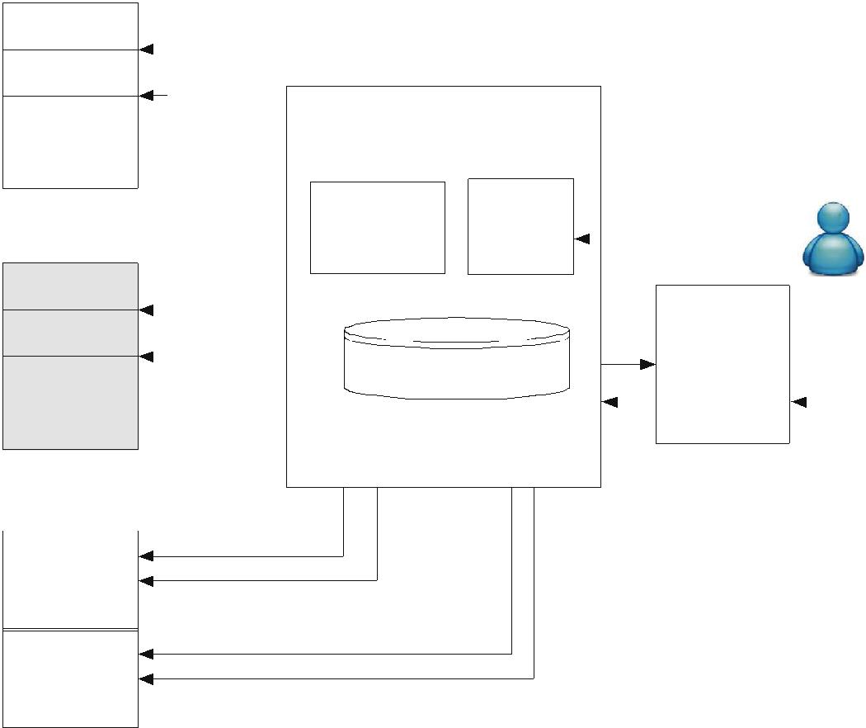

sendTextMessage

Malicious App

sendTextMessage

Compromised App

Legitimatecode
Legitimatecode | sendTextMessage
Maliciouscode
Maliciouscode | sendTextMessage

 |  | (1) |  | OnDroid
 |  | Suspend |  |  |  |  |  | User
 |  |  | API call | Known SMS
(2) Delay sending |  |  | API call
 |  |  | interception | Applications
 |  |  | interception | Applications |  |  | Confirmation
 |  | (1)
 |  | (1) | Policy database |  |  |  | pop-up window
 |  |  |  |  |  |  | and generation of
 |  | Suspend |  |  |  |  | sound alarm
        - Block

    - Suspend

      - Delay sending

    - Suspend

- Block

Fig. 1. Architecture of OnDroid

A. Derhab et al. / Computers in Human Behavior 59 (2016) 9e17 | 13

Send SMS
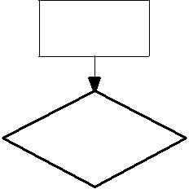

 |  |  |  |  |  |  | Application is |  |  |  |  |  |  | NO
 |  |  |  |  |  |  | Authorized
 |  |  |  |  |  |  | YES
 |  |  |  |  |  |  | Screen=OFF |  |  |  |  |  | YES
 |  |  |  |  |  |  | NO
 |  |  |  |  |  |  | visibility= |  |  |  |  |  |  | YES
 |  |  |  |  |  |  | background
 |  |  |  |  |  |  | NO
 |  |  |  |  |  |  |  | Device |  |  |  |  |  | YES
 |  |  |  |  |  |  |  | locked
 |  |  |  |  |  |  | NO
 |  |  |  |  |  |  | Notification and delay |  |  |  |  |  |  |  | SMS is blocked and user
 |  |  |  |  |  |  | SMS -sending for T units |  |  |  |  |  |  |  |  | is notified
 |  |  |  | NO |  |  |  | User is |  |  |  |  | YES
 |  |  |  |  |  |  | interacting
 |  |  |  |  |  |  |  | YES |  |  |  |  |  | User reacts
NO |  |  |  | User is |  |  |  |  |  |  |  |  |  | immediately
 |  |  |  | available
User reacts |  | after |  |  |  |  |  |  |  | User reacts
being available |  |  |  |  |  |  |  |  |  | immediately
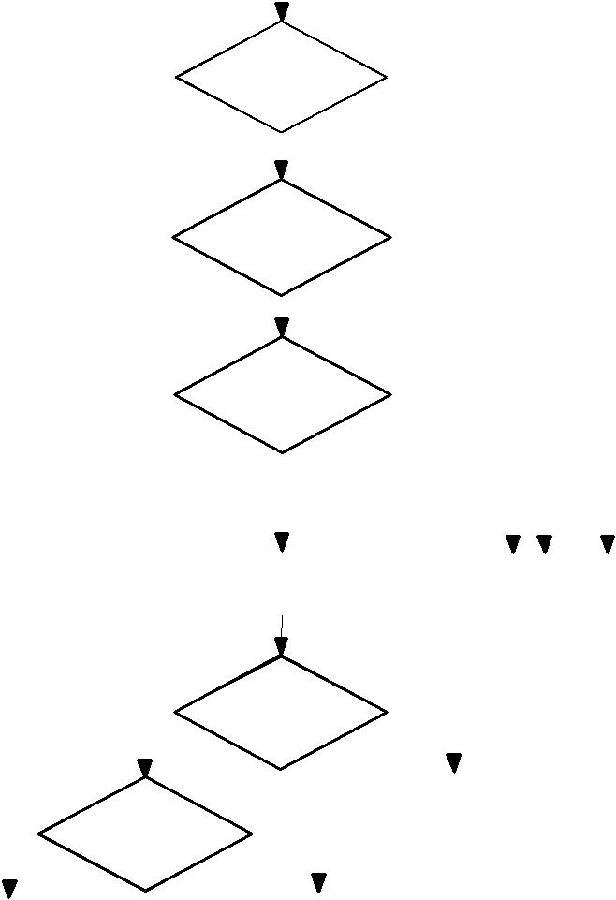
Fig. 2. The flowchart of OnDroid and user interaction cases.

an authorized SMS application in foreground). Here, we distinguish two cases.

If the application is legitimate, it only sends SMSs originating from the user.

If the application is compromised, malicious SMSs might be secretly sent while the user is interacting with the application to send his/her legitimate SMSs.

As the defined rules cannot distinguish between legitimate and compromised foreground applications, OnDroid performs the following steps (see Fig. 2):

It delays the SMS-sending operation for T time units. The delay has to be sufficient for the user to intervene if the SMS is malicious.

It notifies the user using two methods:

Displaying a notification in the notification status bar, which allows the user who is interacting with the device to read the notification and disable the application that sent the SMS.

Generating a sound alarm, which allows the user who is avail-able (i.e., near the device) to hear the notification and disable the application that sent the SMS.
If the user is not available, the attack will stop when the screen becomes off due to user inactivity. When the user interacts again with the device, he/she reads the notification and disables the application that sent the SMS.

The various states assigned to the user and the actions taken by OnDroid in State 9 are illustrated by a Finite State Machine given in Fig. 3. Transitions are labeled with triggering conditions, which need to hold true in order to switch between the states. Each of the states is described below:

ON Active: In this state, the user is active, i.e., he/she interacting with the mobile device (i.e., the user is active).
ON Inactive A: In this state, the screen is still on and the user is inactive (i.e., the user is not interacting with the mobile device) but he/she is able to hear the sound alarms triggered by this device (i.e., the user is available).

ON Inactive N: In this state, the screen is still on but the user is faraway from the mobile device and is not able to hear the sound alarms triggered by this device (i.e., the user is not available).

OFF: In this state, the screen is off.

The screen becomes off if the user does not interact with the device for a time period, called inactivity time, which equals the sum of the sojourn time in ON Inactive A and ON Inactive N states before transiting to OFF. The triggering conditions in the FSM are defined as follows:

User IN A: a predicate that holds true if the user stops inter-acting with the mobile device but he/she is still available.
User IN N: a predicate that holds true if the user stops inter-acting with the mobile device and he/she is not available.
User AC: a predicate that holds true if the user resumes inter-acting with mobile device by transiting from ON Inactive A or

ON Inactive N states to ON Inactive A.

User IN AN: a predicate that holds true if the user transits from

ON Inactive A state to ON Inactive N state.

User_IN_A |  | ScreenTimeOut
 | ON_Inactive_A | ScreenTimeOut
User_AC
ON_Active | User_IN_AN | OFF
User_IN_NA | User_IN_AN | OFF
User_AC
 | ON_Inactive_ N
User_IN_ N | ScreenTimeOut
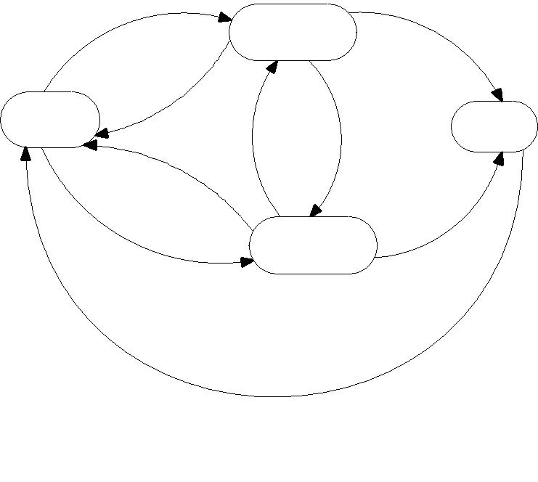

User_AC

Fig. 3. Finite state machine of OnDroid in state 9.

