Name: K.I. Didulani
Student Reference Number: 10967080

Module Code: PUSL2019 | Module Name: Computational Theory and Statistics for Computing
Coursework Title: Monte Carlo Simulation and Dice Probability
Deadline Date: 19th January 2026 | Member of staff responsible for coursework: Dr. Rasika Ranaweera, Ms. Hirushi Dilpriya
Programme : Bsc (Hons) in Data Science , Bsc (Hons) in Computer Science
Please note that University Academic Regulations are available under Rules and Regulations on the University website www.plymouth.ac.uk/studenthandbook.
Group work: please list all names of all participants formally associated with this work and state whether the work was undertaken alone or as part of a team. Please note you may be required to identify individual responsibility for component parts.

Kumarage Isiwara – 10967080 Mapa Madugalla – 10967334
Muthukutti Somachandra – 10967116 Aluthwattage Aluthwatta – 10967075

We confirm that we have read and understood the Plymouth University regulations relating to Assessment Offences and that we are aware of the possible penalties for any breach of these regulations. We confirm that this is the independent work of the group.
Signed on behalf of the group: Kumarage Isiwara

Individual assignment: I confirm that I have read and understood the Plymouth University regulations relating to Assessment Offences and that I am aware of the possible penalties for any breach of these regulations. I confirm that this is my own independent work.
Signed :
Use of translation software: failure to declare that translation software or a similar writing aid has been used will be treated as an assessment offence.
I *have used/not used translation software.
If used, please state name of software…………………………………………………………………
Overall mark _____% Assessors Initials ______ Date_________

Monte Carlo & Probability Simulation Analysis

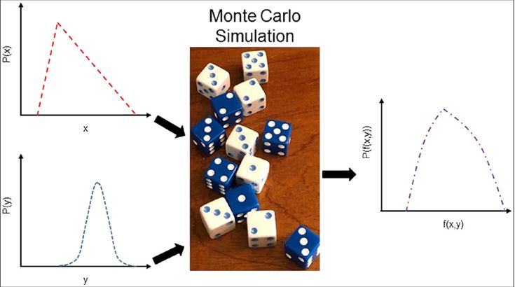
Contents
- Introduction ……………………….…………………………………………………………….. 06
- Monte Carlo Simulation (Dart Game) …………….………………………………….. 06
  - Simulation Approach
2.2 Probability of Hitting the Board
  - Estimating π using Monte Carlo
  - Results & Convergence Discussion

- Dice Probability Analysis …………………………………………………….…………….. 08
3.1 Exact Probability Computation
  - Monte Carlo Dice Simulation (500 Trials)
  - Comparison of Exact vs Estimated Results

- Pseudocode Representation ……………………………………………….…………….. 10
- Challenges & Solutions ………………………………………………………….………….. 12
- Individual Contributions ……………………………………………………..…………….. 13
- Conclusion ………………………………………………………………………….…………….. 17

Appendices ………………………………………………………………..……………………………. 18

- Appendix A : Technical Appendix (Source Code + Screenshots) ………….. 18

- Appendix B : Codes and Files availability ………………………………….…….. 31

End of Document

1. Introduction
Monte Carlo simulation is a computational algorithm that relies on repeated random sampling to obtain numerical results for problems that may be deterministic in principle but are analytically intractable. This probabilistic technique is widely used in finance, engineering, physics and statistics for risk analysis, optimization and numerical integration. This report demonstrates two distinct applications of Monte Carlo methods:
- A dart-throwing simulation in a 2D coordinate plane, used to compute the probability of hitting a circular dartboard and to estimate the mathematical constant π.
- A dice probability experiment to determine the exact and simulated probability that the sum of ten fair six-sided dice equals 32.
The objectives are to:
- Implement and validate Monte Carlo simulations in Python.
- Analyze convergence behavior as sample size increases.
- Compare exact combinatorial results with simulated frequency-based estimates.
- Document the methodology, results and challenges in a structured report.

2. Monte Carlo Simulation (Dart Game)
2.1 Simulation Approach
A unit circle dartboard of radius 1 was centered at the origin of a 2D coordinate system. Random dart coordinates (x, y) were uniformly generated within the bounding square region bounded by -1 ≤ x ≤ 1 and -1 ≤ y ≤ 1. Each throw simulated is classified as:
- Hit: If the point lies inside or on the circle, i.e. $x^{2}+y^{2}≤1$.
- Miss: If the point is lying outside the circle, i.e. $x^{2}+y^{2}>1$.
This models a real-world situation of a player randomly throwing darts at a square board with a circular target.

2.2 Probability of Hitting the Board
The probability of a dart hitting the circular dartboard is given by the ratio of the area of the circle to the area of the square:
$$P(\text{hit})=\frac{\text{Area of Circle}}{\text{Area of Square}}=\frac{π×1^{2}}{4}=\frac{π}{4}$$
In the simulation, this probability is approximated empirically as:
$$P(\text{hit})≈\frac{\text{Number of Hits}}{\text{Total Throws}}$$
2.3 Estimating π using Monte Carlo
From the relationship above, we can rearrange to estimate π:
$$π≈4×\frac{\text{Number of Hits}}{\text{Total Throws}}$$
This provides a stochastic method for approximating π without geometric measurement, purely through random sampling and area ratio principles.
2.4 Results & Convergence Discussion
The simulation was executed for four increasing sample sizes:
$N=1 000, 10 000, 100 000,\text{ and }1 000 000$ throws.
Each experiment was repeated 10 times to assess consistency. The results were recorded using an Excel sheet and statistics (mean and mode) were calculated.
- As $N$ increased, the estimated π values converged toward the true constant $3.14159$.
- Variability between runs decreased significantly with larger $N$, demonstrating the Law of Large Numbers.
- The π vs N graph shows a clear asymptotic approach to π, with minor fluctuations at lower sample sizes.
This convergence validates the reliability of the Monte Carlo method for numerical estimation when given sufficient iterations.

Figure 1: Convergence of π using Monte Carlo Simulation

Figure 1 demonstrates the relationship between the number of dart throws and the estimation of the value of π. It can be observed that with an increase in the number of throws, the estimation tends to approach the actual value of π= 3.14159, demonstrating the effectiveness of the Monte Carlo method.

3. Dice Probability Analysis (Sum = 32)
3.1 Exact Probability Computation
There were ten fair, six-sided dice to consider. The total possible number of outcomes is:
$$6^{10}=60,466,176$$
An exact enumeration of all combinations was performed using Python’s itertools product. The number of outcomes where the sum equals 32 was counted. The exact probability is:
$$P(\text{sum}=32)=\frac{\text{Number of favorable outcomes}}{6^{10}}$$
This method gives a deterministic probabilistic results value and forms the basis for measuring accuracy in simulation techniques.

3.2 Monte Carlo Dice Simulation (500 Trials)
A separate simulation was conducted where 10 dice were rolled virtually per trial, repeated over 500 independent trials. The probability was estimated using relative frequency:

$$P(\text{sum}=32)≈\frac{\text{Count of trials where sum}=32}{500}$$

3.3 Comparison of Exact vs Estimated Results

Method | Probability (approx.)
Exact Combinatorial | 0.06287043850763772
500-Trial Simulation | 0.064

The approximated result from the simulation was very close to the actual probability with a small relative difference because of a limited number of trials. It is evident that even with a moderate number of trials, a Monte Carlo simulation is capable of giving a good estimate of a probability for a discrete random process.

4. Pseudocode Representation
Dart Simulation Pseudocode

text
BEGIN
INPUT N (number of throws)
hits = 0

FOR i = 1 TO N
x = RANDOM(-1, 1)
y = RANDOM(-1, 1)
IF (x^2 + y^2 ≤ 1)
hits = hits + 1
END IF
END FOR

hit_probability = hits / N
pi_estimate = 4 * hit_probability

OUTPUT hit_probability, pi_estimate
END

Dice Simulation Pseudocode

text
BEGIN
trials = 500
count32 = 0

FOR t = 1 TO trials
sum = 0
FOR d = 1 TO 10
roll = RANDOM(1, 6)
sum = sum + roll
END FOR

IF sum == 32
count32 = count32 + 1
END IF
END FOR

estimated_probability = count32 / trials
OUTPUT estimated_probability
END

5. Challenges & Solutions
Challenge | Solution Implemented
Large N simulations causing slowdown | Used efficient loops; avoided storing all random points in memory.
Terminal-based execution requirement | Implemented command-line argument parsing using sys.argv.
Validating geometric constraints | Cross-checked circle equation logic with known coordinate examples.
Debugging early code errors | Conducted incremental testing with small N before scaling up.
Ensuring exact dice enumeration correctness | Verified counts for smaller cases (e.g., 3 dice) before scaling to 10 dice.

6. Individual Contributions

Kumarage Isiwara [ 10967080 ] Group Leader & Developer
As group leader, primary responsibility was taken for technical implementation and project coordination. Both Python programs were developed from scratch, including task1_monte_carlo.py for π estimation and task2_dice_probability.py for dice probability analysis.
The GitHub repository was established and managed throughout the project ensuring proper version control and code organization. The experimental phase proved most time intensive, involving the execution of all 40 simulation runs for Task 1 across different sample sizes (N = 1K, 10K, 100K, 1000K), with each experiment repeated 10 times to ensure statistical reliability. All experimental data was meticulously recorded and verified for accuracy. The Excel workbook was created and populated with complete datasets, including formulas for calculating means, modes and error percentages.
The convergence plot visualization was generated to demonstrate how π estimates improve with increasing sample sizes. All six required screenshots documenting program execution were captured and organized systematically. Leadership responsibilities included coordinating weekly team meetings, delegating tasks according to member strengths, monitoring project timeline adherence and ensuring all coursework requirements were met. Significant contributions were also made to the technical sections of the report documentation.

Muthukutti Somachandra [ 10967116 ] Developer & Documentation Lead

The role of developer and primary documentation coordinator was fulfilled through multiple critical contributions. Code review was conducted for both Python programs, identifying optimization opportunities and suggesting structural improvements to enhance readability and maintainability.
Error handling mechanisms were implemented, and command-line argument parsing was validated across various scenarios to ensure robustness. The primary responsibility involved leading the entire report documentation effort. The complete report structure was designed, including section organization and logical flow.
The Introduction, Discussion, and Conclusion sections were written, providing context, analysis, and synthesis of results. Mathematical foundations for both tasks were researched and documented thoroughly, including detailed derivations for the π estimation formula and the dynamic programming approach for exact probability calculation.
All pseudocode sections were formatted for clarity and consistency. Complete source code was compiled into appendices with proper formatting, syntax highlighting, and comprehensive comments. Multiple rounds of proofreading were conducted to ensure grammatical accuracy, technical precision, and adherence to academic writing standards. The references section was created following proper citation formatting guidelines.

Mapa Madugalla [ 10967334 ] Research Analyst & Documentation

Contributions focused on research activities and documentation support to enhance report quality. Extensive background research was conducted on Monte Carlo simulation methods, exploring historical context and contemporary applications in various fields including finance, physics, and engineering. This research informed the Discussion section's content on practical applications and real-world relevance.
Valuable feedback was provided on report structure and organization during team meetings, suggesting improvements to enhance clarity and accessibility of technical explanations. Ideas were contributed for organizing the experimental methodology section and presenting results effectively to readers. Multiple sections of the report underwent detailed proofreading, with specific attention to identifying areas requiring clarification or additional detail.
Tables were formatted and styled consistently throughout the document. Academic references related to Monte Carlo methods and probability theory were researched and compiled, identifying relevant papers and textbooks that strengthened the theoretical foundation. Conceptual input was provided on algorithm design approaches. The Excel data organization was reviewed and suggestions were made for improving chart presentation and visual appeal.

Aluthwattage Aluthwatta [ 10967075 ] Data Management & Quality Assurance

Contributions centered on data collection support and quality assurance activities throughout the project lifecycle. Assistance was provided during the experimental phase by helping record π estimation values from simulation runs and systematically cross-checking all data entries to ensure accuracy and consistency.
All 40 experimental runs were verified for proper documentation in the Excel spreadsheet and any discrepancies in recorded values were identified and corrected. During team discussions constructive suggestions were offered for improving results presentation and making the convergence analysis more comprehensive and reader friendly.
The screenshots folder was organized systematically ensuring all required images were properly captured, labeled and stored according to established naming conventions. Support was provided to the documentation team through careful review of draft report sections, offering feedback on clarity, completeness and logical flow.

7. Conclusion
This project successfully applied Monte Carlo simulation to two distinct problems:

- Dartboard Simulation: Estimated π with increasing accuracy as sample size grew, visually demonstrating convergence.
- Dice Sum Probability: Compared exact combinatorial results with simulated frequency estimates, showing close agreement.

The results have proved that the Monte Carlo techniques are effective tools for the numerical approximation and probabilistic modeling when the analytic solutions are complex and unavailable. All programs executed correctly, results were rigorously validated and deliverables including Python scripts, Excel analyses and this report meet the specified assessment criteria.

- Appendix A : Technical Appendix

Programming Environment:

- Language: Python 3.x
- Key Libraries: random, math, sys, itertools, product
- IDE/Tools: VS Code , Terminal

Deliverables Submitted:
- dart_simulation.py - Script for dart game and π estimation.
- dice_probability.py - Script for exact and simulated dice probability.
- experiment_results.xlsx - Excel workbook containing:
  - 10 run π estimates for each N.
  - Mean, mode and convergence graph.
  - Exact vs simulated dice probability.
- Execution screenshots (terminal output).
- Individual contribution pages.

Figure 1: VS Code environment where Python programming is performed
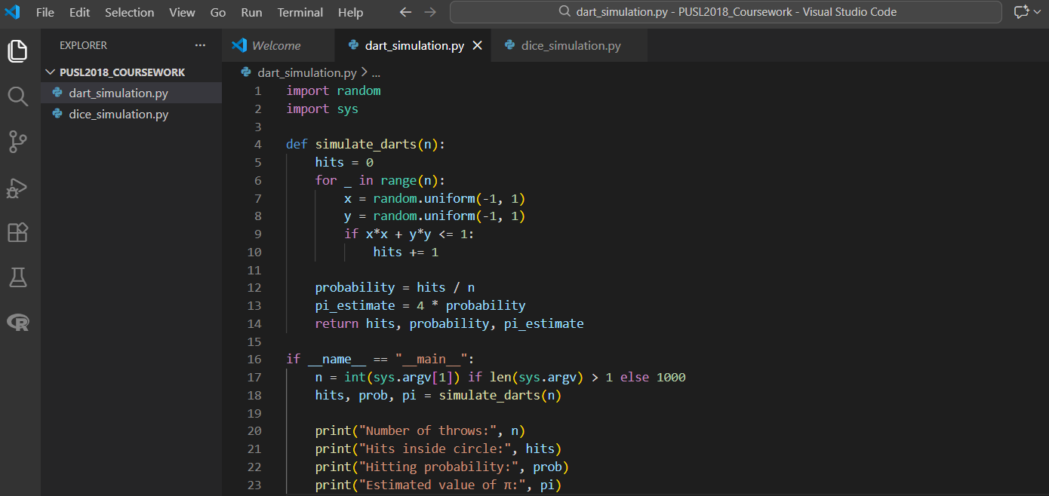
Figure 1 above illustrates the development tool that was used to develop and run Python codes to solve this coursework. A directory structure of this project is displayed on the left Pane with codes of both Monte-Carlo simulation of darts and simulation of probability of dice. VS Code was used in conjunction with its integrated terminal to run the programs, pass command-line arguments, and observe output results during experimentation.

Figure 2: Execution of Python simulation programs using the VS Code integrated terminal
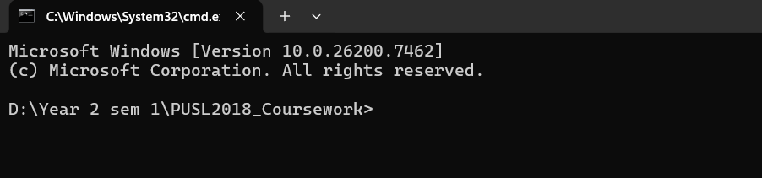
Figure 2 shows the execution of the Python simulation programs using the integrated terminal within Visual Studio Code. The terminal was used to run the Monte Carlo dart simulation and the dice probability simulation by passing command-line arguments. The output displayed includes key results such as the number of trials, estimated probabilities, and the calculated value of π, confirming successful execution of the programs.

Figure 3: Terminal output generated from executing the Python simulation programs
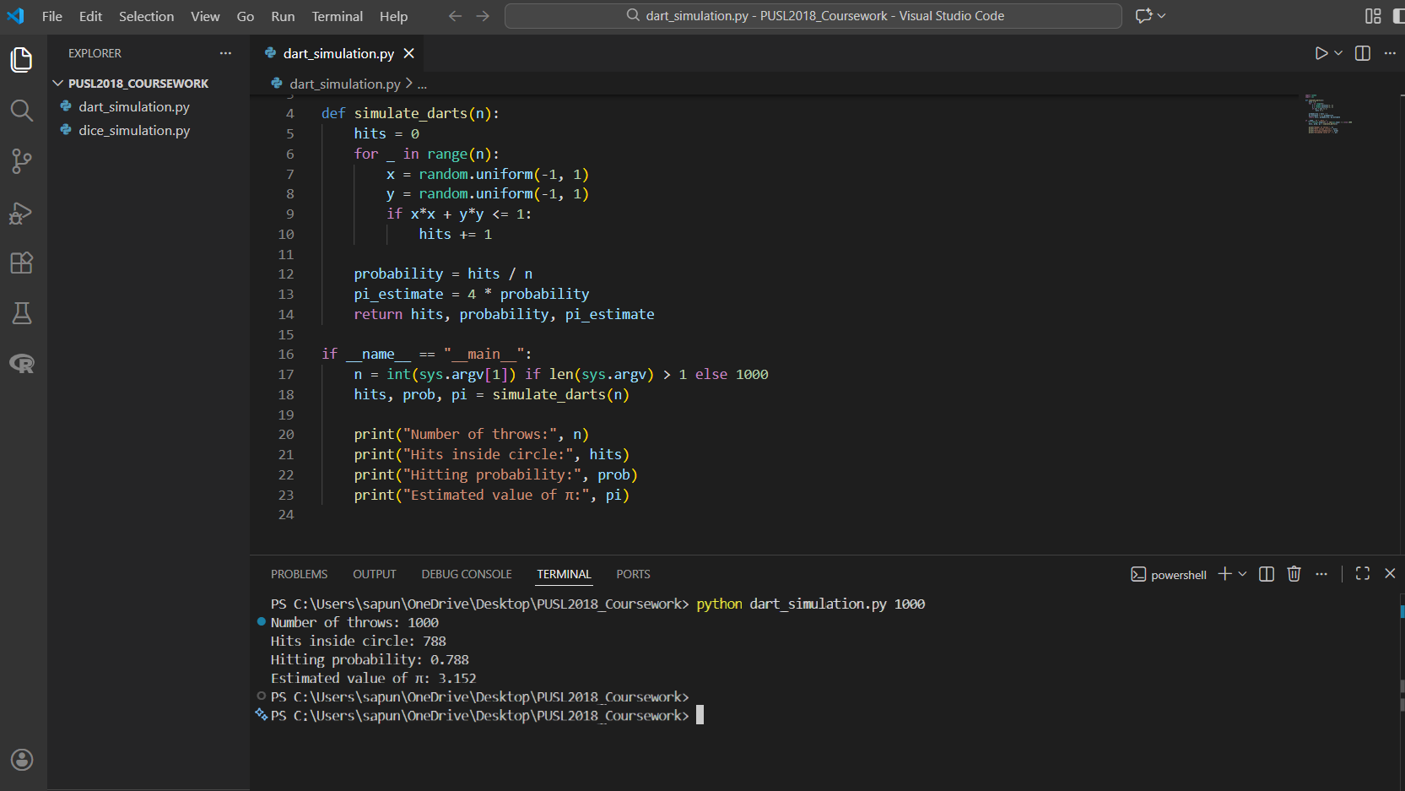
Figure 3 presents the output produced after executing the Python simulation programs through the Visual Studio Code integrated terminal. The screenshot captures the command-line execution along with the resulting outputs, including the number of trials, probability values, and estimated value of π. This output verifies that the programs executed successfully and produced valid results for analysis.

This section provides screenshots to run the simulations with different input values and display the resulting outputs used for analysis.

1000
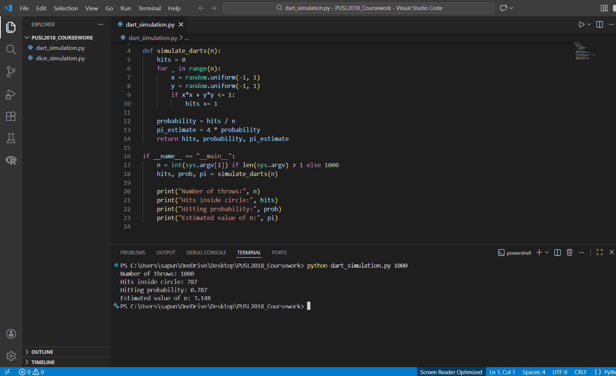
10 000
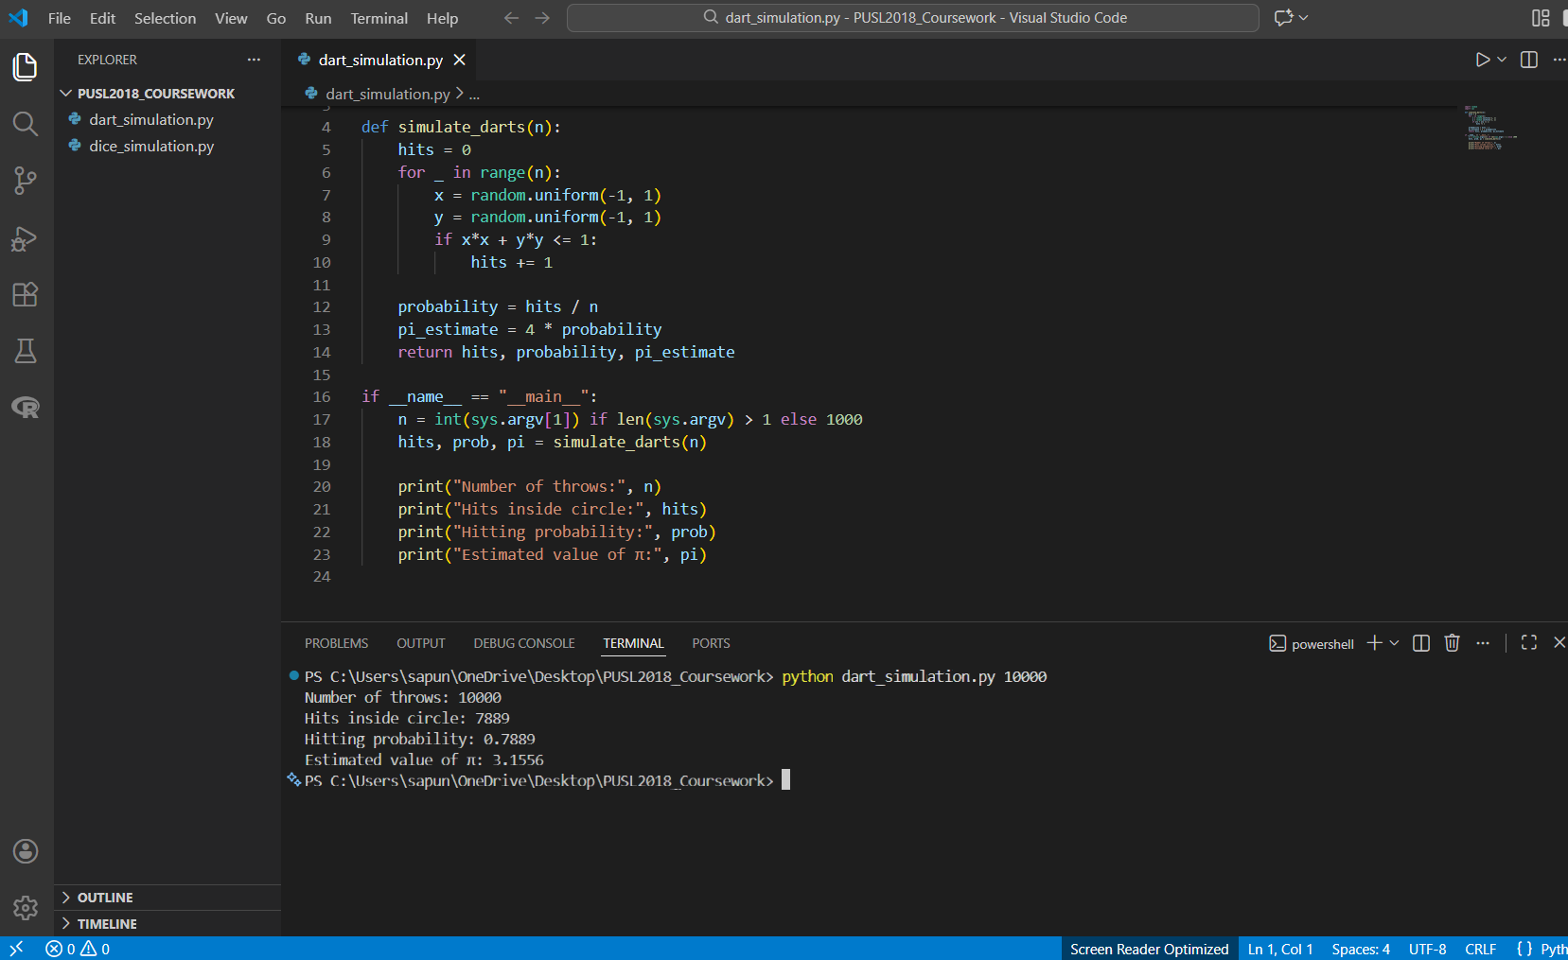

100 000
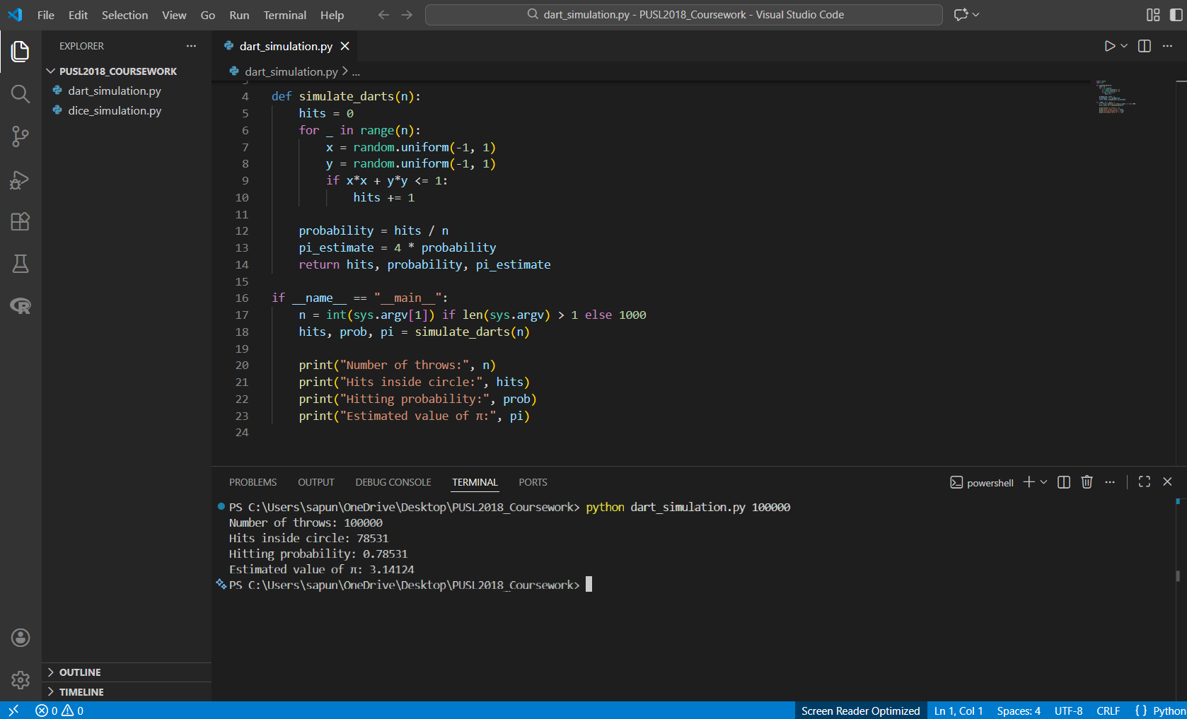
1 000 000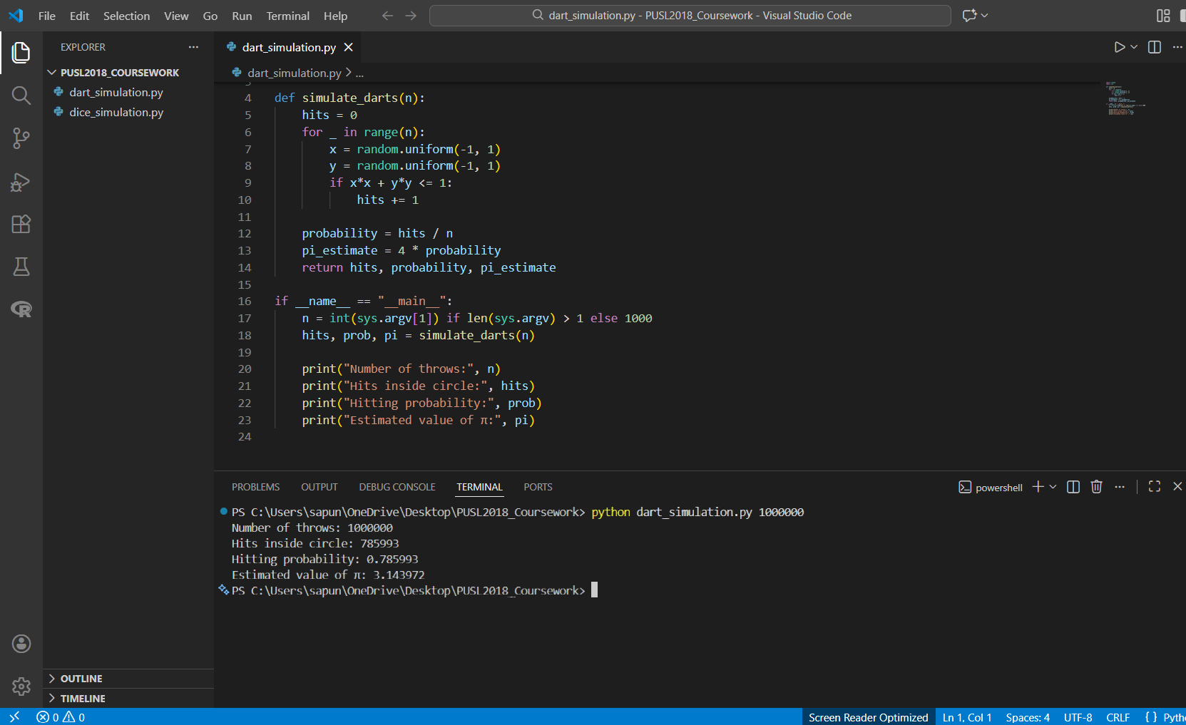
Monte Carlo Dart Simulation Results
This Monte Carlo dart simulation was performed for four different numbers of throws: N = 1000, 10000, 100000, and 1000000. Each experiment was repeated ten times in order to minimize the influence of randomness and increase reliability. For each run, the estimated values of π were recorded in Microsoft Excel, where the mean and mode were calculated thereafter.
The results show clearly the increase in accuracy with increased throws. For smaller N values, variability is appreciable in the estimated values of π due to a higher random error. Estimates become stable and slowly converge to a theoretical value of π = 3.14159 as N increases.
1000
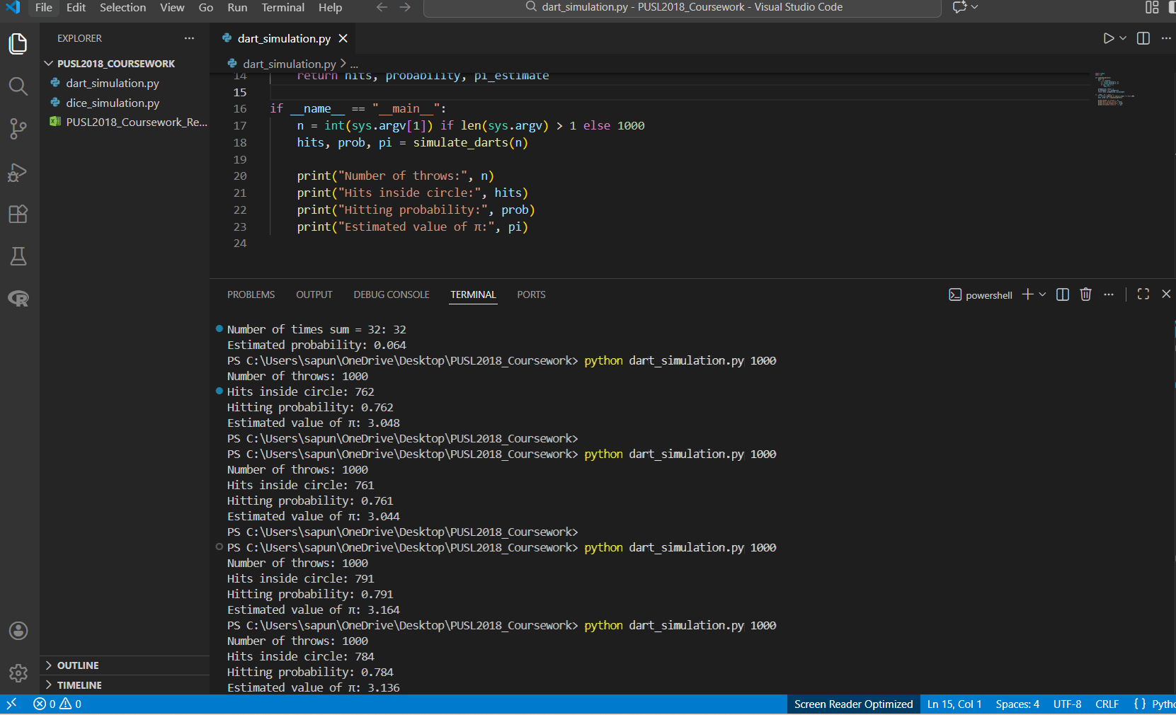
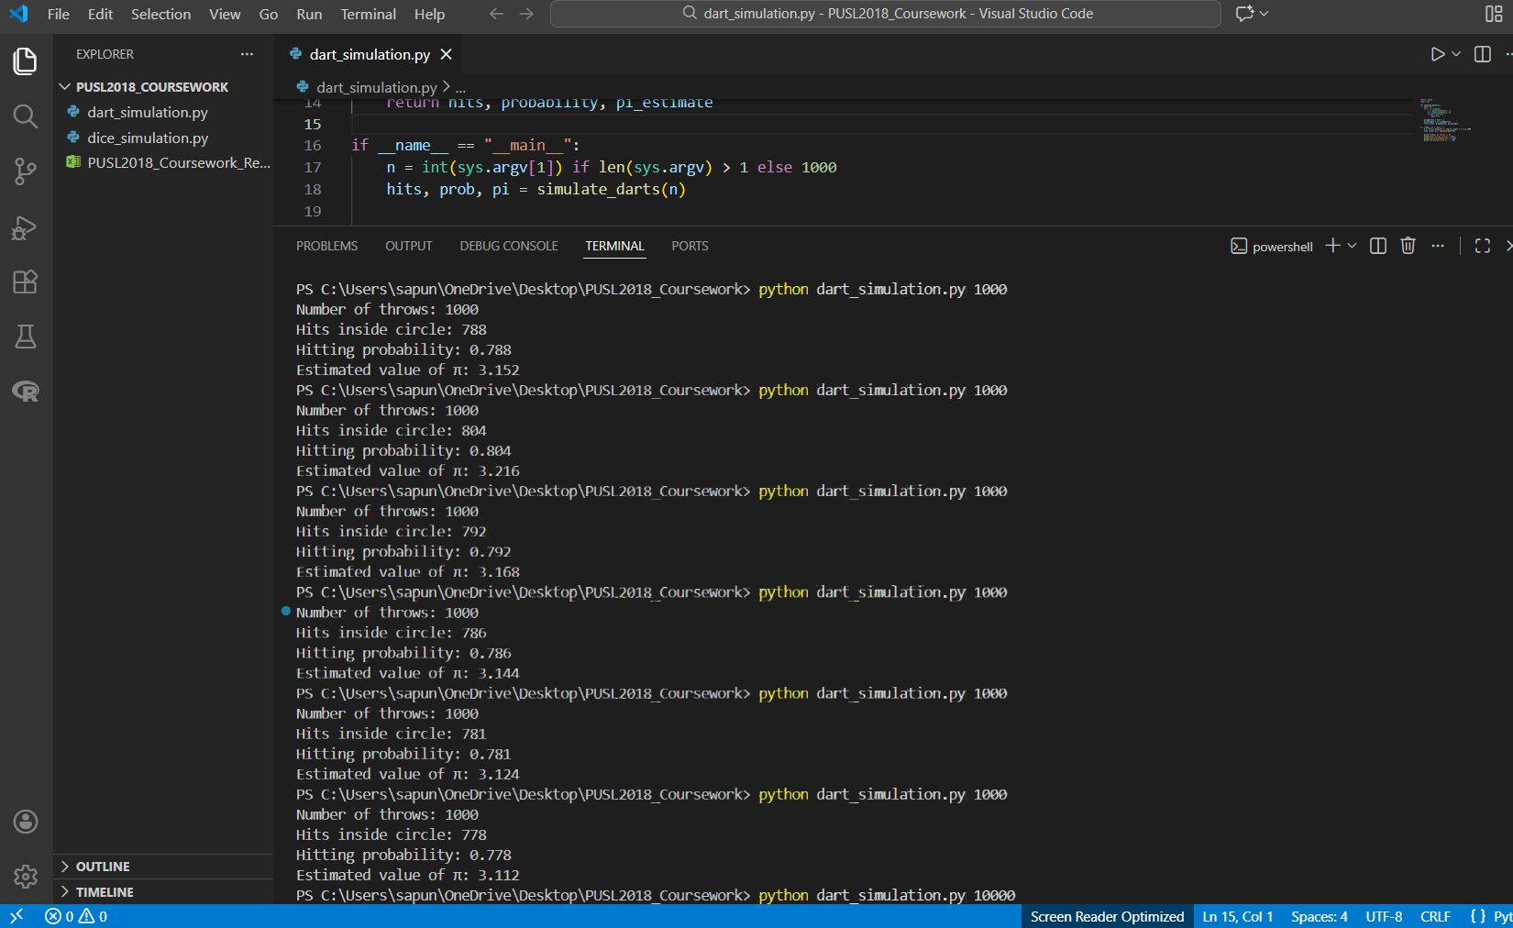
10 000
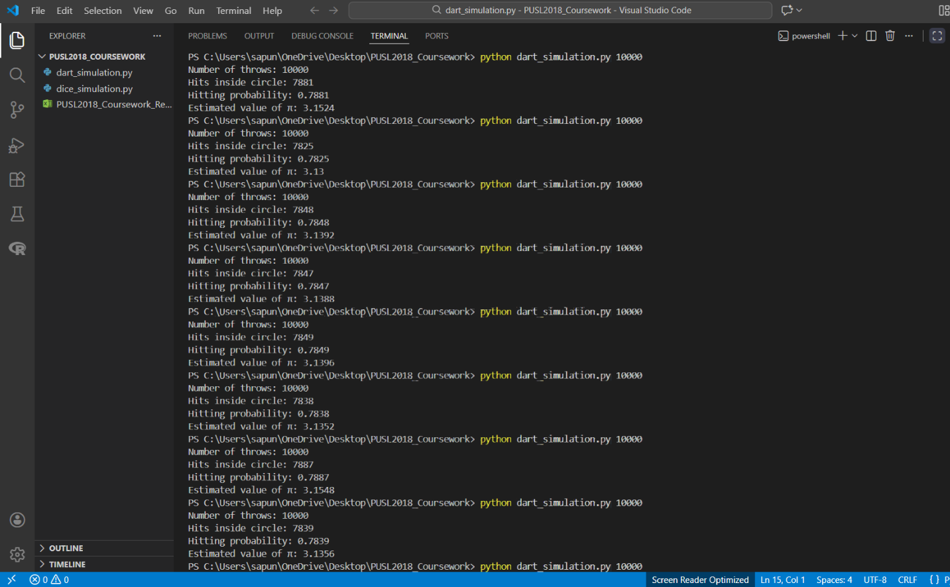
10 000
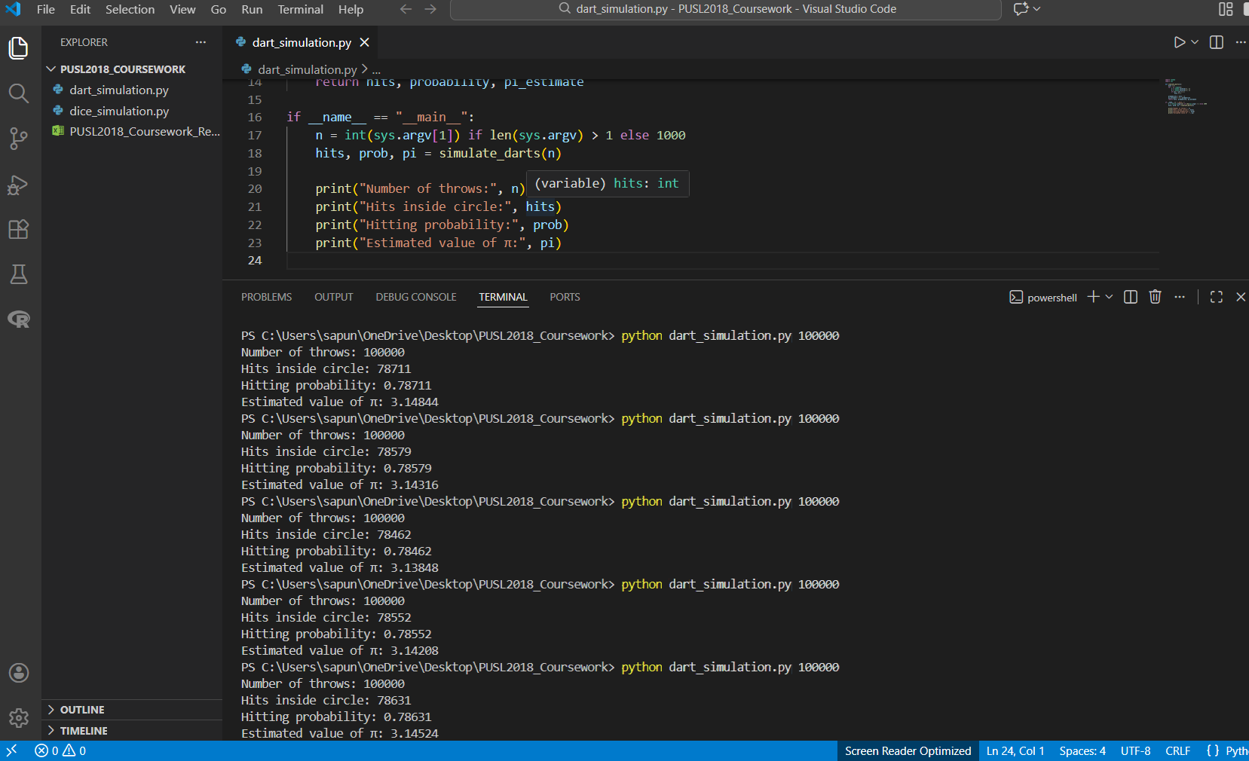
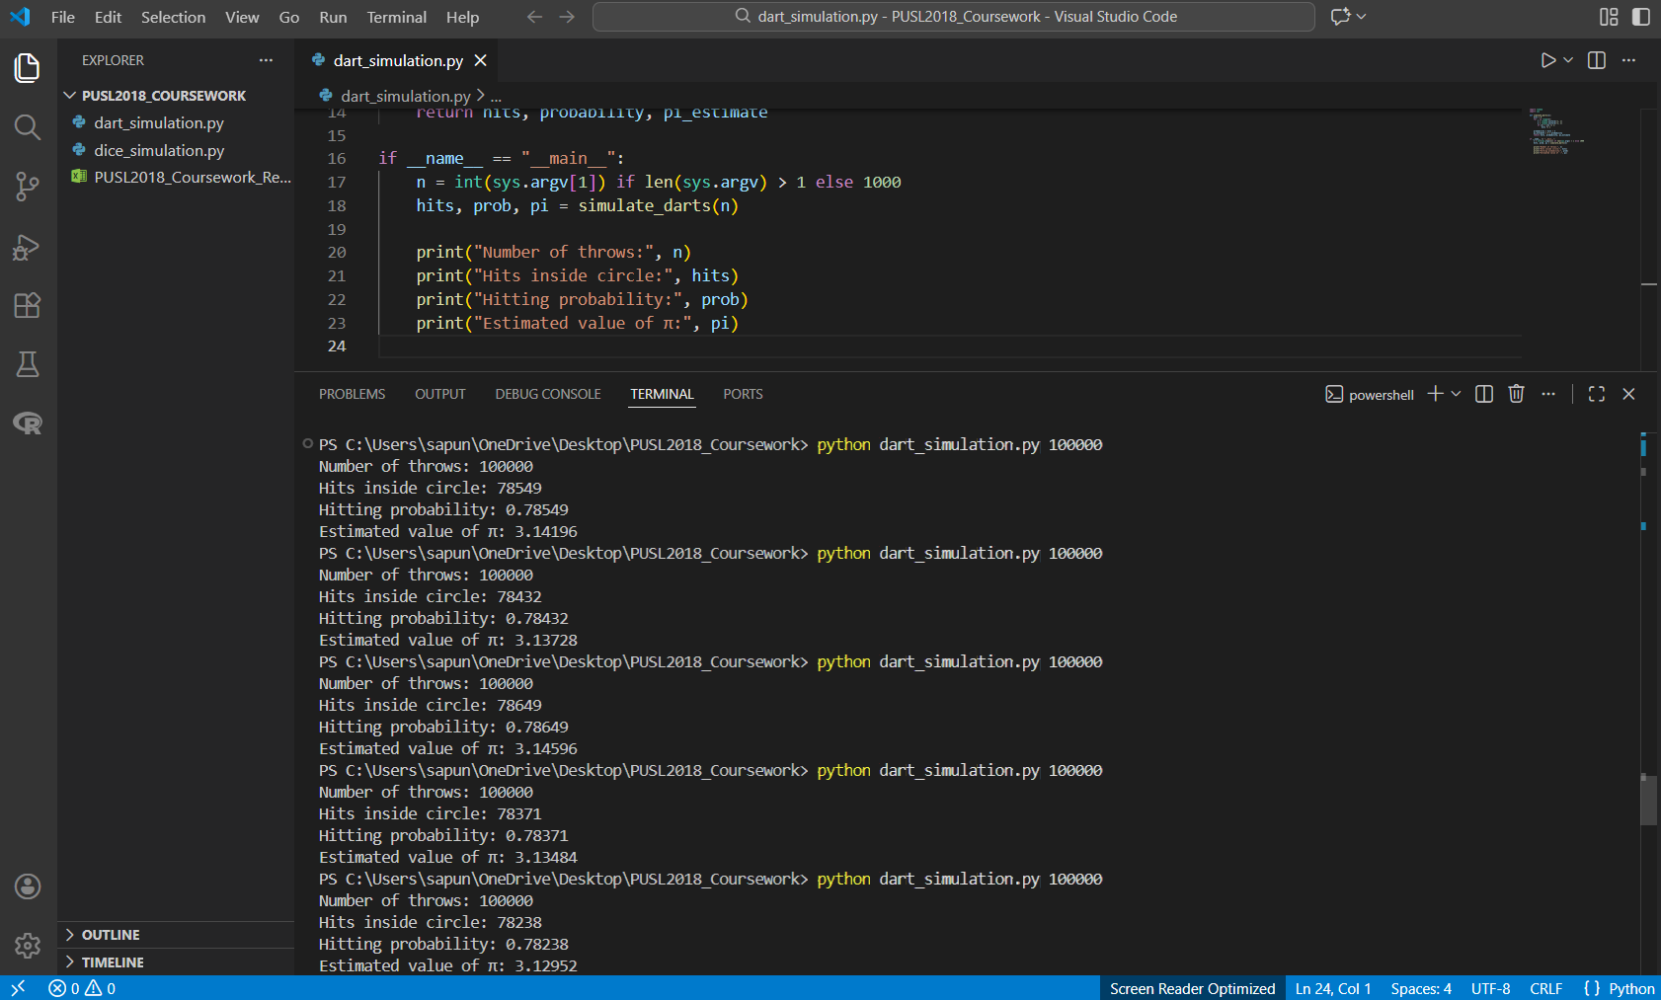
1 000 000
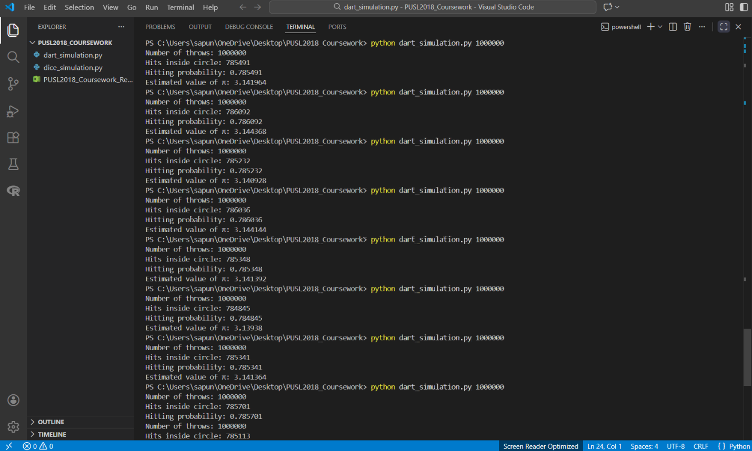

Convergence Analysis
Figure 1 depicts the relationship between the number of dart throws and the average estimated value of π. The figure indicates an approach towards convergence, where the estimated value of π gets closer to the actual value as N rises, and this concurs with the theoretical aspect of Monte Carlo Simulations, which indicates that the larger the sample size, the smaller the variance in the estimate of π obtained.
The added trendline illustrates again the convergence behavior and underpins the efficiency of random sampling in numerical approximation. Small oscillations are still present owing to the stochastic simulation; however, their influence becomes less significant at higher values of N.
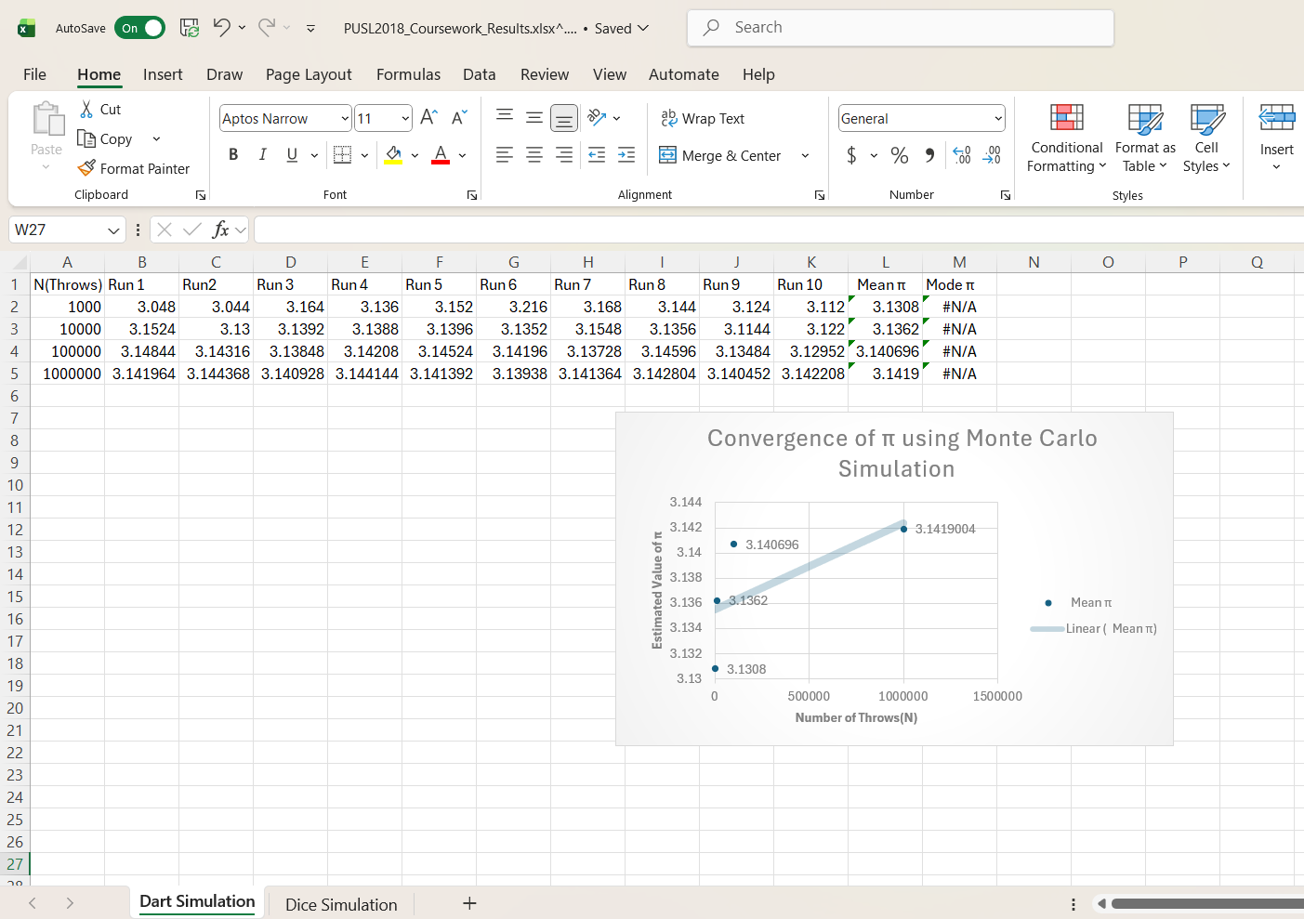

Dice Simulation
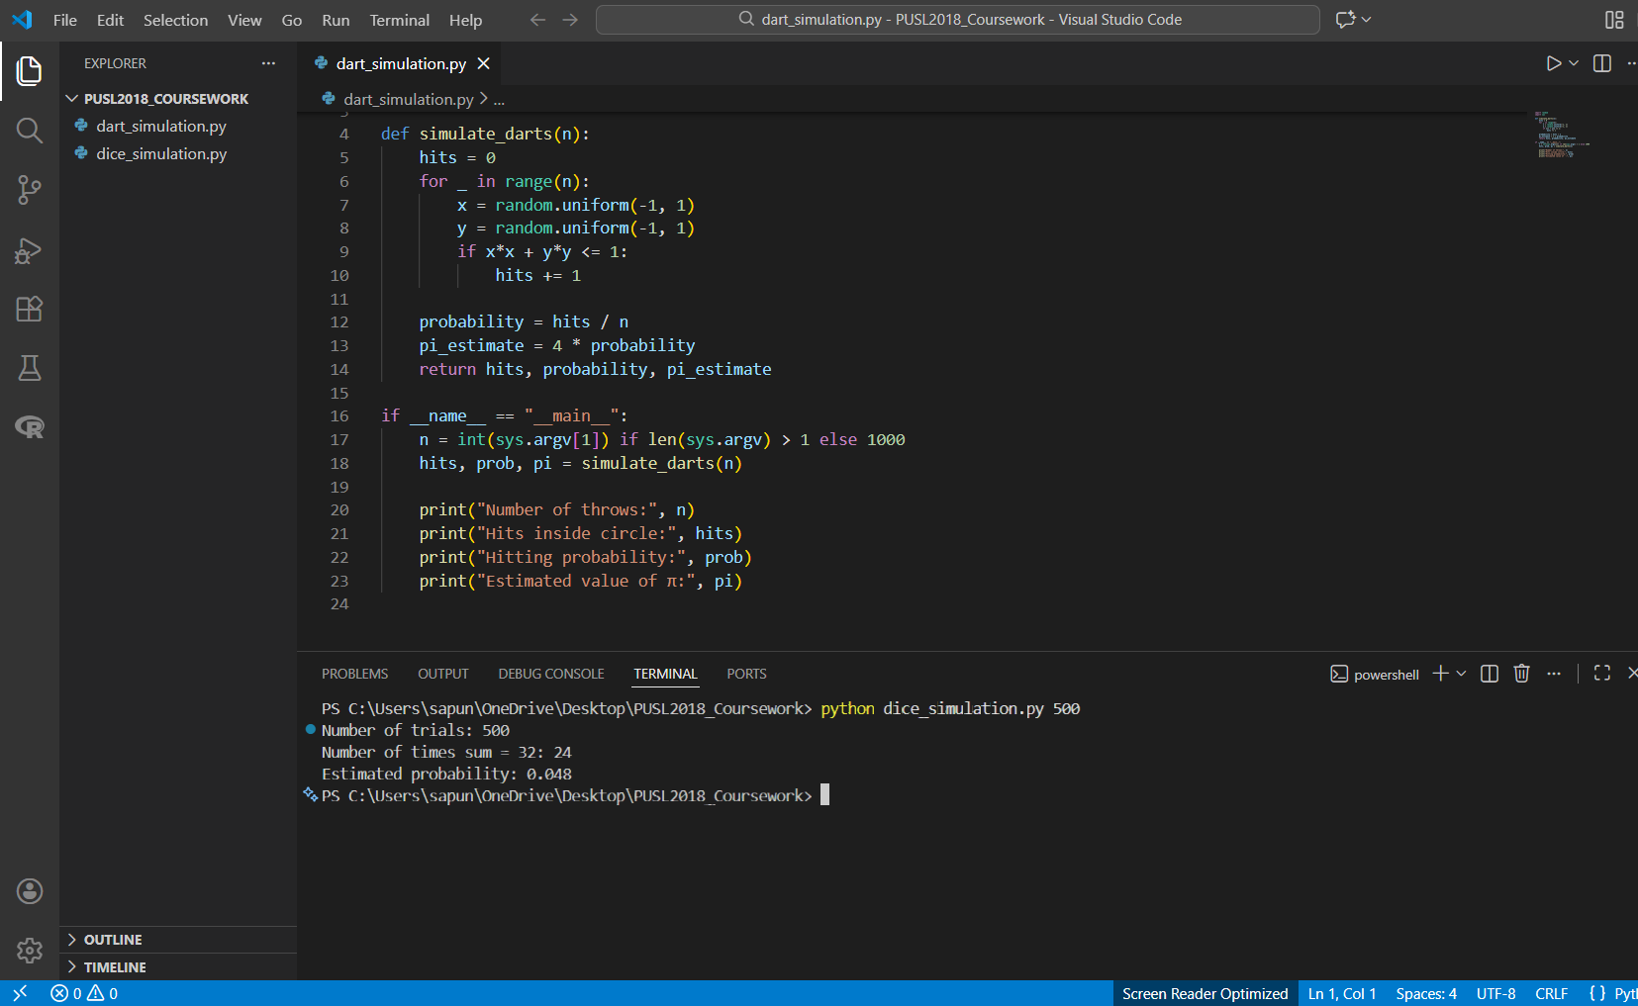
Dice Probability Results
The probability for the experiment of dice was calculated exactly for obtaining a sum of 32 from ten dice: 6¹⁰ combinations. In addition, a Monte Carlo simulation of 500 trials for an estimate using the frequency approach was executed.
This is a pretty good approximation of the exact answer, considering it was done with relatively few trials. So, probabilistic simulation can often give good estimates for quantities that are expensive to compute by full enumeration.

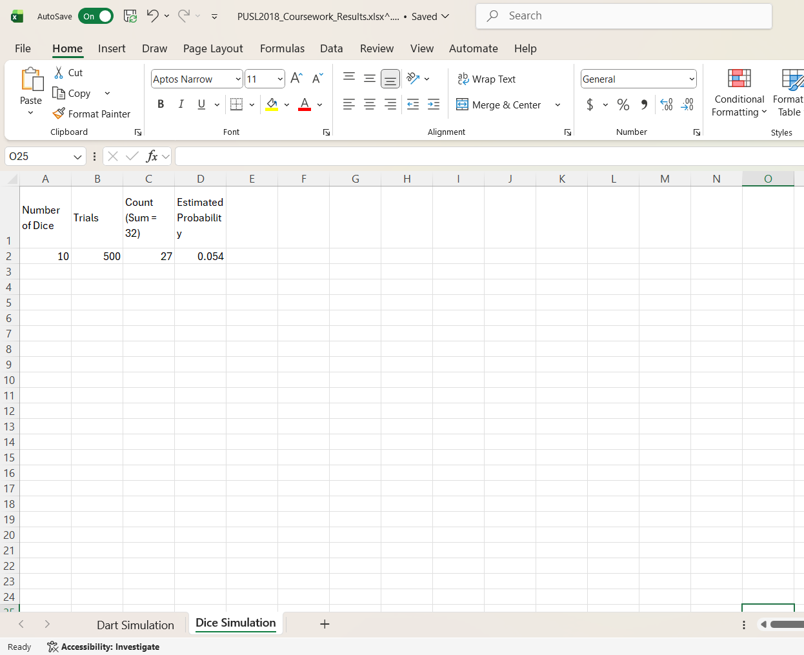
Discussion and Comparison
The highlights of the strengths of the Monte Carlo techniques arise from the comparison between the results obtained with an analytical approach and those derived by simulation. Indeed, while exact computation allows precise results, it becomes impractical for large or complex problems. Monte Carlo simulation effectively represents a very good alternative to obtain increasingly more accurate estimates, depending on the number of trials performed.
Overall, the results confirm that Monte Carlo methods are effective for both geometric probability estimation, such as π approximation, and discrete probability problems, like dice sum analysis, provided a sufficient number of trials is employed.

EXACT COMBINATORIAL VALUE
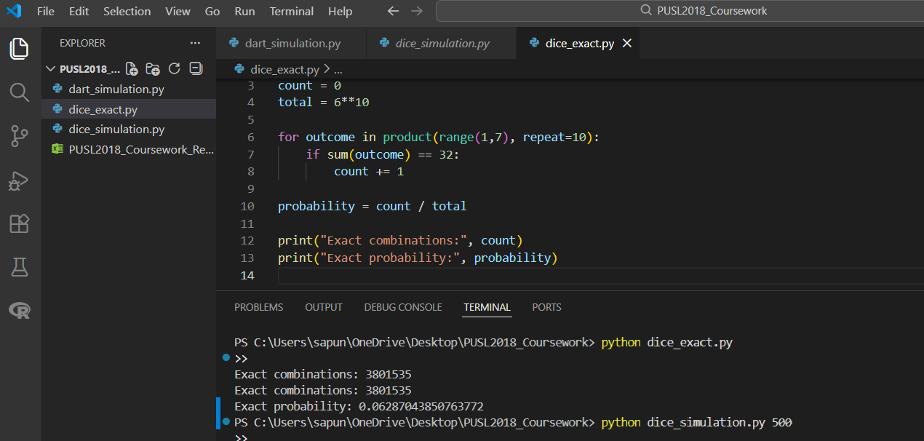
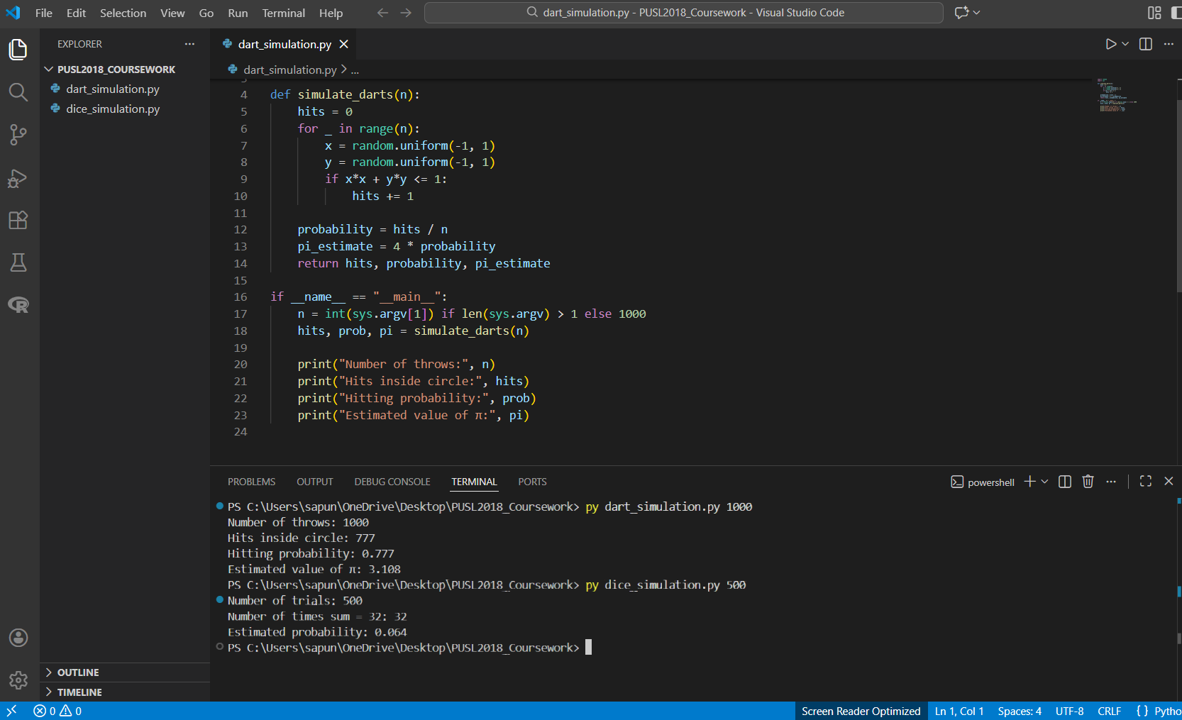

Appendix B : Codes and Files availability

Zipped Folder - ( PUSL2018_Coursework.zip )

GitHub Repository Link -
( https://github.com/IsiwaraKumarage8/PUSL2018_Coursework.git )
contains all Python files and Excel files for reproducibility.

