

**Machine Learning to Improve Microgrid Energy Management**

**ME420 Mechanical Engineering Individual Research Project**

A project report submitted to the

Department of Mechanical Engineering,

Faculty of Engineering,

University of Peradeniya,

Sri Lanka,

in partial fulfilment of the requirements for the degree

Bachelor of the Science of Engineering,

by

M.G.I.U. Karunarathne (E/17/156)

Peradeniya, 2023

**Machine Learning to Improve Microgrid Energy Management**

by

M.G.I.U. Karunarathne

Supervised by

Dr. Damayanthi Herath

Dr, Ubaya Higgoda

Dr. Lahiru Jayasooriya

# Declaration

I confirm that I have written this report without any external help and not using sources other than those I have listed in the report. I confirm also that this report or similar version of it has not been submitted to any other examination board and has not been previously accepted as part of an exam for a qualification. Each direct quotation or paraphrase of an author is clearly referenced.

Place, 28th Nov, 2023 ____________________________

M.G.I.U. Karunarathne

Name of the project supervisor/s:

Dr. Damayanthi Herath

# Summary

Microgrids are localized energy systems that operate independently or in conjunction with the main power grid, integrating various energy sources for reliable and resilient power supply. They can disconnect during outages, ensuring uninterrupted power to critical facilities and promoting sustainability through renewable energy integration. Microgrid energy demand refers to the electrical power needed to meet consumer needs, influenced by factors like time, weather, and habits. Accurate forecasting of energy demand is crucial for efficient microgrid operation, resource management, and optimization. Machine learning offers advantages over traditional methods in forecasting, handling complex relationships, adapting to changes, and providing scalability. This report aims to forecast microgrid energy demand using machine learning, evaluate model performance, and develop optimization technologies for enhanced microgrid operation. The project seeks to advance the application of machine learning in microgrid management.

# Acknowledgement

# Table of contents

Declaration ii

Summary iii

Acknowledgement iv

Table of contents v

List of Figures vii

List of Tables viii

List of Symbols ix

1 Introduction 10

1.1 Background of the problem 10

1.2 Aim of the project 11

1.3 Objectives 11

2 State of the art 12

2.1 Introduction 12

2.2 What is microgrid 12

2.3 Energy demand 13

2.4 Forecasting energy demand 13

2.5 Machine learning 14

2.6 Machine learning models used 15

2.7 Optimization of microgrid operation 16

3 Methodology 18

3.1 Data Collecting and Data Preprocessing 19

3.1.1 Demand charge related data set 19

3.1.2 Data understanding 20

3.1.3 Data preprocessing 26

3.2 Implementing CNN model 30

4 Data Evaluation & Optimization 31

5 Results and discussion 32

6 Summary 33

References 34

Appendix 36

# List of Figures

Figure 3.1: Data set of demand charge data 11

Figure 3.2: Overview of the data set 12

Figure 3.3: Histogram plot for Total Campus Load 12

Figure 3.4: Histogram plot for On Campus Generation 13

Figure 3.5: Histogram plot for SDG&E Import 13

Figure 3.6: Histogram plot for Adjusted Demand 13

Figure 3.7: Heat map for the data set 14

Figure 3.8: Time series plot for Total campus load 15

Figure 3.9: Time series plot for on campus generation 15

Figure 3.10: Time series plot for SDG&E import 15

Figure 3.11: Time series plot for Adjusted demand 16

Figure 3.12: Time series plot for 20 days 16

Figure 3.13: Box plot for the features 17

Figure 3.14: Statistic of the data set 17

Figure 3.15: Violine Plot for the training data set 20

# List of Tables

# List of Symbols

Latin symbols

|  |  |  |
| --- | --- | --- |
| *A* | cross-sectional area | m2 |
| *a* | thermal diffusivity | m2s-1 |
| *B* | rotation constant | m-1 |
| *c* | speed of light *in vacuo* | ms-1 |

Greek symbols

|  |  |  |
| --- | --- | --- |
| ** | thermal conductivity | Wm-1K-1 |
| ** | lag time | s |
| **C | correlation time | s |

Abbreviations

|  |  |
| --- | --- |
| DLS | dynamic light scattering |
| MD | molecular dynamics |

Indices

|  |  |
| --- | --- |
| c | related to concentration fluctuations |
| i | initial state |
| t | related to temperature fluctuations |

# Introduction

## Background of the problem

Microgrids are localized energy systems that integrate various energy sources and operate independently or in conjunction with the main power grid. They provide reliable and resilient power supply to specific areas, incorporating renewable energy technologies, energy storage systems, and conventional generators. Microgrids can disconnect from the main grid during outages and emergencies, ensuring uninterrupted power to critical facilities. They promote sustainability by integrating renewable energy, reducing carbon emissions, and optimizing energy generation and consumption.

When considering Microgrid energy demand it refers to refers to the amount of electrical power required by a microgrid to meet the energy needs of its consumers within a specific time period. It represents the total electricity consumption of the connected loads, including residential, commercial, or industrial facilities related to microgrid. Also, the demand for energy from microgrids might change depending on things like the time of day, the day of the week, seasonal fluctuations, weather, and consumer habits.

If we can accurately forecast the energy demand of microgrid it will be more effective for efficient operation of microgrid, when managing resource and in optimizing microgrid system. Also, it will be helpful in ensuring reliable power supply, manage load balancing inside the microgrid and optimize the generating and storage resources. So, understanding and predicting energy demand will help in using resources wisely, choosing demand response tactics and in optimizing energy usage and minimize cost.

In forecasting energy demand machine learning have advantage than traditional methods as they rely on pre-defined rules and assumptions. Machine learning has ability to handle complex relationships, adapt to changing conditions and leverage diverse data source. Also, it offers data-driven approach and scalability for accurate prediction. Machine learning models continuously learn and improve over time, ensuring accurate and reliable forecasts in dynamic microgrid environments. So, machine learning is providing more advance and effective approach to forecasting energy demand in microgrids.

This report aim is to forecast energy demand of microgrid and use optimization technologies to optimize microgrid operation. The project objectives include developing forecast models using machine learning techniques, evaluating the performance of these models on microgrid data, and developing a simple optimization model for microgrid operation according to that data. By achieving these objectives, the project seeks to enhance the understanding and application of machine learning in microgrids.

## Aim of the project

The aim of the project is to forecast energy demand using machine learning techniques and optimize microgrid operation. We aim to improve accuracy of energy demand forecasts and improve the performance and efficiency of microgrid.

## Objectives

1. Implement a machine learning-based tool for forecasting microgrid energy demand. This will involve training ML models on historical data to predict future energy demand.
2. Identify the most effective algorithm for forecasting energy demand in the microgrid. In this most effective ML algorithm will be find out using trained models and outputs.
3. Deploying machine learning algorithms in optimizing the energy generation of microgrids.

## Proposed methodology

Proposed methodology to forecast energy demand using machine learning is explained briefly as following. Here it is divided mainly to four parts and their basic tasks are explained in point form, this will be discussed in detail in following chapters.

* **Data Collection and Data Preprocessing:**

Select a relevant dataset that includes historical energy demand.

Using the proper techniques, prepare the data to manage any missing or incorrect data. Techniques like data cleansing, standardization, and imputation may be used in this.

* **Forecast Model Selection and Model Training:**

Using historical data, choose a suitable prediction model or algorithm to forecast the demand for energy.

Utilize the historical dataset to train the chosen model and discover the underlying trends and connection between the input variables and energy demand

* **Model Evaluation**

Analyze the trained forecast model's performance and accuracy. This entails evaluating metrics like mean absolute error, root mean square error, and correlation coefficients while contrasting the expected values with the actual data.

To ensure reliability and generalizability of forecast model it will be tested on unseen data.

* **Optimization and Integration:**

Develop a suitable simple optimization model for microgrid operation. This model will consider various factors such as operating cost, emission and other technical constraints to determine the optimal energy demand.

Apply the forecasted data to optimize the microgrid operation. By incorporating the forecasted energy demand, the optimization model will dynamically adjust the energy supply and demand to ensure efficient and cost-effective operation.

# State of the art

## Introduction

In past few years carbon emission and energy demand have been increased. This happens due to increase in energy-consuming equipment and population. So, due to growing concerns regarding the effects of fossil fuel emissions, the importance of renewable energy resources has grown markedly in recent years.[1] . Also, the power management is essential in industrial and local consumers because it is crucial for energy conservation, cost savings, environmental protection, technological advancements, and overall user satisfaction.

The industry standard for power management is a centralized power grid. Which is largely dependent on fossil fuels. There are two major problems in Centralized power grids. First, the rigid, inflexible centralized grid is unable to accommodate the unpredictable nature of current distributed energy resources (DERs). Second, energy is often lost when travelling large distances between energy generation and consumption locations [2] ,[1]. To overcome these problems Distributed, or on-site generation, has been proposed as a next generation smart grid solution. This method has advantages than other methods as its ability to generate energy locally, also it can reduce the energy lost in transmission, and due to its small scale and isolation it has superior reliability.[1] [3] .So, under these circumstances, small-scale grids operating in small areas as fully functioning energy systems have become an interesting solution.[4]. which is known as microgrids. Microgrids promote sustainability by integrating renewable energy, reducing carbon emissions, and optimizing energy generation and consumption. In following sections look more about microgrids in details.

## What is microgrid

Microgrids are localized energy systems that integrate various energy sources. A microgrid is a small-scale grid. However, it is fully functional, operating in a limited geographical area; it can operate independently or be connected to a larger grid [4]. Microgrids are mostly used in remote or off grid areas where it is difficult to connect to main grid. Now a days with the increasing of carbon emission microgrids have been as a solution to that. So now there are microgrids where they can operate independently or connected to main grid. Microgrids are using distributed energy resources (DERs) where it includes renewable energy sources. Such as wind turbines, solar panels, combine heat and power plants and energy storage systems like batteries, these energy resources can be categorized as adjustable or non-adjustable and storage systems The microgrid is the integration of several renewable energy sources with adjustable or nonadjustable loads and storage systems [5]. In the previous 10 years, a lot of research has come out on microgrids as a potential source of energy in the near future [6]. As mentioned in above this localized on-site generation method, is implemented due to their improved reliability and the ease of inclusion of renewable energy generation

## Energy demand

Energy strategy is extremely important for developing countries. The energy demand of a microgrid can vary depending on a number of factors, including the size of the microgrid, the type of loads it serves, and the availability of renewable energy sources. In general, microgrids are designed to meet the peak load demand when they are connected to loads.

This peak load demand is the maximum electricity that a microgrid must deliver at any one moment. A fundamental microgrid system’s load demand often fluctuates hourly [6]. So, this demand fluctuates depending on the time of day, the season, and the weather. For example, peak load demand of microgrid is higher in a hot climate. Energy demand is important in determining microgrids generating cost. The two most important factors that determine a microgrid system’s generating cost are load demand and energy market pricing [6].

So, to ensure that a microgrid can meet its peak load demand, it is important to accurately forecast the demand. This can be done by using historical data, as well as weather forecasts and other factors

## Forecasting energy demand

Energy demand forecasting is the process of predicting future energy consumption based on historical data and other factors. Energy demand forecasting is one of the most important tools that decision makers use (Ediger and Akar, 2007) [7]. As it can help to ensure that there is enough available to meet demand, and that energy resources are used efficiently. There are different methods that can be used to forecast energy demand. Techniques used in energy demand forecasting studies are mainly composed of BoxJenkins models, regression models, econometric models and neural networks (Jebaraj and Iniyan, 2006) [7].

In the studies of forecasting electric energy demand, there are many methods used in the literature including autoregressive integrated moving average (ARIMA), artificial neural networks ANN, time series methods, support vector machines and fuzzy logic method [7]. In time series analysis it uses historical data to identify trends and patterns in energy consumption. These trends can then be used to forecast future demand.

In 1960 Turkey’s Planning Organization realized a demand forecast study based on simple regression. Then they continue studies on energy demand. These early forecasts consistently predicted much higher values than the consumptions that actually realized. also, Short-term energy supply and demand forecasting are necessary to make informed and reliable decisions for distributed energy systems [8]. However, although there are many forecasting methods which take into account the advances in information, metering and control technologies in order to address the challenges of forecasting problems [9] ,[10].

Here are some challenges of energy demand forecasting. Energy demand is often volatile and difficult to predict. This is due to a number of factors, such as weather, economic conditions, and technological change. There is a lack of reliable data. This is especially true for long-term forecasting. Also, the models used for forecasting are often complex and difficult to understand. This can make it difficult to interpret the results of the forecast. Energy demand forecasting is a crucial instrument that may assist to increase the effectiveness and sustainability of energy systems despite these challenges. As the world becomes more interconnected and energy markets become more volatile, the need for accurate and reliable energy demand forecasts will only increase. Machine learning (ML) and deep learning (DL) based models are promising solutions for predicting consumers’ demands and energy generations from RESs [11]. let’s look forward to ML and ML models used in forecasting energy demand.

## Machine learning

Machine learning (ML) is a type of artificial intelligence (AI) that allows computers to learn without being explicitly programmed. In ML algorithms that use available data for the training of a model, where the underlying system is more or less treated as a black box, are usually grouped under the term machine learning. Arthur Samuel was the one who coined the term ‘’Machine Learning’’ in 1959, defining it as “the ability to learn without being explicitly programmed.” Machine Learning, at its most basic form, is the practice of using algorithms to parse data, learn from them, and then make a determination or prediction about something in the world [9].

Machine learning tasks may be classified into three broad categories, namely supervised, unsupervised and semi-supervised. Another categorization of machine learning tasks is by the desired output. If the output of the model is a class, then it is a classification problem, if it is a number then it is a regression problem and if it is a set of input groups, it’s a clustering problem [9].

Machine learning techniques have been proven useful for short-term electricity load forecasting. Especially in microgrids where large variety of data should be included in the energy consumption prognosis. These Novel techniques and models are taking advantage of the advances in artificial intelligence algorithms. Where they allow for faster convergence, manipulating big data sets and solving more complex problems [9].

There are some challenges of using ML for energy demand forecasting. Such as it requires a large amount of data, it can be computationally expensive to train ML models and the results of ML models can be difficult to interpret. However, ML is a potential approach for predicting energy demand. As the technology continues to develop, it is likely to become even more effective for forecasting energy demand.

## Machine learning models used

Machine Learning has been shown to be effective for forecasting energy demand. According to researches it shows that ML was able to produce more accurate forecasts than traditional methods. As Electrical load forecasting algorithms are needed for prediction of the energy demand for the day ahead, a few weeks up to a year or a period of over a year [9]. so, the methods that are using have to be more accurate and efficient. The choice of ML model will depend on the specific needs of the energy planner or decision-maker. For example, if the planner is interested in forecasting short-term demand, then a SVR algorithm may be the best option. However, if the planner is interested in forecasting long-term demand, then an ANN may be more appropriate

In literature it has used many ML methods for forecasting energy demand. Enea Mele (2019) have given a review about short-term forecasting such as Support Vector Machines (SVM), k-Nearest Neighbors (kNN), Random Forest and Artificial Neural Networks (ANN) and compare their performance efficiency, capabilities and limitations.[9].

In [1] it shows that there have been proposed Multiple deep learning techniques in past. These include artificial neural networks (ANN), convolutional neural networks (CNN), recurrent neural networks (RNN), Long short-term memory networks (LSTM) and bidirectional long short-term memory networks (BLSTM).

Maciej Slowik and Wieslaw Urban has developed a universal forecasting tool for energy consumption by end-use consumers. This model allows the end-users to be equipped with an energy demand prediction, enabling them to participate more effectively in the smart grid energy market. A single, long short-term memory (LSTM)-layer-based artificial neural network model for short-term energy demand prediction was developed.[4].

Among these methods deep learning Deep Learning models are a good alternative to learn patterns from customer data and then forecast demand for different forecasting horizons. deep Learning uses multiple layers of neurons composed of complex structures to model high-level data abstractions [12]. most commonly used deep learning-based methods for energy management and power forecasting, namely, artificial neural networks (ANN), deep neural networks (DNN), convolutional neural networks (CNN), and recurrent neural networks (RNN) [13].

Another paper [14] considers a load forecasting problem in residential areas as well as in commercial buildings. A deep RNN is employed for medium to long term energy consumption forecasting. Simulation results show the effectiveness of the proposed deep RNN based model over MLP for load demand prediction of commercial buildings.

In research work [15] also adapts DL based methods for load forecasting. In there a hybrid forecasting method is developed by combining the best features of CNN and K-means clustering. The results show that their hybrid CNN–K-means forecasting algorithm has higher accuracy.

So, there are more research in forecasting energy demand of microgrid. And this existing literature suggests that machine learning techniques have significant potential to improve the accuracy of energy demand forecasting [10], [16]. Further research is needed to develop and evaluate advanced machine learning algorithms for energy demand forecasting, and to investigate their potential applications in microgrid management and optimization.

## Optimization of microgrid operation

Microgrids typically include a mix of renewable energy sources, such as solar and wind power, and conventional generation sources. The effective management and optimization of microgrid operation is essential for ensuring reliable and cost-effective power supply [17].

There are some different optimization techniques that can be used to optimize microgrid operations. Such as Linear programming which can be used to optimize the operation of microgrids by minimizing the cost of electricity generation or by maximizing the reliability of the system. Also mixed integer programming can be used in microgrid operations by considering the discrete nature of some of the decisions, and heuristic optimization can be used find quick solutions that are close to optimal.

By optimizing microgrid operations we can reduce the cost. Where forecasting data can be used in here. Also using that data, it can used to improve the reliability of the microgrid. This can be done by ensuring that there is always enough generation capacity to meet demand and by ensuring that the system is resilient to disruptions. There are some challenges that could occur when optimizing microgrid operations. The optimization problems that arise in microgrid operation can be complex. This is because the system is typically nonlinear and has a large number of variables. Also, the operation of a microgrid is subject to uncertainty, such as the amount of renewable energy that is available and the demand for electricity. This uncertainty can make it difficult to optimize the system. And the availability of data can be a challenge for microgrid optimization. This is because microgrids are relatively new and there is not a lot of historical data available. However, optimizing microgrid operation is a valuable tool that can help to improve the efficiency, reliability, and sustainability of these systems.

# Methodology

In methodology it focusses on major three parts they are data collecting and preprocessing, implementing CNN model then optimize the implemented model such as hyperparameter tuning and third part is deploying forecasted results in optimization of microgrids. Based on these three parts methodologies is explained bellow.

## Data Collecting and Data Preprocessing

Data set was selected from open-source available data set as Open-source multi-year power generation, consumption, and storage data in a microgrid.[18] In this data set it includes comprehensive power dataset of part of the University of California, San Diego microgrid. This microgrid contains several distributed energy resources (DERs). Such as solar power plant, electric vehicles, electric and thermal storage. In this data set most of them contain 15-min average of real and reactive power. Overall, UC San Diego self-generate about 85% of its electricity consumptions and import the remaining 15% from the local utilities.[18] to record the data they have placed meters on 70% of campus generators, storage systems, grid import and building systems. As mentioned, the average of the preceding 15 min is archived as single data point. All available data are starting from 1 January, 2015 to 29 February, 2020. Building loads on a university campus are unique due to the academic year. Depending on the building occupancy, loads can be substantially lower during the summer break, the winter holidays, and spring break.[18]

Data set contains of real and reactive power consumption for two building categories they are building with EV charging and building without EV charging, Trade Street Wearhouse microgrid, EV charging station, Solar PV generation, Campus thermal load and storage, Demand charge related data and battery energy storage system (BESS). In this research project it focusses on energy demand forecasting so it only considers about demand charge related data set.

### Demand charge related data set

This demand charge data set includes data sets of Total Campus Load, On Campus Generation, SDG&E Import and Adjusted Demand. This data set is used to forecast energy demand of microgrid. This data is given in kW and they can be used to calculate demand charges ($/kW).

Total Campus Load provide a historic view of electric consumption, encompassing both external (imported) and internal (On-campus generation) sources. This data can be crucial for understanding the overall energy demand patterns of the entire microgrid. On Campus Generation data is used to compute the actual demand on the campus. It takes into account the electricity generated on-site by the campus's own power generation sources, such as solar panels or other generators. SDG&E import data represents the amount of electricity the campus imports from the utility company, San Diego Gas & Electric (SDG&E), measured in kilowatts (kW). Adjusted demand, which considers on-campus generation, is particularly useful for forecasting non-coincident demand charges. Analyzing the historical adjusted demand data helps in understanding how on-campus generation affects the overall demand patterns.

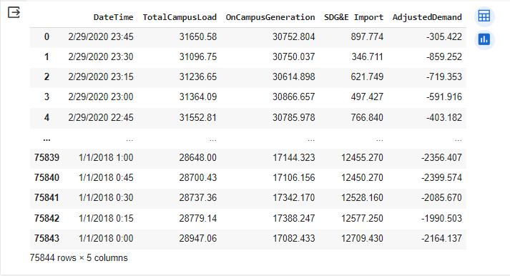As this data can be used to calculate demand charge, they are fees based on the highest power consumption levels during specific time periods (non-coincident or peak periods). To calculate these charges, you need data on real power imports, on-campus generation, and adjusted demand to account for your on-site generation. Accurate tracking and management of these factors can help control and reduce demand charges, which can be a significant portion of a commercial or industrial electricity bill. According to this by forecasting energy demand they can also be used to forecast demand charge. Following figure shows the raw data of demand charge data set

Figure 3.1: Data set of demand charge data

Next have to identify the patterns of this data set and how it varies. So, to do that we need to understand the data set.

### Data understanding

Basic data understanding is must to identify patterns of the data set. To achieve that in this research project have done an EDA on the data set. EDA stands for Exploratory Data Analysis. It is an approach to analyzing and visualizing data sets to summarize their main characteristics, often with the help of statistical graphics and other data visualization methods. The primary goals of EDA include understanding the structure of the data, uncovering patterns, identifying relationships between variables, and identifying any potential outliers or anomalies. EDA is done using pandas profiling. It is a Python library that generates an interactive HTML report with a variety of visualizations and statistical information about a DataFrame. EDA results are 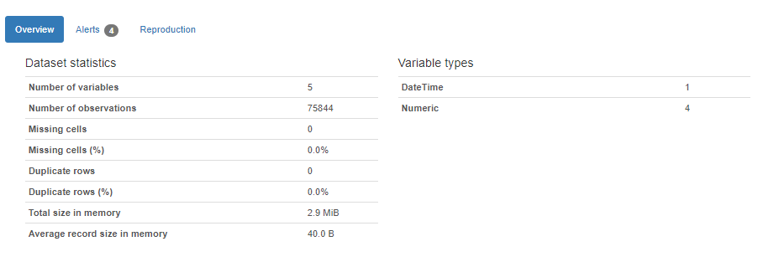explained bellow.

Figure 3.2: Overview of the data set

According to this it can see that there are no missing values and there are no duplicated values in the data set. It gives alerts about correlation of the each of variables.

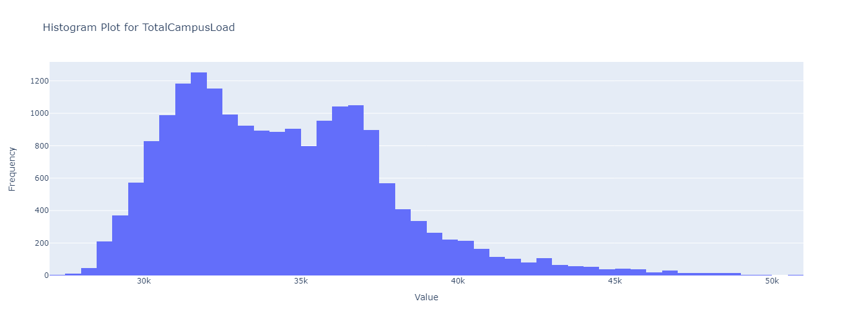Histogram plots provides the visual distribution of a numerical variable. by plotting the histogram plots we can get basic understanding of distribution shape, central tendency, spread and dispersion, outliers etc. figure 3.3 – 3.6 shows histogram plot for each feature.

Figure 3.3: Histogram plot for Total Campus Load

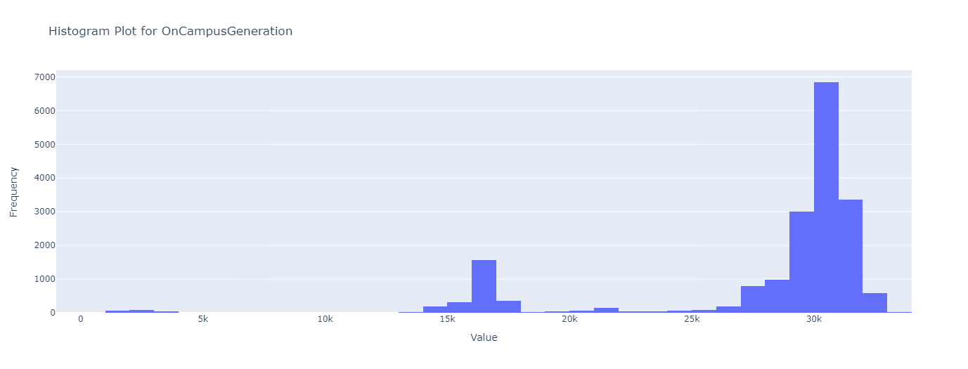Figure 3.4: Histogram plot for On Campus Generation

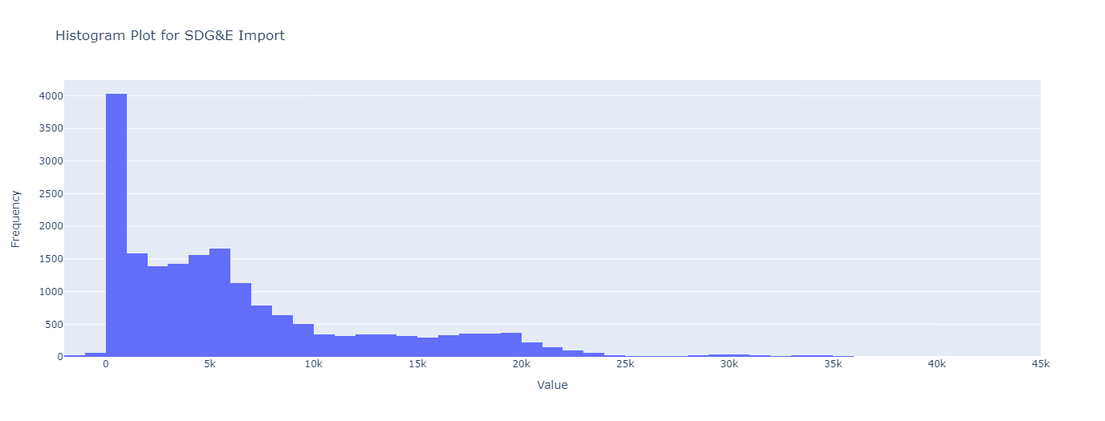

Figure 3.5: Histogram plot for SDG&E Import

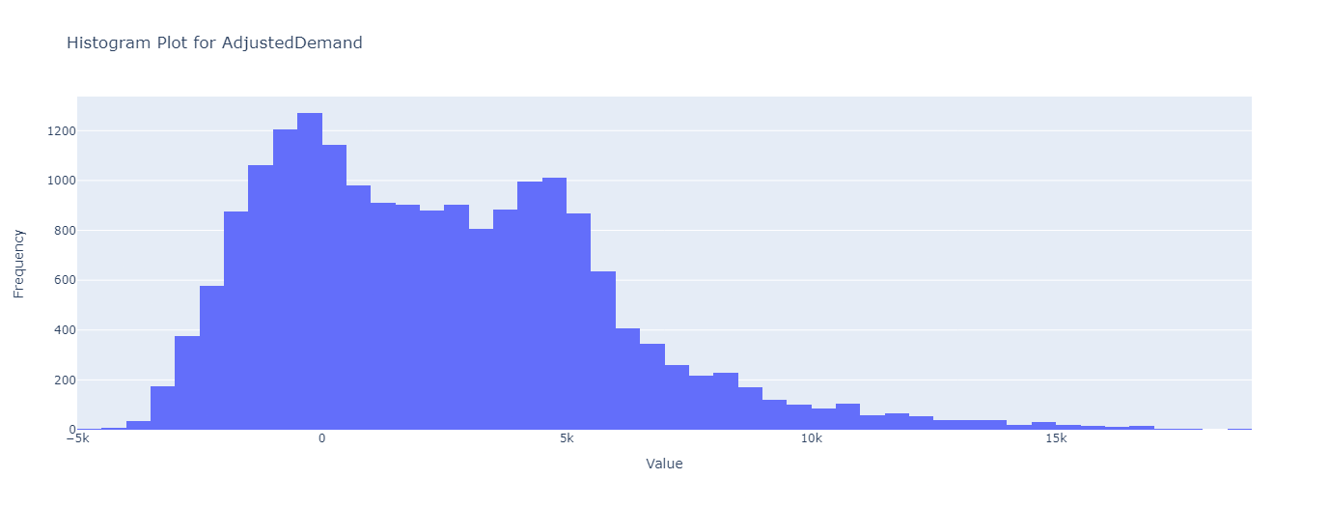

Figure 3.6: Histogram plot for Adjusted Demand

Each plot visualizes the distribution of data set, range of the data set, what are the outliers, spread of it etc. having this basic idea about data set is essential.

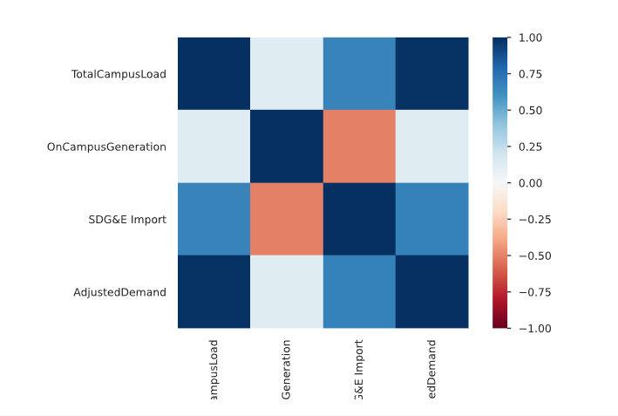Also, it is good to know about the correlation between each of the features, this will help in understanding the dependency of each of them. This correlation can be visualized through a heat map. Heat map corresponds to demand charge data set is shown in figure 3.7.

Figure 3.7: Heat map for the data set

According to this it shows that there is high correlation between Total campus load and Adjusted demand. Then we can see the variation of the data set according to the time. By potting we can identify if there are any pattern with respect to date time or season. Usually for time series there is seasonality patterns. Following figures shows the data variations according to time.

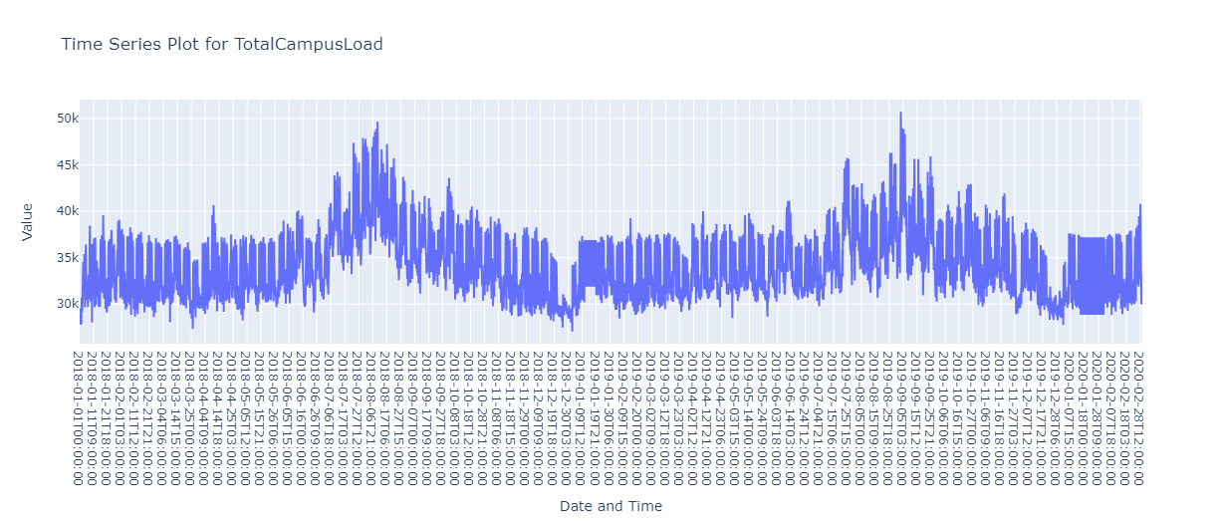

Figure 3.8: Time series plot for Total campus load

Figure 3.9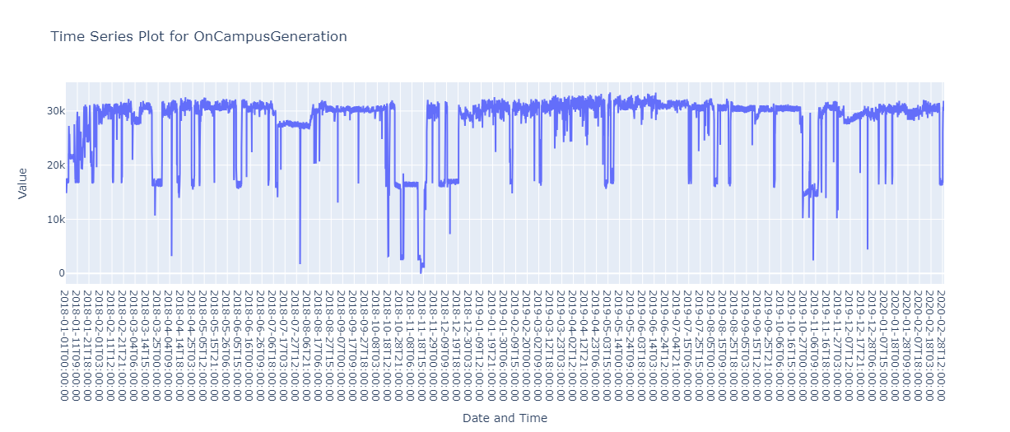: Time series plot for on campus generation

Figure 3.10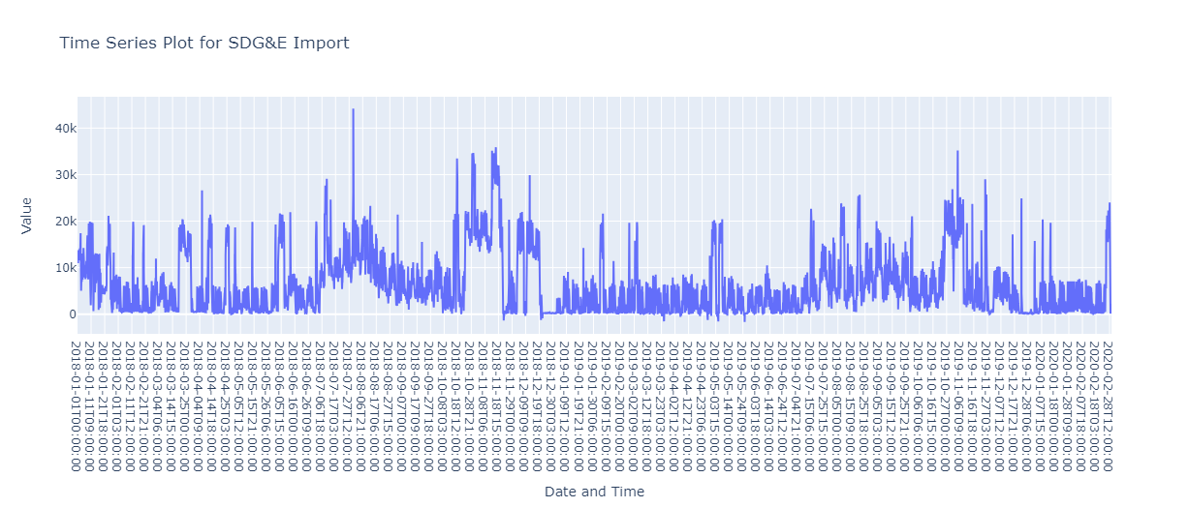: Time series plot for SDG&E import

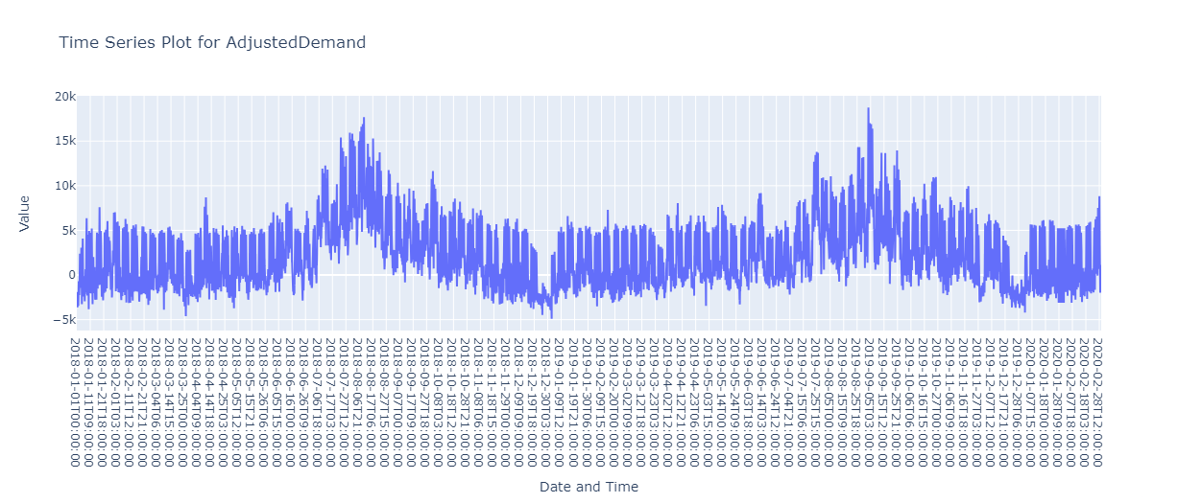

Figure 3.11: Time series plot for Adjusted demand

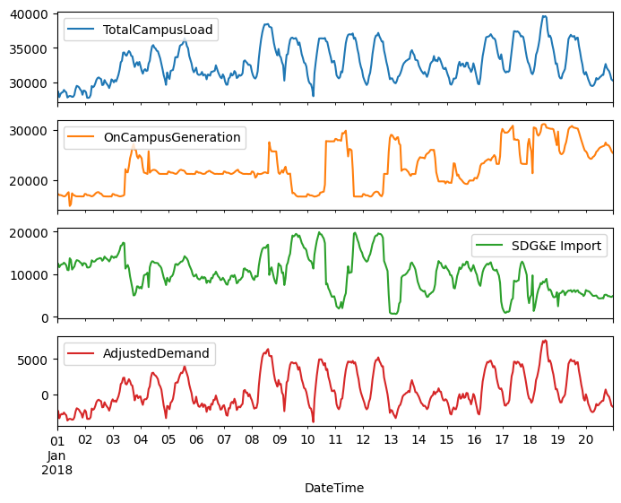Here we can see some seasonal patterns in this plot. According to the date and weeks also it shows some pattern.

Figure 3.12: Time series plot for 20 days

Figure 3.12 shows time plot for 20 days. In this plot it can see there is a pattern. For the day time demand values are higher and they get reduce in other time. Also, it indicates that there is a peak time for a day. Box plot shows graphical representation of the distribution of a dataset. Following figure shows how box plot representation for the initial dataset.

Figure 3.13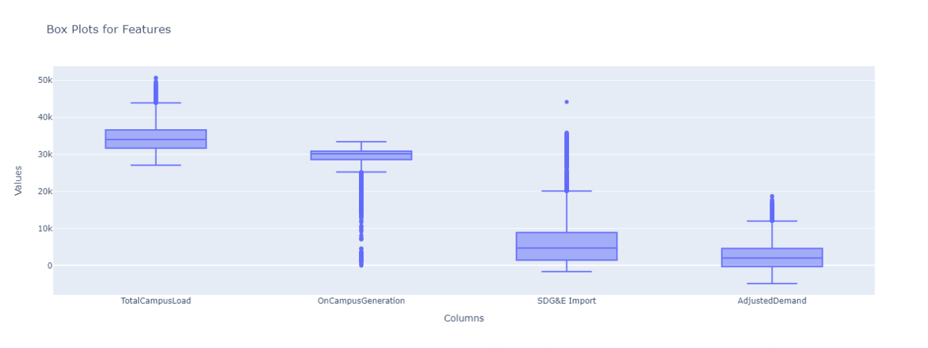: Box plot for the features

Also, it is good to known statistic of the data set. This can obtain from a simple python code. Output is shown in following figure.

Figure 3.14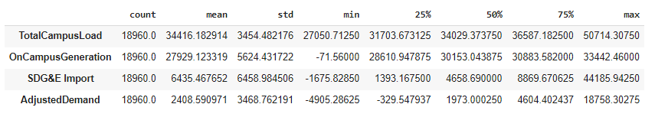: Statistic of the data set

From the data understanding we can identify what are the patterns in data set is there any seasonal patterns on that, variation of the data set and range of the data set whether there is any outlier in the data set. Then before feeding this to model, we have to preprocess the data. In next topic talk about data preprocessing.

### Data preprocessing

This part is also combined with data understanding part. Initially data set was rearrange starting from the oldest date to newest date. it was done in google colabotary. In the research project google colabotory is used as note book.

This data set was taken as 15 min time intervals. To forecast day ahead data it is good to have hourly data. So, using this 15 min time interval data we implemented hourly data. We used mean values of data within one hour to obtain hourly data. Then NaN values were removed. All these initial steps were taken before doing the data understanding part.

Then date time is converted to UNIX timestamp. As it provides a standardized way to represent time, making it easy to incorporate chronological information into your machine learning models. Then in data preparation we use sine and cosine transforms to clear "Time of day" and "Time of year" signals. This will allow to identify more seasonal patterns.

According to figure 3.13 box plot and figure 3.14 statistics of the data set indicates that basic statistics are varies from each feature so it is good to normalize the data set. This will reduce the computational power required for the model to process and it will reduce the biasedness of the outputs. In this research project we do standardization. So, to do that this data should be split to training, validation and testing sets.

This is a very critical step in modeling machine leaning model because they are essential for model development, hyperparameter tuning, and assessing generalization performance. It helps ensure that the model is not only memorizing the training data but also learning patterns that can be applied to new, unseen data. When explaining briefly about them,

**Training Set:**

The training set is used to train the model. The model learns patterns and relationships within the data, adjusting its parameters to minimize the difference between predicted and actual outcomes. A larger training set generally allows the model to learn more complex patterns.

**Validation Set:**

The validation set is used to fine-tune the model's hyperparameters and to assess its performance during training. It acts as a sort of "sandbox" where you can experiment with different configurations without contaminating the test set. This helps in preventing overfitting, where a model performs well on the training data but poorly on new, unseen data.

**Testing Set:**

The testing set is used to evaluate the final performance of the model after training and validation. This set simulates real-world scenarios where the model encounters completely new data. It provides an unbiased evaluation of the model's ability to generalize.

**Preventing Overfitting:**

Overfitting occurs when a model learns the training data too well, including its noise and outliers. By having a separate validation set, you can monitor the model's performance on unseen data during training and stop training when the model starts to overfit.

**Hyperparameter Tuning:**

Machine learning models often have hyperparameters (parameters that are not learned from the data but are set before training). The validation set helps in tuning these hyperparameters by providing a separate dataset for evaluating different configurations.

**Model Selection:**

After training multiple models with different architectures or algorithms, you can use the validation set to compare their performance and select the best-performing model for further evaluation on the test set.

**Generalization Evaluation:**

The ultimate goal of a machine learning model is to generalize well to new, unseen data. The testing set provides a final assessment of how well the model is likely to perform in real-world scenarios.

These overfittings, Hyperparameter tuning, Model selection and Generalization evaluation are done after implementing and running the model. We will talk more about them in next chapters.

Generally, this training, validation and testing sets are divided as following percentages. Training set 70% of data, validation set 20% of data and rest 10% to testing set. After splitting the dataset, they were normalized as following.

#mean and standard deviation should only be computed using the training data so that the models have no access to the values in the validation and test sets.

train_mean = train_df.mean()

train_std = train_df.std()

train_df = (train_df - train_mean) / train_std

val_df = (val_df - train_mean) / train_std

test_df = (test_df - train_mean) / train_std

In this normalization method it uses train mean and train standard deviation for the operation, so that the model has no access to the values in the validation and test data set.

After normalizing the data set it varies between the same region for all the features. This is good for computing the model. Following Figure 3.15 shows the violine plot for training data set

Figure 3.15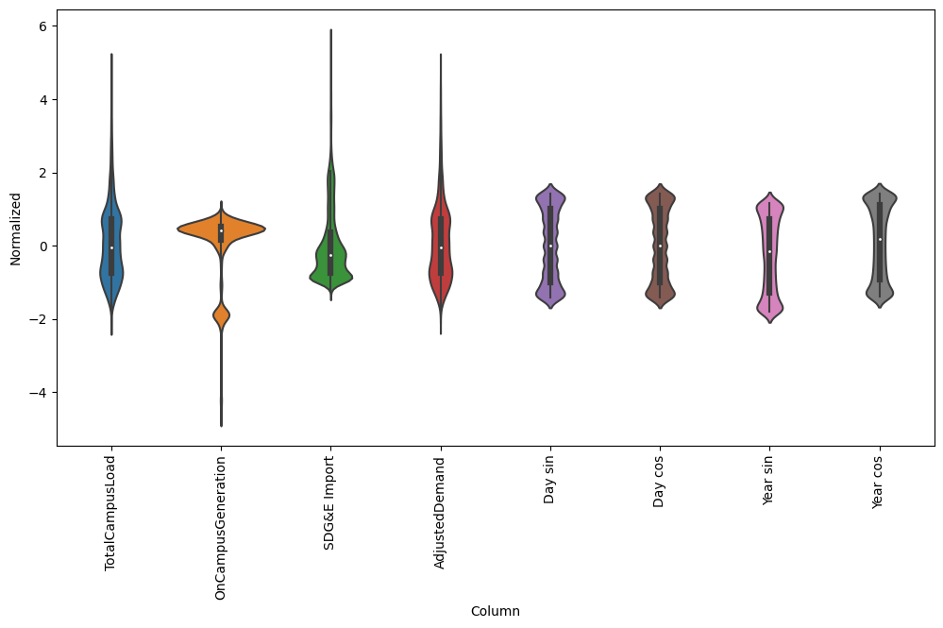: Violine Plot for the training data set

This violin plot show that numerical values of all the features. According to this their range of the features remain in between same values. From the width of the violin plot it represent the data density of that specific point. As well as using this violin plot, we can identify mediant, possible outliers and skewness of the data distribution. Doing data preprocessing critical step, it varies from the data set which is using. Using this properly processed data we can build more accurate and robust machine learning model. In the next topic going to talk about implementing of machine learning model.

## Implementing CNN model

Implementing CNN model is a major task in this research project before going to implementation part lets look at what is CNN model and how it can be used in forecasting energy demand.

A CNN, or Convolutional Neural Network, is a type of deep neural network designed for tasks involving visual data such as images and videos. They automatically learn hierarchical features from the data, starting from simple features at lower layers (e.g., edges and textures) to more complex features at higher layers (e.g., object parts and shapes). This hierarchical feature learning makes CNNs well-suited for image-related tasks, where the spatial relationships among pixels play a crucial role.

CNN model is mainly used in image processing such as tasks involve in grid-like data. But in this research project we are using time series data set, so we are going to implement a 1-D convolutional neural network model for the forecasting process.

### 1-D CNN model

The one-dimensional Convolutional Neural Network (1D CNN) is a specialized neural network architecture uniquely designed for handling sequences of one-dimensional data. This tailored design is particularly advantageous in tasks where understanding sequential information is crucial.

Many real-world applications, data comes in the form of sequences, such as time series data, audio signals, or natural language text. These sequences have an inherent order, and the relationships between elements in the sequence are often vital for understanding and making predictions. The 1D CNN is well-suit ed for capturing and learning patterns within such sequential data.

In the context of time series data, for example, each data point represents a value at a specific point in time. By applying convolutional operations to local regions of the sequence, the 1D CNN can detect patterns and features that may be indicative of temporal relationships or trends. The ability to capture dependencies within the sequence makes the 1D CNN a powerful tool for tasks like time series forecasting, anomaly detection, and signal processing.

Using a 1D CNN has the benefit of not requiring human feature engineering because it can automatically extract pertinent features from the sequential input. As they move over the input sequence, the convolutional layers function as local filters that catch up patterns at various sizes. Pooling layers that come after aid in lowering spatial dimensions, focusing on the most crucial elements, and enhancing computing efficiency.

### Model architecture

In this section we are going to talk about how the model was implemented and what are the specifications having in the model. Initially we have to do data windowing.

Data windowing, refers to the practice of dividing a continuous sequence of data into smaller, overlapping or non-overlapping segments called windows. Each window captures a subset of the original sequence, and this technique is commonly employed for various purposes, such as time series analysis, feature extraction, analysis, and model training. In this research project this data windowing is used in time series data forecasting.

When considering time series data forecasting it breaks the time series into windows allows for the creation of training samples. Each window can be treated as a data point, with the goal of predicting the subsequent values. This is useful approach when using CNNs.

For data windowing, WindowGenerator class was implemented. In this the main features of the input windows are.

* The width (number of time steps) of the input and label windows.
* The time offset between them.
* Which features are used as inputs, labels, or both.

This WindowGenerator function we can be used in

* Single-output, and multi-output predictions.
* Single-time-step and multi-time-step predictions.

As we are forecasting day ahead data, we are using multi output and multi time step predictions.so this helps in organizing and generating windows of data for training and evaluating time series forecasting models.

Then split_window function was created to convert given consecutive inputs to a window of inputs and a window of labels. It separate generated windows to labels and inputs. As this project is doing day ahead data forecasting we have to create window of 48, in that window there are 24 inpluts and 24 labels. So we have been created multi step window model as multi_window.

#create a window for multy step models

OUT_STEPS = 24

multi_window = WindowGenerator(input_width=24,

                               label_width=OUT_STEPS,

                               shift=OUT_STEPS)

this created window can be shown as follows.

Total window size: 48

Input indices: [ 0 1 2 3 4 5 6 7 8 9 10 11 12 13 14 15 16 17 18 19 20 21 22 23]

Label indices: [24 25 26 27 28 29 30 31 32 33 34 35 36 37 38 39 40 41 42 43 44 45 46 47]

Label column name(s): None

As mentioned above there are total number of 48 windows with 24 inputs and 24 labels. This label means it represent actual output data points. So using the input indices

# Data Evaluation & Optimization

# Results and discussion

# Conclusion

# References

[1] A. Xu, “Pecan: A Novel Approach to Energy Supply and Demand Forecasting in a Photovoltaic Microgrid,” *CJSJ*, [Online]. Available: https://scholar.google.com/scholar?hl=en&as_sdt=0%2C5&q=Pecan%3A+A+Novel+Approach+to+Energy+Supply+and+Demand+Forecasting+in+a+Photovoltaic+Microgrid&btnG=

[2] J. Silvente, G. M. Kopanos, E. N. Pistikopoulos, and A. Espuña, “A rolling horizon optimization framework for the simultaneous energy supply and demand planning in microgrids,” *Applied Energy*, vol. 155, pp. 485–501, Oct. 2015, doi: 10.1016/j.apenergy.2015.05.090.

[3] E. Mengelkamp, J. Gärttner, K. Rock, S. Kessler, L. Orsini, and C. Weinhardt, “Designing microgrid energy markets,” *Applied Energy*, vol. 210, pp. 870–880, Jan. 2018, doi: 10.1016/j.apenergy.2017.06.054.

[4] M. Slowik and W. Urban, “Machine Learning Short-Term Energy Consumption Forecasting for Microgrids in a Manufacturing Plant,” *Energies*, vol. 15, no. 9, p. 3382, May 2022, doi: 10.3390/en15093382.

[5] S. N. V. B. Rao *et al.*, “Day-Ahead Load Demand Forecasting in Urban Community Cluster Microgrids Using Machine Learning Methods,” *Energies*, vol. 15, no. 17, p. 6124, Aug. 2022, doi: 10.3390/en15176124.

[6] B. Dey, S. Misra, and F. P. Garcia Marquez, “Microgrid system energy management with demand response program for clean and economical operation,” *Applied Energy*, vol. 334, p. 120717, Mar. 2023, doi: 10.1016/j.apenergy.2023.120717.

[7] G. Oğcu, O. F. Demirel, and S. Zaim, “Forecasting Electricity Consumption with Neural Networks and Support Vector Regression,” *Procedia - Social and Behavioral Sciences*, vol. 58, pp. 1576–1585, Oct. 2012, doi: 10.1016/j.sbspro.2012.09.1144.

[8] F. Ünal, A. Almalaq, and S. Ekici, “A Novel Load Forecasting Approach Based on Smart Meter Data Using Advance Preprocessing and Hybrid Deep Learning,” *Applied Sciences*, vol. 11, no. 6, p. 2742, Mar. 2021, doi: 10.3390/app11062742.

[9] E. Mele, “A Review of Machine Learning Algorithms Used for Load Forecasting at Microgrid Level,” in *Proceedings of the International Scientific Conference - Sinteza 2019*, Novi Sad, Serbia: Singidunum University, 2019, pp. 452–458. doi: 10.15308/Sinteza-2019-452-458.

[10] M. S. Khayaty, A. Movludiazar, R. Fotouhi, and M. K. Sheikh-El-Eslami, “Intelligent Microgrid Energy Management System Based on Deep Learning Approach,” in *2021 11th Smart Grid Conference (SGC)*, Tabriz, Iran, Islamic Republic of: IEEE, Dec. 2021, pp. 1–7. doi: 10.1109/SGC54087.2021.9664022.

[11] S. Aslam, H. Herodotou, S. M. Mohsin, N. Javaid, N. Ashraf, and S. Aslam, “A survey on deep learning methods for power load and renewable energy forecasting in smart microgrids,” *Renewable and Sustainable Energy Reviews*, vol. 144, p. 110992, Jul. 2021, doi: 10.1016/j.rser.2021.110992.

[12] J. M. Aguiar-Pérez and M. Á. Pérez-Juárez, “An Insight of Deep Learning Based Demand Forecasting in Smart Grids,” *Sensors*, vol. 23, no. 3, p. 1467, Jan. 2023, doi: 10.3390/s23031467.

[13] S. Aslam, H. Herodotou, N. Ayub, and S. M. Mohsin, “Deep Learning Based Techniques to Enhance the Performance of Microgrids: A Review,” in *2019 International Conference on Frontiers of Information Technology (FIT)*, Dec. 2019, pp. 116–1165. doi: 10.1109/FIT47737.2019.00031.

[14] A. Rahman, V. Srikumar, and A. Smith, “Predicting electricity consumption for commercial and residential buildings using deep recurrent neural networks,” *Applied Energy*, vol. 212, pp. 372–385, Feb. 2018, doi: 10.1016/j.apenergy.2017.12.051.

[15] Xishuang Dong, Lijun Qian, and Lei Huang, “Short-term load forecasting in smart grid: A combined CNN and K-means clustering approach,” *2017 IEEE International Conference on Big Data and Smart Computing (BigComp)*, pp. 119–125, Feb. 2017, doi: 10.1109/BIGCOMP.2017.7881726.

[16] A. J. Del Real, F. Dorado, and J. Durán, “Energy Demand Forecasting Using Deep Learning: Applications for the French Grid,” *Energies*, vol. 13, no. 9, p. 2242, May 2020, doi: 10.3390/en13092242.

[17] D. A. Widodo, N. Iksan, E. D. Udayanti, and Djuniadi, “Renewable energy power generation forecasting using deep learning method,” *IOP Conf. Ser.: Earth Environ. Sci.*, vol. 700, no. 1, p. 012026, Mar. 2021, doi: 10.1088/1755-1315/700/1/012026.

[18] S. Silwal, C. Mullican, Y.-A. Chen, A. Ghosh, J. Dilliott, and J. Kleissl, “Open-source multi-year power generation, consumption, and storage data in a microgrid,” *Journal of Renewable and Sustainable Energy*, vol. 13, no. 2, p. 025301, Mar. 2021, doi: 10.1063/5.0038650.

# Appendix