WIP - The Hive  
  
Introduction:

The online application we're going to study is made up of two main components: a website builder and a commercial offers site with customer interaction. To provide users with a complete platform, these two components work together.

functional requirements :

Web page creation: Using the website builder, users need to be able to create and customize web pages. This includes the ability to include text, images, videos, forms and other types of content.

Deployment on the server: After creating web pages, users must be able to deploy them on the server to make them available online.

Viewing offers: Users need to be able to view the offers made by companies on the website in question. This includes details of goods, services, costs, special offers, etc.

Customer interaction: Users need to be able to communicate with companies by asking questions, requesting quotes, placing orders, etc.

Non-functional needs :

Performance: To ensure a seamless user experience, the program must be fast and responsive.

Security: User data and interactions with companies must be protected from unauthorized access and secured.

Extensibility: The application must be designed in a modular way to enable the addition of new functionalities and adaptation to changing user needs.

User-friendliness: The user interface must be user-friendly and simple, making it easy to create web pages and consult offers.

Technologies used

Vue.js: A JavaScript framework for developing dynamic user interfaces. It offers a component-based approach and facilitates user interface development.

Node.js: A server-side JavaScript execution platform that enables the development of flexible and efficient online applications.

MongoDB: a NoSQL database offering great flexibility for data archiving and retrieval.

This introduction provides an overview of the web application and its functional and non-functional requirements. We will now go into more detail on each component and the technologies used to implement them.

When a user visits the website, they have the option of creating an account according to their preferences: either as a company, or as a developer.

If the user registers as a company, he has access to a dedicated page where he can post professional job offers. These offers include important details such as price, subject, number of pages and additional information about the project. This enables companies to attract developers interested in their projects.

Furthermore, if the user registers as a developer, he or she is automatically directed to the website creation tool. This tool enables developers to create and customize web pages according to their preferences. In addition, developers also have the option of exploring the offers page, where they can browse available projects posted by companies.

When a developer finds an offer that interests them, they can send a request to the offer's author. Once the request has been received, the offer or can review the developer's profile and qualifications. If the offer or approves the request, the developer and offer or can engage in a conversation about the project. This communication enables them to discuss project details, deadlines and any other relevant information.

By providing this platform, the website encourages collaboration between companies and developers, facilitating meaningful conversations and potential partnerships on various projects.

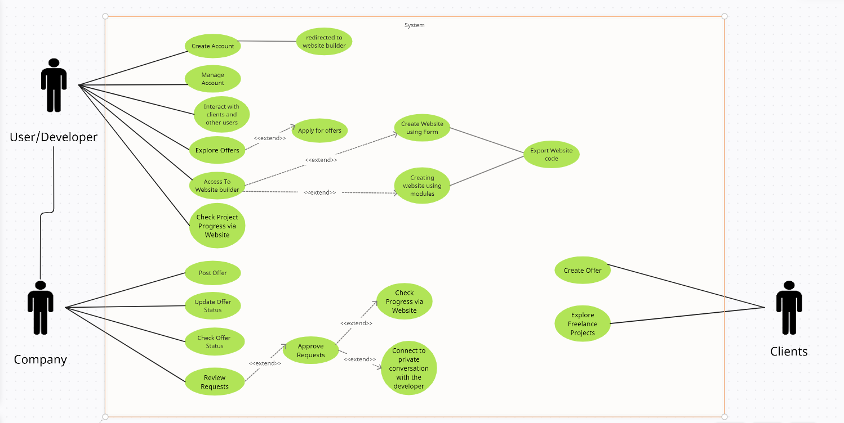

The user navigates to the web page.

The user opens an account and chooses between being a firm or a developer.

If the user is a business:

The dashboard is accessible to the company.

A job offer can be posted by the organization by providing specifics such as pricing, subject, page numbers, and further information.

The job offer from the employer is shown on the offers page.

The corporation can review job application requests from developers.

The requests can be accepted or rejected by the company.

If the request is accepted, a conversation between the company and the developer begins.

The company can negotiate project requirements with the developer and set timeframes.

The project status dashboard allows the organization to monitor the development of the website being produced by the developer.

During the development process, the organization can provide input and make necessary changes.

If the user is a developer, they get automatically redirected to the website builder.

On the offers page, the developer can go through the various career opportunities.

The developer might choose a job offer and apply to work on the project.

The request is forwarded to the company for consideration.

If the request is approved, a conversation between the developer and the company begins.

The developer might meet with the company to discuss project details, ask queries, and set timelines.

Using the website builder, the developer can begin working on the website.

The project status dashboard allows the developer to update the project status and progress on a regular basis.

The developer can engage with the company,ask for feedback, and integrate the necessary modifications  
  
  
If the user is a customer: The client can submit project specifications and requirements to generate an offer for freelance projects.

On the freelancing offers page, the client's offer is visible.

Developers can explore the freelance opportunities and submit applications if they are interested.

Clients cannot apply for company job openings; only developers may.

Applications submitted by developers for their freelance assignment can be evaluated by the client.

The client has the option to accept or reject the applications and to start speaking with the chosen developer.

.