Training curves at 2/2: STE vs. the staircase
Follow-up to the 2/2 progress report, 12 November 2026. ResNet-20 on CIFAR-10, 2-bit weights and activations, seed 0 (the tuning seed), 120 epochs. All accuracies are on the 5k validation images; the test set was not used.

How the two schedules work now
- Learning rate: Adam with cosine decay from the initial rate to 0 over the 120 epochs, stepped once per epoch. It does not depend on α. (The clipping bounds and output scales have their own Adam, at rate 1e-5.)
- α (staircase only): rises linearly from 1 to α_end over the first 60 epochs, then stays fixed; β is fixed for the whole run.
- So the two do not match: during the ramp, the ratio between the steep and the flat slope of S, which equals βα², grows from 2 to 50 (at β = 2), while the cosine only halves the learning rate.

Figure 1: the best STE run and the best staircase run
- The STE keeps improving for all 120 epochs: its training loss falls from 0.74 to 0.09, and validation ends at 90.88.
- The staircase fits the training data worse while α rises: its training loss with S rises from 0.03 to 0.22 during the ramp and stays there for the remaining 60 epochs. Validation with S falls from 89.84 (epoch 1) to 86.28.
- Where the drop from S to hard rounding comes from, at the end: 86.28 with S, 79.34 with hard rounding after re-estimation, 67.92 with hard rounding and the BatchNorm statistics from training. So 6.9 points come from the function itself, and another 11.4 from the BatchNorm statistics, which re-estimation recovers. For the STE, re-estimation changes little (91.40 without, 90.88 with).
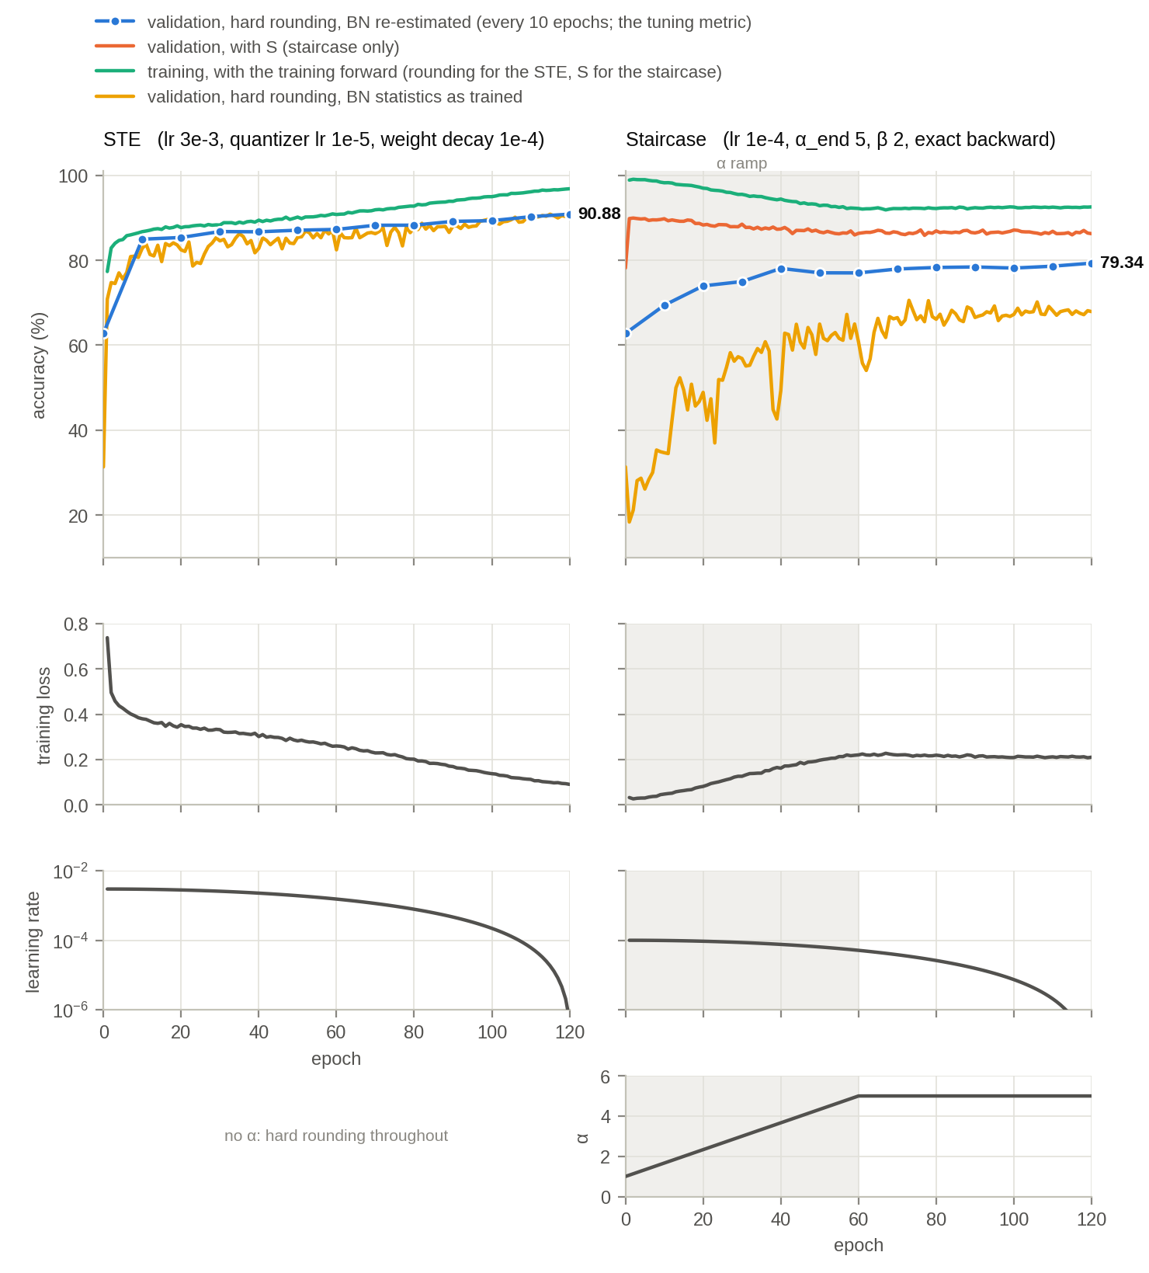
Figure 1. The best runs of the 2/2 tuning. Top: accuracy. Blue: validation with hard rounding after BatchNorm re-estimation, the tuning metric (every 10 epochs). Orange: validation with S. Aqua: training accuracy with the training forward, on augmented batches. Yellow: validation with hard rounding and the BatchNorm statistics from training. Below: training loss, learning rate and α. Grey band: the α ramp. Epoch 0 is the quantized network before training, the same for both methods.

Figure 2: the learning rate against α
- The best learning rate falls as α grows. While α is at most 2.3 the highest rate is best; from α = 3.7 on, the two lowest are. The highest rate reaches 81.38 at epoch 10, more than the tuned run's final 79.34, and loses it as α grows. This matches your hypothesis: a high rate converges fast while α is small and falls apart as it grows; a low rate survives the ramp but converges slowly.
- The damage happens during the ramp and is not recovered. Training accuracy with S at the end of the ramp (epoch 60) is 92.22 / 85.96 / 76.52 / 54.56 for the four rates; after 60 more epochs at fixed α it is 92.59 / 87.66 / 80.79 / 62.80.
Table 1. The numbers behind Figure 2 (top): validation with hard rounding after BatchNorm re-estimation. Bold: the best learning rate at each point.
Epoch (α) | lr 1e-4 | lr 3e-4 | lr 1e-3 | lr 3e-3
10 (1.7) | 69.42 | 71.82 | 75.54 | 81.38
20 (2.3) | 73.98 | 75.00 | 78.44 | 79.26
30 (3.0) | 75.00 | 75.90 | 77.84 | 75.48
40 (3.7) | 78.10 | 77.32 | 76.46 | 66.30
60 (5.0) | 77.04 | 77.42 | 72.68 | 54.76
120 (5.0) | 79.34 | 78.08 | 75.30 | 60.70 (failed)
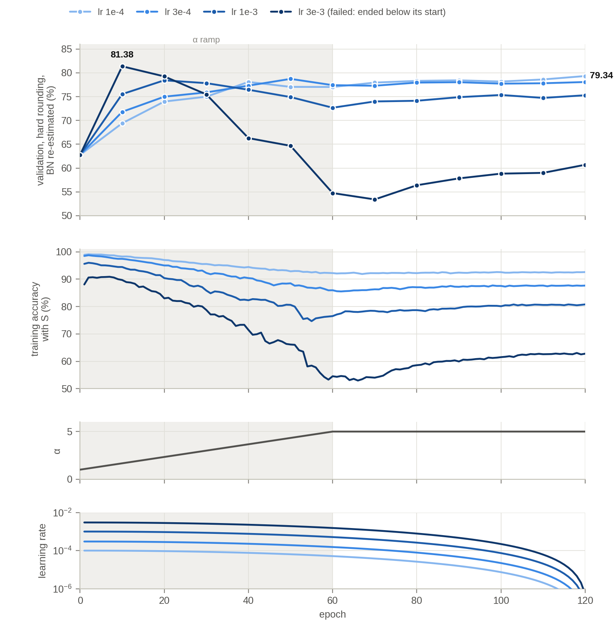
Figure 2. The staircase at α_end 5, β 2 with the four learning rates of the tuning, light to dark: 1e-4, 3e-4, 1e-3, 3e-3. From the top: validation with hard rounding after BatchNorm re-estimation; training accuracy with S; α; learning rate. Grey band: the α ramp.

Not shown yet
Training accuracy with hard rounding was not logged in these runs. From now on every run measures 5,000 fixed training images without augmentation at every epoch, with S, with hard rounding, and with hard rounding after re-estimation when that is done. We checked that this does not change training; it adds about 2 seconds to each epoch.

Proposed next runs
To test the hypothesis, all at 2/2, α_end 5, β 2, exact backward, 120 epochs, with the new measurement:
- learning rates divided by α², times the cosine: the learning rate follows α. The network's rate starts at 3e-3, where high rates work, and is close to the tuned run's rate once α reaches 5;
- the same without the cosine, to see the cosine's effect alongside the coupling;
- a gentler coupling, divided by α, to see how fast the rate has to fall;
- the current schedule with a constant rate of 1e-4, to see the cosine's effect on its own;
- the cosine at 1e-4 with α fixed at 5 from the start (optional), to see the α ramp's effect on its own;
- the best staircase run again, to complete Figure 1 with the training accuracy under hard rounding.
About 5–6 hours on one laptop. If a coupled schedule closes most of the gap, it becomes part of the method, and the staircase is re-tuned with it before the 4-bit runs; a larger α_end, closer to rounding, is the next question after that. Comments on the form of the coupling (1/α², 1/α, or another schedule) are welcome before we start.

