Learning-rate schedules for the staircase at 2/2
Follow-up to the training-curves report, 12 November 2026. ResNet-20 on CIFAR-10, 2-bit weights and activations, seed 0 (the tuning seed), 120 epochs, staircase with α_end 5, β 2 and the exact backward. All accuracies are on the 5k validation images unless stated otherwise; the test set was not used. Tables and figures continue the numbering of that report.

What we ran
Six runs, each changing one thing in the tuned run (learning rate 1e-4 with the cosine; α rising from 1 to 5 over the first 60 epochs):
- Learning rate tied to α: at every step, both learning rates (the network's and the quantizer's) are divided by α², or by α, on top of the schedule. The network's rate starts at 3e-3, the best rate early in training in Table 1. Divided by α², it reaches 3e-3/25 = 1.2e-4 once α is 5, close to the tuned 1e-4. We ran the α² version with and without the cosine.
- The cosine on its own: the tuned run with a constant rate of 1e-4.
- The ramp on its own: the tuned run with α fixed at 5 from the start.
- The tuned run again, to see how much a rerun moves the result.
Every run also measures 5,000 fixed training images (no augmentation) at every epoch, with S and with hard rounding (Figure 4).

Results
Table 2. Accuracy at the end of training (epoch 120). Drop: the accuracy with S minus the accuracy with hard rounding after re-estimation, on the validation images. The last column is the accuracy with S on the 5,000 training images.
Run | Hard rounding, BN re-estimated | With S | Drop | Training images, with S
lr 3e-3 ÷ α², cosine | 82.88 | 86.72 | 3.8 | 93.06
lr 3e-3 ÷ α², no cosine | 81.22 | 85.74 | 4.5 | 91.44
lr 1e-4, cosine: the tuned run again | 79.26 | 85.86 | 6.6 | 93.26
lr 3e-3 ÷ α, cosine | 78.74 | 83.22 | 4.5 | 86.78
lr 1e-4, no cosine | 78.10 | 85.90 | 7.8 | 91.60
lr 1e-4, cosine, α = 5 from the start | 75.82 | 84.92 | 9.1 | 90.34
The tuned run in the 2/2 tuning | 79.34 | 86.28 | 6.9 | not measured
STE, best of the 2/2 tuning | 90.88 | – | – | not measured

- Dividing the learning rate by α² works. With the cosine it reaches 82.88, 3.6 points above the tuned run and the best staircase result so far.
- Dividing by α is not enough: 78.74, about where the tuned run ends.
- We see no sign that the cosine and the α ramp interfere. Removing the cosine lowered the result by 1.2 points without the coupling and by 1.7 with it. Removing the ramp (α = 5 from the start) lowered it by 3.4.
- A rerun moves the final result very little: the tuned run ended at 79.26, against 79.34 in the tuning. In the middle of training the two runs differ by up to 1.5 points, so only end results should be compared. All numbers come from a single seed.

Figure 3: the six runs over time
- The ÷α² run converges early and keeps its accuracy while α grows. It is ahead of the tuned run from epoch 10 on and above 82 from epoch 20; the second half of training adds almost nothing (82.78 at epoch 60, 82.88 at 120). The tuned run instead climbs slowly for all 120 epochs. This matches your hypothesis: with a fixed low rate, the staircase converges slowly.
- The ÷α run falls while α grows. It is the best of the six at epoch 10 (81.18), falls to 78.14 by epoch 60 and stays there. Its rate stays higher during the ramp: when α reaches 5 it is still 3.1e-4, against 6.2e-5 with ÷α². Its fit with S on the training images ends the lowest of the six (86.78).
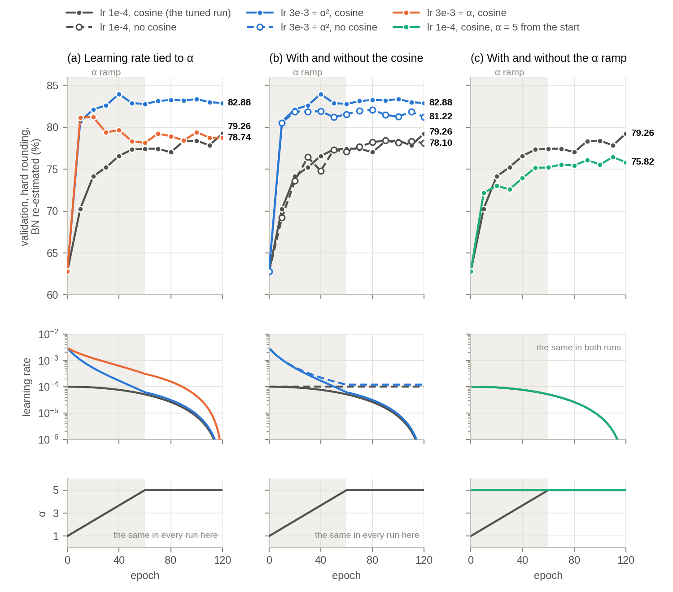
Figure 3. The schedule study. Each panel changes one thing in the tuned run (grey): (a) the learning rate divided by α² (blue) or by α (orange), with the cosine; (b) with the cosine (solid lines, filled markers) and without it (dashed lines, hollow markers); (c) α fixed at 5 from the start (aqua). From the top: validation with hard rounding after BatchNorm re-estimation (every 10 epochs), the network's learning rate, and α. Grey band: the α ramp of the ramped runs. Numbers: the final accuracy.

Figure 4: training and validation, with S and with hard rounding
- With S, both runs fit the training images about equally well at the end: 93.06 with ÷α², 93.26 for the tuned run. So the coupling does not help the network fit the training data with S. (The tuned run fits them better while α is small, up to 99.34, and loses that during the ramp.)
- The coupling helps the rounded network. Hard rounding after re-estimation reaches 88.12 on the training images and 82.88 on validation, against 82.64 and 79.26 for the tuned run. Across the study, the three runs that started at 3e-3 lost 3.8–4.5 points on validation when S was replaced by hard rounding; the three at 1e-4 lost 6.6–9.1 (Table 2).
- The BatchNorm statistics from training are much closer to what hard rounding needs. Without re-estimation, hard rounding gives 78.78 on validation with ÷α², and re-estimation adds 4.1 points. For the tuned run it gives 64.36, and re-estimation adds 14.9.
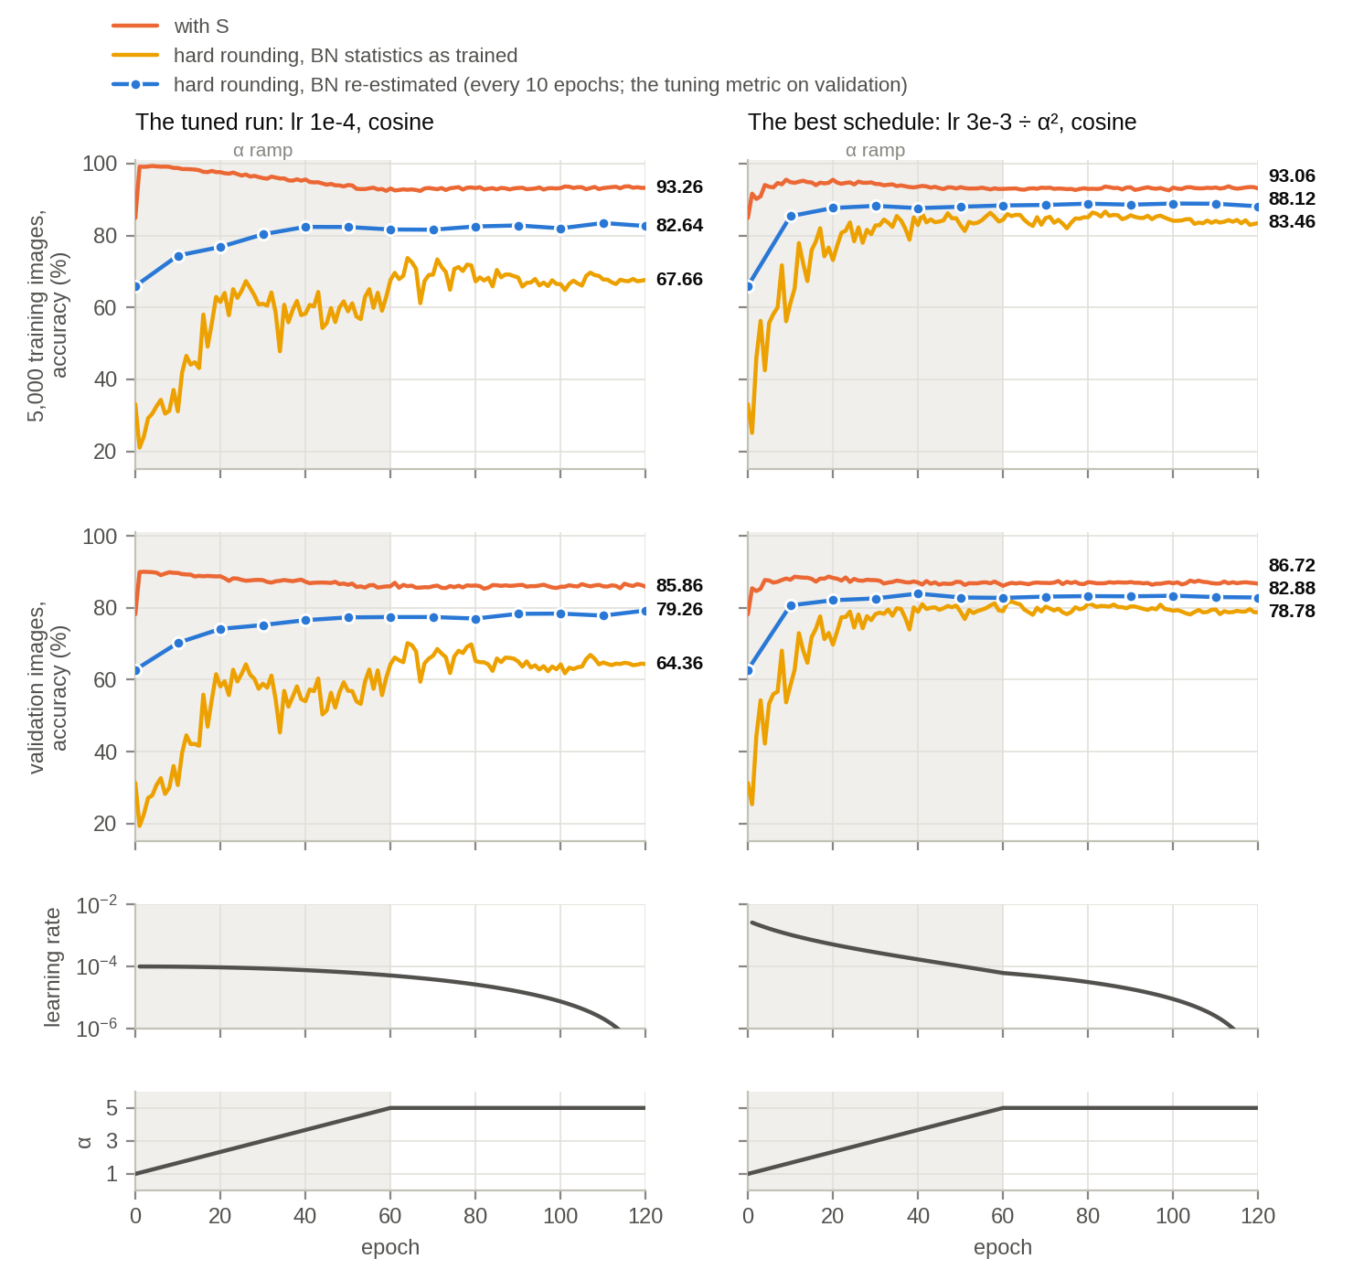
Figure 4. The tuned run (left) and the ÷α² run with the cosine (right), on the 5,000 fixed training images (top) and on the validation images (middle). Orange: with S. Yellow: hard rounding with the BatchNorm statistics from training. Blue: hard rounding after BatchNorm re-estimation (every 10 epochs). Below: the network's learning rate and α. Grey band: the α ramp. Numbers: the final accuracy.

What remains
The best staircase run is still 8.0 points below the STE (90.88), against about 11.5 before. About half of the gap is already there with S (86.72, 4.2 points below the STE); the other half comes from replacing S with hard rounding (3.8). With S, the staircase also fits the training data less well than the STE: training accuracy on the augmented batches, each method with its own training forward, ends at 91.83 against 96.86.

