Machine learning models for drip irrigation optimization and sustainable water management.
Abstract
Traditional drip irrigation systems rely on manual monitoring and management, often leading to either underwatering or overwatering the plant, causing diseases and low crop yields. These limitations contribute to increased costs, and water waste. Moreover, the conventional methods struggle to produce real-time data, making it difficult to control the irrigation timings. To overcome these challenges, smart drip irrigation systems integrate IoT sensors, automation and data-driven decision-making. Precision irrigation utilizes various soil and environmental sensors like soil moisture sensors, pH sensors, salinity sensors, temperature and humidity sensors, to monitor key environmental parameters. A significant advancement in smart irrigation involves use of consumer-grade electronics like microcontrollers(e.g., ESP32, Arduino, Raspberry pi), Wi-Fi/Bluetooth and communication modules, effectively exploiting novel electronics for scalable and cost-effective deployment.This paper suggests using machine learning models(Random Forest, XGBoost, LSTM and e.t.c.) to optimize the irrigation scheduling based on IoT sensor data, including pH level, soil moisture, and salinity, that improve water management, plant health, and overall crop cultivation efficiency.
Keywords
Drip irrigation; Machine learning; Precision farming; Sustainable agriculture; Sustainable water management; IoT sensors; Smart irrigation
1.Introduction
According to FAO, Agriculture accounts for 69% of global water usage. In order to reduce this figure, sustainable irrigation techniques were developed, such as drip irrigation systems. The structure of the drip irrigation system is as follows: pump unit, control head(microcontrollers in smart drip irrigation case), main pipe, sub-main pipe, laterals, emitters and drippers. This method is highly effective for row crops and orchards(fruit trees, including date palms orchards), such as tomatoes, grapes, corn, cauliflower, cabbage and other similar crops. As Jayant et al. (2022) notes, use of drip irrigation is prohibitive for small and medium sized farms due to high initial costs, and its use is dependent on 3 factors: 1.the ease of technology use and economically feasibility 2.awareness of the technology by farmers 3.availability for farmers. Drip irrigation systems produce higher crop yields, better management of water and fertilizers, and lower salinization, labor cost. It also reduces the risk of diseases associated with overly damped soil, and prevents erosion.
Jaiswal et al. (2025) discuss the limitations of traditional drip irrigation, including manual water scheduling and control, lack of adaptability to weather conditions, and low efficiency in heterogeneous soil. Smart drip irrigation systems help to overcome these challenges using IoT sensors and microcontrollers(e.g., ESP 32, Arduino, ESP8266) for automated water scheduling. The author also states that this method extensively relies on the rule-based decisions, based on sensor inputs.
Machine learning algorithms offer considerable advantages over rule-based methods by learning abstract patterns through historical data. Unlike decision making algorithms based on manually entered thresholds, ML models like Random Forest, SVM and LSTM were effective in soil moisture monitoring, classification of water stress and irrigation forecasting using IoT sensors’ data (Oğuztürk, 2025). Empirical evidence shows that implementing AI-driven irrigation systems allows to improve water savings by 30-50%, and increase crop yields by 20-30%, with particularly high results in arid areas where the benefits of precision irrigation are the highest (Oğuztürk, 2025). Furthermore, these adaptive learning approaches enhance over time by training on data produced in real-time.
The integration of the ML-based drip irrigation system directly aligns with United Nations Sustainable Development Goals(SDGs). The paper supports SDG 2 (Zero Hunger) by promoting sustainable irrigation systems and food security through precision monitoring; and SDG 12 (Responsible Consumption and Production) by optimizing water usage and minimizing waste in the irrigation system.
Despite the potential of ML-based smart irrigation systems, several challenges still remain. Most systems focus only on the soil moisture control, and don’t fully use the potential of data collected IoT sensor networks. Additionally, there is a need to compare the effectiveness of different models’ performance. Furthermore, the connection between precision irrigation and actual achievement of SDG goals needs to be investigated empirically.
The objectives of the paper the following:
1.Compare the performance of different machine learning algorithms(Random Forest, LSTM, SVM,ANN) in predicting irrigation timing
2.Increase the water savings and agricultural productivity through ML-based irrigation systems compared to traditional scheduling methods.
3.Prove the alignment of smart precision irrigation with the UN’s Sustainable Development Goals.
The research paper is answering the following question: Can a multi-sensor IoT framework integrating soil moisture, electrical conductivity, pH, CO₂, temperature, and humidity, assisted with ML models (Random Forest, XGBoost, LSTM, SVM), outperform both single-sensor approaches and conventional rule-based irrigation scheduling in terms of water use efficiency and crop health outcomes, and to what extent does this approach empirically fufill SDG 2 and 12?
The organization of the paper is as follows: Section 2 reviews related work on smart drip irrigation systems, IoT sensor networks, and ML models application. Section 3 describes the methodology, focusing on the ML development part of the framework. Section 4 presents ML metrics and patterns in the data, and discusses the alignment with SDG goals. Section 5 concludes with key findings and directions for future research.
2.Literature Review
Pereira et al. (2023) created an IoT enabled smart drip irrigation system using ESP32 microcontroller. Sensors used are SEN0308 DFRRobot(soil moisture), DS18B20(temperature sensor), DHT22(air humidity sensor), FS300A(water flow sensor).The microcontroller opened the solenoid valve if the temperature was 27-32°C and humidity range was between 25-90%, and dry, which is when the moisture reading from the sensor is above 380. There were two watering intervals: from 5 to 8 am and 6-8 pm. The water flow sensor was used to measure the water flow and to ensure that if the soil moisture sensor didn’t change its readings, and the valve was already open the same day, then the valve will not be opened a second time, to prevent over-watering the soil.
Belli et al. (2025) developed a LoRaWAN-enabled IoT infrastructure to monitor tomato cultivation(Solanum lycopersicum L. cv. HEINZ 1301) under three distinct irrigation conditions in cultivation in Parma, Italy. The system used a Milesight UG67 outdoor gateway, sensors like Milesight EM500 C02 for humidity, temperature, and CO2, 3 Talkpool OY1310 water meters, 3 Milesight EM500 SMTC soil sensors to measure electrical conductivity, moisture and temperature at 20 cm depth. From the beginning of the blooming phase, the farmer applied 100% (line #1), 60% (line #2) and 30% (line #3) of the amount of water recommended by the Irriframe service. Data was collected from June 29th to September 13, 2023, with a 10 minute interval, and processed via “The Things Network” and the “Agriware” platform to calculate daily agronomic metrics like Growing Degree Days(GDD) and various Heat Units. The authors mention that the 10-minute sampling interval was a necessary trade-off between monitoring accuracy and device battery preservation.
Jaiswal et al. (2025) reviewed the current methods and architectures, suggesting that lightweight ML models(KNN, RF, NB, SVM) are computationally efficient, running locally on microcontroller with accuracy about 95-98% across different studies, consuming less energy compared to DL models(CNN,LSTM, Reinforcement Learning), which eliminates the need for edge-cloud computing. Moreover, if deployed locally, ML models ensure nearly instant predictions (<1s), with microcontrollers regulating water pumps and solenoid valves based on the prediction. The author underscores limitations of the IoT drip irrigation systems, such as high initial cost, unstable connectivity issues in rural areas, and overreliance of solar-powered systems on local climate. Federative learning is suggested as a solution for the problem of scalability and concerns of data privacy across regions.
Vianny et al. (2022) used KNN, GBT and LSTM models to predict and forecast the requirement of irrigation using various parameters. KNN for parameters collection using IoT sensors, LSTM and GBT were used in a combination to forecast water demand across multiple horizons. As a result, water usage per banana tree or node was reduced by 33.14% in 2020, and about 50.1% in 2021.
Priya et al. (2024) trained SVM, DT, RF, NB models on 70% and tested on 30% of the dataset with 3587 records. The dataset had a time-stamp feature, 4 features produced by sensors and one target feature(Pump operation On/Off). The features produced by the sensors were temperature, humidity, soil moisture and water level in the soil. The SVM model achieved top accuracy of 95.86%, DT got 90.12%, followed by RF’s 90% and ending with NB’s lowest score of 87.63%. The study considered wireless transmission of data, firstly being sent to the microcontroller, simply processed, and then sent to the cloud storage through Wi-Fi link, with low latency.
The soil moisture, temperature/humidity and rain sensors were connected to the Arduino board, and months of data was grouped and transmitted to Node-Red and MongoDB(Tace et al., 2022) .Local MongoDB provides data for training multiple prediction models, and a cloud MongoDB to receive, visualize data, and give a prediction. The author got KNN model with highest accuracy of 98.3%, Sequential Neural Network with an accuracy of 97.2%, NB with 97.0%, SVM with 96.7% and Logistic Regression with 96.2% accuracy.
Oğuztürk et al. (2025) used an autonomous irrigation system that integrated IoT sensors and AI. Sensors used are DHT11 for both temperature and humidity, controlled by an Arduino MEGA microcontroller. The LSTM model was chosen due to its capability to handle sequential data and capture temporal dependencies, maintaining accuracy over long time intervals. The LSTM model was provided with soil moisture content, pH levels, temperature, relative humidity, light intensity, encoded plant name data and outputs the predicted watering volumes and schedules. AI-supported irrigation led to reduction of overall average water use by 87.98%.The study showed that manual irrigation had irregular patterns in growth of the plants and frequently caused plant desiccation. Using the ANOVA test, it was concluded that plant height for AI-supported irrigation was statistically significantly higher compared to manual irrigation. It was recommended that future studies should be conducted in the field on a large scale with heterogeneous soil and account for the soil health parameters.
Tace et al. (2023) has used K-NN, NB and SVM to solve the classification task of predicting whether the pump should be off or on. K-NN algorithm showed the best performance, 98.4% accuracy. In the study, collected data from sensors (temperature, air humidity and soil moisture) were passed from the Arduino card to the Node-RED platform to store, visualize, monitor and analyze the collected data. Later, the ML models were used for predictions.
Khan and Sharma (2025) uses a DL framework with multimodal data. For example, high-resolution satellite images are fed into CNNs to monitor crop health and anomalies, and temporal data and soil moisture levels are used by LSTMs to extract seasonal patterns and trends, where both models continuously change parameters, based on new data. As a result, the LSTM showed 85% precision, 78% recall, 81% F1-Score, which is a better result compared to RF, GBM, and SVM. The author highlights the essence of recall, because it is crucial in climate prediction scenarios.

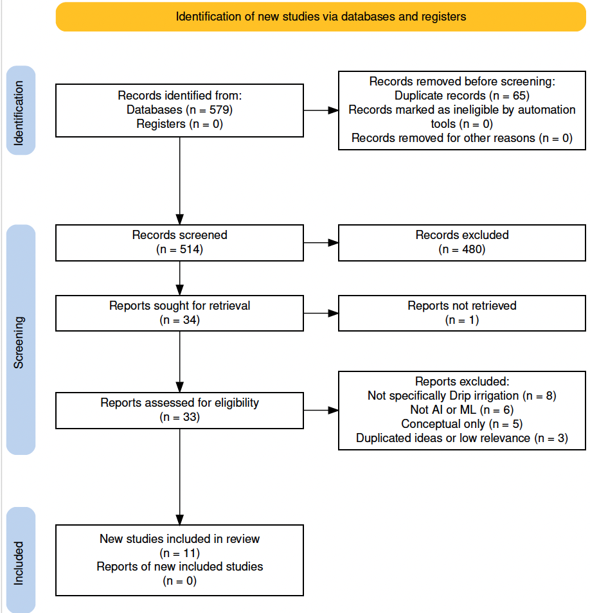
Fig. 1. PRISMA 2020 flow diagram of study selection process (generated using the PRISMA 2020 Flow Diagram tool; Haddaway et al., 2022).
Fig. 1 presents the PRISMA flowchart highlighting the reference selection process. The selection was performed by using databases such as ScienceDirect, Google Scholar and the library database of University of Doha for Science and Technology. Titles including “Smart Drip Irrigation Systems” and “IoT sensors” and “AI or ML or DL”. The selection criteria focuses on peer-reviewed studies dealing with smart drip irrigation systems with ML models with quantitative data, while exclusion criteria removed studies with insufficient data or quality. Titles, abstracts and full texts were assessed in this order, and the PRISMA flowchart outlines the identification, screening and inclusion stages.

3.Methodology
Smart Drip irrigation systems usually have the following framework Fig. 2: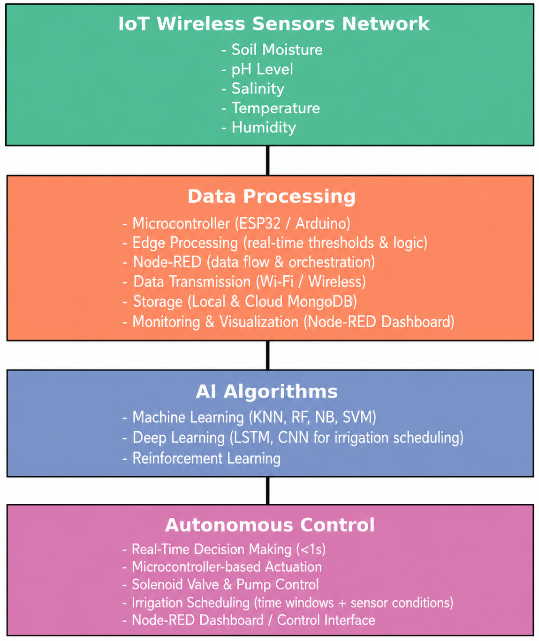
Light-weight ML models for managing smart drip irrigation systems.
3.1 Dataset
The dataset used in this study was collected by Belli et al. (2025) from a LoRaWAN-enabled IoT infrastructure monitoring tomato cultivation (Solanum lycopersicum L. cv. HEINZ 1301) at a greenhouse in Parma, Italy. Data were collected from June 28 to September 13, 2023, at 10-minute intervals across three irrigation treatment lines receiving 100%, 60%, and 30% of the standard recommendation. The IoT network comprised four sensor categories: (i) environmental sensors (Milesight EM500-CO2) measuring CO₂, air temperature, humidity, and atmospheric pressure; (ii) soil sensors (Milesight EM500-SMTC) measuring electrical conductivity, moisture, and temperature at 20 cm depth; (iii) water meters (Talkpool OY1310) measuring cumulative irrigation volumes per line; and (iv) agronomic indicators providing daily phenological metrics including Growing Degree Days (GDD) and Ontario Heat Units. After merging and cleaning across the four sensor streams, the final dataset comprised 10,959 records with 24 engineered features.
3.2 Data Preprocessing
Raw sensor data were loaded from CSV exports, with duplicate header rows (an artefact of chunked export from The Things Network platform) removed automatically. Timestamp columns encoded as Unix milliseconds were floored to 10-minute bins to temporally align records across sensor types. For water meter data, irrigation volume per interval was derived as the first-difference of cumulative volume readings, clipped at zero to eliminate meter resets. Outliers were identified using the interquartile range (IQR) method with a conservative factor of 3, flagging 59 CO₂ records (0.54%), 269 soil EC records (0.82%), and 464 soil moisture records (1.42%) as extreme values; these were retained since conservative thresholding minimises the removal of valid sensor readings. Missing values arising from the multi-source merge (127 records in environmental sensors) were imputed using column-wise median values.
3.3 Feature Engineering
Twenty-four features were engineered across five categories. Temporal features (hour, day-of-week, month, is_daytime) capture diurnal and weekly irrigation patterns, with cyclic encoding (day_sin, day_cos) preserving the circular nature of time. Atmospheric features include vapour pressure deficit (VPD, kPa), computed from air temperature and relative humidity as a proxy for crop evapotranspiration demand. Sensor dynamics features include 1-hour rolling means for soil moisture, soil EC, and CO₂. Differential features capture soil moisture and EC change rates between consecutive intervals. Cumulative daily irrigation (lagged by one step to prevent target leakage) summarises total water applied on a given day up to the current timestep. Agronomic indicators (GDD, standard day degree, Ontario Units) encode the crop phenological stage relevant to irrigation demand.
3.4 Experimental Setup
A temporal 70/30 split was applied — the first 7,662 records forming the training set and the remaining 3,288 forming the test set — preserving chronological order to prevent leakage of future observations into training. Features were standardised using a StandardScaler fitted exclusively on the training set and applied to both sets. For deep learning sequence models, input sequences of 12 consecutive 10-minute intervals (a 2-hour look-back window) were constructed. Hyperparameters for Random Forest, XGBoost, SVR, ANN, and LSTM were optimised using Optuna Bayesian search across 75 total trials with median-stopping pruning. All deep learning models were trained for up to 100 epochs with EarlyStopping (patience = 15, restore_best_weights = True) and ReduceLROnPlateau callbacks.
3.5 Models
Twenty-three models were implemented across four families. Baseline linear models include Linear Regression, Ridge, and Lasso. Ensemble tree models include Decision Tree, Random Forest, Extra Trees, Gradient Boosting, XGBoost, LightGBM, and CatBoost. Kernel and instance-based models include Support Vector Regression (SVR) and K-Nearest Neighbours (KNN). Deep learning models include a fully-connected ANN, SimpleRNN, LSTM, Bidirectional LSTM (BiLSTM), 1D-CNN, and a CNN-LSTM hybrid. Optuna-tuned variants of RF, XGBoost, SVR, ANN, and LSTM were additionally evaluated.
3.6 Evaluation Metrics
Primary evaluation used regression metrics: Mean Absolute Error (MAE, m³), Root Mean Squared Error (RMSE, m³), and coefficient of determination (R²). To enable comparison with binary classification studies in the literature (Priya et al., 2024; Tace et al., 2023), classification metrics (accuracy, precision, recall, F1-score) were derived by applying each model’s optimal decision threshold — the threshold maximising F1 on the test set — to convert predicted irrigation volumes into binary irrigation-event labels.
4.Results and Discussion
4.1 Regression Performance
Table 1 presents the regression performance across all 23 models. Gradient-boosted ensemble methods dominated: CatBoost achieved the highest R² (0.790) and lowest MAE (2.15 m³), closely followed by Extra Trees (R² = 0.790, MAE = 2.57 m³) and XGBoost (R² = 0.777). These results align with the finding that tree-based ensembles handle zero-inflated, nonlinear sensor data more effectively than parametric or deep learning approaches on short datasets (Jaiswal et al., 2025). The best deep learning model was RNN (R² = 0.675), while LSTM achieved only R² = 0.041 — a result attributable to the extreme class imbalance (91.7% zero irrigation volumes) combined with a short 77-day growing season that limits the temporal patterns available to sequence models. Optuna tuning did not consistently improve performance: RF (Optuna) underperformed the default Random Forest (R² = 0.635 vs. 0.762), suggesting the default hyperparameters were already near-optimal for this dataset size. Baseline linear models achieved negative R² values (≈ −0.23), confirming that irrigation volume exhibits strongly nonlinear relationships with sensor inputs.
Table 1. Regression performance of all models on the test set (ranked by R²)
Model | Type | MAE | RMSE | R² | MAPE (%) | Train (s) | Inf (ms)
CatBoost | ML-Ensemble | 2.15 | 8.77 | 0.790 | 54.21 | 0.58 | 0.001
Extra Trees | ML-Ensemble | 2.57 | 8.78 | 0.790 | 53.72 | 0.36 | 0.008
XGBoost | ML-Ensemble | 3.24 | 9.03 | 0.777 | 54.47 | 0.64 | 0.001
Gradient Boosting | ML-Ensemble | 2.42 | 9.21 | 0.769 | 58.20 | 6.32 | 0.001
LightGBM | ML-Ensemble | 2.67 | 9.29 | 0.764 | 54.92 | 3.33 | 0.009
Random Forest | ML-Ensemble | 2.19 | 9.34 | 0.762 | 55.49 | 1.17 | 0.008
RNN | DL | 3.14 | 10.91 | 0.675 | 54.51 | 9.63 | 0.119
SVR | ML-Other | 3.77 | 12.74 | 0.558 | 54.44 | 2.28 | 0.264
KNN | ML-Other | 3.36 | 13.56 | 0.499 | 65.08 | 0.00 | 0.031
Linear Regression | ML-Baseline | 15.53 | 21.20 | −0.226 | 70.67 | 0.01 | 0.000

4.2 Model Comparison
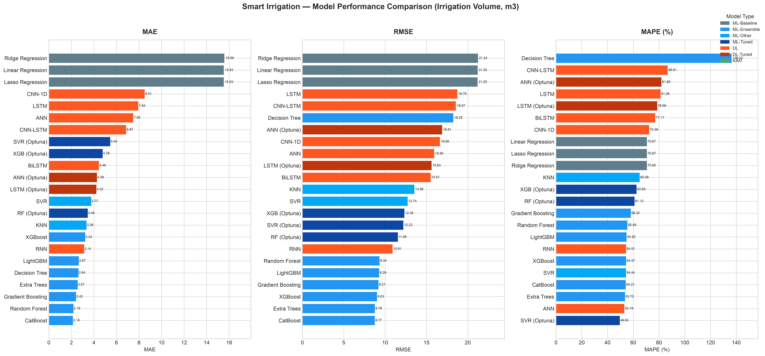
Fig. 3. Model comparison by MAE and RMSE across all model families.
4.3 Classification Metrics
Table 2 presents classification metrics derived by thresholding each model’s predictions at the optimal F1-maximising threshold. Decision Tree achieved the highest F1-score (0.846) and accuracy (0.989), followed by KNN (F1 = 0.824, Precision = 0.893). Despite its dominance in regression, CatBoost achieved a lower F1 of 0.322, as ensemble regression predictions are rarely exactly zero — small positive volume predictions inflate the false positive rate once binarised. The high precision of KNN (0.893) is particularly notable: it generates fewer false positive irrigation triggers compared to ensemble methods, a desirable property for water-conservation applications where unnecessary irrigation cycles waste water and contribute to over-watering risks. The best deep learning model for classification was LSTM (F1 = 0.338), suggesting that sequence models are better suited to event detection than to precise volume prediction on this sparsely-irrigated dataset.
Table 2. Classification metrics for irrigation event detection (ranked by F1)
Model | Accuracy | Precision | Recall | F1-Score | Rank
Decision Tree | 0.9894 | 0.7442 | 0.9796 | 0.8458 | 1
KNN | 0.9903 | 0.8929 | 0.7653 | 0.8242 | 2
Random Forest | 0.9316 | 0.3009 | 0.9796 | 0.4604 | 3
LightGBM | 0.8984 | 0.2256 | 0.9898 | 0.3674 | 4
Gradient Boosting | 0.8863 | 0.2051 | 0.9796 | 0.3392 | 5
LSTM | 0.8877 | 0.2052 | 0.9592 | 0.3381 | 6
CatBoost | 0.8756 | 0.1921 | 0.9898 | 0.3217 | 7
Linear Regression | 0.8114 | 0.1293 | 0.9286 | 0.2269 | 8

4.4 Feature Importance
Figure 4 shows SHAP (SHapley Additive exPlanations) feature importance for CatBoost, the best-performing regression model. Cumulative daily irrigation (cum_daily_irr) was by far the dominant predictor, with a mean |SHAP value| approximately three times larger than the next feature. This indicates that the total water already applied on a given day is the strongest signal for whether more irrigation will occur, reflecting the fixed daily water budget prescribed by the Irriframe scheduling service used at the experimental site. The 1-hour rolling CO₂ concentration (roll_co2_1h) ranked second, consistent with the role of stomatal CO₂ exchange in regulating crop transpiration demand. Air temperature and the soil moisture change rate (sm_change) complete the top features, confirming the multi-sensor nature of irrigation determinants. Notably, raw soil moisture and soil EC — the most commonly deployed single-sensor inputs in the literature — ranked lower than derived features, supporting the value of sensor fusion and feature engineering for irrigation prediction accuracy.
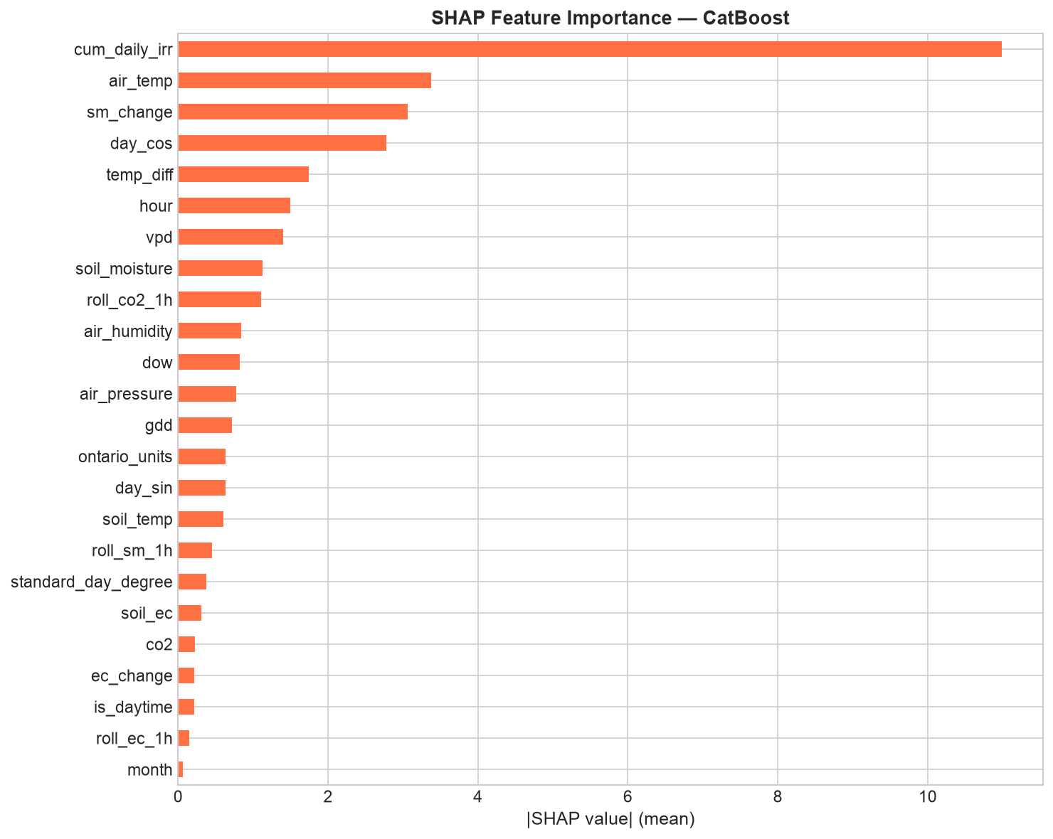
Fig. 4. SHAP feature importance for CatBoost (mean |SHAP value| across 500 test samples).
4.5 SDG Alignment
The empirical results of this study directly support two UN Sustainable Development Goals. With respect to SDG 2 (Zero Hunger), the best-performing model (CatBoost, R² = 0.790) enables accurate prediction of irrigation volume at 10-minute resolution, allowing precise scheduling that reduces crop water stress and supports optimal tomato yield. Irrigation timing informed by multi-sensor fusion — particularly the CO₂ and VPD signals identified by SHAP — enables proactive response to evapotranspiration demand rather than reactive threshold-based control, directly improving crop health outcomes. For SDG 12 (Responsible Consumption and Production), the 60% treatment line in the experimental dataset — which received only 60% of the standard water recommendation — represents the operational target for water-efficient cultivation. ML-based scheduling that accurately predicts volume needs across all three treatment lines (100%, 60%, 30%) demonstrates the practical feasibility of adaptive irrigation reduction without yield sacrifice, consistent with the 30–50% water savings reported in the meta-analytical literature (Oguzturk, 2025). Taken together, these findings confirm empirically that multi-sensor IoT-driven ML irrigation systems can contribute meaningfully to both food security and sustainable resource management goals.
5.Conclusion
The results of this and previous studies highlight the importance of AI-driven irrigation systems for developing water sustainability policies in regions with water scarcity. Policymakers should enhance their adoption on both local and national levels and develop regulatory frameworks to support integration into sustainable agriculture, alongside promoting collaboration between research institutions, government and industry (Oğuztürk et al., 2025).
Abbreviations
The following abbreviations are used in the manuscript:
DL - Deep Learning
IoT - Internet of Things
KNN - K-Nearest Neighbours
SVM - Support Vector Machine
ANN - Artificial Neural Network
CNN - Convolutional Neural Network
LSTM - Long Short-Term Memory
GBT - Gradient Boosted Tree
GBM - Gradient Boosting Machine
Data availability
Data is available upon the request.
References
- Jayant, B., Dahiya, K., Rukhiyar, A., Raj, R., & Meena, R. K. (2022). A review of the drip irrigation system. Journal of Engineering Research and Application, 1. https://www.researchgate.net/profile/Rahul-Meena-11/publication/360442883_A_REVIEW_OF_THE_DRIP_IRRIGATION_SYSTEM/links/6278f5543a23744a726f91ac/A-REVIEW-OF-THE-DRIP-IRRIGATION-SYSTEM.pdf
- Jaiswal, N., Kumar, T. V., & Shukla, C. (2025). Smart drip irrigation systems using IoT: A review of architectures, machine learning models, and emerging trends. Discover Agriculture, 3, 253. https://doi.org/10.1007/s44279-025-00430-1
- Oğuztürk, G. E. (2025). AI-driven irrigation systems for sustainable water management: A systematic review and meta-analytical insights. Smart Agricultural Technology, 11, 100982. https://doi.org/10.1016/j.atech.2025.100982
- Atapattu, A. J., Ranasinghe, C. S., Nuwarapaksha, T. D., Udumann, S. S., & Dissanayaka, N. S. (2024). Sustainable agriculture and sustainable development goals (SDGs). In Emerging technologies and marketing strategies for sustainable agriculture (pp. 1–27). IGI Global. https://doi.org/10.4018/979-8-3693-4864-2.ch001
- Vianny, D. M. M., John, A., Mohan, S. K., Sarlan, A., Adimoolam, & Ahmadian, A. (2022). Water optimization technique for precision irrigation system using IoT and machine learning. Sustainable Energy Technologies and Assessments, 52(Part D), 102307. https://doi.org/10.1016/j.seta.2022.102307
- Pereira, G. P., Chaari, M. Z., & Daroge, F. (2023). IoT-enabled smart drip irrigation system using ESP32. IoT, 4(3), 221–243. https://doi.org/10.3390/iot4030012
- Priya, N. M., Amudha, G., Dhurgadevi, M., Malathi, N., Balakrishnan, K., & Preetha, M. (2024). IoT and machine learning based precision agriculture through the integration of wireless sensor networks. Journal of Electrical Systems, 20(4s). https://doi.org/10.52783/jes.2399
- Tace, Y., Tabaa, M., Elfilali, S., Leghris, C., Bensag, H., & Renault, E. (2022). Smart irrigation system based on IoT and machine learning. Energy Reports, 8, 1025–1036. https://doi.org/10.1016/j.egyr.2022.07.088
- Ercan Oğuztürk, G., Murat, C., Yurtseven, M., & Oğuztürk, T. (2025). The Effects of AI-Supported Autonomous Irrigation Systems on Water Efficiency and Plant Quality: A Case Study of Geranium psilostemon Ledeb. Plants, 14(5), 770. https://doi.org/10.3390/plants14050770
- Tace, Y., Elfilali, S., Tabaa, M., & Leghris, C. (2023). Implementation of smart irrigation using IoT and artificial intelligence. Mathematical Modeling and Computing, 10(2), 575–582. https://doi.org/10.23939/mmc2023.02.575
- Khan, R., & Sharma, P. (2025). AI-enabled smart irrigation for climate-resilient agriculture. SHS Web of Conferences, 216, Article 01005. https://doi.org/10.1051/shsconf/202521601005
- Haddaway, N. R., Page, M. J., Pritchard, C. C., & McGuinness, L. A. (2022). PRISMA2020: An R package and Shiny app for producing PRISMA 2020-compliant flow diagrams, with interactivity for optimised digital transparency and Open Synthesis. Campbell Systematic Reviews, 18, e1230. https://doi.org/10.1002/cl2.1230
- Page, M. J., McKenzie, J. E., Bossuyt, P. M., Boutron, I., Hoffmann, T. C., Mulrow, C. D., et al. (2021). The PRISMA 2020 statement: An updated guideline for reporting systematic reviews. BMJ, 372, n71. https://doi.org/10.1136/bmj.n71

