PENETRATION TESTING REPORT
FOOTPRINTING & NETWORK SCANNING PHASES
W2-PM-FINAL | CYBERSECURITY | NETWORKWALKS

Pentester Name (Cybersecurity Professional) | Islam
Program/Batch | B082-Networkwalks
Date | 13 November 2026
Modules completed | W2-PM1 (Multiple Kali Tools)  W2-PM5 (Zenmap Scanning)
Client/Target | 1. Networkwalks (networkwalks.com — secured written permission already)  2. My own local LAN Network (192.168.1.0/24)
Permission secured from client? | Yes
Phases covered | Phase 1: Reconnaissance & Footprinting  Phase 2: Scanning & Network Discovery  Phase 3–5: In Progress

1. Liability Disclaimer
I have performed these activities only on the systems & devices where I had secured written permission or the devices/systems that I own myself. All these materials are for education and research purpose only. Do not use anything from here to break the law. The instructor, the authors and Networkwalks are not responsible for what you do with this knowledge. Every action you take is your own responsibility. Misuse can lead to criminal charges, heavy fines, loss of your job and a permanent record. In most countries unauthorised access is a crime even when nothing is damaged.
2. Introduction
This report covers footprinting the networkwalks.com domain using multiple Kali Linux tools (W2-PM1) and scanning my own local network with Zenmap (W2-PM5). One module covers the footprinting phase and the other covers the scanning phase, so together they show how an attacker moves from gathering public information to mapping live hosts on a network. It is the Week 2 part of my ongoing internship program at Networkwalks.
All commands were run in Kali Linux (footprinting) and on a Windows PC with Zenmap installed (scanning). Every step below includes the exact command used, the result I observed, screenshots as evidence, and an assessment of why each finding matters from a security perspective.
3. Tools Used
The table below lists each tool used in this report and its purpose.
Tool | Purpose
Kali Linux & Windows | Operating systems used for reconnaissance and network scanning activities
WHOIS | Find domain registration details (owner/privacy proxy, dates, name servers)
whatweb | Fingerprint web technologies (server, CMS, plugins, IP)
nslookup | Resolve the domain name to its IP address using DNS
curl -I | Read the HTTP response headers of the website
wafw00f | Detect whether a Web Application Firewall protects the site
dnsrecon | Enumerate all DNS records (SOA, NS, MX, A, TXT, SRV)
Zenmap (Nmap GUI) | Scan the local subnet to find live hosts, IPs, MAC addresses, and topology
Windows CMD | Local IP and MAC address identification (ipconfig / ipconfig /all)

4. Activities Performed
4.1 Footprinting & Reconnaissance (W2-PM1)
I performed passive and active reconnaissance against the networkwalks.com domain on 13 November 2026 using six Kali Linux tools: whois, whatweb, nslookup, curl, wafw00f, and dnsrecon.
- WHOIS (whois networkwalks.com): Obtained publicly available domain registration records. The domain is registered through GoDaddy.com, LLC (created 2019-11-06, expiring 2027-11-06), uses privacy protection via Domains By Proxy, LLC (Tempe, Arizona), has DNSSEC: unsigned, and delegates authoritative name resolution to HostGator (NS6135.HOSTGATOR.COM and NS6136.HOSTGATOR.COM).
- WhatWeb (whatweb networkwalks.com): Fingerprinted the web application stack. The HTTP endpoint redirects (301 Moved Permanently) to HTTPS (200 OK) hosted at IP 192.232.216.135 in the United States. Identified technologies include Apache, WordPress 7.1.4, WordPress Download Manager 3.3.76, Bootstrap 7.1.4, jQuery 3.7.1, Google Tag Manager, and the public contact email info@networkwalks.com.
- Nslookup (nslookup networkwalks.com): Queried the local DNS resolver (10.0.0.1) and confirmed that networkwalks.com resolves to the IPv4 address 192.232.216.135.
- Curl (curl -I https://networkwalks.com): Inspected the HTTP/1.1 200 OK response headers. The headers confirmed the Apache server banner, WordPress caching (X-nginx-cache: WordPress), session cookie __wpdm_client (with secure; HttpOnly flags), Permissions-Policy, Referrer-Policy, and exposed the WordPress REST API endpoint /wp-json/.
- Wafw00f (wafw00f networkwalks.com): Tested whether a Web Application Firewall (WAF) was actively filtering requests to https://networkwalks.com. During my scan, the connection timed out on port 443 (HTTPSConnectionPool(host='networkwalks.com', port=443): Read timed out (read timeout=7)), indicating active connection throttling/filtering or temporary unresponsiveness to automated WAF fingerprinting probes.
- DNSRecon (dnsrecon -d networkwalks.com): Enumerated DNS infrastructure records. Identified the SOA record (ns6135.hostgator.com at 50.87.144.87), NS records (ns6135.hostgator.com at 50.87.144.87 and ns6136.hostgator.com at 192.232.216.131), DNS server software version (Bind 9.16.23-RH on 192.232.216.131), MX record (mail.networkwalks.com at 192.232.216.135), A record (192.232.216.135), and TXT records containing the SPF policy (v=spf1 +a +mx +ip4:50.87.144.87 +include:websitewelcome.com ~all) and Google site verification token. No DNSSEC or SRV records were returned.
4.2 Network Scanning with Zenmap (W2-PM5)
For the second activity, I used Windows Command Prompt and Zenmap to perform network discovery on my local LAN subnet:
- Local Subnet & Host Identification (ipconfig): Identified my local network subnet as 192.168.1.0/24 (with my Windows host assigned 192.168.1.105).
- Zenmap Ping Scan (nmap -sn 192.168.1.0/24): Ran a Ping Scan across the 192.168.1.0/24 subnet, which discovered 2 live hosts: 192.168.1.1 (Local Default Gateway / Router) and 192.168.1.105 (My local Windows PC).
- MAC Address Identification: Recorded the MAC address of the remote gateway (192.168.1.1) directly from the Zenmap Nmap Output tab, and retrieved my own host's physical MAC address (192.168.1.105) using ipconfig /all in Windows CMD.
- Network Topology Export: Opened the Topology tab in Zenmap, verified the visual map connecting localhost to 192.168.1.1 and 192.168.1.105, enabled the legend, and saved the topology graphic in PDF format.
5. Risk Analysis / Impact
Based on the information collected during the footprinting and network scanning activities, I identified the following potential risks.
# | Risk / Finding | Evidence / Observation | Potential Impact | Risk Level
1 | Web technology & version information exposed | whatweb identified WordPress 7.1.4, WordPress Download Manager 3.3.76, Bootstrap 7.1.4, and jQuery 3.7.1 | Attackers can cross-reference exposed CMS and plugin versions against CVE databases to look for known vulnerabilities | ● Medium
2 | Origin server IP address identifiable | nslookup and dnsrecon resolved networkwalks.com and mail.networkwalks.com to 192.232.216.135 | Reveals the hosting infrastructure location and allows direct IP targeting | ● Low
3 | HTTP technical headers & REST API exposed | curl -I returned Apache server headers and exposed the /wp-json/ REST API endpoint | Assists attackers in technology fingerprinting and user/endpoint enumeration | ● Low
4 | HTTPS probe timeout / filtering behavior | wafw00f timed out on port 443 (Read timed out) | Indicates potential rate-limiting or perimeter filtering, though automated WAF detection was inconclusive due to timeout | ● Low
5 | DNS infrastructure & Bind version exposed | dnsrecon identified HostGator name servers, Bind 9.16.23-RH, SPF records, and noted unsigned DNSSEC | Exposes DNS daemon version details and mail routing architecture; lack of DNSSEC increases DNS spoofing risk | ● Medium
6 | Active local network hosts discoverable | Zenmap Ping Scan discovered 2 live hosts (192.168.1.1 and 192.168.1.105) on 192.168.1.0/24 | Unmonitored local networks allow unauthorized devices to remain undetected if periodic scans are not performed | ● Low

Risk level key: ● Critical | ● Medium | ● Low
The findings above represent observations from passive/active reconnaissance and host discovery exercises rather than confirmed exploitable vulnerabilities. No exploitation was performed during these two modules.
6. Recommendations
Based on the observations from these activities, I recommend the following security improvements:
- Minimize Exposed Version Metadata: Configure WordPress and plugins (such as WP Download Manager) to suppress version generator tags from public HTML and HTTP headers.
- Keep CMS, Plugins, and DNS Software Patched: Regularly update WordPress, third-party plugins, Apache, and Bind (9.16.23-RH) against current security advisories.
- Harden HTTP Response Headers & API Access: Review exposed HTTP headers and restrict unauthenticated enumeration on /wp-json/ where not publicly required.
- Enable DNSSEC & Audit DNS Records: Enable DNSSEC on the domain registrar/DNS provider and periodically audit NS, MX, and TXT/SPF records.
- Verify Perimeter Protection: Ensure the Web Application Firewall and rate-limiting rules are properly tuned to block malicious automated traffic without disrupting legitimate monitoring.
- Conduct Periodic Local Subnet Audits: Regularly scan internal networks (192.168.1.0/24) to verify all connected IP and MAC addresses against an approved asset inventory.
7. Conclusion
During Week 2 of my Cybersecurity & Ethical Hacking internship, I completed practical exercises covering footprinting, reconnaissance (W2-PM1), and local network scanning (W2-PM5).
In the footprinting module, I used whois, whatweb, nslookup, curl, wafw00f, and dnsrecon against networkwalks.com, demonstrating how publicly accessible DNS, registration, and HTTP metadata reveal a target's underlying hosting and software architecture. In the network scanning module, I used Windows CMD and Zenmap to map my 192.168.1.0/24 subnet, identify the 2 active hosts (192.168.1.1 and 192.168.1.105), collect hardware MAC addresses, and export the network topology diagram. All activities were conducted strictly within authorized educational scope.
8. Evidences Collected
Below are the screenshots and outputs captured during the practical execution of W2-PM1 and W2-PM5:

Figure 1: WHOIS Domain Registration & Registrar Record (Capture.PNG & Capture2.PNG)
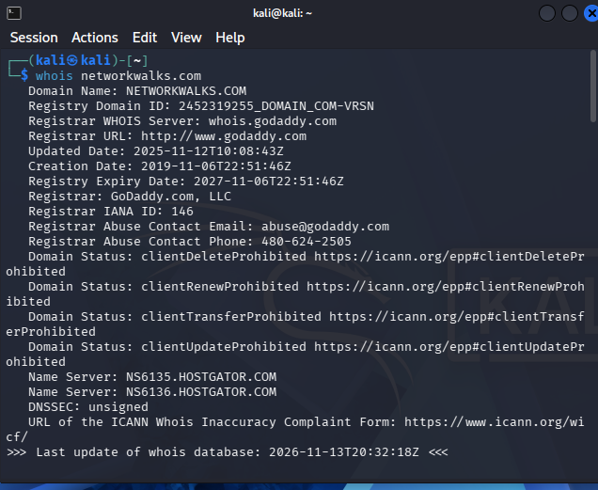

Figure 2: WhatWeb Technology Fingerprinting Output (Capture3.PNG)
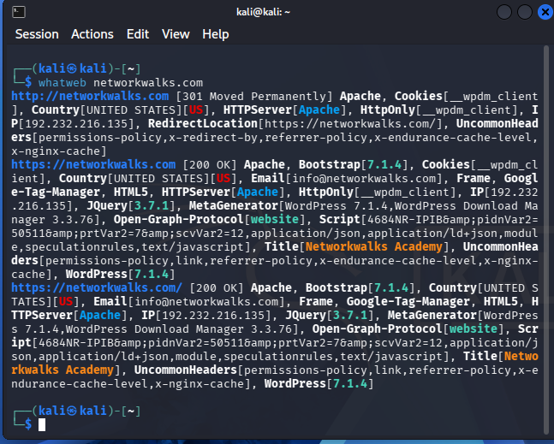

Figure 3: Nslookup DNS Resolution Output (Capture4.PNG)
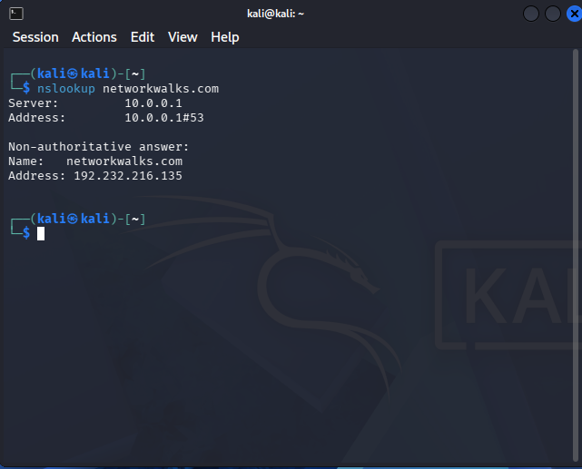

Figure 4: Curl HTTP Response Headers (Capture5.PNG)
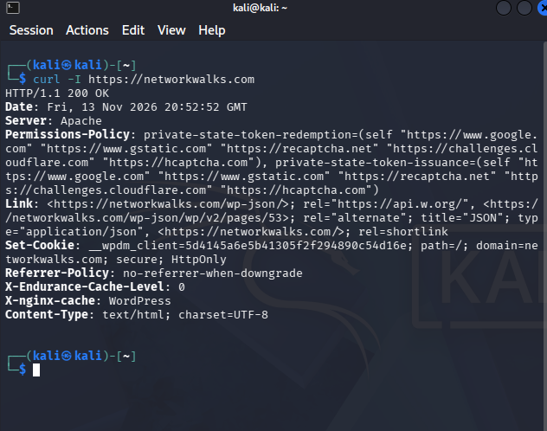

Figure 5: Wafw00f WAF Fingerprinting Output (Capture6.PNG)
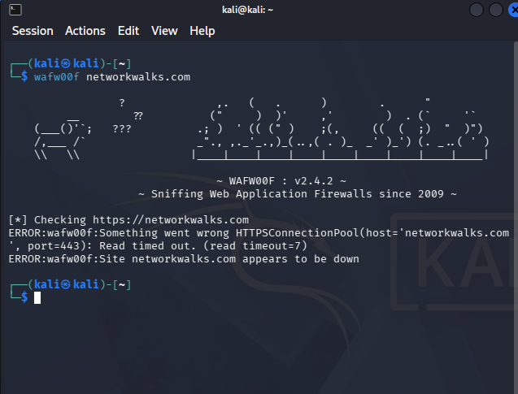

Figure 6: DNSRecon DNS Enumeration Output (Capture7.PNG)
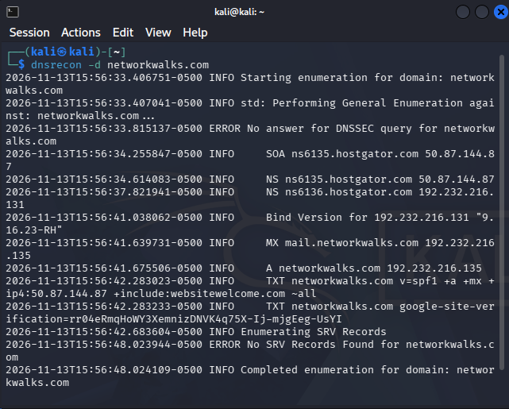

Figure 7: Zenmap Ping Scan Output on 192.168.1.0/24 (Zenmap Scan)
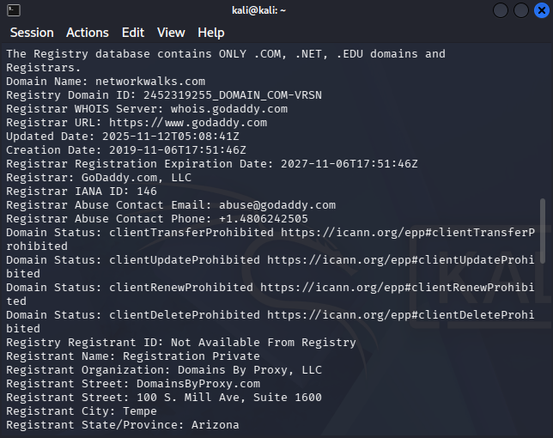

Figure 8: Zenmap Network Topology Export (192.168.1.1 and 192.168.1.105)

[Image missing or unable to load: topology_page-1.png]

