

**Cairo University**

**Faculty of Computers and Artificial Intelligence**

**CS213: object oriented programming**

**Assignment 1**

**Tasks 2&3**

**محمد علي حسن امين شكري 20230347 S21**

**يوسف فريد سيد حسنين حبلص S21 20230504**

**اسلام وليد صلاح عبدالمطلب 20230062 S15**

Marking standards:

In this report we have given the estimations of code quality following this methodology:

* 65 correctness
* 15 code being easy to read, understood and modified in the future.
* 20 efficiency.

Code has 19 functions, which means each function has ~5 marks:

* 3.25 on correctness.
* 0.75 on elegancy.
* 1 on efficiency.

1. Chatgpt code:
   1. Prompt:

I want to make a class for polynomial of degree 3, this is the header file, take the prototypes and give me the source file with all the prototypes implemented :

And then provided the Ai with the header file.

* 1. Constructors:

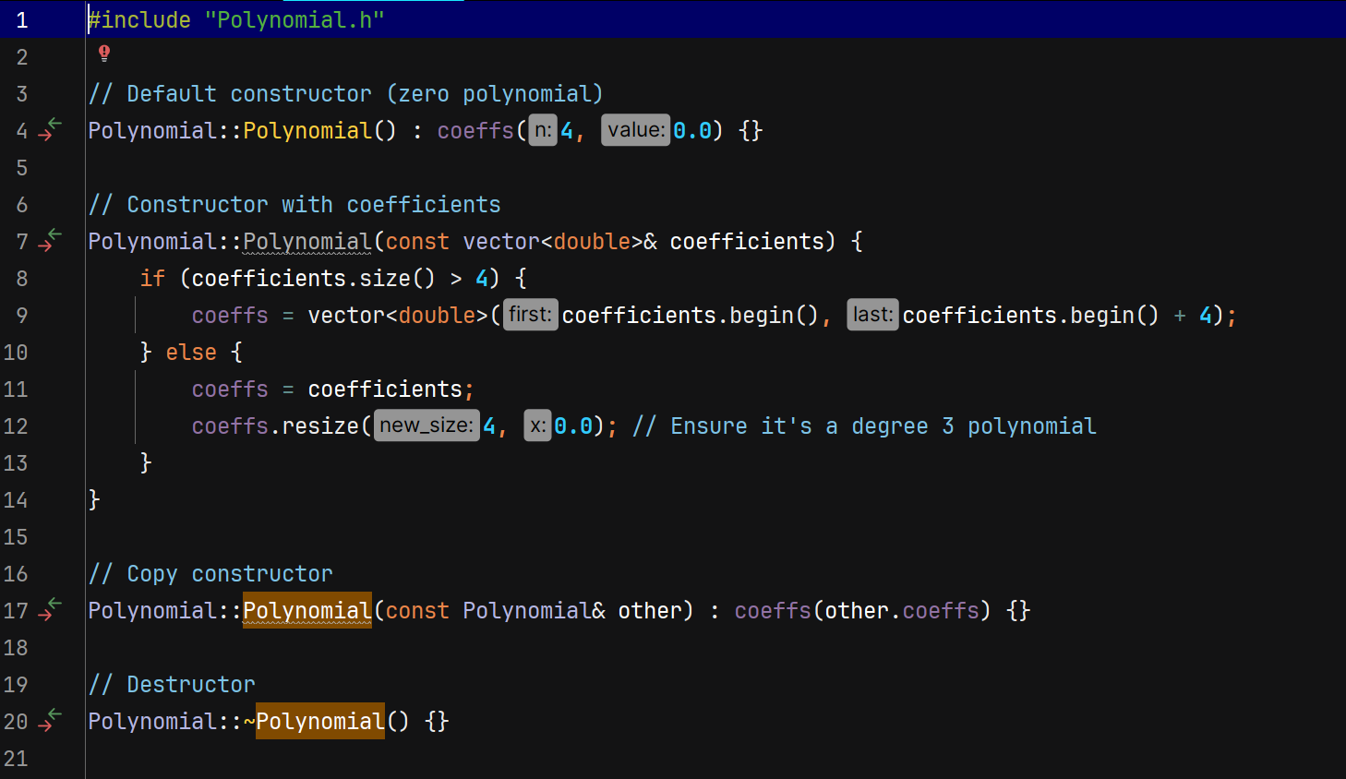

No issues found with these methods of construction.

It’s a good practice to make a copy constructor Although cpp provide it by default.

* 1. Operator overloading

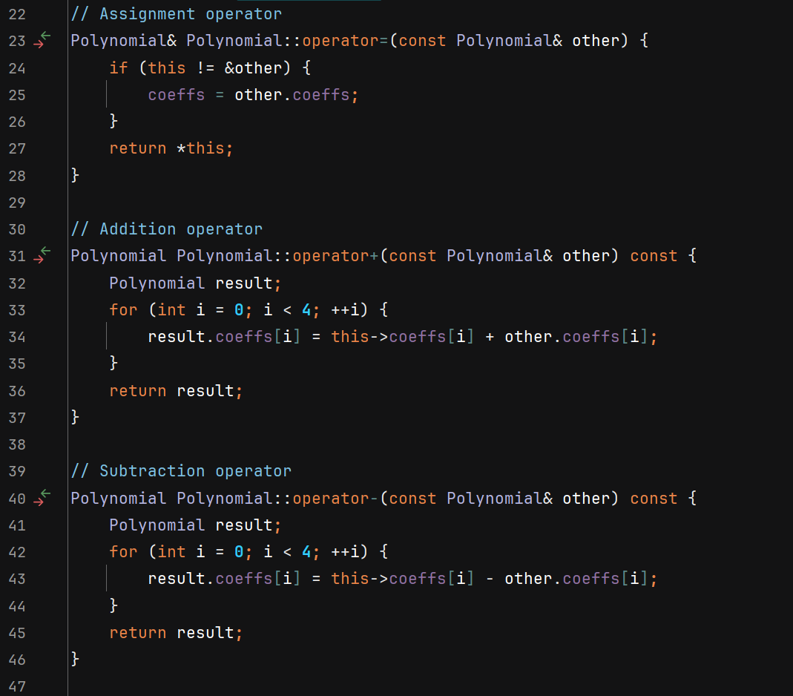

Test case:

Assignment, addition, subtraction, and insertion operators work well.

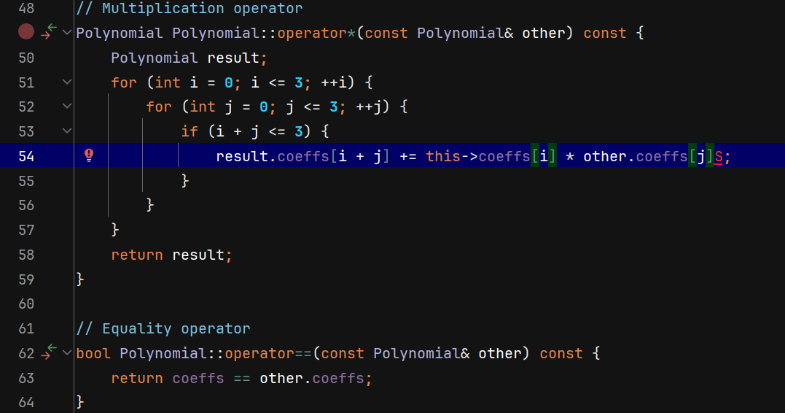

* Multiplying each coefficient and summing it in the result polynomial is , needless to say, vain and silly.
* Making variable named max_coefficients instead of the magical number 3, would have been a better practice, although code is clean enough.

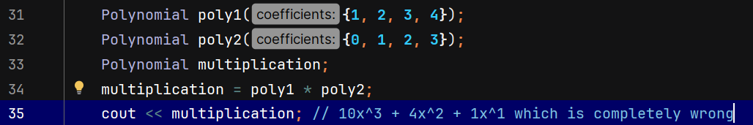

* As expected code doesn’t work with this test case.

So code looses 3.25 marks .

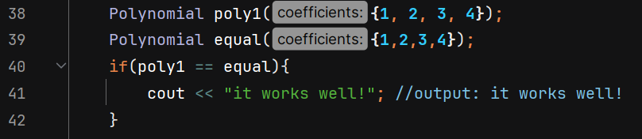

Equal operator overloading works well.

* 1. Utility functions:
     1. Degree and evaluate

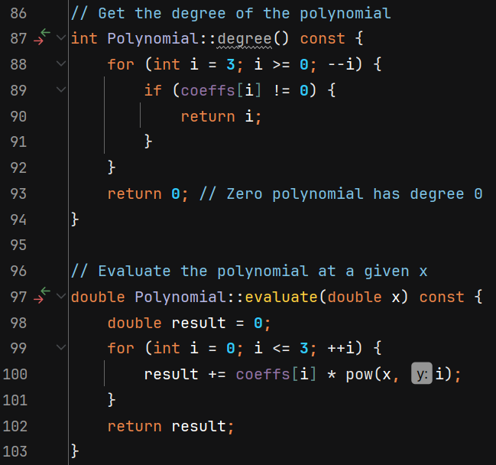

Using pow function is not the best idea, since using fast power would have been more efficient, code looses 1 mark.

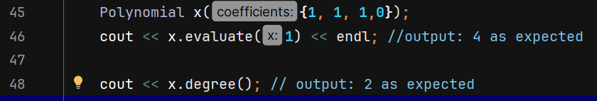

Incorrect evaluation, code losses 3.25.

* + 1. Compose and derivative

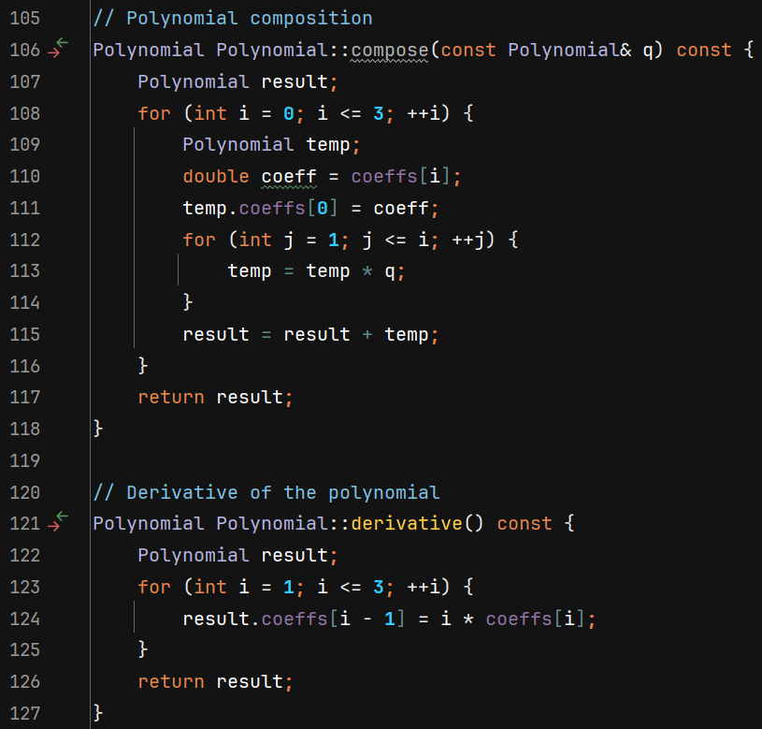

Function compose is poorly coded, as variable name ‘q’ doesn’t really tell anything about what it is, and same thing goes with variable name ‘temp’, code looses 0.75 mark.



Code looses 3.25 for function compose for being not correct.

* + 1. Integral and definite integral :

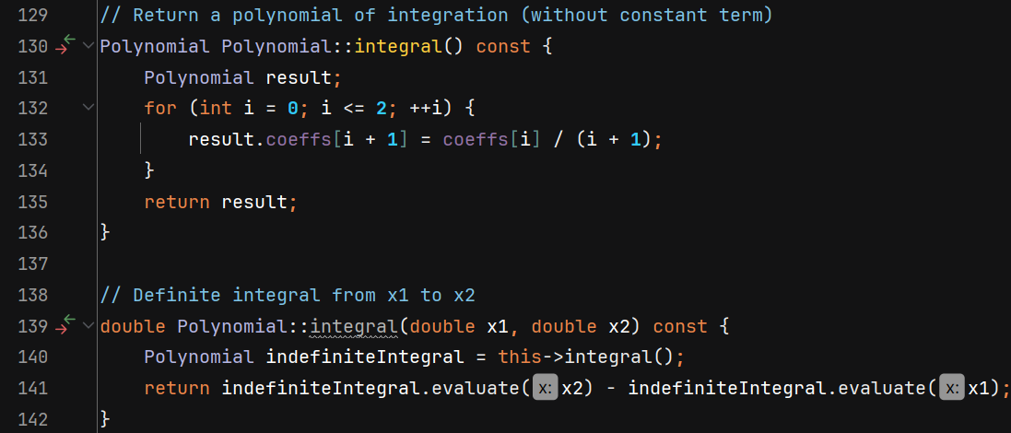

Test case :



Code fails!, consequently looses 3.25 * 2 for being incorrect.

* + 1. getRoot function:

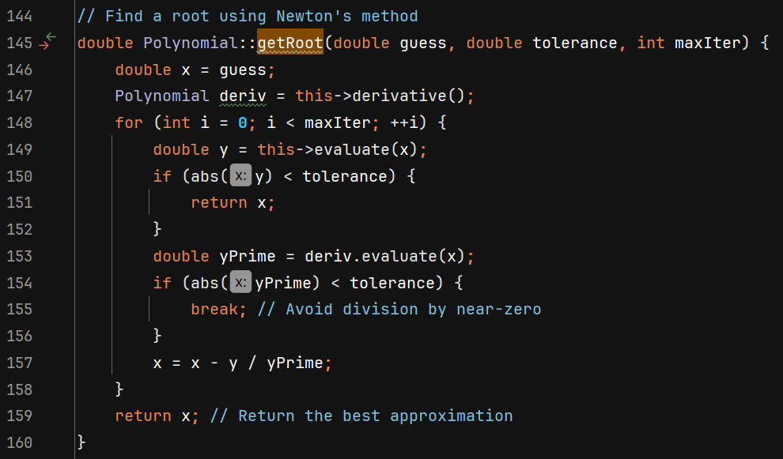

‘x’ and ‘y’ variable names are not meaningful, ‘maxIter’ as well as ‘deriv’ can not be pronounced, consequently can not be discussed between programmers, code looses 0.75.

Using newton’s method instead of simply using sqrt function or any other specialist function makes code more messy and problematic, code looses 0.5 marks.

Test case :

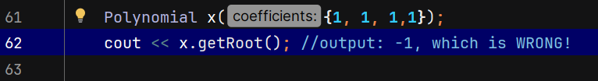

Code looses 3.25 for being incorrect.

* + 1. Getters and setters:

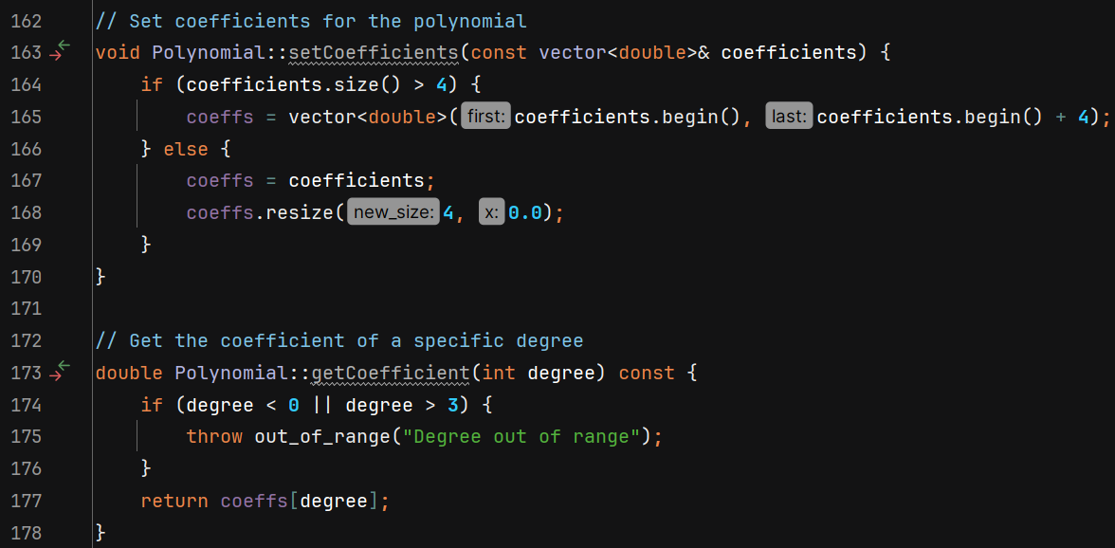

setCoefficients function does not throw any errors when given more than 4 items in the vector, code looses 1 mark for being incorrect.

Test case:

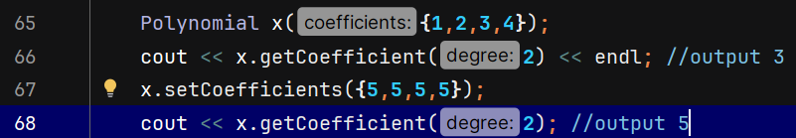

* 1. Final score : 68.25/100

1. Gimini:
   1. Prompt:

Same as chat gpt.

* 1. Constructor, destructor, copy and assignment operator :

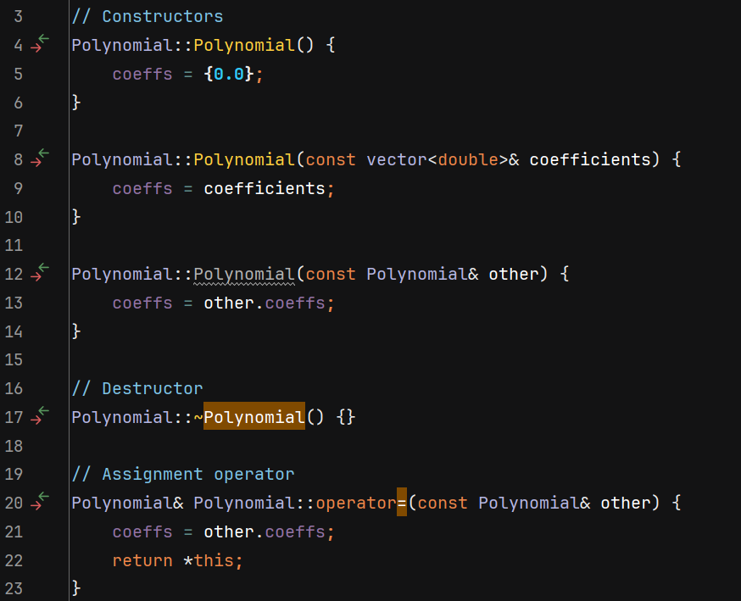

Test cases:

Code looses 3.25 marks for incorrectness.

Applies deep copy ok.

* 1. Addition and subtraction :

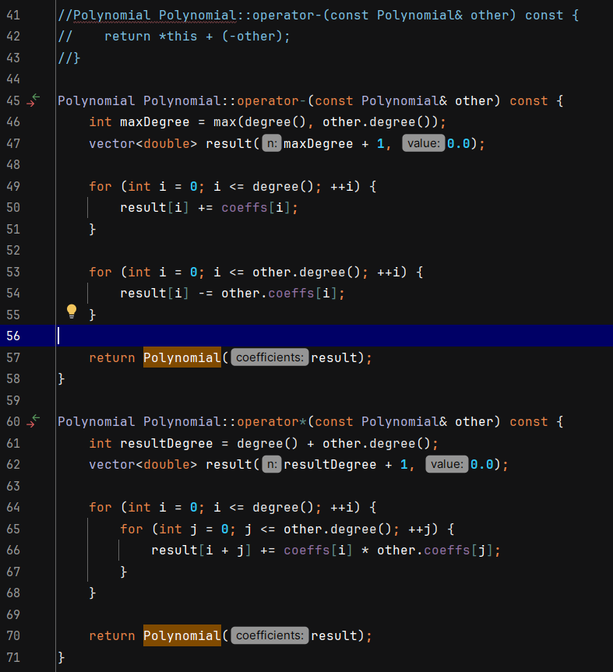

At first ‘-‘ Gimini did the overloading wrongly, and whe I prompted it to fix it, it did.

Code looses 4 marks for not even compiling at the beginning.

Test cases :

Works great.

* 1. Multiplication and equal operators :

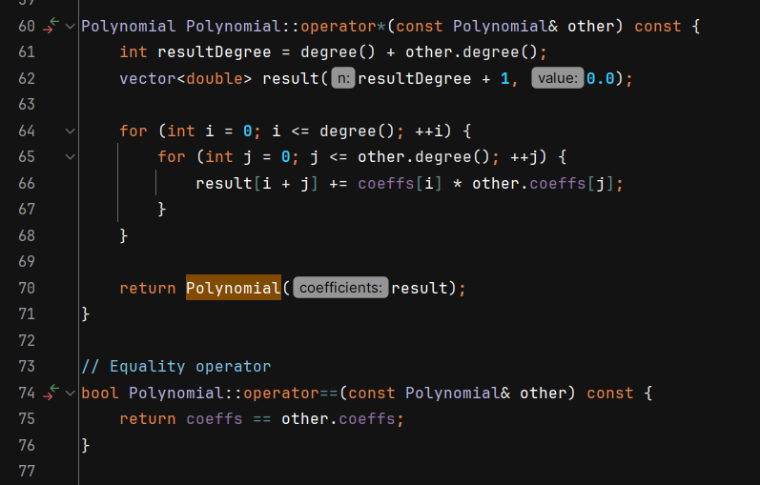

Great coding style!

Test cases :

Works great!

* 1. Output operator :

Making no comments at all is considered a bad coding practice, code looses 0.25.

* 1. Utility functions
     1. Degree and evaluate :

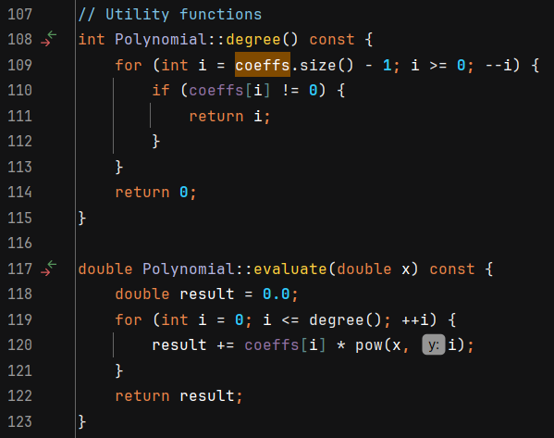

Using pow function is not the best idea, since using fast power would have been more efficient, code looses 1 mark.

Test cases :

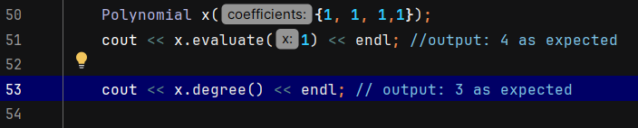

Works well!

* + 1. Compose and derivative:

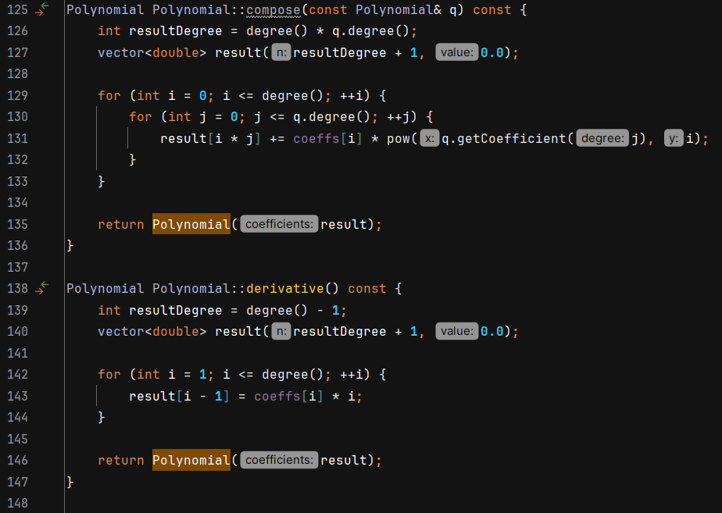

variable name ‘q’ doesn’t really tell anything about what it is, code looses 0.1 marks.

Test cases:

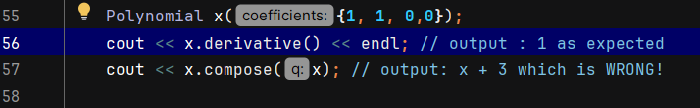

code looses 3.25 marks for incorrectness.

* + 1. Integral:

Test cases :

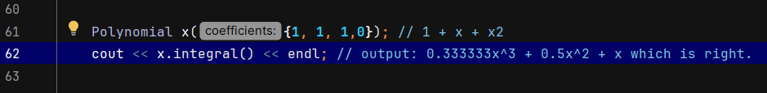

Forgetting about the constant at the end makes code loose 0.25 marks.

* + 1. getRoot:

Names like f and df are not meaningful names, maxIter is not pronounceable name, parantathese should have been used in line 166, code looses 0.6

Gimini did a fatal mistake by redefining default argument causing a compilation error.

Code looses 2 mark.

Test case :

Code looses 2.25 marks for incorrectness.

* + 1. Getters and setters :

Test cases :

* 1. Final score : 83.05/100

Finally, we can confidently say Gimini has done better in this assignment than chatgpt, 83.05/100 for Gimini and 68.25/100 for chat gpt, Although it wouldn’t be fair to say Gimini is better coder than chatgpt from 1 task.

Task 3

**Route Academy:**

An independent Egyptian education provider whose CEO is Ahmed Bahnasy. It is located in Cairo, but courses are available online as well. It offers learning programs for : (Web Development, Mobile App Development, Data Science, UI/UX Design.)

The duration of each program varies, but it’s safe to assume that it won’t take more than months.

Requirements to enroll in Route Academy programs typically include a basic understanding of programming, though beginners are also welcome, as some bootcamps are designed for students with little or no experience. Additionally, students should have access to a computer and reliable internet, particularly if taking online courses.

**AlMakinah :**

is a coding bootcamp based in Cairo, Egypt, aimed at providing practical tech education and preparing students for careers in the tech industry:

Full-time and part-time bootcamps with in-person and online options. And it’s located in Cairo, Egypt (Nasr City)

**Full-Stack Web Development Bootcamp**:

* **Duration**: 12 weeks (full-time).
* **Curriculum**: Covers front-end and back-end web development, HTML, CSS, JavaScript, Node.js, databases, and version control systems like Git.
* **Projects**: Students work on individual and group projects to build a portfolio, which is crucial for job applications.

Fees and conditions are not mentioned but it’s known to be affordable.

**Misk Academy :**

is an educational initiative launched by the Misk Foundation, a non-profit organization founded by Saudi Crown Prince Mohammed bin Salman. The academy is part of Misk’s broader efforts to empower Saudi youth and develop the kingdom’s workforce by providing cutting-edge education and training in key sectors like technology, media, leadership, and culture.

**Location**: Primarily based in Riyadh, Saudi Arabia, but offers online learning for students worldwide.

Partnered with institutions like General Assembly to offer coding bootcamps and courses in data science, UX/UI design, and cybersecurity. The programs are designed to be intensive and project-based, preparing students for real-world employment in the tech sector.

**Conditions**: Many programs target Saudi youth, but online programs and global partnerships also make it accessible to international students. Programs are available for both beginners and experienced professionals looking to upskill.

**Fees**: Misk Academy often provides scholarships or fully-funded programs, especially for Saudi citizens. Some international courses might have associated fees, but Misk frequently subsidizes them to make education more accessible.

**As the students** :

Youssef Farid 20230504: chose cybersecurity as it’s a reliable job that’s hard to replace.

Islam Waleed 20230062: chose the backend track because of its availability and how easy to find a job there.

Mohamed Ali 20230347: chose AI as it’s the future of the world and he likes to push it to its maximum.