Architecture of model

Summary

Dataset link: <https://www.kaggle.com/datasets/ayushv322/animal-classification>

Dataset details:

There are four classes ( Zebra _ elephant _ Rhino _ Buffalo )

Each class has one thousand of images in it

And the total number is four thousands image

Implementation details

1. A CSV file has been created to contain an index for all images from classes [Zebra_elephant_bufflao_Rhino]
2. With python scripting code three CSV files have been generated to index the chosen images and partition images randomly into four equal subset [G1 – G2 – G3 - test] contain the images name, image classes
3. Each subset contain equal number of images ( 250 image for each class ) and the total number is 1000.
4. The cross-validation technique has been used in training and validation. In the first training and validation cycle, the subsets G1 and G2 have been used for training the model and the subset G3 has been used for the validation
5. In the second training and validation cycle subsets G1 and G3 have been used for training and the subset G2 are used for the validation process. In the third training and validation cycle, subsets G2 and G3 have been used for the training process and subset G1 for the validation process.
6. After each cycle we test the algorithm with (test data) and see the accuracy and try to develop it.

Results and visualizations

Accuracy on test images after cycle 1 =79% ,cycle 2 =81% ,cycle 3 = 81%

Accuracy average is = 80%

Train and validation (loss , accuracy) :

Confusion matrix on test images:

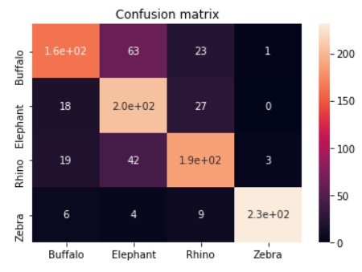

Reports on test images:

Images of train and validation: images of test :

