***Dr.*** Hesham

***Dr***. kaream / Nourhan

***Name :*** islam mohamed

***Id :4211063***

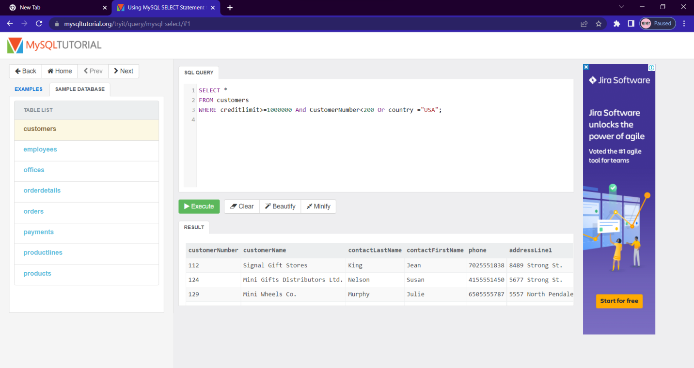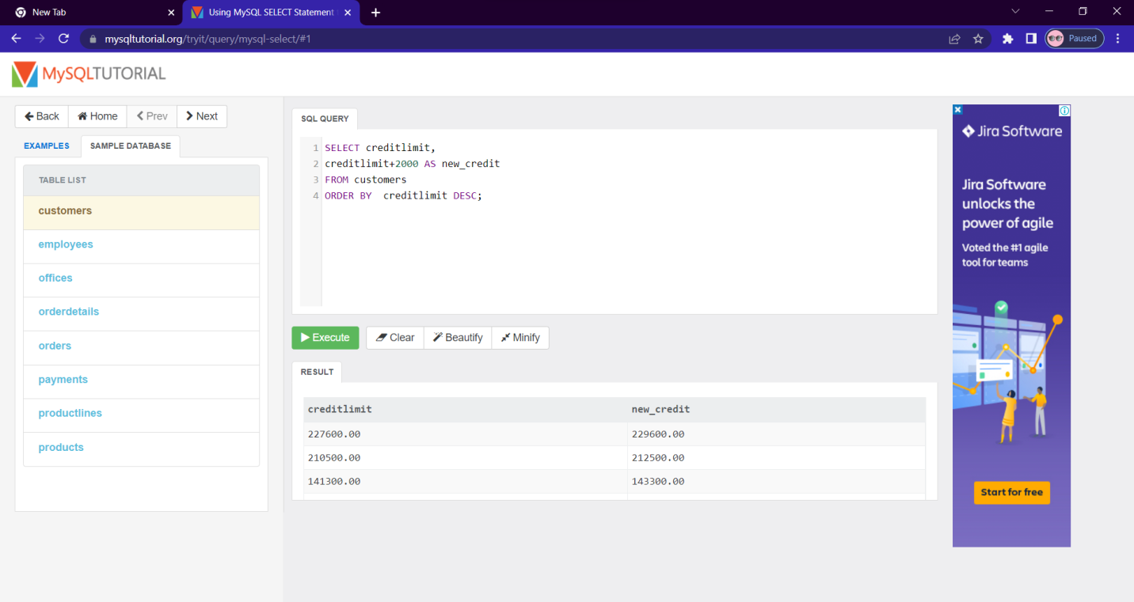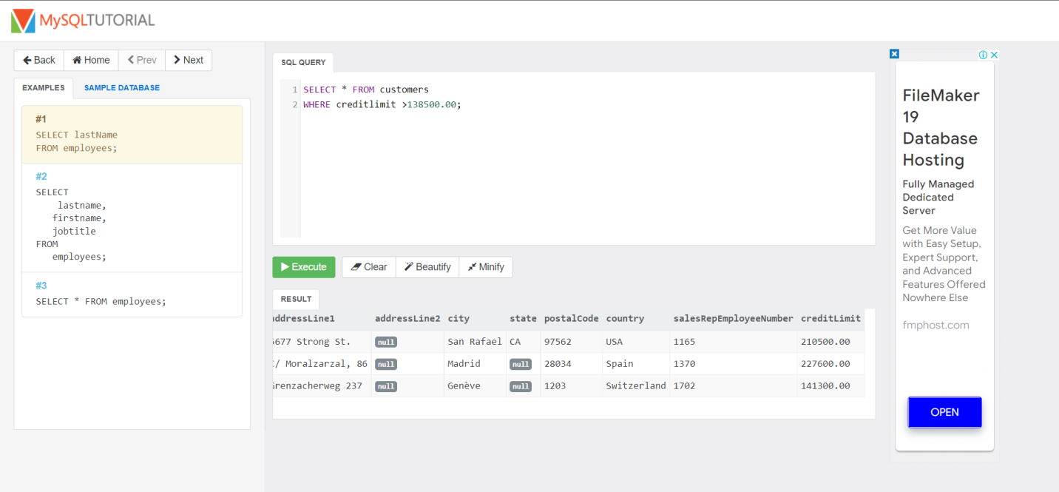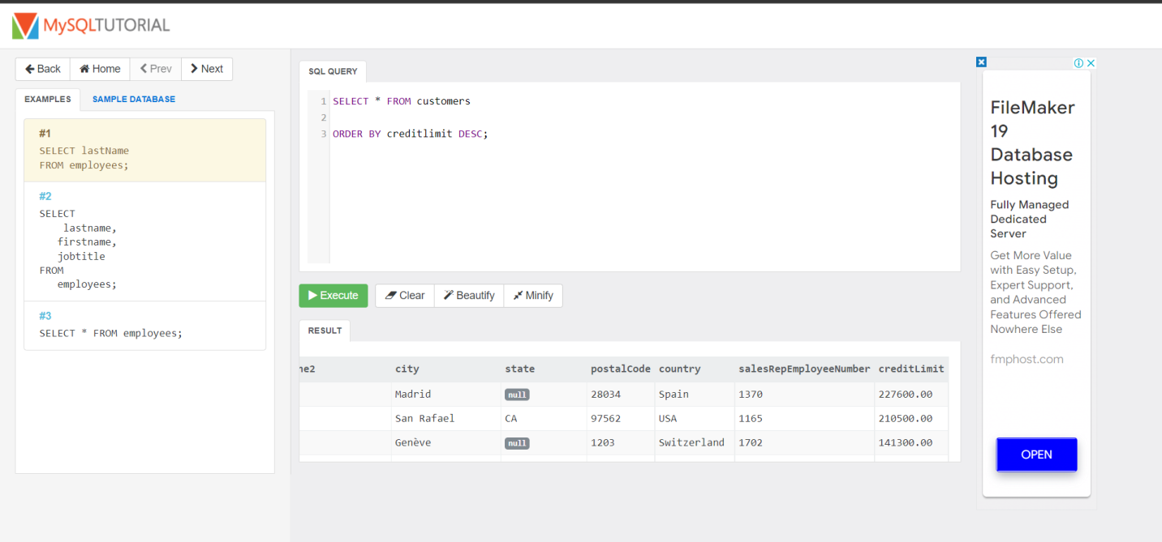

## What are regular expressions?

Regular Expressions help search data matching complex criteria. We looked at wildcards in the previous tutorial. If you have worked with wildcards before, you may be asking why learn regular expressions when you can get similar results using the wildcards. Because, compared to wildcards, regular expressions allow us to search data matching even more complex criterion.

## Basic syntax

HERE –

* “SELECT statements…” is the standard SELECT statement
* “WHERE fieldname” is the name of the column on which the regular expression is to be performed on.
* “REGEXP ‘pattern'” REGEXP is the regular expression operator and ‘pattern’ represents the pattern to be matched by REGEXP. **RLIKE** is the **synonym for REGEXP** and achieves the same results as REGEXP. To avoid confusing it with the LIKE operator, it **better to use REGEXP** instead
* SELECT * FROM `movies` WHERE `title` REGEXP 'code';
* SELECT * FROM `movies` WHERE `title` REGEXP '^[abcd]';
* SELECT * FROM `movies` WHERE `title` REGEXP '^[^abcd]';

## Regular expression metacharacters

What we looked at in the above example is the simplest form of a regular expression. Let’s now look at more advanced regular expression pattern matches. Suppose we want to search for movie titles that start with the pattern “code” only using a regular expression, how would we go about it? The answer is metacharacters. They allow us to fine tune our pattern search results using regular expressions.

