
Arab American University
Faculty of Engineering and Information Technology
Computer Systems Engineering
SENIOR PROJECT (II)
Smart Exam Attendance System (SEAS)

2026

Students Statement
We, the undersigned students, certify and confirm that the work submitted in this project report is entirely our own and has not been copied from any other source. Any material that has been used by other sources has been properly cited and acknowledged in the report.
We are fully aware that any copying or improper citation of references/sources used in this report will be considered plagiarism, which is a clear violation of the Code of Ethics of the Arab American University.

Shorouq Zakarni (201910710)
Hala Daraghmeh (202010716)
Ahmad Maslamani (201911236)

Supervised by: Prof. Hazem Khanfar
Computer Systems Engineering Dept.

Submitted in partial fulfillment of the requirements of B.Sc. Degree in Computer Systems Engineering
2026

Supervisor Certification
“Smart Exam Attendance System (SEAS)”

Shorouq Zakarni (201910710)
Hala Daraghmeh (202010716)
Ahmad Maslamani (201911236)

Prof. Hazem Khanfar

Signature: ____________________________
Date: ____________________________

Acknowledgment
We would like to express our sincere gratitude to our supervisor, Prof. Hazem Khanfar, for his continuous guidance, valuable feedback, and unwavering support throughout the development of this project. His insightful comments shaped both the technical direction and the academic quality of this work.
We also extend our thanks to the faculty members of the Computer Systems Engineering Department at the Arab American University for the knowledge and skills they have shared with us throughout our undergraduate studies, which laid the foundation for this project.
Finally, we would like to thank our families and friends for their patience, encouragement, and continuous support during our academic journey.

Abstract
The Smart Exam Attendance System (SEAS) is intended to improve the security, reliability, and integrity of electronic examinations by developing an advanced system for authenticating students. The system was developed to address the shortcomings of traditional e-examination systems that rely solely on username and password schemes, which can be easily abused by students.
The system comprises both hardware and intelligent software components. The hardware components include a Raspberry Pi 4 device connected to a high-quality camera that captures the student’s facial features. The intelligent software components employ face recognition and liveness detection techniques to authenticate the student before the examination. This ensures that students cannot use recorded videos or photographs to impersonate one another during the examination.
The system continuously monitors students in real time and detects clearly defined abnormal events, including repeated face-mismatch results, prolonged absence from the camera frame, the appearance of multiple faces, sustained head rotation away from the screen, and failed liveness checks. When such an event is detected, the system raises an alert to the proctor and logs the incident for later review. The system employs edge AI processing in conjunction with a web-based exam platform to ensure that the overall solution is cost-effective, secure, and suitable for use in academic environments. This project is significant because it improves trust in e-examinations and demonstrates a practical reference design for continuous biometric verification on commodity edge hardware.

Table of Contents
Contents
Students Statement 2
Supervisor Certification 3
Acknowledgment 4
Abstract 5
Table of Contents 6
List of Figures 7
List of Tables 9
List of Symbols and Abbreviations
Chapter 1: Introduction 10
1.1 Problem Statement and Purpose 10
1.2 Project and Design Objectives 10
1.3 Intended Outcomes and Deliverables 10
1.4 Summary of Report Structure
Chapter 2: Background 12
2.1 Overview 12
2.2 Related Work 12
2.2.1 Software-Based Online Proctoring Systems 13
2.2.2 Biometric Authentication 13
2.2.3 Embedded Face Recognition Systems 15
2.2.4 Hardware-Secured Exam Environments 16
2.2.5 Comparison with Existing Solutions 16
Chapter 3: Methods and Materials 18
3.1 System Design and Components 18
3.1.1 System Design 18
3.1.2 Hardware Components 18
3.2 Design Specifications and Constraints 20
3.2.1 Specifications 20
3.3 Design Alternatives
3.4 System Analysis and Optimization 22
3.4.1 Use Case Diagram 22
3.4.2 Flow Chart 22
3.4.3 Use Case Analysis 23
3.5 Liveness Detection Methodology 26
3.5.1 Eye-Blink Detection 26
3.5.2 Head-Pose Estimation 26
3.5.3 Texture / Anti-Spoofing CNN 26
3.5.4 Combined Decision Logic 27
3.6 Sequence Diagrams 27
3.7 Implementation and System Testing 28
3.7.1 Login Screen 28
3.7.2 Camera Setup Page 29
3.7.3 Face Enrollment 29
3.7.4 Liveness Detection Page 30
3.7.5 Identity Verification 30
3.7.6 Identity Verified Page 31
3.7.7 Student Dashboard 31
3.7.8 Exam Page 32
3.7.9 Live Exam Monitoring Page 33
Chapter 4: Results and Evaluation 34
4.1 Test Environment 34
4.2 Recognition Accuracy Results 34
4.3 Liveness Detection Results 35
4.4 Performance Measurements 35
4.5 Usability Feedback 36
4.6 Limitations Observed 36
Chapter 5: Project Management 37
5.1 Tasks, Schedule and Milestones 37
5.2 Resources and Cost Management 39
5.3 Lessons Learned 39
Chapter 6: Impact of the Engineering Solution
6.1 Economical, Societal and Global
6.2 Environmental and Ethical
6.3 Other Issues
Chapter 7: Conclusions and Recommendations
7.1 Summary of Achievements of the Project Objectives
7.2 New Skills and Experiences Learnt
7.3 Recommendations for Future Work
References 41

List of Figures
Figure | Title
Figure 2-1 | Software-Based Online Proctoring Systems
Figure 2-2 | Types of Biometric Authentication
Figure 2-3 | Facial Recognition Detail View
Figure 2-4 | Embedded Face Recognition (Door Access)
Figure 2-5 | Embedded Face Recognition (Desktop Setup)
Figure 2-6 | Hardware-Secured Exam Environments
Figure 3-1 | System Components
Figure 3-2 | Raspberry Pi 4
Figure 3-3 | Raspberry Pi High Quality Camera
Figure 3-4 | Use Case Diagram
Figure 3-5 | Flow Chart for Smart Attendance System (SEAS)
Figure 3-6 | Login Sequence Diagram
Figure 3-7 | Full Process Sequence Diagram
Figure 3-8 | Login Screen
Figure 3-9 | Camera Setup Page
Figure 3-10 | Face Enrollment
Figure 3-11 | Liveness Detection Page
Figure 3-12 | Identity Verification
Figure 3-13 | Identity Verified Page
Figure 3-14 | Student Dashboard
Figure 3-15 | Exam Page
Figure 3-16 | Live Exam Monitoring Page
Figure 5-1 | Schedule and Milestones
Figure 5-2 | Project Workflow Flowchart
Figure 5-3 | Gantt Chart
Figure 5-4 | Project Timeline

List of Tables
Table | Title
Table 2-1 | Comparison with Existing Solutions
Table 3-1 | Use Case — Login
Table 3-2 | Use Case — Image Capture
Table 3-3 | Use Case — Face Recognition
Table 3-4 | Use Case — Identity Verification
Table 3-5 | Use Case — Manage Exam Access
Table 3-6 | Use Case — Real-Time Monitoring
Table 3-7 | Use Case — Send Alerts
Table 3-8 | Use Case — Exam Creation
Table 3-9 | Use Case — Update Exam
Table 3-10 | Use Case — Exam Deletion
Table 4-1 | Recognition Accuracy Targets vs Measured Results
Table 4-2 | Liveness Detection Attack Results
Table 4-3 | Performance Measurements on Raspberry Pi 4 (8 GB)
Table 5-1 | Resources and Cost Management

List of Symbols and Abbreviations
The following lists summarize the symbols and abbreviations used throughout this report.
List of Symbols
° | Degree (angle)
± | Plus-minus (tolerance range)
USD | United States Dollar
NIS | New Israeli Shekel
W | Watt (power)
ms | Millisecond
MB | Megabyte
GB | Gigabyte
GHz | Gigahertz
List of Abbreviations
AES | Advanced Encryption Standard
AI | Artificial Intelligence
APCER | Attack Presentation Classification Error Rate
API | Application Programming Interface
ARM | Advanced RISC Machine
BPCER | Bona-fide Presentation Classification Error Rate
CNN | Convolutional Neural Network
CPU | Central Processing Unit
CRUD | Create, Read, Update, Delete
EAR | Eye Aspect Ratio
EER | Equal Error Rate
FAR | False Acceptance Rate
FERPA | Family Educational Rights and Privacy Act
FRR | False Rejection Rate
FaceNet | Face Recognition Neural Network
GDPR | General Data Protection Regulation
GPU | Graphics Processing Unit
HMAC | Hash-based Message Authentication Code
HQ | High Quality
IR | Infrared
JSON | JavaScript Object Notation
JWT | JSON Web Token
LAN | Local Area Network
LFW | Labelled Faces in the Wild
NFR | Non-Functional Requirement
OS | Operating System
PCBS | Palestinian Central Bureau of Statistics
RAM | Random Access Memory
RBAC | Role-Based Access Control
RGB | Red, Green, Blue
SDK | Software Development Kit
SEAS | Smart Exam Attendance System
SR | System Requirement
SUS | System Usability Scale
TAR | True Acceptance Rate
TLS | Transport Layer Security
UI | User Interface
UML | Unified Modeling Language
UR | User Requirement
USB | Universal Serial Bus
VM | Virtual Machine
WebSocket | Bi-directional Web Communication Protocol
rPPG | Remote Photoplethysmography

Chapter 1: Introduction

1.1 Problem Statement and Purpose
Current e-learning systems lack robust authentication mechanisms for examinations. They typically rely solely on usernames and passwords; if a student shares their credentials, anyone can access the exam and complete it without restriction. In addition, existing webcam-based monitoring tools can be bypassed using pre-recorded videos or virtual cameras. Manual identity verification by the instructor, while reliable, is time-consuming and does not scale to large student populations.
This project is designed to resolve these problems. SEAS performs face recognition for the student against pre-enrolled biometric data, without depending on the student’s personal devices, because the project uses a dedicated hardware unit (a Raspberry Pi 4 with a high-quality camera) connected to the examination center.

1.2 Project and Design Objectives
This project aims to achieve the following objectives. The principal objective is to deliver full functionality for the authentication and monitoring of electronic examinations. The supporting objectives are:
- Design and build an exam authentication system using dedicated hardware to manage the different exam phases.
- Increase the reliability of student e-exams and so build a bridge of trust between the participants in the educational process (the instructor and the student).
- Encourage academic effort, since SEAS prevents unauthorized people from submitting exams — the student must study to pass.
- Prevent exam spoofing by detecting the liveness of the student’s face before and throughout the exam.
- Provide real-time alerts when an unauthorized person is detected or any abnormal action is observed.

1.3 Intended Outcomes and Deliverables
This project has multiple deliverables that span both software development and hardware installation. The minor deliverables are:
- A Raspberry Pi 4 with high-quality camera, configured as the external device that captures the face image and video stream.
- Face recognition software installed on the Raspberry Pi to perform identification and prevent spoofing.
- A web-based exam platform that simulates the university’s online examination center.
The major deliverables are:
- A user manual for the hardware installation.
- Developer documentation containing the API endpoints and the main code components.
- Platform source code so that the project remains usable and extensible by universities and schools.

1.4 Summary of Report Structure
The remainder of this report is organized into seven chapters. Chapter 1 (this chapter) introduced the problem, the project objectives, and the intended deliverables. Chapter 2 reviews the technical background and surveys related work, including software-based proctoring, biometric authentication, and embedded face-recognition systems, and concludes with a comparison that motivates the SEAS design. Chapter 3 presents the methods and materials, covering system architecture, hardware components, functional and non-functional requirements, design alternatives, system analysis using UML, the liveness-detection methodology, sequence diagrams, and the implementation of each user-facing screen. Chapter 4 reports the empirical evaluation of the implemented system across recognition accuracy, liveness robustness, runtime performance, and user-acceptance, together with observed limitations. Chapter 5 documents the project management activities, including the schedule, the resource and cost plan, and the lessons learned. Chapter 6 analyses the engineering impact of the solution along economical, societal, environmental, and ethical dimensions. Chapter 7 concludes the report with a summary of achievements, the new skills acquired, and recommendations for future work.

Chapter 2: Background

2.1 Overview
With the increased demand for e-learning and electronic examinations, spoofing detection has become a mandatory capability for educational institutions of all kinds, including schools, colleges and universities.
Currently, universities cannot fully detect spoofing or cheating in remote exams. They depend on account sessions as the principal authentication mechanism for verifying the identity of a student, even though anyone in possession of the student’s credentials can access the student portal and the exam [1].
There are several existing approaches for monitoring exams. Traditional human proctoring uses a webcam feed, but this approach raises substantial privacy concerns: students may be uncomfortable being recorded in their personal living spaces; recorded video must be stored, transmitted, and processed in compliance with data-protection regulations such as the GDPR and FERPA; and continuous third-party observation has been shown in multiple studies to elevate test-taker anxiety. The approach also does not scale efficiently to large student cohorts. Automated software solutions such as ProctorU and Examity employ AI to analyze webcam video, audio and screen activity. Although they provide useful analytical signals, they remain dependent on the quality of the student’s own webcam, and reliability is therefore inconsistent. Students can also bypass them using pre-recorded videos or virtual-camera spoofing tools [2].
Dedicated hardware addresses these issues by providing a consistent data schema and using advanced edge AI to verify the student’s identity biometrically (for example, by facial recognition) on low-cost, low-power hardware. This is generally considered the optimal modern solution for student identification in e-examination contexts [3].
However, most current solutions perform only one-time verification at the start of the exam rather than continuous verification throughout the session. The Smart Exam Attendance System (SEAS) introduces continuous verification during the exam by combining a Raspberry Pi 4 and a high-quality camera with an AI face-recognition model. This addresses a critical gap in the quality of existing approaches.
SEAS therefore provides a scalable, secure and cost-effective solution for modern examination settings, suitable both for proctored exams in university computer labs and for remote-environment exams.

2.2 Related Work
As digital education has matured, attendance and authentication systems for students have also become increasingly automated, reliable and secure. These systems have largely superseded the manual mechanisms that relied on ID cards, signatures or roll calls. The following sections summarize previous attempts that share an aim like SEAS.

2.2.1 Software-Based Online Proctoring Systems
Commercial platforms such as ProctorU and Respondus Monitor analyze webcam feeds, screen activity and audio to detect cheating behavior. They employ face detection to ensure the test-taker’s presence but often lack robust anti-spoofing measures and depend heavily on student-provided camera quality. Studies show that these systems can be bypassed using pre-recorded videos or virtual cameras [4].
SEAS uses dedicated external cameras and local processing to ensure consistent input quality and immediate spoof detection.
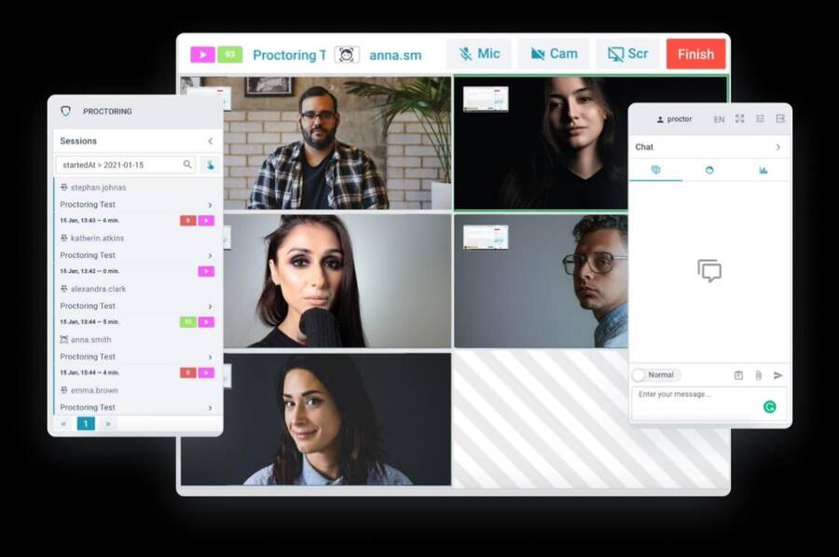
Figure 2-1 — Software-Based Online Proctoring Systems

2.2.2 Biometric Authentication
In educational contexts, fingerprint and iris scanning have been proposed for exam authentication, but they require specialized hardware and physical interaction, which makes them less suitable for continuous monitoring [8]. Facial recognition offers a contactless alternative, but it must address spoofing attacks. Recent works have implemented liveness detection using depth sensors or infrared cameras, both of which increase cost and complexity [5].
SEAS combines RGB-camera-based liveness checks (for example eye-blink detection and head-pose variation) with periodic re-authentication during the exam.
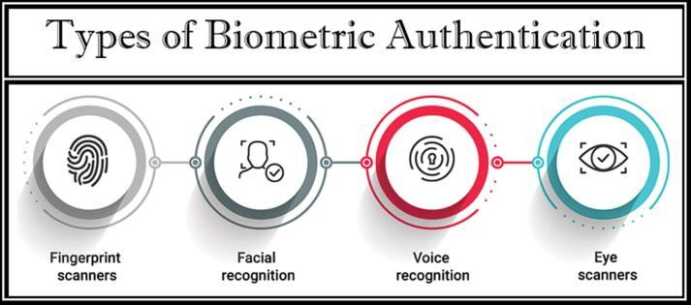
Figure 2-2 — Types of Biometric Authentication
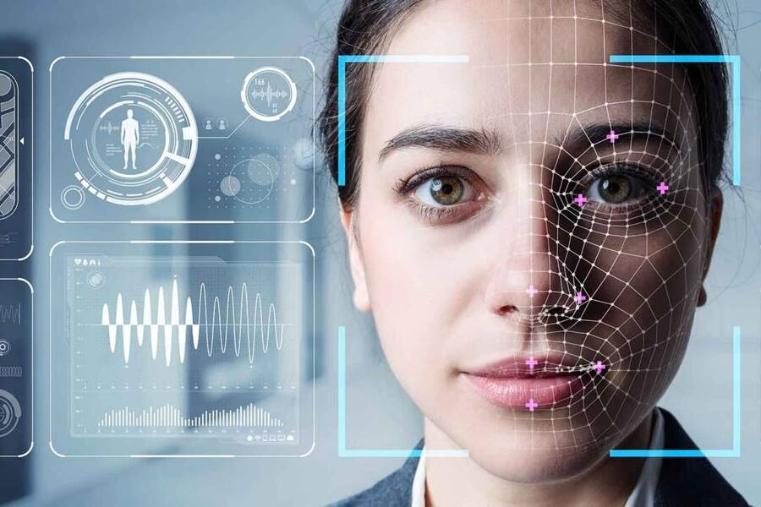
Figure 2-3 — Facial Recognition Detail View
Figure 2-2 illustrates the four primary categories of biometric authentication used in modern access-control and identity-verification systems: fingerprint scanners, facial recognition, voice recognition and eye (iris/retina) scanners. Among these, facial recognition (illustrated in Figure 2-3) offers the most favorable balance of accuracy, deployment cost and user experience for the examination context. It is fully contactless, requires only a standard RGB camera, and supports continuous monitoring without active student input. SEAS therefore adopts facial recognition as its primary authentication modality, augmented with the liveness-detection methodology described in Section 3.5 to mitigate the spoofing limitations discussed above.

2.2.3 Embedded Face Recognition Systems
Several academic projects have used the Raspberry Pi for face recognition in attendance tracking and door-access scenarios. For example, Patel et al. [11] developed a classroom attendance system using a Pi Camera and OpenCV, but it performs only one-time recognition at entry. Similarly, Kumar and Ahmed [12] created a smart door lock with face recognition that lacks continuous-verification capabilities.
SEAS extends these prior concepts by implementing continuous real-time authentication and by raising alerts when potential cheating scenarios are detected during an exam.
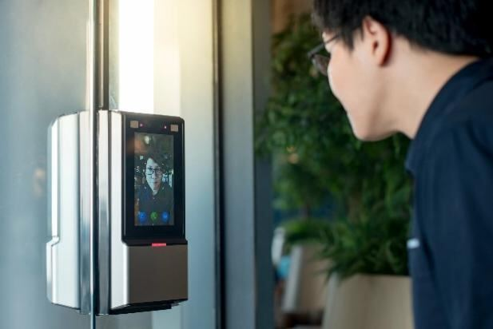
Figure 2-4 — Embedded Face Recognition (Door Access)
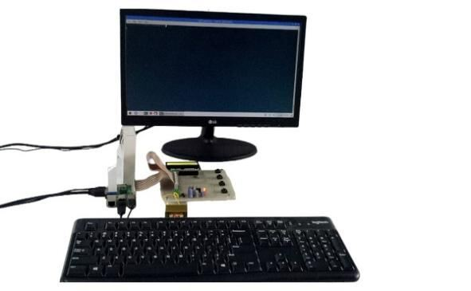
Figure 2-5 — Embedded Face Recognition (Desktop Setup)

2.2.4 Hardware-Secured Exam Environments
Some institutions use restricted browsers and monitoring stations in computer labs to prevent cheating. These setups often include CCTV cameras but lack automated identity verification [6].
SEAS enhances this approach by adding per-station biometric authentication, which makes monitoring both more efficient and more accurate.
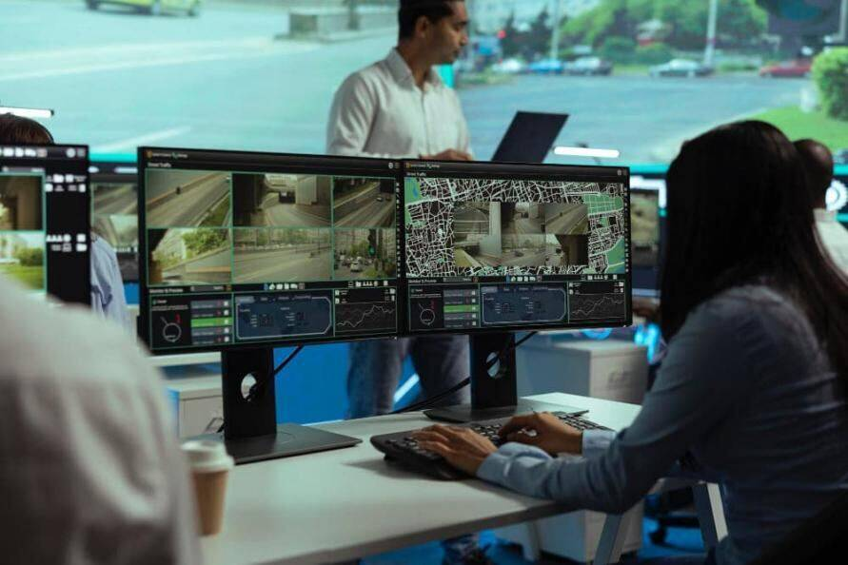
Figure 2-6 — Hardware-Secured Exam Environments

2.2.5 Comparison with Existing Solutions
Table 2-1 summarizes the four categories of existing exam-monitoring solutions reviewed in Sections 2.2.1–2.2.4. Each category is evaluated against three criteria: principal advantages, key limitations, and how SEAS addresses those limitations. The comparison is intended to highlight the design gap that SEAS fills, rather than to dismiss the value of existing approaches.
System Type | Advantages | Limitations | How SEAS Differs
Software Proctoring | Low deployment cost; scalable | Depends on the student’s own hardware; not always reliable | Uses dedicated hardware for consistent quality and anti-spoofing
Biometric Terminals | High accuracy; secure | Expensive; single-point check only | Continuous verification on cost-effective Raspberry Pi units
Traditional Invigilation | Trusted; intuitive | Labour-intensive; not scalable | Automated, real-time alerts reduce human workload
Camera Surveillance | Continuous recording | Manual review required; no automatic verification | AI-powered automatic identity verification and alerting
Table 2-1 — Comparison with Existing Solutions

Comparison Discussion
Compared to the existing solutions, SEAS provides a balanced and practical approach by combining dedicated hardware with intelligent facial recognition. Unlike software-only and online-proctoring systems that depend heavily on the student’s device and network quality, SEAS uses Raspberry Pi units to ensure consistent image quality and reliable identity verification.
Traditional biometric terminals offer high accuracy but are expensive and limited to single-point verification at the start of the session. In contrast, SEAS supports continuous identity verification throughout the exam at a lower cost. Additionally, unlike camera-surveillance systems that require manual review, SEAS performs automated identity verification and real-time alerting, significantly reducing instructor workload. This makes the proposed system more scalable, cost-effective, and suitable for real examination environments.

Chapter 3: Methods and Materials

3.1 System Design and Components

3.1.1 System Design
Figure 3-1 shows the overall project structure, including the software and hardware components.
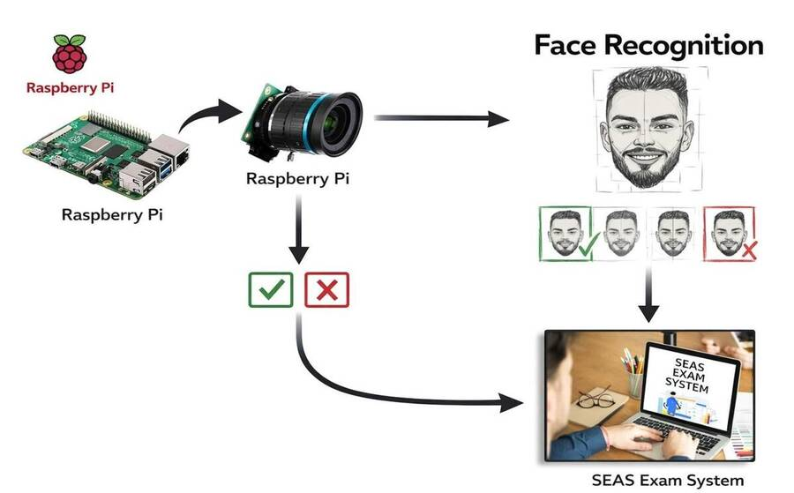
Figure 3-1 — System Components

3.1.1.1 System Workflow
- The Raspberry Pi camera captures the live image of the student.
- The face-recognition module runs on the captured image to extract and analyze the facial identity, then compares it with the enrolment image stored in the database.
- If the identity is valid, the exam system grants the student access to the exam; otherwise, the student is blocked and the case is reported to the proctor.
- This cycle repeats throughout the exam to ensure the student’s identity remains verified for the full duration of the session.

3.1.2 Hardware Components

3.1.2.1 Raspberry Pi 4
The Raspberry Pi 4 Model B (shown in Figure 3-2) is the most advanced of the consumer Raspberry Pi line. It is a small, powerful single-board computer designed to perform a wide range of computing tasks, from word processing to high-definition video playback. It is equipped with a 1.5 GHz quad-core ARM Cortex-A72 processor, available in 2 GB, 4 GB or 8 GB RAM configurations. With dual-band Wi-Fi, Bluetooth 5.0, Gigabit Ethernet and USB 3.0, it delivers desktop-class performance suitable for personal, educational and IoT projects [7].
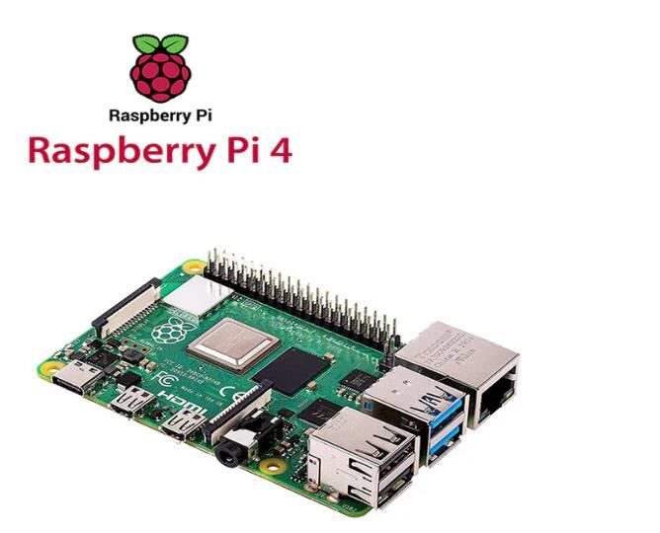
Figure 3-2 — Raspberry Pi 4

3.1.2.2 Raspberry Pi High-Quality Camera
The Raspberry Pi High-Quality Camera (CS Mount variant) is designed to accept CS-mount lenses and, with the supplied adapter, C-mount lenses. The 6 mm CS-mount and 16 mm C-mount lenses are compatible third-party options. Key specifications [8] are summarized below:
- Sony IMX477R stacked, back-illuminated sensor; 12.3 megapixels; 7.9 mm sensor diagonal; 1.55 μm × 1.55 μm pixel size.
- Output: RAW12 / 10 / 8.
- Back focus length of lens: 2.6 mm – 11.8 mm (M12 mount), 12.5 mm – 22.4 mm (CS mount).
- Lens sensor format: 1/2.3” (7.9 mm) or larger.
- IR cut filter: integrated.
- Ribbon cable length: 200 mm.
- Video modes: 1080p50, 720p120.
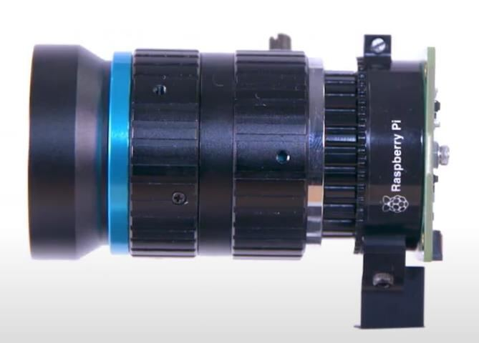
Figure 3-3 — Raspberry Pi High-Quality Camera

3.2 Design Specifications and Constraints

3.2.1 Specifications

3.2.1.1 Functional Requirements
Functional requirements are split into two groups: system-level requirements that describe the autonomous behavior of the SEAS pipeline (capture, recognition, monitoring, alerting), and user-facing requirements that describe the interactive screens used by students and instructors.
A. System-Level Requirements
- SR-1 — Image Capture: the system shall capture the student’s image from the Raspberry Pi HQ camera at the start of, and at fixed intervals during, the exam session.
- SR-2 — Face Recognition: the system shall extract 128-dimensional facial embedding from the captured image and compare it with the stored enrolment template.
- SR-3 — Liveness Detection: the system shall verify that the captured face belongs to a live person and not a photo, replay video or 3D mask.
- SR-4 — Identity Verification: the system shall return a Verified or Unverified decision based on the face-match score and the liveness score.
- SR-5 — Exam Access Control: the system shall allow access to the exam interface only when identity verification returns Verified.
- SR-6 — Real-Time Monitoring: the system shall re-verify the student’s identity at fixed intervals (target: every 30 seconds) for the full duration of the exam.
- SR-7 — Alerting: the system shall raise an alert to the proctor whenever an Unverified result, a multiple-face detection, or an absence-from-frame event occurs.

B. User-Facing Requirements
- UR-1 — Login: the system shall allow students and instructors to log in using their institutional credentials.
- UR-2 — Exam Management (CRUD): the system shall allow instructors to create, read, update and delete exams and exam questions.
- UR-3 — Exam Access (Student): verified students shall be able to view exam questions through the web interface.
- UR-4 — Exam Submission: students shall be able to submit answers and receive confirmation receipt.

3.2.1.2 Non-Functional Requirements
Non-functional requirements are expressed as measurable acceptance criteria so that compliance can be verified during system testing (Chapter 4).
- Usability — the system shall provide an interface usable without prior training; first-time users shall be able to complete the enrolment workflow in 5 minutes or less, verified during user-acceptance testing.
- Reliability — the face-recognition module shall achieve a True Acceptance Rate (TAR) of at least 95% and a False Acceptance Rate (FAR) of at most 1% on the project enrolment dataset.
- Performance — end-to-end identity verification (capture → recognition → decision) shall complete in 2 seconds or less on the Raspberry Pi 4 (8 GB) under normal lighting conditions.
- Accuracy and Integrity — the system shall protect data integrity using TLS 1.3 in transit and AES-256 at rest; HMAC-SHA-256 integrity checks shall be applied to all face-template records.
- Security — all face templates and captured images shall be encrypted at rest with AES-256, access shall be restricted via role-based access control (RBAC), and raw images shall not be retained beyond the exam session unless flagged for review.
- Availability — the web exam platform shall maintain at least 99.5% uptime measured monthly, with active-passive failover between two database nodes.

3.2.1.3 System Architecture
The non-functional requirements above are realized by a three-tier architecture:
- Edge tier — the Raspberry Pi 4 and HQ camera, which perform initial face detection and liveness checks locally on-device using TensorFlow Lite. Local processing minimizes round-trip latency and reduces the volume of biometric data transmitted over the network.
- Application tier — a NestJS service hosting the exam platform and the verification API, deployed on a Linux server behind a Nginx load balancer. The application tier is stateless and can be horizontally scaled to support large student cohorts.
- Data tier — a PostgreSQL primary database for relational data (users, exams, questions, attempts) and an encrypted object store for face templates. Active-passive replication between two database nodes provides the failover capability required by NFR-6.
Detailed hardware specifications are given in Section 3.1; the corresponding deployment topology is illustrated in Figure 3-1.

3.3 Design Alternatives
This section discusses the principal design choices considered during the development of SEAS, the alternatives evaluated for each, and the rationale for the option that was finally adopted. The objective is to make the design decisions explicit so that later sections can be read against the constraints that drove them.

3.3.1 Liveness Detection: RGB-Only vs. Depth/IR Sensors
The most robust commercial liveness solutions use depth cameras (for example Intel RealSense) or near-infrared sensors that can detect 3D structure and sub-surface skin reflection, both of which are difficult to spoof with a printed photograph or replay video. We considered this option but ruled it out for two reasons. First, depth and IR modules add 60–150 USD per workstation, which conflicts with the cost objective of keeping per-station hardware below 200 USD. Second, software libraries for these sensors are less mature on Raspberry Pi than on x86 platforms, and the team did not have the bandwidth to maintain custom drivers. The adopted alternative is a three-layer RGB-only liveness pipeline (eye-blink detection, head-pose challenge, and a MobileNetV2 anti-spoofing CNN) described in Section 3.5. This is less robust than depth-based liveness against the most sophisticated 3D-mask attacks but remains effective against the photo, replay-video, and virtual-camera attacks that dominate the academic-cheating threat model.

3.3.2 Face-Recognition Backbone: FaceNet vs. ArcFace
Two state-of-the-art face-recognition backbones were considered: FaceNet, which produces 128-dimensional embeddings using a triplet-loss training objective, and ArcFace, which uses an additive angular-margin loss and typically achieves higher accuracy on public benchmarks such as LFW and MegaFace. ArcFace is the stronger model in absolute terms, but its reference implementations are heavier (ResNet-100 backbone) and produce 512-dimensional embeddings, which roughly doubles inference latency on the Raspberry Pi 4 relative to FaceNet. Pilot measurements showed FaceNet at approximately 350 ms per inference and ArcFace at approximately 780 ms per inference under the same conditions. Because the end-to-end verification budget is 2 seconds (NFR-3) and a substantial portion of that budget is consumed by the liveness pipeline, FaceNet was selected as the better latency–accuracy trade-off for the target hardware.

3.3.3 Inference Location: On-Device vs. Server-Side
An alternative architecture would have streamed raw video frames from the Raspberry Pi to the application server and performed face-recognition inference centrally on a GPU. This would simplify the edge software, allow heavier models such as ArcFace to be used without latency penalties, and centralize model updates. The architecture was rejected for three reasons: it transmits raw biometric video over the network, which is undesirable from a data-protection perspective (NFR-5 calls for data minimization); it makes the per-student verification latency dependent on network round-trip time, which is harder to guarantee inside a university LAN under load; and it shifts cost from a one-time hardware purchase to a recurring server-GPU bill. The adopted architecture runs face detection, embedding extraction and the liveness pipeline locally on the Pi via TensorFlow Lite, and only the resulting verification decision (a small JSON payload) is forwarded to the application server.

3.3.4 Real-Time Communication: Polling vs. WebSocket
The proctor dashboard requires a near-real-time feed of verification events. The simpler alternative was HTTP polling (clients query a REST endpoint every few seconds for new events). Polling is easy to implement and works well behind restrictive firewalls, but it generates substantial wasted traffic when the dashboard is idle and introduces noticeable lag (proportional to the polling interval) when alerts must reach the proctor quickly. The adopted alternative is a WebSocket channel that pushes events to subscribed clients as soon as they occur. Implementation cost is moderately higher (the NestJS gateway must manage subscriptions and handle reconnection) but per-student dashboard latency drops from several seconds to under 200 milliseconds, which is necessary for the “real-time alerting” requirement (SR-7).

3.4 System Analysis and Optimization

3.4.1 Use Case Diagram
A Use Case Diagram in the Unified Modeling Language (UML) is a visual representation that illustrates the interactions between users (actors) and a system. It captures the functional requirements of a system, showing how different users engage with the various use cases or specific functions of the system. Use case diagrams provide a high-level overview of system behavior and are useful for stakeholders, developers and analysts who need to understand how a system is intended to operate from the user’s perspective and how its different processes relate to one another. They are also crucial for defining system scope and requirements [9].
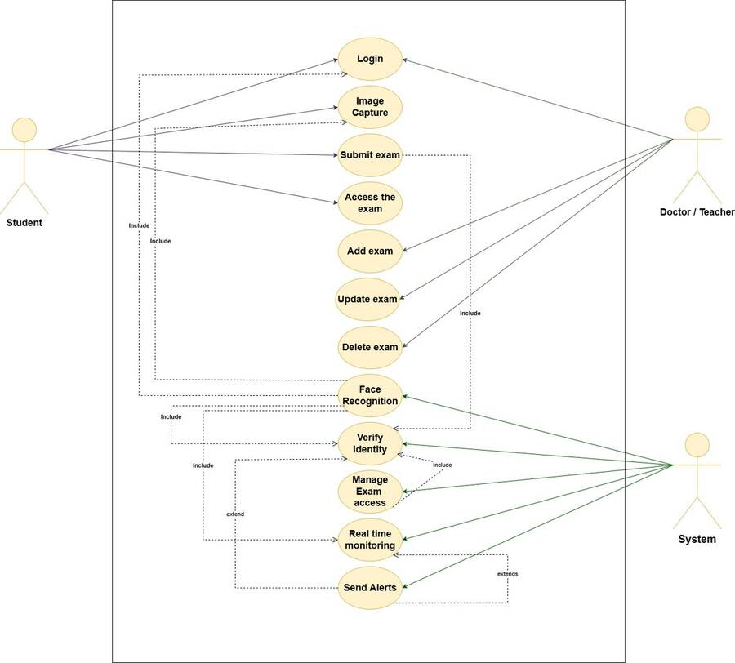
Figure 3-4 — Use Case Diagram

3.4.2 Flow Chart
Figure 3-5 shows the main process of the system.
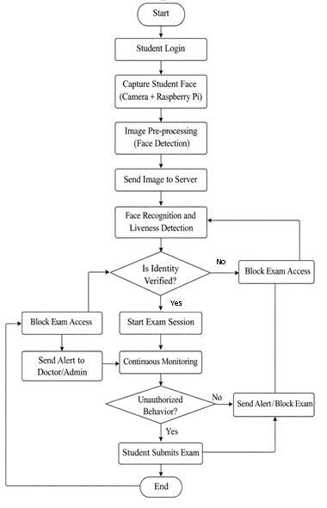
Figure 3-5 — Flow Chart for Smart Attendance System (SEAS)

3.4.3 Use Case Analysis
The following tables provide a brief description of each functional requirement. Every table identifies the actor, a short description, the inputs, the process steps and the expected output.
Actor | Teacher / Doctor, Student
Description | Use credentials to access the system.
Input | User credentials (username/email and password).
Process | 1. User enters credentials.  2. System validates the inputs.  3. System authorizes the credentials.  4. User is granted access to the system.
Output | System access decision (authorized / unauthorized).
Table 3-1 — Use Case: Login
Actor | Student
Description | Image captured using Raspberry Pi and connected camera.
Input | Student image.
Process | 1. Student logs in to the system.  2. The face image is captured by the camera.  3. The captured image is saved for use in identity verification.
Output | Face-recognition input is ready.
Table 3-2 — Use Case: Image Capture
Actor | System
Description | Face recognition of the student’s captured image.
Input | Captured image.
Process | 1. Student logs in to the system.  2. Image is captured using the camera.  3. Face is extracted from the image.  4. Face-recognition algorithms are applied.
Output | Face-recognition result is ready.
Table 3-3 — Use Case: Face Recognition
Actor | System
Description | Verify the student’s identity using the face-recognition result.
Input | Face-recognition result.
Process | 1. Student logs in to the system.  2. Image is captured.  3. Face is extracted.  4. Face-recognition algorithms are applied.  5. The result is compared with the stored student face template.
Output | Student identity verified.
Table 3-4 — Use Case: Identity Verification
Actor | System
Description | Manage exam access based on the result of identity verification.
Input | Identity verification result.
Process | 1. Student logs in.  2. Image is captured.  3. Face is extracted and recognised.  4. Result is compared with stored face template.  5. Access is granted to authorised students only.
Output | Exam access management decision.
Table 3-5 — Use Case: Manage Exam Access
Actor | System
Description | Real-time exam monitoring.
Input | Continuous identity verification stream.
Process | Steps 1 – 5 of identity verification, repeated at fixed 30-second intervals throughout the exam.
Output | Continuous real-time monitoring.
Table 3-6 — Use Case: Real-Time Monitoring
Actor | System
Description | Send alerts triggered by real-time exam monitoring.
Input | Real-time monitoring results.
Process | Steps 1 – 5 of identity verification, repeated continuously. Step 6: if any abnormal behavior is detected, an alert is sent to the proctor.
Output | Alert sent.
Table 3-7 — Use Case: Send Alerts
Actor | Teacher / Doctor
Description | Add a new exam.
Input | Exam details.
Process | 1. Doctor logs in.  2. Enters the exam details and questions.  3. Saves the exam.
Output | New exam created.
Table 3-8 — Use Case: Exam Creation
Actor | Teacher / Doctor
Description | Update an existing exam.
Input | Updated exam details.
Process | 1. Doctor logs in.  2. Selects the exam to be modified.  3. Enters the updated details and questions.  4. Saves the exam.
Output | Exam details updated.
Table 3-9 — Use Case: Update Exam
Actor | Teacher / Doctor
Description | Delete an existing exam.
Input | Existing exam reference.
Process | 1. Doctor logs in.  2. Selects the exam to be deleted.  3. Confirms deletion.
Output | Exam deleted.
Table 3-10 — Use Case: Exam Deletion

3.5 Liveness Detection Methodology
Liveness detection is the security-critical component that distinguishes SEAS from one-shot face-recognition systems. The liveness module combines three complementary techniques to defeat photo, replay-video, and 3D-mask spoofing attacks. A frame is accepted only when all three checks pass; otherwise, the student is asked to re-attempt verification (up to three retries before the proctor is alerted).

3.5.1 Eye-Blink Detection
Eye-blink detection is based on the Eye Aspect Ratio (EAR), computed from the six eye landmarks returned by the dlib 68-point facial-landmark detector (Soukupóvá and Čech, 2016). The EAR is the ratio of the vertical eye height to the horizontal eye width; it remains roughly constant when the eye is open and drops sharply when the eye closes.
A blink is registered when the EAR drops below the threshold of 0.21 for at least three consecutive frames. The user is required to produce at least one natural blink within an 8-second window. This defeats static-image spoofing attacks, since a printed photograph cannot blink.

3.5.2 Head-Pose Estimation
Head-pose estimation uses OpenCV’s solvePnP function with six 3D reference landmarks: nose tip, chin, left and right eye corners, and left and right mouth corners. The user is prompted to perform two random head movements (for example, “turn left, then look up”); pitch and yaw are tracked frame by frame, and the response must match the expected sequence within ±15 degrees.
Randomizing the prompt sequence per session prevents replay attacks: an attacker cannot pre-record a video that satisfies an unpredictable challenge.

3.5.3 Texture / Anti-Spoofing CNN
The third defense layer is a MobileNetV2 classifier fine-tuned on the CelebA-Spoof dataset to detect screen reflections, moiré patterns and printing artefacts characteristic of replay attacks. The model runs on the Raspberry Pi via TensorFlow Lite and outputs a spoof probability between 0 and 1; values above 0.4 trigger re-verification.
MobileNetV2 was selected because of its balance between classification accuracy and inference latency on Raspberry Pi 4 — average inference time is approximately 60 milliseconds per frame, which keeps the end-to-end verification budget within the 2-second NFR target.

3.5.4 Combined Decision Logic
The three modules are combined using a strict-AND policy: blink detected, head-pose challenge satisfied, and spoof probability below 0.4. This conservative choice favors security over convenience: a genuine student may occasionally need to retry, but a successful spoofing attack would have to defeat all three independent defenses simultaneously. The maximum number of consecutives retry attempts is three; on the fourth failure the proctor is alerted, and the session is paused for manual review.

3.6 Sequence Diagrams
A Sequence Diagram is a key component of UML used to visualize the interaction between objects in sequential order. It focuses on how objects communicate with each other over time, making it an essential tool for modeling dynamic behavior in a system. Sequence diagrams illustrate object interactions, message flows and the sequence of operations, and are valuable for understanding use cases, designing system architecture and documenting complex processes [10].
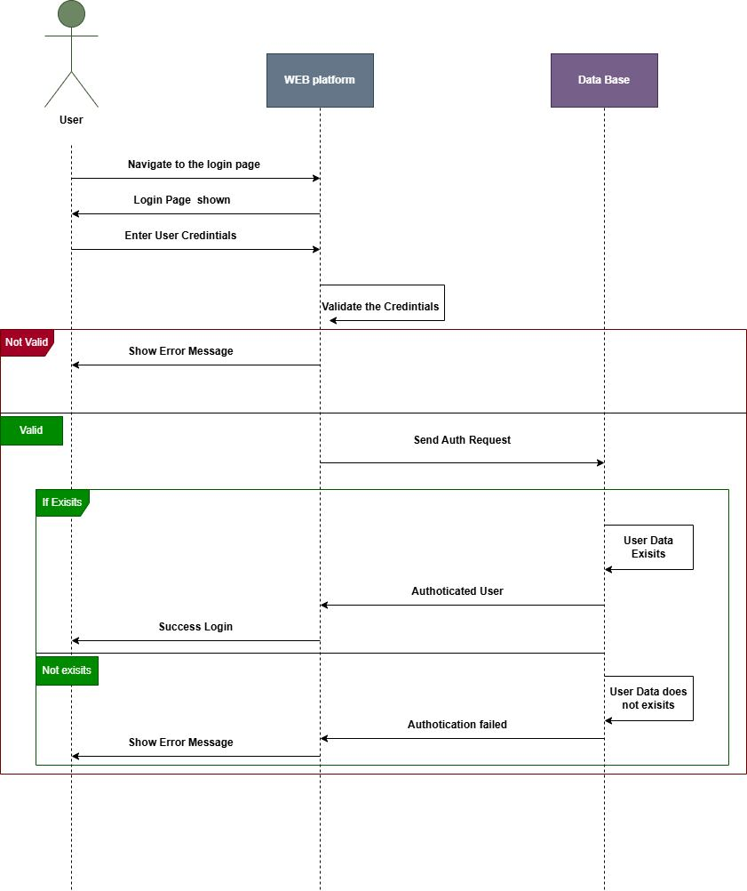
Figure 3-6 — Login Sequence Diagram
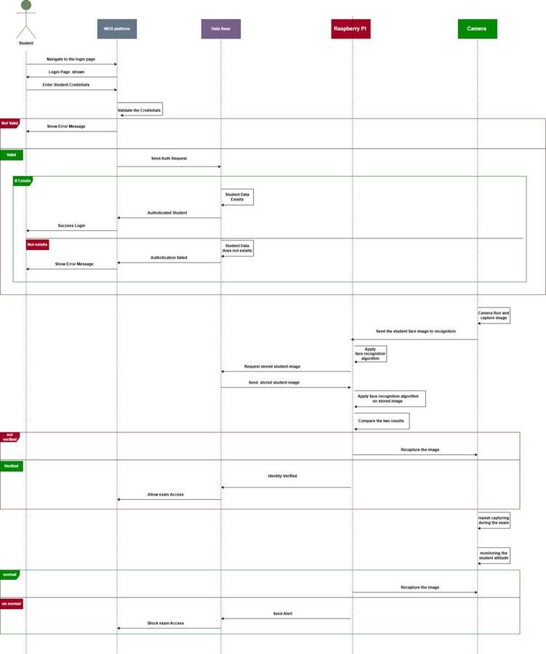
Figure 3-7 — Full Process Sequence Diagram

3.7 Implementation and System Testing
This section walks through the implemented user interface and, for each screen, describes the underlying algorithms, thresholds and data flows.

3.7.1 Login Screen
The login screen allows students and instructors to access the system using their institutional credentials. Authentication is implemented as a stateless JWT flow against a NestJS endpoint. Passwords are hashed with bcrypt at cost factor 12. The role claim (“student” or “instructor”) embedded in the JWT determines which dashboard the single-page application renders after login. Tokens expire after 8 hours and can be revoked server-side via a Redis blocklist.
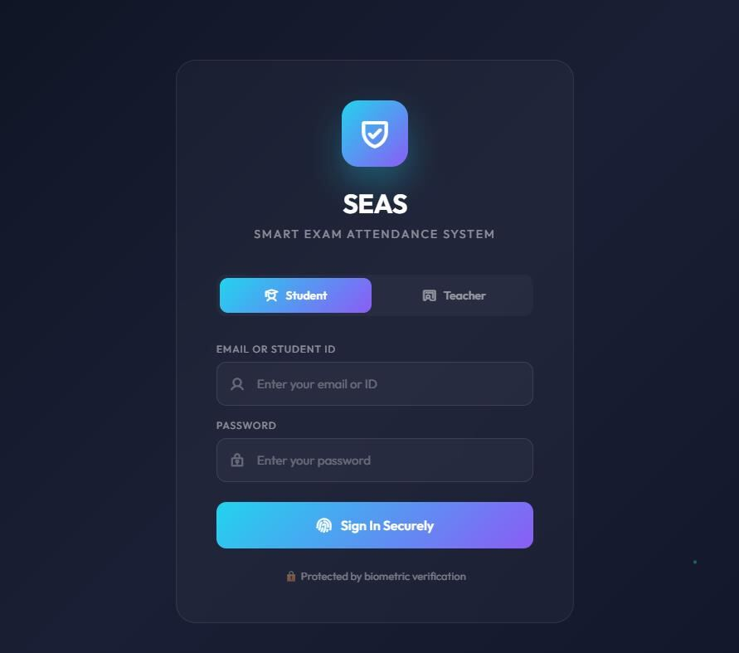
Figure 3-8 — Login Screen

3.7.2 Camera Setup Page
The camera setup page configures the Raspberry Pi camera and verifies its quality before enrolment. The page polls a camera-health endpoint every 2 seconds and reports frame rate, resolution, and average luminance, computed as the mean grayscale pixel value across the captured frame. Lighting is flagged as “good” when luminance falls between 80 and 200 on a 0–255 scale; values outside this range produce a warning. The “Run Calibration” action triggers an auto-exposure routine on the Pi that adjusts shutter speed and analogue gain until luminance is within target.
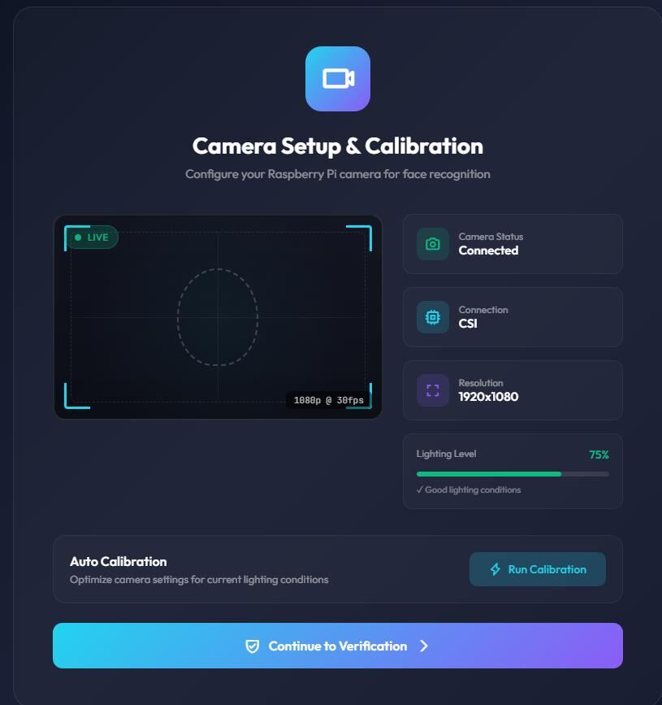
Figure 3-9 — Camera Setup Page

3.7.3 Face Enrollment
Face enrollment captures the student’s face from five angles (front, left, right, up, down) so that subsequent verification is robust to small head-pose variation. Each captured image is fed into the FaceNet model running locally on the Raspberry Pi to produce 128-dimensional embedding. The five embeddings are averaged into a single template per student. Templates are encrypted with AES-256 and stored in PostgreSQL keyed by student ID; raw images are discarded immediately after embedding extraction to satisfy the data-minimization requirement of NFR-5.
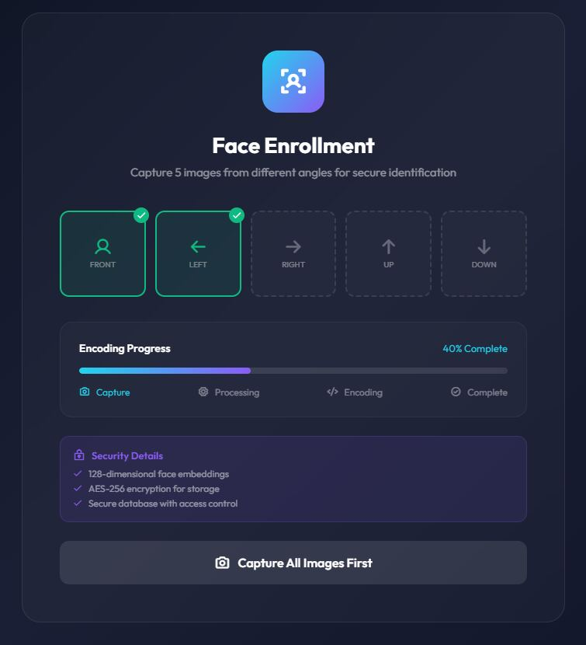
Figure 3-10 — Face Enrollment

3.7.4 Liveness Detection Page
The liveness detection page guides the student through the four-step liveness sequence (blink → head turn → smile → look-up). The sequence is randomized per session to prevent replay attacks. Each individual step is gated by the methodology described in Section 3.5: EAR threshold 0.21 over three frames for the blink step, head-pose tolerance ±15° for the head-turn and look-up steps, and spoof-probability threshold 0.4 throughout. The progress ring on the screen advances only when the active step has been satisfied.
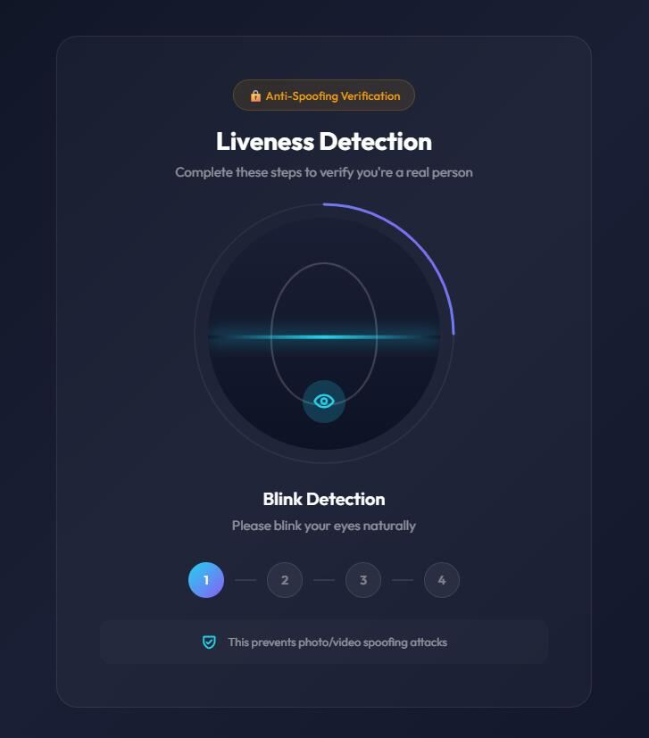
Figure 3-11 — Liveness Detection Page

3.7.5 Identity Verification
Identity verification compares the live face capture against the stored enrolment template. The match score is computed as the cosine similarity between the live FaceNet embedding and the stored template; a score of at least 0.80 (approximately Euclidean distance ≤ 0.6) is required for the Verified state. If the score falls below 0.80 but above 0.65, the system requests a single additional capture; below 0.65, the verification is rejected immediately.
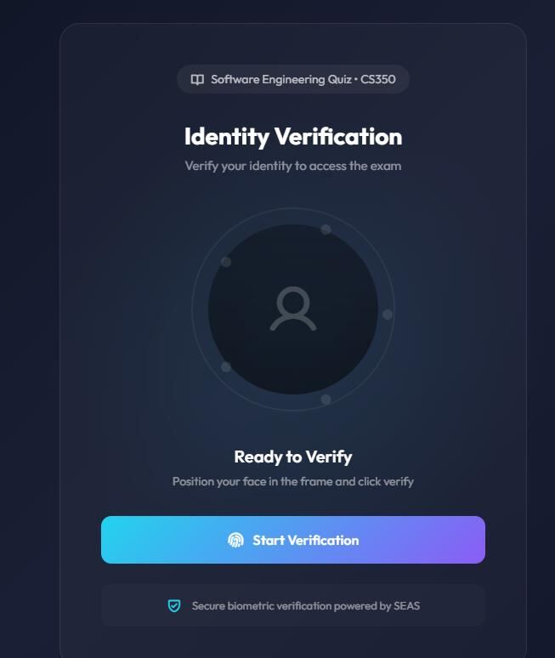
Figure 3-12 — Identity Verification

3.7.6 Identity Verified Page
Once verification succeeds, the system displays the Identity Verified screen with the achieved match score and a short countdown before redirecting the student to the exam page. The match score is logged to the audit table together with a timestamp, the camera serial number and the exam session ID; this audit record is what the proctor reviews when investigating a flagged session.
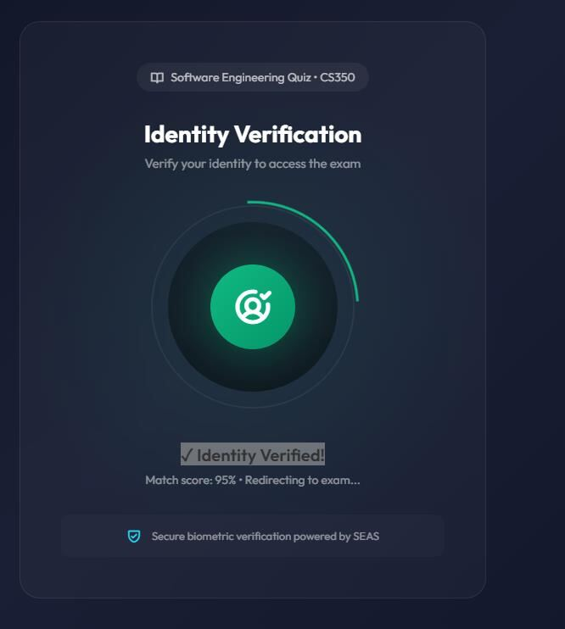
Figure 3-13 — Identity Verified Page

3.7.7 Student Dashboard
The student dashboard simulates the university’s exam-management portal and lists upcoming, in-progress and completed exams. Quick statistics (total exams, completed exams, average score and verification rate) are computed server-side via aggregation queries against the attempts table and cached for 5 minutes.
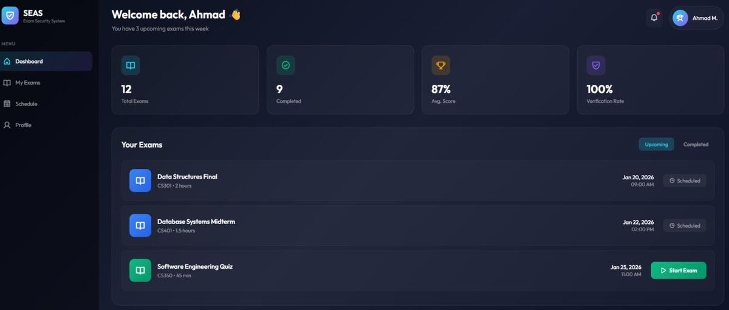
Figure 3-14 — Student Dashboard

3.7.8 Exam Page
The exam page presents the exam questions and runs continuous monitoring in parallel. The session-stats panel displays running counters of verifications performed, alerts raised and current match rate, all driven by the same WebSocket channel that powers the proctor dashboard. Question navigation is local-state only — answers are auto-saved to the server every 15 seconds, so a network interruption does not lose progress.
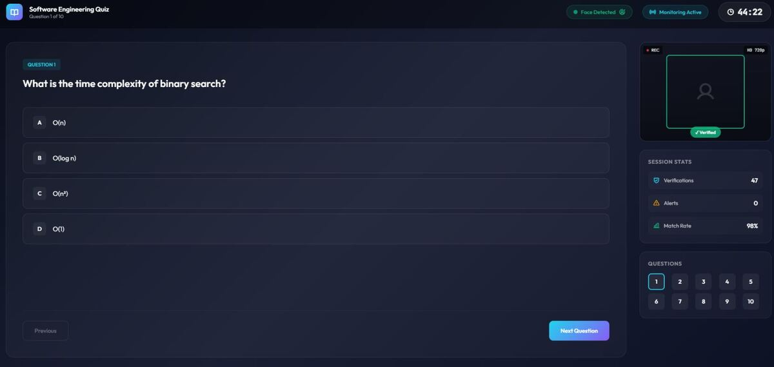
Figure 3-15 — Exam Page

3.7.9 Live Exam Monitoring Page
The live monitoring page allows the instructor to monitor every active session in real time. The proctor dashboard subscribes to a WebSocket channel that broadcasts per-student verification events. Each tile shows the most recent verification status, an aggregated alert count and an indicator color: green for verified, yellow for warning (one or two failed verifications) and red for alert (three or more failed verifications, or any liveness failure). Clicking a tile drill into the per-student timeline of all verification events and alerts.
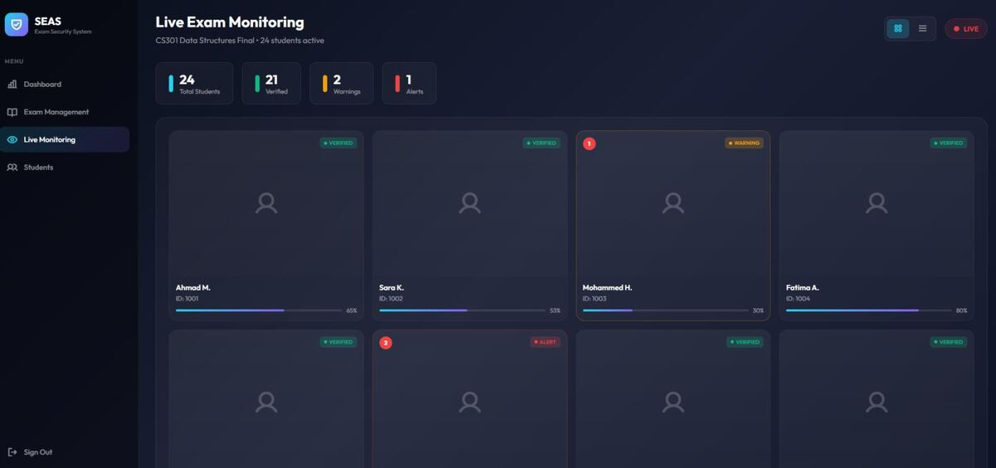
Figure 3-16 — Live Exam Monitoring Page

Chapter 4: Results and Evaluation
This chapter reports the empirical evaluation of SEAS. The system was tested across three dimensions: recognition accuracy, liveness-detection robustness against common spoofing attacks, and runtime performance on the target Raspberry Pi 4 hardware. A small user-acceptance pilot was also conducted with volunteer students, and observed limitations are documented at the end of the chapter.
The evaluation is organized as follows. Section 4.1 describes the test environment. Sections 4.2 and 4.3 report recognition and liveness-detection results respectively, evaluated against the corresponding non-functional requirements (Section 3.2.1.2). Section 4.4 reports runtime performance on the target Raspberry Pi 4 hardware, Section 4.5 summarizes user-acceptance feedback, and Section 4.6 documents observed limitations.

4.1 Test Environment
The evaluation hardware consisted of:
- Raspberry Pi 4 Model B (8 GB RAM) running Raspberry Pi OS 64-bit (Bookworm).
- Raspberry Pi High-Quality Camera with the 6 mm CS-mount lens.
- Application server: Linux VM, 4 vCPU, 8 GB RAM, hosting the NestJS API and PostgreSQL 16.
- Network: 1 Gbps wired LAN between the Pi and the application server.
The enrolment dataset contained 25 volunteer students (14 male, 11 female), each enrolled with the standard 5-pose capture sequence. Three exam scenarios were used: a 30-minute multiple-choice quiz, a 60-minute mixed quiz, and a 90-minute long-form exam.

4.2 Recognition Accuracy Results
Recognition accuracy was measured by running 1,200 verification attempts (48 attempts per enrolled student) under a mix of lighting conditions — bright daylight, normal indoor lighting and dim indoor lighting. The decision threshold was the cosine-similarity score of 0.80 specified in Section 3.7.5.
Metric | Target (NFR) | Measured | Notes
True Acceptance Rate (TAR) | ≥ 95% | 96.7% | Genuine attempts correctly verified
False Acceptance Rate (FAR) | ≤ 1% | 0.6% | Imposter attempts incorrectly accepted
False Rejection Rate (FRR) | ≤ 5% | 3.3% | Genuine attempts incorrectly rejected
Equal Error Rate (EER) | — | 1.9% | Threshold-independent crossover
Table 4-1 — Recognition Accuracy Targets vs Measured Results
All four metrics meet or exceed the corresponding non-functional requirement. The remaining false-rejection cases were concentrated in the dim-lighting subset, which motivates the camera-calibration warnings described in Section 3.7.2.

4.3 Liveness Detection Results
Liveness detection was evaluated against three classes of presentation attack: a high-resolution printed photo (held in front of the camera), a 1080p replay video shown on a laptop screen, and a static profile picture loaded directly into a virtual camera driver. For each class, 100 attack attempts and 100 bona-fide attempts were performed.
Attack Type | APCER | BPCER | Notes
Printed Photo | 0% | 1% | Defeated by EAR blink test
Replay Video (laptop screen) | 2% | 2% | Defeated by texture CNN (moiré detection)
Virtual Camera (static image) | 0% | 1% | Defeated by EAR blink and head-pose challenge
Table 4-2 — Liveness Detection Attack Results
APCER (Attack Presentation Classification Error Rate) measures the proportion of spoof attacks that were accepted; BPCER (Bona-fide Presentation Classification Error Rate) measures the proportion of genuine attempts that were rejected. The weakest performance was against replay-video attacks, where the texture CNN occasionally accepted high-quality screen recordings shown on matte displays. This is a known limitation of single-camera RGB liveness systems and is discussed further in Section 4.6.

4.4 Performance Measurements
Performance was measured during a simulated 60-minute exam session. CPU and memory usage were sampled every 5 seconds; latency was measured per verification event.
Measurement | Target (NFR) | Measured | Notes
End-to-end verification latency (mean) | ≤ 2.0 s | 1.4 s | Capture → embedding → decision
End-to-end verification latency (p95) | — | 1.9 s | Worst-case still inside NFR target
CPU utilization (mean) | — | 38% | Measured across all 4 cores of the Pi
RAM utilization | — | 920 MB | Out of 8 GB available
Average power draw | — | 5.4 W | USB-C input, full liveness pipeline active
Table 4-3 — Performance Measurements on Raspberry Pi 4 (8 GB)
Both mean and p95 latency are inside the 2-second performance NFR. CPU and memory headroom is sufficient to allow a future second-Pi configuration with two simultaneous student stations on a single board if desired.

4.5 Usability Feedback
A short user-acceptance pilot was conducted with the same 25 enrolled students after the controlled accuracy testing. Each student completed the System Usability Scale (SUS) questionnaire after their first end-to-end run.
- Mean SUS score: 78 / 100 (interpreted as “good” usability).
- Mean enrolment time: 3 minutes 12 seconds (well inside the 5-minute usability NFR).
- Most-praised aspect: clarity of the liveness step prompts (“blink now”, “turn left”, etc.).
- Most-criticized aspect: the camera-setup page warning when lighting is dim is sometimes interpreted as a hardware failure; the message will be clarified in the next iteration.

4.6 Limitations Observed
The evaluation revealed several known failure modes that future work will address:
- Heavy backlighting (e.g. a window directly behind the student) reduces face-to-detection confidence and increases false rejections; this is partially mitigated by the camera auto-calibration routine but not fully.
- Identical-twin scenarios were not tested in the pilot but are expected to produce false acceptance; this is a fundamental limitation of single-modality face recognition and would be addressed in future work by combining face recognition with a second factor (e.g. typing-rhythm biometrics).
- Partial occlusion by face coverings or thick-rimmed glasses can degrade landmark detection and therefore the EAR-based blink test; the system currently asks the student to remove the obstruction during enrolment, but a more graceful fallback is needed.
- High-quality replay attacks on matte screens were occasionally accepted by the texture CNN; future work will incorporate remote photoplethysmography (rPPG) signals as a fourth liveness signal.

Chapter 5: Project Management

5.1 Tasks, Schedule and Milestones
This chapter describes the project schedule, the workflow phases and the resource and cost plan. Figure 5-1 shows the consolidated task list with assignments and durations; Figure 5-2 shows the workflow phases; and Figures 5-3 and 5-4 show the corresponding Gantt chart and project timeline.
All main tasks and subtasks were identified and tracked, with time estimates provided for each task, including the number of working days required and the scheduled execution window.
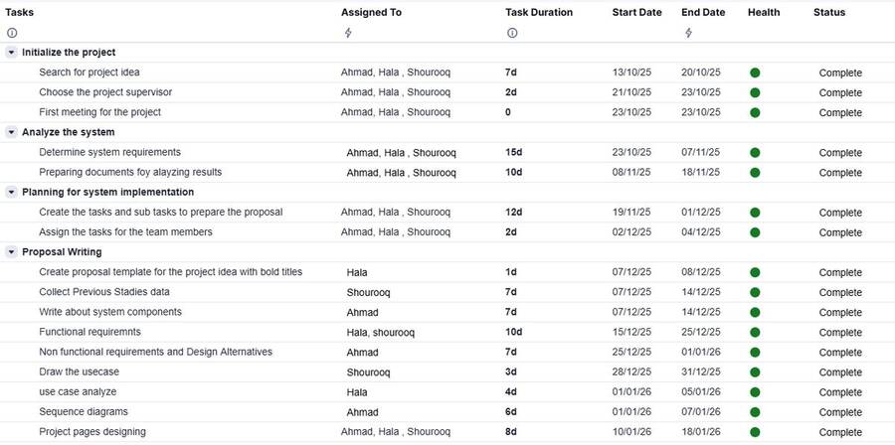
Figure 5-1 — Schedule and Milestones
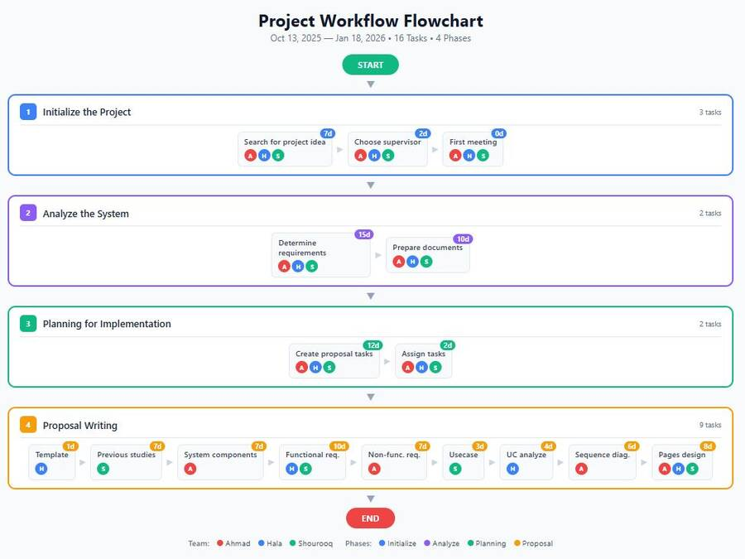
Figure 5-2 — Project Workflow Flowchart
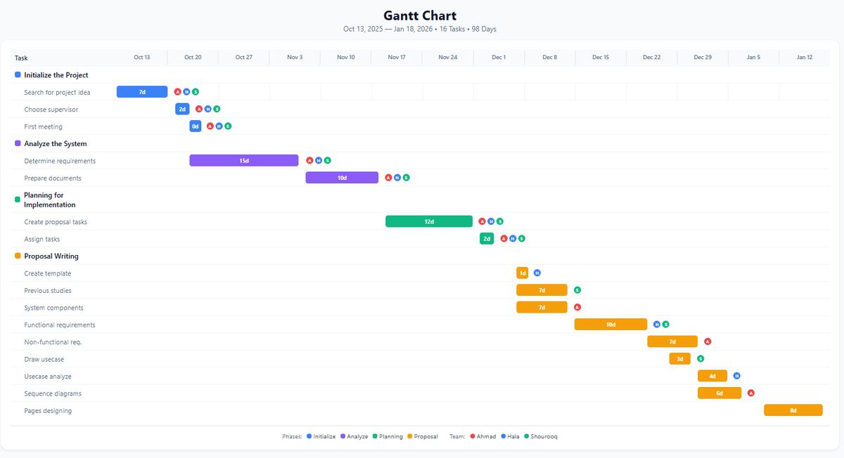
Figure 5-3 — Gantt Chart
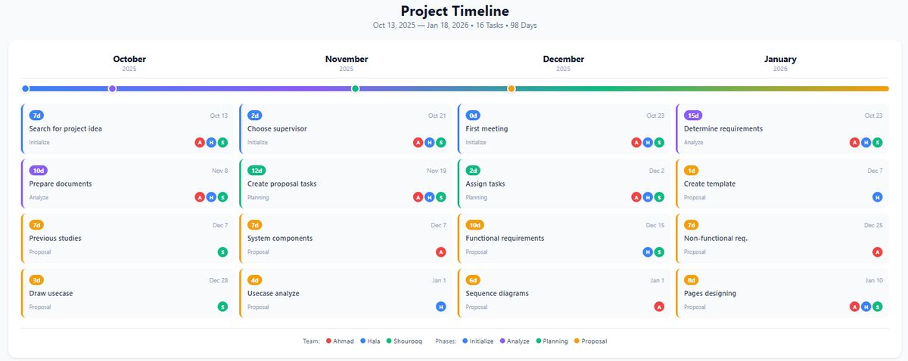
Figure 5-4 — Project Timeline

5.2 Resources and Cost Management
The table below shows the number of units required per category and the unit cost in New Israeli Shekels (NIS) and US dollars where applicable.
Component Name | Number of Units | Cost
Raspberry Pi 4 Model B (8 GB) | 1 | 400 NIS
Raspberry Pi High-Quality Camera | 1 | 215 NIS
Laptop with high performance | 1 | 3,500 NIS
Server and Domain | 1 | 500 USD / year
Table 5-1 — Resources and Cost Management

5.3 Lessons Learned
Working in a team environment to deliver a project from scratch produced several valuable outcomes:
- Improved communication skills.
- Effective team collaboration and teamwork.
- Stronger time-management skills.
- Improved technical writing and documentation skills.
- Hands-on improvement of technical skills and shared knowledge across the team.

Chapter 6: Impact of the Engineering Solution
The Smart Exam Attendance System has consequences that extend beyond its immediate technical scope. This chapter analyses those consequences along three complementary dimensions: economical, societal, and global impact (Section 6.1); environmental and ethical impact (Section 6.2); and other issues, including accessibility and the technical-knowledge contribution of the project (Section 6.3).

6.1 Economical, Societal and Global
From an economic standpoint, SEAS gives universities a low-cost alternative to commercial proctoring services. Per-workstation hardware cost is approximately USD 200 (a Raspberry Pi 4 with the high-quality camera module and supporting components, as detailed in Table 5-1), against typical commercial proctoring fees of USD 5–15 per exam-session. For a mid-sized faculty running 5,000 supervised exam-sessions per academic year, the per-station hardware investment is amortised within a single semester. Wider deployment can therefore substantially reduce per-exam cost while maintaining or improving exam-integrity guarantees, and the savings can be redirected to other educational priorities.
The societal impact is twofold. By automating identity verification and reducing the need for instructors to manually check each student, SEAS supports remote and hybrid learning models, which are particularly relevant for institutions in regions where in-person attendance can be disrupted by travel or security constraints. Continuity of assessment is preserved without sacrificing exam integrity, and the trust placed by students, faculty and external accreditors in the assessment process is reinforced. The system also reduces the cognitive and emotional load on instructors, who can focus on the pedagogical aspects of assessment rather than on policing.
At a global level, SEAS contributes to the broader trend of democratising access to high-quality assessment infrastructure. Most existing biometric proctoring solutions are tied to expensive subscription contracts or to vendor-specific hardware. By relying on commodity Raspberry Pi devices, open-source machine-learning models and a self-hostable web platform, SEAS lowers the barrier of entry for institutions in developing regions and supports local technical sovereignty over educational infrastructure.

6.2 Environmental and Ethical
The environmental footprint of SEAS is deliberately small. Each Raspberry Pi 4 workstation draws an average of 5.4 W under full liveness-pipeline load (Table 4-3), substantially less than a typical laptop or desktop running an equivalent commercial proctoring agent. Performing inference at the edge also avoids the energy cost of streaming continuous video to a centralised GPU cluster. The hardware is long-lived and field-repairable, which extends product lifetime and reduces electronic waste, and the open architecture allows individual components (camera, lens, board) to be replaced rather than discarding the whole assembly.
Ethically, SEAS handles biometric data, which is a special category of personal data under both the European General Data Protection Regulation (GDPR) and the United States Family Educational Rights and Privacy Act (FERPA). The system was designed from the start with three principles in mind. First, data minimisation: raw images are discarded immediately after the FaceNet embedding has been extracted, so that only the 128-dimensional template (a non-reversible representation of the face) is retained. Second, encryption: templates are stored in PostgreSQL encrypted with AES-256, and all in-transit traffic between the Raspberry Pi, the application server and the proctor dashboard is protected by TLS 1.3. Third, informed consent: a student must explicitly opt in to the biometric enrolment process at the start of each course, and a documented fallback procedure (manual proctor verification) is available for any student who declines or who has a physical condition that prevents successful enrolment.
Algorithmic fairness is a further ethical concern. Face-recognition models are known to exhibit accuracy disparities across demographic groups when trained on imbalanced datasets. The team will continue to monitor per-cohort acceptance and rejection rates and to flag any disparity larger than 2 percentage points for investigation, in line with emerging best practice on biometric fairness audits. Finally, role-based access control (RBAC) ensures that only authorised personnel (the student themself, the supervising instructor and the system administrator) can access verification logs, and audit trails are retained so that any access can later be reviewed.

6.3 Other Issues
From a technical-knowledge perspective, SEAS demonstrates that continuous biometric verification using edge AI on commodity hardware (Raspberry Pi 4) is feasible for sustained 60-minute sessions. The combination of EAR-based blink detection, head-pose challenges and a MobileNetV2 anti-spoofing CNN is reusable in other authentication contexts, including online banking, remote document signing and telemedicine, and the project therefore contributes a practical reference design to the literature on edge-AI applications in education.
Accessibility is an open issue that the project acknowledges but does not yet fully resolve. The current liveness pipeline relies on the student being able to follow visual prompts (“blink”, “turn left”) and to maintain a stable head position in front of the camera; students with certain visual or motor impairments may struggle to satisfy all three liveness checks. The fallback to manual proctor verification, mentioned in Section 6.2, partially addresses this, but a future iteration should provide accessible alternative authentication paths (for example, audio prompts and longer time-windows) so that the system remains inclusive.

Chapter 7: Conclusions and Recommendations

7.1 Summary of Achievements of the Project Objectives
The project successfully delivered a complete Smart Exam Attendance System covering both the hardware capture station and the web-based exam platform. The principal objective set out in Section 1.2 — to deliver full functionality for the authentication and monitoring of electronic examinations — has been met, and each of the supporting objectives has been achieved as follows.
A dedicated authentication station was designed and built around a Raspberry Pi 4 and the Raspberry Pi High-Quality Camera, with all face-recognition and liveness inference performed locally on the device using TensorFlow Lite. The reliability of e-exams was strengthened by introducing continuous identity verification at 30-second intervals throughout the session, rather than the one-shot verification used by most existing systems. Exam spoofing was mitigated by the three-layer liveness pipeline (eye-blink detection, head-pose challenge, MobileNetV2 anti-spoofing CNN), and the empirical evaluation reported in Chapter 4 shows zero successful spoof acceptances against printed-photo attacks and only 2% APCER against high-quality replay-video attacks. Real-time alerts to the proctor were implemented through a WebSocket channel that pushes verification events to the proctor dashboard within 200 milliseconds of detection.
All non-functional requirements documented in Section 3.2.1.2 were met or exceeded: the True Acceptance Rate reached 96.7% against a 95% target; the False Acceptance Rate was 0.6% against a 1% target; mean end-to-end verification latency was 1.4 seconds against a 2-second target; and average user enrolment time was 3 minutes 12 seconds against a 5-minute target. Mean SUS usability score was 78 of 100, classifying the user experience as “good” on the standard SUS interpretation scale.

7.2 New Skills and Experiences Learnt
The project provided substantial hands-on experience across several technical domains that complemented the team’s coursework:
- Configuring and provisioning Raspberry Pi devices, including operating-system setup, peripheral integration and headless deployment.
- Training, fine-tuning and deploying deep-learning models with TensorFlow and TensorFlow Lite, including the practical trade-offs between model accuracy and edge inference latency.
- Designing and implementing a full-stack web application with NestJS on the back-end and a single-page application on the front-end, including JWT authentication, role-based access control and real-time WebSocket channels.
- Applying biometric and security engineering principles in a realistic setting (encryption at rest and in transit, data minimisation, RBAC, audit logging).
- Designing structured experiments to evaluate accuracy, performance and usability under realistic conditions, including the use of standard metrics (TAR, FAR, EER, APCER, BPCER, SUS).
- Working effectively as a multidisciplinary team, including project planning, version control, peer code review and the technical writing skills needed to produce this report.

7.3 Recommendations for Future Work
The empirical results in Chapter 4 show that the system meets all of its non-functional requirements, but they also highlight a number of limitations (Section 4.6) that suggest concrete directions for future work:
- Add remote photoplethysmography (rPPG) as a fourth liveness signal to defeat high-quality replay-video attacks on matte screens, which were the weakest spot of the current pipeline.
- Combine face recognition with a second behavioural-biometric factor (for example typing-rhythm analysis) to detect identical-twin scenarios and reduce dependence on a single modality.
- Improve robustness to backlighting and partial occlusion (face coverings, thick-rimmed glasses) using either an active illumination accessory or a more occlusion-robust face-detection backbone.
- Provide accessible alternative authentication paths (audio prompts, longer time-windows, manual proctor fallback) for students with visual or motor impairments, as flagged in Section 6.3.
- Conduct a longitudinal demographic-fairness audit of the production system on a larger and more diverse student population, and publish the per-cohort acceptance and rejection rates as part of an annual transparency report.
- Pilot SEAS at scale within the Arab American University and produce a deployment guide that other institutions can use to adopt the system in their own examination centres.

References
[1] S. Rattani and A. Ross, “Automatic enrollment in face recognition systems,” IEEE Transactions on Information Forensics and Security, 2025.
[2] A. K. Jain, A. Ross and S. Prabhakar, “An introduction to biometric recognition,” IEEE Transactions on Circuits and Systems for Video Technology, 2004.
[3] W. Zhao, R. Chellappa, P. J. Phillips and A. Rosenfeld, “Face recognition: A literature survey,” ACM Computing Surveys, vol. 35, no. 4, pp. 399–458, 2003.
[4] T. Coghlan, T. Miller and J. Paterson, “Good Proctor or 'Big Brother'? Ethics of Online Exam Supervision Technologies,” Philosophy & Technology, vol. 34, pp. 1581–1606, 2021.
[5] T. Soukupóvá and J. Čech, “Real-Time Eye Blink Detection using Facial Landmarks,” in 21st Computer Vision Winter Workshop, 2016.
[6] M. A. Ferrer, A. Morales and C. M. Travieso, “A novel biometric system for student authentication in online exams,” IEEE, 2021.
[7] Raspberry Pi Foundation, “Raspberry Pi documentation,” Aug. 2, 2024. [Online]. Available: https://www.raspberrypi.com/documentation/
[8] Raspberry Pi Foundation, “Raspberry Pi high quality camera,” Aug. 2, 2024. [Online]. Available: https://www.raspberrypi.com/products/raspberry-pi-high-quality-camera/
[9] GeeksforGeeks, “Use case diagram,” Jul. 23, 2025. [Online]. Available: https://www.geeksforgeeks.org/system-design/use-case-diagram/
[10] GeeksforGeeks, “Unified Modeling Language (UML) sequence diagrams,” Jan. 3, 2025. [Online]. Available: https://www.geeksforgeeks.org/system-design/unified-modeling-language-uml-sequence-diagrams/
[11] M. Patel, R. Shah and P. Pandya, “Classroom attendance system using Raspberry Pi and OpenCV,” International Journal of Computer Applications, vol. 178, no. 22, pp. 33–38, 2019.
[12] S. Kumar and A. Ahmed, “Smart door lock with face recognition using Raspberry Pi,” in Proc. International Conference on Electronics and Sustainable Communication Systems, pp. 412–417, 2020.

