Flight Dynamics and Control Course

Altitude Hold Autopilot Design

**Alaa Abdelbadie Mandor 201301556**

**Islam Sami Fadl 201303364**

**Mohamed Ashraf Hassan 201302677**

**Mostafa Eliwa Mohamed - 201303022**

# INTRODUCTION

Our approach in this autopilot design is to use a state feedback mechanism to maintain a constant altitude. We used the linearized longitudinal model of the plane around trim conditions with an additional fifth state (altitude), and with the input as the the elevator angle.

Assumptions were made to ensure the validity of the simulation output:

* Forward velocity (Uo) was assumed to be constant by a separate Mach hold autopilot.
* The control surface actuator dynamics is neglected (such as the servo motor lag). Otherwise, the order of the system will increase.

The altitude rate equation obtained was:

$$h' = Uo*θ - w$$

So the resulting model becomes:

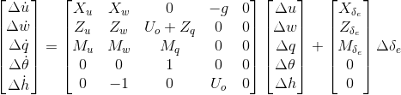

# Operating Conditions

The FOXTROT fighter/bomber was used in the simulation (choice 2), with the following operating conditions (OC_ch 2):

Uo = 265 m/s alphao = 2.6 deg gammao=0 deg

And the following Stability Derivatives:

Xu=-0.009; Xw=0.016; Xde=0.69;

Zu=-0.088; Zw=-0.547; Zq=-0.88; Zde=-15.12;

Mu=-0.008; Mw=-0.03; Mq=-0.487; Mde=-11.4;

Therefore, our resulting state space model becomes:

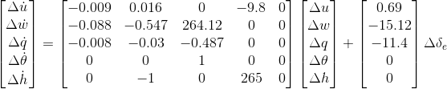

# Controller Design

LQR (Linear–quadratic regulator) controller was used, which is an optimal control method that is both easily implemented and robust. The Q and R weights were obtained through trial and error with giving emphasis to the weights of q and h (our objective), and the cost of the control input. The emphasis on q resulted from the fact that our linear system would no longer be valid for large changes in theta, while the emphasis on h is obvious as our final objective is to hold the altitude. Moreover, as our control input is not unlimited (actually, it is limited to be within the range of -30 and +30 degrees), high cost should be put on the use of the control input.

The weights of both q and the control input are noted to be orders of magnitude higher than that of h to give a reasonable response, and that can be understood if we know that h changes within the range of meters (1 to 100 meters for example), while the angles change within the range of several radians (0 to 0.175 radians for a change of 0 to 10 degrees).

After tuning, the resultant Q and R are:

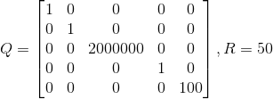

Giving the following K matrix (gains):

$$K = \left[-0.0007 0.0153 -1.4903 -5.7449 -0.01\right]$$

# Simulation and Results

Simulink was used for simulation

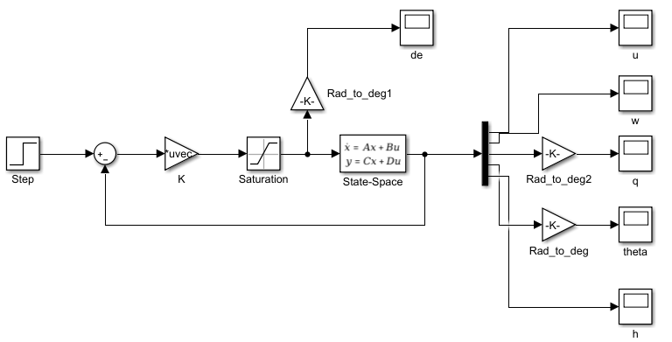

A step reference increase in altitude of 50 meters was given to the system, and the response was as follows:

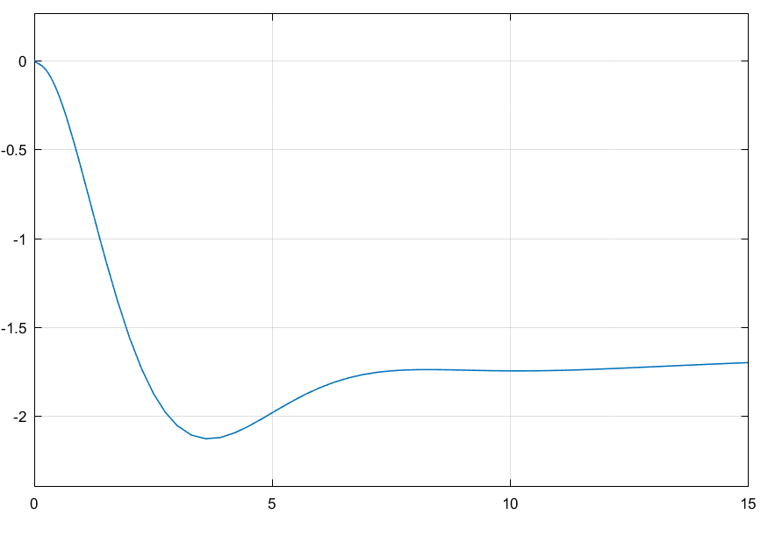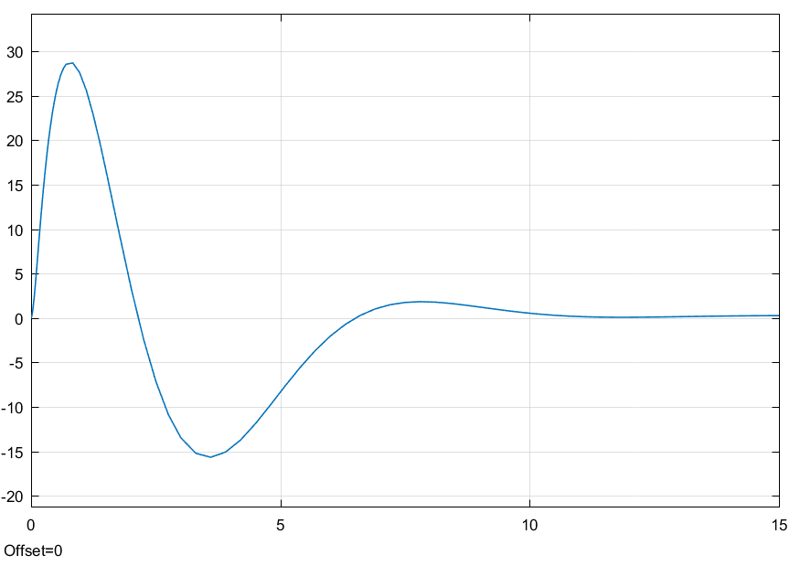

u (m/sec) w (m/sec)

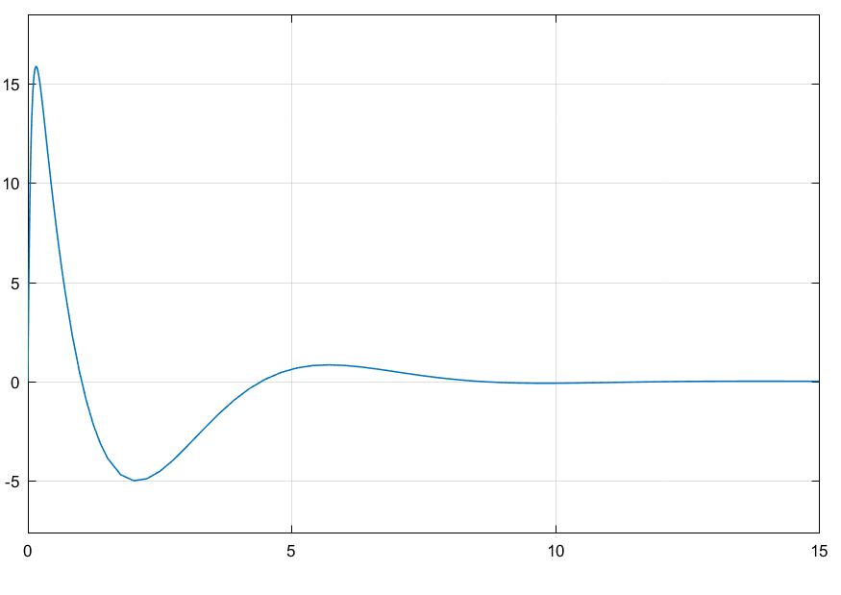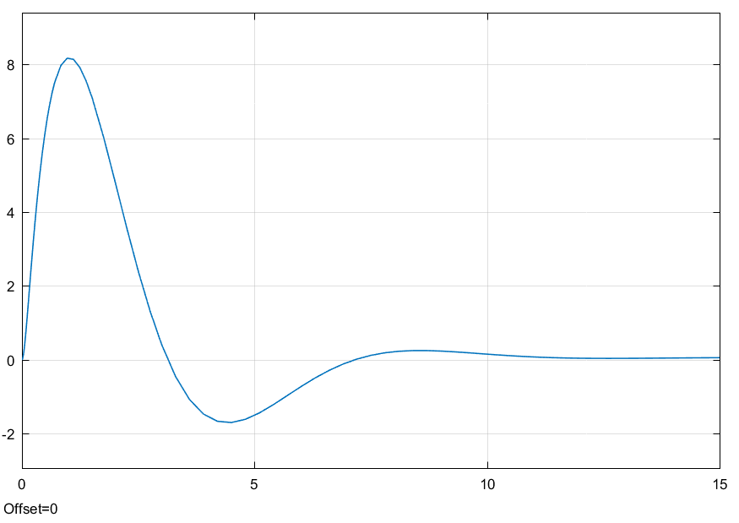

q (deg/sec) theta (deg)

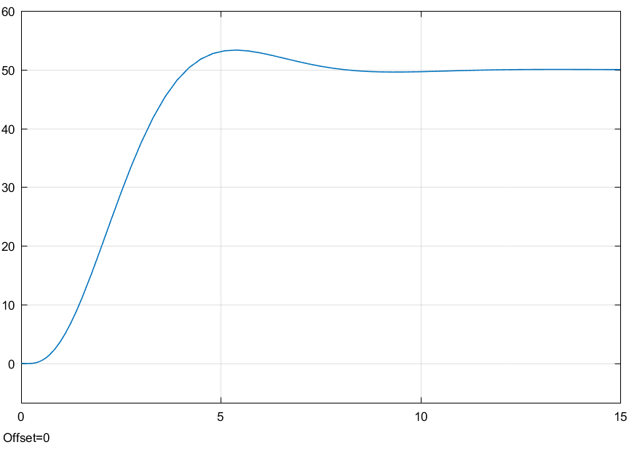

altitude (m)

Moreover, the flying qualities of the Aircraft were analyzed before and after being controlled. Before adding the autopilot, the damping ratios for the short and long period respectively were 0.1814 and -1, which makes the airplane (Class IV, Cat A) level 3.

After adding the autopilot, the control input coupled the short and long period parameters. However, the new damping ratios became 1 and 0.567, which both satisfy the criteria of level 1 for both the short period and the long period.