Process Definition Document (PDD)

*Process Name: <ToDayMatch>*

Table of Contents

**Introduction**1

Purpose of the Document 1

Objectives 1

Process Key Contact 1

Minimum Prerequisites for Automation 1

**As-Is Process Description**2

Process Overview 2

Applications used in the Process 3

As-Is Process Map 3

**To-Be Process Description**5

Detailed Process Map 5

Robot Type 6

Business Exceptions Handling 6

Known Exceptions 6

Unknown Exceptions 7

System Exceptions Handling 7

**Other Observations**7

**Additional sources of process documentation**7



# Introduction

## Purpose of the Document

The Process Definition Document outlines the business process chosen for automation using UiPath Robotic Process Automation (RPA) technology.

The document describes the sequence of steps performed as part of the business process, the conditions and rules of the process prior to automation and how they are envisioned to work after automating it, partly or entirely. This specifications document serves as a base for developers, providing them with the details required for applying robotic process automation to the selected business process.

## Objectives

The business objectives and benefits expected by the Business Process Owner after automation of the selected business process are:

* Include at least one here
* Up to as many as you want

## Process Key Contact

The specifications document includes concise and complete requirements of the business process and it is built based on the inputs provided by the process Subject Matter Expert (SME)/ Process Owner.

The Process Owner is expected to review it and provide signoff for accuracy and completion of the steps, context, impact and a set of process exceptions. The details are to be included in the table below.

|  |  |  |  |
| --- | --- | --- | --- |
| Role | Name | Contact Details  (email & phone number) | Notes |
| Process Owner | Islam Nady | Islamnady134@gmail.com |  |
| Business Analyst | Islam Nady | Islamnady134@gmail.com |  |

## Minimum Prerequisites for Automation

|  |  |
| --- | --- |
| Met (Y/N) | Prerequisites |
| Y | A filled in and completed Process Definition Document |
| Y | Closure of any open process questions |
| Y | Environment set up |
| Y | Test Data to support development and testing |
| Y | User access and creation of user accounts (licences, permissions, restriction to create accounts for robots) |

# As-Is Process Description

## Process Overview

General information about the process selected for RPA prior to automation.

|  |  |  |
| --- | --- | --- |
| # | Item | Description |
| 1 | Process Full Name | ToDayMatch |
| 2 | Process Area | Get Information |
| 3 | Department | Sporting |
| 4 | Process Short Description  (operation, activity, outcome) | Get the today match details of the desired team. |
| 5 | Role(s) required for performing the process | Goal.com |
| 6 | Process schedule and frequency | Daily |
| 7 | # of items processed /reference period | 0-4 |
| 8 | Process execution time | 1 time at day / client |
| 9 | Peak period(s) | No Peak period(s) |
| 10 | Transaction Volume During Peak period | N/A |
| 11 | Total # of FTEs supporting this activity | 1 |
| 12 | Expected increase of volume in the next reference period | N/A |
| 13 | Level of exception rate | No expected exception. |
| 14 | Input data | Match details |
| 15 | Output data | The desired match details. |

*Add more rows to the table to include relevant data for the automation process. No fields should be left empty. Use “n/a” for the items that don't apply to the selected business process.

## Applications used in the Process

The table includes a comprehensive list of all the applications that are used as part of the process to be automated to perform the given steps in the flow.

|  |  |  |  |  |  |
| --- | --- | --- | --- | --- | --- |
| # | Application Name & Version | System Language | Thin/Thick Client | Environment/ Access Method | Comments |
| 1 | Google Chrome | English | Thin | Direct |  |

*Add more rows to the table to include the complete list of applications.

## As-Is Process Map

**High Level As-Is Process Map:** This chapter depicts the As-Is business process at a High Level to enable developers to have a high-level understanding of the current process.

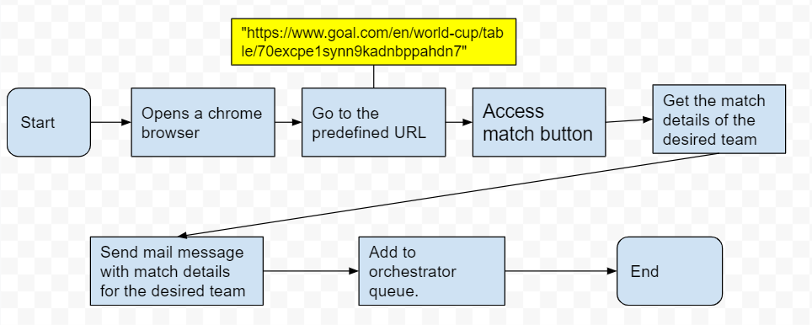

(IF ON GOOGLE DOCS GO TO INSERT DRAWING TO PUT YOUR DRAWING HERE)

**Detailed Process Map:** This chapter depicts the As-Is business process at a detailed view to enable process owners to document their process

|  |  |  |  |
| --- | --- | --- | --- |
| # | Step Action/Description | Screenshot | Remarks |
| 1 | Opens a browser to get match information. | N/A | Chrome browser open to URL  <https://www.goal.com/en/world-cup/fixtures-results/70excpe1synn9kadnbppahdn7> |
| 2 | Access match button |  | N/A |
| 3 | Access the list of match details |  | N/A |
| 4 | For the Match Details of desired team, perform the following. |  | Possible exception:  Handle exception if no match for the desired team exists. |
| 5 | Send mail message with match details for the desired team and with mail subject ‘Today's matches’ | N/A | Possible exception:  Handle exception if failed to send mail message. |
| 6 | Add the match details for the desired team to orchestrator queue. | N/A | Possible exception:  Handle exception if failed to add data to queue. |
| 7 | Close browsers opened  during process | N/A |  |

# To-Be Process Description

## Detailed Process Map

**High Level To-Be Process Map:** This chapter depicts the To-Be automation process at a High Level to enable developers/COE to have a high-level understanding of the to be developed process.

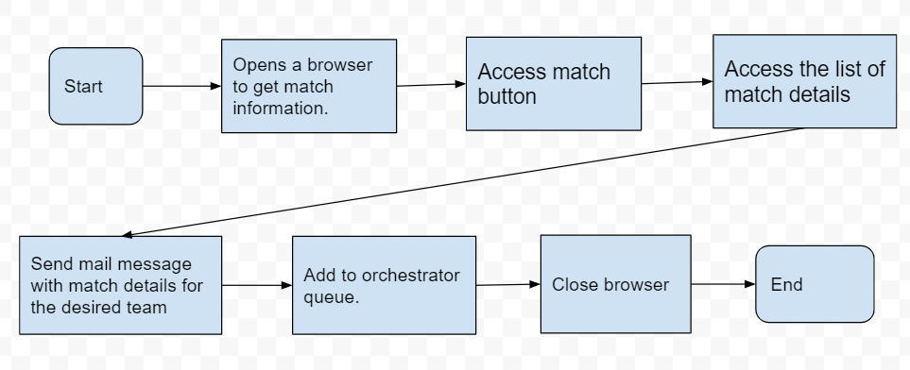

(IF ON GOOGLE DOCS GO TO INSERT DRAWING TO PUT YOUR DRAWING HERE)

**Detailed Process Map:** This chapter depicts the To-Be automation process at a detailed view to enable developers/COE to see the workflows involved in the RPA solution

|  |  |  |  |  |  |
| --- | --- | --- | --- | --- | --- |
| **Workflow Name** | **Description** | **Pre-conditions** | **Post-actions** | **Arguments** | **Notes** |
| OpenBrowser | Opens a browser to get match information. | N/A | Chrome browser open to URL | in_URL – string |  |
| IterateToDayMatch | Scrapes the match details from goal.com and filters by the desired team. If there is a match for the desired team, it will send an email with match details and add It to the orchestrator queue. | open goal.com on chrome. | iterate for each match and send it to mail and add it to queue. | N/A |  |
| Send_Emails | send a mail message with match details. | get email credentials. | send a mail message. | in_toDayMatch – string |  |
| Write_To_Queue | add the match details to the queue. | N/A | Add to queue | in_matchDetails – string [] |  |

## Robot Type

|  |  |  |  |  |
| --- | --- | --- | --- | --- |
| # | Attended | Unattended | Trigger | Comments |
| 1 | N/A | Unattended | N/A |  |

## Business Exceptions Handling

The Business Process Owner and Business Analysts are expected to document below all the business exceptions identified in the automation process. These can be classified as:

### Known Exceptions

The table below reflects all the business process exceptions encountered during the process evaluation and documentation. These are known exceptions that occurred before. For each of these exceptions, define a corresponding expected action that the robot should complete if it encounters the exception.

|  |  |  |  |  |
| --- | --- | --- | --- | --- |
| BE # | Exception Name | Step | Parameters | Action to be Taken |
| 1 | No match for the desired team exist. | 4 | N/A | Log with Warn level and Throw BRE |

### Unknown Exceptions

For all other unanticipated or unknown business (process) exceptions, the robot should:

## System Exceptions Handling

A comprehensive list of all errors, warnings or notifications should be consolidated here with the description and action to be taken, for each, by the robot.

Errors identified in the automation process can be classified as:

|  |  |  |  |  |
| --- | --- | --- | --- | --- |
| SE # | Exception Name | Step | Parameters | Action to be Taken |
| 1 | failed to send mail message. | 5 | Connection Error | Log with Warn level and Throw BRE |
| 2 | failed to add data to queue. | 6 | Connection Error | Log with Warn level and Throw BRE |

For all the other unanticipated or unknown system exceptions, send an email to **<placeholder>** and attach a screenshot of the error message.

# Other Observations

Include below any other relevant observations you consider needed to be documented here.

# Additional sources of process documentation