HAM10000 Skin Lesion Classification
Using Deep Learning and Transfer Learning with PyTorch
Machine Learning — Term Project Report
Islam Saad Aldeen | Nemeh Abu Issa
May 2026

1. Summary
This project presents an academic decision-support prototype for automated skin lesion classification using deep learning. We trained and evaluated convolutional neural network models on the HAM10000 dataset, which contains 10,015 dermoscopic images across seven diagnostic categories. Using transfer learning with ResNet50 as the primary backbone and EfficientNet-B0 as a comparison, we conducted five systematic experiments comparing different fine-tuning strategies and class imbalance handling techniques. Our best model (ResNet50 full fine-tuning with weighted loss) achieved a test accuracy of 78.25% and a macro F1-score of 0.65, outperforming EfficientNet-B0 (69.68% accuracy, macro F1 0.56). Grad-CAM visualizations provide explainability. The system is strictly an academic prototype and must not replace professional dermatological diagnosis.

2. Introduction

2.1 Motivation
Skin cancer is one of the most prevalent forms of cancer worldwide, with melanoma being particularly dangerous due to its high mortality rate when detected late. Early and accurate diagnosis significantly improves patient outcomes. Dermoscopy — the use of a dermatoscope to examine skin lesions — is a standard clinical tool, but its interpretation requires specialized expertise not universally available. Automated image classification systems based on deep learning offer the potential to assist dermatologists by providing a fast, consistent second opinion, especially in resource-limited settings.

This project addresses the challenge of multi-class skin lesion classification using the HAM10000 benchmark dataset. We investigate how transfer learning, class imbalance handling, and progressive fine-tuning strategies affect model performance on this medically important task.

2.2 Background
Deep convolutional neural networks (CNNs) have achieved remarkable results in medical image analysis. The ImageNet Large Scale Visual Recognition Challenge demonstrated that deep models like ResNet50 learn rich hierarchical feature representations that transfer well to specialized domains including dermoscopy. Transfer learning — initializing a model with ImageNet weights and fine-tuning it on a target dataset — is now standard practice for medical imaging tasks where labeled data is scarce.

The HAM10000 dataset (Human Against Machine with 10,000 training images) was introduced by Tschandl et al. (2018) as a benchmark for skin lesion analysis. Class imbalance — with melanocytic nevi comprising roughly 67% of samples while dermatofibroma accounts for only 1.1% — makes this a particularly challenging classification problem.

3. Dataset

3.1 Source
We used the HAM10000 dataset, publicly available on Kaggle ("Skin Cancer MNIST: HAM10000") and the ISIC Archive. The dataset was downloaded via the Kaggle API and stored in Google Drive for collaborative access during training on Google Colab with T4 GPU.

3.2 Description
The dataset contains 10,015 dermoscopic images distributed across seven diagnostic classes. Images are divided into two folders accompanied by a metadata CSV file. A key characteristic is that a single physical lesion can have multiple images — there are 7,470 unique lesions across 10,015 images. This has important implications for data splitting.

Class | Medical Name | Count | % of Dataset | Clinical Risk
nv | Melanocytic Nevi | 6,705 | 66.9% | Low
mel | Melanoma | 1,113 | 11.1% | HIGH
bkl | Benign Keratosis-like Lesions | 1,099 | 11.0% | Low
bcc | Basal Cell Carcinoma | 514 | 5.1% | HIGH
akiec | Actinic Keratoses / Bowen Disease | 327 | 3.3% | Moderate
vasc | Vascular Lesions | 142 | 1.4% | Low
df | Dermatofibroma | 115 | 1.1% | Low

Table 1: HAM10000 class distribution and clinical significance

3.3 Preprocessing & Augmentation
All images were resized to 224x224 pixels, converted to RGB tensors, and normalized using ImageNet statistics (mean=[0.485, 0.456, 0.406], std=[0.229, 0.224, 0.225]). The dataset was split 70/15/15 (train/val/test) at the lesion_id level to prevent data leakage from multi-image lesions. Training augmentation included RandomResizedCrop, RandomHorizontalFlip, RandomVerticalFlip, RandomRotation (±15°), and light ColorJitter.

4. Methodology

4.1 Model Architecture
ResNet50 was the primary architecture, using residual connections that allow gradients to flow through very deep networks without vanishing. The final fully-connected layer was replaced with a custom classification head outputting 7 classes (Dropout → Linear(2048, 512) → ReLU → Dropout → Linear(512, 7)). EfficientNet-B0 was included as Experiment 5 for comparison.

4.2 Experiments
Exp | Architecture | Weighted Loss | Fine-Tuning | Purpose
1 | ResNet50 | No | Head only | Baseline
2 | ResNet50 | Yes | Head only | Handle imbalance
3 | ResNet50 | Yes | Last block | Improve features
4 | ResNet50 | Yes | Whole model | Best candidate
5 | EfficientNet-B0 | Yes | Last block | Model comparison

Table 2: Experiment configurations

4.3 Training Setup
AdamW optimizer was used throughout. Learning rates were set to 1e-3 for head-only training and 1e-5 for full fine-tuning to protect pretrained weights. A cosine annealing scheduler smoothly decayed the learning rate. Mixed precision training (AMP) was enabled on GPU. Best model checkpoints were saved based on validation macro F1-score, not final epoch.

4.4 Evaluation Metrics
Due to severe class imbalance, accuracy alone is misleading. A model always predicting 'nv' achieves 67% accuracy while being clinically useless. We therefore prioritized:
- Macro F1-score
- Per-class Recall
- Weighted F1-score
- Confusion matrix

5. Results

5.1 Experiment Progression
Experiment | Architecture | Val Macro F1 | Test Accuracy | Test Macro F1
Exp 1 — Baseline | ResNet50 | 0.34 | 0.7697 | 0.5013
Exp 2 — Weighted Loss | ResNet50 | 0.49 | 0.6867 | 0.4968
Exp 3 — Last Block | ResNet50 | 0.65 | 0.7631 | 0.6347
Exp 4 — Full Fine-tune | ResNet50 | 0.67 | 78.25% | 0.6488
Exp 5 — EfficientNet | EfficientNet-B0 | 0.56 | 69.68% | 0.5588

Table 3: Summary of all experiment results

The progression demonstrates a clear and consistent improvement at each stage. The largest single gain came from unfreezing the last residual block in Experiment 3 (+0.16 macro F1), showing that fine-tuning deeper layers allows the model to learn dermoscopy-specific features. ResNet50 (Exp 4) outperformed EfficientNet-B0 (Exp 5) by 8.57% in accuracy and 0.09 in macro F1.

5.2 Detailed Results — Best Model (Exp 4: ResNet50 Full Fine-tune)
Class | Precision | Recall | F1-Score | Support
akiec | 0.590 | 0.571 | 0.581 | 63
bcc | 0.630 | 0.750 | 0.685 | 68
bkl | 0.578 | 0.783 | 0.665 | 152
df | 0.240 | 0.857 | 0.375 | 7
mel | 0.526 | 0.652 | 0.582 | 187
nv | 0.948 | 0.819 | 0.879 | 996
vasc | 0.679 | 0.905 | 0.776 | 21
Macro avg | 0.599 | 0.763 | 0.649 | 1,494
Weighted avg | 0.821 | 0.783 | 0.795 | 1,494

Table 4: Classification report — Exp 4 (best model) on test set

5.3 Detailed Results — Exp 5 (EfficientNet-B0)
Class | Precision | Recall | F1-Score | Support
akiec | 0.539 | 0.556 | 0.547 | 63
bcc | 0.623 | 0.559 | 0.589 | 68
bkl | 0.428 | 0.822 | 0.563 | 152
df | 0.147 | 0.714 | 0.244 | 7
mel | 0.394 | 0.508 | 0.444 | 187
nv | 0.943 | 0.727 | 0.821 | 996
vasc | 0.576 | 0.905 | 0.704 | 21
Macro avg | 0.521 | 0.684 | 0.559 | 1,494
Weighted avg | 0.781 | 0.697 | 0.721 | 1,494

Table 5: Classification report — Exp 5 (EfficientNet-B0) on test set

5.4 Model Comparison
Metric | ResNet50 (Exp 4) | EfficientNet-B0 (Exp 5) | Winner
Test Accuracy | 78.25% | 69.68% | ResNet50 ✓
Macro F1 | 0.6488 | 0.5588 | ResNet50 ✓
Weighted F1 | 0.7947 | 0.7210 | ResNet50 ✓
mel Recall | 0.652 | 0.508 | ResNet50 ✓
bcc Recall | 0.750 | 0.559 | ResNet50 ✓
vasc Recall | 0.905 | 0.905 | Tie
Trainable Params | 23.5M | ~4M | EfficientNet (smaller)

Table 6: ResNet50 vs EfficientNet-B0 comparison

ResNet50 outperformed EfficientNet-B0 on all key metrics. This is likely because ResNet50 has a larger capacity (23.5M vs ~4M trainable parameters) that better captures the fine-grained visual differences between skin lesion classes. EfficientNet-B0, while more parameter-efficient, may require more epochs or different hyperparameters to reach peak performance on this dataset.

5.5 Demo — Real-World Testing
The trained model was deployed in a Streamlit web application and tested on 5 unseen images sourced outside the HAM10000 dataset. The following screenshots illustrate the system's predictions, confidence scores, top-3 outputs, and Grad-CAM explanations:

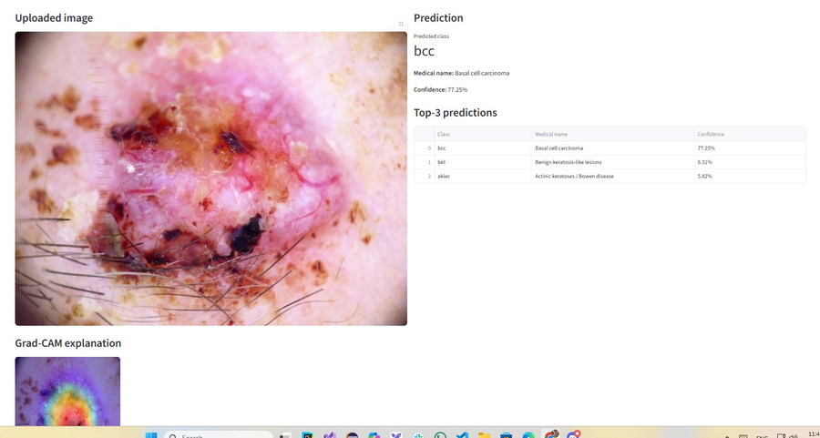
Figure 1: Demo prediction — bcc (Basal cell carcinoma), 77.25% confidence. Grad-CAM correctly highlights the lesion center.
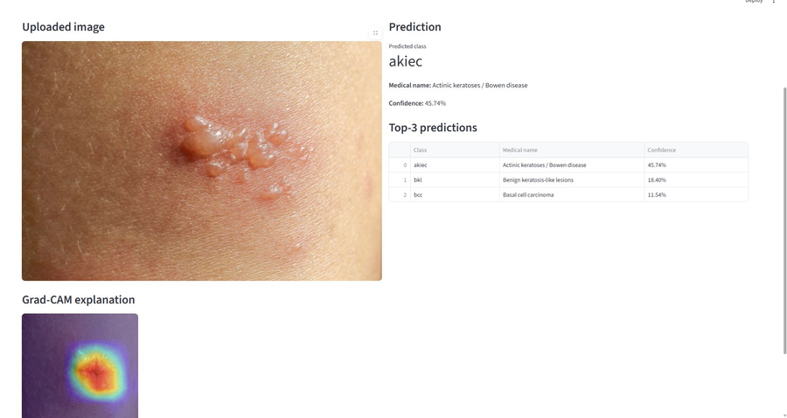
Figure 2: Demo prediction — akiec (Actinic keratosis), 45.74% confidence. Lower confidence reflects visual similarity with bkl and bcc.
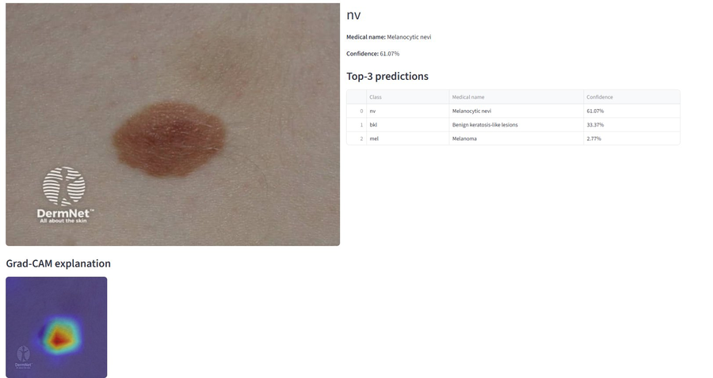
Figure 3: Demo prediction — nv (Melanocytic nevi), 61.07% confidence. Round brown lesion correctly classified with Grad-CAM focused on lesion.
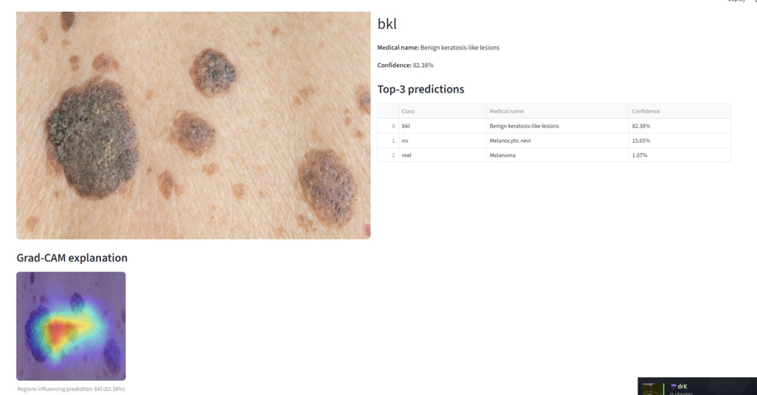
Figure 4: Demo prediction — bkl (Benign keratosis-like), 82.38% confidence. Highest confidence result; model correctly identifies the warty dark lesions.

An important finding from the real-world test: one image showing a diffuse rash (not a skin lesion) produced a low-confidence nv prediction (30.53%), and a wound image also produced low-confidence results. This confirms the model's expected limitation — it was trained exclusively on dermoscopic images and does not generalize reliably to standard camera photos or non-lesion skin conditions. This is noted as a key limitation in Section 6.

5.6 Discussion
The results confirm several expected patterns. First, weighted loss is essential: the macro F1 improvement from Exp 1 to Exp 2 (0.34 to 0.49) shows that without addressing class imbalance, the model is heavily biased toward the dominant nv class. Second, progressive unfreezing is effective: each stage of unfreezing additional layers improved performance consistently. Third, overfitting becomes a concern with deeper fine-tuning — in Exp 3 and Exp 4, training F1 continued climbing past epoch 10-12 while validation F1 plateaued. Saving best checkpoints based on validation macro F1 was critical.

The confusion between mel, nv, and bkl accounts for a significant portion of errors. This is consistent with clinical literature where even expert dermatologists struggle to differentiate these classes without dermoscopy. The model's melanoma recall of 65.2% means it misses approximately one in three melanoma cases — clinically significant and the most important area for future improvement.

6. Conclusion
This project successfully built, trained, and evaluated a deep learning pipeline for 7-class skin lesion classification using the HAM10000 dataset. Key contributions:
- Systematic comparison of 5 experiments showing progressive impact of weighted loss, layer unfreezing, and architecture choice on classification performance
- Best model (ResNet50, full fine-tune) achieving 78.25% accuracy and 0.65 macro F1, outperforming EfficientNet-B0 by 8.57% accuracy
- Grad-CAM explainability showing the model focuses on diagnostically relevant lesion regions
- Group-based data split by lesion_id preventing data leakage
- Functional Streamlit demo with real-time image upload, top-3 predictions, and Grad-CAM visualization
- Real-world testing on 5 unseen images validating and revealing generalization limits

Key limitations: the dataset is imbalanced and relatively small; the model is not clinically validated; dermoscopic images may not generalize to smartphone photos; and melanoma recall of 65.2% remains clinically insufficient for deployment. Future work should focus on improving melanoma recall through focal loss or oversampling, exploring ensemble methods, using larger datasets, and conducting dermatologist-validated evaluation.

7. References
[1] Tschandl, P., Rosendahl, C., & Kittler, H. (2018). The HAM10000 dataset, a large collection of multi-source dermatoscopic images of common pigmented skin lesions. Scientific Data, 5(1), 1-9.

[2] He, K., Zhang, X., Ren, S., & Sun, J. (2016). Deep residual learning for image recognition. CVPR, 770-778.

[3] Tan, M., & Le, Q. (2019). EfficientNet: Rethinking model scaling for convolutional neural networks. ICML.

[4] Selvaraju, R. R., et al. (2017). Grad-CAM: Visual explanations from deep networks via gradient-based localization. ICCV.

[5] Loshchilov, I., & Hutter, F. (2019). Decoupled weight decay regularization. ICLR.

[6] ISIC Archive. International Skin Imaging Collaboration. https://www.isic-archive.com

[7] Kaggle Dataset: Skin Cancer MNIST: HAM10000. https://www.kaggle.com/datasets/kmader/skin-lesion-analysis-toward-melanoma-detection

