Game Description

This is the console version of 2048 game. It is a simple, fun, and addictive number puzzle game. Join the numbers and get to the 2048 tile. Swipe (Up, Down, Left, Right) to move the tiles. When two tiles with the same number touch, they merge into one. When 2048 tile is created, you wins!

Functional Requirements

* Swipe up
* Swipe down
* Swipe left
* Swipe right
* Choose dimensions
* Choose level

Use case diagram

player

Use Case details

|  |  |  |
| --- | --- | --- |
| *Use case Name* | Swipe left | |
| *Initiating actor* | player | |
| *Preconditions* | The game is opened, and start playing | |
| *Flow of events* | ***Actor Steps*** | ***System Steps*** |
|  | 1. the customer press left arrow |  |
|  |  | 2. The system shifts all tiles to left and in case of 2 equivalent adjacent tiles, the left one will be equal to their total, and the other one will be empty. |

|  |  |  |
| --- | --- | --- |
| *Use case Name* | Swipe up | |
| *Initiating actor* | player | |
| *Preconditions* | The game is opened, and start playing | |
| *Flow of events* | ***Actor Steps*** | ***System Steps*** |
|  | 1. the customer press up arrow |  |
|  |  | 2. The system shifts all tiles to up and in case of 2 equivalent adjacent tiles, the left one will be equal to their total, and the other one will be empty. |

|  |  |  |
| --- | --- | --- |
| *Use case Name* | Swipe right | |
| *Initiating actor* | player | |
| *Preconditions* | The game is opened, and start playing | |
| *Flow of events* | ***Actor Steps*** | ***System Steps*** |
|  | 1. the customer press right arrow |  |
|  |  | 2. The system shifts all tiles to right and in case of 2 equivalent adjacent tiles, the left one will be equal to their total, and the other one will be empty. |

|  |  |  |
| --- | --- | --- |
| *Use case Name* | Swipe down | |
| *Initiating actor* | player | |
| *Preconditions* | The game is opened, and start playing | |
| *Flow of events* | ***Actor Steps*** | ***System Steps*** |
|  | 1. the customer press down arrow |  |
|  |  | 2. The system shifts all tiles to down and in case of 2 equivalent adjacent tiles, the left one will be equal to their total, and the other one will be empty. |

|  |  |  |
| --- | --- | --- |
| *Use case Name* | Choose Dimensions | |
| *Initiating actor* | player | |
| *Preconditions* | The game is opened | |
| *Flow of events* | ***Actor Steps*** | ***System Steps*** |
|  | 1. the player choose one of three dimensions ( 4X4 , 6X6, 8X8) |  |
|  |  | 2. The system will print the grid with the initial state with the chosen settings |

Class Diagram

Player

* String name
* int score
* int maxScore

+ Player()

+ void save(string name, int mScore)

+ void retrieve (string& name, int& mScore)

GameEngine

* int ** grid
* int size
* Player p
* RandomGenerator* generator

+ GameEngine( size,level)

+ SwipeUp()

+SwipeDown()

+SwipeLeft()

+ SwipeRight()

+ print()

+ Generate()

+ ~ GameEngine()

1 1

EasyGenerator

+ void generate(int** arr);

RandomGenerator

+ virtual void generate(int** arr) =0;

1 1

User interface design

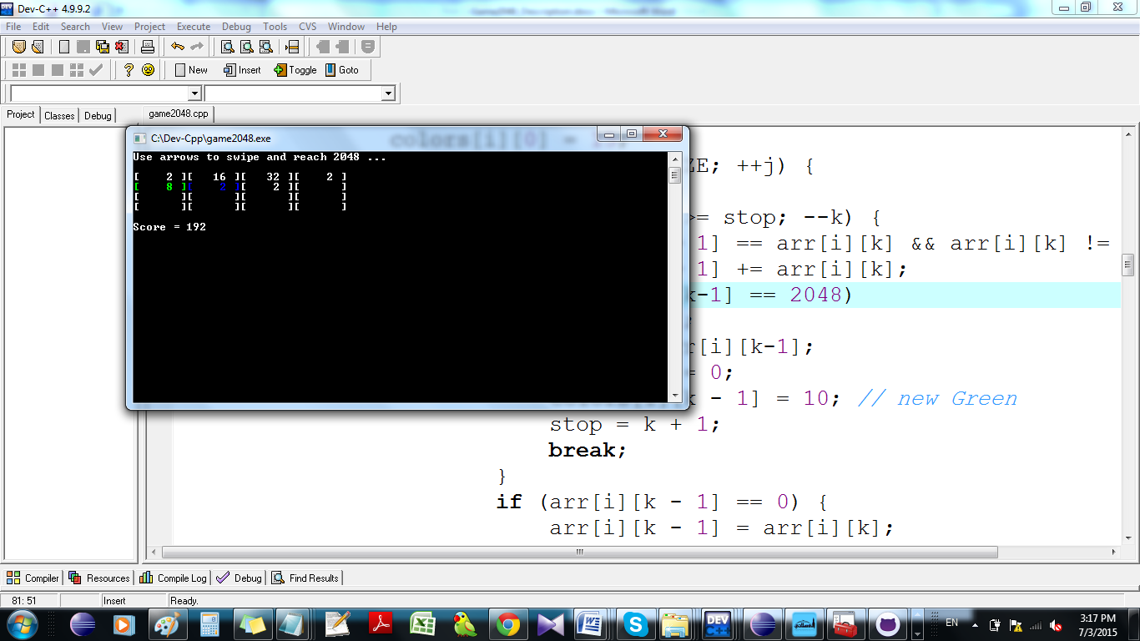

Green means newly computed tile

Blue means newly generated tile

White means old tiles